Additional file legends
Additional file 1: Table S1. Composition of Artificial seawater used in this study
Ingredients | Quantity
Water LC-MS grade | 1000 mL
Sodium chloride | 24.53 g
Magnesium chloride | 5.2 g
Sodium sulfate | 4.09 g
Calcium chloride | 1.16 g
Potassium chloride | 0.695 g
Sodium bicarbonate | 0.201 g
Potassium bromide | 0.101 g
Boric acid | 0.027 g
Strontium chloride | 0.025 g
Sodium fluoride | 0.003 g

Additional file 2: Figure S1. Bar graph detailing the ‘other protein classes’ in ADC and AC groups (from Figure 4b), with the percentage (%) of proteins containing signal peptides shown next to the bars.
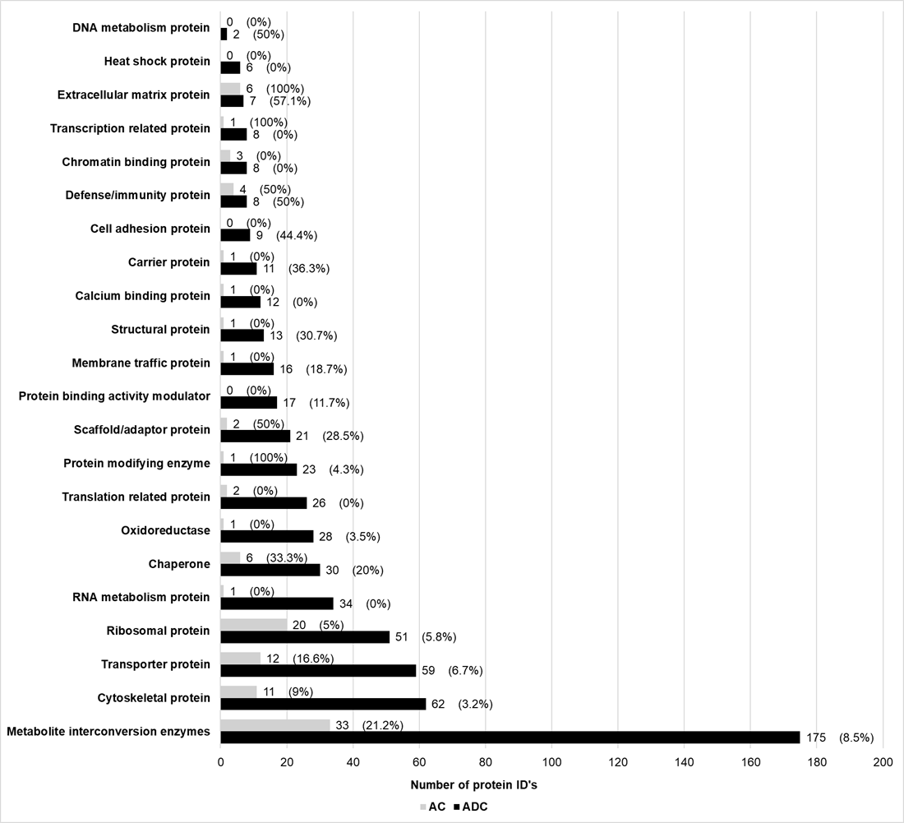
Additional file 3: Figure S2. Final number of protein IDs (a) for NSW groups, after filtering and (b) represented as a Venn diagram
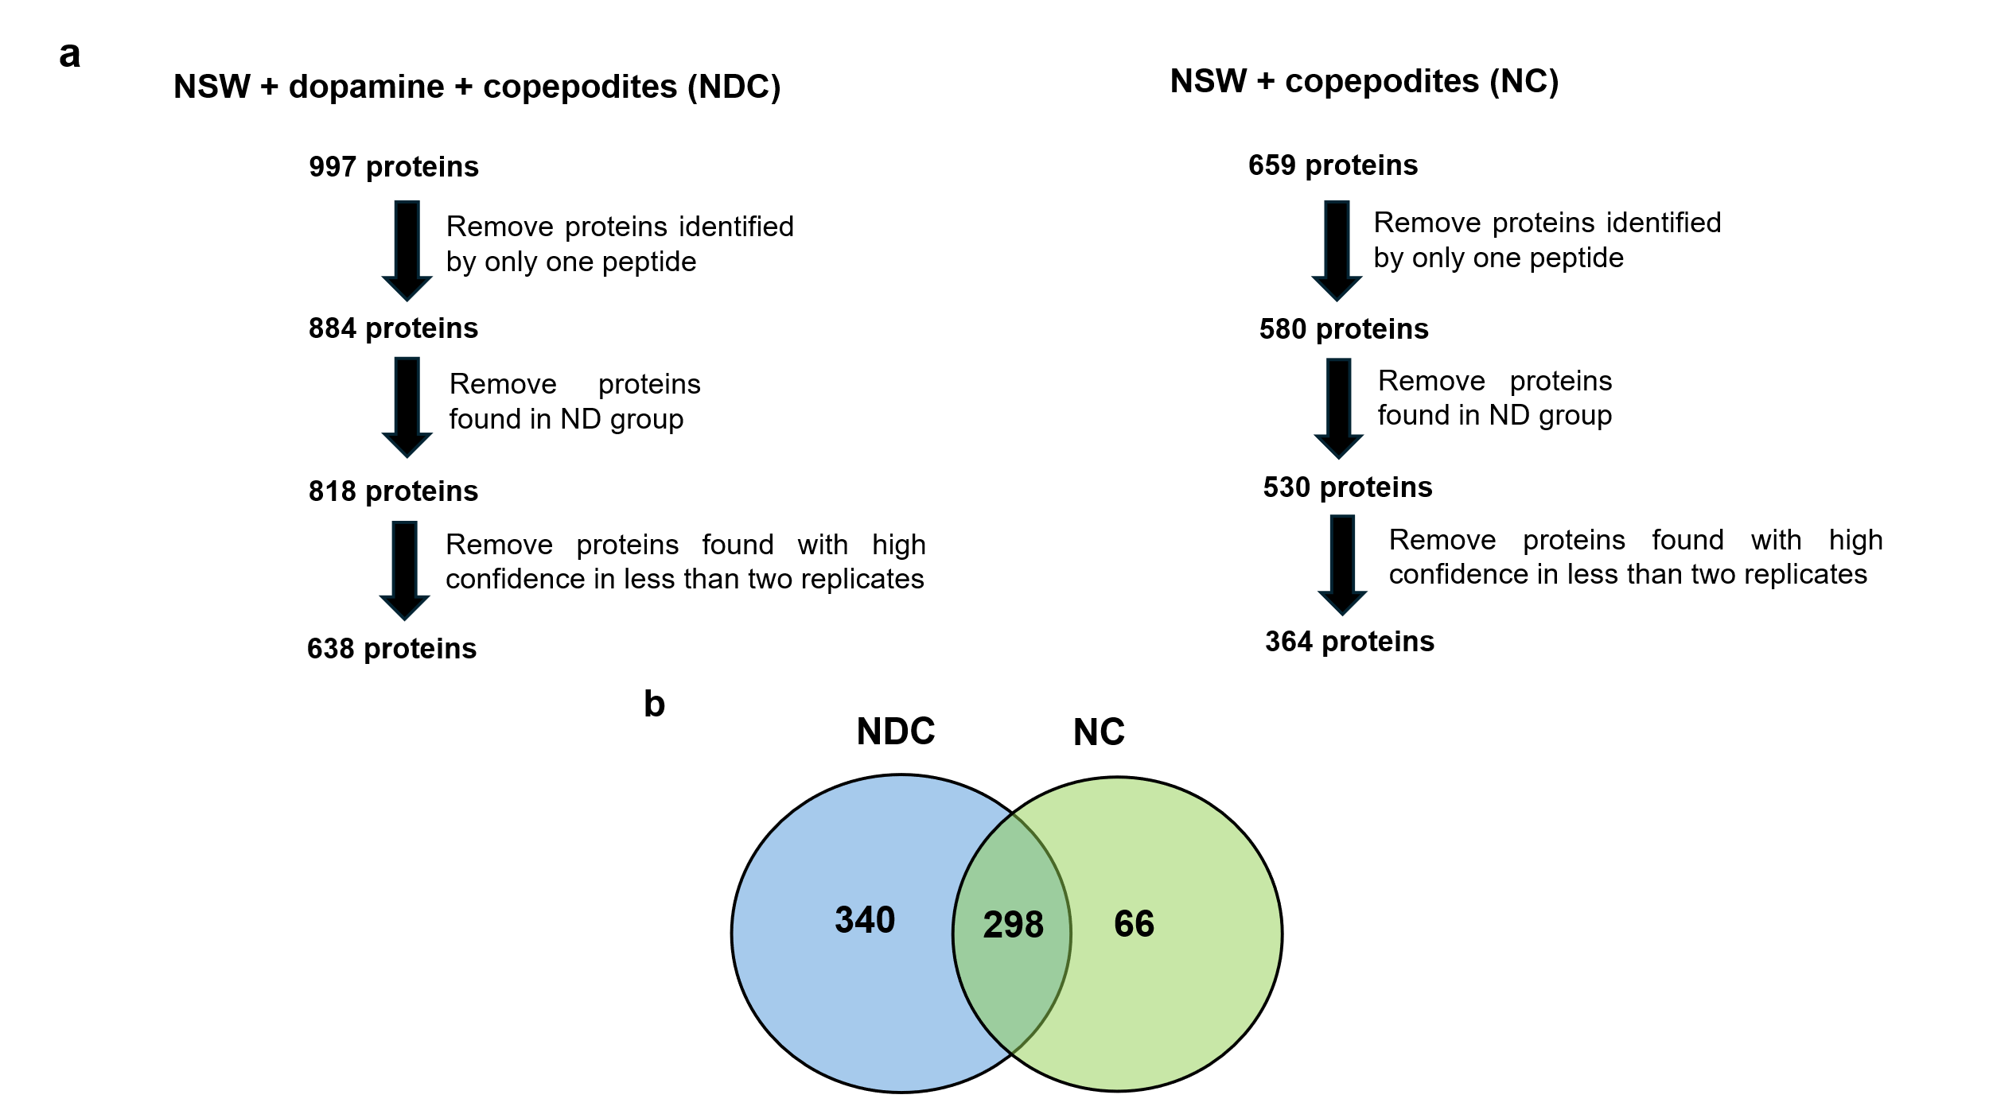
Additional file 4: Figure S3. Bar graph showing (a) important classes in the NDC and NC groups, (b) distribution of uncategorized and ‘other protein classes’ and (c) details of ‘other protein classes’. The percentage (%) of proteins with signal peptides is shown next to the bars
