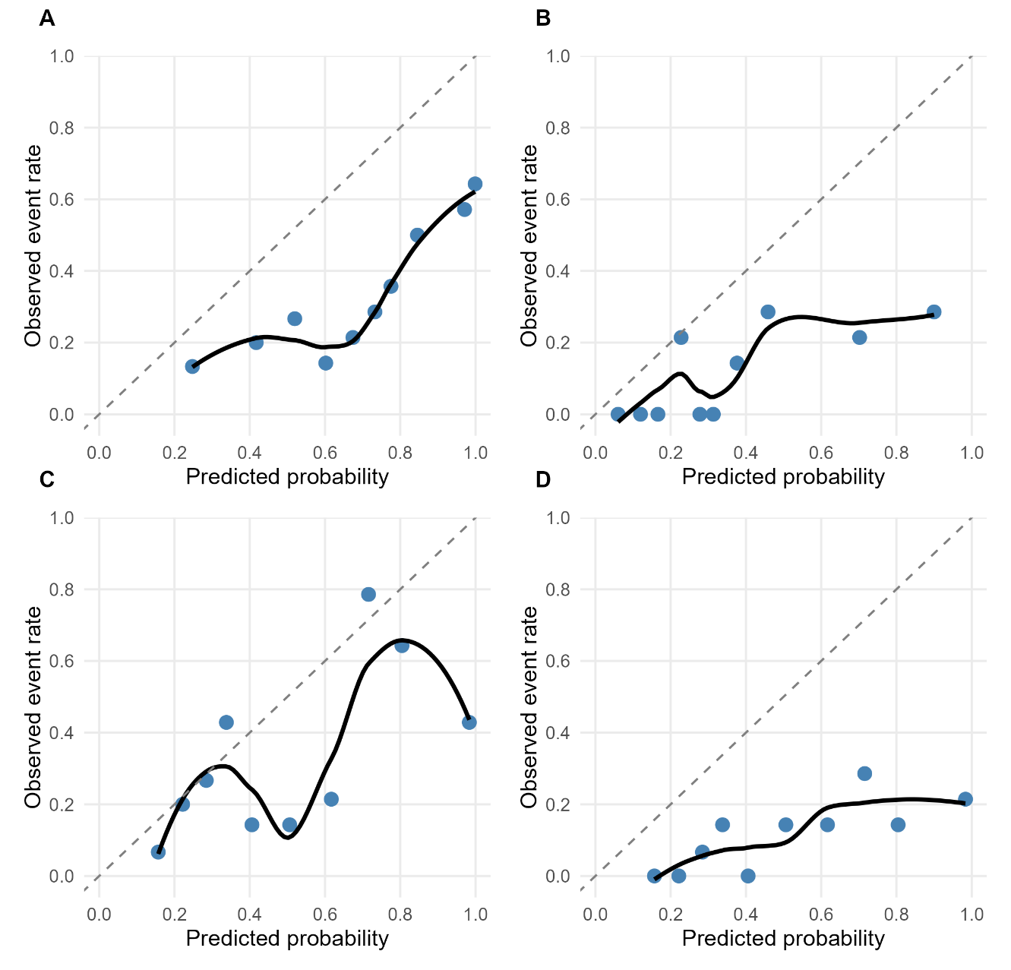
Fig. S1. Calibration plots with LOESS smoothing. A) Vienna ≥10 mmHg, B) Vienna ≥16 mmHg, C) FIB4+ ≥10 mmHg, D) FIB4+ ≥16 mmHG

