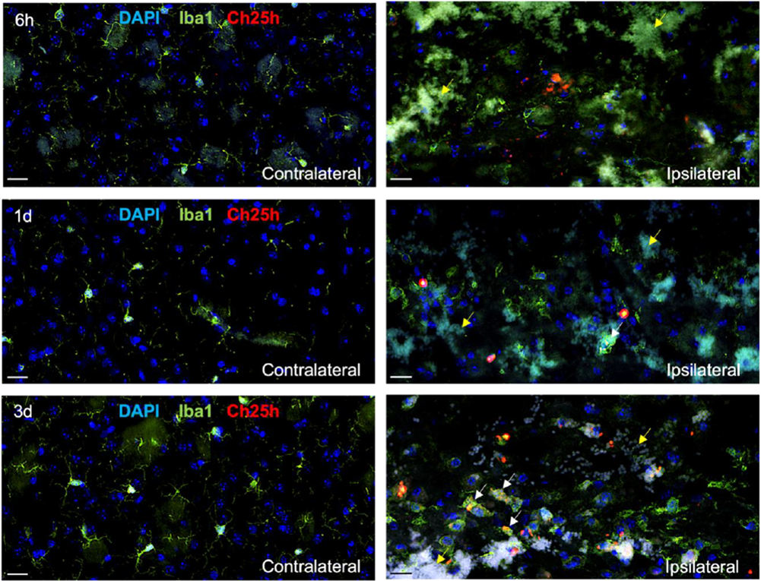
Supplementary Figure 1. Ch25h immunofluorescence in mouse ICH. Representative images of Ch25h (red), Iba1 (green) and DAPI (blue) in the contralateral and ipsilateral hemispheres at 6 h, 1 or 3 days after intracerebral haemorrhage (ICH) in mice. White arrows indicate Ch25h+ Iba+ cells. Yellow arrows indicate red blood cell clusters with pale green/white autofluorescent cells. Scale bars = 20 µm.

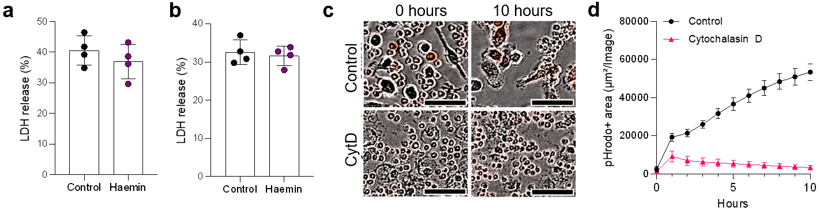
Supplementary Figure 2. Characterisation of in vitro ICH models. a,b, Cell death analysis measured by lactate dehydrogenase (LDH) release in BV2 microglial cells (a) or primary bone-marrow derived murine macrophages (BMDMs) (b) after 6 h of haemin exposure (100 µM). c,d, pHrodo-based phagocytosis assay confirming BMDMs phagocytosis of pHrodo-labelled IgG-opsonised red blood cells. Representative images (c) and quantification (d) of pHrodo-positive area (n=10 mice per group) are shown. Cytochalasin D (CytD) at 10 µM was used as a phagocytosis inhibitor. Scale bars = 50 µm. Statistics were performed using an unpaired t-test (a,b). Data area mean ± SEM.

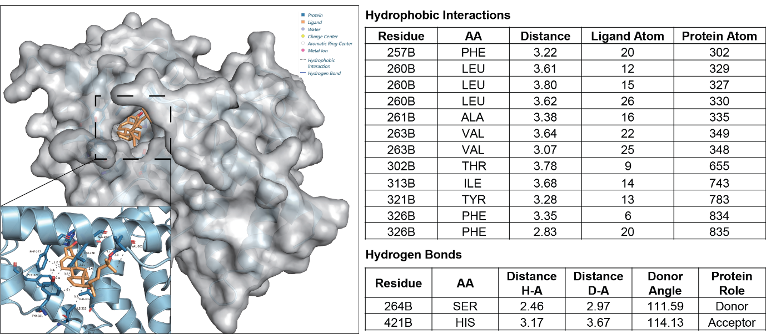
Supplementary Figure 3. Molecular docking-derived binding mode of LXRα with its endogenous ligand 25HC. (Left) Three-dimensional representation of 25HC bound within the ligand-binding pocket of LXRα. The protein surface is shown as a semi-transparent grey surface, with secondary structure elements displayed as a light-blue cartoon; 25HC is shown as an orange stick model. (Zoom-in box) Enlarged view of the local binding environment highlighting predicted interactions between 25HC and surrounding residues. Blue solid lines indicate hydrogen bonds, and grey dashed lines denote hydrophobic contacts. (Right) Tables summarising predicted hydrophobic contacts and hydrogen bonds between 25HC and LXRα, including interacting residues, atom-atom distances, and donor/acceptor assignment for hydrogen bonds. Distances are given in ångströms (Å).

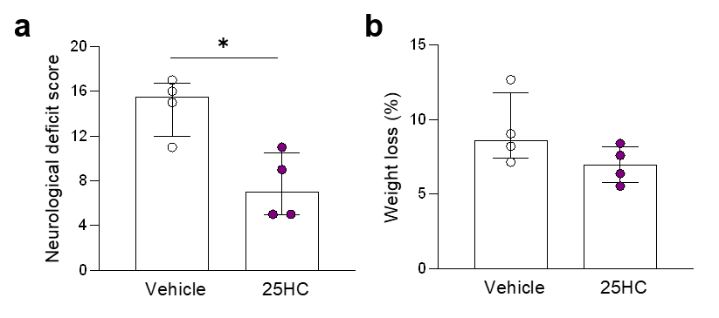
Supplementary Figure 4. 25HC treatment improves outcomes at 24 h post-ICH. Neurological deficit score (a) and weight loss (b) in vehicle and 25HC-treated mice (50 mg kg⁻¹ i.p., n=4 per group) 1 day after ICH. Statistics were performed using an unpaired t-test (a,b). Data are mean ± SEM. * P < 0.05.
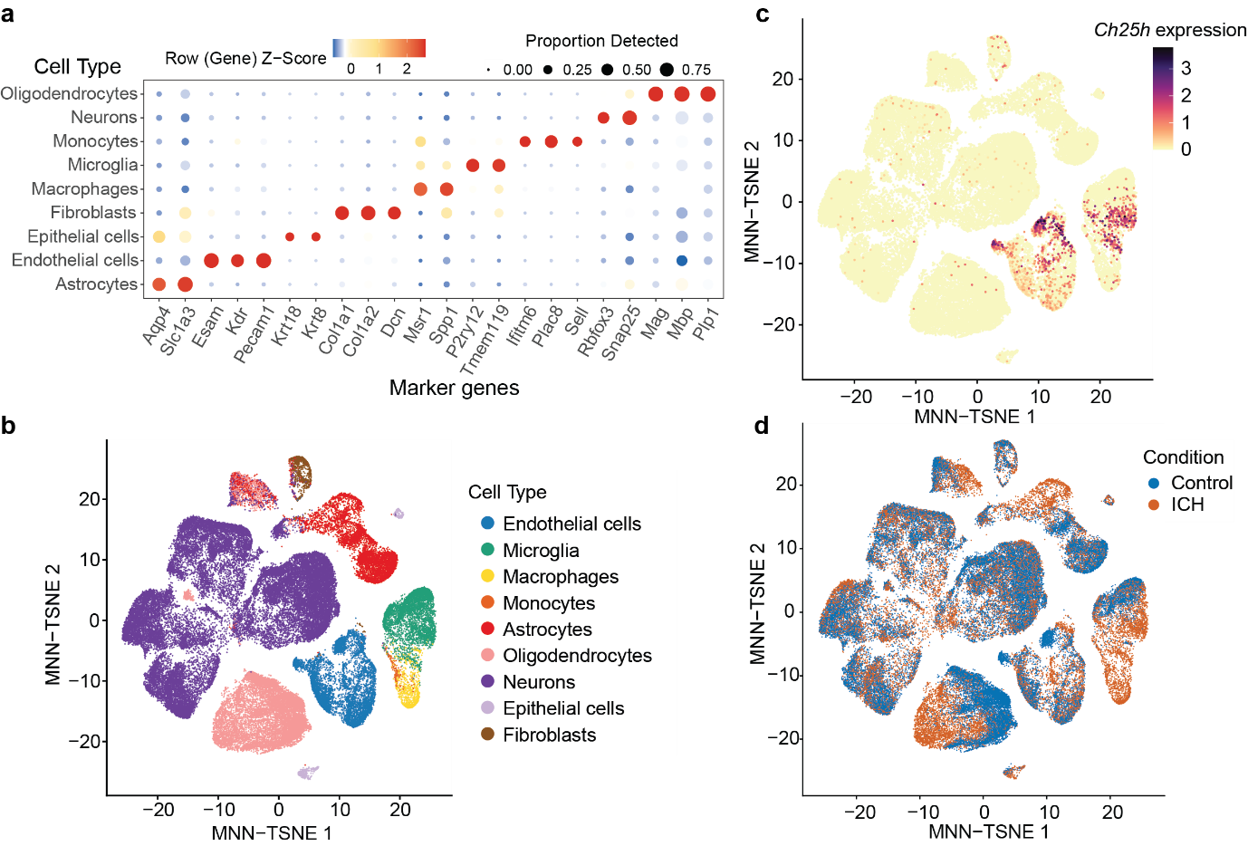
Supplementary Figure 5. Coarse cell clustering and Ch25h expression in single-cell RNA-seq analysis 3 days post-ICH. a, Manually selected marker genes for each coarse cell type found in scRNA-seq. Dot size indicates the percentage of cells expressing each gene within a cluster, and colour represents the scaled average gene expression (Z-score). b-d, MNN-TSNE representation of cells in control and ICH pooled conditions labelled by coarse cell types (b), Ch25h expression (c), and experimental condition (d).
`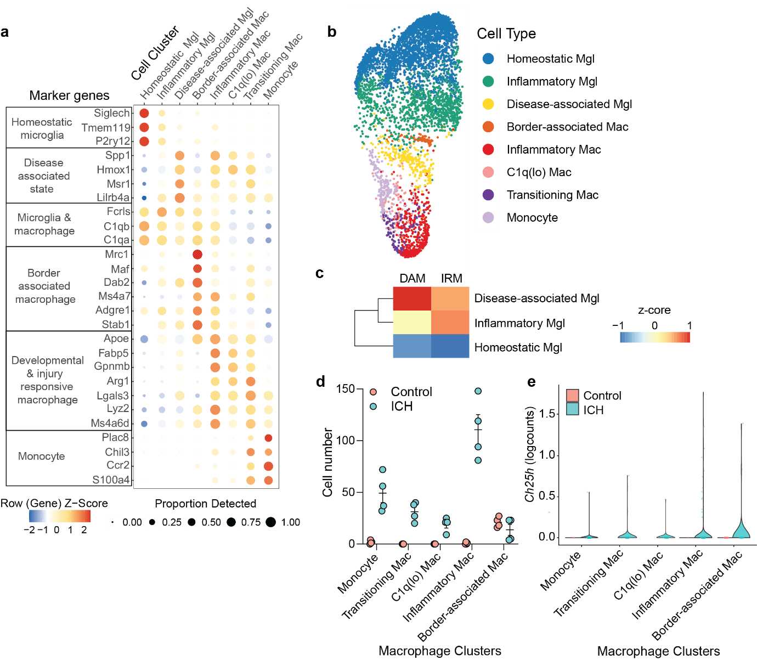
Supplementary Figure 6. Myeloid clustering and Ch25h expression in single-cell RNA-seq analysis. a, Selected marker genes for microglial (Mgl), macrophage (Mac) and monocyte cell clusters. Dot size indicates the percentage of cells expressing each gene within a cluster, and colour represents the scaled average gene expression (Z-score). b, MNN-TSNE representation of microglial, macrophage and monocyte cell clusters in control and ICH pooled conditions. c, Heatmap shows AUCell scores for disease-associated microglia (DAM) and injury-responsive microglia (IRM) gene signatures in microglial clusters. Values are shown as row-scaled Z-scores. d, Cell number of each macrophage cluster in control and ICH samples (n=4 mice per group). Data are mean ± SEM. e, Violin plot showing Ch25h cell expression in macrophage clusters in control and ICH.

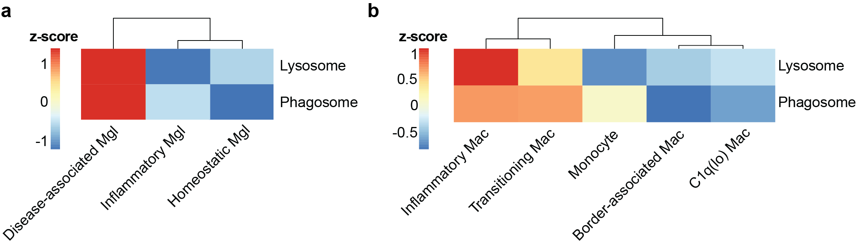
Supplementary Figure 7. Phago-lysosomal transcriptomic activity in microglia and macrophage clusters. Heatmaps show AUCell scores for lysosome and phagosome KEGG pathway gene sets in microglia (Mgl) (a) and macrophage (Mac) clusters (b).
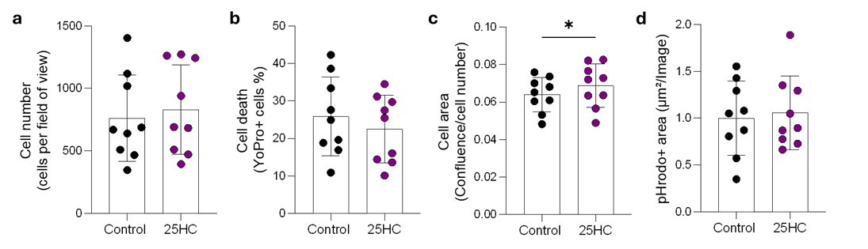
Supplementary Figure 8. Cellular effects of 25HC treatment. a-c, BMDMs were treated with 25HC (1 µM, 24 h) and evaluated for cell density (a), cell death by YoPro+ permeability (b) and cell area quantified by confluency (c). d, Area under the curve (AUC) analysis of pHrodo-based phagocytosis assay in BV2 microglia pre-treated with 25HC (1 µM, 24 h) and then exposed to pHrodo-labelled oxidised red blood cells (oxRBCs) (n=9 cell passages). Statistics were performed using a paired t-test. Data are mean ± SEM. * P < 0.05.

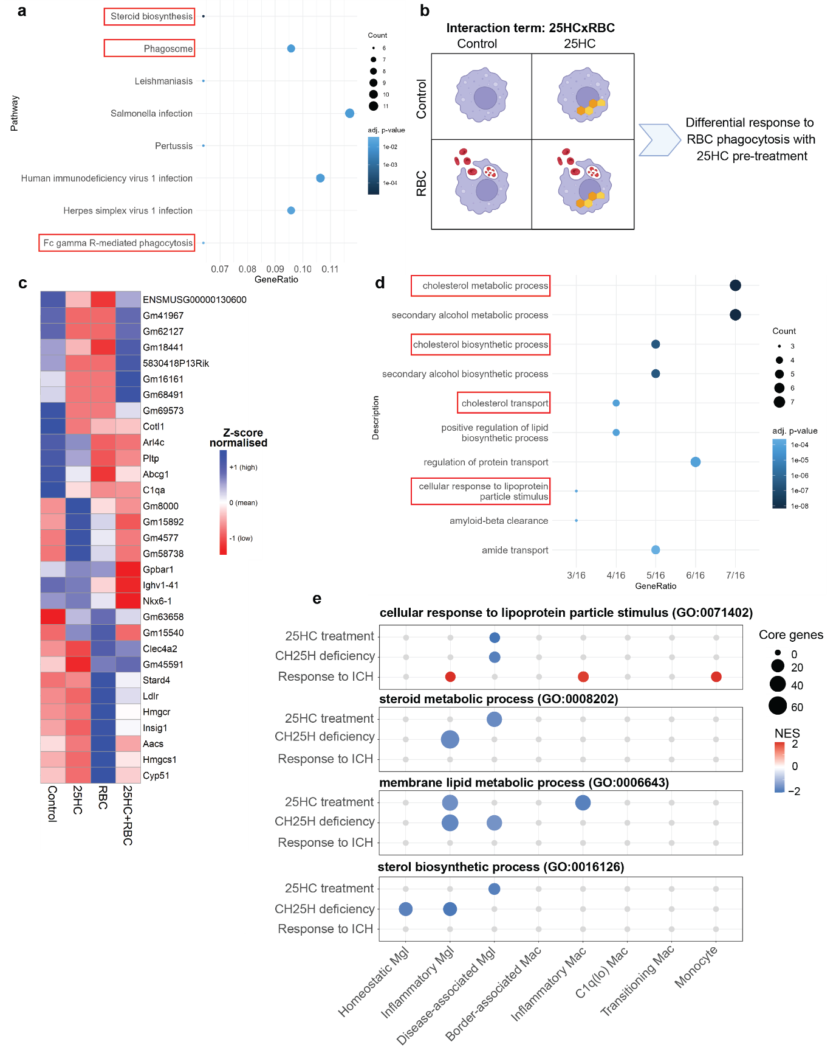
Supplementary Figure 9. 25HC modulates lipid metabolism during RBC phagocytosis and ICH. a, Enriched KEGG pathways in over-representation analysis (ORA) of genes that were significantly downregulated by 25HC pre-treatment and upregulated by RBC phagocytosis. Dot colour indicates adj. P-value, and dot size represents the number of genes contributing to each pathway. b, Schematic of the 2×2 factorial RNA-seq design used to test the interaction between 25HC and RBC phagocytosis. BMDMs were exposed to vehicle or 25HC pre-treatment in the absence or presence of RBC phagocytosis. The interaction term (25HC × RBC) identifies genes showing a differential transcriptional response to RBC phagocytosis following 25HC pre-treatment. c, Heat map of genes with a significant interaction (adj. P value < 0.05) between 25HC × RBC. Colour represents the normalised average gene expression (Z-score). d, Top ten enriched Gene Ontology Biological Process terms in ORA of genes with significant 25HC × RBC interaction. Dot colour indicates adj. P-value, and dot size represent the number of genes contributing to each term. e, Dot plot illustrating the enrichment of lipid and sterol-related GO terms in scRNA-Seq ICH comparisons across microglial (Mgl) and macrophages (Mac). The size of each dot corresponds to the number of leading-edge genes, while the colour scale reflects the normalised enrichment score (NES).

