Supplementary Material S3: Confidence intervals (95%) in marsh deer local abundance map
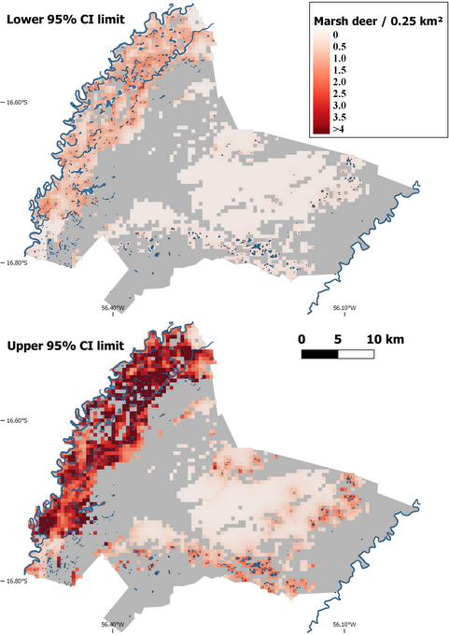
Fig. S3.1. 95% confidence intervals marsh deer local abundance for the dry season of 2017 in Sesc Pantanal Reserve, derived from spatially replicated drone counts. Blue polygons indicate water bodies and gray areas correspond to highly forested areas (>80%) for which local abundance was not predicted.

