Supplementary Information
Title: Can human-made structures enhance the genetic diversity and population dynamics of midwife toads (Alytes dickhilleni)?

Authors: Jesús Manuel Aragón ¹, Carles Vilà ^{2,} Eva M. Albert ³
¹ Department of Physical, Chemical and Natural Systems, Universidad Pablo de Olavide, Seville, Spain.

² Conservation and Evolutionary Genetics Group, Estación Biológica de Doñana (EBD-CSIC),
Seville, Spain
³ Department of Evolutionary Biology and Environmental Studies, University of Zurich,
Zurich, Switzerland

Corresponding Author: Eva M. Albert, eva.albert@ieu.uzh.ch

Table S1. Characteristics of the 29 populations. Includes: population code, status (natural/artificial), subpopulation, full name, geographic coordinates (lat, lon), UTM coordinates (X, Y), number of genotyped individuals (N), genetic diversity parameters (expected heterozygosity Hexp., observed heterozygosity Hobs., private alleles PA, allelic richness AR, inbreeding coefficient FIS), environmental variables (NDVI, altitude), and pond characteristics (distance to nearest pond, size in m²)."
Population | status | subpopulation | name_population |  |  |  |  | N | Hexp. | H.n.b. | Hobs. | PA | AR | FIS
1 | artificial | 1 | Campamento Cañada Fuentes |  |  |  |  | 11 | 0.61 | 0.639 | 0.664 | 1 | 5.25 | 0.01
2 | artificial | 1 | Casa control Chozuelas |  |  |  |  | 16 | 0.584 | 0.607 | 0.599 | 2(2) | 4.417 | 0.008
3 | artificial | 1 | Casa control Rasos |  |  |  |  | 22 | 0.669 | 0.684 | 0.655 | 5(5) | 5.917 | 0.008
4 | natural | 1 | Arroyo Guadahornillos |  |  |  |  | 37 | 0.644 | 0.653 | 0.667 | 2(2) | 7.833 | 0.012
5 | artificial | 1 | Piscina Roblehondo |  |  |  |  | 15 | 0.598 | 0.619 | 0.644 | 0 | 4.917 | 0.01
6 | natural | 1 | Arroyo de la Gracea Este |  |  |  |  | 16 | 0.662 | 0.683 | 0.672 | 2(2) | 7 | 0.009
7 | natural | 1 | Arroyo del rio Barosa |  |  |  |  | 9 | 0.692 | 0.733 | 0.722 | 3(2) | 5.333 | 0.009
8 | natural | 1 | Canada Pajarera |  |  |  |  | 16 | 0.628 | 0.648 | 0.664 | 0 | 4.75 | 0.009
9 | artificial | 1 | Bebederos de Rambla seca |  |  |  |  | 12 | 0.66 | 0.688 | 0.632 | 0 | 5.667 | 0.007
10 | artificial | 1 | Cortijo de Pinar Negro |  |  |  |  | 11 | 0.628 | 0.658 | 0.705 | 0 | 5.25 | 0.011
11 | artificial | 1 | Cueva Paria |  |  |  |  | 30 | 0.667 | 0.678 | 0.653 | 0 | 5.75 | 0.007
12 | artificial | 1 | Refugio Cañada rincón |  |  |  |  | 31 | 0.674 | 0.685 | 0.682 | 2(2) | 7 | 0.009
13 | artificial | 1 | Pozo nuevo |  |  |  |  | 20 | 0.691 | 0.708 | 0.695 | 2(2) | 6.417 | 0.009
14 | artificial | 1 | Canada rincon |  |  |  |  | 12 | 0.622 | 0.649 | 0.648 | 0 | 5.25 | 0.009
15 | artificial | 1 | Pozo Purga |  |  |  |  | 24 | 0.649 | 0.662 | 0.667 | 1 | 7 | 0.01
16 | artificial | 1 | Pozo la Losilla |  |  |  |  | 34 | 0.691 | 0.702 | 0.667 | 1 | 8.083 | 0.006
17 | artificial | 1 | Bebederos Espinos |  |  |  |  | 20 | 0.654 | 0.671 | 0.654 | 1 | 6.333 | 0.008
18 | artificial | 1 | Abrevadero Don Fernando |  |  |  |  | 16 | 0.685 | 0.707 | 0.677 | 1 | 5.583 | 0.008
19 | artificial | 1 | Pozo Prado Gonzalo |  |  |  |  | 20 | 0.643 | 0.659 | 0.667 | 2(2) | 6.333 | 0.01
20 | natural | 2 | Fuente del Borbotón |  |  |  |  | 20 | 0.668 | 0.685 | 0.679 | 1 | 6.417 | 0.01
21 | artificial | 2 | Fuente de la Chaparra |  |  |  |  | 16 | 0.585 | 0.604 | 0.672 | 0 | 3.917 | 0.013
22 | natural | 2 | Loma de los muertos |  |  |  |  | 13 | 0.65 | 0.676 | 0.718 | 0 | 4.5 | 0.011
23 | artificial | 2 | Tiná de las cruces |  |  |  |  | 16 | 0.636 | 0.656 | 0.682 | 2(1) | 5.083 | 0.011
24 | natural | 2 | Arroyo de la Juan fria |  |  |  |  | 20 | 0.652 | 0.669 | 0.658 | 1 | 6.083 | 0.009
25 | artificial | 2 | Pozo de los Navarros |  |  |  |  | 16 | 0.642 | 0.663 | 0.588 | 0 | 5.5 | 0.006
26 | artificial | 2 | Fuente de la Zarza |  |  |  |  | 19 | 0.593 | 0.609 | 0.623 | 0 | 4.417 | 0.011
27 | artificial | 2 | Fuentesaltas |  |  |  |  | 15 | 0.653 | 0.675 | 0.671 | 3(3) | 5.75 | 0.009
28 | natural | 2 | Fuente del Engarbo |  |  |  |  | 16 | 0.617 | 0.636 | 0.646 | 1 | 5.333 | 0.01
29 | artificial | 2 | Hoya de la Viga |  |  |  |  | 16 | 0.682 | 0.704 | 0.771 | 2(2) | 6 | 0.013

Population | NDVI_mean | altitude_mean | NDVI_mean_1000 | altitude_min | altitude_max | near_pond | size_pond.m2.
1 | 0.18711875 | 1416.33533 | 0.18059823 | 1355 | 1538 | 2.96509731 | 33.7
2 | 0.05325267 | 1454.5875 | 0.17108839 | 1377 | 1579 | 6.71198338 | 2
3 | 0.22045118 | 1193.30539 | 0.18647049 | 1177 | 1226 | 2.96509731 | 0.073
4 | 0.19466317 | 1252.70482 | 0.22434946 | 1178 | 1353 | 1.06029143 | 0.24
5 | 0.21628205 | 1273.27607 | 0.2162228 | 1180 | 1339 | 1.06029143 | 7.6
6 | 0.23060474 | 788.567901 | 0.24738967 | 731 | 894 | 1.07352372 | 898
7 | 0.20612645 | 798.573171 | 0.24456841 | 722 | 922 | 1.07352372 | 12.4
8 | 0.14737816 | 1630.65432 | 0.16332719 | 1616 | 1672 | 4.27651573 | 1.3
9 | 0.21132059 | 1587.5509 | 0.17031503 | 1580 | 1596 | 4.20217998 | 29
10 | 0.20076418 | 1684.71687 | 0.17532921 | 1663 | 1734 | 2.81791621 | 210
11 | 0.16980289 | 1666.97576 | 0.14446461 | 1650 | 1696 | 2.04495009 | 84
12 | 0.16724045 | 1716.05325 | 0.14810603 | 1705 | 1743 | 0.35676318 | 4.6
13 | 0.1400312 | 1744.70122 | 0.14783016 | 1715 | 1809 | 0.35676318 | 8
14 | 0.19350657 | 1721.42945 | 0.14720511 | 1713 | 1747 | 0.51578279 | 4.7
15 | 0.15243315 | 1659.20988 | 0.15037576 | 1645 | 1672 | 2.04495009 | 8.3
16 | 0.14796707 | 1716.51829 | 0.14470914 | 1708 | 1727 | 0.51578279 | 155
17 | 0.12797512 | 1757.78313 | 0.15287031 | 1731 | 1806 | 1.87531384 | 26.4
18 | 0.14333735 | 1686.37126 | 0.14485405 | 1663 | 1730 | 1.9718234 | 0.34
19 | 0.13907835 | 1735.27108 | 0.1607971 | 1726 | 1748 | 1.9718234 | 4.6
20 | 0.14132238 | 1606.21472 | 0.17479857 | 1576 | 1662 | 1.16167304 | 6.7
21 | 0.16650209 | 1782.95092 | 0.16705941 | 1708 | 1844 | 1.16167304 | 6.2
22 | 0.19101707 | 1658.24096 | 0.17865006 | 1639 | 1670 | 0.0745416 | 6.7
23 | 0.18912823 | 1661.99401 | 0.17598822 | 1643 | 1672 | 0.0745416 | 9.8
24 | 0.12440703 | 1643.76786 | 0.14308296 | 1608 | 1715 | 3.64481973 | 0.24
25 | 0.17537005 | 1671.63473 | 0.16994579 | 1628 | 1748 | 2.18556568 | 127.5
26 | 0.20466013 | 1568.31515 | 0.17800989 | 1543 | 1590 | 2.18556568 | 4.6
27 | 0.20383608 | 1571.90798 | 0.19244775 | 1560 | 1606 | 8.98152793 | 63
28 | 0.12815148 | 1655.90244 | 0.14042975 | 1625 | 1683 | 5.2159872 | 35.4
29 | 0.13310629 | 1649.74699 | 0.13396782 | 1607 | 1703 | 10.217367 | 98.9

Table S2. Population pair matrix showing genetic differentiation values (FST) in the upper triangle and geographical distances in kilometers in the lower triangle. The main diagonal is represented by dashes.
Pop | 1 | 2 | 3 | 4 | 5 | 6 | 7 | 8 | 9 | 10 | 11 | 12 | 13 | 14
1 | - | 0.08077 | 0.05579 | 0.0161 | 0.04726 | 0.01957 | 0.02727 | 0.1061 | 0.01797 | 0.11372 | 0.07597 | 0.05984 | 0.06865 | 0.06686
2 | 6.712 | - | 0.06766 | 0.08943 | 0.09817 | 0.04115 | 0.07742 | 0.10918 | 0.09467 | 0.12545 | 0.08285 | 0.08786 | 0.09105 | 0.08308
3 | 2.9651 | 9.5616 | - | 0.05134 | 0.07856 | 0.02864 | 0.05304 | 0.06177 | 0.05783 | 0.08844 | 0.07219 | 0.05729 | 0.06105 | 0.05807
4 | 16.2135 | 21.6708 | 13.5286 | - | 0.03939 | 0.02299 | 0.031 | 0.09033 | 0.02249 | 0.08084 | 0.0532 | 0.0454 | 0.05052 | 0.04052
5 | 16.0193 | 21.2553 | 13.4309 | 1.0603 | - | 0.02603 | 0.03668 | 0.10587 | 0.06634 | 0.07449 | 0.06173 | 0.06171 | 0.07043 | 0.0636
6 | 21.9706 | 27.4283 | 19.2357 | 5.7814 | 6.2001 | - | 0.00745 | 0.05644 | 0.03828 | 0.06813 | 0.034 | 0.03415 | 0.04254 | 0.02425
7 | 22.9861 | 28.3764 | 20.2689 | 6.7769 | 7.1226 | 1.0735 | - | 0.08287 | 0.05532 | 0.06963 | 0.04548 | 0.03824 | 0.04836 | 0.05033
8 | 19.9511 | 23.4057 | 18.0911 | 8.6254 | 7.6771 | 9.8308 | 9.9899 | - | 0.09394 | 0.09236 | 0.09757 | 0.08911 | 0.0916 | 0.10924
9 | 24.1656 | 27.6709 | 22.2027 | 11.22 | 10.495 | 10.0877 | 9.7853 | 4.2765 | - | 0.1074 | 0.0528 | 0.05502 | 0.04363 | 0.04223
10 | 30.3482 | 34.7489 | 27.9527 | 14.8332 | 14.6499 | 10.2789 | 9.3018 | 11.8611 | 8.204 | - | 0.05305 | 0.05648 | 0.09117 | 0.10171
11 | 28.1258 | 31.8336 | 26.027 | 14.028 | 13.5152 | 11.16 | 10.4813 | 8.4301 | 4.2022 | 4.7947 | - | 0.01461 | 0.01916 | 0.01955
12 | 30.6611 | 34.5996 | 28.4453 | 15.8772 | 15.5123 | 12.0748 | 11.2085 | 11.2494 | 7.1093 | 2.8606 | 2.9641 | - | 0.01927 | 0.00339
13 | 30.9978 | 34.9512 | 28.7736 | 16.1645 | 15.8124 | 12.2838 | 11.4018 | 11.6048 | 7.4659 | 2.8179 | 3.3156 | 0.3568 | - | 0.00664
14 | 31.6006 | 35.543 | 29.3763 | 16.7476 | 16.4038 | 12.7962 | 11.8978 | 12.1858 | 8.0261 | 3.0551 | 3.849 | 0.945 | 0.6031 | -
15 | 30.0493 | 33.5982 | 27.9974 | 16.071 | 15.5598 | 13.0307 | 12.2907 | 10.2156 | 5.9391 | 5.119 | 2.045 | 2.3913 | 2.6187 | 2.8969
16 | 31.5239 | 35.3843 | 29.3329 | 16.8203 | 16.4457 | 13.013 | 12.137 | 11.9982 | 7.7955 | 3.4866 | 3.5947 | 0.9518 | 0.7421 | 0.5158
17 | 33.2811 | 37.3329 | 31.0022 | 18.1571 | 17.8834 | 13.8317 | 12.8677 | 14.0151 | 9.887 | 3.5751 | 5.7224 | 2.7779 | 2.4212 | 1.8753
18 | 33.8577 | 37.2945 | 31.8198 | 19.7706 | 19.3057 | 16.286 | 15.4398 | 13.9736 | 9.7082 | 6.7438 | 5.8291 | 4.2434 | 4.0941 | 3.7056
19 | 33.4512 | 36.5743 | 31.5451 | 20.0158 | 19.4581 | 17.033 | 16.2654 | 13.5007 | 9.3476 | 8.1545 | 6.022 | 5.3863 | 5.3508 | 5.1279
20 | 37.6113 | 41.2648 | 35.4627 | 22.9275 | 22.5826 | 18.7709 | 17.8122 | 17.8739 | 13.5992 | 8.519 | 9.496 | 7.0729 | 6.7703 | 6.1814
21 | 38.3629 | 42.1332 | 36.1648 | 23.4635 | 23.1633 | 19.1062 | 18.12 | 18.7281 | 14.4644 | 8.8284 | 10.309 | 7.7197 | 7.3945 | 6.793
22 | 41.9745 | 45.9523 | 39.681 | 26.6743 | 26.4735 | 21.8938 | 20.8557 | 22.5623 | 18.3314 | 11.8411 | 14.1366 | 11.3656 | 11.0182 | 10.4207
23 | 41.9754 | 45.9441 | 39.6854 | 26.6872 | 26.4834 | 21.9164 | 20.8792 | 22.5522 | 18.319 | 11.8542 | 14.1254 | 11.3606 | 11.0137 | 10.4156
24 | 38.121 | 41.2416 | 36.1818 | 24.3445 | 23.8586 | 20.8268 | 19.9538 | 18.1705 | 13.9809 | 10.9494 | 10.3467 | 8.752 | 8.5521 | 8.072
25 | 40.834 | 44.5375 | 38.6497 | 25.95 | 25.6552 | 21.5272 | 20.5282 | 21.1418 | 16.8689 | 11.2635 | 12.7453 | 10.2073 | 9.8846 | 9.2837
26 | 41.3199 | 44.7366 | 39.2447 | 26.8688 | 26.4972 | 22.7525 | 21.7896 | 21.447 | 17.1817 | 12.4905 | 13.2178 | 10.9924 | 10.7053 | 10.1272
27 | 50.9553 | 54.8885 | 48.6497 | 35.5545 | 35.3943 | 30.5733 | 29.5143 | 31.484 | 27.2288 | 20.7444 | 23.055 | 20.3353 | 19.9904 | 19.3907
28 | 45.4842 | 48.4532 | 43.566 | 31.6231 | 31.1764 | 27.7811 | 26.8452 | 25.5345 | 21.3636 | 17.5796 | 17.6924 | 15.8182 | 15.5655 | 15.0188
29 | 61.1482 | 64.9684 | 58.8608 | 45.7644 | 45.6109 | 40.7237 | 39.6593 | 41.5702 | 37.2991 | 30.9612 | 33.1582 | 30.4994 | 30.1586 | 29.5568

Pop | 15 | 16 | 17 | 18 | 19 | 20 | 21 | 22 | 23 | 24 | 25 | 26 | 27 | 28 | 29
1 | 0.0815 | 0.08915 | 0.07053 | 0.08926 | 0.10771 | 0.10503 | 0.17216 | 0.14687 | 0.12299 | 0.1077 | 0.18635 | 0.11805 | 0.13416 | 0.17643 | 0.12663
2 | 0.09381 | 0.07551 | 0.08829 | 0.09863 | 0.10908 | 0.12646 | 0.18512 | 0.15857 | 0.12817 | 0.10905 | 0.14868 | 0.11863 | 0.17689 | 0.15646 | 0.14403
3 | 0.06728 | 0.06224 | 0.04704 | 0.08252 | 0.08377 | 0.09626 | 0.1651 | 0.11805 | 0.10745 | 0.09346 | 0.12213 | 0.104 | 0.1317 | 0.11816 | 0.08464
4 | 0.05785 | 0.07124 | 0.05654 | 0.07945 | 0.07471 | 0.0884 | 0.14809 | 0.12076 | 0.0988 | 0.08562 | 0.15776 | 0.09213 | 0.13461 | 0.14701 | 0.11235
5 | 0.06891 | 0.08653 | 0.07912 | 0.07734 | 0.07298 | 0.1037 | 0.17507 | 0.13698 | 0.10877 | 0.10125 | 0.13876 | 0.12057 | 0.12923 | 0.16619 | 0.11775
6 | 0.04467 | 0.02942 | 0.03506 | 0.05772 | 0.0534 | 0.05494 | 0.11908 | 0.09132 | 0.06074 | 0.05655 | 0.09753 | 0.07875 | 0.09978 | 0.10653 | 0.08396
7 | 0.04526 | 0.04346 | 0.04754 | 0.06707 | 0.07386 | 0.07039 | 0.12173 | 0.11093 | 0.08872 | 0.07362 | 0.1111 | 0.09597 | 0.08575 | 0.13026 | 0.08394
8 | 0.10241 | 0.08323 | 0.09069 | 0.11996 | 0.12206 | 0.1268 | 0.20388 | 0.15805 | 0.13648 | 0.12547 | 0.15355 | 0.15252 | 0.18004 | 0.17678 | 0.13004
9 | 0.06062 | 0.06813 | 0.06958 | 0.05092 | 0.06798 | 0.09028 | 0.16104 | 0.09359 | 0.08368 | 0.06962 | 0.1493 | 0.11087 | 0.14349 | 0.13299 | 0.11389
10 | 0.08785 | 0.0756 | 0.04642 | 0.08365 | 0.08793 | 0.10676 | 0.15924 | 0.13894 | 0.12134 | 0.11317 | 0.12976 | 0.15534 | 0.14145 | 0.16035 | 0.12494
11 | 0.04601 | 0.02526 | 0.04644 | 0.02777 | 0.02193 | 0.04189 | 0.0873 | 0.07046 | 0.06427 | 0.01859 | 0.08073 | 0.08157 | 0.09244 | 0.08324 | 0.09665
12 | 0.04011 | 0.03012 | 0.02117 | 0.03165 | 0.03008 | 0.04472 | 0.10547 | 0.07103 | 0.06468 | 0.02877 | 0.09106 | 0.08884 | 0.07364 | 0.09564 | 0.07737
13 | 0.02895 | 0.03085 | 0.04843 | 0.02919 | 0.02691 | 0.0376 | 0.09996 | 0.06825 | 0.06711 | 0.01599 | 0.09534 | 0.07399 | 0.09338 | 0.09807 | 0.08073
14 | 0.03232 | 0.02194 | 0.0305 | 0.02736 | 0.0199 | 0.04321 | 0.11068 | 0.07052 | 0.06105 | 0.02124 | 0.08878 | 0.0779 | 0.09569 | 0.08953 | 0.08186
15 | - | 0.03898 | 0.05395 | 0.06321 | 0.05159 | 0.07332 | 0.13138 | 0.08681 | 0.07019 | 0.04866 | 0.10711 | 0.07496 | 0.10375 | 0.11996 | 0.08768
16 | 2.442 | - | 0.0396 | 0.03548 | 0.02673 | 0.02933 | 0.0633 | 0.06113 | 0.05926 | 0.01794 | 0.06001 | 0.06609 | 0.08778 | 0.07786 | 0.07831
17 | 4.6344 | 2.2188 | - | 0.07119 | 0.04168 | 0.06743 | 0.12061 | 0.09115 | 0.06398 | 0.06131 | 0.09854 | 0.10119 | 0.10562 | 0.10752 | 0.08461
18 | 3.823 | 3.3532 | 3.9194 | - | 0.02208 | 0.03886 | 0.10002 | 0.06005 | 0.06716 | 0.02168 | 0.06982 | 0.0884 | 0.077 | 0.07799 | 0.07715
19 | 4.0241 | 4.6693 | 5.7641 | 1.9718 | - | 0.02421 | 0.08314 | 0.03726 | 0.03395 | 0.00169 | 0.04944 | 0.07051 | 0.0724 | 0.04861 | 0.07527
20 | 7.6667 | 6.1513 | 4.9454 | 4.1263 | 5.5911 | - | 0.03773 | 0.04594 | 0.05195 | 0.01005 | 0.05987 | 0.07733 | 0.05557 | 0.0527 | 0.07995
21 | 8.5666 | 6.8394 | 5.3216 | 5.187 | 6.7339 | 1.1617 | - | 0.10556 | 0.11561 | 0.05904 | 0.11347 | 0.12067 | 0.12146 | 0.12103 | 0.1385
22 | 12.5102 | 10.5683 | 8.6936 | 9.2361 | 10.7332 | 5.1517 | 4.0492 | - | 0.02941 | 0.03656 | 0.05071 | 0.09405 | 0.08458 | 0.06374 | 0.06801
23 | 12.4922 | 10.5598 | 8.6943 | 9.2053 | 10.6939 | 5.1153 | 4.0183 | 0.0745 | - | 0.03555 | 0.06527 | 0.07963 | 0.07538 | 0.06778 | 0.07153
24 | 8.3053 | 7.8171 | 7.5504 | 4.5898 | 4.6835 | 3.6448 | 4.5418 | 7.6122 | 7.5517 | - | 0.05221 | 0.05372 | 0.06246 | 0.04017 | 0.07211
25 | 10.9406 | 9.318 | 7.7974 | 7.359 | 8.6176 | 3.2757 | 2.4931 | 2.5085 | 2.4438 | 5.1271 | - | 0.10815 | 0.08416 | 0.05297 | 0.08526
26 | 11.2706 | 10.053 | 8.9223 | 7.4738 | 8.2698 | 3.9837 | 3.8068 | 4.4548 | 4.382 | 3.951 | 2.1856 | - | 0.13655 | 0.11286 | 0.11311
27 | 21.3351 | 19.5171 | 17.675 | 17.8007 | 18.9592 | 13.704 | 12.7698 | 8.9815 | 8.982 | 14.783 | 10.4422 | 10.8383 | - | 0.0748 | 0.04108
28 | 15.6615 | 14.8663 | 14.0059 | 11.8731 | 12.034 | 9.0789 | 9.0217 | 8.5362 | 8.4655 | 7.3863 | 7.0926 | 5.216 | 10.2652 | - | 0.0748
29 | 31.3708 | 29.6595 | 27.87 | 27.7182 | 28.6706 | 23.7042 | 22.8494 | 19.1809 | 19.1777 | 24.1951 | 20.4309 | 20.4011 | 10.2174 | 17.9908 | -

Table S3. Contemporary migration rate matrix (m) estimated using BAYESASS v3.0.5, representing the proportion of recent migrants (last 2-3 generations) between each pair of populations. The values indicate the probability that an individual in the destination population (row) is a recent immigrant from the source population (column). The migration rates detected were generally low (<1%), although notable flows exceeding 10% were observed in some population pairs. The table only shows pairs of populations with migration rates above 1%.
Pop-target | Pop-source (migration rate)
4 | 1 (0.101), 2 (0.074), 3 (0.103), 5 (0.103), 6 (0.088), 7 (0.046), 9 (0.083), 10 (0.042)
11 | 2 (0.017), 3 (0.015), 4 (0.010), 5 (0.013), 6 (0.018), 9 (0.017), 10 (0.020), 12 (0.091), 13 (0.095), 14 (0.042), 15 (0.074), 16 (0.072), 17 (0.041), 18 (0.067), 19 (0.101), 20 (0.084), 21 (0.084), 22 (0.058), 23 (0.092), 24 (0.105), 25 (0.073), 26 (0.072), 28 (0.089)
12 | 2 (0.015), 5 (0.011), 6 (0.023), 7 (0.034), 8 (0.066), 9 (0.017), 10 (0.032), 11 (0.018), 13 (0.025), 14 (0.062), 15 (0.030), 16 (0.066), 17 (0.062), 18 (0.042)
16 | 3 (0.010), 6 (0.013), 10 (0.023), 20 (0.019), 21 (0.024), 25 (0.020)
26 | 18 (0.015), 22 (0.011), 28 (0.012)
29 | 18 (0.014), 22 (0.013), 25 (0.017), 27 (0.092), 28 (0.017)
21 | 20 (0.014)
23 | 22 (0.013)
25 | 22 (0.013)

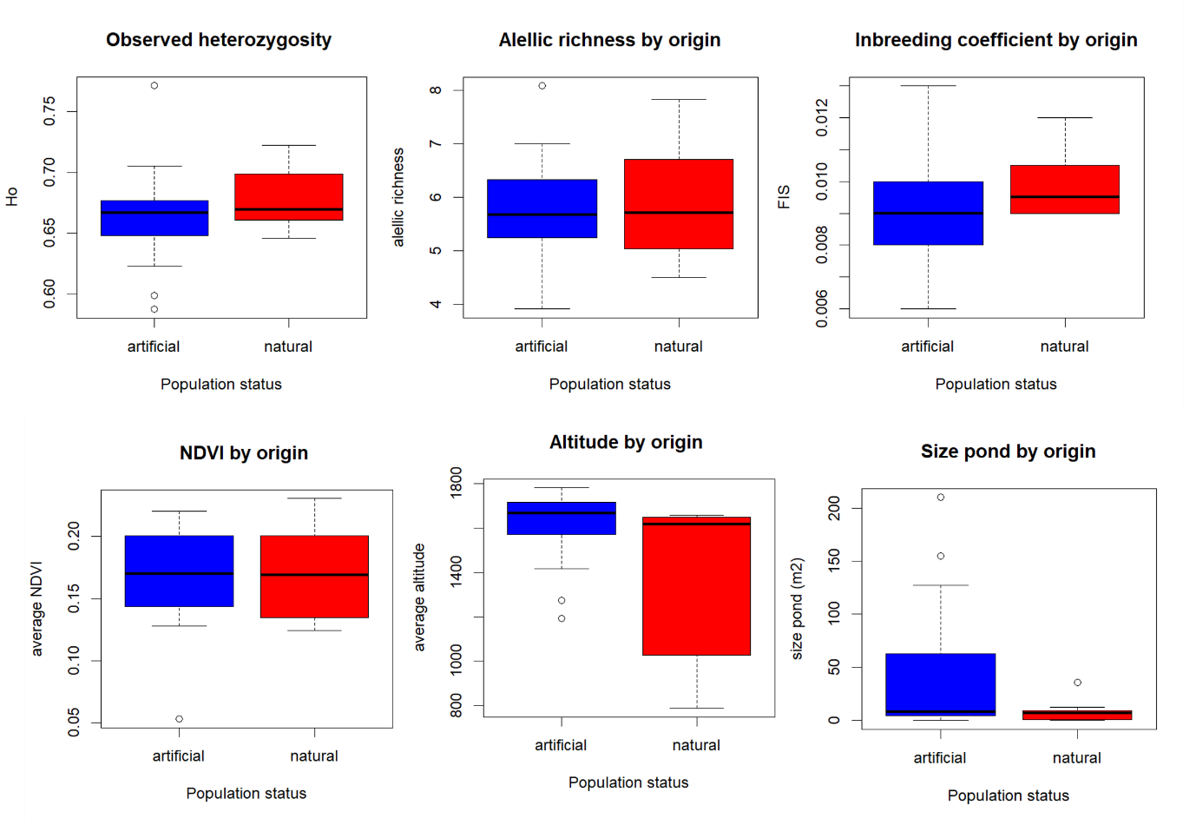
Fig S1. Comparison of multiple genetic and environmental parameters between natural and artificial ponds. The boxplots show (from left to right, top row): observed heterozygosity (Ho), allelic richness (AR), inbreeding coefficient (FIS); (bottom row): NDVI vegetation index, average altitude, and pond size. No statistically significant differences were detected between natural and artificial ponds (p > 0.05).
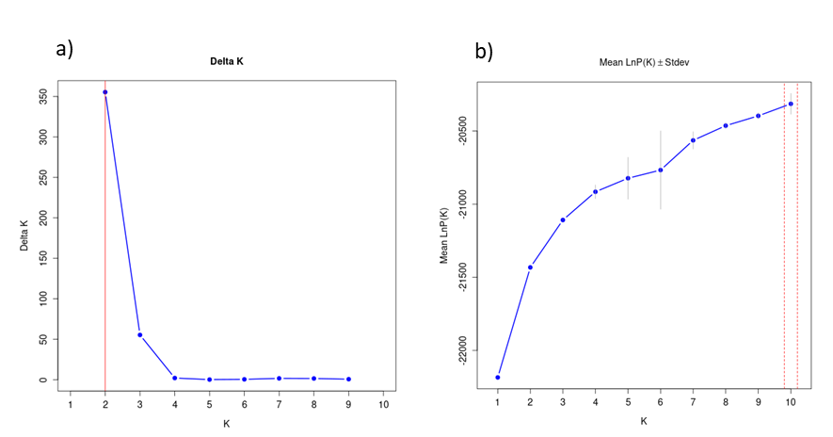
Fig S2. These Bayesian structure analyses performed using STRUCTURE for Alytes dickhilleni. (a) Delta K plot according to Evanno et al. (2005), indicating that the optimal value of K is 2. (b) Mean values ​​of Ln P(K) ± standard deviation for K = 1 to 10. Although the values ​​increase progressively, the greatest difference in the rate of change is observed between K = 1 and K = 2.

