Supplementary Information

Supplemental Tables

Table S4. Test sample characteristics for health phenotypes (n=645)
 | Mean (SD) | Range | N (%)
Grip strength | 30.6 (11.0) | 8-100
Walking speed | 3.5 (1.3) | 2-12
ADLs | 0.3 (0.9) | 0-5
Frailty index | 22.4 (14.9) | 0-39
Cognitive functioning | 15.1 | 0-26
BMI | 30.1 (6.3) | 16.5-58.2
Interkeukin-6 | 6.6 (11.6) | 0.8-177.4
Interkeukin-10 | 4.4 (2.8) | 1.1-34.2
Telomere length | 1.3 (0.4) | 0.1-3.3
6-year mortality |  |  | 123 (19.0%)
Heart problems |  |  | 198 (30.7%)
Diabetes diagnosis |  |  | 184 (28.5%)
Lung problems |  |  | 87 (13.5%)
Psychological problems |  |  | 149 (23.1%)

Table S5. Regression results with both epigenetic and transcriptomic clocks in the same model predicting health outcomes
Grip Strength | Estimate | Std. Error | p-value | 95% CI Lower Bound | 95% CI Upper Bound | p<.05 when both in the model | p<.05 when alone in the model
DNAmHorvath | 0.05 | 0.03 | 8.4E-02 | -0.01 | 0.10
TAGSHorvath | -0.11 | 0.04 | 9.6E-03 | -0.20 | -0.03 | * | *
DNAmHannum | -0.01 | 0.03 | 6.3E-01 | -0.07 | 0.04
TAGSHannum | -0.07 | 0.05 | 1.0E-01 | -0.16 | 0.02
DNAmPhenoAge | -0.03 | 0.03 | 3.4E-01 | -0.08 | 0.03
TAGSPhenoAge | -0.01 | 0.03 | 8.0E-01 | -0.08 | 0.06
DNAmGrimAge | -0.02 | 0.03 | 5.3E-01 | -0.09 | 0.04
TAGSGrimAge | -0.05 | 0.03 | 1.6E-01 | -0.12 | 0.02
DNAmDunedinPACE | -0.03 | 0.03 | 4.3E-01 | -0.09 | 0.04
TAGSDunedinPACE | -0.01 | 0.04 | 7.2E-01 | -0.09 | 0.06
Cognitive Function
DNAmHorvath | -0.02 | 0.04 | 6.8E-01 | -0.09 | 0.06
TAGSHorvath | 0.03 | 0.06 | 6.2E-01 | -0.09 | 0.15
DNAmHannum | -0.10 | 0.04 | 1.3E-02 | -0.18 | -0.02 | *
TAGSHannum | 0.14 | 0.06 | 3.0E-02 | 0.01 | 0.26 | *
DNAmPhenoAge | -0.04 | 0.04 | 3.6E-01 | -0.12 | 0.04
TAGSPhenoAge | 0.10 | 0.05 | 4.4E-02 | 0.00 | 0.19 | *
DNAmGrimAge | 0.10 | 0.05 | 2.2E-02 | 0.02 | 0.19 | * | *
TAGSGrimAge | 0.08 | 0.05 | 9.7E-02 | -0.01 | 0.17 |  | *
DNAmDunedinPACE | 0.10 | 0.05 | 2.3E-02 | 0.01 | 0.20 | * | *
TAGSDunedinPACE | 0.04 | 0.05 | 4.1E-01 | -0.06 | 0.15 |  | *
BMI
DNAmHorvath | 0.07 | 0.04 | 1.2E-01 | -0.02 | 0.15 |  | *
TAGSHorvath | 0.01 | 0.07 | 8.8E-01 | -0.12 | 0.14
DNAmHannum | 0.11 | 0.04 | 1.1E-02 | 0.03 | 0.19 | * | *
TAGSHannum | 0.22 | 0.07 | 1.3E-03 | 0.09 | 0.35 | * | *
DNAmPhenoAge | 0.03 | 0.04 | 4.6E-01 | -0.05 | 0.12 |  | *
TAGSPhenoAge | 0.28 | 0.05 | 6.6E-08 | 0.18 | 0.37 | * | *
DNAmGrimAge | 0.03 | 0.05 | 5.7E-01 | -0.07 | 0.13 |  | *
TAGSGrimAge | 0.18 | 0.05 | 7.1E-04 | 0.08 | 0.28 | * | *
DNAmDunedinPACE | 0.17 | 0.05 | 3.4E-04 | 0.08 | 0.27 | * | *
TAGSDunedinPACE | 0.25 | 0.06 | 1.2E-05 | 0.14 | 0.37 | * | *
Mortality
DNAmHorvath | 0.01 | 0.10 | 9.4E-01 | -0.19 | 0.21
TAGSHorvath | 0.51 | 0.16 | 1.4E-03 | 0.20 | 0.82 | * | *
DNAmHannum | -0.13 | 0.10 | 2.0E-01 | -0.33 | 0.07
TAGSHannum | 0.69 | 0.15 | 3.9E-06 | 0.39 | 0.98 | * | *
DNAmPhenoAge | 0.02 | 0.09 | 8.2E-01 | -0.16 | 0.20 |  | *
TAGSPhenoAge | 0.42 | 0.11 | 1.7E-04 | 0.20 | 0.64 | * | *
DNAmGrimAge | 0.52 | 0.12 | 1.3E-05 | 0.29 | 0.76 | * | *
TAGSGrimAge | 0.37 | 0.12 | 2.4E-03 | 0.13 | 0.61 | * | *
DNAmDunedinPACE | 0.39 | 0.12 | 1.1E-03 | 0.16 | 0.63 | * | *
TAGSDunedinPACE | 0.30 | 0.14 | 3.3E-02 | 0.02 | 0.57 | * | *
Diabetes
DNAmHorvath | -0.01 | 0.10 | 9.4E-01 | -0.20 | 0.19
TAGSHorvath | 0.31 | 0.15 | 4.1E-02 | 0.01 | 0.61 | * | *
DNAmHannum | 0.15 | 0.11 | 1.6E-01 | -0.06 | 0.36 |  | *
TAGSHannum | 0.98 | 0.17 | 4.0E-09 | 0.66 | 1.32 | * | *
DNAmPhenoAge | 0.03 | 0.11 | 8.1E-01 | -0.18 | 0.23 |  | *
TAGSPhenoAge | 0.85 | 0.13 | 9.1E-11 | 0.60 | 1.11 | * | *
DNAmGrimAge | 0.03 | 0.11 | 7.9E-01 | -0.20 | 0.25 |  | *
TAGSGrimAge | 0.54 | 0.12 | 8.8E-06 | 0.31 | 0.78 | * | *
DNAmDunedinPACE | 0.32 | 0.12 | 7.3E-03 | 0.09 | 0.56 | * | *
TAGSDunedinPACE | 0.62 | 0.15 | 2.1E-05 | 0.34 | 0.92 | * | *
Frailty
DNAmHorvath | -0.04 | 0.04 | 2.7E-01 | -0.12 | 0.03
TAGSHorvath | 0.16 | 0.06 | 1.2E-02 | 0.03 | 0.28 | * | *
DNAmHannum | 0.07 | 0.04 | 9.4E-02 | -0.01 | 0.14 |  | *
TAGSHannum | 0.34 | 0.06 | 6.8E-08 | 0.22 | 0.46 | * | *
DNAmPhenoAge | 0.00 | 0.04 | 9.4E-01 | -0.08 | 0.08 |  | *
TAGSPhenoAge | 0.31 | 0.05 | 4.7E-11 | 0.22 | 0.41 | * | *
DNAmGrimAge | 0.18 | 0.04 | 4.2E-05 | 0.10 | 0.27 | * | *
TAGSGrimAge | 0.23 | 0.05 | 1.3E-06 | 0.14 | 0.32 | * | *
DNAmDunedinPACE | 0.20 | 0.05 | 1.3E-05 | 0.11 | 0.29 | * | *
TAGSDunedinPACE | 0.21 | 0.05 | 1.3E-04 | 0.10 | 0.31 | * | *
Heart Disease
DNAmHorvath | -0.15 | 0.10 | 1.4E-01 | -0.34 | 0.04
TAGSHorvath | 0.22 | 0.15 | 1.5E-01 | -0.08 | 0.51
DNAmHannum | -0.10 | 0.10 | 3.1E-01 | -0.30 | 0.09
TAGSHannum | 0.39 | 0.15 | 1.2E-02 | 0.09 | 0.70 | * | *
DNAmPhenoAge | 0.01 | 0.10 | 9.1E-01 | -0.19 | 0.21
TAGSPhenoAge | 0.42 | 0.12 | 4.9E-04 | 0.19 | 0.66 | * | *
DNAmGrimAge | 0.17 | 0.11 | 1.3E-01 | -0.05 | 0.39 |  | *
TAGSGrimAge | 0.34 | 0.12 | 4.4E-03 | 0.11 | 0.58 | * | *
DNAmDunedinPACE | 0.28 | 0.12 | 1.8E-02 | 0.05 | 0.51 | * | *
TAGSDunedinPACE | 0.34 | 0.14 | 1.7E-02 | 0.06 | 0.62 | * | *
Interleukin-6
DNAmHorvath | 0.01 | 0.03 | 8.1E-01 | -0.05 | 0.06
TAGSHorvath | -0.01 | 0.04 | 8.6E-01 | -0.09 | 0.08
DNAmHannum | 0.03 | 0.03 | 3.1E-01 | -0.03 | 0.08
TAGSHannum | 0.15 | 0.04 | 6.1E-04 | 0.06 | 0.23 | * | *
DNAmPhenoAge | 0.00 | 0.03 | 9.2E-01 | -0.06 | 0.05 |  | *
TAGSPhenoAge | 0.21 | 0.03 | 4.4E-11 | 0.15 | 0.27 | * | *
DNAmGrimAge | 0.00 | 0.03 | 9.6E-01 | -0.06 | 0.06 |  | *
TAGSGrimAge | 0.29 | 0.03 | 1.7E-20 | 0.23 | 0.35 | * | *
DNAmDunedinPACE | 0.11 | 0.03 | 3.5E-04 | 0.05 | 0.16 | * | *
TAGSDunedinPACE | 0.22 | 0.03 | 9.3E-10 | 0.15 | 0.29 | * | *
Interleukin-10
DNAmHorvath | 0.02 | 0.01 | 2.2E-01 | -0.01 | 0.04
TAGSHorvath | 0.04 | 0.02 | 6.6E-02 | 0.00 | 0.08 |  | *
DNAmHannum | 0.04 | 0.01 | 6.3E-03 | 0.01 | 0.06 | * | *
TAGSHannum | 0.09 | 0.02 | 1.5E-05 | 0.05 | 0.14 | * | *
DNAmPhenoAge | 0.03 | 0.01 | 1.2E-02 | 0.01 | 0.06 | * | *
TAGSPhenoAge | 0.11 | 0.02 | 8.2E-11 | 0.07 | 0.14 | *
DNAmGrimAge | -0.04 | 0.02 | 2.1E-02 | -0.07 | -0.01 | * | *
TAGSGrimAge | 0.11 | 0.02 | 1.1E-11 | 0.08 | 0.14 | * | *
DNAmDunedinPACE | 0.01 | 0.02 | 6.4E-01 | -0.02 | 0.04 |  | *
TAGSDunedinPACE | 0.11 | 0.02 | 2.4E-09 | 0.08 | 0.15 | * | *
Lung Problems
DNAmHorvath | -0.27 | 0.13 | 4.3E-02 | -0.54 | -0.01 | *
TAGSHorvath | 0.65 | 0.20 | 1.4E-03 | 0.25 | 1.05 | * | *
DNAmHannum | -0.06 | 0.14 | 6.5E-01 | -0.35 | 0.21
TAGSHannum | 0.67 | 0.20 | 9.6E-04 | 0.28 | 1.08 | * | *
DNAmPhenoAge | -0.18 | 0.14 | 2.0E-01 | -0.46 | 0.09
TAGSPhenoAge | 0.47 | 0.16 | 2.9E-03 | 0.16 | 0.78 | * | *
DNAmGrimAge | 0.68 | 0.15 | 1.2E-05 | 0.38 | 0.99 | * | *
TAGSGrimAge | 0.13 | 0.16 | 4.0E-01 | -0.18 | 0.45 |  | *
DNAmDunedinPACE | 0.42 | 0.15 | 5.9E-03 | 0.12 | 0.72 | * | *
TAGSDunedinPACE | 0.12 | 0.19 | 5.3E-01 | -0.25 | 0.49 |  | *
Psychological Problems
DNAmHorvath | -0.11 | 0.11 | 3.1E-01 | -0.32 | 0.10
TAGSHorvath | 0.23 | 0.16 | 1.6E-01 | -0.09 | 0.55
DNAmHannum | 0.22 | 0.11 | 3.9E-02 | 0.01 | 0.44 | * | *
TAGSHannum | 0.16 | 0.17 | 3.5E-01 | -0.17 | 0.48
DNAmPhenoAge | 0.01 | 0.11 | 9.4E-01 | -0.22 | 0.23
TAGSPhenoAge | 0.09 | 0.13 | 5.0E-01 | -0.17 | 0.33
DNAmGrimAge | 0.20 | 0.12 | 1.0E-01 | -0.04 | 0.44 |  | *
TAGSGrimAge | 0.12 | 0.13 | 3.7E-01 | -0.14 | 0.37
DNAmDunedinPACE | 0.10 | 0.12 | 4.1E-01 | -0.14 | 0.34
TAGSDunedinPACE | 0.00 | 0.15 | 1.0E+00 | -0.29 | 0.29
Telomere Length
DNAmHorvath | 0.02 | 0.04 | 5.4E-01 | -0.06 | 0.11
TAGSHorvath | 0.02 | 0.06 | 7.3E-01 | -0.10 | 0.15
DNAmHannum | -0.05 | 0.04 | 2.0E-01 | -0.13 | 0.03
TAGSHannum | -0.11 | 0.06 | 1.0E-01 | -0.23 | 0.02
DNAmPhenoAge | -0.01 | 0.04 | 7.7E-01 | -0.09 | 0.07
TAGSPhenoAge | -0.17 | 0.05 | 6.6E-04 | -0.26 | -0.07 | * | *
DNAmGrimAge | -0.02 | 0.05 | 6.8E-01 | -0.11 | 0.07
TAGSGrimAge | -0.13 | 0.05 | 1.1E-02 | -0.22 | -0.03 | * | *
DNAmDunedinPACE | -0.02 | 0.05 | 7.5E-01 | -0.11 | 0.08 |  | *
TAGSDunedinPACE | -0.19 | 0.06 | 5.8E-04 | -0.30 | -0.08 | * | *
Walking Speed
DNAmHorvath | 0.03 | 0.02 | 6.2E-02 | 0.00 | 0.06
TAGSHorvath | 0.04 | 0.02 | 1.2E-01 | -0.01 | 0.09 |  | *
DNAmHannum | 0.02 | 0.02 | 1.1E-01 | -0.01 | 0.06 |  | *
TAGSHannum | 0.08 | 0.02 | 1.9E-03 | 0.03 | 0.13 | * | *
DNAmPhenoAge | 0.00 | 0.02 | 8.9E-01 | -0.03 | 0.03 |  | *
TAGSPhenoAge | 0.06 | 0.02 | 4.3E-03 | 0.02 | 0.09 | * | *
DNAmGrimAge | 0.06 | 0.02 | 5.1E-04 | 0.03 | 0.10 | * | *
TAGSGrimAge | 0.03 | 0.02 | 2.0E-01 | -0.01 | 0.06 |  | *
DNAmDunedinPACE | 0.03 | 0.02 | 1.5E-01 | -0.01 | 0.06 |  | *
TAGSDunedinPACE | 0.05 | 0.02 | 2.5E-02 | 0.01 | 0.09 | * | *
ADLs
DNAmHorvath | -0.12 | 0.08 | 1.2E-01 | -0.27 | 0.03
TAGSHorvath | 0.39 | 0.11 | 7.2E-04 | 0.16 | 0.61 | * | *
DNAmHannum | 0.17 | 0.08 | 2.1E-02 | 0.03 | 0.32 | * | *
TAGSHannum | 0.30 | 0.10 | 3.4E-03 | 0.10 | 0.50 | * | *
DNAmPhenoAge | 0.04 | 0.08 | 6.1E-01 | -0.11 | 0.18
TAGSPhenoAge | 0.27 | 0.08 | 9.8E-04 | 0.11 | 0.43 | * | *
DNAmGrimAge | 0.16 | 0.09 | 5.4E-02 | 0.00 | 0.33 | * | *
TAGSGrimAge | 0.27 | 0.09 | 1.9E-03 | 0.10 | 0.44 | * | *
DNAmDunedinPACE | 0.27 | 0.08 | 1.6E-03 | 0.10 | 0.43 | * | *
TAGSDunedinPACE | 0.17 | 0.10 | 9.2E-02 | -0.03 | 0.38 |  | *

Supplementary Figures

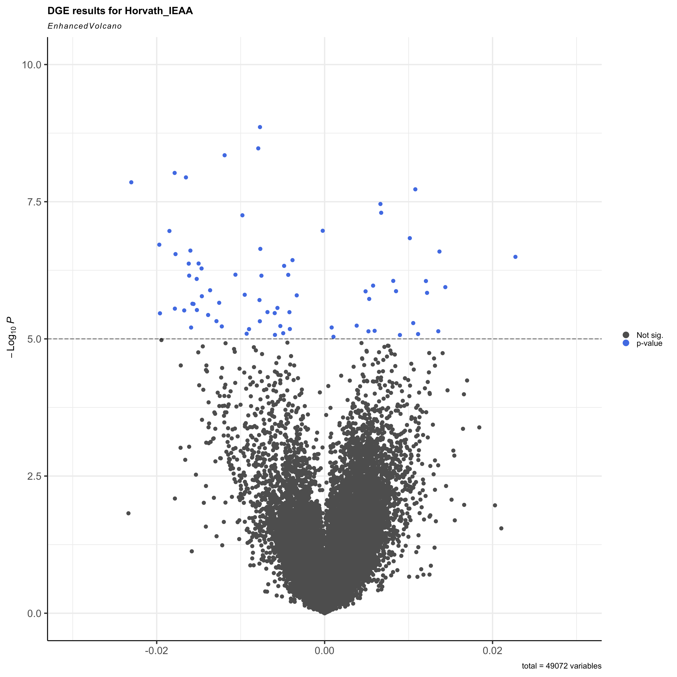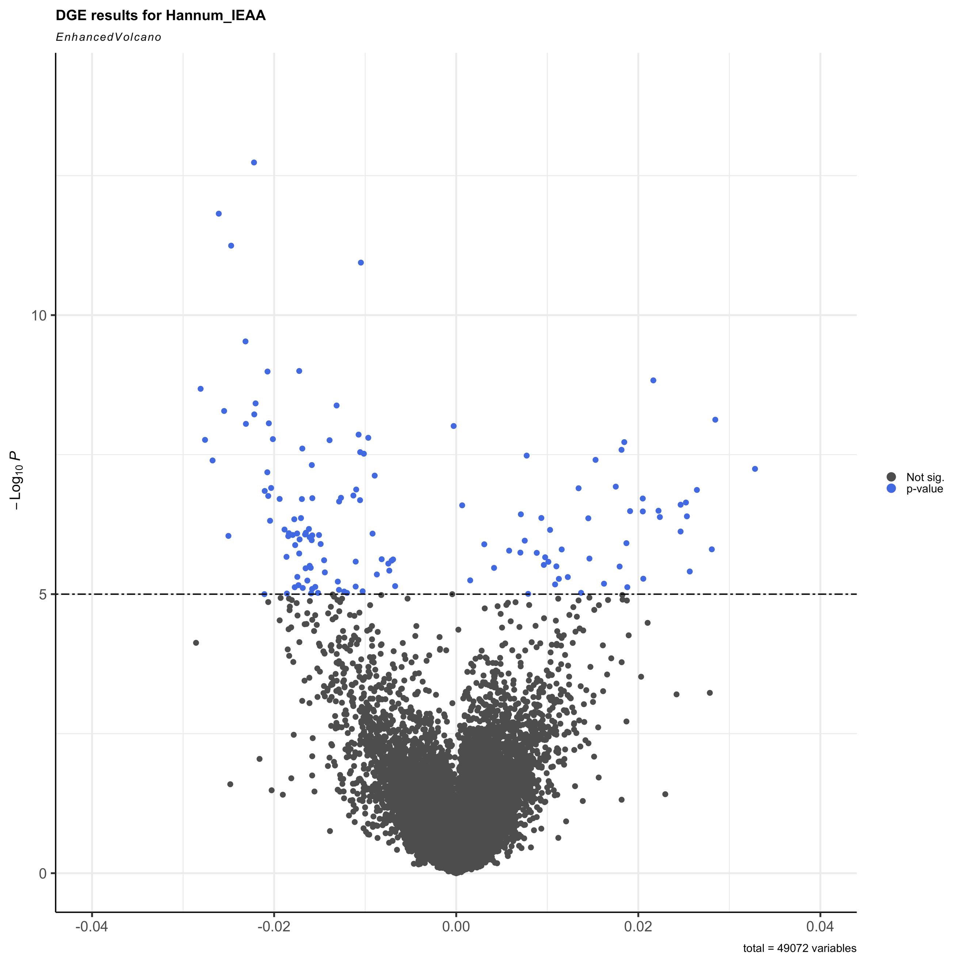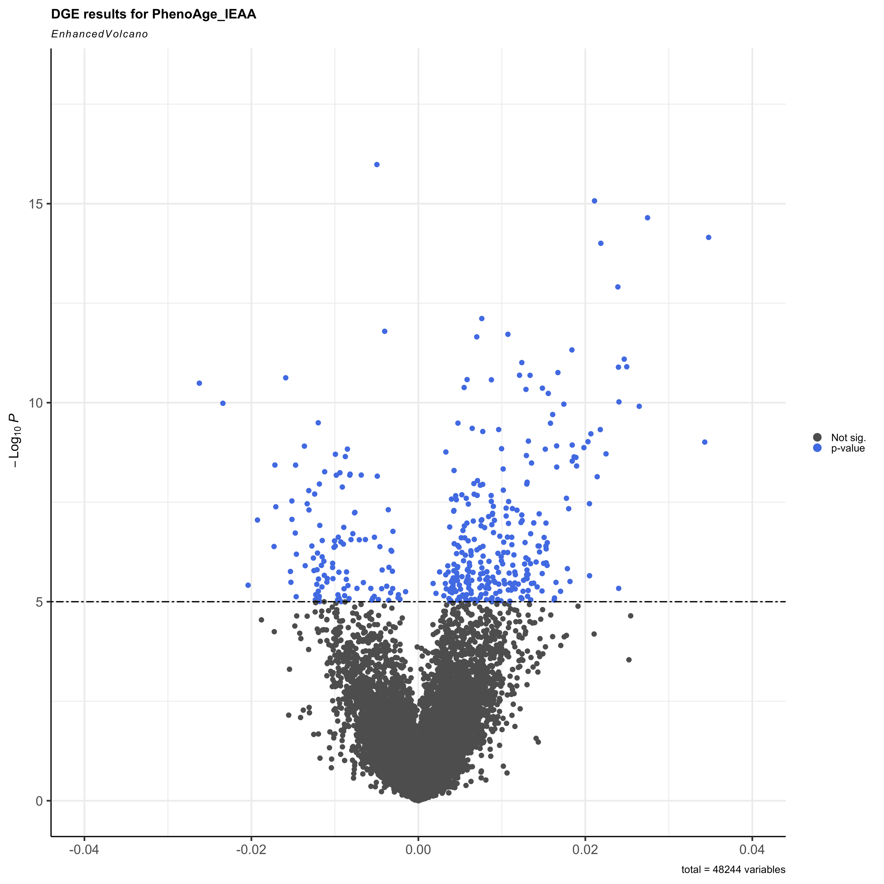
a. Horvath b. Hannum c. PhenoAge

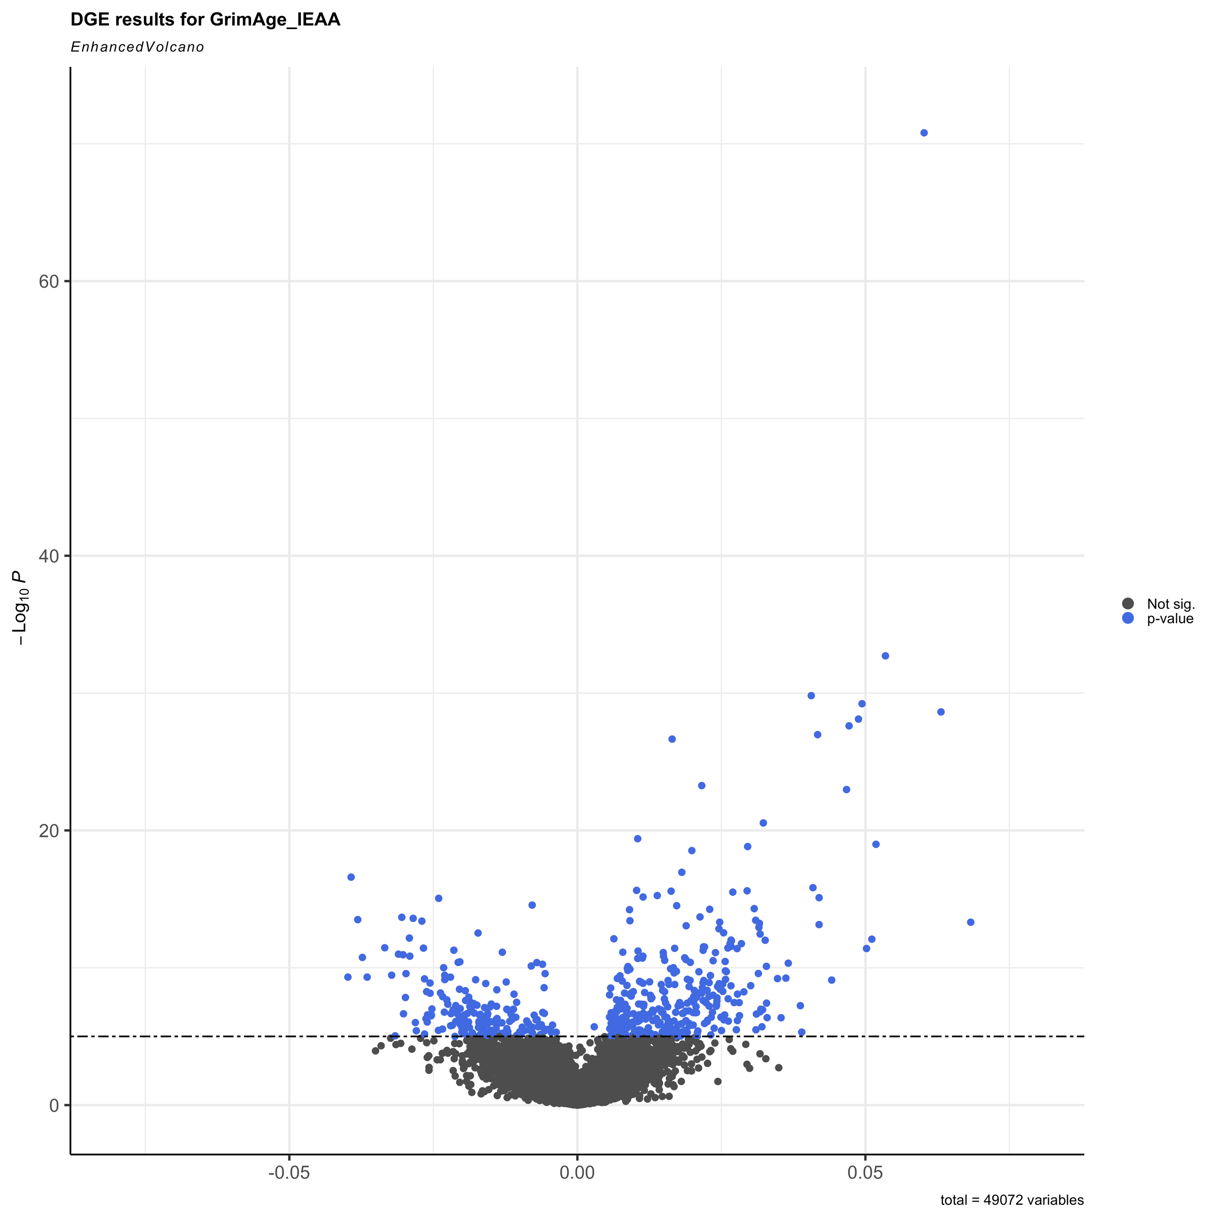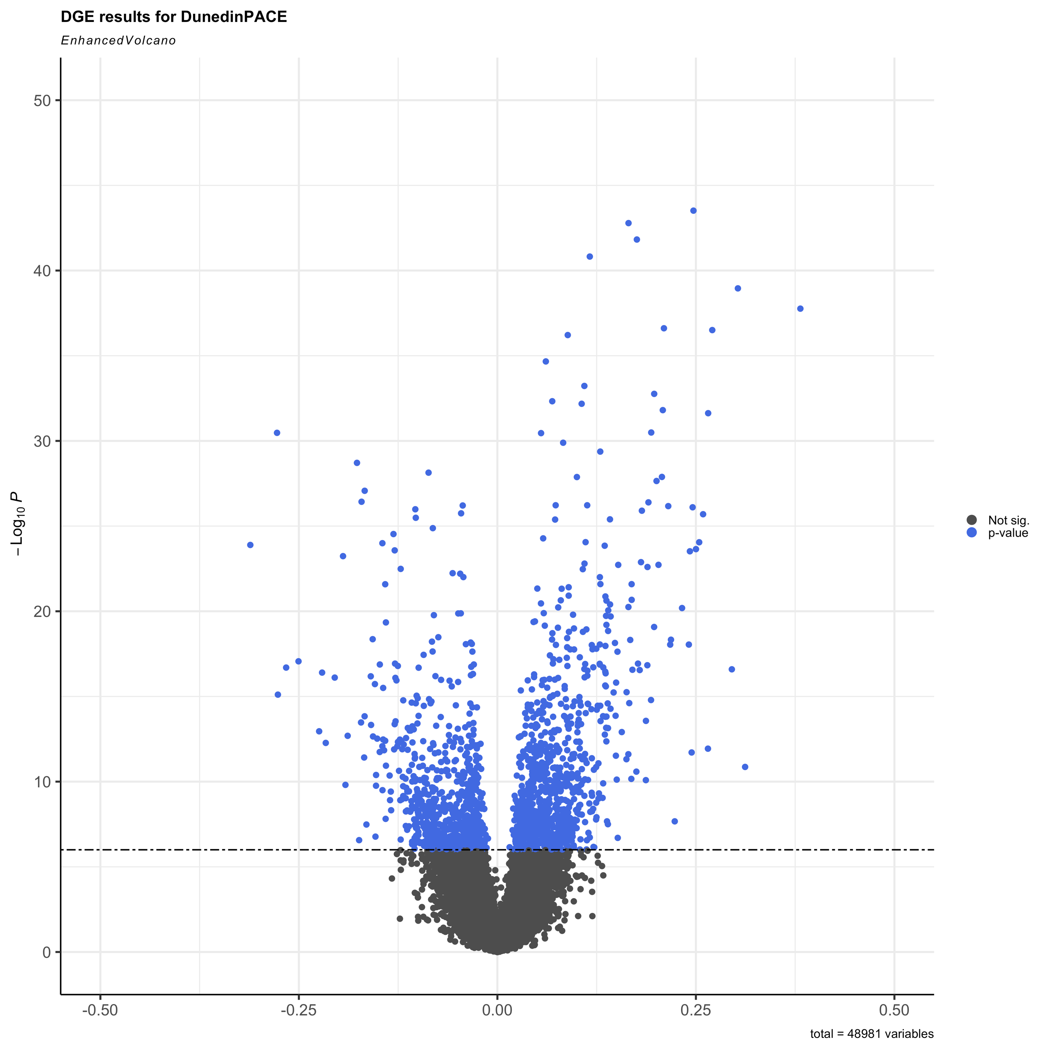
d. GrimAge e. DunedinPACE

Supplemental Figure S1a-e. Volcano plots show the pattern of upregulated and downregulated genes for each epigenetic clock: (a) Horvath, (b) Hannum, (c) PhenoAge, (d) GrimAge, and (e) DunedinPACE. Volcano plots show the pattern of upregulated and downregulated genes for each epigenetic clock. Plots show unadjusted -log₁₀ p-values on the y-axis and magnitude of the regression coefficient on the x-axis. Because the differential gene expression models used the predictors that were log₂-transformed, a one-unit increase corresponds to a doubling of its expression level and thus the regression coefficient represents the expected change in the age acceleration clock value per two-fold increase in predictor, or gene expression level, adjusted for covariates. The blue dots correspond to the genes in each clock that surpass the Bonferroni multiple testing p-value threshold of p<1e-06 and black dots indicate genes under that threshold.

A. 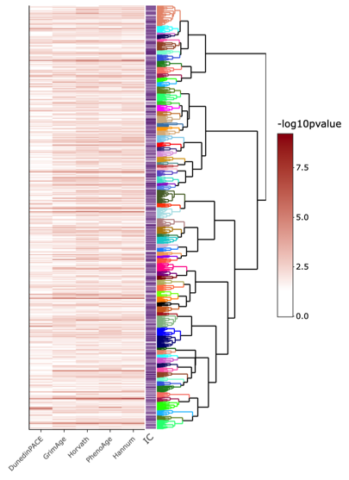
B.
Supplementary Figure S2. Gene Ontologies (GO) across clocks. (a) A clustering heatmap plot that combines a dendrogram based on Wang’s semantic similarity distance method, which uses graph-based similarity, and Ward D2 aggregation criterion yielding 75 clusters of biological processes across the clocks from the 1,453 enriched GO terms (SI Tables S3). The branches are colored according to cluster membership. The -log10(p-value) from functional enrichment tests uses the DEGs from the 5 clocks and information content (IC) of the GO term. The IC is computed as the probability of occurrence of the term in a set of GO terms. (b) The IC and 75 functional clusters are listed.

Supplementary Methods

Gene Ontology (GO) enrichment analysis

Enriched Gene Ontologies[86, 87] were identified using the topGO package, implemented in ViSEAGO[89]. We implemented a gene network approach and ran Kolmogorov-Smirnov (k-s) tests with the elim algorithm [88], which takes into account local dependencies between GO terms in a GO graph to remove redundant terms. To calculate semantic similarity between enriched GO terms across clocks, we used the Wang semantic similarity method in ViSEAGO, which calls the GoSemSim package[90]. Enriched GO terms identified across all clocks were then organized into a dendrogram using hierarchical clustering based on the Wang semantic similarity distance between the enriched GO terms and Ward D2 (ward.D2 function) aggregation criterion. Ward’s method is appropriate when the data contains clusters of different sizes and densities. To identify functional roles of higher-level parent clusters, we used the Best-Match Average (BMA) distance[41] approach to calculate the average of all maximum similarities over all pairs of GO terms in the sets [41, 42]. We then visualized a GO cluster heatmap using the first common GO ancestor of each set of GO terms in each cluster, with the dendrogram showing grouping based on BMA semantic similarity distance and Ward D2 aggregation criterion. Proximities of the clusters and functional groups were then visualized in a Multi-dimensional Scaling (MDS) plot to enable us to distinguish functional profiles and more easily interpret the biological functions carried out by the clustered groups. Higher level GO ancestors for each cluster set were then determined using AmiGO2 v.2.5.17[91].

To further interpret the functional meaning of the GO terms and evaluate common biological processes, we implemented a series of clustering steps. First, we computed semantic similarity of the terms to group-related GO terms by their annotation and GO graph position. We then constructed a heatmap and dendrogram to hierarchically cluster the terms by semantic similarity distance between the terms and applied aggregation criterion to minimize within-cluster variance. This reduced redundancies in the 1,453 enriched GO terms (provided in SI Table S3) and resulted in 75 clusters (coded by branch color) (Fig S2a). Next, we calculated the average of all maximum similarities over all pairs of GO terms using a Best Match Average (BMA) approach [41, 42]. This revealed higher level GO ancestors for each cluster (Fig S2b).

