Supplementary Material
Programming the third-order nonlinear Hall effect by dimensionality and electric field
Jiaju Yang¹, Yanghui Li¹, Lina Chen¹, Wei Niu¹, Jiarui Chen^{2, 3}, Jun Du^{3, 4,} *, Yong Pu^{1,} *, and Lujun Wei^{1,} *
¹School of Science, Nanjing University of Posts and Telecommunications, Nanjing 210023, P. R. China
²National Laboratory of Solid State Microstructures, Nanjing University, Nanjing 210093, P. R. China
³Department of Physics, Nanjing University, Nanjing 210093, P. R. China
⁴National Key Laboratory of Spintronics, Nanjing University, Suzhou 215163, P. R. China
*Corresponding authors: jdu@nju.edu.cn; yongpu@njupt.edu.cn; wlj@njupt.edu.cn;.

Table of Contents
Note 1. The AFM image of device A 1
Note 2. Polarized Raman spectrum 2
Note 3. Transverse and longitudinal first harmonic voltages 3
Note 4. Diode effect, mixing from $V_{∥}^{3ω}$, capacitance coupling effect, transverse resistance R⊥, and thermal effect for device A 4
Note 5. Angular dependence of the third-order nonlinear Hall response ${V_{⊥}^{3ω}}/{{\left(V_{∥}^{ω}\right)}^{3}}$ 7
Note 6. Comparison of third-order nonlinear Hall response strength in different materials 8
Note 7. Third-order nonlinear Hall signals dependent on temperature in device A when E^{ω} ∥ θ = 60° and 120° 9
Note 8. Optical microscope image, thickness, and electrical characteristics of devices 10
Note 9. Electric field control of third-order NLHE at 290 K in device A 23
Note 10. Electric field control of third-order NLHE in device B 24
Note 11. Electric field control of third-order NLHE in device E 25
Note 12. Third-order nonlinear Hall response ${E_{⊥}^{3ω}}/{{\left(E_{∥}^{ω}\right)}^{3}}$ versus σ² in device A 26
Note 13. Scaling law analysis of devices 27
Note 14. Extract γ(T) by fitting the dependency relationship between χ_{BCP} and 1/d 30

Note 1. The AFM image of device A
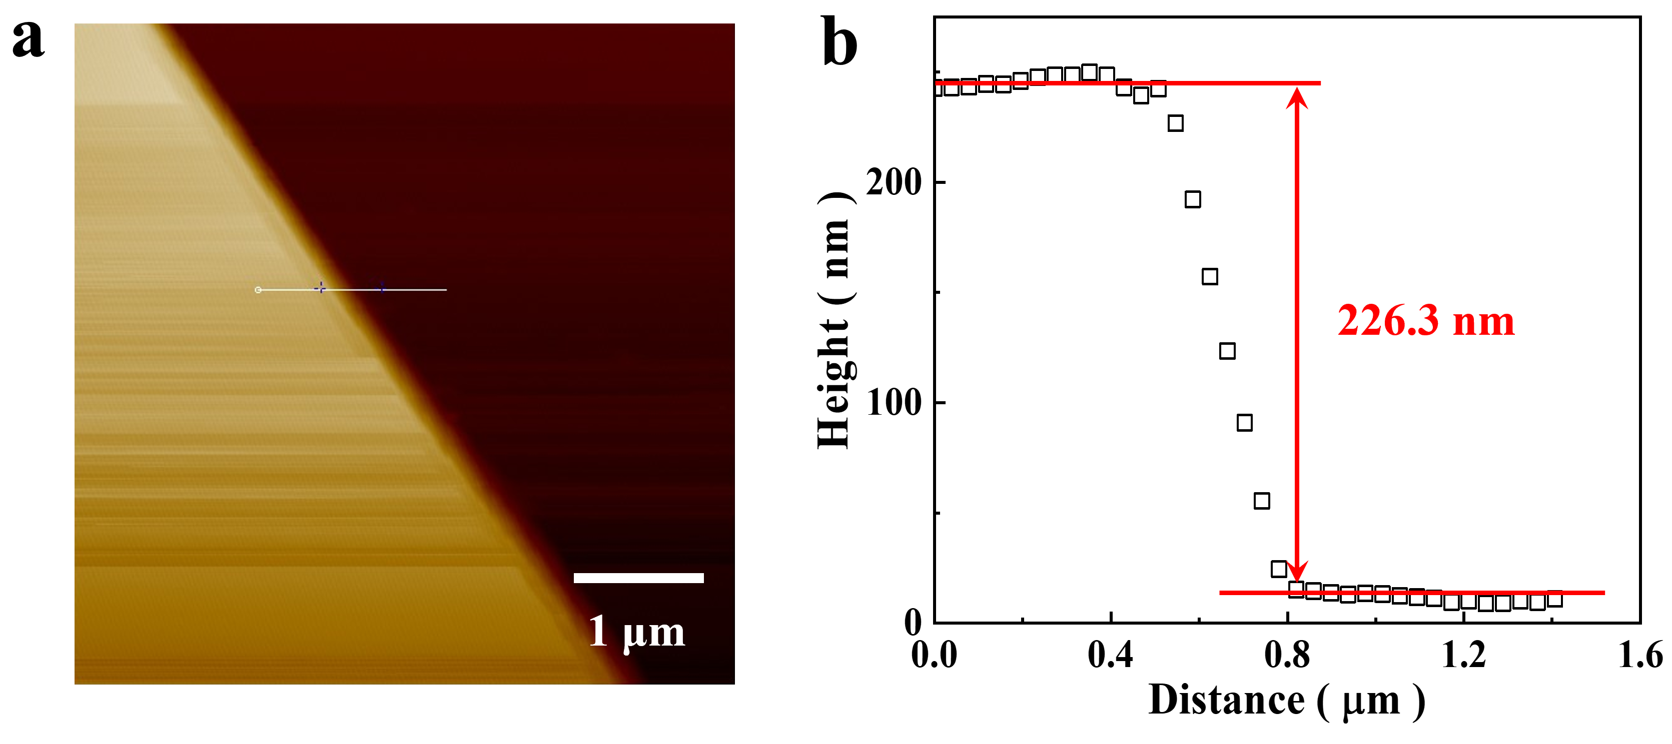
Fig. S1. (a) The AFM picture of the device A. (b) The thickness of the TaIrTe₄ flake is about 226.3 nm, measured from the edge of the TaIrTe₄ flake denoted by the white line displayed in (a). The scale bar in (a) is 1 μm.

Note 2. Polarized Raman spectrum
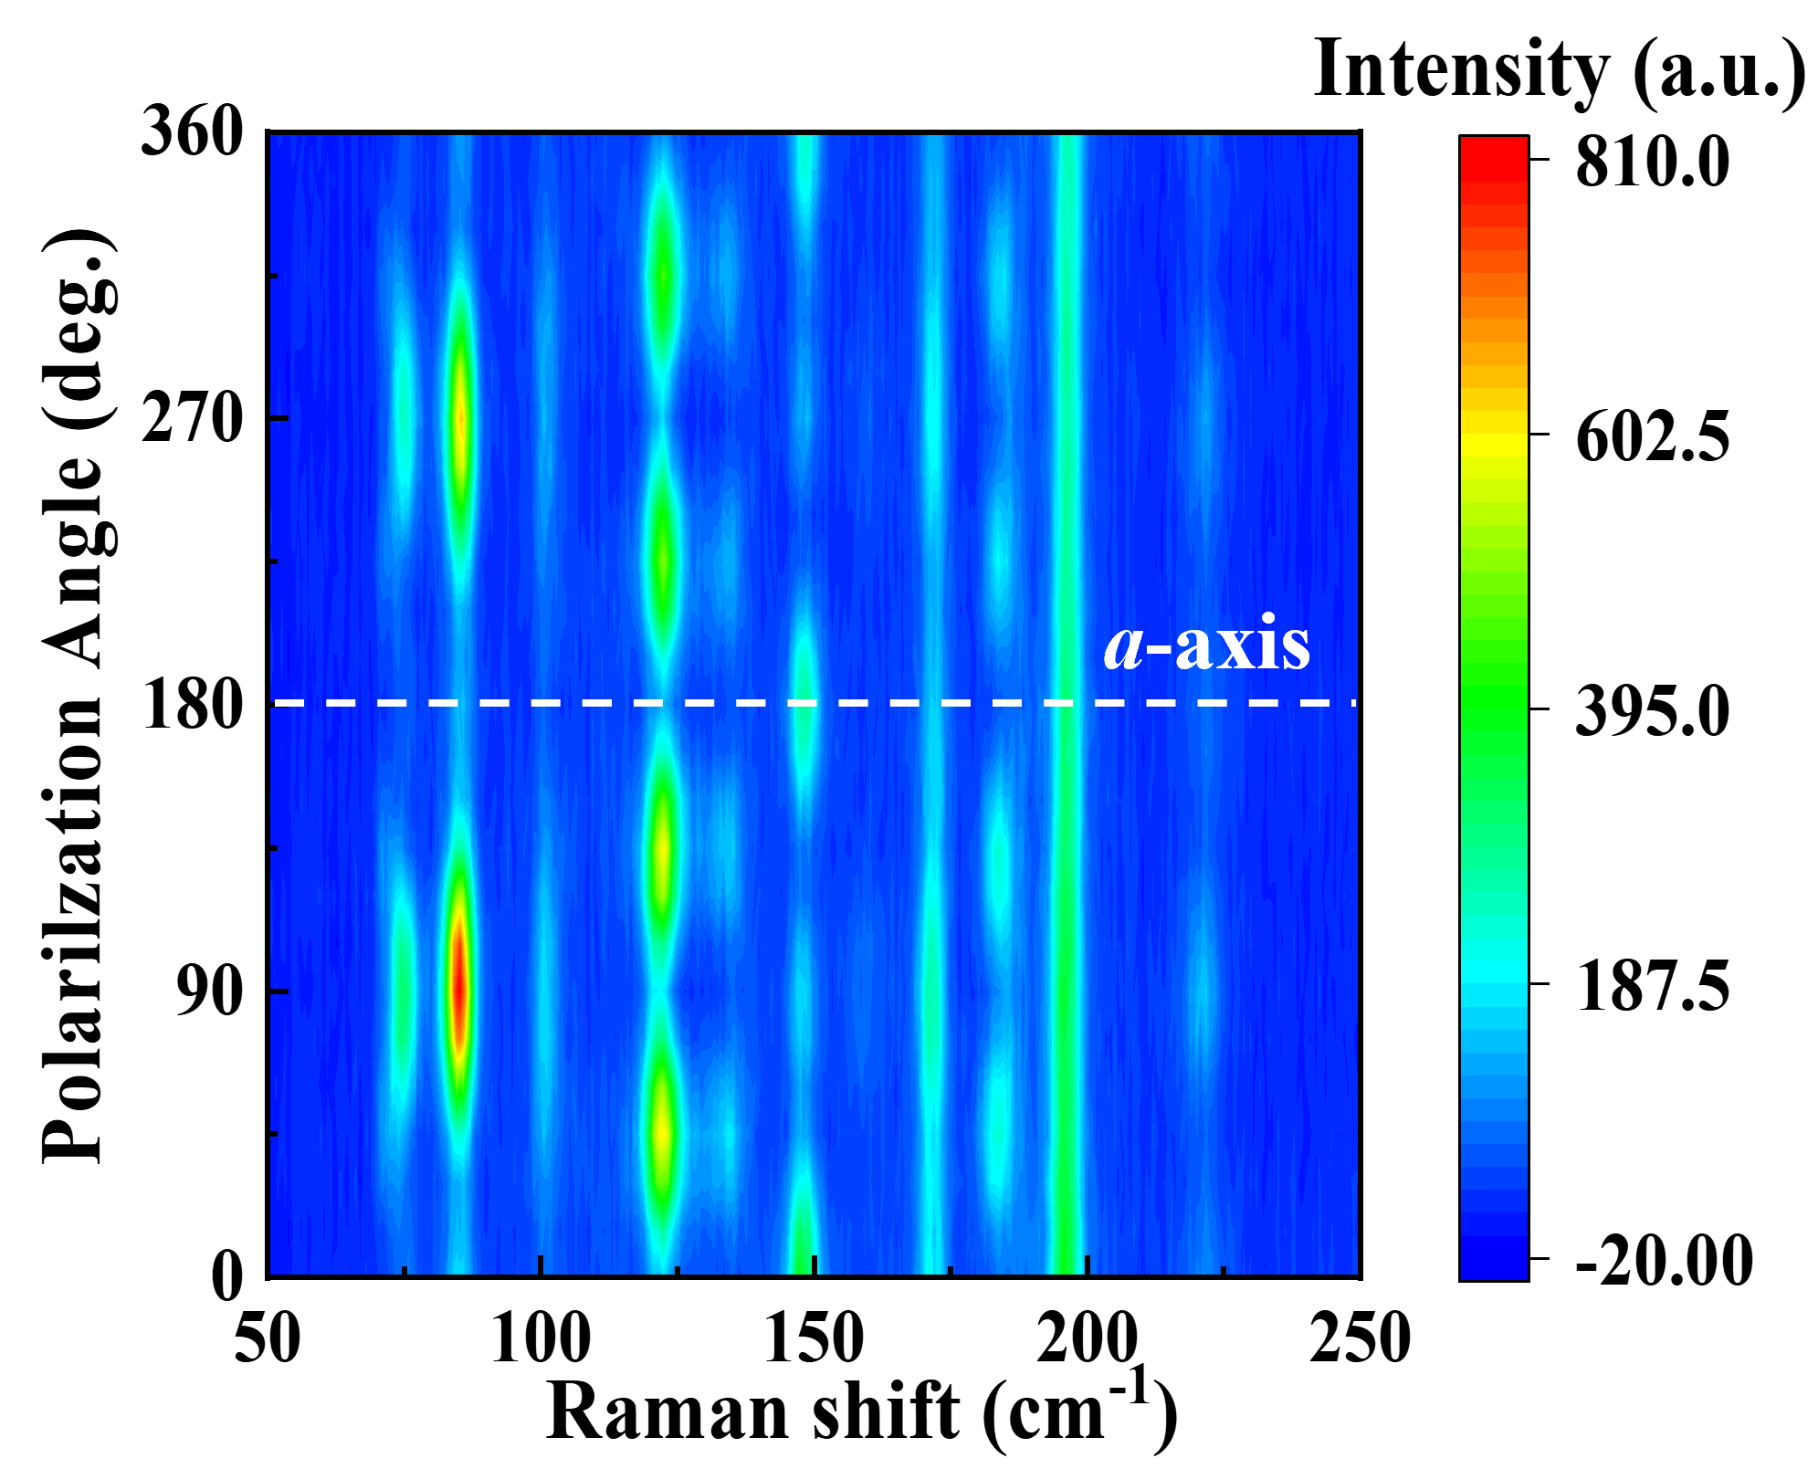
Fig. S2. Polarized Raman spectrum of T_{d}-TaIrTe₄ in device A.

Note 3. Transverse and longitudinal first harmonic voltages
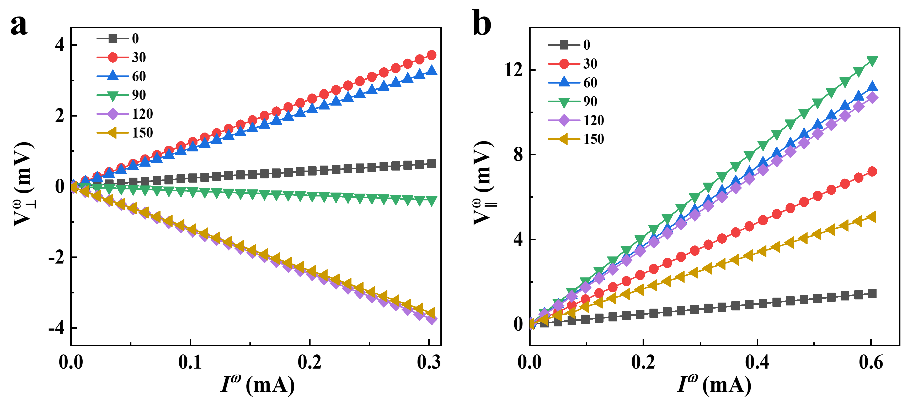
Fig. S3. The first harmonic voltage signals under E^{ω} along different angles at room temperature in device A. The transverse (a) and longitudinal (b) harmonic voltage signals as a function of I^{ω}, respectively.

Note 4. Diode effect, mixing from $V_{∥}^{3ω}$, capacitance coupling effect, transverse resistance R⊥, and thermal effect for device A
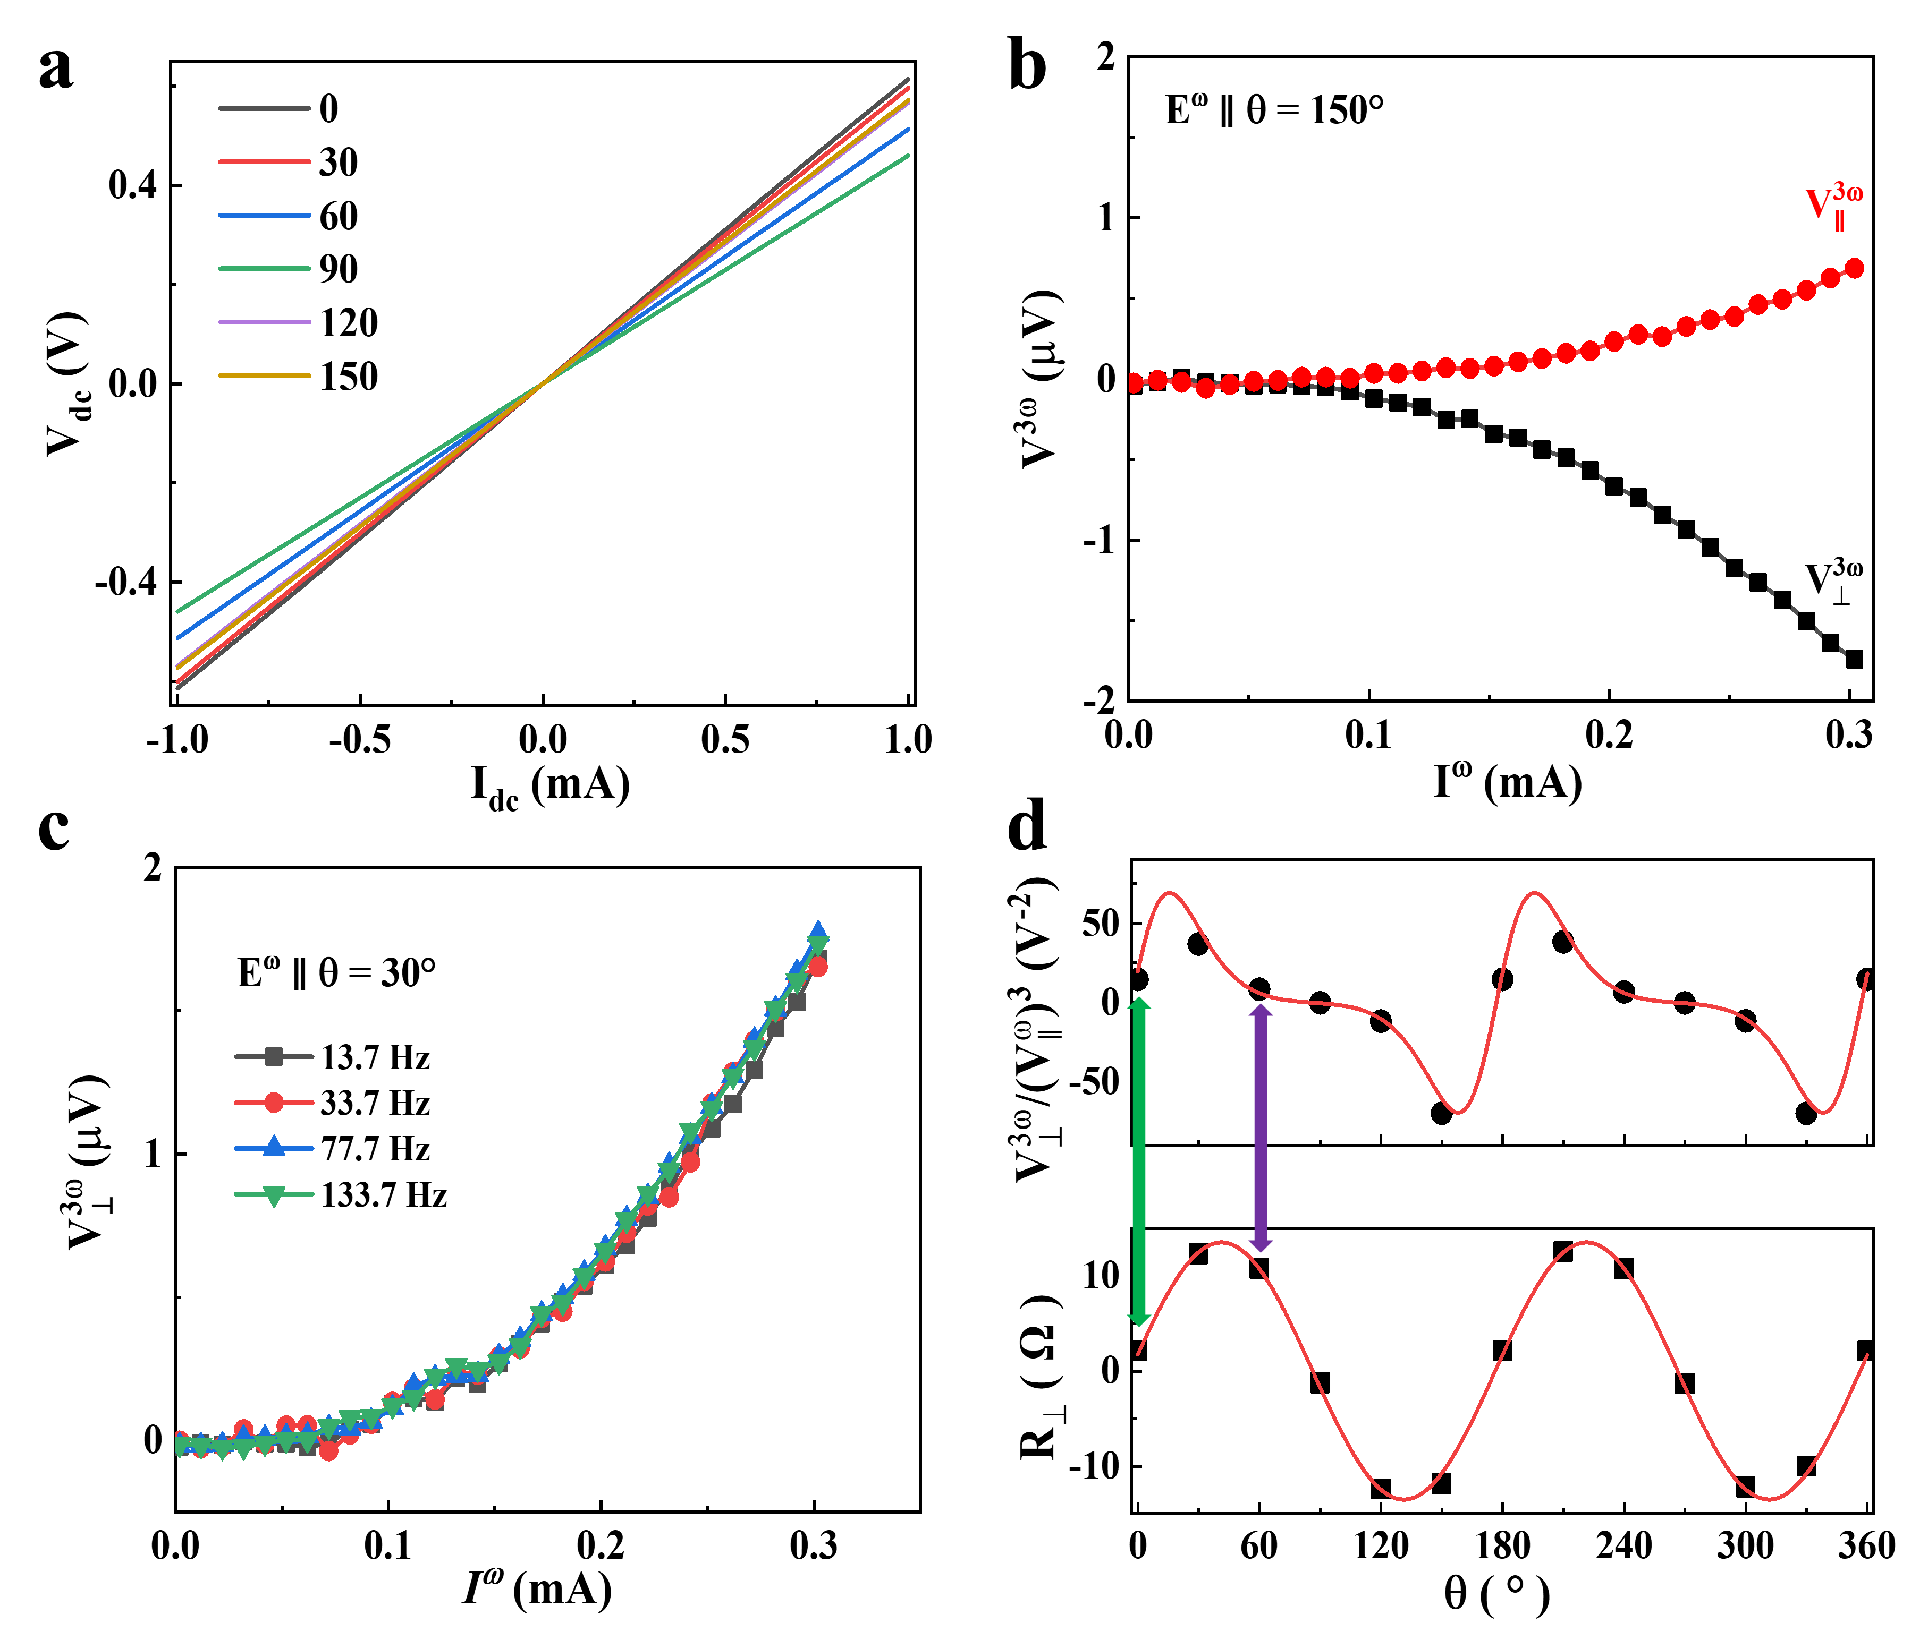
Fig. S4. (a) Two-probe DC measurements of TaIrTe₄ in the device A at room temperature. (b) E^{ω} ∥ θ = 150°, transverse and longitudinal third harmonics. (c) Frequency dependence of the third-order NLHE under E^{ω} ∥ θ = 30°, at room temperature. (d) The angle-dependence of ${V_{⊥}^{3ω}}/{{\left(V_{∥}^{ω}\right)}^{3}}$ and R⊥, respectively.
Diode effect. The Schottky barrier between the metal electrodes and two-dimensional materials is usually unavoidable, which would produce a diode-like rectification effect, leading to higher-order transport effect. However, measurements of the two-terminal I-V characteristics of device A show a linear behavior (Fig. S4a), which ruled out the extrinsic diode effect as the origin of third-order NLHE.
Mixing from $V_{∥}^{3ω}$. The observed third-order Hall signals may be mixed from nonzero third-order longitudinal voltage $V_{∥}^{3ω}$. To exclude this possibility, we simultaneously measured the third-harmonic longitudinal and Hall voltage, i.e., $V_{∥}^{3ω}$and $V_{⊥}^{3ω}$, in the device A at 290 K (Fig. S4b). Compared to $V_{⊥}^{3ω}$, $V_{∥}^{3ω}$ shows a relatively small signal. Therefore, $V_{⊥}^{3ω}$ dominates over $V_{∥}^{3ω}$.
Capacitance coupling effect. Higher-order transport phenomena may also be caused by capacitance coupling within the circuit. To exclude the spurious capacitive coupling effect, frequency-dependent measurements were performed, as shown in Fig. S4c. By applying AC with different frequencies (13.7 – 133.7 Hz), no frequency dependence of the third-order NLHE is observed, inconsistent with the spurious capacitive coupling effect, which typically exhibit strong on frequency dependence.
Transverse resistance R⊥. The influence of R⊥ on the observed third-order NLHE can be ruled out by the angle dependence of the third-order NLHE. R⊥ and the third-order NLHE show different angle dependencies (Fig. S4d). For example, when θ = 0◦, both R⊥ and the third-order Hall signal ${V_{⊥}^{3ω}}/{{\left(V_{∥}^{ω}\right)}^{3}}$ show a minimum value. However, at θ = 60◦, R⊥ reaches its maximum value, while the value of ${V_{⊥}^{3ω}}/{{\left(V_{∥}^{ω}\right)}^{3}}$ is very close to its minimum value (zero). The distinctly different angle dependencies between R⊥ and ${V_{⊥}^{3ω}}/{{\left(V_{∥}^{ω}\right)}^{3}}$ indicate the observed third-order NLHE is not generated by R⊥.
Thermal effect. On the one hand, the Joule heating effect may cause changes in sample temperature. Due to the significant temperature dependence of sample resistance, this can lead to a third-order response to current. On the other hand, the temperature gradient across the sample terminals may also generate a thermoelectric voltage. These effects can be ruled out by measuring the angular dependence of the nonlinear Hall response ${V_{⊥}^{3ω}}/{{\left(V_{∥}^{ω}\right)}^{3}}$ (Fig. S5), where the angular dependence of the nonlinear Hall response ${V_{⊥}^{3ω}}/{{\left(V_{∥}^{ω}\right)}^{3}}$ agrees well with the model based on the internal symmetry analysis of TaIrTe₄.

Note 5. Angular dependence of the third-order nonlinear Hall response ${V_{⊥}^{3ω}}/{{\left(V_{∥}^{ω}\right)}^{3}}$
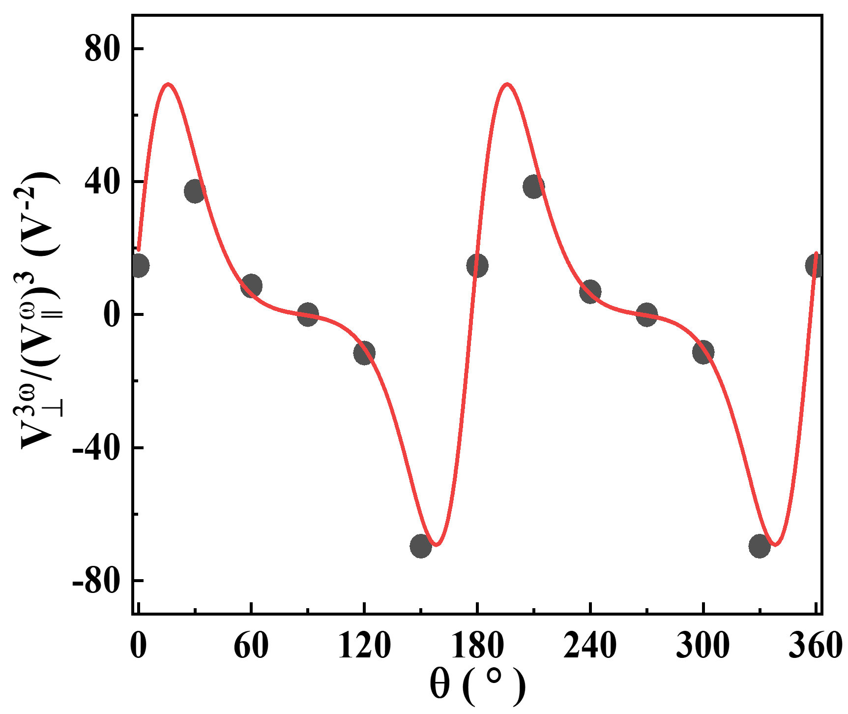
Fig. S5. The angular dependence of the third-order nonlinear Hall response${V_{⊥}^{3ω}}/{{\left(V_{∥}^{ω}\right)}^{3}}$ at room temperature in device A. The red solid line represents the fitting result of Eq. (1) in the main text.

Note 6. Comparison of third-order nonlinear Hall response strength in different materials
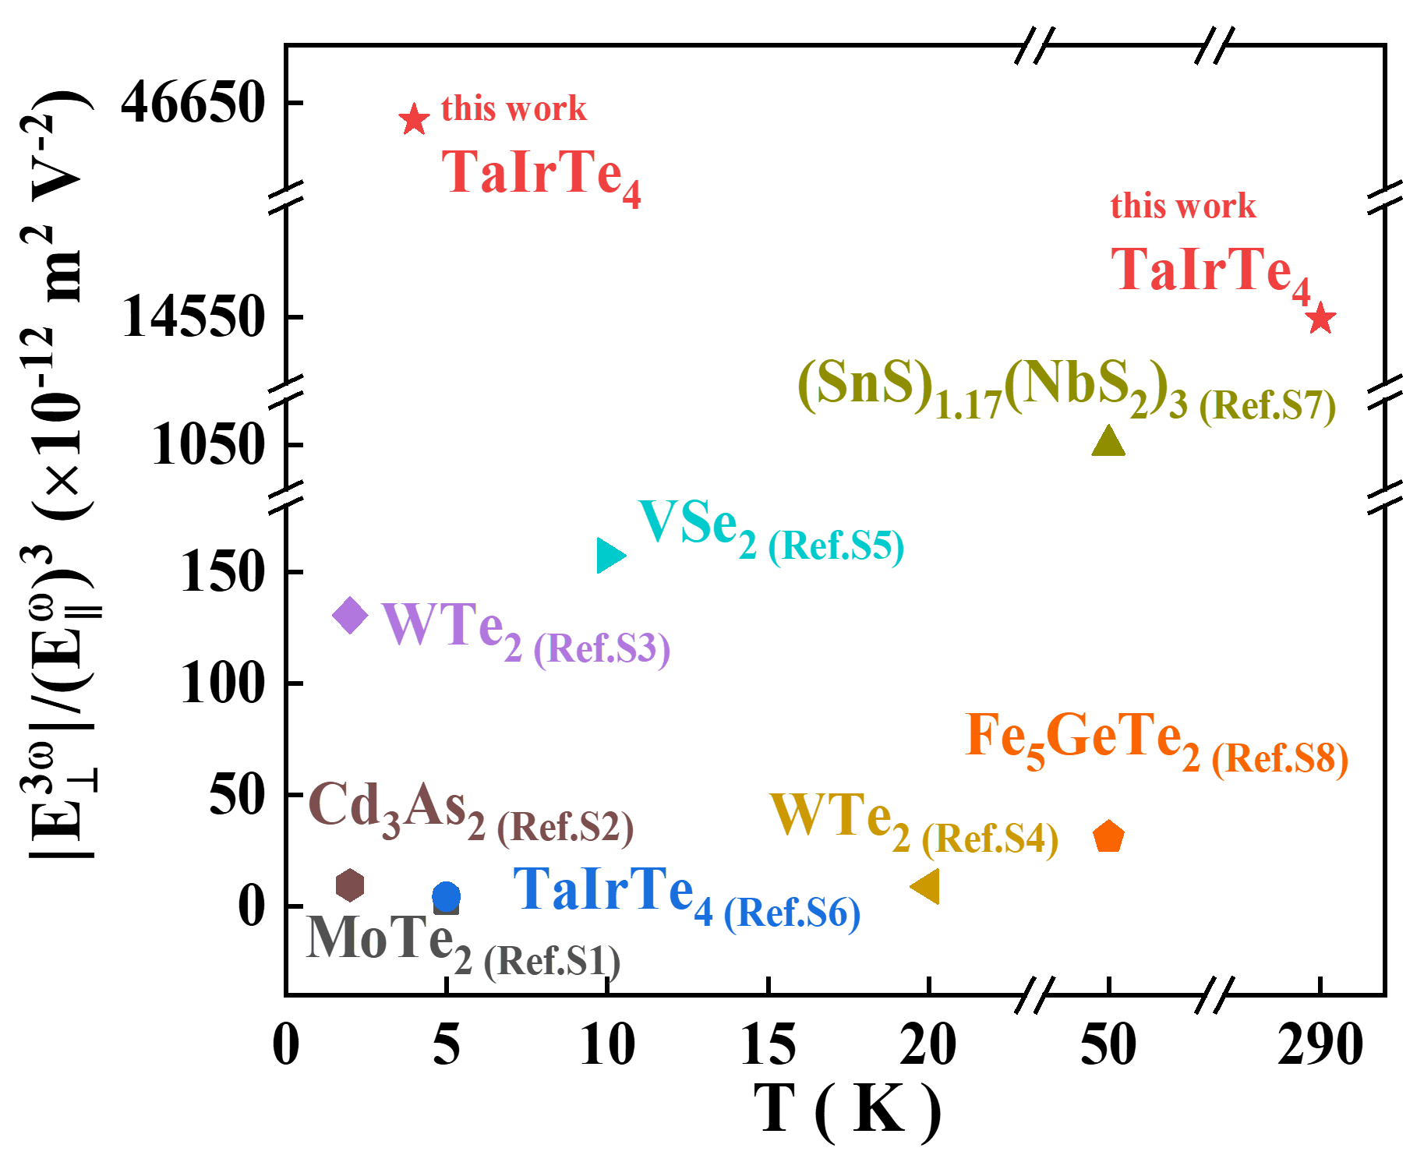
Fig. S6. Comparison of the third-order nonlinear Hall response strength of this work with other materials.

Note 7. Third-order nonlinear Hall signals dependent on temperature in device A when E^{ω} ∥ θ = 60° and 120°
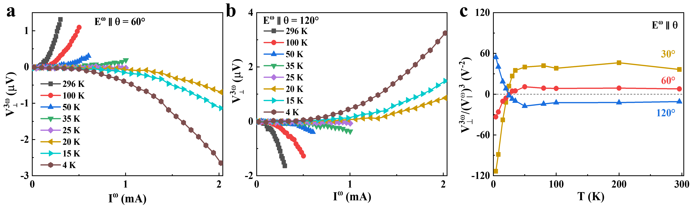
Fig. S7. (a) $V_{⊥}^{3ω}$ versus I^{ω} curves at different temperatures under E^{ω} along θ = 60°. (b) $V_{⊥}^{3ω}$ versus I^{ω} curves at different temperatures under E^{ω} along θ = 120°. (c) Temperature dependence of ${V_{⊥}^{3ω}}/{{\left(V_{∥}^{ω}\right)}^{3}}$.

Note 8. Optical microscope image, thickness, and electrical characteristics of devices

Table S1. Thickness and size parameters of TaIrTe₄ ﬂakes used in TaIrTe₄ devices.
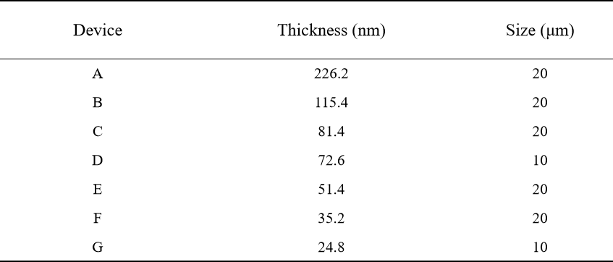
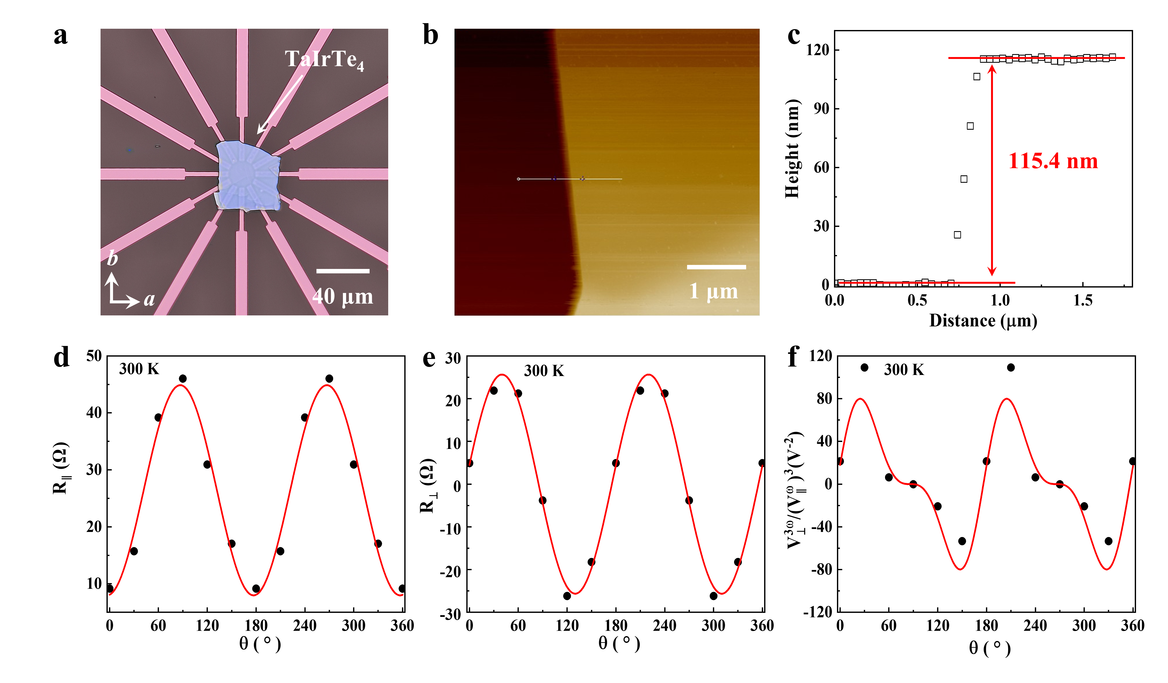
Fig. S8. Optical microscope image, AFM, and electrical characteristics of device B. (a) Optical microscope image of device C. The scale bar in (a) is 40 μm. (b) The AFM picture of the device C. (c) The thickness of the TaIrTe₄ flake is about 115.4 nm, measured from the edge of the TaIrTe₄ flake denoted by the white line displayed in (b). The scale bar in (b) is 1 μm. (d) Anisotropy plots of longitudinal resistance (R‖) of the device C, with the red solid line representing the fitted curve. (e) Anisotropy plots of the Hall resistance (R⊥) of the device C, with the red solid line representing the fitted curve. (f) The angular dependence of the third-order nonlinear Hall response ${V_{⊥}^{3ω}}/{{\left(V_{∥}^{ω}\right)}^{3}}$ at room temperature. The red solid line represents the fitting result of Eq. (1) in the main text.

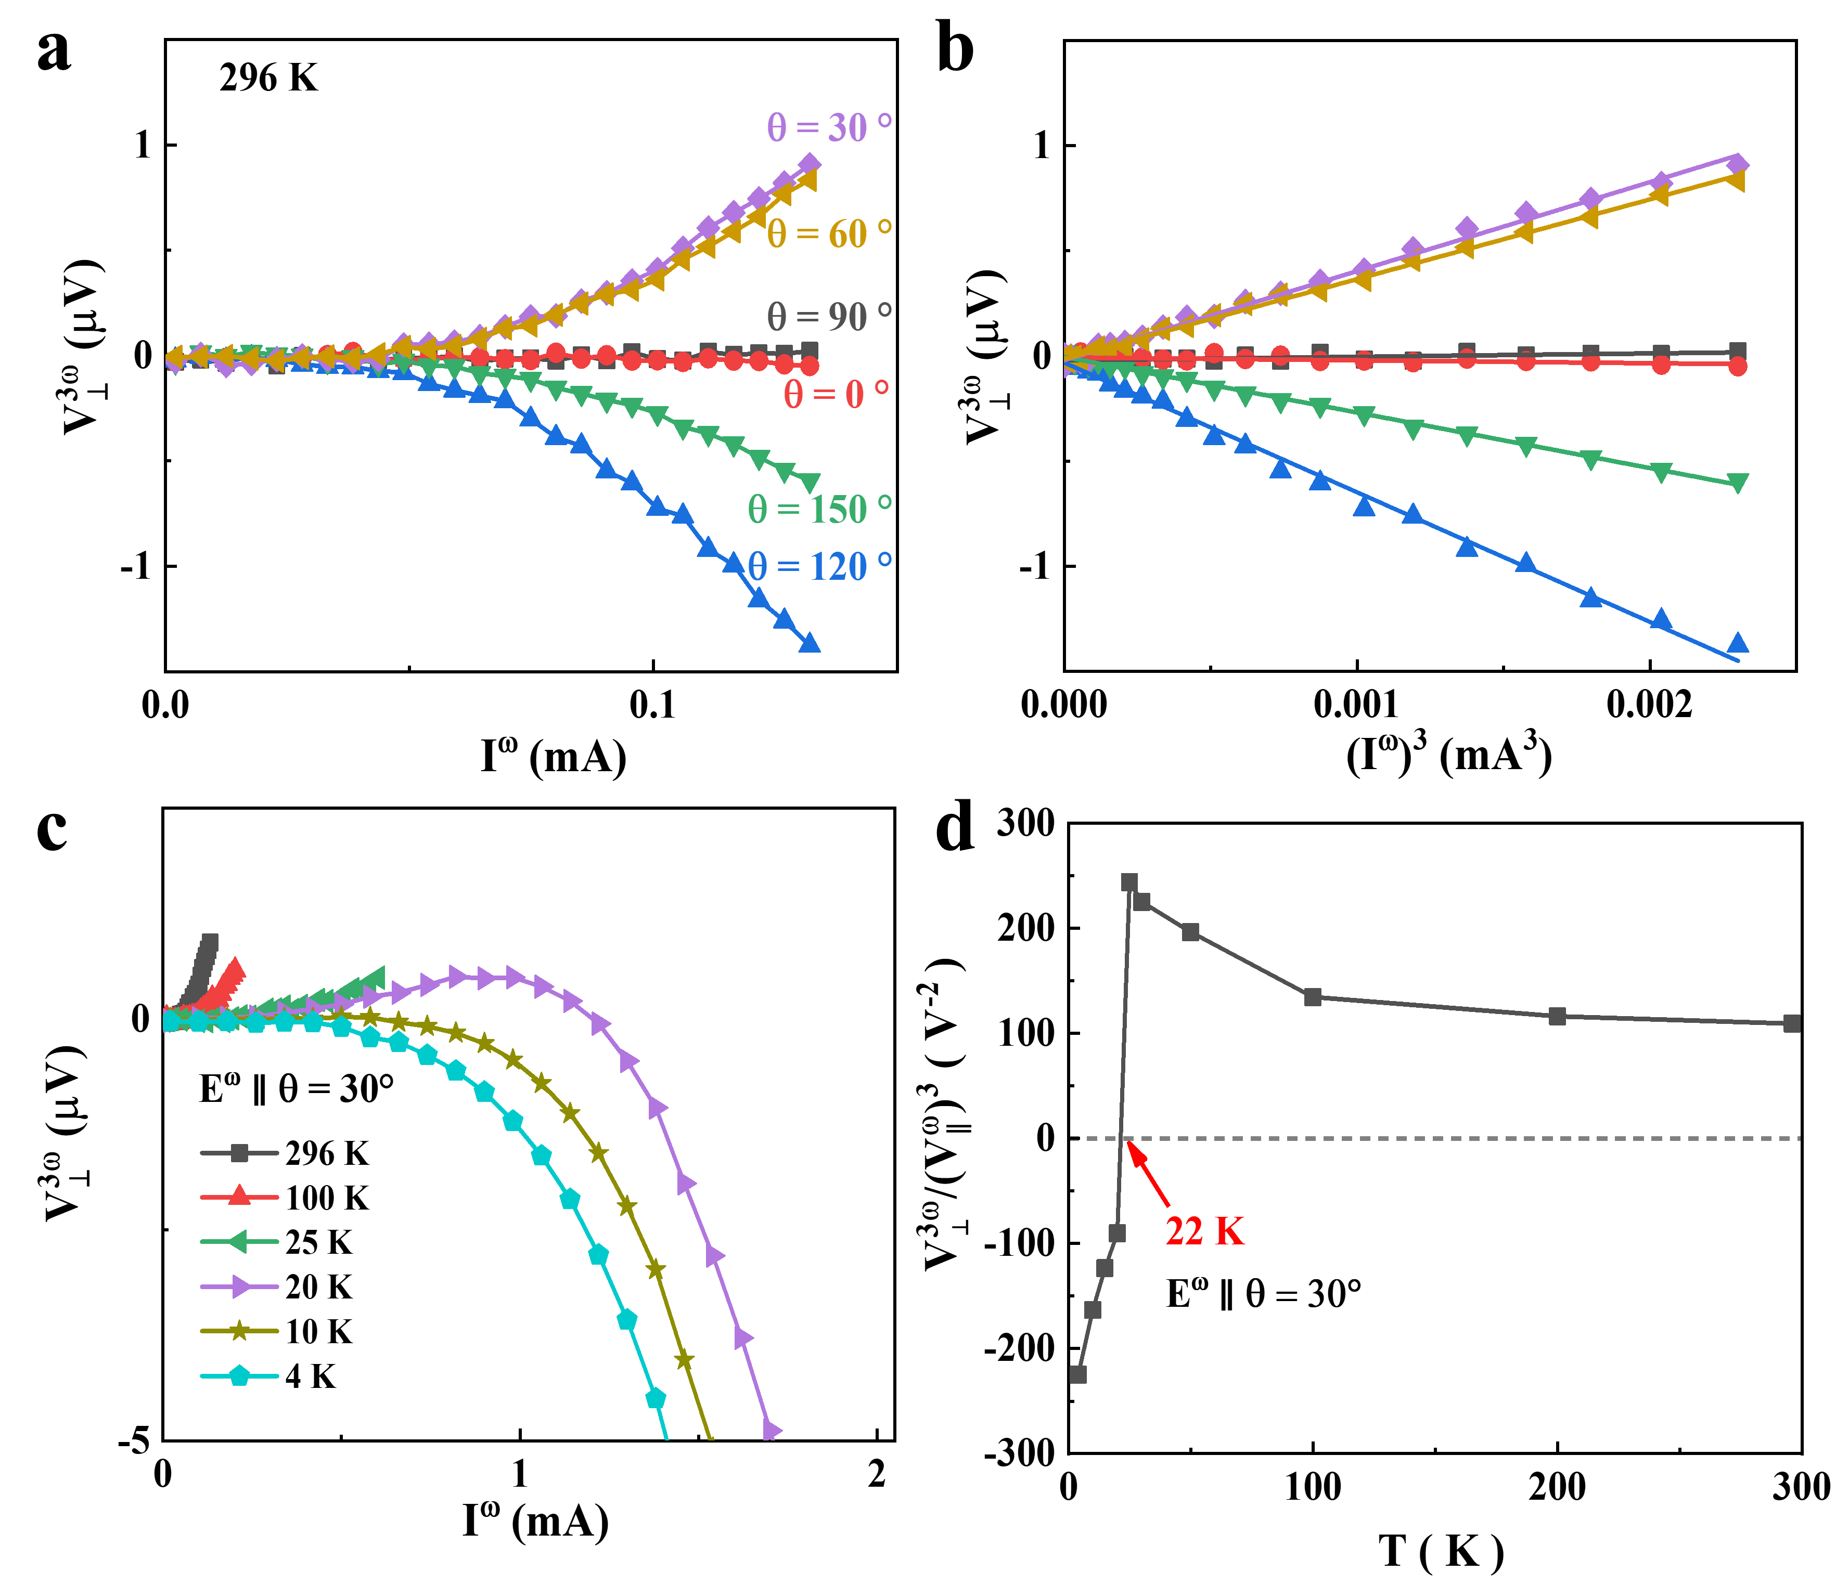
Fig. S9. Third-order NLHE in device B. (a) The dependence of the third-order Hall voltage $V_{⊥}^{3ω}$ on I^{ω} at 296 K under E^{ω} along different angles. (b) $V_{⊥}^{3ω}$ versus (I^{ω})³ curves at 296 K under E^{ω} along different angles. These lines represent the results of linear fitting. (c) $V_{⊥}^{3ω}$ versus I^{ω} curves at different temperatures under E^{ω} along θ = 30°. (d) Temperature dependence of ${V_{⊥}^{3ω}}/{{\left(V_{∥}^{ω}\right)}^{3}}$.
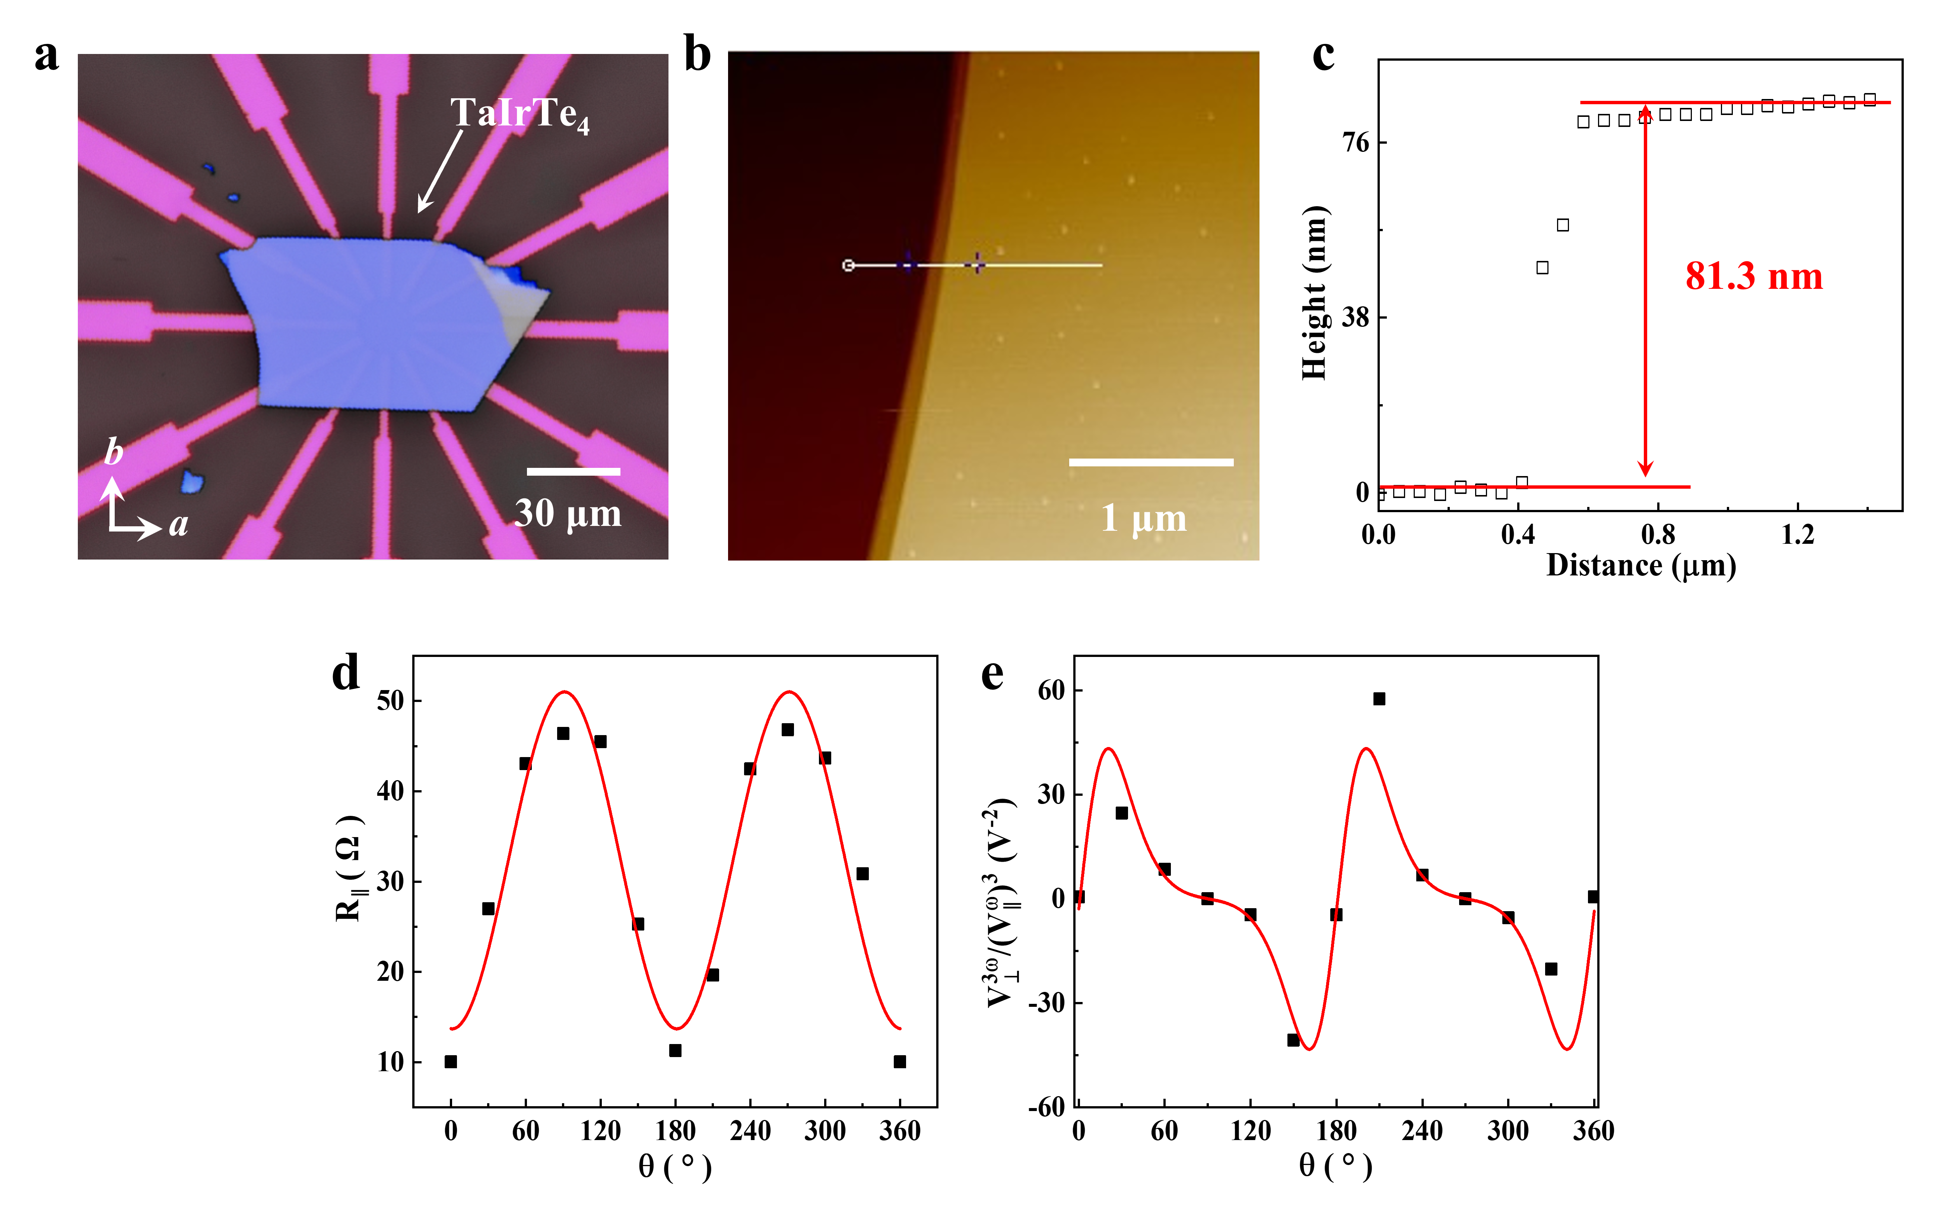
Fig. S10. Optical microscope image, AFM, and electrical characteristics of device C. (a) Optical microscope image of device D. The scale bar in (a) is 30 μm. (b) The AFM picture of the device D. (c) The thickness of the TaIrTe₄ flake is about 81.3 nm, measured from the edge of the TaIrTe₄ flake denoted by the white line displayed in (b). The scale bar in (b) is 1 μm. (d) Anisotropy plots of longitudinal resistance (R‖) of the device D, with the red solid line representing the fitted curve. (f) The angular dependence of the third-order nonlinear Hall response ${V_{⊥}^{3ω}}/{{\left(V_{∥}^{ω}\right)}^{3}}$ at room temperature. The red solid line represents the fitting result of Eq. (1) in the main text.

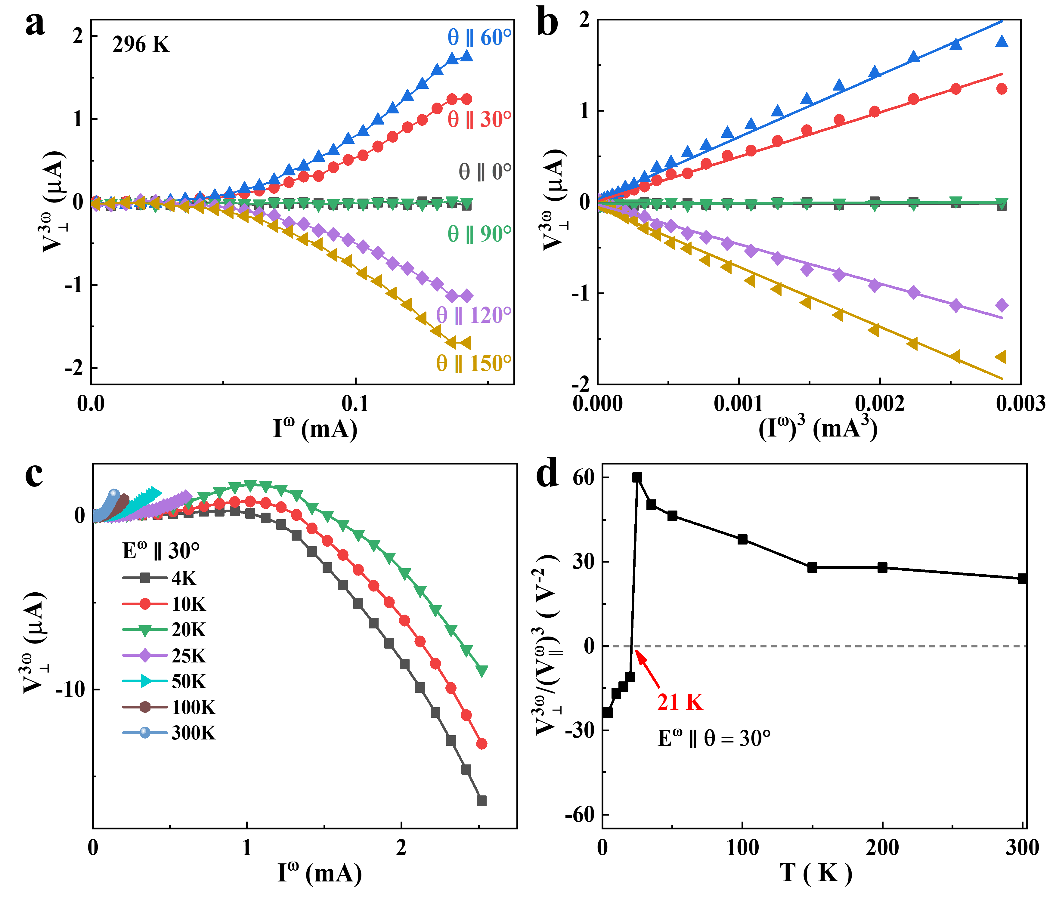
Fig. S11. Third-order NLHE in device C. (a) The dependence of the third-order Hall voltage $V_{⊥}^{3ω}$ on I^{ω} at 296 K under E^{ω} along different angles. (b) $V_{⊥}^{3ω}$ versus (I^{ω})³ curves at 296 K under E^{ω} along different angles. These lines represent the results of linear fitting. (c) $V_{⊥}^{3ω}$ versus I^{ω} curves at different temperatures under E^{ω} along θ = 30°. (d) Temperature dependence of ${V_{⊥}^{3ω}}/{{\left(V_{∥}^{ω}\right)}^{3}}$.

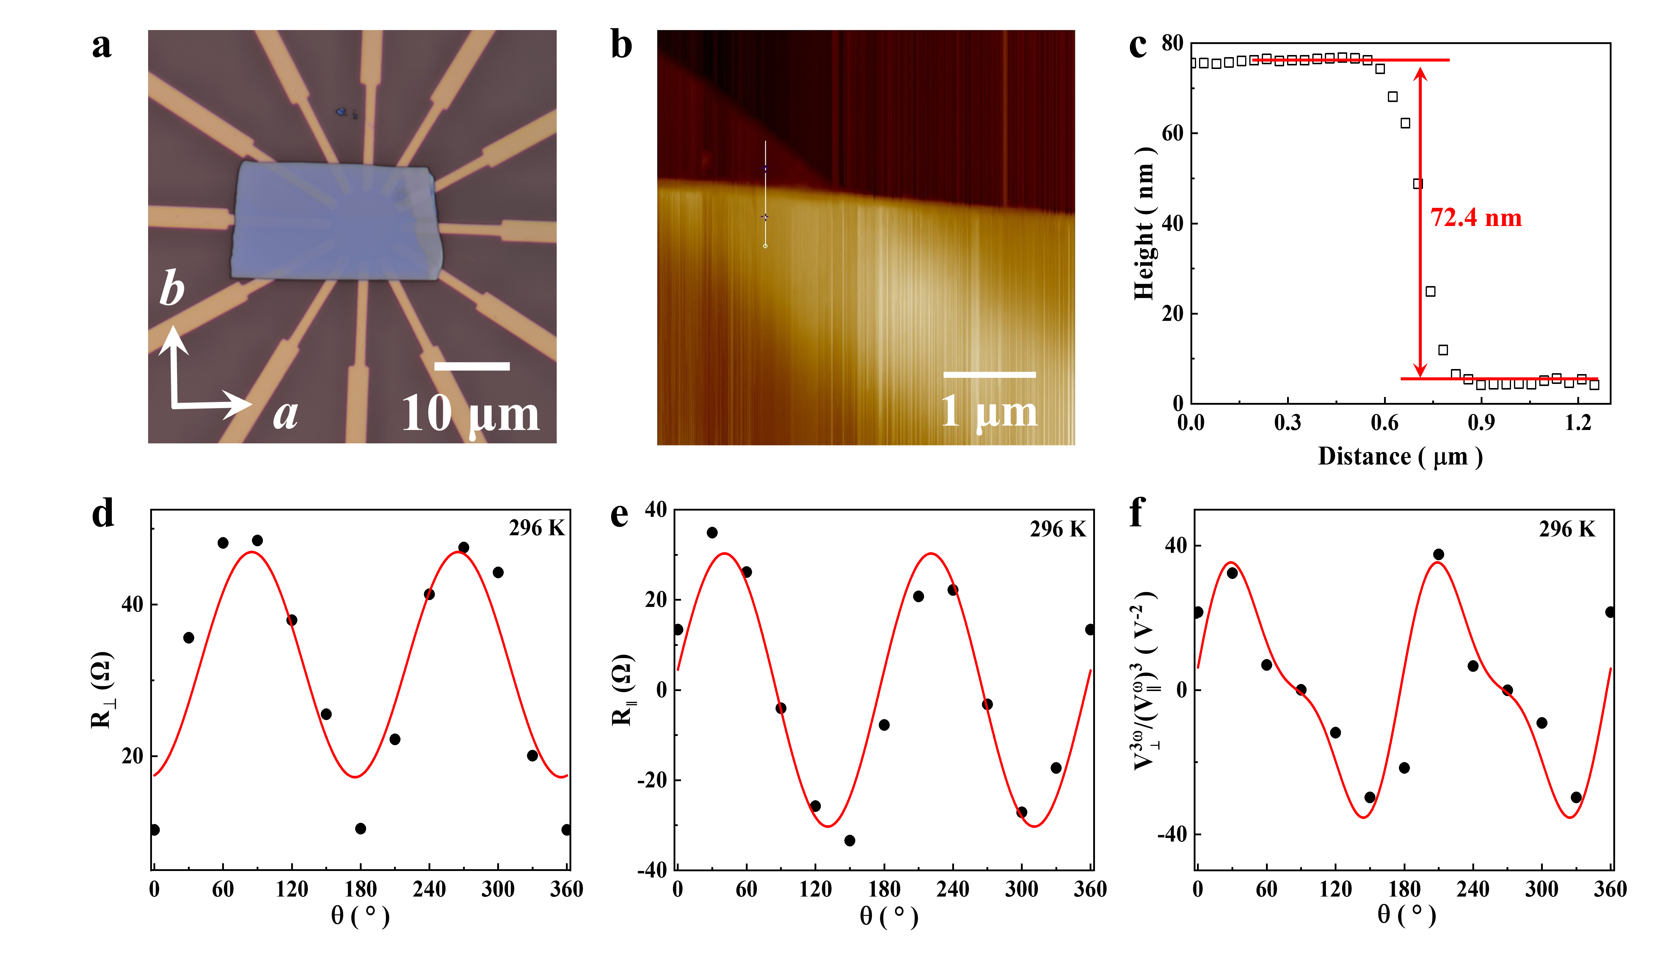
Fig. S12. Optical microscope image, AFM, and electrical characteristics of device D. (a) Optical microscope image of device B. The scale bar in (a) is 10 μm. (b) The AFM picture of the device B. (c) The thickness of the TaIrTe₄ flake is about 72.4 nm, measured from the edge of the TaIrTe₄ flake denoted by the white line displayed in (b). The scale bar in (b) is 1 μm. (d) Anisotropy plots of the Hall resistance (R⊥) of the device B, with the red solid line representing the fitted curve. (e) Anisotropy plots of longitudinal resistance (R‖) of the device B, with the red solid line representing the fitted curve. (f) The angular dependence of the third-order nonlinear Hall response ${V_{⊥}^{3ω}}/{{\left(V_{∥}^{ω}\right)}^{3}}$ at room temperature. The red solid line represents the fitting result of Eq. (1) in the main text.

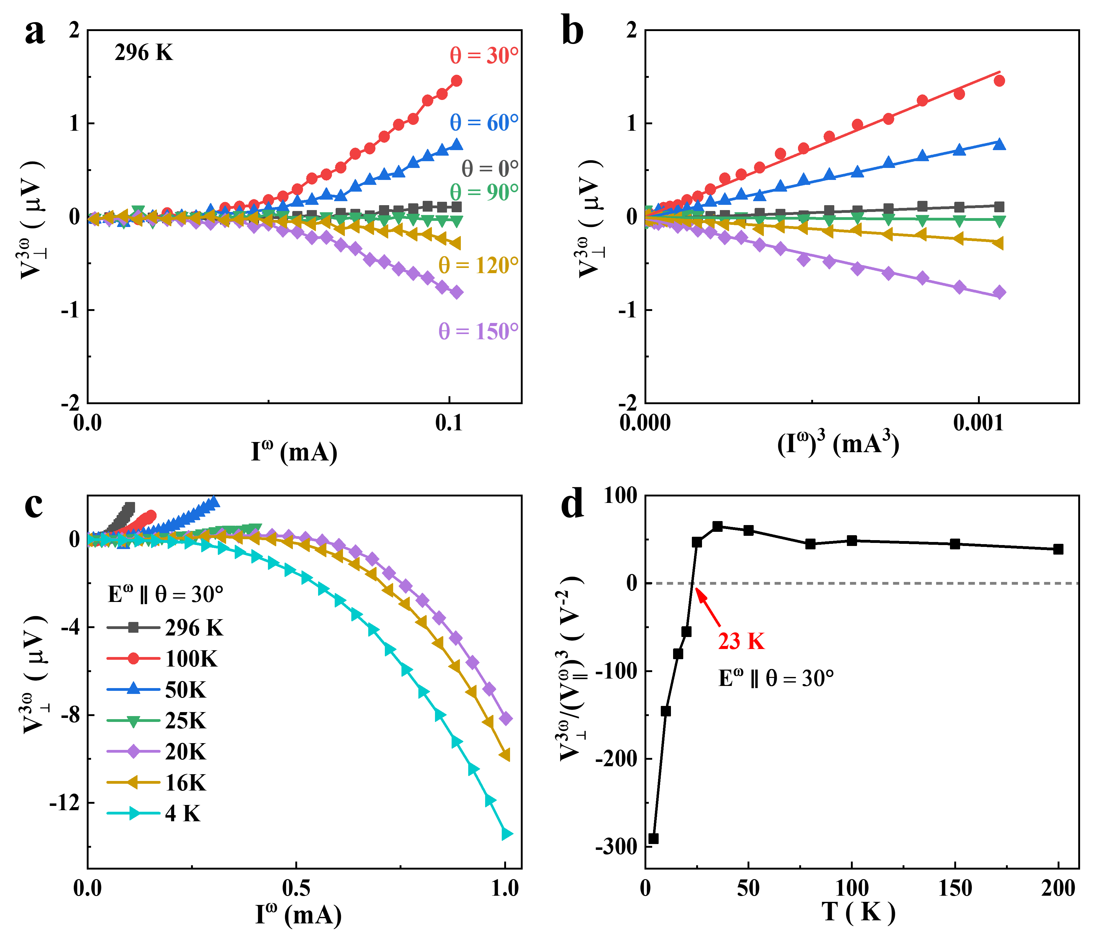
Fig. S13. Third-order NLHE in device D. (a) The dependence of the third-order Hall voltage $V_{⊥}^{3ω}$ on I^{ω} at 296 K under E^{ω} along different angles. (b) $V_{⊥}^{3ω}$ versus (I^{ω})³ curves at 296 K under E^{ω} along different angles. These lines represent the results of linear fitting. (c) $V_{⊥}^{3ω}$ versus I^{ω} curves at different temperatures under E^{ω} along θ = 30°. (d) Temperature dependence of ${V_{⊥}^{3ω}}/{{\left(V_{∥}^{ω}\right)}^{3}}$.

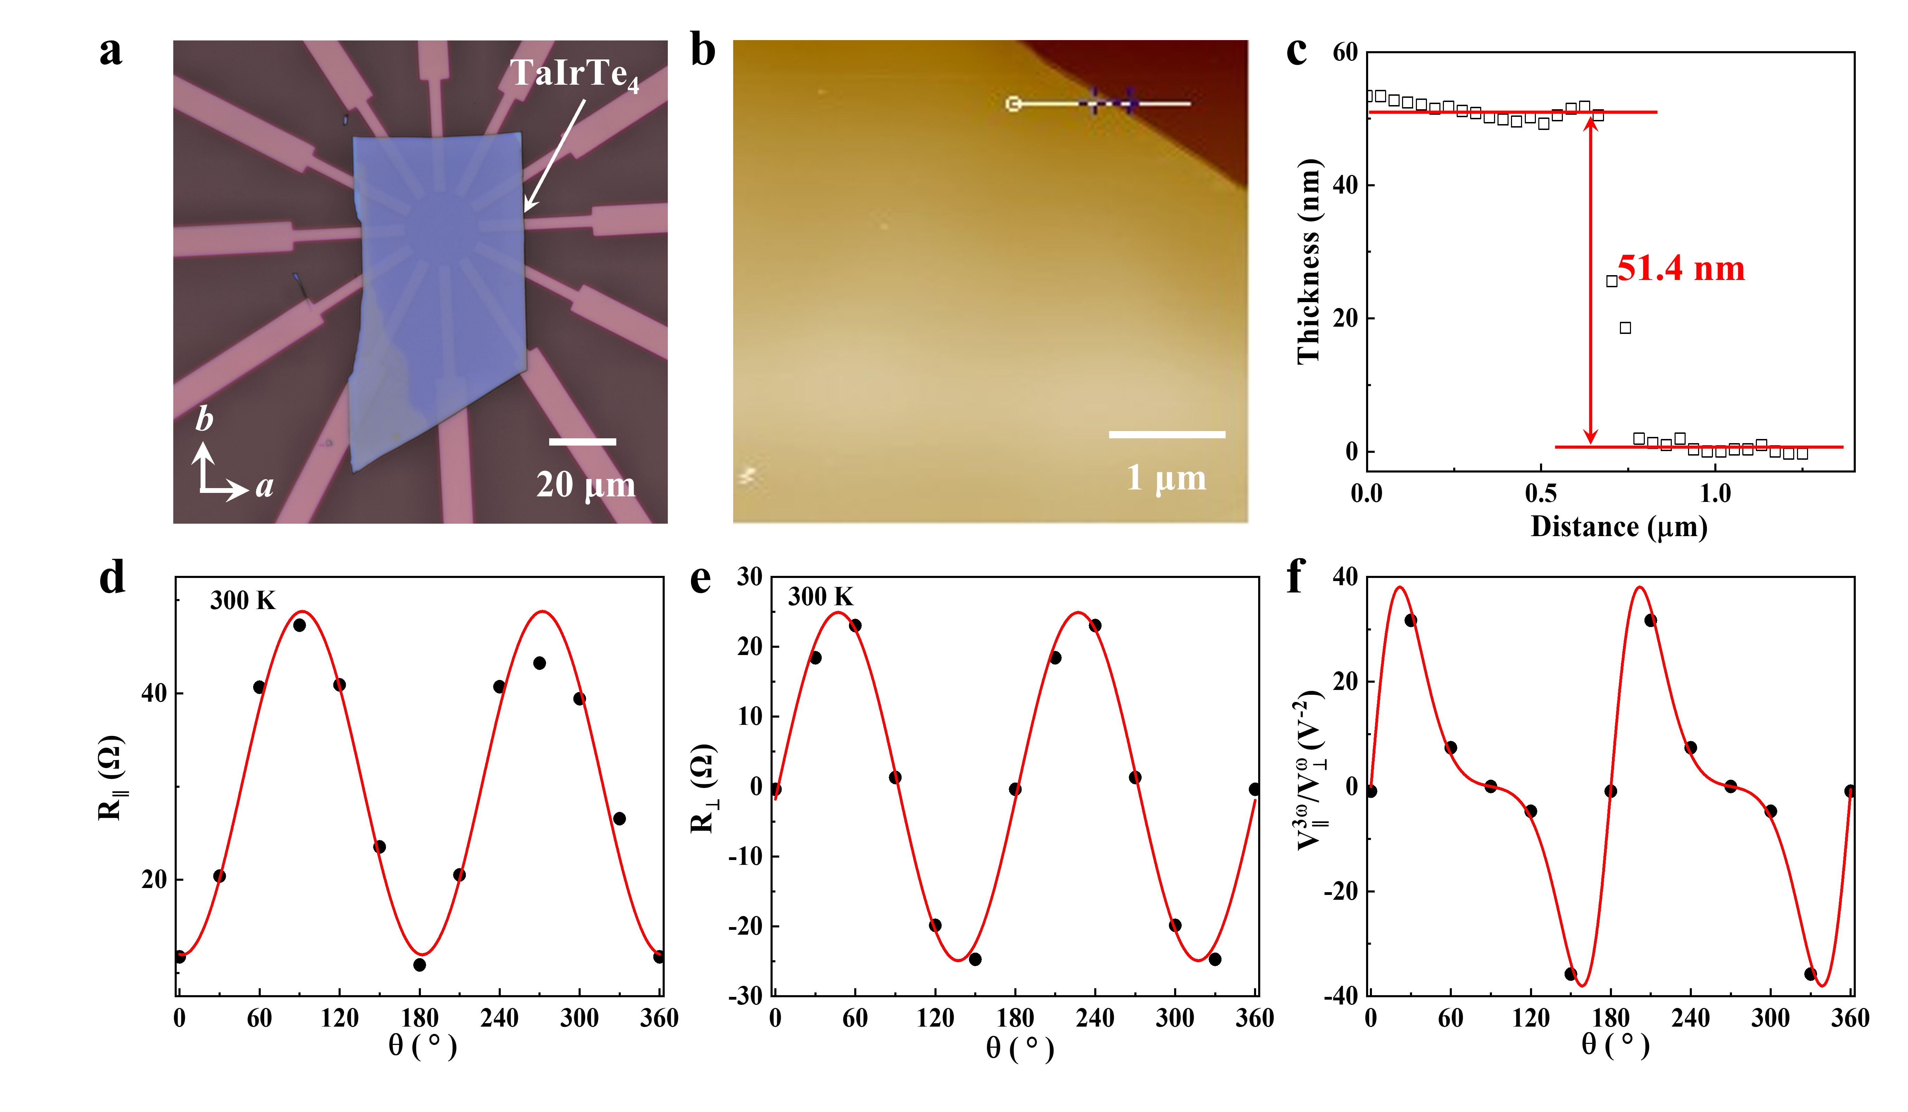
Fig. S14. Optical microscope image, AFM, and electrical characteristics of device E. (a) Optical microscope image of device E. The scale bar in (a) is 20 μm. (b) The AFM picture of the device E. (c) The thickness of the TaIrTe₄ flake is about 51.4 nm, measured from the edge of the TaIrTe₄ flake denoted by the white line displayed in (b). The scale bar in (b) is 1 μm. (d) Anisotropy plots of longitudinal resistance (R‖) of the device E, with the red solid line representing the fitted curve. (e) Anisotropy plots of the Hall resistance (R⊥) of the device E, with the red solid line representing the fitted curve. (f) The angular dependence of the third-order nonlinear Hall response ${V_{⊥}^{3ω}}/{{\left(V_{∥}^{ω}\right)}^{3}}$ at room temperature. The red solid line represents the fitting result of Eq. (1) in the main text.

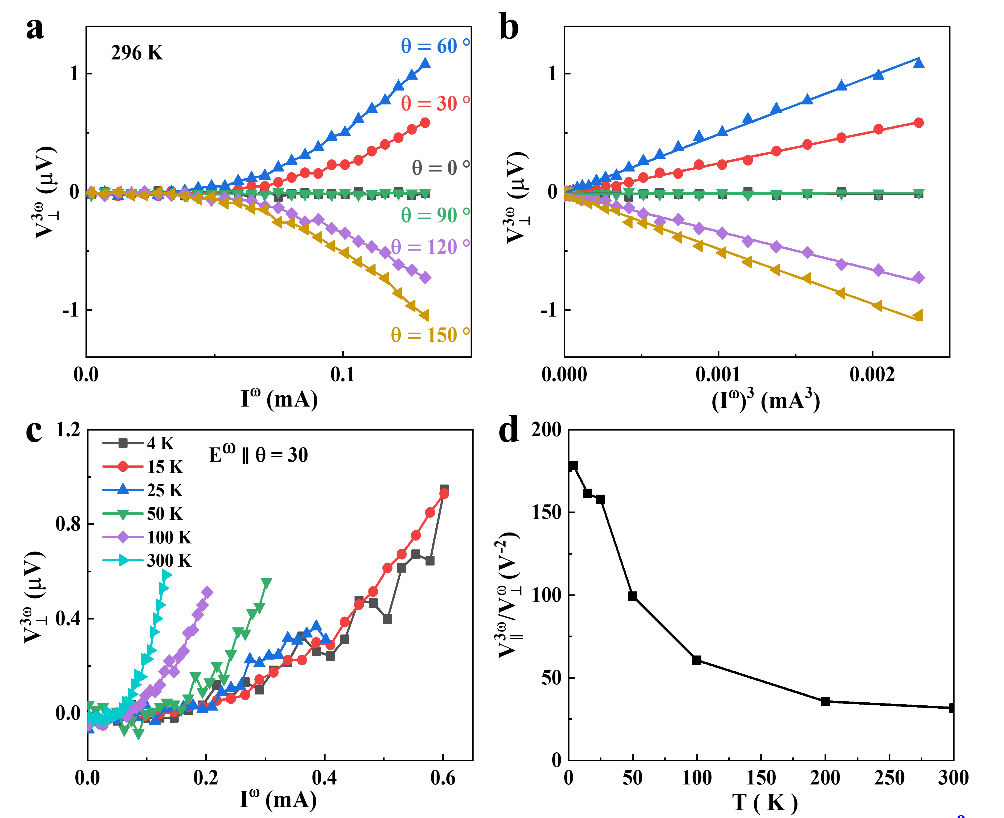
Fig. S15. Third-order NLHE in device E. (a) The dependence of the third-order Hall voltage $V_{⊥}^{3ω}$ on I^{ω} at 296 K under E^{ω} along different angles. (b) $V_{⊥}^{3ω}$ versus (I^{ω})³ curves at 296 K under E^{ω} along different angles. These lines represent the results of linear fitting. (c) $V_{⊥}^{3ω}$ versus I^{ω} curves at different temperatures under E^{ω} along θ = 30°. (d) Temperature dependence of ${V_{⊥}^{3ω}}/{{\left(V_{∥}^{ω}\right)}^{3}}$.

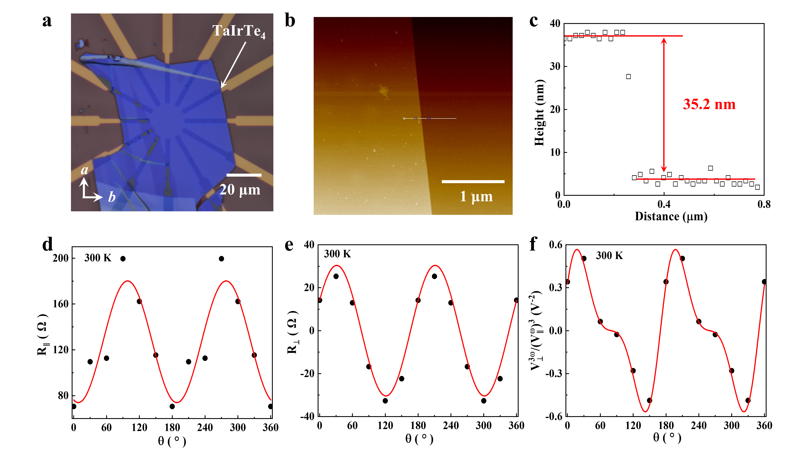
Fig. S16. Optical microscope image, AFM, and electrical characteristics of device F. (a) Optical microscope image of device F. The scale bar in (a) is 20 μm. (b) The AFM picture of the device F. (c) The thickness of the TaIrTe₄ flake is about 35.2 nm, measured from the edge of the TaIrTe₄ flake denoted by the white line displayed in (b). The scale bar in (b) is 1 μm. (d) Anisotropy plots of longitudinal resistance (R‖) of the device F, with the red solid line representing the fitted curve. (e) Anisotropy plots of the Hall resistance (R⊥) of the device F, with the red solid line representing the fitted curve. (f) The angular dependence of the third-order nonlinear Hall response ${V_{⊥}^{3ω}}/{{\left(V_{∥}^{ω}\right)}^{3}}$ at room temperature. The red solid line represents the fitting result of Eq. (1) in the main text.

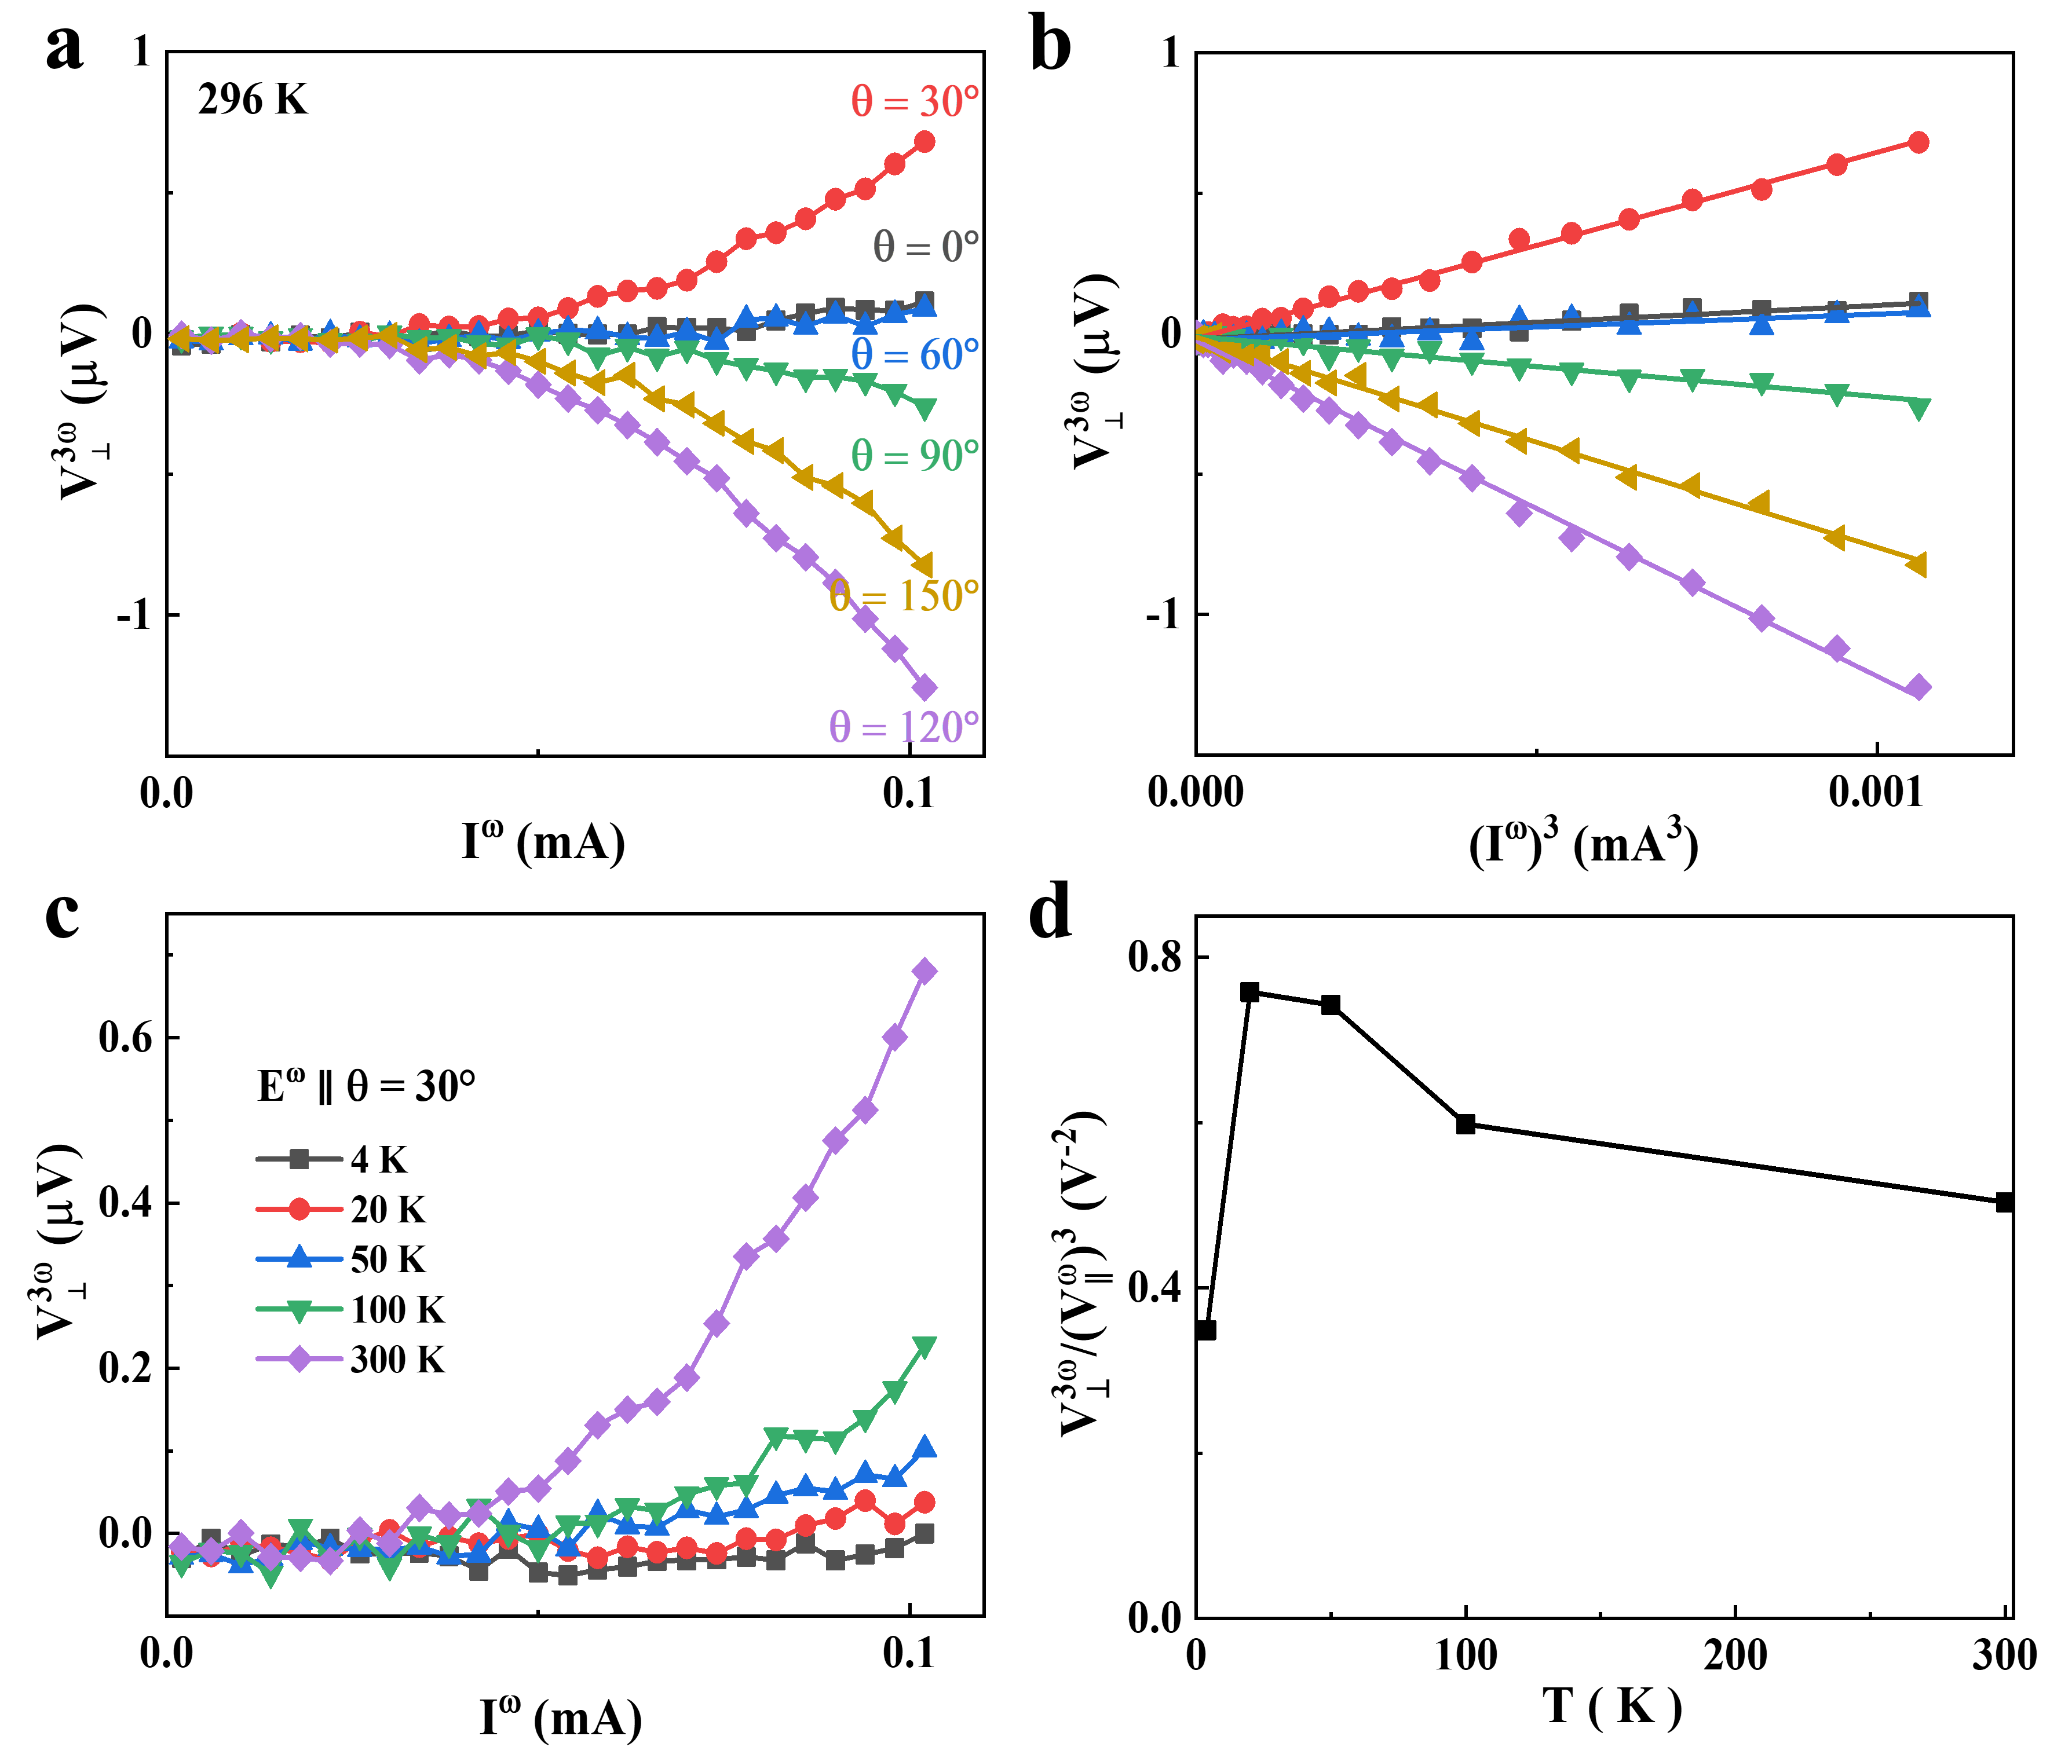
Fig. S17. Third-order NLHE in device F. (a) The dependence of the third-order Hall voltage $V_{⊥}^{3ω}$ on I^{ω} at 296 K under E^{ω} along different angles. (b) $V_{⊥}^{3ω}$ versus (I^{ω})³ curves at 296 K under E^{ω} along different angles. These lines represent the results of linear fitting. (c) $V_{⊥}^{3ω}$ versus I^{ω} curves at different temperatures under E^{ω} along θ = 30°. (d) Temperature dependence of ${V_{⊥}^{3ω}}/{{\left(V_{∥}^{ω}\right)}^{3}}$.

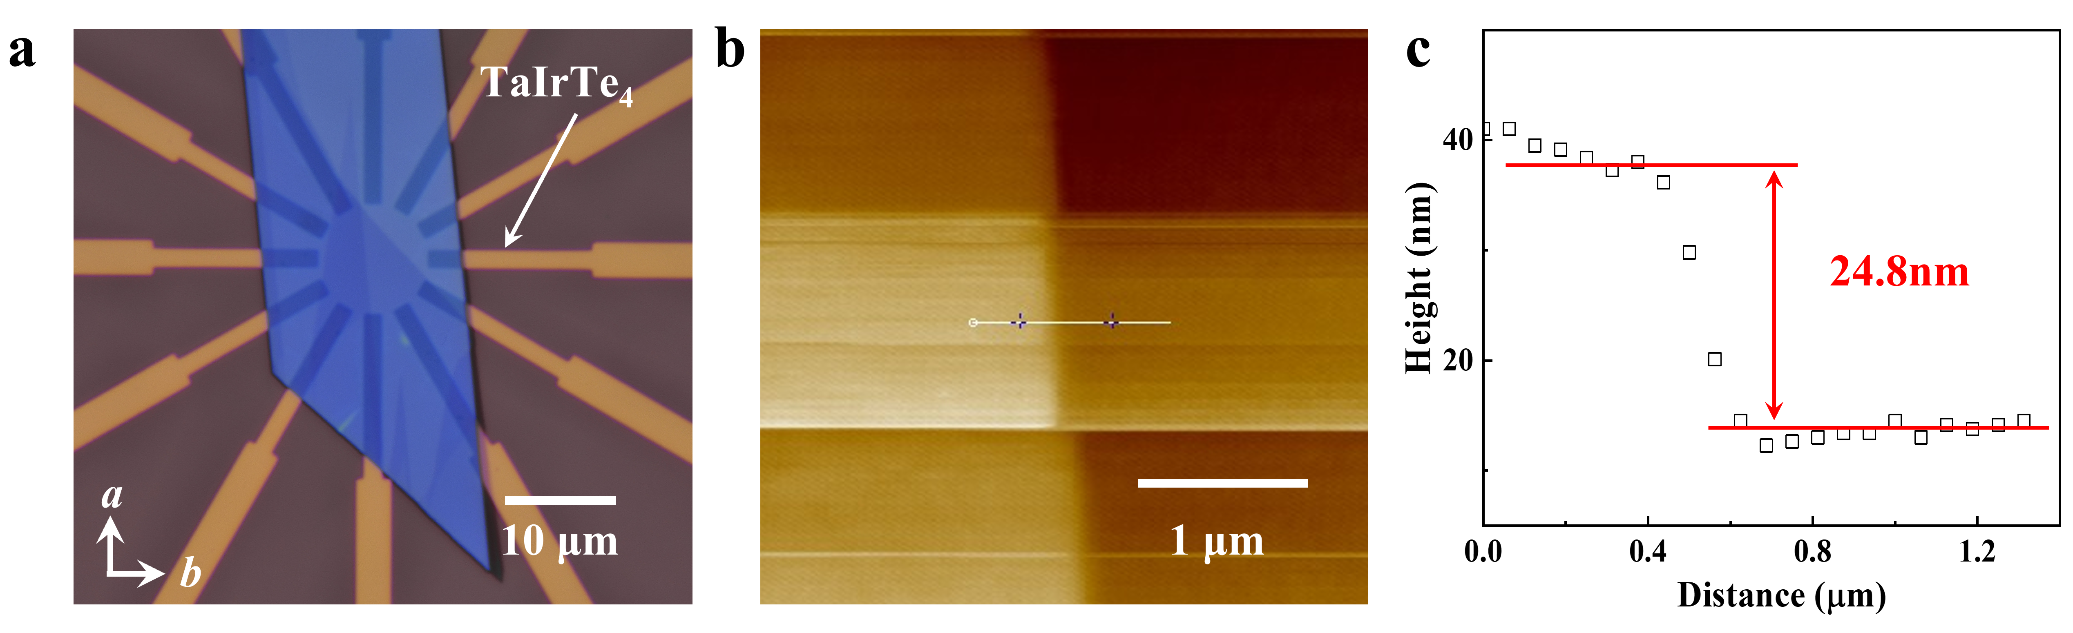
Fig. S18. Optical microscope image and AFM of device G. (a) Optical microscope image of device G. (b) The AFM picture of the device G. (c) The thickness of the TaIrTe₄ flake is about 24.8 nm, measured from the edge of the TaIrTe₄ flake denoted by the white line displayed in (b). The scale bars in (a) and (b) are 10 μm and 1 μm, respectively.

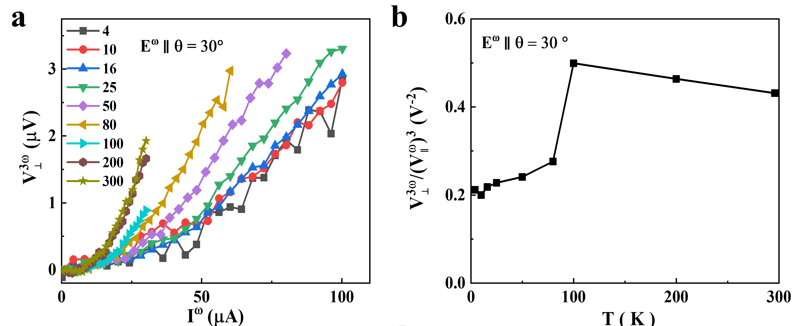
Fig. S19. Third-order NLHE and scaling law analysis in device G. (a) $V_{⊥}^{3ω}$ versus I^{ω} curves at different temperatures under E^{ω} along θ = 30°. (b) Temperature dependence of ${V_{⊥}^{3ω}}/{{\left(V_{∥}^{ω}\right)}^{3}}$.

Note 9. Electric field control of third-order NLHE at 290 K in device A
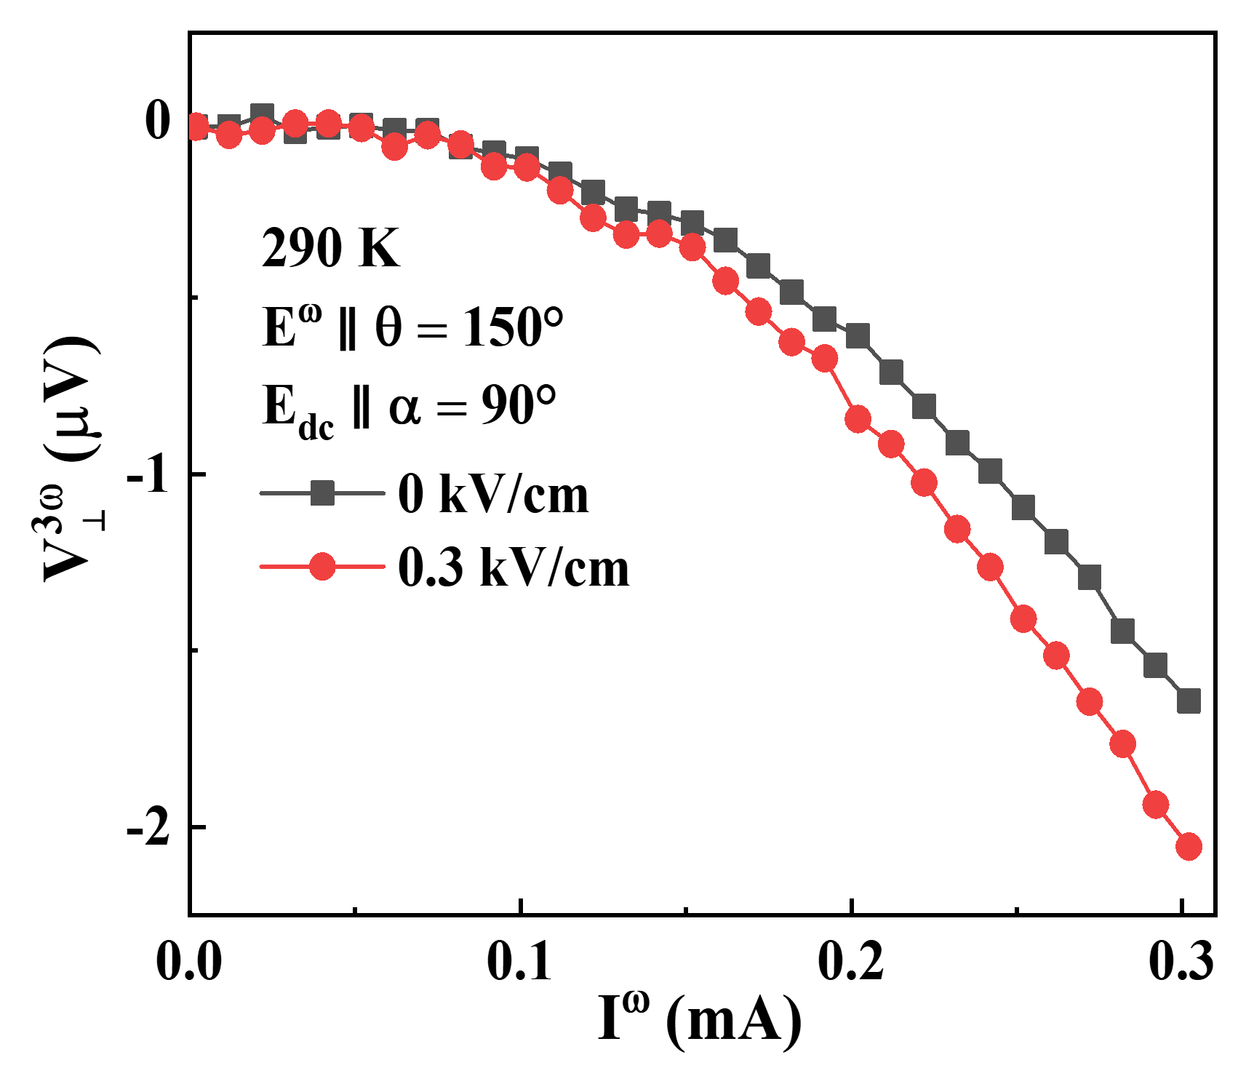
Fig. S20. The third-order harmonic Hall voltage $V_{⊥}^{3ω}$ versus $I^{ω}$ measured by E^{ω} ∥ θ = 150°, E_{dc} ∥ α = 90° and at 290 K under E_{dc} = 0 kV/cm and 0.3 kV/cm in the device A, respectively.

Note 10. Electric field control of third-order NLHE in device B
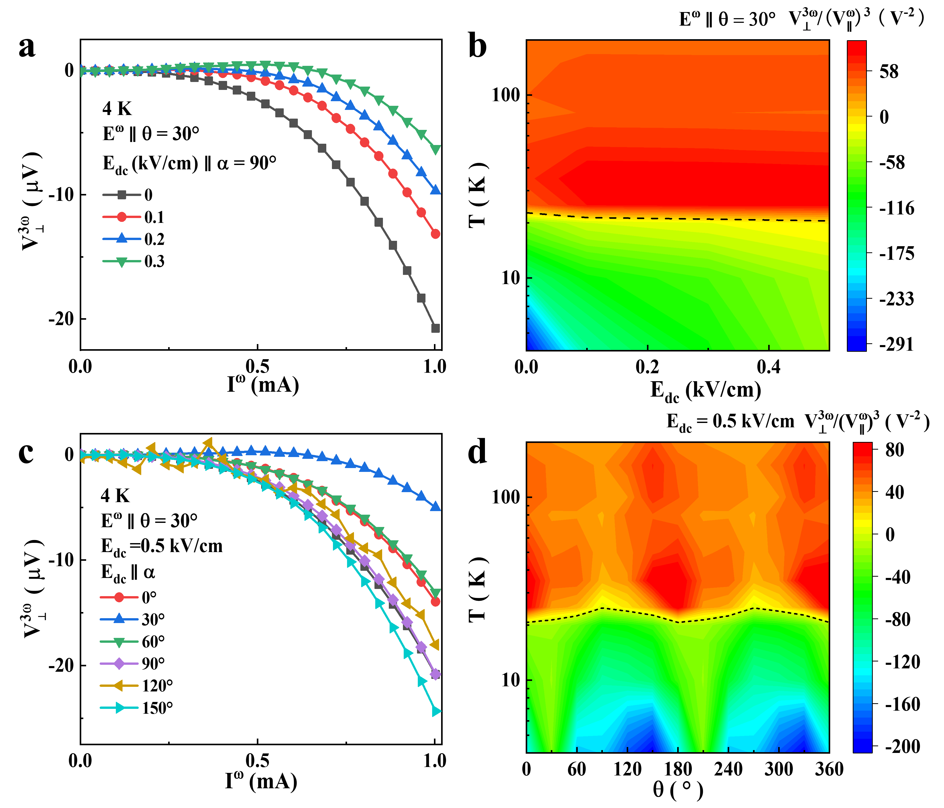
Fig. S21. (a) The dependence of $V_{⊥}^{3ω}$ on I^{ω} under different E_{dc} at 4 K with E^{ω} ∥ θ = 30° and E_{dc} ∥ α = 90°. (b) The variation of ${V_{⊥}^{3ω}}/{{\left(V_{∥}^{ω}\right)}^{3}}$ with temperature (T) and E_{dc} with E_{dc} ∥ α = 90° and E^{ω} ∥ θ = 30°. (c) $V_{⊥}^{3ω}$ versus I^{ω} under different external field directions at 4 K under E^{ω} ∥ θ = 30° and E_{dc} = 0.5 kV/cm. (d) The nonlinear Hall response ${V_{⊥}^{3ω}}/{{\left(V_{∥}^{ω}\right)}^{3}}$ as a function of temperature and angle α at E^{ω} ∥ θ = 30° and E_{dc} = 0.5 kV/cm.

Note 11. Electric field control of third-order NLHE in device E
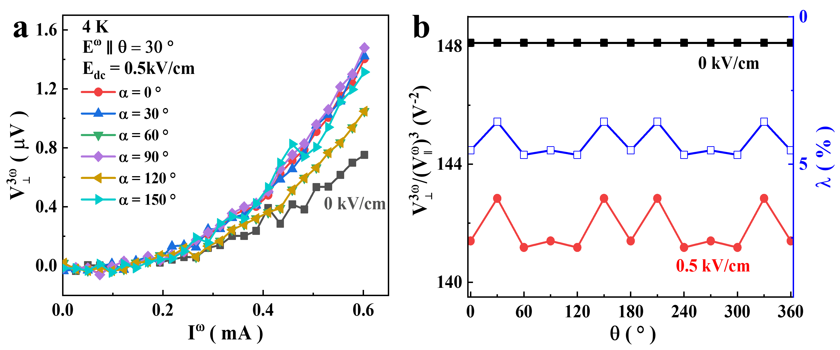
Fig. S22. Electric field control of third-order NLHE in device E. (a) $V_{⊥}^{3ω}$ versus I^{ω} under different external field directions at 4 K under E^{ω} ∥ θ = 30° and E_{dc} = 0.5 kV/cm. (b) Third-order nonlinear Hall response ${V_{⊥}^{3ω}}/{{\left(V_{∥}^{ω}\right)}^{3}}$ versus α at 4 K and under E^{ω} ∥ θ = 30° and E_{dc} = 0, 0.5 kV/cm. The blue data indicates the relative change in the electric field modulation parameter λ.

Note 12. Third-order nonlinear Hall response ${E_{⊥}^{3ω}}/{{\left(E_{∥}^{ω}\right)}^{3}}$ versus σ² in device A
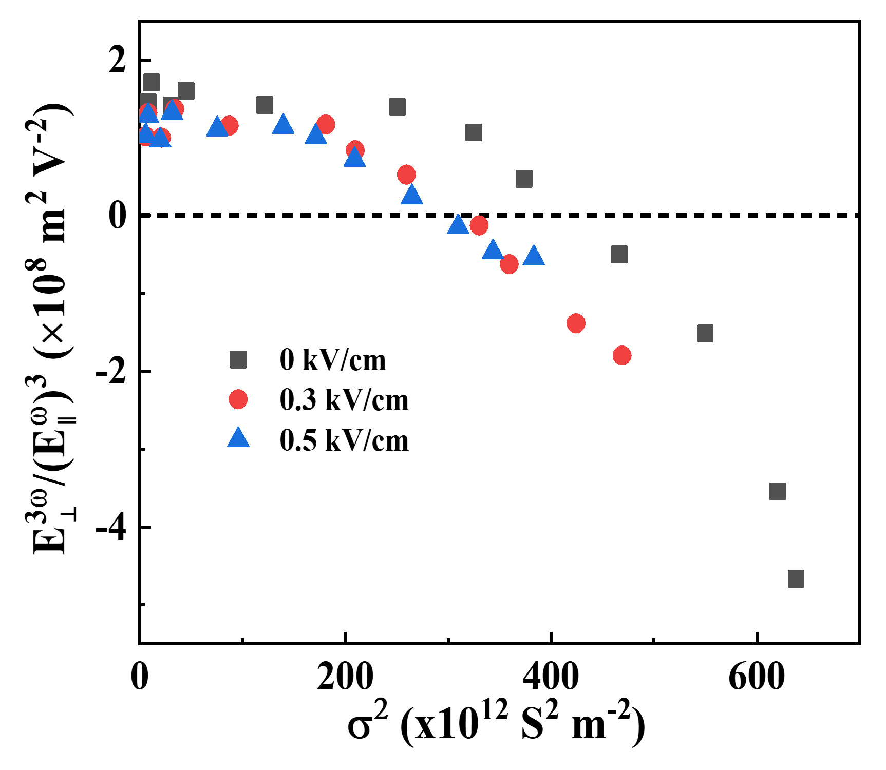
Fig. S23. The ${E_{⊥}^{3ω}}/{{\left(E_{∥}^{ω}\right)}^{3}}$ as a function of σ² for the temperature range from 4 K to 290 K.

Note 13. Scaling law analysis of devices
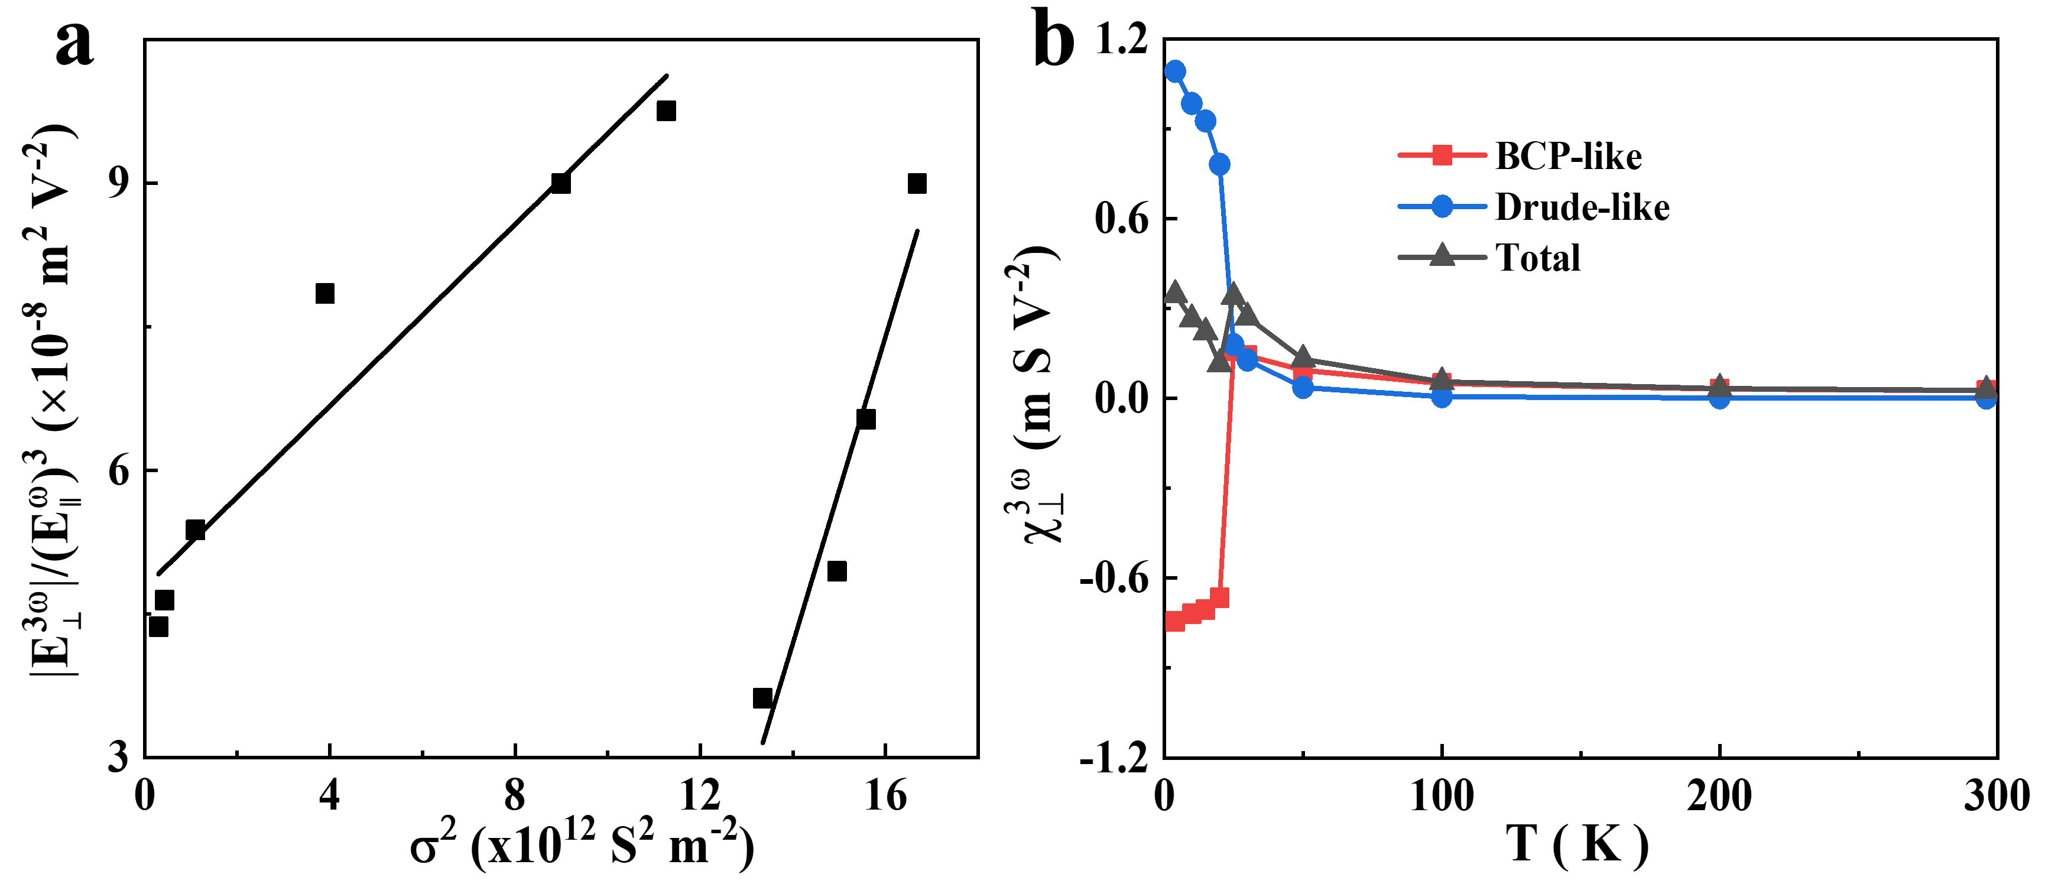
Fig. S24. Scaling law analysis of device B. (a) ${\left|E_{⊥}^{3ω}\right|}/{{\left(E_{∥}^{ω}\right)}^{3}}$ as a function of σ² under E^{ω} ∥ θ = 30° without external field. The solid lines represent the results of linear fitting. (b) The temperature dependence of the BCP-like, Drude-like, and Total response coefficients.

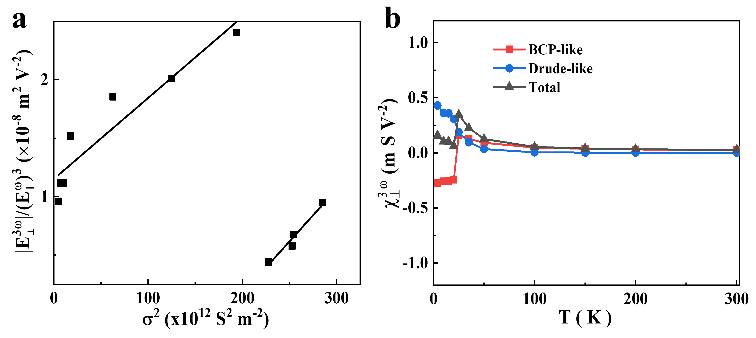
Fig. S25. Scaling law analysis of device C. (a) ${\left|E_{⊥}^{3ω}\right|}/{{\left(E_{∥}^{ω}\right)}^{3}}$ as a function of σ² under E^{ω} ∥ θ = 30°, without external field. The solid lines represent the results of linear fitting. (b) The temperature dependence of the BCP-like, Drude-like, and Total response coefficients.
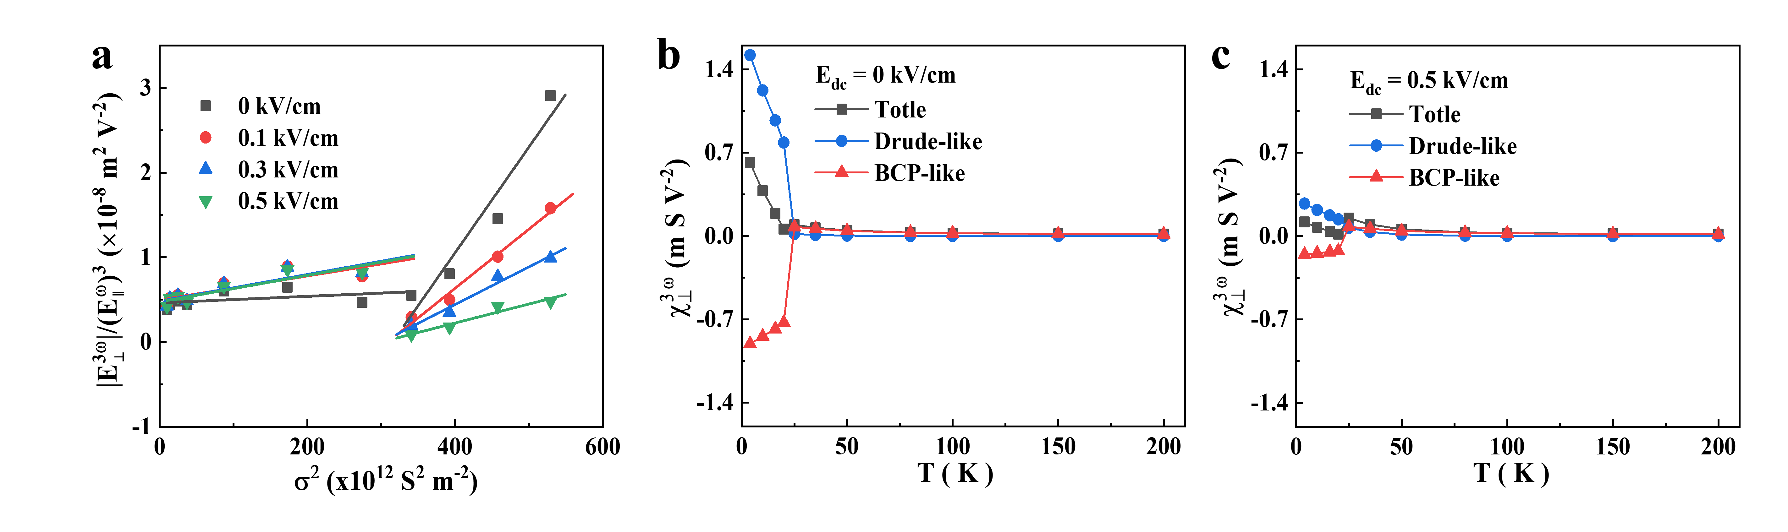
Fig. S26. Scaling law analysis of device D. (a) ${\left|E_{⊥}^{3ω}\right|}/{{\left(E_{∥}^{ω}\right)}^{3}}$ as a function of σ² under E^{ω} ∥ θ = 30°, E_{dc} ∥ α = 90°, and E_{dc} = 0, 0.1, 0.3 and 0.5 kV/cm. The solid lines represent the results of linear fitting. (b, c) The temperature dependence of the BCP-like, Drude-like, and Total response coefficients under E_{dc} = 0 and 0.5 kV/cm, respectively.

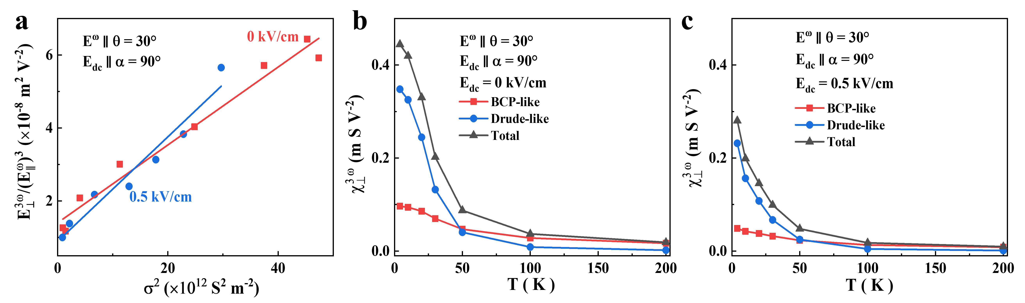
Fig. S27. Scaling law analysis of device E. (a) ${\left|E_{⊥}^{3ω}\right|}/{{\left(E_{∥}^{ω}\right)}^{3}}$ as a function of σ² under E^{ω} ∥ θ = 30°, E_{dc} ∥ α = 90°, and E_{dc} = 0, 0.5 kV/cm. The solid lines represent the results of linear fitting. (b, c) The temperature dependence of the BCP-like, Drude-like, and Total response coefficients under E_{dc} = 0 and 0.5 kV/cm, respectively.

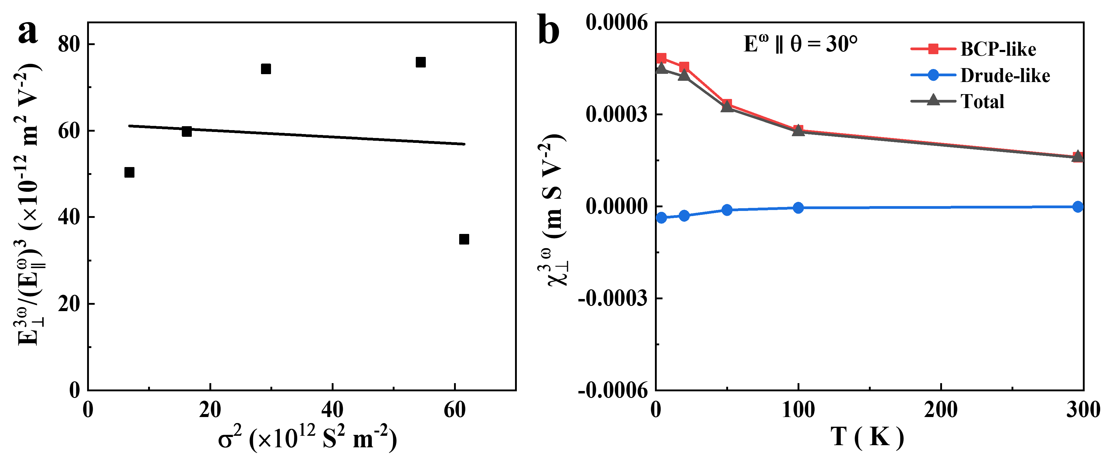
Fig. S28. Scaling law analysis of device F. (a) ${\left|E_{⊥}^{3ω}\right|}/{{\left(E_{∥}^{ω}\right)}^{3}}$ as a function of σ² under E^{ω} ∥ θ = 30° without external field. The solid lines represent the results of linear fitting. (b) The temperature dependence of the BCP-like, Drude-like, and Total response coefficients.

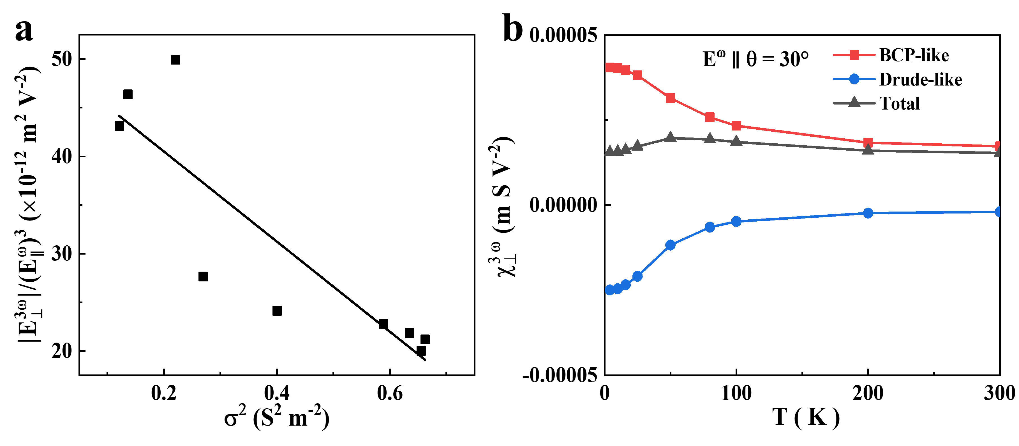
Fig. S29. Scaling law analysis of device G. (a) ${\left|E_{⊥}^{3ω}\right|}/{{\left(E_{∥}^{ω}\right)}^{3}}$ as a function of σ² under E^{ω} ∥ θ = 30°, without external field. The solid lines represent the results of linear fitting. (b) The temperature dependence of the BCP-like, Drude-like, and Total response coefficients.

Note 14. Extract γ(T) by fitting the dependency relationship between χ_{BCP} and 1/d
Fig. S30. $χ_{BCP}$ as a function of 1/d at different temperatures. Solid curves represent the fitting results with the equation χ_{BCP}(d, T) = χ₀(T)⋅e^{[−2γ(T)/d]}.
References
[S1] Lai, S., et al. Third-order nonlinear Hall effect induced by the Berry-connection polarizability tensor. Nature Nanotechnol. 16, 869-873 2021.
[S2] Zhao, T. Y., et al. Gate-Tunable Berry Curvature Dipole Polarizability in Dirac Semimetal Cd₃As₂. Phys. Rev. Lett. 131, 186302 2023.
[S3] Ye, X. G. et al. Orbital polarization and third-order anomalous Hall effect in WTe₂. Phys. Rev. B 106, 045414 2022.
[S4] Liu, Z., et al. Skin‐Inspired in‐Sensor Encoding of Strain Vector Using Tunable Quantum Geometry. Adv. Func. Mater. 2416204 2024.
[S5] Chen, Z. H. et al. Charge density wave modulated third-order nonlinear Hall effect in 1T−VSe₂ nanosheets. Phys. Rev. B. 110, 235135 2024.
[S6] Wang, C. et al. Room-temperature third-order nonlinear Hall effect in Weyl semimetal TaIrTe₄. Natl. Sci. Rev. 9, nwac020 2022.
[S7] Li, S., et al. Giant Third-Order Nonlinear Hall Effect in Misfit Layer Compound (SnS)_{1.17}(NbS₂)₃. ACS Appl. Mater. Interfaces. 16, 11043-11049 2024.
[S8] Yu, H., et al. Quantum metric third-order nonlinear Hall effect in a non-centrosymmetric ferromagnet. Nat. Commun. 16, 7698 2025.
[S9] C. Dames and G. Chen, 1ω, 2ω, and 3ω methods for measurements of thermal properties, Rev. Sci. Instrum. 76, 124902 2005.

