Extended data

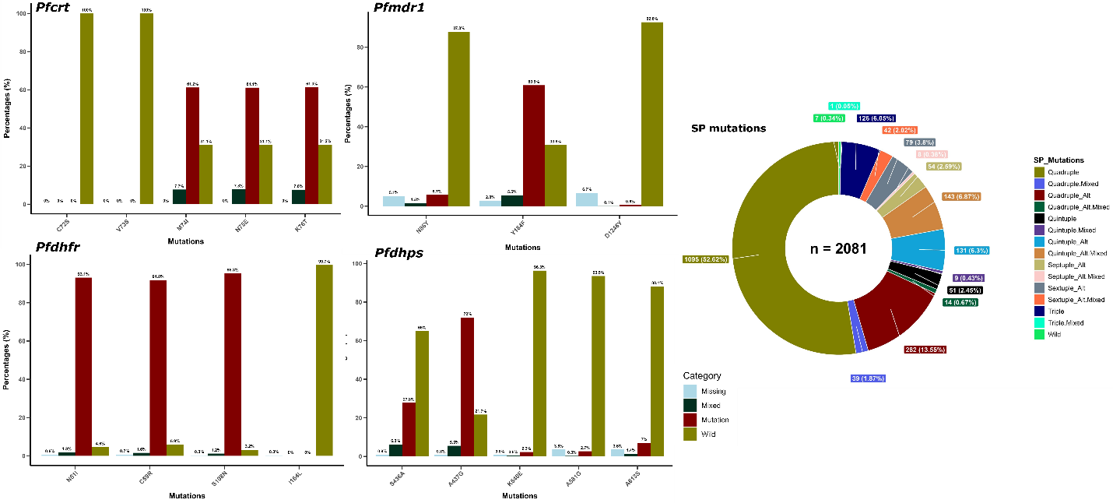
Extended data Figure 1: Overall mutation frequencies at the different antimalarial resistance loci

Extended data Table 1: Resistance categories for SP mutation
S/N | Mutation Categories | Pfdhfr | Pfdhps | Alternative Pfdhps mutants
1 | Triple | IRN | SAKAA
2 | Quadruple | IRN | SGKAA | AAKAA
3 | Quintuple | IRN | AGKAA | SGEKAA
4 | Sextuple | IRN | AGEAA | AGKAS
5 | Septuple | IRN | AGEGA | AGEAS, AGKGS
8 | Octuple | IRN | AGKGS

