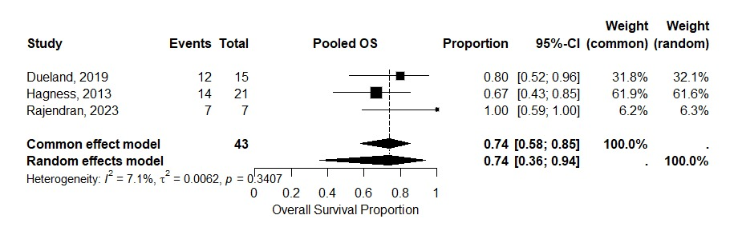
Supplementary Figure S1: Leave-one-out Sensitivity Analysis Forest Plot for 3-Year Overall Survival
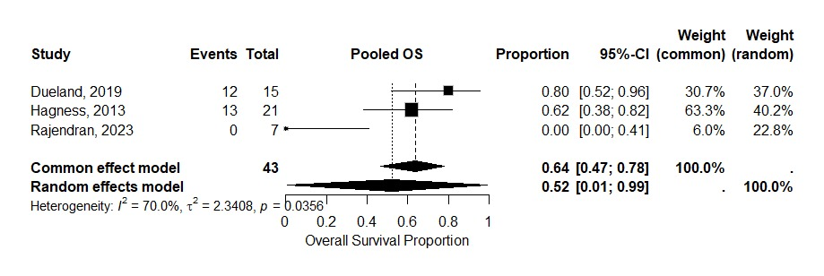
Supplementary Figure S2: Leave-one-out Sensitivity Analysis Forest Plot for 5-Year Overall Survival
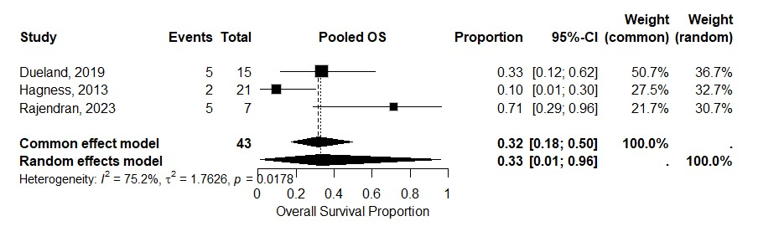
Supplementary Figure S3: Leave-one-out Sensitivity Analysis Forest Plot for 3-Year Progression-Free Survival
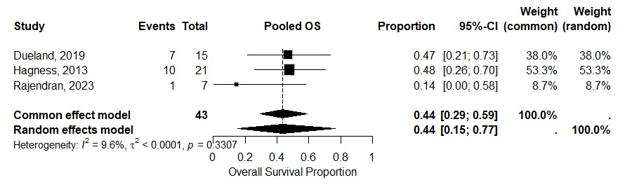
Supplementary Figure S4: Leave-one-out Sensitivity Analysis Forest Plot for Adverse Event

