Supplementary Table S1. Steps implementing the workflow in Fig. 1.
- #Genome nucleotide fragments processing
- create a list of FASTA files (fasta_list) to process
- for file_name in fasta_list:
- store a line of genome sequence
- for line in file_name:
- strip line into a list of nucleotide fragments (nucleotide_fragments)
- for line in nucleotide_fragments:
- write nucleotide code into complete genome file (complete_genome)
- #Direct nucleotide alignment and genome features extraction
- open complete_genome for read
- store a line of nucleotide code from complete_genome
- #Extract dinucleotide transitions
- for line in complete_genome:
- compare previous and current nucleotide codes
- accumulate dinucleotides frequency within acceptable transitions (AA, AC…)
- #Extract dinucleotide mutations
- for line in complete_genome:
- align nucleotide pair with reference genome
- accumulate nucleotide changes within acceptable mutations (AC, TA…)
- #AGNES/hierarchical clustering: generate phylogenomic tree and cluster plots
- treat observations (nucleotides) as cluster points and compute AGNES distance coefficients between clusters
- compute scores between genome isolates clusters
- build and visualize genomic tree
- discover and validate optimal natural clusters (k) using any k-means based N approaches (N>2) (elbow, silhouettes, gap-statistics etc.).
- partition the tree into k clusters
- #Genome expression patterns discovery
- perform SOM clustering on complete_genome
- obtain SOM component planes of learned genome expression patterns
- obtain pairwise correlation coefficients
- label target (output) classes using genome expression clusters for mutant sub-strains and viral expression patterns, to form enriched genome datasets.
- generate cognitive maps with embedded links of genome isolates.
- learn and classify genome (isolate) patterns characterized by (generated) cognitive knowledge, using artificial neural network (ANN) with k-fold validation method.
- predict SARS-CoV-2 sub-strain.

Supplementary Table S2. Excel macro code implementing the delete duplicate columns
- Sub DeleteDuplicateColumns()
- Dim rngData As Range
- Dim arr1, arr2
- Dim i As Integer, j As Integer, n As Integer
- On Error Resume Next
- Set rngData = ActiveSheet.UsedRange
- If rngData Is Nothing Then Exit Sub
- n = rngData.Columns.Count
- For i = n To 2 Step -1
- For j = i - 1 To 1 Step -1
- If WorksheetFunction.CountA(rngData.Columns(i)) <> 0 And _
- WorksheetFunction.CountA(rngData.Columns(j)) <> 0 Then
- arr1 = rngData.Columns(i)
- arr2 = rngData.Columns(j)
- If AreEqualArr(arr1, arr2) Then
- With rngData.Columns(j)
- 'mark column to be deleted
- .Copy
- If MsgBox("Delete marked column?", vbYesNo) _
- = vbYes Then
- rngData.Columns(j).Delete
- Else
- 'remove mark
- Application.CutCopyMode = False
- End If
- End With
- End If
- End If
- Next j
- Next i
- End Sub
- Function AreEqualArr(arr1, arr2) As Boolean
- Dim i As Long, n As Long
- AreEqualArr = False
- For n = LBound(arr1) To UBound(arr1)
- If arr1(n, 1) <> arr2(n, 1) Then
- Exit Function
- End If
- Next n
- AreEqualArr = True
- End Function

Supplementary Table S3. Novel cognitive map of identified cluster patterns and linked countries/isolates
Cluster | Discovered genome pattern | Associated (linked) isolate chain
1-Reference genome | Africa:  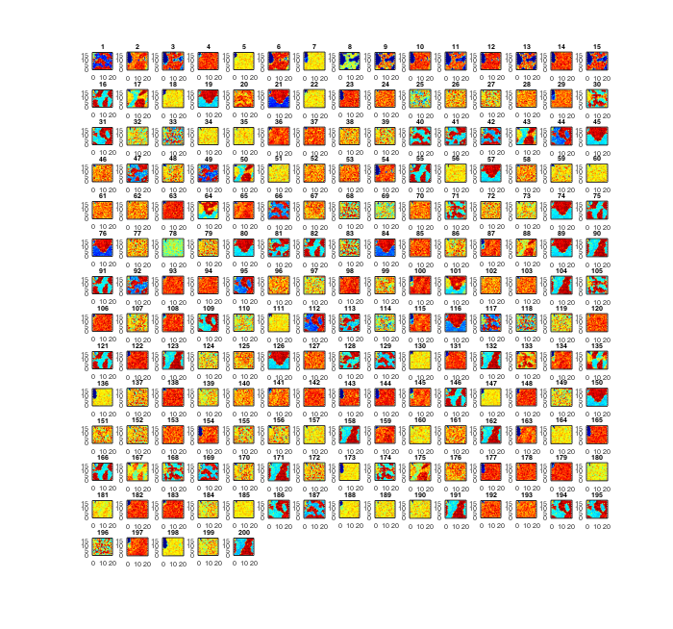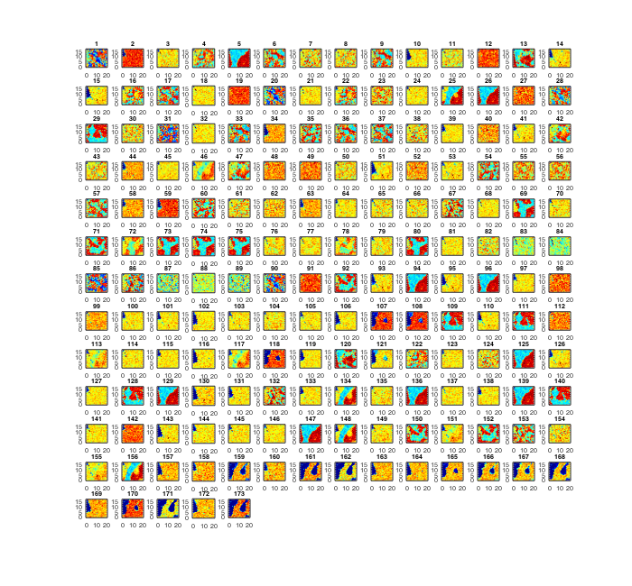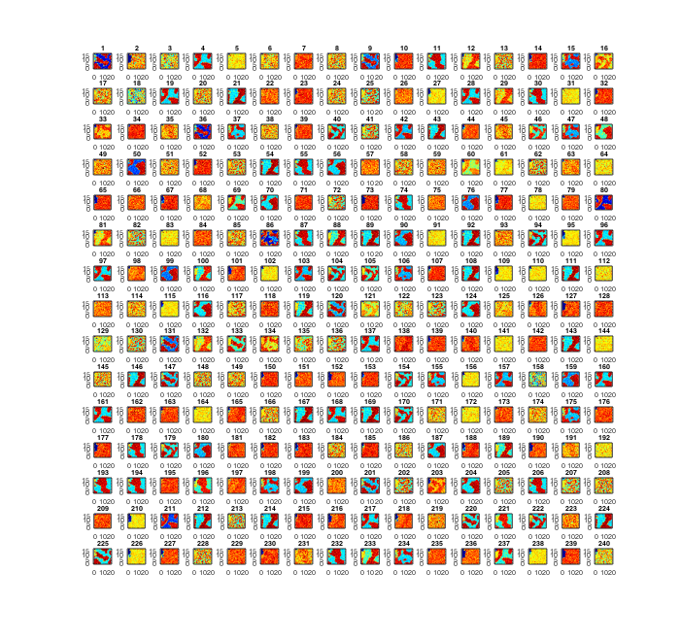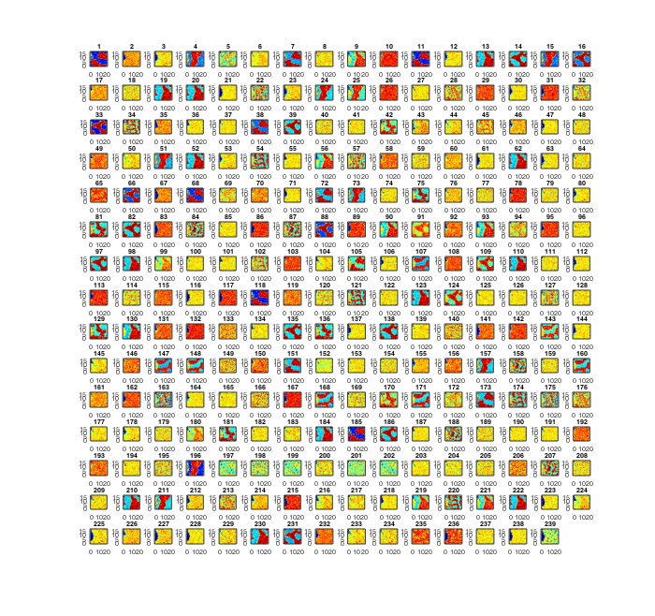  Asia:  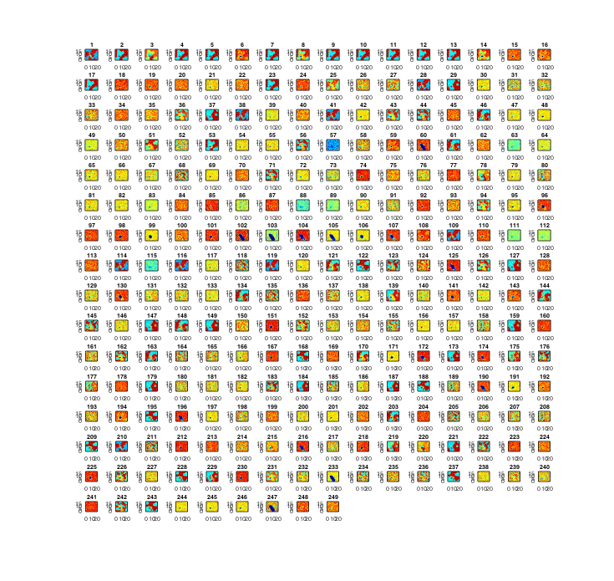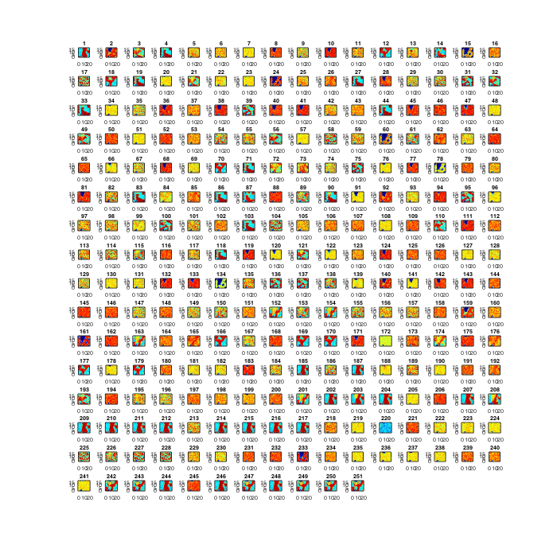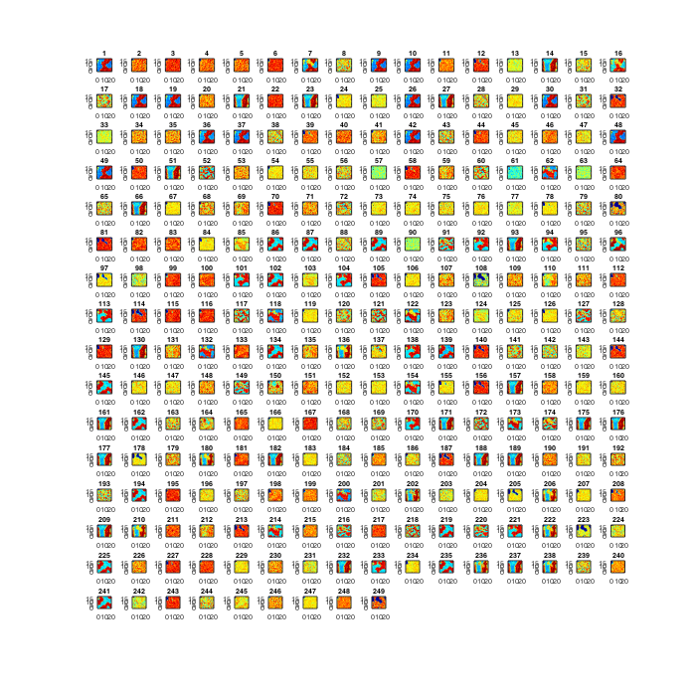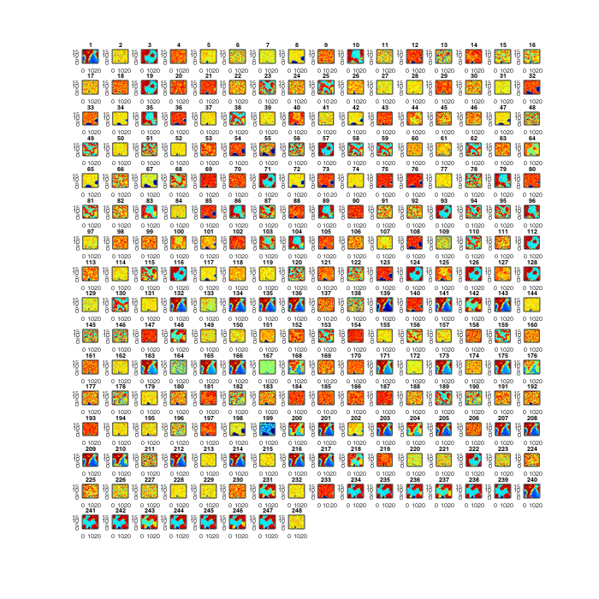  Europe:  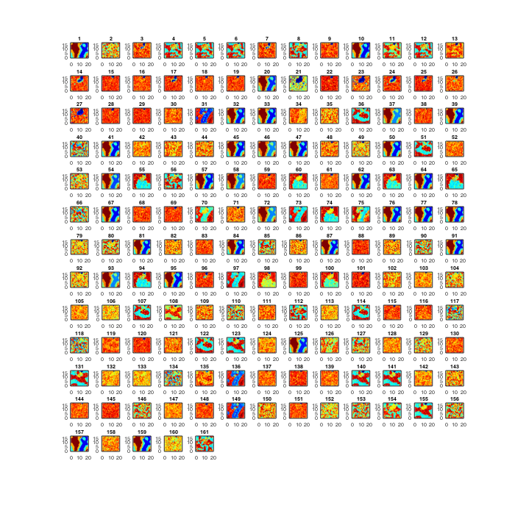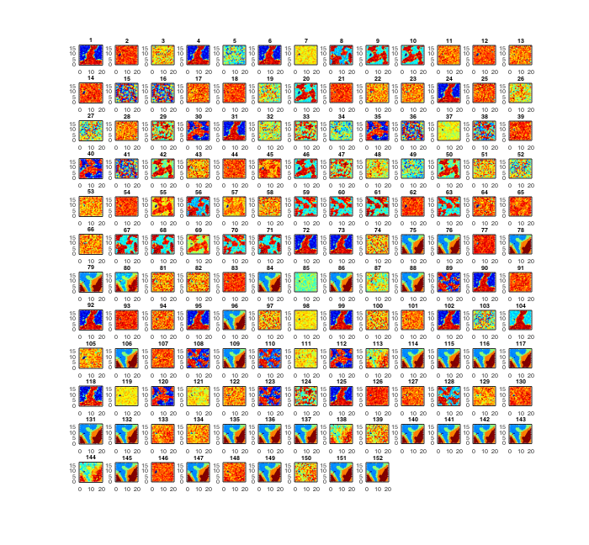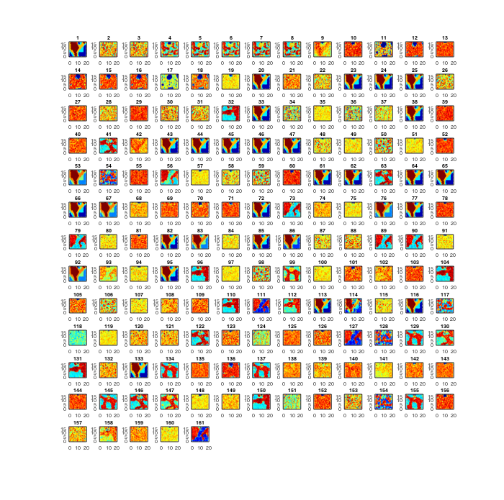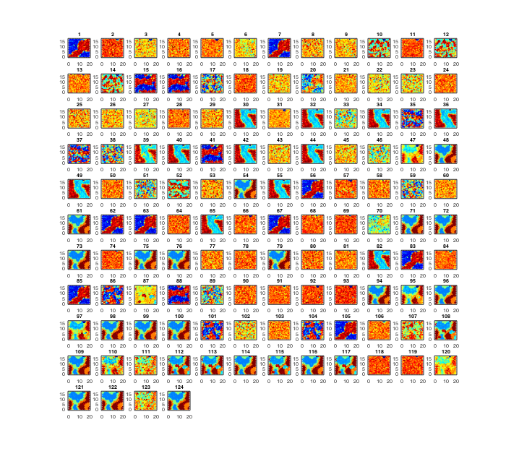  North America:  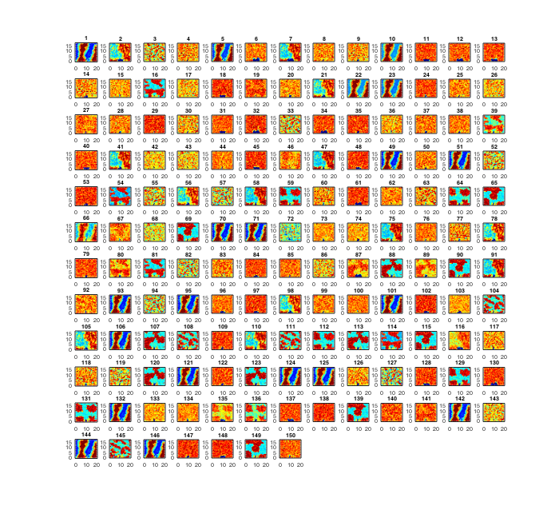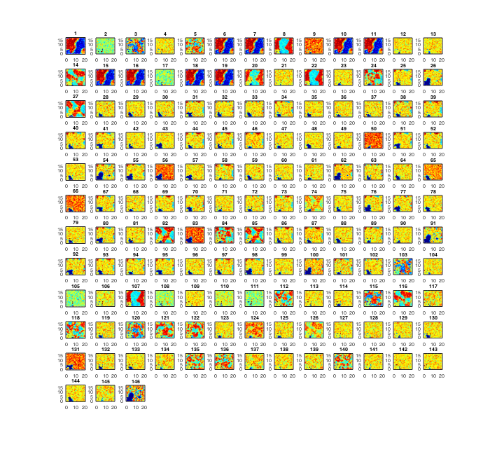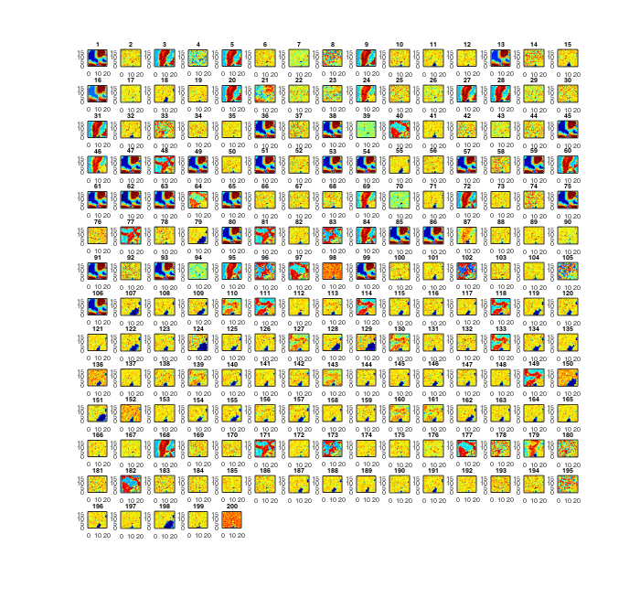  South America:  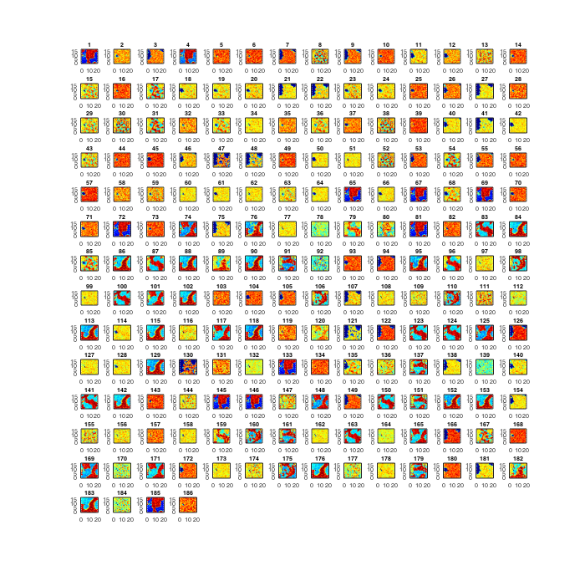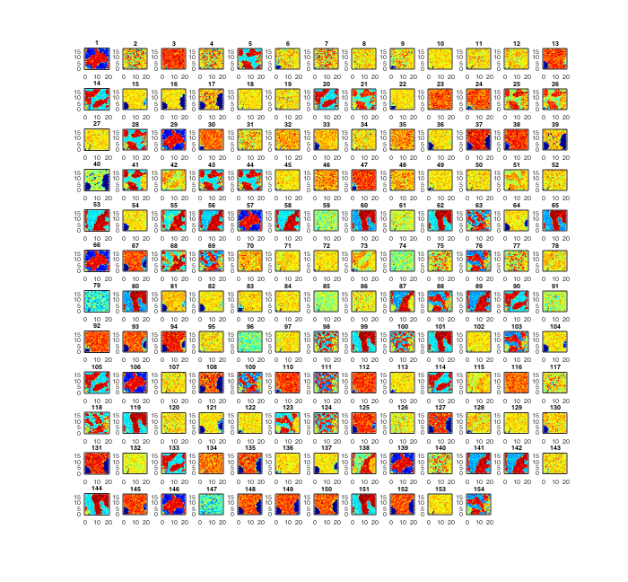  Oceania:  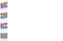 | Male:  ZAF_28, ZAF_29, ZAF_31, ZAF_38, ZAF_41, ZAF_72, ZAF_120, ZAF_293, ZAF_333, ZAF_400, ZAF_419, ZAF_430, TUN_5, TUN_13, CHN_15, CHN_29, CHN_51, LKA_23, BGD_10, BGD_13, BGD_19, IND_229, TWN_3, TWN_9, SAU_15, SAU_71, SAU_106, SAU_123, SAU_126, SAU_196, SAU_200, SAU_207, SAU_250, SAU_305, SAU_322, SAU_335, SAU_349, ARE_55, ARE_58, ARE_61, POL_2, GRC_7, ROU_4, ROU_10, ROU_13, ROU_15, ESP_2, ESP_3, ESP_4, ESP_7, ESP_12, ESP_20, ESP_21, ESP_30, ESP_34, ESP_41, ESP_55, ESP_68, ESP_69, ESP_70, ESP_81, ESP_88, ESP_97, ESP_101, ESP_108, ITA_38, ITA_129, ITA_135, ITA_153, ITA_158, ITA_200, ITA_225, RUS_38, FRA_37, FRA_39, FRA_43, FRA_51, FRA_55, FRA_57, HUN_36, UKR_7, MEX_4, MEX_10, MEX_25, MEX_28, USA_10, USA_38, USA_44, USA_46, USA_111, USA_116, USA_127, USA_140, USA_167, USA_175, USA_176, USA_200, USA_238, USA_251, USA_257, USA_278, USA_282, USA_288, USA_289, USA_298, USA_299, USA_310, USA_311, CHL_1, ECU_4, ECU_8, ECU_17, ECU_20, BRA_9, BRA_113, BRA_142, BRA_144, BRA_256, GUM_1, GUM_2, NZL_1  Female:  ZAF_7, ZAF_46, ZAF_239, ZAF_262, ZAF_303, ZAF_419, ZAF_468, ZAF_475, ZAF_530, ZAF_546, ZAF_615, ZAF_691, ZAF_700, ZAF_829, ZAF_921, ZAF_969, ZAF_1002, CHN_1, CHN_6, CHN_9, CHN_19, CHN_22, CHN_27, CHN_40, CHN_47, CHN_69, CHN_70, CHN_86, CHN_110, CHN_114, KAZ_2, KAZ_7, KAZ_8, KAZ_10, IDN_6, IDN_9, IDN_11, TWN_6, TWN_7, TWN_19, TWN_22, TWN_26, TWN_27, SAU_1, SAU_3, SAU_16, SAU_17, SAU_22, SAU_24, SAU_25, SAU_28, SAU_29, SAU_39, SAU_83, SAU_85, SAU_88, ARE_16, DEU_1, DEU_4, DEU_5, DEU_9, ROU_8, ROU_17, ROU_25, ROU_29, ROU_31, ROU_33, ROU_34, ESP_11, ESP_26, ESP_28, ESP_34, ESP_36, ESP_37, ESP_38, ESP_53, ESP_61, ESP_62, ESP_77, ESP_79, ESP_83, ESP_84, ESP_102, ESP_115, ITA_43, ITA_44, ITA_46, ITA_87, ITA_188, FRA_1, FRA_10, FRA_11, FRA_18, FRA_46, FRA_50, AUT_8, MEX_14, MEX_17, USA_2, USA_5, USA_14, USA_17, USA_20, USA_23, USA_27, USA_28, USA_32, USA_34, USA_43, USA_46, USA_49, USA_57, USA_95, USA_112, USA_132, USA_133, USA_150, USA_169, USA_181, COL_40, BRA_9, BRA_24, BRA_102, BRA_216, BRA_243, NZL_1
2-G1 inter-continent sub-strain(s) |  | Male:  GHA_2, GHA_4, GHA_8, GHA_12, ZAF_5, ZAF_9, ZAF_10, ZAF_15, ZAF_16, ZAF_24, ZAF_25, ZAF_36, ZAF_44, ZAF_45, ZAF_46, ZAF_56, ZAF_63, ZAF_64, ZAF_65, ZAF_70, ZAF_76, ZAF_82, ZAF_111, ZAF_114, ZAF_121, ZAF_123, ZAF_125, ZAF_128, ZAF_130, ZAF_133, ZAF_136, ZAF_144, ZAF_149, ZAF_167, ZAF_175, ZAF_178, ZAF_192, ZAF_199, ZAF_204, ZAF_218, ZAF_223, ZAF_231, ZAF_232, ZAF_235, ZAF_236, ZAF_239, ZAF_245, ZAF_255, ZAF_256, ZAF_266, ZAF_286, ZAF_310, ZAF_311, ZAF_312, ZAF_319, ZAF_323, ZAF_340, ZAF_341, ZAF_359, ZAF_366, ZAF_380, ZAF_396, ZAF_417, ZAF_438, ZAF_445, ZAF_451, ZAF_464, ZAF_465, ZAF_476, ZAF_488, ZAF_490, ZAF_501, NGA_2, NGA_3, SEN_12, SGP_104, SGP_211, SGP_239, SGP_276, SGP_410, IRQ_1, CHN_3, CHN_6, CHN_8, CHN_24, CHN_38, CHN_70, CHN_117, CHN_124, CHN_127, CHN_184, KWT_3, MYS_1, MYS_3, MYS_21, MYS_23, MYS_30, MYS_37, MYS_41, LKA_3, LKA_5, LKA_10, LKA_12, LKA_13, LKA_14, LKA_16, LKA_21, LKA_22, BGD_1, BGD_9, IND_8, IND_15, IND_20, IND_52, IND_58, IND_81, IND_101, IND_117, IND_121, IND_129, IND_136, IND_145, IND_189, IND_191, IND_193, IND_195, IND_205, IND_209, IND_214, IND_232, IND_236, IND_252, IND_257, IND_265, IND_270, IND_271, IND_279, IND_324, IND_357, IND_361, IND_362, IND_379, IND_394, IND_420, IND_482, IND_494, IND_515, IND_521, IND_527, IND_534, IND_542, IND_543, IND_544, IND_552, IND_560, IND_595, IND_611, IND_614, IND_624, IND_655, IND_664, IND_678, IND_690, IND_708, IND_717, IND_733, IND_823, IND_830, IND_834, IND_865, IND_879, IND_908, IND_914, IND_932, IND_976, IND_978, IND_1007, IND_1021, IND_1024, IND_1036, IND_1039, South Korea_1, South Korea_7, IDN_5, IDN_48, IDN_50, IDN_52, IDN_57, TUR_1, TUR_12, TUR_17, TUR_32, TUR_47, TUR_79, Iran_3, TWN_23, VNM_1, VNM_4, VNM_22, VNM_29, VNM_30, VNM_34, SAU_121, SAU_360, SAU_385, OMN_24, LBN_2, LBN_4, LBN_11, LBN_12, ARE_57, FRO_1, FRO_7, BEL_5, POL_6, GRC_1, GRC_2, GRC_3, GRC_4, GRC_5, GRC_6, GRC_9, GRC_10, GRC_11, GRC_12, GRC_13, GRC_15, GRC_16, GRC_17, ROU_1, ROU_6, ROU_8, ROU_12, ROU_16, ROU_17, ESP_1, ESP_5, ESP_10, ESP_24, ESP_26, ESP_48, ESP_49, ESP_52, ESP_75, ESP_77, ESP_87, ESP_89, ESP_90, ESP_113, ESP_136, ESP_142, GEO_1, GEO_3, ITA_4, ITA_6, ITA_15, ITA_17, ITA_26, ITA_28, ITA_29, ITA_37, ITA_46, ITA_50, ITA_56, ITA_61, ITA_63, ITA_72, ITA_73, ITA_77, ITA_91, ITA_92, ITA_94, ITA_95, ITA_101, ITA_102, ITA_116, ITA_130, ITA_147, ITA_171, ITA_172, ITA_173, ITA_176, ITA_181, ITA_182, ITA_186, ITA_189, ITA_195, ITA_201, ITA_213, ITA_249, ITA_269, ITA_270, ITA_273, ITA_294, ITA_295, ITA_300, ITA_301, RUS_9, RUS_19, RUS_22, RUS_24, FRA_5, FRA_11, FRA_13, FRA_14, FRA_38, FRA_40, FRA_42, FRA_54, FRA_59, FRA_61, UKR_3, SWE_1, AUT_9, BIH_3, CZE_3, CZE_5, CZE_50, CZE_64, MEX_3, MEX_5, MEX_8, MEX_9, MEX_11, MEX_12, MEX_13, MEX_16, MEX_17, MEX_20, MEX_21, MEX_23, MEX_31, MEX_32, MEX_34, MEX_36, MEX_39, MEX_42, MEX_43, MEX_46, MEX_47, MEX_48, MEX_51, MEX_52, MEX_54, MEX_59, MEX_61, MEX_62, USA_3, USA_9, USA_12, USA_26, USA_27, USA_28, USA_33, USA_40, USA_49, USA_50, USA_66, USA_68, USA_72, USA_81, USA_85, USA_89, USA_106, USA_118, USA_121, USA_123, USA_124, USA_129, USA_133, USA_144, USA_161, USA_163, USA_169, USA_177, USA_187, USA_198, USA_203, USA_205, USA_227, USA_229, USA_234, USA_237, USA_260, USA_261, USA_266, USA_286, PAN_49, PAN_59, PAN_79, PAN_81, PAN_117, CRI_24, VEN_1, VEN_2, ARG_1, COL_1, COL_2, COL_4, COL_5, COL_7, COL_10, COL_12, COL_28, COL_29, COL_31, COL_36, COL_44, COL_48, COL_51, COL_60, COL_62, COL_73, COL_77, COL_91, COL_94, COL_96, ECU_18, ECU_19, PER_1, BRA_10, BRA_29, BRA_32, BRA_53, BRA_55, BRA_56, BRA_81, BRA_89, BRA_102, BRA_108, BRA_114, BRA_137, BRA_149, BRA_176, BRA_209, BRA_211, BRA_220, BRA_237, BRA_257  Female:  ZAF_5, ZAF_9, ZAF_13, ZAF_25, ZAF_26, ZAF_31, ZAF_38, ZAF_39, ZAF_43, ZAF_45, ZAF_61, ZAF_64, ZAF_71, ZAF_77, ZAF_86, ZAF_98, ZAF_102, ZAF_107, ZAF_108, ZAF_109, ZAF_113, ZAF_120, ZAF_126, ZAF_128, ZAF_130, ZAF_144, ZAF_176, ZAF_186, ZAF_203, ZAF_223, ZAF_237, ZAF_254, ZAF_255, ZAF_256, ZAF_271, ZAF_274, ZAF_278, ZAF_292, ZAF_307, ZAF_308, ZAF_311, ZAF_312, ZAF_330, ZAF_331, ZAF_335, ZAF_353, ZAF_359, ZAF_360, ZAF_375, ZAF_376, ZAF_377, ZAF_379, ZAF_390, ZAF_391, ZAF_398, ZAF_403, ZAF_412, ZAF_426, ZAF_445, ZAF_455, ZAF_457, ZAF_459, ZAF_467, ZAF_471, ZAF_479, ZAF_482, ZAF_489, ZAF_491, ZAF_502, ZAF_508, ZAF_518, ZAF_523, ZAF_536, ZAF_568, ZAF_586, ZAF_595, ZAF_601, ZAF_607, ZAF_646, ZAF_682, ZAF_688, ZAF_694, ZAF_713, ZAF_733, ZAF_741, ZAF_753, ZAF_761, ZAF_769, ZAF_786, ZAF_798, ZAF_815, ZAF_820, ZAF_828, ZAF_830, ZAF_874, ZAF_879, ZAF_903, ZAF_906, ZAF_912, ZAF_917, ZAF_928, ZAF_936, ZAF_937, ZAF_950, EGY_11, EGY_12, NGA_2, SEN_9, SEN_46, SEN_49, SEN_52, SGP_1, SGP_2, SGP_3, SGP_25, IRQ_1, CHN_12, CHN_14, CHN_30, CHN_34, CHN_52, CHN_54, CHN_64, CHN_75, CHN_80, CHN_101, CHN_115, CHN_123, MYS_6, MYS_17, MYS_28, MYS_30, LKA_2, LKA_3, LKA_4, IND_11, IND_12, IND_17, IND_26, IND_29, IND_31, IND_32, IND_49, IND_57, IND_70, IND_80, IND_85, IND_95, IND_103, IND_106, IND_124, IND_131, IND_135, IND_144, IND_154, IND_157, IND_158, IND_173, IND_177, IND_180, IND_182, IND_186, IND_200, IND_201, IND_205, IND_212, IND_233, IND_240, IND_251, IND_254, IND_255, IND_267, IND_279, IND_289, IND_299, IND_305, IND_311, IND_313, IND_336, IND_339, IND_341, IND_350, IND_355, IND_359, IND_361, IND_363, IND_364, IND_379, IND_385, IND_395, IND_403, IND_422, IND_423, IND_428, IND_433, IND_434, IND_439, IND_462, IND_471, IND_475, IND_491, IND_493, IND_500, IND_503, IND_509, IND_516, IND_534, IND_540, IDN_2, IDN_8, TUR_15, TUR_35, TUR_50, Iran_1, Iran_2, TWN_14, TWN_18, VNM_6, VNM_10, VNM_11, VNM_13, VNM_14, VNM_26, VNM_32, VNM_33, ISR_13, SAU_23, PAK_2, LBN_3, LBN_6, GRC_2, GRC_4, GRC_5, GRC_6, GRC_7, GRC_9, GRC_12, DEU_2, ROU_1, ROU_3, ROU_20, ROU_22, ESP_9, ESP_15, ESP_25, ESP_45, ESP_46, ESP_51, ESP_63, ESP_70, ITA_9, ITA_11, ITA_17, ITA_29, ITA_32, ITA_68, ITA_71, ITA_72, ITA_96, ITA_97, ITA_102, ITA_108, ITA_114, ITA_115, ITA_116, ITA_137, ITA_145, ITA_161, ITA_167, ITA_170, ITA_174, ITA_189, ITA_199, ITA_206, ITA_231, ITA_235, ITA_242, ITA_244, ITA_245, ITA_252, RUS_1, RUS_3, RUS_32, RUS_41, RUS_73, RUS_78, FRA_2, FRA_4, FRA_7, FRA_12, FRA_14, FRA_19, FRA_21, FRA_28, FRA_38, FRA_39, FRA_41, FRA_43, FRA_47, SVK_3, MDA_1, MDA_2, MDA_3, UKR_4, FIN_2, CZE_52, CZE_58, USA_159, PAN_51, PAN_77, PAN_79, DOM_5, ARG_1, COL_14, COL_32, COL_33, COL_41, COL_47, COL_48, COL_52, COL_57, COL_75, COL_77, BRA_25, BRA_75, BRA_77, BRA_78, BRA_107, BRA_115, BRA_120, BRA_142, BRA_175, BRA_182, BRA_190, BRA_196, BRA_200, BRA_242, BRA_246, BRA_247, BRA_254, BRA_258
3-G2 inter-continent sub-strain(s) |  | Male:  GHA_3, GHA_5, ZAF_3, ZAF_8, ZAF_21, ZAF_23, ZAF_43, ZAF_51, ZAF_57, ZAF_60, ZAF_85, ZAF_96, ZAF_98, ZAF_112, ZAF_126, ZAF_161, ZAF_198, ZAF_213, ZAF_244, ZAF_263, ZAF_269, ZAF_284, ZAF_301, ZAF_313, ZAF_316, ZAF_328, ZAF_329, ZAF_334, ZAF_336, ZAF_337, ZAF_362, ZAF_363, ZAF_367, ZAF_377, ZAF_387, ZAF_393, ZAF_402, ZAF_408, ZAF_433, ZAF_444, ZAF_446, ZAF_457, ZAF_467, ZAF_470, ZAF_479, GMB_2, GMB_6, GMB_7, EGY_1, EGY_3, EGY_13, EGY_16, EGY_19, EGY_21, MOZ_1, MOZ_3, NGA_1, NGA_4, NGA_6, NGA_7, NGA_8, NGA_9, NGA_11, NGA_12, SEN_7, SEN_16, SEN_17, SEN_18, SEN_25, SEN_27, SEN_30, SEN_32, SEN_35, SEN_36, SEN_39, SEN_40, SEN_44, SEN_47, SEN_50, SEN_52, SEN_58, SEN_61, SEN_62, SEN_63, SEN_65, SEN_71, CHN_5, CHN_19, CHN_35, CHN_52, CHN_74, CHN_79, CHN_90, CHN_104, CHN_108, CHN_150, CHN_154, CHN_157, CHN_168, CHN_183, KWT_1, MYS_8, MYS_14, MYS_17, MYS_34, LKA_11, LKA_17, LKA_18, BGD_14, IND_1, IND_17, IND_22, IND_25, IND_27, IND_42, IND_56, IND_67, IND_93, IND_94, IND_124, IND_162, IND_173, IND_190, IND_199, IND_206, IND_208, IND_274, IND_300, IND_315, IND_346, IND_352, IND_354, IND_377, IND_442, IND_453, IND_458, IND_508, IND_545, IND_558, IND_572, IND_598, IND_616, IND_625, IND_651, IND_716, IND_724, IND_746, IND_767, IND_816, IND_890, IND_892, IND_933, IND_946, IND_960, IND_962, IND_1003, IND_1010, TUR_61, Iran_1, Iran_2, TWN_10, TWN_18, SAU_115, SAU_378, MNG_1, MNG_2, MNG_3, OMN_22, LBN_5, LBN_7, LBN_8, LBN_9, ARE_21, ESP_6, ESP_72, ESP_98, ITA_1, ITA_10, ITA_142, ITA_149, ITA_160, FRA_49, FRA_72, CYP_1, UKR_2, HRV_6, MEX_19, MEX_33, MEX_41, MEX_56, MEX_57, USA_244, USA_276, USA_290, USA_294, USA_314, USA_318, PAN_2, PAN_3, PAN_7, PAN_8, PAN_9, PAN_10, PAN_14, PAN_16, PAN_17, PAN_19, PAN_23, PAN_24, PAN_25, PAN_29, PAN_31, PAN_32, PAN_33, PAN_34, PAN_36, PAN_38, PAN_39, PAN_45, PAN_46, PAN_47, PAN_51, PAN_53, PAN_55, PAN_57, PAN_58, PAN_62, PAN_64, PAN_65, PAN_67, PAN_68, PAN_70, PAN_71, PAN_73, PAN_86, PAN_87, PAN_91, PAN_93, PAN_94, PAN_96, PAN_99, PAN_102, PAN_105, PAN_107, PAN_108, PAN_112, PAN_113, PAN_114, PAN_124, PAN_125, PAN_128, PAN_130, PAN_131, PAN_133, PAN_134, PAN_136, PAN_137, PAN_140, PAN_141, PAN_144, PAN_145, PAN_146, PAN_147, PAN_148, Saint Martin_3, GLP_4, GLP_7, CRI_1, CRI_2, CRI_7, CRI_9, CRI_15, CRI_17, CRI_19, CRI_20, CRI_22, CRI_23, CRI_25, CRI_26, CRI_27, CRI_30, CRI_32, CRI_33, CRI_35, CRI_36, CRI_37, CRI_38, CRI_39, COL_14, COL_15, COL_18, COL_22, COL_24, COL_25, COL_27, COL_30, COL_43, COL_52, COL_53, COL_55, COL_65, COL_74, COL_75, COL_106, COL_107, COL_108, ECU_2, ECU_6, BRA_3, BRA_5, BRA_40, BRA_46, BRA_59, BRA_64, BRA_65, BRA_69, BRA_73, BRA_75, BRA_103, BRA_104, BRA_123, BRA_126, BRA_139, BRA_170, BRA_174, BRA_179, BRA_191, BRA_225, BRA_226, BRA_235, BRA_241  Female:  ZAF_3, ZAF_33, ZAF_37, ZAF_95, ZAF_99, ZAF_129, ZAF_143, ZAF_154, ZAF_166, ZAF_187, ZAF_208, ZAF_213, ZAF_218, ZAF_225, ZAF_285, ZAF_294, ZAF_318, ZAF_333, ZAF_352, ZAF_395, ZAF_449, ZAF_476, ZAF_511, ZAF_524, ZAF_531, ZAF_549, ZAF_571, ZAF_577, ZAF_580, ZAF_590, ZAF_599, ZAF_608, ZAF_613, ZAF_621, ZAF_622, ZAF_642, ZAF_645, ZAF_648, ZAF_656, ZAF_659, ZAF_664, ZAF_667, ZAF_673, ZAF_675, ZAF_698, ZAF_705, ZAF_710, ZAF_714, ZAF_721, ZAF_740, ZAF_770, ZAF_779, ZAF_780, ZAF_789, ZAF_795, ZAF_805, ZAF_810, ZAF_826, ZAF_844, ZAF_854, ZAF_857, ZAF_870, ZAF_885, ZAF_896, ZAF_900, ZAF_908, ZAF_910, ZAF_923, ZAF_925, ZAF_944, ZAF_947, ZAF_978, ZAF_980, ZAF_984, ZAF_993, ZAF_995, GMB_2, EGY_7, EGY_9, EGY_10, EGY_14, TUN_13, MDG_1, NGA_1, NGA_4, SEN_2, SEN_5, SEN_13, SEN_15, SEN_24, SEN_28, SEN_29, SEN_30, SEN_31, SEN_33, SEN_47, SEN_48, SEN_53, RWA_1, CHN_38, CHN_45, CHN_98, CHN_106, CHN_128, MYS_1, MYS_20, MYS_32, MYS_33, MYS_35, MYS_38, MYS_45, MYS_46, LKA_5, IND_9, IND_18, IND_35, IND_45, IND_62, IND_78, IND_79, IND_86, IND_88, IND_90, IND_96, IND_97, IND_104, IND_121, IND_129, IND_132, IND_145, IND_155, IND_164, IND_167, IND_170, IND_209, IND_217, IND_250, IND_253, IND_257, IND_272, IND_278, IND_332, IND_338, IND_345, IND_351, IND_354, IND_356, IND_358, IND_370, IND_377, IND_409, IND_414, IND_425, IND_429, IND_435, IND_456, IND_488, IND_505, IND_517, IND_529, IND_531, South Korea_4, IDN_18, IDN_25, TUR_2, TUR_37, TUR_45, TWN_21, VNM_4, ISR_2, ISR_8, PHL_1, SAU_13, SAU_79, SAU_84, OMN_5, LBN_1, LBN_2, LBN_5, BHR_1, GRC_13, ROU_11, ESP_1, ESP_3, ESP_8, ESP_18, ESP_42, ESP_58, ESP_60, ESP_69, ESP_82, ESP_87, ESP_101, ESP_108, ESP_111, ITA_1, ITA_6, ITA_26, ITA_45, ITA_54, ITA_109, ITA_127, ITA_129, ITA_152, ITA_164, ITA_168, ITA_176, ITA_191, ITA_237, ITA_239, FRA_53, UKR_2, MEX_1, MEX_5, MEX_9, MEX_11, MEX_13, MEX_15, MEX_16, MEX_18, MEX_19, MEX_20, MEX_31, MEX_39, MEX_41, MEX_43, USA_1, USA_3, USA_9, USA_11, USA_13, USA_21, USA_26, USA_29, USA_31, USA_58, USA_66, USA_67, USA_80, USA_93, USA_94, USA_97, USA_107, USA_108, USA_124, USA_135, USA_137, USA_138, USA_144, USA_171, USA_173, USA_175, USA_178, PAN_1, PAN_2, PAN_3, PAN_6, PAN_7, PAN_9, PAN_10, PAN_15, PAN_19, PAN_21, PAN_22, PAN_24, PAN_27, PAN_29, PAN_30, PAN_31, PAN_34, PAN_35, PAN_40, PAN_42, PAN_44, PAN_46, PAN_54, PAN_56, PAN_59, PAN_61, PAN_62, PAN_64, PAN_67, PAN_69, PAN_71, PAN_73, PAN_78, PAN_80, PAN_81, PAN_83, PAN_84, PAN_85, PAN_86, PAN_88, PAN_92, PAN_98, PAN_101, PAN_102, Saint Martin_1, Saint Martin_2, GLP_1, GLP_2, GLP_5, GLP_7, GLP_9, GLP_10, CAN_10, CRI_2, CRI_3, CRI_4, CRI_5, CRI_6, CRI_7, CRI_9, CRI_10, CRI_11, CRI_12, CRI_13, CRI_14, CRI_17, DOM_1, DOM_2, DOM_4, COL_3, COL_5, COL_7, COL_8, COL_13, COL_19, COL_20, COL_24, COL_26, COL_30, COL_38, COL_44, COL_49, COL_55, COL_64, COL_72, ECU_2, ECU_4, BRA_3, BRA_5, BRA_19, BRA_33, BRA_35, BRA_39, BRA_50, BRA_54, BRA_55, BRA_58, BRA_61, BRA_65, BRA_79, BRA_82, BRA_91, BRA_99, BRA_103, BRA_130, BRA_140, BRA_151, BRA_155, BRA_159, BRA_178, BRA_185, BRA_186, BRA_188, BRA_202, BRA_211, BRA_233, BRA_259
4-G3 inter-country sub-strain(s) |  | Male:  ZAF_12, ZAF_78, ZAF_97, ZAF_151, ZAF_379, TUN_3, TUN_4, TUN_9, TUN_11, TUN_12, CHN_135, MYS_31, MYS_32, LKA_15, BGD_4, BGD_8, BGD_11, TUR_24, GRC_8, ITA_155, ITA_183, ITA_207, ITA_226, ITA_292, FRA_18, FRA_32, USA_48, USA_267, USA_301, Saint Martin_4, GLP_6, CAN_8, CAN_10, BRA_6, BRA_24, BRA_111, BRA_125, BRA_194, BRA_217, BRA_231, BRA_253  Female:  ZAF_20, ZAF_257, ZAF_526, ZAF_922, TUN_4, TUN_5, TUN_8, TUN_10, TUN_11, RWA_2, CHN_16, CHN_39, CHN_53, MYS_5, MYS_12, MYS_15, BGD_7, IND_10, IND_42, IND_161, IND_163, IND_197, IND_198, IND_214, IND_237, IND_275, KAZ_5, TWN_3, TWN_8, GRC_11, ROU_14, ITA_52, ITA_70, ITA_134, ITA_247, RUS_7, RUS_45, FRA_23, MEX_4, MEX_6, MEX_27, MEX_37, USA_7, USA_12, USA_77, USA_151, COL_65, BRA_11, BRA_15, BRA_43, BRA_62, BRA_74, BRA_80
5-G4 inter-continent sub-strain(s) |  | Male:  CHN_115, SAU_381, ITA_235, ITA_289  Female:  PHL_6, ESP_14, ITA_141, ITA_225, ITA_233, RUS_14, RUS_16, RUS_17, FRA_52, UKR_1, UKR_5, BRA_51, BRA_244
6-G5 inter-continent sub-strain(s) |  | Male:  ZAF_14, ZAF_19, ZAF_20, ZAF_26, ZAF_27, ZAF_77, ZAF_106, ZAF_173, ZAF_214, ZAF_246, ZAF_252, ZAF_253, ZAF_257, ZAF_259, ZAF_372, ZAF_391, ZAF_439, ZAF_440, ZAF_441, ZAF_482, ZAF_487, ZAF_493, DZA_1, SEN_42, SEN_77, CHN_13, CHN_14, CHN_20, CHN_22, CHN_23, CHN_99, CHN_116, CHN_182, MYS_9, MYS_35, BGD_17, IND_31, IND_40, IND_86, IND_91, IND_95, IND_103, IND_112, IND_115, IND_153, IND_154, IND_170, IND_184, IND_192, IND_204, IND_218, IND_219, IND_223, IND_224, IND_231, IND_304, IND_306, IND_312, IND_317, IND_356, IND_381, IND_395, IND_406, IND_425, IND_499, IND_502, IND_514, IND_536, IND_563, IND_564, IND_576, IND_579, IND_584, IND_593, IND_623, IND_641, IND_680, IND_711, IND_760, IND_763, IND_787, IND_801, IND_838, IND_846, IND_861, IND_867, IND_956, IND_984, IND_997, South Korea_3, South Korea_8, KAZ_1, IDN_9, IDN_25, IDN_26, IDN_35, TUR_7, Iran_5, TWN_4, TWN_12, VNM_6, VNM_15, SAU_273, OMN_3, OMN_5, OMN_17, OMN_19, CHE_1, ROU_14, ESP_11, ESP_37, ESP_73, ESP_83, ESP_95, ITA_5, ITA_18, ITA_23, ITA_48, ITA_62, ITA_98, ITA_118, ITA_120, ITA_121, ITA_216, ITA_227, ITA_281, UKR_5, MEX_2, MEX_44, USA_11, USA_14, USA_18, USA_80, USA_90, USA_114, USA_164, USA_181, USA_274, USA_277, PAN_1, CRI_10, CRI_28, CRI_29, CRI_34, DOM_1, COL_6, COL_8, BRA_67, BRA_118, BRA_119, BRA_173, BRA_210  Female:  ZAF_1, ZAF_4, ZAF_6, ZAF_12, ZAF_28, ZAF_30, ZAF_49, ZAF_54, ZAF_76, ZAF_79, ZAF_88, ZAF_96, ZAF_118, ZAF_138, ZAF_146, ZAF_224, ZAF_232, ZAF_242, ZAF_243, ZAF_260, ZAF_269, ZAF_298, ZAF_304, ZAF_306, ZAF_339, ZAF_351, ZAF_355, ZAF_378, ZAF_380, ZAF_421, ZAF_439, ZAF_443, ZAF_444, ZAF_452, ZAF_480, ZAF_519, ZAF_578, ZAF_594, ZAF_602, ZAF_604, ZAF_635, ZAF_641, ZAF_657, ZAF_661, ZAF_738, ZAF_747, ZAF_782, ZAF_843, ZAF_860, ZAF_902, ZAF_916, ZAF_933, ZAF_941, ZAF_948, ZAF_957, ZAF_962, ZAF_971, ZAF_975, ZAF_977, DZA_1, TUN_1, NGA_3, SEN_6, SEN_17, CHN_5, CHN_18, CHN_20, CHN_43, CHN_50, CHN_71, CHN_88, CHN_122, MYS_4, MYS_7, MYS_8, MYS_18, MYS_24, MYS_31, MYS_47, LKA_1, BGD_4, IND_2, IND_7, IND_33, IND_36, IND_37, IND_46, IND_48, IND_72, IND_74, IND_81, IND_82, IND_100, IND_101, IND_107, IND_108, IND_113, IND_146, IND_148, IND_156, IND_184, IND_187, IND_190, IND_228, IND_274, IND_284, IND_296, IND_301, IND_302, IND_314, IND_337, IND_366, IND_376, IND_387, IND_411, IND_436, IND_446, IND_476, IND_481, IND_483, IND_484, IND_520, IND_532, IND_538, IDN_4, IDN_19, IDN_20, VNM_2, VNM_7, VNM_22, ISR_12, SAU_33, CHE_1, FRO_1, GRC_3, DEU_10, ROU_10, ROU_13, ITA_2, ITA_23, MEX_7, MEX_28, MEX_42, USA_33, USA_179, CAN_3, CAN_7, CRI_15, VEN_1, COL_1, COL_4, COL_6, COL_21, COL_58, BRA_44, BRA_49, BRA_83, BRA_85, BRA_118, BRA_168, BRA_217
7-Intra-continent sub-strains | Africa:  Asia:  Europe:  North America:  South America:  Oceania: | Male:  CMR_1, GHA_1, GHA_6, GHA_7, GHA_9, GHA_10, GHA_11, GHA_13, ZAF_1, ZAF_2, ZAF_4, ZAF_7, ZAF_13, ZAF_17, ZAF_18, ZAF_32, ZAF_33, ZAF_35, ZAF_39, ZAF_42, ZAF_47, ZAF_55, ZAF_66, ZAF_83, ZAF_84, ZAF_89, ZAF_91, ZAF_94, ZAF_99, ZAF_100, ZAF_102, ZAF_108, ZAF_115, ZAF_116, ZAF_118, ZAF_119, ZAF_124, ZAF_129, ZAF_132, ZAF_137, ZAF_141, ZAF_148, ZAF_150, ZAF_162, ZAF_163, ZAF_166, ZAF_168, ZAF_170, ZAF_174, ZAF_177, ZAF_179, ZAF_182, ZAF_185, ZAF_186, ZAF_195, ZAF_196, ZAF_201, ZAF_203, ZAF_207, ZAF_219, ZAF_240, ZAF_251, ZAF_264, ZAF_270, ZAF_275, ZAF_277, ZAF_287, ZAF_288, ZAF_290, ZAF_295, ZAF_297, ZAF_298, ZAF_302, ZAF_303, ZAF_304, ZAF_330, ZAF_338, ZAF_345, ZAF_347, ZAF_350, ZAF_364, ZAF_368, ZAF_369, ZAF_373, ZAF_374, ZAF_375, ZAF_383, ZAF_385, ZAF_390, ZAF_403, ZAF_407, ZAF_409, ZAF_412, ZAF_426, ZAF_429, ZAF_436, ZAF_442, ZAF_449, ZAF_450, ZAF_461, ZAF_463, ZAF_485, ZAF_486, ZAF_495, ZAF_499, EGY_2, EGY_4, EGY_6, EGY_8, EGY_10, EGY_11, EGY_17, EGY_20, TUN_2, TUN_8, MAR_1, MAR_2, MOZ_2, MOZ_4, NGA_13, SEN_2, SEN_4, SEN_9, SEN_13, SEN_21, SEN_22, SEN_26, SEN_28, SEN_34, SEN_37, SEN_38, SEN_45, SEN_48, SEN_54, SEN_57, SEN_59, SEN_66, SEN_69, SEN_72, SEN_73, SEN_76, SEN_79, SEN_81, SEN_82, RWA_1, RWA_2, RWA_3, RWA_5, RWA_7, RWA_9, RWA_10, RWA_11, RWA_12, RWA_15, RWA_16, RWA_18, RWA_20, RWA_21, RWA_22, RWA_24, RWA_25, SGP_2, SGP_22, SGP_31, SGP_90, SGP_130, SGP_141, SGP_156, SGP_162, SGP_169, SGP_194, SGP_201, SGP_302, CHN_7, CHN_10, CHN_17, CHN_25, CHN_26, CHN_27, CHN_57, CHN_64, CHN_71, CHN_96, CHN_98, CHN_101, CHN_110, CHN_125, CHN_189, KWT_2, MYS_2, MYS_4, MYS_19, MYS_29, MYS_42, LKA_2, IND_2, IND_3, IND_4, IND_6, IND_9, IND_14, IND_29, IND_37, IND_44, IND_48, IND_61, IND_66, IND_68, IND_69, IND_71, IND_79, IND_82, IND_89, IND_97, IND_107, IND_108, IND_116, IND_119, IND_123, IND_135, IND_139, IND_140, IND_143, IND_150, IND_167, IND_169, IND_174, IND_175, IND_194, IND_210, IND_228, IND_248, IND_249, IND_256, IND_258, IND_259, IND_261, IND_264, IND_273, IND_277, IND_278, IND_282, IND_289, IND_314, IND_323, IND_332, IND_335, IND_369, IND_370, IND_372, IND_374, IND_396, IND_414, IND_416, IND_426, IND_430, IND_448, IND_474, IND_480, IND_484, IND_503, IND_505, IND_506, IND_520, IND_523, IND_537, IND_539, IND_547, IND_562, IND_567, IND_628, IND_632, IND_634, IND_637, IND_649, IND_663, IND_666, IND_681, IND_685, IND_697, IND_702, IND_714, IND_735, IND_768, IND_792, IND_794, IND_802, IND_808, IND_815, IND_828, IND_869, IND_891, IND_898, IND_981, IND_987, IND_996, IDN_6, IDN_13, IDN_51, IDN_53, TUR_5, TUR_14, TUR_16, TUR_35, TUR_48, TUR_53, TUR_69, VNM_2, ISR_11, OMN_20, LBN_3, ARE_26, ARE_38, ARE_59, ARE_64, ARE_66, ARE_69, FRO_2, FRO_3, FRO_4, BEL_1, POL_4, POL_5, ROU_2, ROU_9, ESP_9, ESP_16, ESP_17, ESP_25, ESP_33, ESP_35, ESP_50, ESP_57, ESP_61, ESP_65, ESP_103, ESP_116, ESP_134, ESP_141, ESP_147, GEO_2, ITA_2, ITA_3, ITA_9, ITA_12, ITA_34, ITA_35, ITA_40, ITA_41, ITA_55, ITA_70, ITA_79, ITA_84, ITA_107, ITA_108, ITA_125, ITA_126, ITA_143, ITA_164, ITA_165, ITA_169, ITA_177, ITA_179, ITA_184, ITA_206, ITA_223, ITA_238, ITA_243, ITA_245, ITA_247, ITA_255, ITA_259, ITA_266, ITA_274, ITA_285, ITA_290, ITA_291, ITA_297, ITA_299, ITA_303, RUS_2, RUS_7, RUS_10, RUS_25, RUS_28, RUS_29, RUS_30, RUS_36, RUS_42, FRA_1, FRA_2, FRA_4, FRA_7, FRA_8, FRA_10, FRA_16, FRA_19, FRA_35, FRA_36, FRA_44, FRA_47, FRA_52, FRA_56, FRA_60, FRA_63, FRA_65, FRA_71, FRA_76, SVK_1, HUN_1, HUN_5, HUN_17, HUN_25, UKR_1, UKR_4, HRV_5, CZE_1, CZE_2, CZE_9, CZE_17, CZE_18, CZE_19, CZE_24, CZE_25, CZE_31, CZE_35, CZE_38, CZE_41, CZE_49, CZE_56, CZE_69, CZE_73, CZE_82, CZE_85, MEX_1, MEX_6, MEX_18, MEX_24, MEX_53, MEX_55, USA_1, USA_13, USA_16, USA_21, USA_25, USA_35, USA_37, USA_41, USA_43, USA_60, USA_70, USA_78, USA_79, USA_92, USA_94, USA_97, USA_99, USA_100, USA_122, USA_137, USA_139, USA_141, USA_142, USA_149, USA_151, USA_152, USA_153, USA_155, USA_157, USA_159, USA_165, USA_173, USA_191, USA_199, USA_209, USA_219, USA_231, USA_255, USA_262, USA_285, USA_295, USA_312, USA_315, PAN_6, PAN_116, PAN_119, PAN_122, Saint Martin_2, GLP_5, CRI_5, CRI_6, CRI_8, CRI_12, CRI_13, CRI_16, CRI_18, COL_3, COL_11, COL_13, COL_32, COL_33, COL_34, COL_42, COL_45, COL_50, COL_56, COL_69, COL_70, COL_90, COL_103, COL_104, ECU_1, ECU_16, BRA_1, BRA_4, BRA_7, BRA_8, BRA_11, BRA_12, BRA_13, BRA_15, BRA_16, BRA_17, BRA_18, BRA_19, BRA_22, BRA_33, BRA_36, BRA_44, BRA_48, BRA_51, BRA_52, BRA_58, BRA_66, BRA_71, BRA_74, BRA_76, BRA_79, BRA_83, BRA_88, BRA_92, BRA_94, BRA_99, BRA_105, BRA_107, BRA_122, BRA_127, BRA_134, BRA_145, BRA_147, BRA_156, BRA_158, BRA_160, BRA_163, BRA_187, BRA_190, BRA_193, BRA_202, BRA_216, BRA_218, BRA_227, BRA_229, BRA_236, BRA_247, BRA_250, AUS_1, AUS_2, AUS_3, AUS_4, AUS_6, AUS_7, PAN_139, IDN_47, ROU_5, ESP_74, USA_8, PAN_100, CAN_14, COL_76, BRA_188  Female:  GHA_1, ZAF_2, ZAF_10, ZAF_11, ZAF_14, ZAF_17, ZAF_19, ZAF_22, ZAF_23, ZAF_24, ZAF_34, ZAF_35, ZAF_36, ZAF_47, ZAF_50, ZAF_53, ZAF_57, ZAF_59, ZAF_66, ZAF_69, ZAF_70, ZAF_75, ZAF_80, ZAF_82, ZAF_84, ZAF_89, ZAF_90, ZAF_110, ZAF_112, ZAF_121, ZAF_127, ZAF_132, ZAF_133, ZAF_147, ZAF_149, ZAF_150, ZAF_152, ZAF_153, ZAF_160, ZAF_164, ZAF_165, ZAF_169, ZAF_172, ZAF_179, ZAF_185, ZAF_189, ZAF_193, ZAF_194, ZAF_196, ZAF_207, ZAF_217, ZAF_226, ZAF_238, ZAF_240, ZAF_244, ZAF_245, ZAF_263, ZAF_265, ZAF_266, ZAF_267, ZAF_270, ZAF_293, ZAF_302, ZAF_313, ZAF_314, ZAF_319, ZAF_321, ZAF_324, ZAF_327, ZAF_329, ZAF_341, ZAF_343, ZAF_345, ZAF_349, ZAF_357, ZAF_363, ZAF_373, ZAF_374, ZAF_381, ZAF_383, ZAF_388, ZAF_396, ZAF_397, ZAF_400, ZAF_405, ZAF_408, ZAF_429, ZAF_442, ZAF_450, ZAF_451, ZAF_453, ZAF_458, ZAF_469, ZAF_470, ZAF_472, ZAF_493, ZAF_497, ZAF_499, ZAF_510, ZAF_525, ZAF_528, ZAF_532, ZAF_552, ZAF_553, ZAF_558, ZAF_562, ZAF_572, ZAF_574, ZAF_583, ZAF_585, ZAF_603, ZAF_620, ZAF_623, ZAF_632, ZAF_634, ZAF_649, ZAF_651, ZAF_660, ZAF_662, ZAF_666, ZAF_669, ZAF_683, ZAF_693, ZAF_701, ZAF_706, ZAF_708, ZAF_722, ZAF_727, ZAF_751, ZAF_754, ZAF_755, ZAF_764, ZAF_767, ZAF_771, ZAF_773, ZAF_778, ZAF_791, ZAF_797, ZAF_801, ZAF_803, ZAF_817, ZAF_833, ZAF_849, ZAF_853, ZAF_872, ZAF_873, ZAF_884, ZAF_889, ZAF_894, ZAF_897, ZAF_907, ZAF_913, ZAF_915, ZAF_926, ZAF_931, ZAF_934, ZAF_935, ZAF_953, ZAF_960, ZAF_961, ZAF_988, ZAF_992, ZAF_997, ZAF_1003, TUN_3, TUN_9, SEN_3, SEN_4, SEN_8, SEN_12, SEN_16, SEN_18, SEN_19, SEN_26, SEN_39, SEN_41, CHN_17, CHN_32, CHN_36, CHN_42, CHN_73, CHN_94, CHN_121, MYS_13, MYS_19, MYS_26, LKA_6, BGD_1, BGD_2, BGD_5, IND_4, IND_5, IND_6, IND_8, IND_13, IND_14, IND_15, IND_16, IND_19, IND_22, IND_23, IND_24, IND_25, IND_28, IND_34, IND_39, IND_41, IND_44, IND_53, IND_54, IND_55, IND_58, IND_60, IND_61, IND_64, IND_65, IND_75, IND_76, IND_77, IND_89, IND_91, IND_94, IND_98, IND_99, IND_110, IND_112, IND_115, IND_117, IND_118, IND_119, IND_120, IND_122, IND_123, IND_128, IND_130, IND_137, IND_139, IND_150, IND_160, IND_162, IND_168, IND_175, IND_176, IND_179, IND_181, IND_189, IND_191, IND_196, IND_199, IND_215, IND_216, IND_219, IND_221, IND_223, IND_225, IND_236, IND_244, IND_266, IND_281, IND_304, IND_310, IND_317, IND_318, IND_319, IND_322, IND_330, IND_348, IND_352, IND_365, IND_368, IND_386, IND_389, IND_392, IND_393, IND_396, IND_398, IND_408, IND_421, IND_424, IND_437, IND_444, IND_447, IND_465, IND_469, IND_472, IND_482, IND_487, IND_497, IND_499, IND_501, IND_502, IND_504, IND_510, IND_512, IND_514, IND_515, IND_522, IND_530, IND_541, IND_548, IND_551, IND_552, IND_554, IND_555, South Korea_2, IDN_10, IDN_23, TUR_7, TUR_28, TUR_41, TUR_53, Iran_4, TWN_2, TWN_10, TWN_24, VNM_1, VNM_5, VNM_8, VNM_16, VNM_17, PAK_1, OMN_6, OMN_14, OMN_19, OMN_20, OMN_21, OMN_23, OMN_28, LBN_4, ARE_5, ARE_6, ARE_8, ARE_11, ARE_14, ARE_15, ARE_18, ARE_20, ARE_21, ARE_23, ARE_25, ARE_36, ARE_38, FRO_2, FRO_3, FRO_7, BEL_1, BEL_3, GRC_1, DEU_3, ROU_2, ROU_4, ROU_6, ROU_7, ROU_23, ROU_24, ESP_5, ESP_16, ESP_17, ESP_31, ESP_57, ESP_67, ESP_88, ESP_90, ESP_93, GEO_1, ITA_4, ITA_10, ITA_12, ITA_35, ITA_37, ITA_38, ITA_50, ITA_58, ITA_60, ITA_64, ITA_74, ITA_77, ITA_79, ITA_81, ITA_85, ITA_86, ITA_90, ITA_98, ITA_104, ITA_121, ITA_123, ITA_126, ITA_130, ITA_139, ITA_142, ITA_155, ITA_166, ITA_195, ITA_204, ITA_215, ITA_217, ITA_218, ITA_232, RUS_2, RUS_6, RUS_8, RUS_15, RUS_18, RUS_23, RUS_25, RUS_28, RUS_33, RUS_48, RUS_49, RUS_59, RUS_74, RUS_75, RUS_81, RUS_82, FRA_6, FRA_8, FRA_13, FRA_25, FRA_26, FRA_27, FRA_34, FRA_35, FRA_40, FRA_44, SVK_1, SVK_2, HUN_3, HUN_7, HUN_10, HUN_18, HUN_27, HUN_41, HUN_43, BIH_1, CZE_1, CZE_10, CZE_11, CZE_24, CZE_27, CZE_28, CZE_35, CZE_38, CZE_45, CZE_50, CZE_66, CZE_69, CZE_71, CZE_82, CZE_85, MEX_2, MEX_3, MEX_8, MEX_21, MEX_22, MEX_30, MEX_33, MEX_35, MEX_36, MEX_40, USA_8, USA_15, USA_18, USA_41, USA_56, USA_72, USA_86, USA_101, USA_120, USA_126, USA_130, USA_134, USA_139, USA_154, USA_158, USA_167, USA_174, PAN_4, PAN_8, PAN_16, PAN_33, PAN_37, PAN_43, PAN_57, PAN_63, PAN_76, PAN_90, PAN_91, Saint Martin_3, GLP_4, GLP_6, CAN_1, CAN_5, CAN_12, COL_2, COL_18, COL_27, COL_28, COL_34, COL_35, COL_39, COL_66, COL_67, COL_68, COL_69, ECU_1, BRA_2, BRA_4, BRA_6, BRA_8, BRA_10, BRA_13, BRA_16, BRA_18, BRA_20, BRA_30, BRA_31, BRA_40, BRA_45, BRA_52, BRA_67, BRA_68, BRA_69, BRA_73, BRA_84, BRA_87, BRA_92, BRA_101, BRA_113, BRA_136, BRA_145, BRA_149, BRA_150, BRA_161, BRA_193, BRA_194, BRA_213, BRA_230, BRA_231, BRA_237, BRA_257, BRA_260, AUS_1, AUS_2, AUS_3, AUS_4, AUS_5, ESP_23, IDN_21, PAN_5

Key: An isolate is defined by the Alpha-3 country code_unique isolate number. Where country code is not available, the full country name is adopted. For this study, the following countries were harvested. ARE-United Arab Emirates, ARG-Argentina, AUS-Australia, AUT-Austria, BEL-Belgium, BGD-Bangladesh, BHR-Bahrain, BIH-Bosnia and Herzegovina, BRA-Brazil, CAN-Canada, CHE-Switzerland, CHL-Chile, CHN-China, CMR-Cameroon, COL-Colombia, CRI-Costa Rica, CYP-Cyprus, CZE-Czechia, DEU-Germany, DOM-Dominican Republic, DZA-Algeria, ECU-Ecuador, EGY-Egypt, ESP-Spain, FIN-Finland, FRA-France, FRO-Faroe Islands, GEO-Georgia, GHA-Ghana, GLP-Guadeloupe, GMB-Gambia, GRC-Greece, GUM-Guam, HRV-Croatia, HUN-Hungary, IDN-Indonesia, IND-India, IRQ-Iraq, ISR-Israel, ITA-Italy, Iran-Iran, KAZ-Kazakhstan, KWT-Kuwait, LBN-Lebanon, LKA-Sri Lanka, MAR-Morocco, MDA-Republic of Moldova, MDG-Madagascar, MEX-Mexico, MNG-Mongolia, MOZ-Mozambique, MYS-Malaysia, NGA-Nigeria, NZL-New Zealand, OMN-Oman, PAK-Pakistan, PAN-Panama, PER-Peru, PHL-Philippines, POL-Poland, ROU-Romania, RUS-Russian Federation, RWA-Rwanda, SAU-Saudi Arabia, SEN-Senegal, SGP-Singapore, SVK-Slovakia, SWE-Sweden, Saint Martin-Saint Martin, South Korea-South Korea, TUN-Tunisia, TUR-Turkey, TWN-Taiwan Province of China, UKR-Ukraine, USA-United States of America, VEN-Bolivarian Republic of Venezuela, VNM-Viet Nam.

