Labeling of PET and PP nanoplastic test materials with non-leachable π-conjugated fluorescent polymers
Electronic supplementary information

My Vanessa Nguyen Hoang^{1,2}, Maria Anzengruber¹, Yoel Negrin Montecelo³, Lukas Wimmer^{1,2}, Dragana J. Stanić-Vučinić⁴, Tanja Ćirković Veličković^{4,5}, Frank von der Kammer⁶, Mark Green³, Richard D. Harvey¹, Lea Ann Dailey¹

Table S1. Literature data for the sensitivity of different methods for quantification of PP/PET-based micro and nanoplastics in solid environmental and biological samples, as well as water and air samples. LODs/LoQs are expressed as concentration [μg /g or μg /ml or μg /m³] of real sample. * - alkaline depolymerization, extraction and cleanup by SPE.
Method | Plastics | LOD | LOQ | Sample type | Reference
Less complex matrices
LC-MS/MS* | PET: MPs + NPs | 0.0012-0.002 μg/ml | 0.004-0.0067 μg/ml | Domestic wastewater | Tian et al., 2023, https://doi.org/10.1016/j.scitotenv.2022.159209
Py-GC-MS | PET: MPs + NPs | 0.000002 – 0.000009 μg/ml | 0.000007-0.00003 μg/ml | Wastewater Treatment Plants | Xu et al, 2023, https://doi.org/10.1021/acs.est.2c07810
Py-GC-MS | PP: MPs + NPs | 0.000001 – 0.000002 μg/ml | 0.000002-0.000007 μg/ml | Wastewater Treatment Plants | Xu et al, 2023, https://doi.org/10.1021/acs.est.2c07810
Py-GC-MS | PP: NPs | 0.000001 μg/ml | 0.000002 μg/ml | Surface water  and groundwater | Xu et al., 2022, https://doi.org/10.1021/acs.est.1c07377
Py-GC-MS | PET: NPs | 0.000002 μg/ml | 0.000007 μg/ml | Surface water  and groundwater | Xu et al., 2022, https://doi.org/10.1021/acs.est.1c07377
Py-GC/MS-MS | PET: MPs + NPs | 0.000011 μg/ml | 0.000018 μg/ml | Bottled water | Albignac et al., 2023, https://doi.org/10.1016/j.jaap.2023.105993
Py-GC-MS | PP: MPs + NPs | na | 0.00004 μg/ml | Environmental and potable waters | Okkofo, 2024, https://doi.org/10.1016/j.jhazmat.2023.133013
Py-GC-MS | PET: MPs + NPs | na | 0.00004 μg/ml | Environmental and potable waters | Okkofo, 2024, https://doi.org/10.1016/j.jhazmat.2023.133013
Py-GC-MS | PET : MPs + NPs | 0.00022 µg/m³ | 0.00074 µg/m³ | Atmospheric fine particles (PM2.5) | Ma, 2025, https://doi.org/10.1016/j.jhazmat.2025.137292
Py-GC-MS | PP: MPs + NPs | 0.00044 µg/m³ | 0.00148 µg/m³ | Atmospheric fine particles (PM2.5) | Ma, 2025, https://doi.org/10.1016/j.jhazmat.2025.137292
More complex matrices
Py-GC-MS | PP: MPs + NPs | 0.68 μg/ml | 2.3 μg/ml | Human blood | Leslie et al., 2022, https://doi.org/10.1016/j.envint.2022.107199
Py-GC-MS | PET: MPs + NPs | 0.13 μg/ml | 0.43 μg/ml | Human blood | Leslie et al., 2022, https://doi.org/10.1016/j.envint.2022.107199
Py-GC-MS | PP: MPs + NPs | n.a. | 7 μg/g | Sediment | Dierkes et al., 2019, https://doi.org/10.1007/s00216-019-02066-9
LC-UV* | PET: MPs + NPs | 1.55 μg/g | 6.05 μg/g | Soil | Muller et al., 2020, https://doi.org/10.1186/s12302-020-00358-x
LC-MS/MS* | PET: MPs + NPs | na | 0.053 μg/g | Sediment, dust, mollusca shellfish, sea salt | Wang et al., 2017 , https://doi.org/10.1021/acs.estlett.7b00454
LC–MS/MS* | PET: MPs + NPs | na | 0.1783 μg/g | Dust | Liu et al., 2019 , https://doi.org/10.1016/j.envint.2019.04.024
LC–MS/MS* | PET: MPs + NPs | na | 1.3-2.0 μg/g dw g (for depolymerized TPA) | Pet food and feces | Zhang et al., 2019a, https://doi.org/10.1021/acs.est.9b03912
LC–MS/MS* | PET: MPs + NPs | na | 3.1 μg/g (for depolymerized TPA) | Sewage sludge | Zhang et al., 2019b, https://doi.org/10.1021/acs.estlett.9b00601
LC–MS/MS* | PET: MPs + NPs | na | 4.6 μg/g (for depolymerized TPA) | House dust | Zhang, 2020, https://doi.org/10.1016/j.envint.2019.105314
LC-ESI-MS* | PET: MPs + NPs | na | 0.2-1 μg/g | Indor dust and wet sludge | Tian et al., 2022, https://doi.org/10.1016/j.marpolbul.2022.113403
LC-MS/MS* | PET: MPs + NPs | na | 1.7 μg/g (for depolymerized TPA) | Human feces | Zhang et al., 2021, https://doi.org/10.1021/acs.estlett.1c00559
LC-MS/MS* | PET: MPs + NPs | na | 0.25 μg/g | Liver and fat  tissues of turtle | Di Renzo etal., 2021 , https://doi.org/10.1007/s11270-021-04994-8
Py-GC-MS | PP: MPs + NPs | 0.244 μg/ml | 0.806 μg/ml | Human blood | Brits et al., 2024, https://doi.org/10.1186/s43591-024-00090-w
Py-GC-MS | PET: MPs + NPs | 0.048 μg/ml | 0.159 μg/ml | Human blood | Brits et al., 2024, https://doi.org/10.1186/s43591-024-00090-w
Py-GC-MS | PP: MPs + NPs | 0.07-0.85 μg/g wt | 0.19-2.44 μg/g wt | Seafood | Ribeiro et al., 2020, https://dx.doi.org/10.1021/acs.est.0c02337
Py-GC-MS | PET: MPs + NPs | na | 1 µg/g ww | Tissues of wild coastal animals | Haave et al., 2021, https://doi.org/10.3389/fenvs.2021.575058
Py-GC-MS | PP: MPs + NPs | na | 1 µg/g ww | Tissues of wild coastal animals | Haave et al., 2021, https://doi.org/10.3389/fenvs.2021.575058
Py-GC/MS-MS | PP: MPs + NPs | 0.3 µg/g dw | 1.0 µg/g dw | Vertebrate tissues | Almeida et al., 2026, https://doi.org/10.1016/j.jhazmat.2025.140658
Py-GC/MS-MS | PET: MPs + NPs | 10.8 µg/g dw | 21.6 µg/g dw | Vertebrate tissues | Almeida et al., 2026, https://doi.org/10.1016/j.jhazmat.2025.140658
Py-GC-MS | PET: MPs + NPs | 1.46 µg/g | na | Human placenta | Garcia et al., 2024, https://doi.org/10.1093/toxsci/kfae021
Py-GC-MS | PP: MPs + NPs | 2.45 µg/g | na | Human placenta | Garcia et al., 2024, https://doi.org/10.1093/toxsci/kfae021
Py-GC-MS | PET: MPs + NPs | 0.02 µg/g | 0.06 µg/g | Human bone marrow | Guo, 2024, https://doi.org/10.1016/j.jhazmat.2024.135266
Py-GC-MS | PP: MPs + NPs | 0.05 µg/g | 0.15 µg/g | Human bone marrow | Guo, 2024, https://doi.org/10.1016/j.jhazmat.2024.135266
Py-GC-MS | PP: MPs + NPs | na | 11 µg/g | Food and Beverages | Jeffries, 2025, https://doi.org/10.1021/acsfoodscitech.4c01093
Py-GC-MS | PET: MPs + NPs | na | 31 µg/g | Food and Beverages | Jeffries, 2025, https://doi.org/10.1021/acsfoodscitech.4c01093
LC-MS/MS* | PET: MPs + NPs | na | 0.386 μg/g | Sediments of the lake | Yan, 2022, https://doi.org/10.1016/j.scitotenv.2021.152430
LC–MS/MS | PET: MPs + NPs | 0.0172 μg/g | 0.057 μg/g | Marine sediments | Casterlvetro, 2020, https://doi.org/10.1016/j.jhazmat.2019.121517
LC–MS/MS | PET: MPs + NPs | na | 1.3 μg/g | Sediments | Zhang, 2021, https://doi.org/10.1016/j.chemosphere.2021.130551

Table S2. Literature data on nanoplastics labelling by fluorescent dyes by dye encapsulation. Na denotes nonavailable data.
Plastics | Fluorescent dye / % of the polymer  weight | Preparation | Shape | Size [nm] | Zeta potential [mV] | Reference
PS, PVC, PMMA | dibenzyl-fluorescein dye /0.25 % | Preparation of fluorescently labeled plastic followed by film abrasion | Irregular | 300-1000 | na | Annenkov, 2021, https://doi.org/10.1016/j.envpol.2021.116910.
PMMA, PVA | perylene-3,4,9,10-tetracarboxylic tetrabutylester (PTE)/ 4 % | Dye incorporation by nanoprecipitation | Spheric, | 90-135 PMMA, 70- 100 PVA | −22 to −26 PMMA, −24 to −33 PVA | Bartool, 2020, https://dx.doi.org/10.1021/acssuschemeng.0c04511
PMMA | perylene-3,4,9,10-tetracarboxylic tetrabutylester (PTE)/ 4 % | Dye incorporation by nanoprecipitation | na | 185 ± 3 | −35.1 ±  0.4 | Bhaargava, 2018, DOI: 10.1021/acssuschemeng.8b00766
PMMA PMMA–PSMA | 7-[4-(trifluoromethyl)coumarin]acrylamide/na | Dye incorporation by mini-emulsion polymerisation | Spheric | 86 - 125 | na | Booth, 2013, DOI: 10.1504/IJEP.2013.056358
PET, PP, PS | 1,4-bis(α-cyano-4-methoxystyryl)-  2,5-dimethoxybenzene (C1RG)/ 0.01 % PS and PP, 0.1 % PET | Melt-processing and  milling | Irregular | 71 ± 40 PP, 70 ± 39 PS, 74 ± 42 PET | -36 PP,  -43 PS,  -26 PET | Calldwell, 2021, https://doi.org/10.1039/D0EN00944J
PET | Rhodamine B/ 0.03 % | Dye incorporation by nanoprecipitation | Spheric | 158 ± 2 in BSA sol. | -38 in BSA sol. | Johnson, 2021, DOI: 10.1039/d0na00888e
PVC, PMMA | perylene-3,4,9,10-tetracarboxylic tetrabutylester (PTE)/ 4 % | Dye incorporation by nanoprecipitation | Spheric | 125 ± 18 PVC, 140 ± 16 PMMA | −26.4 PVC, −24.6 PMMA | Mahadevan, 2121, https://doi.org/10.1038/s41598-020-80708-0
PS | 7‐[4‐(trifluoromethyl)coumarin]acrylamide/ 0.016 % | Dye incorporation during polymerization | Spheric | 94.5 ± 3.9 | –51.5 ± 1.3 | Vicentini, 2019, DOI: 10.1002/etc.4528
PP | Rhodamine B isothiocyanate /15 % | Dye incorporation by combined swelling-diffusion | Spheric | 562.15 ± 118.47 | −58.53 ± 1.76 | Lee, 2022, https://doi.org/10.1021/acsomega.1c06779
PS | Tetraphenylene (TPE) / 1 % | Dye incorporation by combined swelling-diffusion | Spheric | 100 and 500 | na | Zhang, 2024, https://doi.org/10.1016/j.snb.2024.135878
PET, PS, PE, and PP | Nile red, fluorescein, rhodamine 6G/ na | Dye incorporation by confined impinging jet mixing | Spheric | 30±8 PET-NR, 27±7 PET-FL, 24±7 PET-RH, 52±8 PS-NR, 39±10 PE-NR, 31±10 PP-NR | -31±6 PET-NR, -35±4 PET-FL, -29±4 PET-RH, -36±9 PS-NR, -20±6 PE-NR, -19±4 PP-NR | Muff, 2023, https://doi.org/10.1021/acs.est.3c03697
PMMA-MA, PS-MA | dibutoxy-aza-BODIPY/ 0.75 % | Dye incorporation by nanoprecipitation | Spheric | 99 PMMA-MA, 166 PS-MA | -29 PMMA-MA, -28 PS-MA | Okkelman, 2025, https://doi.org/10.1038/s41377-025-01949-0
PS-PVP | dibutoxy-aza-BODIPY/0.75 % | Dye incorporation by combined swelling-diffusion | Spheric | 200 | -7 | Okkelman, 2025, https://doi.org/10.1038/s41377-025-01949-0
PVC | dibenzylfluo-rescein/ 0.25 % | Dye incorporation by nanoprecipitation | Spheric | 60-110 nm | na | Palshin, 2020, https://doi.org/10.31951/2658-3518-2020-A-5-1067

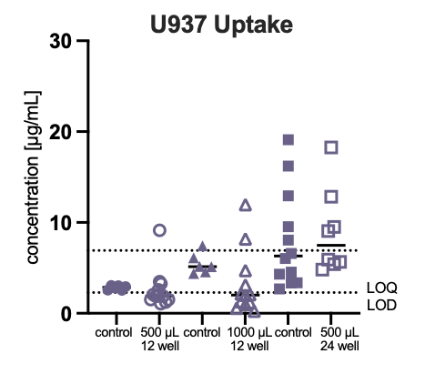
Figure S1. Cellular uptake assessed using a Tecan plate reader. Pilot experiments investigated the uptake of PET nanoplastics (5 % F8BT) in U937 cells at an administered dose of 50 µg/mL. Different well plate formats and exposure volumes were compared. Control wells were treated identically but without seeded cells to determine background signals and indicated particle adhesion to the well plate walls.

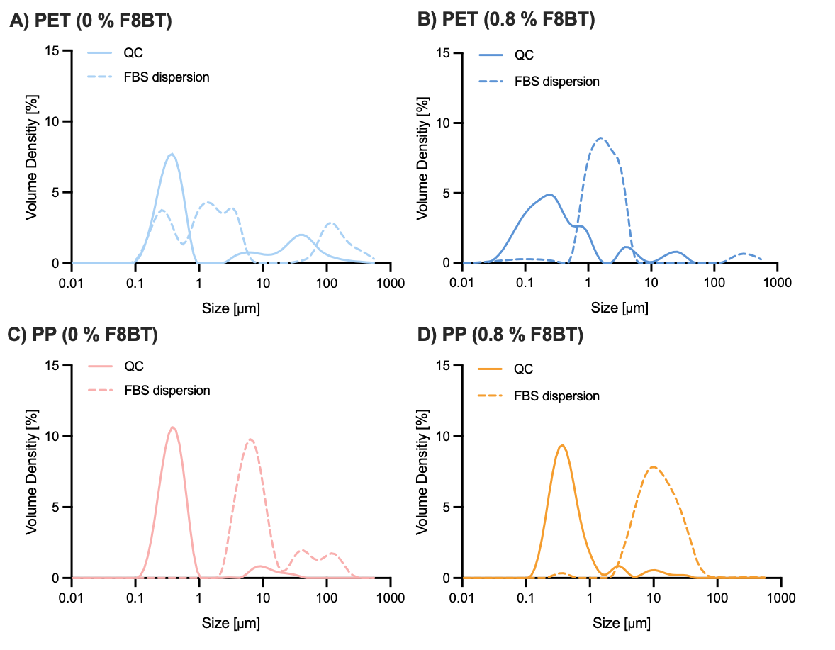
Figure S2. Particle size distributions of (A) unlabeled PET, (B) PET (0.8 % F8BT), (C) unlabeled PP, and (D) PP (0.8 % F8BT) obtained using a non-optimized biorelevant dispersion protocol with FBS as the dispersing agent.

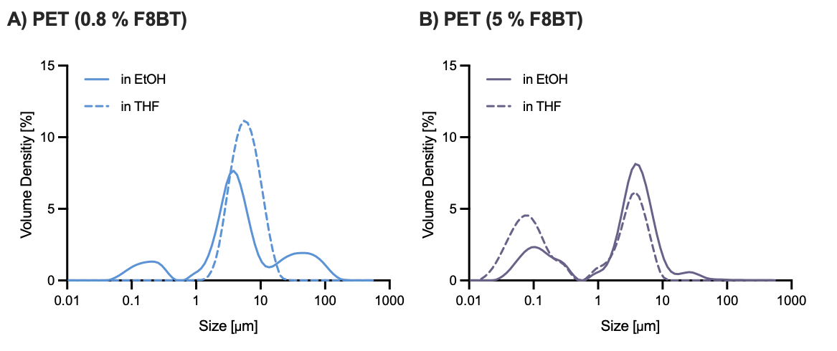
Figure S3. Particle size distribution curves after a washing step with THF to remove externally bound F8BT. (A) PET particles (0.8 % F8BT) and (B) PET particles (5 % F8BT).

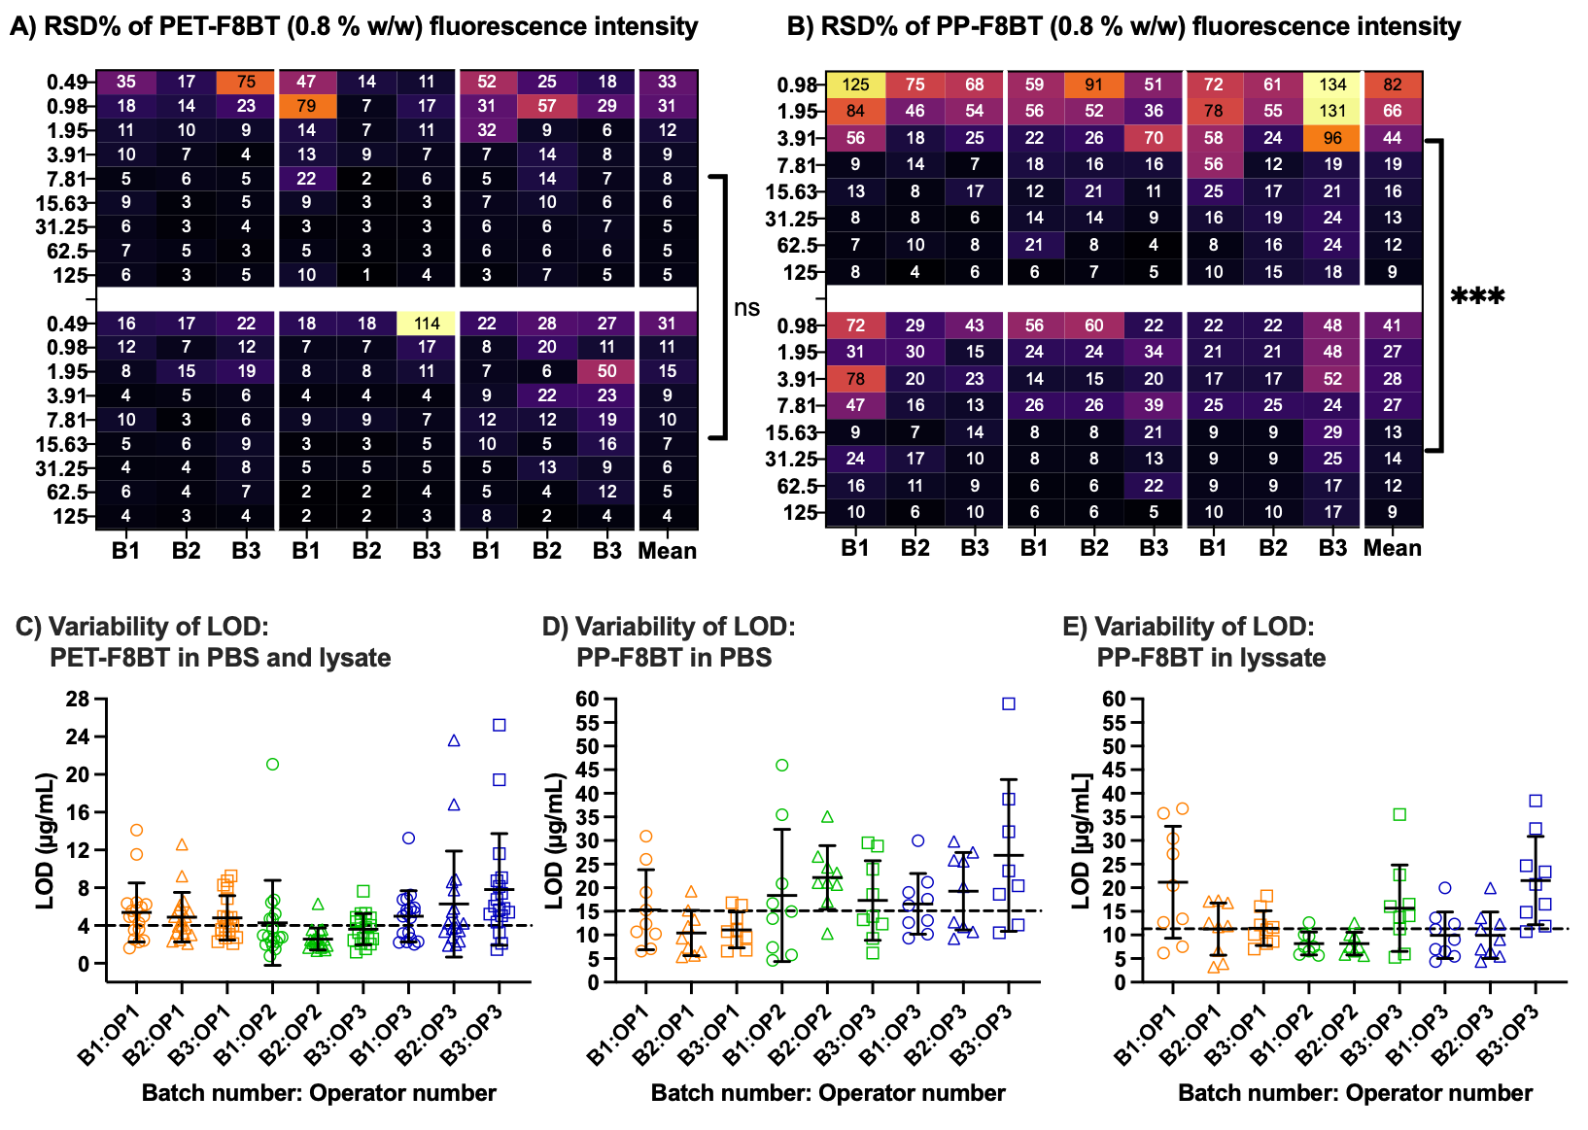Figure S4. Relative standard deviation (RSD%) of measured fluorescence values for (A) PET (0.8 % F8BT) and (B) PP (0.8 % F8BT) particles at each concentration of the serial dilution across multiple experimental replicates using a non-optimized biorelevant dispersion protocol with FBS. Evaluation of the LOD for (C) PET (0.8 % F8BT) using PBS and cell lysate as dispersing media, (D) PP (0.8 % F8BT) using PBS, and (E) PP (0.8 % F8BT) using cell lysate.

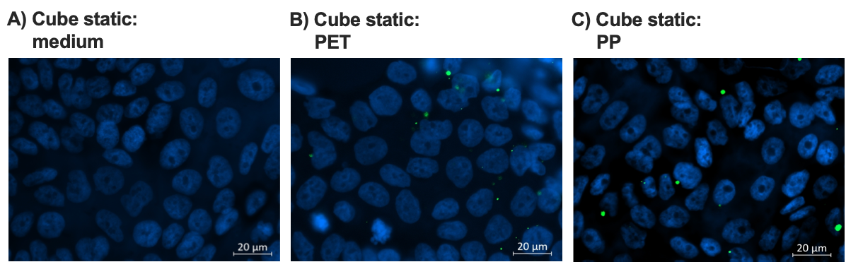
Figure S5. Fluorescence microscopy images of stained Calu-3 monolayers under static conditions (without magnetic stirring). (A) Untreated cells, (B) cells treated with PET (5 % F8BT), and (C) cells treated with PP (3 % F8BT).

PET-F8BT nanoprecipitation
Version date version
21/08/2024 2.0
PROJECT DETAILS
PROJECT ACRONYM | Project title
Imptox | An innovative analytical platform to investigate the effect and toxicity of micro and nano plastics combined with environmental contaminants on the risk of allergic disease in preclinical and clinical studies.
GRANT AGREEMENT NO: | Funding SCheme
965173 | H2020-EU.3.1.1. - Understanding health, wellbeing and disease  SC1-BHC-36-2020 - Micro- and nano-plastics in our environment: Understanding exposures and impacts on human health.
START DATE
01/04/2021

SOP DETAILS
principal contact/S
My Vanessa Nguyen Hoang (UniVie) <my.nguyen@univie.ac.at>
vERSION* | DATE | Authors | DESCRIPTION/ COMMENTS
1.0. | 18/08/2022 | Lukas Wimmer
1.1 | 10/10/2022 | Lukas Wimmer | Procedure updated; Section 3 added
1.2 | 27/03/2023 | Lukas Wimmer | More detail added to the procedure; Section 4 added
1.3 | 04/12/2023 | Johanne Szilvássy | Procedure update
1.4 | 25/06/2024 | Lukas Wimmer | All sections updated; “Notes” sections added; “Particle size measurement (Glycerol)” section added
2.0 | 21/08/2024 | My Vanessa Nguyen Hoang | Protocol adapted to including a fluorescently label

*XX.YY.
XX. first number : Major amendments: changes in the procedure or new procedure
YY. Second number: Minor amendments: improvements in the description of the procedures, with no changes in the procedures.

INTRODUCTION
This assay protocol is suitable for creating precipitated polyethylene terephthalate (PET) particles with a size range of 0.1-100 µm (initially) [1], [2]. The main fraction obtained with this method is between 0.1-1 µm. The quantities described correspond to a “double approach” and can be divided by two if less particles are needed. Particles can be dried and provided as a dry powder, kept as an ethanolic suspension, or transferred into glycerol. In the last case, best results are obtained when all steps are carried out on the same day.

SPECIFIC PROCEDURES

Precipitation

Materials
- PET (Polyethylene terephthalate, BAM)
- F8BT (poly(9,9-dioctylfluorene-alt-benzothiadiazole), average MN ≤ 25000, Sigma-Aldrich)
- EtOH (96 %, v/v)
- Benzyl alcohol (Sigma-Aldrich)
- Round bottom flask (100 mL)
- Metal spatula
- Scale pan
- Magnetic stir bar large (⌀: 1 cm, length: 6 cm)
- Magnetic stir bar small (⌀: 0.8 cm, length: 2.5 cm)
- Magnetic stir plate with temperature control for heating benzyl alcohol/PET (IKA® C-MAG HS 7)
- Magnetic stir plate for ice bath (VELP® AREX-6 DIGITAL PRO)
- Silicone bath
- Reflux condenser
- Beaker (250 mL: ⌀ 7 cm, height 9.5 cm)
- Glass pipette (25 mL)
- Aspirator (Peleus ball)
- Ice
- Plastic box for ice (1 L)
- Plastic grid from a cryo box

Step-by-step operating procedure
- Before starting the procedure, clean the workspace and wash all materials listed in 1.3 Notes
- Set the temperature controller of the magnetic stir plate for heating the silicone bath to 240°C (420 on the temperature wheel) for fast heating and stir at “setting 2” (corresponds to 250 rpm).
- Place the small magnetic stir bar into the round bottom flask.
- Weigh in 255 mg ± 5 mg of PET granules with a metal spatula into a scale pan, note the exact weight (A), and transfer them into the round bottom flask.
- Weigh the required amount of F8BT (according to the desired % w/w) directly into the round bottom flask and record the exact mass. (Example: For 5 % w/w, weigh 12.75 mg F8BT.)
- Transfer 10 mL of benzyl alcohol into the round bottom flask.
- When the temperature of the silicone bath reaches 195°C ± 10°C, connect the flask to the reflux condenser place it into the silicone bath, and turn on the water flow for the reflux condenser.
- Heat the silicone bath further to 240°C while stirring at “setting 2”.
- When 235°C ± 5°C is reached, set the temperature controller to 215°C and start the timer (45 min).
- After 15 min, the ice bath (ice cubes + little water) is prepared in a 1 L plastic box and placed onto the second magnetic stir plate (keep at RT).
- After 30 min, transfer the calculated amount of EtOH into the beaker (250 mL: ⌀ 7 cm, height 9.5 cm), add the large magnetic stir bar (⌀ 1 cm, length: 6 cm), and place the beaker into the ice bath for the last 15 min while stirred at 400 rpm.
- On top of the beaker, the grid from a cryo box (81 places) is mounted with tape. The spout of the beaker is positioned at place 57 and the top and left edges are touching the glass wall of the beaker (see Figure 1).
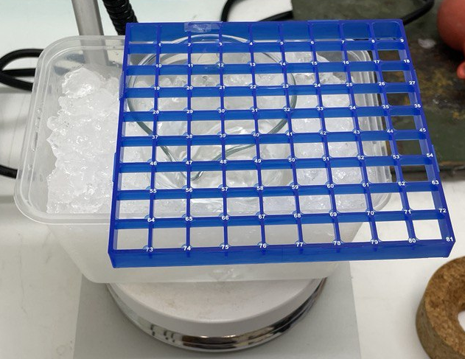
Figure 1: Placement of the plastic grid for positioning the glass pipette during precipitation. Blue rectangles show the position of the spout and glass walls of the beaker. The orange rectangle marks the position of the glass pipette.

- After 45 min of heating and when the temperature drops to 215°C ± 0.2 °C, disconnect the flask and start the precipitation immediately. Fast precipitation is key because small temperature changes have a tremendous influence on the particle size! If the temperature is not precisely at 215°C, adjust the temperature controller and wait until it is reached before precipitating.
- Aspire the entire hot benzyl alcohol/PET solution with the glass pipette (25 mL) and pipette it with maximum speed through the plastic grid at position 12 into the chilled EtOH.
- After the whole solution is transferred, let the suspension stir for 3 min until it cools down.
- Immediately rinse the round bottom flask and glass pipette with acetone, to avoid a plastic layer inside the glassware. Subsequently, sonicate until all residuals are removed.

Notes
The amount of EtOH needed is calculated according to the following formular:
$$EtOH \left(mL\right)= \frac{PETgranules \left(mg\right)-19.2}{1.92}$$
This formular is derived from the optimal concentration of PET for this procedure, which is 1.92 mg PET per mL mixture of EtOH+benzyl alcohol:
$$conc.PET \left({mg}/{mL}\right)=\frac{PETgranules \left(mg\right)}{EtOH\left(mL\right)+benzyl alcohol \left(mL\right)}$$

Washing

Materials
- EtOH (96 %, v/v)
- Pointed flask (50 mL, narrow neck)
- Filter (2 µm, PC membrane, Merck Millipore)
- Sonication bath (Sonocool, SC 255, Bandelin electronic)
- Glass filter holder set (VWR)
- Glass beaker (500 mL)
- 2 x glass vial (20 mL)
- Glass pipette (10 mL)
- Glass Pasteur pipette
- Aspirator
- Stainless steel spatula
- Stainless steel tweezer
- Parafilm

Step-by-step operating procedure
- Set up the rinsed glass filter holder as follows: Place a gasket (PTFE, older one with damaged edges) onto the glass filter holder of the filter set, put the metal mesh support on top, and a second gasket onto the support. In this way, particle loss between the filter and the glass funnel is avoided.
- Place the filter (2 µm, polycarbonate membrane) onto the metal support, wet it with a few drops of EtOH, and adjust it to avoid wrinkles.
- Put the second gasket onto the membrane and fixate the glass funnel with a clamp.
- Pour 40 mL of the suspension into the funnel and turn on the vacuum pump without connecting it to the filter flask. Carefully connect the vacuum pump and check if the filter system leakes and the filtrate is clear.
- Now, transfer the entire suspension from the beaker into the funnel. Rinse the magnetic stir bar and beaker with 5-10 mL twice using a Pasteur pipette and transfer the wash fluid into the funnel of the filtration system. Hold back the magnetic stir bar with a magnet and keep it inside the beaker.
- During filtration, use a small spatula to stir occasionally. Gently scrape the filter membrane with the spatula and crush clumps of PET on the glass wall.
- When the filtration process is almost completed, add 100 mL of fresh and clean EtOH. Particles on the membrane must never run dry. Keep them moist all the time or particles will form non-dispersible aggregates.
- Repeat steps 6) and 7) four times (washing 5 times in total).
- During the last filtration step, the particles must – again – stay moist but not too wet (if too wet, the suspension is lost when the funnel is disconnected from the filter holder).
- The obtained nano PET can either be dried and used as a powder or resuspended in EtOH for further processing.
- For resuspending, weigh a 50 mL pointed flask closed with a stopper and write down the weight (B).
- Wash the weighed flask with EtOH to remove fibers.
- Prepare two EtOH rinsed glass vials (20 mL) with 20 mL and 5 mL of EtOH. Use 20 mL for rinsing and transferring the particles and keep 1 mL to carry out step 20.
- Disassemble the filtration system carefully and transfer the membrane with a tweezer into the beaker.
- Check if particles are attached to the funnel and rinse it with 5-10 mL of EtOH or transfer them with a spatula, depending on the amount of particles attached to the glass.
- Gently shake the beaker to detach particles from the membrane. Thereafter, take the membrane on the edge with the tweezer and rinse both sides with EtOH.
- Sonicate the suspension in the beaker (10-20 sec) until all big PET clumps are dispersed well.
- Transfer the suspension into the pointed flask with the Pasteur pipette and seal it with parafilm.
- Vortex and sonicate until there are no more clumps visible (10-20 sec, multiple cycles).
- Remove the parafilm and rinse the walls of the flask with the remaining 1 mL of EtOH.
- To avoid particles sticking and drying at the top of the flask, close the flask with parafilm and pierce it.
- Sonicate the sample for 2 h at 22°C ± 1°C (Sonocool, SC 255, Bandelin electronic, intensity 100 %, 35 kHz). During sonication, the position of the flask is very important for the final particle size distribution. Place the flask at the spot of the highest energy transfer in the bath. Immerse the flask in the water bath until the liquid level of the suspension matches the one of the water bath. There must be no interruption during sonication.
- After sonication, remove the parafilm and wipe the outside of the flask.
- Close it with the pre-weighed stopper, weigh the flask, and note the weight (C).
- Calculate the amount of suspension by subtracting B from C and write it down (D).

Notes
To obtain a concentration of ~10 mg/mL suspension, 25 mL of EtOH is used for resuspending and washing. If more or less EtOH is used, the density of the suspension is different and has to be corrected before calculating the yield.

Particle size measurement (EtOH sample)

Materials
- MilliQ water
- Mastersizer 3000 (Malvern Panalytical Ltd.)
- Tween® 80 (SigmaAldrich)
- Beaker (150 mL)
- Stir bar
- Magnetic stirrer with temperature control
- Syringe (Braun, 20 mL)
- Syringe filter (0.22 µm, PVDF, Rotilabo)
- Vial (20 mL)
- Vial (4 mL)
- Sonication bath (Sonocool, SC 255, Bandelin electronic)

Step-by-step operating procedure
- To prepare a 5 % Tween®80 solution, weigh in 1 g of Tween®80 into a beaker and add 19 g of MilliQ water.
- Add a stir bar and stir until Tween® is fully dissolved. If needed, moderately heat the mixture to 30°C and cover the beaker with a watch glass.
- Aspirate the solution into a syringe and filter through a 0.22 µm syringe filter into a 20 mL vial.
- Directly after sonication (washing section, step 22), transfer 200 µL of the suspension into a clean vial (4 mL).
- Add 800 µL of the Tween®80 (5 %) solution and mix with the Eppendorf pipette until an evenly distributed suspension is obtained.
- Sonicate the mixture for 15 min at 22°C ± 1°C (Sonocool, SC 255, Bandelin electronic, intensity 100 %, 35 kHz).
- Fill the measurement cell with 5 mL MilliQ water and add 400 µL of Tween®80 solution (5 %).
- Set the stir speed to 1200 rpm.
- Start the background measurement.
- Add the sample in 50 µL increments until 3-4 % obscuration is reached.
- Perform the measurement.

Concentration determination

Materials
- Eppendorf tube (2 mL)
- Eppendorf piepette (1 mL)
- Rotary evaporator
- Adapter for rotary evaporator (NS 29/32)
- Parafilm

Step-by-step operating procedure
- Cut the lid off the Eppi, close the Eppi with the loose lid, and note the weight in the table below.
- Transfer 1 mL of the sonicated and vortexed sample into the Eppi, weigh it, and note the weight in the table below.
- Attach the Eppi to the rotary evaporator with parafilm and slowly dry it by starting at 250 mbar at 55°C. Slowly decrease the pressure to 80 mbar and bring the sample to dryness. When dry, apply the lowest possible pressure and let it dry for another 10 min.
- Weigh the dry Eppi with the dry powder inside and note the weight.

Eppi (g) | Eppi + Suspension (g) | Eppi dry (g) | Suspension in Eppi (g)
Weight of suspension = Eppi+suspension – Eppi

Weight of particles (mg) | Concentration (mg/g) | Amount of particles (mg) | Yield (%)
Weight of particles = (Eppi – Eppi dry) x 1000
Concentration = Weight of particles/Suspension in Eppi
Amount of particles = D x Concentration
Yield = Amount of particles x 100/A

- To produce a dry powder product (code: npPET-dp), dry the sample with a rotary evaporator (bath temperature: 55°C, slowly decreasing pressure from 250 to 50 mbar) and transfer the product into a clean glass vial.

Medium exchange to glycerol (npPET-gly)

Materials
- Polymer suspension in ethanol – 10 mg/mL
- Glycerol anhydrous for synthesis (Sigma-Aldrich)
- EtOH (96 %, v/v)
- Round bottom flask (50-100 mL)
- Spatula
- Pasteur glass pipette

Step-by-step operating procedure
- Heat glycerol in a water bath up to 60°C.
- Heat the water bath of the rotary evaporator to 50°C.
- Weigh an appropriately sized flask and note the weight (E).
- Transfer the ethanolic polymer suspension (10 mg/mL) into the flask and document the weight (F). The volume must not exceed 1/3 of the flasks volume.
- Calculate the needed amount of glycerol using the following equation:
$$\frac{Concentration of EtOH suspension \left(\frac{mg}{g}\right)×F \left(g\right)}{Wanted concentration of final glycerol suspension \left(\frac{mg}{g}\right)} \\ Geben Sie hier eine Formel ein.$$
- $Add the calculated amount of hot glycerol to the suspension and document the weight in (G).$
- Vortex the mixture immediately after glycerol is added until glycerol is mixed well with the EtOH suspension.
- Sonicate the sample for 1 min.
- Attach the flask to the rotary evaporator and put it into the water bath (50°C).
- Slowly and stepwise decrease the pressure (starting at 220 mbar) over a period of around 30 min, until 20-30 mbar are reached (bubbles and foam may form during this process).
- After 30 min at 10-20 mbar weigh the flask and note the weight.
- Start the evaporation of EtOH again and slowly reduce the pressure over 2 min to 10-20 mbar.
- Weigh the flask every 15 min and note the weight. If the sample weight difference of the last two measurements is less than 1 %, the evaporation process is assumed to be completed.

$$RSD (\%)=\frac{σ × 100}{x ̅}$$

σ = Standard deviation
x̅ = Mean

Time(point) | Sample weight (g) | Difference to last measurement (%)
 |  | -
Difference to last measurement = 100-Timepoint_{x+1}/Timepoint_{x} x 100

Notes
Best results are obtained when all steps - including the medium exchange - are carried out on the same day! At least 1 g of glycerol (40 mg of npPET) is needed. Lower amounts cannot be processed as described here and may lead to aggregated samples. Usually, concentrations of 10-40 mg/g glycerol suspension are used because they have the best handling properties. However, higher concentrations are possible but pipetting these highly concentrated suspensions can be challenging.

Particle size measurement (Glycerol sample)

Materials
- MilliQ water
- Mastersizer 3000 (Malvern Panalytical Ltd.)
- Tween® 80 solution (5 %)
- Beaker (150 mL)
- Stir bar
- Magnetic stirrer with temperature control
- Water bath
- Syringe (Braun, 20 mL)
- Syringe filter (0.22 µm, PVDF, Rotilabo)
- Vial (20 mL)
- Vial (4 mL)
- Sonication bath (Sonocool, SC 255, Bandelin electronic)

Step-by-step operating procedure
- Heat a water bath and sonication bath to 60°C and place the vial containing the glycerol suspension inside. Check that the vial is closed well and sealed.
- When 60°C are reached, heat for at least 2 min.
- Vortex the vial for 30 sec and heat it again for 2 min.
- Repeat step 3 twice.
- Sonicate the sample at 60°C for 3 min and repeat step 3 three more times.
- After homogenizing the glycerol stock, weigh in 25 mg ± 0.25 mg of the glycerol suspension (40 mg/g) into a clean vial (4 mL).
- Add 1000 µL of the Tween®80 (5 %) solution and mix with the Eppendorf pipette until an evenly distributed suspension is obtained.
- Sonicate the mixture for 15 min at 22°C ± 1°C (Sonocool, SC 255, Bandelin electronic, intensity 100 %, 35 kHz).
- Fill the measurement cell with 5 mL MilliQ water and add 400 µL of Tween®80 solution (5 %).
- Set the stir speed to 1200 rpm.
- Start the background measurement.
- Add the sample in 50 µL increments until 3-4 % obscuration is reached.
- Perform the measurement.

Notes
For the particle size distribution analysis of the glycerol stock, a 1 mg/mL suspension in Tween80 (5 %) is prepared.

REFERENCES
[1] D. S. Achilias, A. A. Giannoulis, A. G. Z. Papageorgiou, Á. A. Giannoulis, and G. Z. Papageorgiou, “Recycling of polymers from plastic packaging materials using the dissolution-reprecipitation technique,” Polym. Bull, vol. 63, pp. 449–465, 2009, doi: 10.1007/s00289-009-0104-5.
[2] W. S. Lee, H. Kim, Y. Sim, T. Kang, and J. Jeong, “Fluorescent Polypropylene Nanoplastics for Studying Uptake, Biodistribution, and Excretion in Zebrafish Embryos,” ACS Omega, vol. 7, no. 2, pp. 2467–2473, Jan. 2022, doi: 10.1021/acsomega.1c06779.

PP-F8BT nanoprecipitation
Version date version
20/08/2024 2.0
PROJECT DETAILS
PROJECT ACRONYM | Project title
Imptox | An innovative analytical platform to investigate the effect and toxicity of micro and nano plastics combined with environmental contaminants on the risk of allergic disease in preclinical and clinical studies.
GRANT AGREEMENT NO: | Funding Scheme
965173 | H2020-EU.3.1.1. - Understanding health, wellbeing and disease  SC1-BHC-36-2020 - Micro- and nano-plastics in our environment: Understanding exposures and impacts on human health.
START DATE
01/04/2021

SOP DETAILS
principal contact/S
My Vanessa Nguyen Hoang (UniVie) <my.nguyen@univie.ac.at>
vERSION* | DATE | Authors | DESCRIPTION/ COMMENTS
1.0. | 10/08/2022 | Itziar OA & Markus Falkenstätter
1.1 | 10/10/2022 | Lukas Wimmer | Procedure updated
1.2 | 28/03/2023 | Lukas Wimmer | Procedure updated
1.3 | 04/12/2023 | Johannes Szilvássy | Procedure updated
1.4 | 25/06/2024 | Lukas Wimmer | All sections updated; “Notes” sections added; “Particle size measurement (Glycerol)” section added
2.0 | 20/08/2024 | My Vanessa Nguyen Hoang | Protocol adapted to including a fluorescently label

*XX.YY.
XX. first number: Major amendments: changes in the procedure or new procedure
YY. Second number: Minor amendments: improvements in the description of the procedures, with no changes in the procedures.

INTRODUCTION
This assay protocol is suitable for creating precipitated PP particles with a size range of 0.1-100 µm (initially) [1], [2]. The main fraction obtained with this method is between 0.1-1 µm. Particles can be dried and provided as a dry powder, kept as an ethanolic suspension, or transferred into glycerol. In the last case, best results are obtained when all steps are carried out on the same day.

SPECIFIC PROCEDURES

Precipitation

Materials
- PP (Polypropylene, BAM)
- F8BT (poly(9,9-dioctylfluorene-alt-benzothiadiazole), average MN ≤ 25000, Sigma-Aldrich)
- EtOH (96 %, v/v)
- Xylene (Sigma-Aldrich)
- Metal spatula
- Round bottom flask (250 mL)
- Magnetic stir bar large (⌀: 1 cm, length: 6 cm)
- Magnetic stir bar small (⌀: 0.8 cm, length: 2.5 cm)
- Magnetic stir plate with temperature control for heating xylene/PP (IKA® C-MAG HS 7)
- Magnetic stir plate for ice bath (VELP® AREX-6 DIGITAL PRO)
- Silicone bath
- Reflux condenser
- Beaker (400 mL: ⌀ 7.5 cm, height 11 cm)
- Glass pipette (25 mL)
- Aspirator (Peleus ball)
- Ice
- Plastic box (1 L) for the ice
- Plastic grid from a cryo box

Step-by-step operating procedure
- Before starting the procedure, clean the workspace and wash all materials listed in 1.3 Notes
- Set the temperature controller of the magnetic stir plate for heating the silicone bath to 390°C (for fast heating) and stir at 250 rpm.
- Place the small magnetic stir bar into the round bottom flask.
- Weigh in 165 mg ± 3 mg of PP granules with a metal spatula into a scale pan, note the exact weight (A), and transfer them into the round bottom flask.
- Weigh the required amount of F8BT (according to the desired % w/w) directly into the round-bottom flask and record the exact mass. (Example: For 3 % w/w, weigh 4.95 mg F8BT.)
- Transfer 80 mL of xylene into the round bottom flask.
- Note the exact amount of xylene used in the toxic record book!
- When the temperature of the silicone bath reaches 185°C ± 10°C, connect the flask to the reflux condenser place it into the silicone bath, and turn on the water flow for the reflux condenser.
- Heat the silicone bath further to 210°C while stirring at 250 rpm.
- When 210°C is reached, set the temperature controller to 185°C and start the timer (45 min).
- After 15 min, the ice bath (ice cubes + little water) is prepared in a 1 L plastic box and placed onto the second magnetic stir plate (keep at RT).
- Transfer 240 mL of EtOH (96 %, v/v) into the beaker (400 mL: ⌀ 7.5 cm, height 11 cm), add the large magnetic stir bar (⌀ 1 cm, length: 6 cm), and place the beaker into the ice bath for the last 15 min and stir at 400 rpm.
- On top of the beaker, the grid from a cryo box (81 places) is mounted with tape. The spout of the beaker is positioned at place 57 and the top and left edges are touching the glass wall of the beaker (see Figure 1).
Figure 1: Placement of the plastic grid for positioning the glass pipette during precipitation. Blue rectangles show the position of the spout and glass walls of the beaker. The orange rectangle marks the position of the glass pipette.

- After 45 min of heating and when the temperature drops to 185°C ± 0.2 °C, disconnect the flask and start the precipitation immediately. Fast precipitation is key because small temperature changes have a tremendous influence on the particle size! If the temperature is not precisely at 185°C, adjust the temperature controller and wait until it is reached before precipitating.
- Aspire as much as possible of the hot xylene/PP solution with the glass pipette (25 mL) and pipette it with maximum speed through the plastic grid at position 12 into the chilled EtOH.
- After the whole solution is transferred, let the suspension stir for 3 min until it cools down.
- Immediately rinse the round bottom flask and glass pipette with acetone, to avoid a plastic layer inside the glassware. Subsequently, sonicate until all residuals are removed.

Washing

Materials
- EtOH (96 %, v/v)
- Pointed flask (50 mL, narrow neck)
- Filter (0.8 µm, nylon membrane filter, Cytiva, Whatman)
- Sonication bath (Sonocool, SC 255, Bandelin electronic)
- Glass filter holder set (VWR)
- Glass beaker (500 mL)
- 2 x glass vial (20 mL)
- Glass pipette (10 mL)
- Glass Pasteur pipette
- Aspirator
- Stainless steel spatula
- Stainless steel tweezer
- Parafilm

Step-by-step operating procedure
- Set up the rinsed glass filter holder as follows: Place a gasket (PTFE, older one with damaged edges) onto the glass filter holder of the filter set, put the metal mesh support on top, and a second gasket onto the support. In this way, particle loss between the filter and the glass funnel is avoided.
- Place the filter (0.8 µm, nylon membrane) onto the metal support, wet it with a few drops of EtOH, and adjust it to avoid wrinkles.
- Put the second gasket onto the membrane and fixate the glass funnel with a clamp.
- Pour 40 mL of the suspension into the funnel and turn on the vacuum pump without connecting it to the filter flask. Carefully connect the vacuum pump and check if the filter system is leaks and the filtrate is clear.
- Now, transfer the entire suspension from the beaker into the funnel. Rinse the magnetic stir bar and beaker with 5-10 mL twice using a Pasteur pipette and transfer the wash fluid into the funnel of the filtration system. Hold back the magnetic stir bar with a magnet and keep it inside the beaker.
- During filtration, use a small spatula to stir occasionally. Gently scrape the filter membrane with the spatula and crush clumps of PP on the glass wall.
- When the filtration process is almost completed, add 100 mL of fresh and clean EtOH. Particles on the membrane must never run dry. Keep them moist all the time or particles will form non-dispersible aggregates.
- Repeat steps 6) and 7) four times (washing 5 times in total).
- During the last filtration step, the particles must – again – stay moist but not too wet (if too wet, the suspension is lost when the funnel is disconnected from the filter holder).
- The obtained nano PP can either be dried and used as a powder or resuspended in EtOH for further processing.
- For resuspending, weigh a 50 mL pointed flask closed with a stopper and write down the weight (B).
- Wash the weighed flask with EtOH to remove fibers.
- Prepare two EtOH rinsed glass vials (20 mL) with 10 mL and 6 mL of EtOH. Use 15 mL for rinsing and transferring the particles and keep 1 mL to carry out step 20.
- Disassemble the filtration system carefully and transfer the membrane onto a flat and even glass plate.
- Gently crape off the particles from the membrane and transfer them into the beaker. Subsequently, wash the membrane with 2-4 mL of EtOH with a glass Pasteur pipette and collect the wash in the same beaker.
- Check if particles are attached to the funnel and rinse it with 5-10 mL of EtOH or transfer them with a spatula, depending on the amount of particles attached to the glass.
- Sonicate the suspension in the beaker (10-20 sec) until all big PP clumps are dispersed well.
- Transfer the suspension into the pointed flask with the Pasteur pipette and seal it with parafilm.
- Vortex and sonicate until there are no more clumps visible (10-20 sec, multiple cycles).
- Remove the parafilm and rinse the walls of the flask with the remaining 1 mL of EtOH.
- To avoid particles sticking and drying at the top of the flask, close the flask with parafilm and pierce it with a cannula.
- Sonicate the sample for 45 min at 21°C ± 1°C (Sonocool, SC 255, Bandelin electronic, intensity 100 %, 35 kHz). During sonication, the position of the flask is very important for the final particle size distribution. Place the flask at the spot of the highest energy transfer in the bath. Immerse the flask in the water bath until the liquid level of the suspension matches the one of the water bath. There must be no interruption during sonication.
- After sonication, remove the parafilm and wipe the outside of the flask.
- Close it with the pre-weighed stopper, weigh the flask, and note the weight (C).
- Calculate the amount of suspension by subtracting B from C and write it down (D).

Notes
To obtain a concentration of ~10 mg/mL suspension, 16 mL of EtOH is used for resuspending and washing. If more or less EtOH is used, the density of the suspension is different and has to be corrected before calculating the yield.

Particle size measurement (EtOH sample)

Materials
- MilliQ water
- Mastersizer 3000 (Malvern Panalytical Ltd.)
- Tween® 80 (SigmaAldrich)
- Beaker (150 mL)
- Stir bar
- Magnetic stirrer with temperature control
- Syringe (Braun, 20 mL)
- Syringe filter (0.22 µm, PVDF, Rotilabo)
- Vial (20 mL)
- Vial (4 mL)
- Sonication bath (Sonocool, SC 255, Bandelin electronic)

Step-by-step operating procedure
- To prepare a 5 % Tween®80 solution, weigh in 1 g of Tween®80 into a beaker and add 19 g of MilliQ water.
- Add a stir bar and stir until Tween® is fully dissolved. If needed, moderately heat the mixture to 30°C and cover the beaker with a watch glass.
- Aspirate the solution into a syringe and filter through a 0.22 µm syringe filter into a 20 mL vial.
- Directly after sonication (washing section, step 22), transfer 200 µL of the suspension into a clean vial (4 mL).
- Add 800 µL of the Tween®80 (5 %) solution and mix with the Eppendorf pipette until an evenly distributed suspension is obtained.
- Sonicate the mixture for 40 min at 21°C ± 1°C (Sonocool, SC 255, Bandelin electronic, intensity 100 %, 35 kHz).
- Fill the measurement cell with 5 mL MilliQ water and add 400 µL of Tween®80 solution (5 %).
- Set the stir speed to 1200 rpm.
- Start the background measurement.
- Add the sample in 50 µL increments until 3-4 % obscuration is reached.
- Perform the measurement.

Concentration determination

Materials
- Eppendorf tube (2 mL)
- Rotary evaporator
- Adapter for rotary evaporator (NS 29/32)
- Parafilm

Step-by-step operating procedure
- Cut the lid off the Eppi, close the Eppi with the loose lid, and note the weight in the table below.
- Transfer 1 mL of the sonicated and vortexed sample into the Eppi, weigh it, and note the weight in the table below.
- Attach the Eppi to the rotary evaporator with parafilm and slowly dry it by starting at 250 mbar at 55°C. Slowly decrease the pressure to 80 mbar and bring the sample to dryness. When dry, apply the lowest possible pressure and let it dry for another 10 min.
- Weigh the dry Eppi with the dry powder inside and note the weight.

Eppi (g) | Eppi + Suspension (g) | Eppi dry (g) | Suspension in Eppi (g)
Weight of suspension = Eppi+suspension – Eppi
Weight of particles (mg) | Concentration (mg/g) | Amount of particles (mg) | Yield (%)
Weight of particles = (Eppi – Eppi dry) x 1000
Concentration = Weight of particles/Suspension in Eppi
Amount of particles = D x Concentration
Yield = Amount of particles x 100/A

- To produce a dry powder product (code: npPP-dp), dry the sample with a rotary evaporator (bath temperature: 55°C, slowly decreasing pressure from 250 to 50 mbar) and transfer the product into a clean glass vial.

Medium exchange to glycerol (npPP-gly)

Materials
- Polymer suspension in ethanol – 10 mg/mL
- Glycerol anhydrous for synthesis (Sigma-Aldrich)
- EtOH (96 %, v/v)
- Round bottom flask (50-100 mL)
- Spatula
- Pasteur glass pipette

Step-by-step operating procedure
- Heat glycerol in a water bath up to 60°C.
- Heat the water bath of the rotary evaporator to 50°C.
- Weigh an appropriately sized flask and note the weight (E).
- Transfer the ethanolic polymer suspension (10 mg/mL) into the flask and document the weight (F). The volume must not exceed 1/3 of the flasks volume.
- Calculate the needed amount of glycerol using the following equation:
$$\frac{Concentration of EtOH suspension \left(\frac{mg}{g}\right)×F \left(g\right)}{Wanted concentration of final glycerol suspension \left(\frac{mg}{g}\right)}$$
- $Add the calculated amount of hot glycerol to the suspension and document the weight in (G).$
- Vortex the mixture immediately after glycerol is added until glycerol is mixed well with the EtOH suspension.
- Sonicate the sample for 1 min.
- Attach the flask to the rotary evaporator and put it into the water bath (50°C).
- Slowly and stepwise decrease the pressure (starting at 220 mbar) over a period of around 30 min, until 20-30 mbar are reached (bubbles and foam may form during this process).
- After 30 min at 10-20 mbar weigh the flask and note the weight.
- Start the evaporation of EtOH again and slowly reduce the pressure over 2 min to 10-20 mbar.
- Weigh the flask every 15 min and note the weight. If the sample weight difference of the last two measurements is less than 1 %, the evaporation process is assumed to be completed.

$$RSD (\%)=\frac{σ × 100}{x ̅}$$

σ = Standard deviation
x̅ = Mean

Time(point) | Sample weight (g) | Difference to last measurement (%)
 |  | -
Difference to last measurement = 100-Timepoint_{x+1}/Timepoint_{x} x 100

Notes
Best results are obtained when all steps - including the medium exchange - are carried out on the same day! At least 1 g of glycerol (40 mg of npPP) is needed. Lower amounts cannot be processed as described here and may lead to aggregated samples. Usually, concentrations of 10-40 mg/g glycerol suspension are used because they have the best handling properties. However, higher concentrations are possible but pipetting these highly concentrated suspensions can be challenging.

Particle size measurement (Glycerol sample)

Materials
- MilliQ water
- Mastersizer 3000 (Malvern Panalytical Ltd.)
- Tween® 80 solution (5 %)
- Stir bar
- Magnetic stirrer with temperature control
- Water bath
- Syringe (Braun, 20 mL)
- Syringe filter (0.22 µm, PVDF, Rotilabo
- Vial (20 mL)
- Vial (4 mL)
- Sonication bath (Sonocool, SC 255, Bandelin electronic)

Step-by-step operating procedure
- Heat a water bath and sonication bath to 60°C and place the vial containing the glycerol suspension inside. Check that the vial is closed well and sealed.
- When 60°C are reached, heat for at least 2 min.
- Vortex the vial for 30 sec and heat it again for 2 min.
- Repeat step 3 twice.
- Sonicate the sample at 60°C for 3 min and repeat step 3 three more times.
- After homogenizing the glycerol stock, weigh in 25 mg ± 0.25 mg of the glycerol suspension (40 mg/g) into a clean vial (4 mL).
- Add 1000 µL of the Tween®80 (5 %) solution and mix with the Eppendorf pipette until an evenly distributed suspension is obtained.
- Sonicate the mixture for 40 min at 21°C ± 1°C (Sonocool, SC 255, Bandelin electronic, intensity 100 %, 35 kHz).
- Fill the measurement cell with 5 mL MilliQ water and add 400 µL of Tween®80 solution (5 %).
- Set the stir speed to 1200 rpm.
- Start the background measurement.
- Add the sample in 50 µL increments until 3-4 % obscuration is reached.
- Perform the measurement.

Notes
For the particle size distribution analysis of the glycerol stock, a 1 mg/mL suspension in Tween80 (5 %) is prepared.

REFERENCES
[1] D. S. Achilias, A. A. Giannoulis, A. G. Z. Papageorgiou, Á. A. Giannoulis, and G. Z. Papageorgiou, “Recycling of polymers from plastic packaging materials using the dissolution-reprecipitation technique,” Polym. Bull, vol. 63, pp. 449–465, 2009, doi: 10.1007/s00289-009-0104-5.
[2] W. S. Lee, H. Kim, Y. Sim, T. Kang, and J. Jeong, “Fluorescent Polypropylene Nanoplastics for Studying Uptake, Biodistribution, and Excretion in Zebrafish Embryos,” ACS Omega, vol. 7, no. 2, pp. 2467–2473, Jan. 2022, doi: 10.1021/acsomega.1c06779.

Dispersion protocol
Version date version
21/08/2024 1.0
PROJECT DETAILS
PROJECT ACRONYM | Project title
Imptox | An innovative analytical platform to investigate the effect and toxicity of micro and nano plastics combined with environmental contaminants on the risk of allergic disease in preclinical and clinical
GRANT AGREEMENT NO: | Funding SCheme
965173 | H2020-EU.3.1.1. - Understanding health, wellbeing and disease  SC1-BHC-36-2020 - Micro- and nano-plastics in our environment: Understanding exposures and impacts on human health
START DATE
01/04/2021

SOP DETAILS
principal contact/S
My Vanessa Nguyen Hoang (UniVie) <my.nguyen@univie.ac.at>
vERSION* | DATE | Authors | DESCRIPTION/ COMMENTS
1.0 | 21/08/2024 | My Vanessa Nguyen Hoang | Biorelevant dispersion protocol using BSA

*XX.YY.
XX. first number : Major amendments: changes in the procedure or new procedure
YY. Second number: Minor amendments: improvements in the description of the procedures, with no changes in the procedures.

INTRODUCTION
For studies investigating biological endpoints such as cellular uptake, the use of Tween 80 as a dispersing agent may interfere with assay outcomes and is therefore not recommended. Instead, biorelevant dispersing agents were evaluated, including bovine serum albumin (BSA) and serum-supplemented cell culture medium (10 % FBS, 1 % penicillin/streptomycin)

SPECIFIC PROCEDURES

Biorelevant dispersion and size measurement

Materials
- Bovine serum albumin (Carl Roth)
- Dulbecco's modified eagle medium/nutrient mixture F-12 (DMEM/F-12) + GlutaMAX, trypsin-EDTA (0.25 %) (Gibco)
- Fetal bovine serum (FBS, Sigma-Aldrich)
- Penicillin/streptomycin (Gibco)
- MilliQ water
- Mastersizer 3000 (Malvern Panalytical Ltd.)
- Stir bar
- Magnetic stirrer with temperaure control
- Water bath
- Syringe (Braun, 20 mL)
- Syringe filter (0.45 µm, PVDF, Rotilabo)
- Vial (20 mL)
- Vial (4 mL)
- Sonication bath (Sonocool, SC 255, Bandelin electronic)

Step-by-step operating procedure
- Heat a water bath and sonication bath to 60°C and place the vial containing the glycerol suspension inside. Check that the vial is closed well and sealed.
- When 60 °C is reached, heat for at least 2 min.
- Vortex the vial for 30 sec and heat it again for 2 min.
- Repeat step 3 twice.
- Sonicate the sample at 60°C for 3 min and repeat step 3 three more times.
- After homogenizing the glycerol stock, weigh in 25 mg ± 0.25 mg of the glycerol suspension (40 mg/g) into a clean vial (4 mL).
- Add 1000 µL of BSA solution (10 % m/v in ultrapure water, filtered through a 0.45 µm PVDF membrane) and mix gently by pipetting with an Eppendorf pipette until a homogeneous suspension is obtained. This results in a nanoplastic concentration of 1 mg/mL (first dilution).
- Sonicate the mixture for 30 min at 21 °C ± 1 °C using a Sonocool SC 255 (Bandelin electronic; intensity 100 %, 35 kHz).
- Add serum-supplemented cell culture medium to reach the desired concentration for further studies. This second dilution is followed by an additional sonication step of 15 min for PET and 40 min for PP (due to its higher hydrophobicity) before further use.
- Fill the measurement cell with 5 mL of degassed serum-supplemented cell culture medium
- Set the stir speed to 1200 rpm.
- Start the background measurement.
- Add the sample in 50 µL increments until 3-4 % obscuration is reached.
- Perform the measurement.

Notes
The choice of dispersing agent may vary depending on the specific bioassay.

