Supporting information

Taurolithocholic acid alleviates hepatic glycolipid dysregulation in low birth weight piglets by activating HNF4α and FXR

Tianle Gao, Hairong Liang¹, Meizheng Li¹, Rui Zhou¹, Li Wang^{1,3}, Ran Li¹, Lingjie Huang¹, Yong Zhuo¹, Shengyu Xu¹, Yan Lin¹, Bin Feng¹, Jian Li¹, Hua Li¹, Lun Hua¹, Lianqiang Che¹, De Wu¹, Liang Hu¹*, Zhengfeng Fang^{1,2}*

Supplementary Material and Methods

Table S1. Ingredient and nutrient composition of experimental diets (%, as-fed basis).
Items | Gestation | Lactation
Ingredients%
Corn | 57.79 | 51.17
Wheat bran | 14.00 | 10.00
Rice bran | 8.00 | 4.00
Soybean meal | 11.00 | 15.45
Soybean hull | 5.06 | -
Soybean oil | 0.55 | 2.53
Soybean, heat-treated | - | 8.00
Fish meal Peru | - | 2.00
Sucrose | - | 2.00
Glucose | - | 2.00
L-lysine HCl（78.8%） | 0.16 | 0.13
DL-methionine (98%) | 0.04 | -
L-Threonine (98%) | 0.11 | 0.02
L-Tryptophan (98%) | 0.03 | -
L-Valine (99%) | - | 0.08
Dicalcium phosphate | 1.22 | 0.89
Limestone | 1.12 | 0.89
Sodium chloride | 0.40 | 0.40
Premixª | 0.52 | 0.44
Total | 100 | 100
Calculated analysis
DE, Mcal/kg | 12.77 | 14.24
ME, Mcal/kg | 11.87 | 13.13
Crude protein, % | 14.22 | 18.21
Calcium, % | 0.70 | 0.66
phosphorus, % | 0.81 | 0.71
ªThe premix (per kilogram of diet) provided the following: Gestation: Fe, 95mg; Cu, 46 mg; Zn, 100 mg; Mn, 54 mg and Se, 0.17 mg. vitamin A, 6000 IU; vitamin E, 50 IU; vitamin D₃, 1200 IU; vitamin K₃, 2.4 mg; vitamin B₁, 1 mg; vitamin B₂, 3.6 mg; vitamin B₆, 1.8 mg; vitamin B₁₂, 0.0125 mg; biotin, 0.24 mg; folic acid, 2 mg; niacin, 25 mg; pantothenic acid, 14 mg; preservative, 500 g; antioxidant, 200 g; mycotoxin adsorbent, 1000 g; and choline chloride (60%), 1300 g. Lactation: Fe, 100 mg; Cu, 25 mg; Zn, 125 mg; Mn, 35 mg; I, 0.2 mg; and Se, 0.3 mg. Vitamin A, 6000 IU; vitamin A, 50 IU; vitamin D₃, 1200 IU; vitamin K₃, 2.4 mg; vitamin B₁, 1 mg; vitamin B₁, 3.6 mg; vitamin B₆, 1.8 mg; vitamin B₁₂, 0.0125 mg; biotin, 0.24 mg; folic acid, 2 mg; niacin, 25 mg; pantothenic acid, 14 mg; preservative, 500 g; antioxidant, 200 g; mycotoxin adsorbent, 1000 g; and choline chloride (60%), 1000 g.

Table S2. Primer sequences of target and reference genes in pig study.
Gene | Primer sequence (5'-3')
Gene | forward | revese
BAAT | TCCCCATTGAAAAGGCCCAG | GTTCTGTGGCTTGTTGTGCG
FGF19 | TGAGTACCGTGGCGATCAAG | GCGGATCTCCTCCTCGAAAG
BESP | CGCAGCGTGAAGAAATGTGG | AAAACCGAAACAGTTGAAAGAGGC
CYP8B1 | GGAGCGACTTGGCTTTCTCT | GCAGGCGGAGGAGTTATTCA
HNF4α | GCTTCTTTCGGAGGAGTGTG | TTGACCTGCGAGTGCTGAT
FXR | TATGAACTCAGGCGAATGCCTGCT | ATCCAGATGCTCTGTCTCCGCAAA
CYP7A1 | GAAAGAGAGACCACATCTCGG | GAATGGTGTTGGCTTGCGAT
CYP27A1 | ACTGAAGACCGCGATGAAAC | CAAAGGCGAATCAGGAAGGG
CYP4A21 | TTTTCCCGCTTGAGGAGTGC | ACTCGGTCTGTGTGTTGATGGA
MRP2 | TGCAAGTACGGACCAGTGTC | AACGGTGTACTGCTTCCTGG
MRP3 | TGGACAAAGGGACAATAGCTGAGT | TGGCCATCCCGTAGAAGATG
OSTβ | GAAATCCAAAGACGCTGCCA | CCCTTAGGATGGTCAGGTTGT
OATP1 | TGACACTGGATCGGTGAACA | AGGAATGGCAGTGAGCACAT
SULT2A1 | CCATGCGAGACAAGGAGAAC | CATGACCTGGAAGGAGCTGT
SLC27A5 | CATTCAGTCCGCCTGGCTAT | AAGCCGACATTGCCTTCTGT
GYS2 | AATTCTGTGGGAAGCCCAGC | GCAGGGATTCAGAGCTGGTA
GCK | CCGACTTCCTGGACAAGCAT | ATCGTGGCCACAGTGTCATT
PFKL | ACTCCCTTCGACCGGAACTA | TGCTCAAAGTCGGTGTCCTA
PKLR | CCCACTGAAGTCACCGCTAT | GAGGAAGCCACGGAGTTTT
PYGL | ATCGGGGAGGACTACGTGAA | CTCGGAGGAAGACATCGTCG
G6PC | TGAACGTCTGTCTGTCACGA | ATACTTCTTGAGGCTGGCGT
PC | GGACTTCACTGCCACCTTTG | GCTCCACCTCAAACTCCTCT
GLUT2 | GGTTCATGGTGGCCGAGTT | ATTGCGGGTCCAGTTGC
HSL | AGTGCCTATGCTGGCGGGGA | CCCAGGCGGAGGTCTCGGAA
ATGL | GGCGGAACGGCCTCCTGAAC | TTGGCTCCGGCCCTCTCCTC
PPARγ | AAGACGGGGTCCTCATCTCC | CGCCAGGTCGCTGTCATCT
ACC | AGCAAGGTCGAGACCGAAAG | TAAGACCACCGGCGGATAGA
FAS | CTACGAGGCCATTGTGGACG | AGCCTATCATGCTGTAGCCC
SREBP-1c | AAGCGGACGGCTCACAATG | GCAAGACGGCGGATTTATTCA
CPT1α | GATTATCCACCAGCCAGACCC | CCCCACAATAATGTACGACACC
HMGCS2 | GGACCAAACAGACCTGGAGA | ATGGTCTCAGTGCCCACTTC
PPARα | GAGTTCGCCAAGTCCATCC | CCGTCCTTGTTCATCACAGAG
β-actin | CACCTTCTACAACGAGCTGC | TCATCTTCTCACGGTTGGCT

Table S3. Primer sequences of target and reference genes in Hepa 1-6 cell lines.

Gene | Primer sequence (5'-3')
Gene | forward | revese
HSL | TGGTGACACTCGCAGAAGAC | GATGGCAGGTGTGAACTGGA
GLUT2 | TGAGTTCCTTCCAGTTCGGC | ATTCCTGAGAACTGCTGGGC
GYS2 | TCCTCAGTACCACCTTCC | AGCCTCCTCTTCCTCATC
β-actin | GGAGATTACTGCCCTGGCTCCTA | GACTCATCGTACTCCTGCTTGCTG
SHP | CGATCCTCTTCAACCCAGATG | AGGGCTCCAAGACTTCACACA
CYP7A1 | AGCAACTAAACAACCTGCCAGT | ACTAGTCCGGATATTCAAGGATGCA
FXR | CGTGACTTGCGNCAAGTGACC | CCANGACATCAGCATCTCAGC
HNF4α | GGGCTGGCATGAAGAAGGAAGC | CCATGCCGAAGAGCTTGATGAAC
PPARα | GATGCACTGCTATGAGCACTT | AGAGGTCCACAGAGCTGATCC
ACC | GGGAATACCTGTGGGAGTAGT | GCTGGATTATCTTGGCTTCA
FAS | CATCCGGTCAGAGAGTACTTTT | TAGGGTTATGATGCTCTTCACC
CPT1 | TATGTGAGGATGCTGCTTCC | CTCGGAGAGCTAAGCTTGTC
PEPCK | TGCGGATCATGACTCGGATG | AGGCCCAGTTGTTGACCAAA

Table S4. Bile acid profile of liver tissue, nmol/g.
 | Group |  | P-value
 | NBW | LBW | P-value
C4 | 0.36 ± 0.03 | 0.42 ± 0.06 | 0.084
TwMCA | 0.43 ± 0.10 | 0.58 ± 0.34 | 0.377
TaMCA | 0.17 ± 0.05 | 0.21 ± 0.14 | 0.515
TbMCA | 0.38 ± 0.10 | 0.57 ± 0.46 | 0.377
THCA | 3.96 ± 1.80 | 4.01 ± 2.50 | 0.969
TCA | 3.11 ± 1.65 | 2.49 ± 0.70 | 0.460
THDCA | 23.12 ± 16.54 | 9.83 ± 7.09 | 0.130
TCDCA | 22.28 ± 14.10 | 10.37 ± 5.53 | 0.109
TDCA | 0.10 ± 0.06 | 0.07 ± 0.03 | 0.289
TLCA | 0.27 ± 0.13 | 0.06 ± 0.03 | 0.005
wMCA | 0.31 ± 0.12 | 0.32 ± 0.08 | 0.967
aMCA | 0.41 ± 0.13 | 0.42 ± 0.06 | 0.904
bMCA | 0.86 ± 0.50 | 0.85 ± 0.42 | 0.972
HCA | 0.11 ± 0.06 | 0.23 ± 0.16 | 0.150
AlloCA | 0.31 ± 0.14 | 0.32 ± 0.06 | 0.876
CA | 0.80 ± 0.42 | 1.07 ± 0.61 | 0.434
NorCA | 0.03 ± 0.00 | 0.03 ± 0.00 | 0.740
GHCA | 25.16 ± 10.38 | 35.71 ± 22.06 | 0.356
GCA | 5.14 ± 2.31 | 7.73 ± 2.19 | 0.099
GHDCA | 37.85 ± 22.52 | 27.49 ± 17.64 | 0.437
GCDCA | 24.66 ± 12.96 | 18.55 ± 8.53 | 0.399
GDCA | 0.27 ± 0.08 | 0.24 ± 0.06 | 0.545
GLCA | 0.28 ± 0.13 | 0.08 ± 0.03 | 0.010
muroCA | 0.74 ± 0.27 | 1.30 ± 0.57 | 0.079
bHDCA | 0.08 ± 0.03 | 0.10 ± 0.03 | 0.216
UDCA | 0.04 ± 0.02 | 0.04 ± 0.01 | 0.787
HDCA | 0.63 ± 0.29 | 1.15 ± 0.40 | 0.041
bDCA | 0.03 ± 0.02 | 0.03 ± 0.02 | 0.508
CDCA | 0.23 ± 0.10 | 0.37 ± 0.14 | 0.111
DCA | 1.78 ± 1.41 | 1.48 ± 0.77 | 0.684
NorDCA | 0.39 ± 0.05 | 0.40 ± 0.06 | 0.800
isoalloLCA | 0.03 ± 0.02 | 0.02 ± 0.01 | 0.676
isoLCA | 0.01 ± 0.01 | 0.01 ± 0.00 | 0.780
LCA | 0.11 ± 0.06 | 0.10 ± 0.03 | 0.687
LCA-3S | 0.45 ± 0.06 | 0.46 ± 0.06 | 0.765
dehydroLCA | 0.01 ± 0.00 | 0.01 ± 0.00 | 0.736
6-KetoLCA | 0.09 ± 0.03 | 0.12 ± 0.06 | 0.346
7-KetoLCA | 0.32 ± 0.04 | 0.33 ± 0.04 | 0.736
12-KetoLCA | 0.41 ± 0.11 | 0.39 ± 0.05 | 0.847
apoCA | 0.06 ± 0.01 | 0.06 ± 0.03 | 0.935
7-DHCA | 0.20 ± 0.16 | 0.19 ± 0.09 | 0.953
12-DHCA | 0.03 ± 0.01 | 0.03 ± 0.02 | 0.770
3-DHCA | 0.08 ± 0.01 | 0.08 ± 0.01 | 0.273
CA-3-S | 0.47 ± 0.20 | 0.43 ± 0.11 | 0.724
Sulfate-GCA | 0.14 ± 0.01 | 0.19 ± 0.02 | 0.001
Conjugated BAs | 147.32 ± 79.90 | 118.18 ± 63.20 | 0.537
Unconjugated BAs | 9.37 ± 3.77 | 10.74 ± 1.58 | 0.469
TBAs | 156.61±78.80 | 128.92±62.87 | 0.552

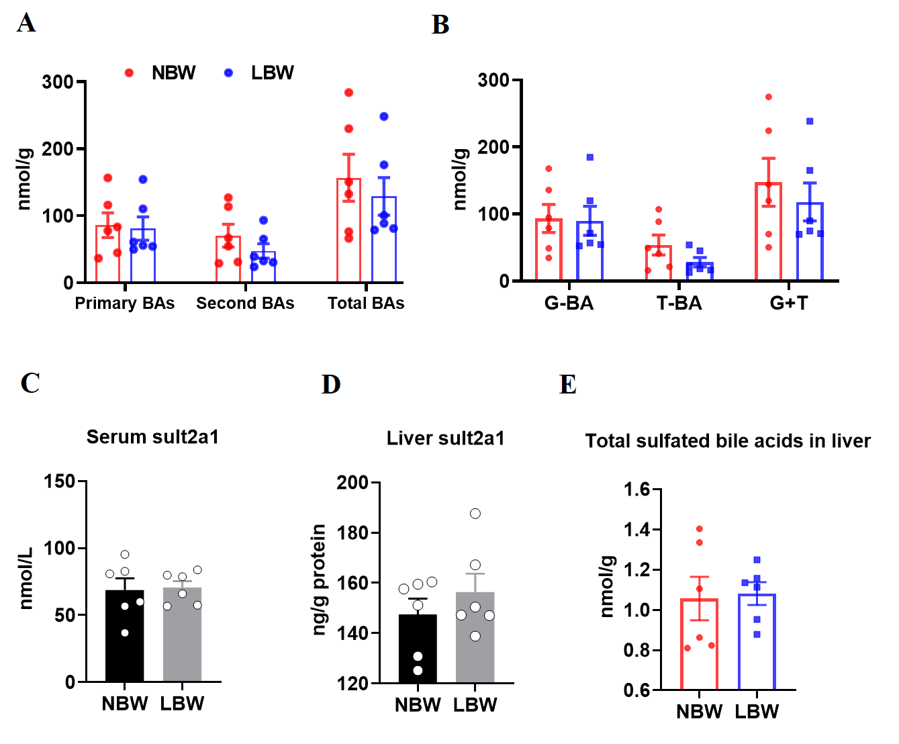

Fig. S1. LBW fetuses exhibit reduced hepatic glycogen stores and increased hepatic lipid accumulation. (A) Concentrations of primary BAs, secondary BAs, and TBAs in liver tissue. (B) Concentrations of primary BAs, secondary BAs, and TBAs in liver tissue. (C) Serum and liver sult2a1 Concentrations.

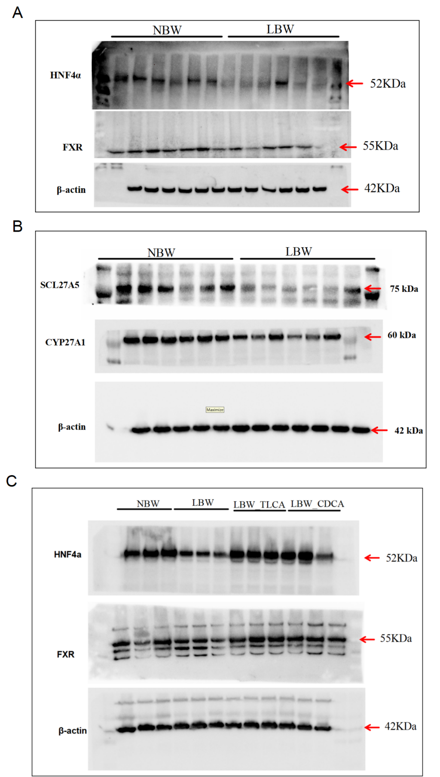

Fig. S2. Blots image in animal study. (A) Relative expression levels of FXR and HNF4α proteins normalized to β-actin in the liver tissue. (B) Protein expression levels of SLC27A5 and CYP27A1 normalized to β-actin in the liver. (C) Relative protein expression levels of FXR and HNF4α normalized to β-actin in the liver.
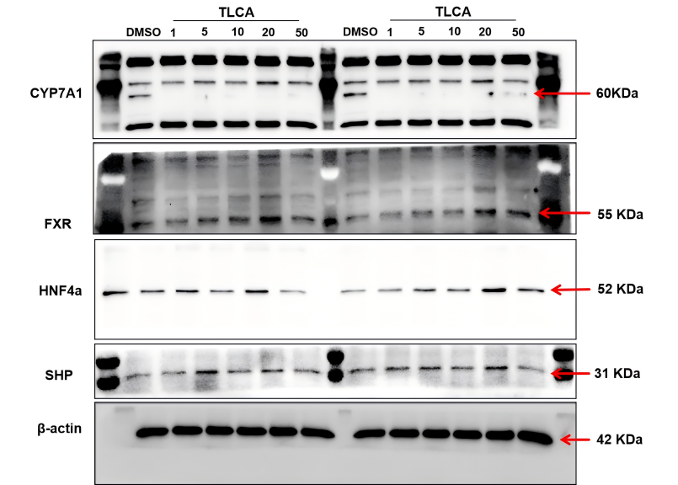

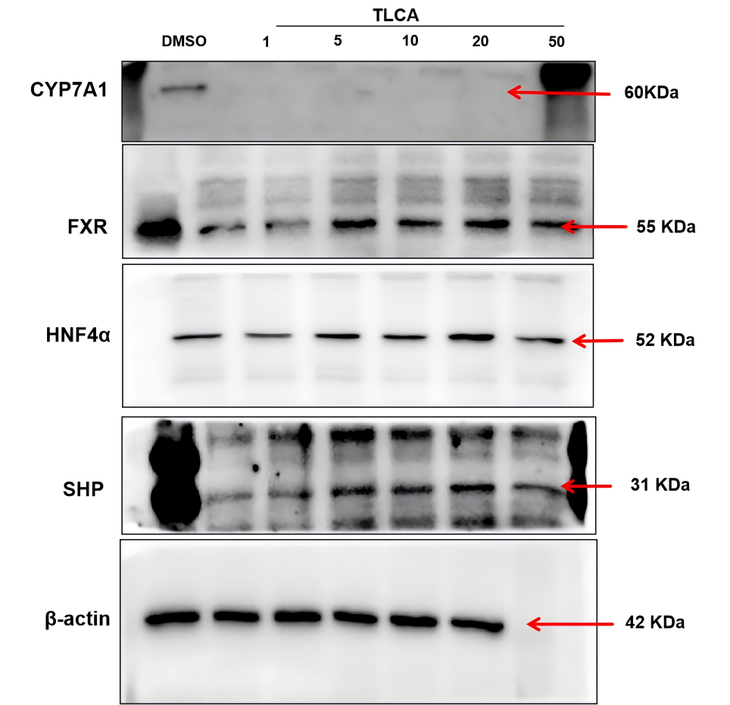

Fig. S3. Blots image in Hepa1-6 cells. Relative protein expression levels of CYP7A1, FXR, HNF4α, and SHP normalized to β-actin.

* Correspondence: ZFang@sicau.edu.cn (Z. F.); Tel: 0835-2882363; Fax: 0835-2882363 huliang@sicau.edu.cn；Tel: 0835-2882311 Key Laboratory for Animal Disease-Resistance Nutrition of China Ministry of Education, Animal Nutrition Institute, Sichuan Agricultural University, 211 Huimin Road, Wenjiang District, Chengdu, 611130, China; ² Key Laboratory of Agricultural Product Processing and Nutrition Health (Co-construction by Ministry and Province), Ministry of Agriculture and Rural Affairs, College of Food Science, Sichuan Agricultural University, Ya’ an 625014, China; ³ Dekon food and agriculture group, Chengdu, China

