Graphical abstract
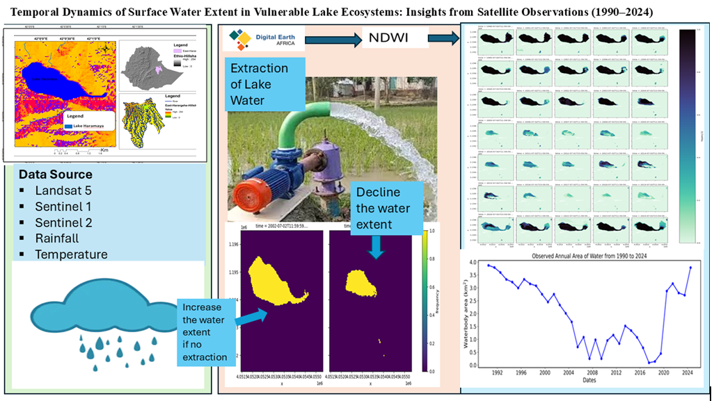
Graphical abstract Description
This study analysed the spatiotemporal dynamics of Lake Haramaya, eastern Ethiopia, from 1990 to 2024 using multi-temporal Landsat and Sentinel satellite imagery, processed on the Digital Earth Africa Open Data Cube platform using the Water Observations from Space (WOfS) model. The analysis employed the Modified Normalised Difference Water Index (MNDWI) to map changes in lake extent, supported by rainfall and temperature data from NASA and PERSIANN-CDR. Results revealed a drastic 87.5% decline in surface area from 3.77 km² in 1990 to 0.47 km² by 2020, showing a weak correlation with rainfall (r ≈ = -0.27) and indicating that unregulated water extraction, khat cultivation, and erosion were the primary drivers. Remarkably, the lake recovered to 2.73 km² by 2024 following integrated watershed management and conservation interventions, demonstrating that while human activities caused the lake’s collapse, targeted restoration and sustainable water resource governance can reverse ecosystem degradation and foster recovery.

