Graphical abstract
Suppressing lattice expansion via engineering oxygen vacancy into sub-5 nm NiO for durable methanol electrooxidation

Tao Chen,*^{1,2,4}, Zhiying Lyu³, Jiaxing Song*²

1 State Key Laboratory of Silicon and Advanced Semiconductor Materials, Department of Polymer Science and Engineering, Zhejiang University, Hangzhou 310027, PR China.
2 Zhejiang Key Laboratory of Advanced Tandem Photovoltaic Technology, College of Biological and Chemical Engineering, Jiaxing University, Jiaxing 314001, PR China.
3 RWTH International Academy, RWTH Aachen University, Aachen, 52074, Germany.
4 G60 STI Valley Industry & Innovation Institute Jiaxing University, Jiaxing 314001, PR China.

Corresponding Authors
E-mail: 0624528@zju.edu.cn; songjx@zjxu.edu.cn

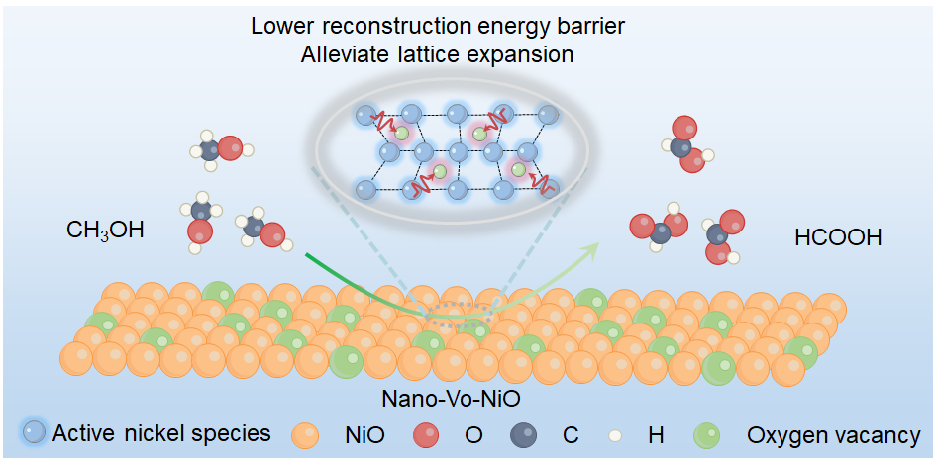
A sub-5 nm electrocatalyst (Nano-Vo-NiO) enables durable electrocatalytic methanol oxidation-assisted hydrogen production under industrial-level current densities by lowering the reconstruction potential and suppressing lattice expansion.

