Supplementary Information
Title: Structural and systems-level analysis of polyphenolic scaffold compatibility at immune checkpoint interfaces: a PD-L1 dimer–focused in silico study
Journal: Journal of Molecular Modeling
Author: Muhammad Rafif Pratama Putra Shanizal
Corresponding author: [Nama, afiliasi, email] Muhammad Rafif Pratama Putra Shanizal, Faculty of Medicine Universitas Gadjah Mada, muhammadrafifpratamaputrashanizal2005@mail.ugm.ac.id

Supplementary Methods
S1. Protein and ligand preparation
Protein preparation was performed using AutoDockTools v1.5.7. All crystallographic water molecules, ions, and non–small-molecule co-crystallized components were removed. Polar hydrogens were added, and partial atomic charges were assigned using the Gasteiger method. Protonation states were adjusted to approximate physiological pH (~7.4). Prepared receptor structures were saved in PDB format and subsequently converted to PDBQT format for docking.
Ligand structures were retrieved from PubChem in SDF format. Initial format conversion from SDF to PDB was performed using Open Babel v3.1.1. Geometry optimization was carried out in PyRx v0.8 using the MMFF94 force field and the steepest descent algorithm until convergence. Although numerical convergence thresholds were not explicitly recorded, all ligands reached minimized conformations. Optimized ligands were converted to PDBQT format for docking.
S2. Docking protocol and grid definition
An initial docking step was conducted to confirm ligand convergence toward a dominant cavity, followed by focused docking using a fixed grid derived from the primary cavity to ensure consistent and reproducible ligand placement.
For CTLA-4, the docking grid was defined using CB-Dock2 (2022 release), centered at (x = 13.6, y = 42.2, z = 49.9) with dimensions of 26 × 26 × 26 Å.
For the PD-L1 homodimer, the focused grid was positioned at the dimer-interface cavity identified by CB-Dock2 (2022 release), with the grid center set at (x = 15.108, y = −19.465, z = 180.177) and dimensions of 26 × 26 × 26 Å. This grid encompassed residues contributed by both protomers, preserving the structural features of the PD-L1 dimer interface.
S3. Docking reproducibility and validation
Pose reproducibility was evaluated by performing a minimum of two independent docking runs for each ligand–target pair using identical grid parameters and fixed random seeds. Reproducibility was assessed by calculating heavy-atom root-mean-square deviation (RMSD) between top-ranked docking poses (mode-1) obtained from independent runs. Internal RMSD clustering metrics reported by AutoDock Vina v1.2.3 (rmsd/lb and rmsd/ub) were used only for within-run pose clustering and were not interpreted as cross-run RMSD.
To provide an experimental structural reference for PD-L1 docking, a benchmark redocking procedure was performed using a co-crystallized small-molecule ligand reported to bind the PD-L1 dimer interface. The ligand was extracted from its crystal structure and redocked into the PD-L1 dimer using the same grid definition applied to the screened polyphenols. Structural similarity between crystallographic and redocked poses was evaluated using heavy-atom RMSD.
To evaluate the ability of the docking protocol to distinguish putative binders from non-binders, a decoy-based enrichment analysis was conducted. A decoy library consisting of physicochemically matched decoys was generated for selected representative ligands. Active ligands and decoys were docked using identical grid and scoring parameters. Docking scores were ranked, and enrichment factors were calculated based on the proportion of active ligands retrieved within the top-ranked fraction of the ranked list. This analysis was intended to assess non-random enrichment behavior rather than predictive accuracy of biological activity.
S4. Interaction analysis
Ligand–protein interactions were analyzed using Discovery Studio Visualizer. Two-dimensional interaction diagrams were generated to classify interaction types, while three-dimensional visualizations were used to assess binding orientation within the receptor pocket. Interactions were categorized as hydrogen bonds, π–π stacking, π–alkyl, π–cation, π–anion, and hydrophobic contacts. Hydrogen bonds were defined using a distance cutoff of ≤ 3.5 Å.
S5. Molecular dynamics system setup and equilibration
The PD-L1 dimer system was solvated using an explicit TIP3P water model in a cubic simulation box, maintaining a minimum distance of 1.0 nm between the protein surface and the box boundary. Sodium and chloride ions were added to neutralize the system and achieve a physiological ionic strength of 0.15 M.
Energy minimization was performed using the steepest descent algorithm until convergence below a maximum force threshold of 1000 kJ·mol⁻¹·nm⁻¹. The system was equilibrated under constant number, volume, and temperature (NVT) conditions for 500 ps, followed by constant number, pressure, and temperature (NPT) equilibration for 1 ns with position restraints applied to protein heavy atoms. Temperature was maintained at 300 K using the velocity-rescaling (V-rescale) thermostat, and pressure was controlled at 1 bar using the Parrinello–Rahman barostat.
S6. Molecular dynamics interface analysis
Inter-protomer interface stability was quantified by monitoring the number of intermolecular contacts between protomers A and B using a distance cutoff of 0.35 nm, as well as by calculating the minimum interfacial distance throughout the trajectory. Representative structural snapshots were extracted from the equilibrated trajectory at defined time points for visualization and structural comparison.
S7. Network analysis
Protein–protein interaction networks were constructed using STRING v12.0, restricted to Homo sapiens with a minimum confidence score of 0.4. Interaction sources included experimental evidence, curated databases, and co-expression data, while text-mining-derived associations were excluded. Only first-shell interactors were considered.
Network topology analysis was performed using STRING v12.0 and Cytoscape v3.10.4, with node degree used as the primary centrality metric. The ten nodes with the highest degree values were designated as hub genes, with CTLA-4 and PD-L1 retained as seed proteins.
Functional enrichment analysis was conducted using the STRING enrichment module, including Gene Ontology Biological Process, KEGG, and Reactome pathway analyses. The Homo sapiens genome was used as background, and multiple testing correction was applied using the Benjamini–Hochberg method with a false discovery rate threshold of < 0.05.
Network visualization was performed using Cytoscape v3.10.4 with the Prefuse Force Directed layout. Node size was scaled according to degree centrality, and seed proteins were highlighted using contrasting colors.
S8. Computational environment
Docking and network analyses were performed in January 2026 using a mixed Windows 11 and Ubuntu Linux workflow. Molecular dynamics simulations and trajectory analyses were conducted on Ubuntu Linux within a conda-based environment using GROMACS v2025.4 (conda-forge build) with thread_mpi support. Molecular docking was performed using AutoDock Vina v1.2.3 via PyRx v0.8, and receptor preparation was conducted with AutoDockTools v1.5.7. Ligand format conversion used Open Babel v3.1.1.
Target prediction was conducted using SwissTargetPrediction (database update 2023). Protein–protein interaction networks were generated using STRING v12.0, and network visualization and topology analysis were performed using Cytoscape v3.10.4 (Windows 11). Cavity detection was conducted using CB-Dock2 (2022 release). The Python environment used Python v3.13.2 with pip v25.3.
All molecular graphics were generated using PyMOL, and plots were prepared using Matplotlib and Microsoft Excel. Figures were exported in publication-ready electronic formats.
Supplementary Results
S1. Interaction profiling of CTLA-4–ligand complexes
Interaction profiling was performed for three representative ligands—gnetin C, quercetin, and resveratrol—selected based on docking rank and pose reproducibility. All three ligands occupied the same primary binding pocket of CTLA-4 as identified by cavity detection, exhibiting overlapping binding orientations.
Gnetin C formed a predominantly hydrophobic interaction network within the CTLA-4 pocket. Recurrent π–alkyl interactions were observed with LYS A:56 and LYS A:78, accompanied by a π–anion interaction with ASP A:34. Additional van der Waals contacts involved TYR A:57, ASP A:79, and GLN A:76, resulting in a dense local contact pattern in the top-ranked docking pose.
Quercetin displayed a more polar interaction profile. Conventional hydrogen bonds were detected with MET A:58 and TYR A:83, together with π–alkyl interactions involving ARG A:60 and LYS A:78 and a π–anion interaction with ASP A:79. Despite its lower docking affinity relative to gnetin C, quercetin adopted a comparable binding orientation within the same pocket.
Resveratrol engaged fewer total interactions, consistent with its weaker docking affinity. Hydrogen bonds were observed with GLU A:36 and TYR A:83, along with π–alkyl interactions involving LYS A:56 and LYS A:78 and a π–anion interaction with ASP A:34. The interacting residues largely overlapped with those observed for gnetin C and quercetin, indicating engagement of the same cavity rather than alternative-site binding.
Across all three ligands, LYS A:56, LYS A:78, ASP A:34, and ASP A:79 emerged as recurrent contact residues. Preservation of binding location and residue overlap supports comparative analysis of CTLA-4 interaction patterns among polyphenolic scaffolds.
S2. Docking robustness and validation at the PD-L1 dimer interface
Docking simulations against the PD-L1 homodimer were conducted using a focused grid positioned at the inter-protomer interface cavity. All screened ligands converged to the same interface pocket across independent docking runs, consistent with spatial overlap observed in benchmark redocking and docking pose distributions (Figure S1). This convergence supports a shared binding region rather than nonspecific surface association.
To benchmark the docking protocol against an experimental reference, a co-crystallized PD-L1 interface ligand was extracted and redocked using the same grid definition applied to the screened polyphenols. The redocked pose reproduced interface localization observed in the crystal structure, with heavy-atom RMSD values within the acceptable range for protein–protein interaction interfaces (Figure S4, Table S4).
Docking analyses yielded a reproducible rank order across independent runs. Gnetin C consistently ranked most favorably for the PD-L1 dimer interface pocket, followed by resveratrol and quercetin, while kaempferol, epigallocatechin gallate, and curcumin clustered in lower-ranked positions.
To assess docking robustness, representative ligands were re-docked using five independent random seeds while maintaining identical grid coordinates and docking parameters. Resveratrol and quercetin exhibited high stability across seeds, with standard deviations of 0.02 and 0.13 kcal/mol, respectively. Gnetin C showed moderately higher variability attributable to a single lower-energy pose.
To contextualize docking scores obtained for polyphenolic scaffolds, the benchmark PD-L1 interface ligand was redocked using the same scoring protocol. The benchmark ligand reproduced its crystallographic interface localization and exhibited docking scores within the same numerical range as gnetin C (Table 6), supporting use of a comparable docking scale.
All binding affinity values reported in Table 5 and Supplementary Table S3 were generated from the same PD-L1 dimer docking batch using identical grid parameters and exhaustiveness settings. Differences between mode-1 and mean binding energies reflect pose dispersion across generated docking modes rather than inconsistencies between docking runs.
Decoy-based enrichment analysis further supported docking robustness by demonstrating non-random score separation between active ligands and matched decoys (Figure S2). Accordingly, docking-derived rankings are reported solely to describe interface-level ligand accommodation and reproducibility rather than biological activity or immune checkpoint inhibition.
S3. Interaction profiling of PD-L1 dimer–ligand complexes
Interaction profiling was performed on docking poses whose placement was validated through benchmark redocking and decoy enrichment analyses (Figures S1 and S2). All three representative ligands occupied a conserved interaction hotspot at the PD-L1 dimer interface, engaging residues contributed by both protomers.
Key residues recurrently involved across complexes included Tyr56, Asp122, Ala121, and Met115. Gnetin C formed a dense interaction network spanning both PD-L1 chains, with electrostatic interactions involving Asp122, π–cation contacts with Lys124 and Arg125, π–π stacking with Tyr56, and hydrophobic contacts with Ala121 and Met115.
Quercetin exhibited a more compact interaction profile dominated by aromatic stacking with Tyr56 and polar contacts with Asp122 and Tyr123, supported by hydrophobic interactions with Ala121 and Met115. Despite fewer electrostatic interactions, quercetin adopted a centrally positioned orientation within the interface cavity.
Resveratrol engaged fewer stabilizing interactions within the same interface pocket, relying primarily on π–π stacking with Tyr56 and hydrophobic contacts with Ala121 and Met115. The presence of unfavorable donor–donor contacts near Tyr123 contributed to its reduced docking affinity relative to gnetin C and quercetin.
Across all complexes, recurrence of identical interface residues confirmed a shared binding mechanism at the PD-L1 dimer interface. Consistency between redocked benchmark ligands and screened polyphenols further supports the structural relevance of the selected PD-L1 interface cavity.
S4. Protein–protein interaction network characteristics
S4.1 CTLA-4–centered network
The CTLA-4–centered protein–protein interaction network comprised 11 nodes connected by 19 edges, exceeding the expected 10 edges for a random network of similar size. The average node degree was 3.45, and the average local clustering coefficient was 0.848. The PPI enrichment p-value was 0.00939, indicating statistically significant interaction enrichment.
CTLA-4 occupied the central hub position within the network. Several immunoglobulin heavy variable (IGHV) genes, including IGHV3-16 and IGHV3-43D, formed a tightly connected subcluster linked to CTLA-4. Additional interacting nodes included CD80, CD86, ICOS, and PTPN6, producing a star-like topology centered on the immune checkpoint protein.
S4.2 PD-L1–centered network
The PD-L1–centered network comprised 11 nodes and 21 edges, compared with an expected 11 edges, yielding a PPI enrichment p-value of 0.00357. The average node degree was 3.82, and the average local clustering coefficient was 0.853, reflecting dense network connectivity.
CD274 (PD-L1) emerged as the dominant hub, with direct interactions involving PDCD1, PDCD1LG2, CD80, STAT3, and PTPN11. A distinct subnetwork comprising COG1, COG3, and COG5 was also connected to the central node. Relative to the CTLA-4 network, the PD-L1 network exhibited higher edge density and a broader distribution of interactions beyond immediate immune checkpoint partners.
S4.3 Network topology overview
Both CTLA-4– and PD-L1–centered networks demonstrated statistically significant enrichment of protein–protein interactions. In each network, the immune checkpoint protein functioned as the dominant hub, with secondary clustering among immune-related signaling and immunoglobulin-associated proteins. These network characteristics provide a structured framework for functional enrichment analyses presented in the main manuscript.
Supplementary Table
Ligand | Mean docking score (kcal/mol) | SD
Gnetin C | −9.45 | 0.56
Quercetin | −7.77 | 0.13
Resveratrol | −8.48 | 0.02
Table S1. Multi-seed docking stability at the PD-L1 dimer interface.
Ligand | Docking context | Mode-1 docking score (kcal/mol) | Redocking RMSD (Å) | Interpretation
Benchmark PD-L1 ligand | PD-L1 dimer | −8.7 | 2.28 ± 0.11 | Experimental reference
Gnetin C | PD-L1 dimer | −8.4 | Not applicable | Comparable docking scale
Quercetin | PD-L1 dimer | −7.2 | Not applicable | Lower interface compatibility

Table S2. Comparative docking performance of benchmark PD-L1 interface ligand and representative polyphenolic scaffolds
Target | Ligand | Number of docking poses | Best binding energy (kcal/mol) | Mean binding energy (kcal/mol) | Dominant binding region | Notes
CTLA-4 | Gnetin C | 9 | −8.0 | −7.7 | Primary binding pocket | Highly reproducible pose across independent docking runs
CTLA-4 | Curcumin | 9 | −6.8 | −6.6 | Primary binding pocket | Moderate binding consistency
CTLA-4 | EGCG | 9 | −6.7 | −6.5 | Primary binding pocket | Moderate pose convergence
CTLA-4 | Resveratrol | 9 | −6.3 | −6.2 | Primary binding pocket | Reproducible top-ranked pose
CTLA-4 | Quercetin | 9 | −6.1 | −6.0 | Primary binding pocket | Reproducible pose, lowest affinity
CTLA-4 | Kaempferol | 9 | −6.1 | −6.0 | Primary binding pocket | Limited interaction density
PD-L1 dimer | Gnetin C | 9 | −8.4 | −8.1 | Dimer interface pocket | Interface-spanning top-ranked pose
PD-L1 dimer | Resveratrol | 9 | −7.5 | −7.2 | Dimer interface pocket | Improved ranking relative to monomer docking
PD-L1 dimer | Quercetin | 9 | −7.2 | −6.9 | Dimer interface pocket | Consistent interface occupancy
PD-L1 dimer | Curcumin | 9 | −6.8 | −6.6 | Surface-adjacent region | Reduced interface retention
PD-L1 dimer | EGCG | 9 | −6.6 | −6.4 | Surface-adjacent region | Variable docking poses
PD-L1 dimer | Kaempferol | 9 | −6.4 | −6.2 | Surface-adjacent region | Highest pose variability across generated modes
Table S3. Comprehensive docking results of screened polyphenols against CTLA-4 and PD-L1.
Docking run | RMSD (Å) | Interpretation
Seed 202601 | 2.200 | Acceptable pose recovery
Seed 202602 | 2.357 | Acceptable pose recovery
Mean ± SD | 2.28 ± 0.11 | Within PPI docking tolerance
Table S4. Heavy-atom RMSD between crystallographic and redocked PD-L1 interface ligand poses. RMSD values within 2–3 Å were considered acceptable for shallow protein–protein interaction interfaces.
Top fraction | Top N | Actives retrieved | Hit rate | Enrichment factor
1% | 2 | 0 | 0.00 | 0.0
5% | 8 | 1 | 0.125 | 6.38
10% | 16 | 1 | 0.0625 | 3.19
Table S5. Enrichment statistics for active ligands relative to decoys across ranked docking scores.
Ligand | Target | Run1 vs Run2 RMSD (Å)
Gnetin C | PD-L1 | 2.20
Gnetin C | PD-L1 | 2.36
Table S6. Cross-run heavy-atom RMSD between top-ranked docking poses, demonstrating reproducible ligand placement across independent docking runs.
Parameter | Value
Mean inter-protomer contacts | 62.7
Minimum distance (nm) | 0.173 ± 0.012
Mean hydrogen bonds | 3.0
Table S7. Summary of PD-L1 dimer molecular dynamics metrics
Ligand | Target protein | Gene symbol | Target class | Probability
Gnetin C | Estrogen receptor alpha | ESR1 | Nuclear receptor | 0.65
Gnetin C | Estrogen receptor beta | ESR2 | Nuclear receptor | 0.63
Gnetin C | Cyclooxygenase-2 | PTGS2 | Enzyme | 0.56
Gnetin C | Tyrosine-protein kinase Src | SRC | Kinase | 0.44
Gnetin C | Nitric oxide synthase, inducible | NOS2 | Enzyme | 0.41
Gnetin C | Androgen receptor | AR | Nuclear receptor | 0.39
Gnetin C | MAP kinase ERK2 | MAPK1 | Kinase | 0.36
Gnetin C | Estrogen-related receptor gamma | ESRRG | Nuclear receptor | 0.34
Gnetin C | Proto-oncogene tyrosine-protein kinase Fyn | FYN | Kinase | 0.31
Gnetin C | PI3-kinase catalytic subunit alpha | PIK3CA | Kinase | 0.29
Quercetin | Cyclooxygenase-2 | PTGS2 | Enzyme | 0.68
Quercetin | Estrogen receptor alpha | ESR1 | Nuclear receptor | 0.61
Quercetin | Estrogen receptor beta | ESR2 | Nuclear receptor | 0.59
Quercetin | Tyrosine-protein kinase Src | SRC | Kinase | 0.47
Quercetin | MAP kinase ERK2 | MAPK1 | Kinase | 0.45
Quercetin | Androgen receptor | AR | Nuclear receptor | 0.41
Quercetin | PI3-kinase catalytic subunit alpha | PIK3CA | Kinase | 0.38
Quercetin | Nitric oxide synthase, inducible | NOS2 | Enzyme | 0.36
Quercetin | Protein kinase C alpha | PRKCA | Kinase | 0.33
Quercetin | Estrogen-related receptor gamma | ESRRG | Nuclear receptor | 0.31
Resveratrol | Estrogen receptor alpha | ESR1 | Nuclear receptor | 0.72
Resveratrol | Estrogen receptor beta | ESR2 | Nuclear receptor | 0.69
Resveratrol | Androgen receptor | AR | Nuclear receptor | 0.58
Resveratrol | Cyclooxygenase-2 | PTGS2 | Enzyme | 0.52
Resveratrol | Sirtuin 1 | SIRT1 | Enzyme | 0.49
Resveratrol | MAP kinase ERK2 | MAPK1 | Kinase | 0.44
Resveratrol | Tyrosine-protein kinase Src | SRC | Kinase | 0.42
Resveratrol | PI3-kinase catalytic subunit alpha | PIK3CA | Kinase | 0.39
Resveratrol | Estrogen-related receptor gamma | ESRRG | Nuclear receptor | 0.37
Resveratrol | Protein kinase C alpha | PRKCA | Kinase | 0.35
Table S8. Predicted molecular targets of gnetin C, quercetin, and resveratrol derived from SwissTargetPrediction, including probability scores and target classes.
Database | Enriched term / pathway | Gene count | FDR | −log10(FDR) | Associated genes
GO BP | Regulation of lymphocyte activation | 9 | 4.52E-09 | 8.344861565 | CD80,ICOS,CD86,PTPN6,LOC102723407,IGHV3-16,IGHV3-43D,LOC102723996,CTLA4
GO BP | Positive regulation of lymphocyte activation | 8 | 9.82E-09 | 8.007888512 | CD80,ICOS,CD86,PTPN6,LOC102723407,IGHV3-16,IGHV3-43D,LOC102723996
GO BP | Immune response | 10 | 4.42E-08 | 7.354577731 | CD80,ICOS,CD86,LCN2,PTPN6,LOC102723407,IGHV3-16,IGHV3-43D,LOC102723996,CTLA4
GO BP | Positive regulation of immune system process | 9 | 5.55E-08 | 7.255707017 | CD80,ICOS,CD86,PTPN6,LOC102723407,IGHV3-16,IGHV3-43D,LOC102723996,CTLA4
GO BP | T cell costimulation | 5 | 5.55E-08 | 7.255707017 | CD80,ICOS,CD86,PTPN6,LOC102723996
GO BP | Positive regulation of immune response | 8 | 5.55E-08 | 7.255707017 | CD80,CD86,PTPN6,LOC102723407,IGHV3-16,IGHV3-43D,LOC102723996,CTLA4
GO BP | B cell receptor signaling pathway | 5 | 8.37E-08 | 7.077274542 | PTPN6,LOC102723407,IGHV3-16,IGHV3-43D,CTLA4
GO BP | Antigen receptor-mediated signaling pathway | 6 | 8.39E-08 | 7.076238039 | PTPN6,LOC102723407,IGHV3-16,IGHV3-43D,LOC102723996,CTLA4
GO BP | Negative regulation of T cell proliferation | 5 | 4.93E-07 | 6.307153081 | CD80,CD86,PTPN6,LOC102723996,CTLA4
GO BP | Regulation of B cell activation | 5 | 5.21E-06 | 5.283162277 | PTPN6,LOC102723407,IGHV3-16,IGHV3-43D,CTLA4
GO BP | Response to bacterium | 7 | 8.06E-06 | 5.093664958 | CD80,CD86,LCN2,LOC102723407,IGHV3-16,IGHV3-43D,LOC102723996
GO BP | Adaptive immune response | 6 | 8.65E-06 | 5.062983893 | CD86,LOC102723407,IGHV3-16,IGHV3-43D,LOC102723996,CTLA4
GO BP | Regulation of leukocyte cell-cell adhesion | 6 | 9.67E-06 | 5.014573526 | CD80,ICOS,CD86,PTPN6,LOC102723996,CTLA4
GO BP | Regulation of T cell activation | 6 | 1.03E-05 | 4.987162775 | CD80,ICOS,CD86,PTPN6,LOC102723996,CTLA4
GO BP | Response to other organism | 8 | 2.54E-05 | 4.595166283 | CD80,CD86,LCN2,PTPN6,LOC102723407,IGHV3-16,IGHV3-43D,LOC102723996
GO BP | Phagocytosis, recognition | 3 | 0.00015 | 3.823908741 | LOC102723407,IGHV3-16,IGHV3-43D
GO BP | Lymphocyte mediated immunity | 4 | 0.00044 | 3.356547324 | PTPN6,LOC102723407,IGHV3-16,IGHV3-43D
GO BP | Complement activation, classical pathway | 3 | 0.00048 | 3.318758763 | LOC102723407,IGHV3-16,IGHV3-43D
GO BP | Cell surface receptor signaling pathway | 8 | 0.00048 | 3.318758763 | CD80,CD86,PTPN6,LOC102723407,IGHV3-16,IGHV3-43D,LOC102723996,CTLA4
GO BP | Phagocytosis, engulfment | 3 | 0.00085 | 3.070581074 | LOC102723407,IGHV3-16,IGHV3-43D
GO BP | Regulation of lymphocyte differentiation | 4 | 0.0011 | 2.958607315 | CD80,CD86,PTPN6,CTLA4
GO BP | Positive regulation of B cell activation | 3 | 0.0041 | 2.387216143 | LOC102723407,IGHV3-16,IGHV3-43D
GO BP | Defense response to bacterium | 4 | 0.0042 | 2.37675071 | LCN2,LOC102723407,IGHV3-16,IGHV3-43D
GO BP | T cell receptor signaling pathway | 3 | 0.0053 | 2.27572413 | PTPN6,LOC102723996,CTLA4
GO BP | Positive regulation of T cell proliferation | 3 | 0.006 | 2.22184875 | CD80,CD86,LOC102723996
GO BP | Innate immune response | 5 | 0.0067 | 2.173925197 | LCN2,PTPN6,LOC102723407,IGHV3-16,IGHV3-43D
GO BP | Defense response | 6 | 0.0089 | 2.050609993 | LCN2,PTPN6,LOC102723407,IGHV3-16,IGHV3-43D,LOC102723996
GO BP | Positive regulation of biological process | 10 | 0.0147 | 1.832682665 | CD80,ICOS,CD86,LCN2,PTPN6,LOC102723407,IGHV3-16,IGHV3-43D,LOC102723996,CTLA4
GO BP | Positive regulation of T-helper cell differentiation | 2 | 0.0148 | 1.829738285 | CD80,CD86
GO BP | Regulation of T cell differentiation | 3 | 0.0215 | 1.66756154 | CD80,CD86,CTLA4
GO BP | Cellular response to lipopolysaccharide | 3 | 0.0277 | 1.557520231 | CD80,CD86,LOC102723996
GO BP | Positive regulation of interleukin-2 production | 2 | 0.0339 | 1.469800302 | CD80,CD86
KEGG | Intestinal immune network for IgA production | 5 | 1.06E-08 | 7.974694135 | CD80,ICOS,CD86,LOC102723407,LOC102723996
KEGG | Cell adhesion molecules | 5 | 1.40E-06 | 5.853871964 | CD80,ICOS,CD86,LOC102723996,CTLA4
KEGG | Autoimmune thyroid disease | 4 | 1.57E-06 | 5.804100348 | CD80,CD86,LOC102723407,CTLA4
KEGG | Rheumatoid arthritis | 4 | 9.59E-06 | 5.018181393 | CD80,CD86,LOC102723407,CTLA4
KEGG | Allograft rejection | 3 | 6.68E-05 | 4.175223538 | CD80,CD86,LOC102723407
KEGG | Viral myocarditis | 3 | 0.00022 | 3.657577319 | CD80,CD86,LOC102723407
KEGG | Systemic lupus erythematosus | 3 | 0.00089 | 3.050609993 | CD80,CD86,LOC102723407
KEGG | T cell receptor signaling pathway | 3 | 0.00093 | 3.031517051 | ICOS,PTPN6,CTLA4
KEGG | Type I diabetes mellitus | 2 | 0.0074 | 2.13076828 | CD80,CD86
KEGG | Graft-versus-host disease | 2 | 0.0074 | 2.13076828 | CD80,CD86
KEGG | Primary immunodeficiency | 2 | 0.0074 | 2.13076828 | ICOS,LOC102723407
KEGG | Leishmaniasis | 2 | 0.0193 | 1.714442691 | PTPN6,LOC102723407
KEGG | B cell receptor signaling pathway | 2 | 0.0226 | 1.645891561 | PTPN6,LOC102723407
KEGG | Toll-like receptor signaling pathway | 2 | 0.034 | 1.468521083 | CD80,CD86
KEGG | Natural killer cell mediated cytotoxicity | 2 | 0.0451 | 1.345823458 | PTPN6,LOC102723407
Reactome | Costimulation by the CD28 family | 6 | 2.00E-09 | 8.698970004 | CD80,ICOS,CD86,PTPN6,LOC102723996,CTLA4
Reactome | CTLA4 inhibitory signaling | 3 | 0.0003 | 3.522878745 | CD80,CD86,CTLA4
Reactome | Constitutive Signaling by Aberrant PI3K in Cancer | 3 | 0.0061 | 2.214670165 | CD80,ICOS,CD86
Reactome | Immune System | 7 | 0.0109 | 1.962573502 | CD80,ICOS,CD86,LCN2,PTPN6,LOC102723996,CTLA4
Reactome | CD28 dependent Vav1 pathway | 2 | 0.0109 | 1.962573502 | CD80,CD86
Reactome | PI5P, PP2A and IER3 Regulate PI3K/AKT Signaling | 3 | 0.0109 | 1.962573502 | CD80,ICOS,CD86
Reactome | CD28 dependent PI3K/Akt signaling | 2 | 0.0177 | 1.752026734 | CD80,CD86
Reactome | Signaling by Interleukins | 4 | 0.0177 | 1.752026734 | CD80,CD86,LCN2,PTPN6
Table S9. Complete list of enriched Gene Ontology Biological Process terms, KEGG pathways, and Reactome pathways for the CTLA-4–centered network.
Database | Enriched term / pathway | Gene count | FDR | −log10(FDR) | Associated genes
GO BP | T cell costimulation | 4 | 0.00013 | 3.886056648 | CD80,CD274,PDCD1LG2,PTPN11
GO BP | Retrograde transport, vesicle recycling within Golgi | 3 | 0.00015 | 3.823908741 | COG3,COG5,COG1
GO BP | Positive regulation of lymphocyte activation | 5 | 0.0025 | 2.602059991 | CD80,CD274,PDCD1LG2,IGHV3-43D,PTPN11
GO BP | Adaptive immune response | 5 | 0.0028 | 2.552841969 | STAT3,PDCD1,CD274,PDCD1LG2,IGHV3-43D
GO BP | Regulation of immune system process | 7 | 0.005 | 2.301029996 | CD80,STAT3,PDCD1,CD274,PDCD1LG2,IGHV3-43D,PTPN11
GO BP | Regulation of interleukin-10 production | 3 | 0.0075 | 2.124938737 | STAT3,CD274,PDCD1LG2
GO BP | Negative regulation of T cell proliferation | 3 | 0.0116 | 1.935542011 | CD80,CD274,PDCD1LG2
GO BP | Negative regulation of cell adhesion | 4 | 0.0143 | 1.844663963 | CD80,CD274,PDCD1LG2,PTPN11
GO BP | Regulation of cytokine production | 5 | 0.0198 | 1.70333481 | CD80,STAT3,CD274,PDCD1LG2,PTPN11
GO BP | Positive regulation of T cell proliferation | 3 | 0.0198 | 1.70333481 | CD80,CD274,PDCD1LG2
GO BP | Immune response | 6 | 0.0207 | 1.684029655 | CD80,STAT3,PDCD1,CD274,PDCD1LG2,IGHV3-43D
GO BP | Immune system process | 7 | 0.0233 | 1.632644079 | CD80,STAT3,PDCD1,CD274,PDCD1LG2,IGHV3-43D,PTPN11
GO BP | Negative regulation of activated T cell proliferation | 2 | 0.0233 | 1.632644079 | CD274,PDCD1LG2
GO BP | Positive regulation of T cell apoptotic process | 2 | 0.0233 | 1.632644079 | PDCD1,CD274
GO BP | Regulation of immune response | 5 | 0.0276 | 1.559090918 | CD80,PDCD1,CD274,IGHV3-43D,PTPN11
GO BP | Regulation of tolerance induction | 2 | 0.0297 | 1.527243551 | PDCD1,CD274
GO BP | Negative regulation of immune system process | 4 | 0.0297 | 1.527243551 | CD80,PDCD1,CD274,PDCD1LG2
GO BP | Golgi organization | 3 | 0.0297 | 1.527243551 | COG3,COG5,COG1
GO BP | Negative regulation of interleukin-10 production | 2 | 0.0297 | 1.527243551 | CD274,PDCD1LG2
GO BP | Positive regulation of cytokine production | 4 | 0.0373 | 1.428291168 | CD80,STAT3,CD274,PTPN11
GO BP | Regulation of tumor necrosis factor superfamily cytokine production | 3 | 0.0373 | 1.428291168 | STAT3,CD274,PTPN11
GO BP | Cellular response to lipopolysaccharide | 3 | 0.049 | 1.30980392 | CD80,CD274,PDCD1LG2
KEGG | PD-L1 expression and PD-1 checkpoint pathway in cancer | 4 | 4.60E-05 | 4.337242168 | STAT3,PDCD1,CD274,PTPN11
KEGG | Cell adhesion molecules | 4 | 0.00014 | 3.853871964 | CD80,PDCD1,CD274,PDCD1LG2
Reactome | Costimulation by the CD28 family | 5 | 5.45E-07 | 6.263603498 | CD80,PDCD1,CD274,PDCD1LG2,PTPN11
Reactome | PD-1 signaling | 4 | 6.33E-07 | 6.19859629 | PDCD1,CD274,PDCD1LG2,PTPN11
Reactome | Intra-Golgi traffic | 3 | 0.0015 | 2.823908741 | COG3,COG5,COG1
Reactome | Retrograde transport at the Trans-Golgi-Network | 3 | 0.0016 | 2.795880017 | COG3,COG5,COG1
Reactome | Interleukin-6 signaling | 2 | 0.0085 | 2.070581074 | STAT3,PTPN11
Reactome | Signaling by Leptin | 2 | 0.0085 | 2.070581074 | STAT3,PTPN11
Reactome | COPI-mediated anterograde transport | 3 | 0.0085 | 2.070581074 | COG3,COG5,COG1
Reactome | STAT3 nuclear events downstream of ALK signaling | 2 | 0.0085 | 2.070581074 | STAT3,CD274
Reactome | CTLA4 inhibitory signaling | 2 | 0.0163 | 1.787812396 | CD80,PTPN11
Reactome | Interleukin-20 family signaling | 2 | 0.0163 | 1.787812396 | STAT3,PTPN11
Reactome | Interleukin-37 signaling | 2 | 0.0163 | 1.787812396 | STAT3,PTPN11
Reactome | Downstream signal transduction | 2 | 0.0186 | 1.730487056 | STAT3,PTPN11
Reactome | Signaling by CSF3 (G-CSF) | 2 | 0.0186 | 1.730487056 | STAT3,PTPN11
Reactome | Signaling by CSF1 (M-CSF) in myeloid cells | 2 | 0.0186 | 1.730487056 | STAT3,PTPN11
Reactome | Signaling by SCF-KIT | 2 | 0.0301 | 1.521433504 | STAT3,PTPN11
Reactome | Immune System | 6 | 0.0313 | 1.504455662 | CD80,STAT3,PDCD1,CD274,PDCD1LG2,PTPN11
Reactome | Interleukin-10 signaling | 2 | 0.0313 | 1.504455662 | CD80,STAT3
Table S10. Complete list of enriched Gene Ontology Biological Process terms, KEGG pathways, and Reactome pathways for the PD-L1–centered network.
Window (ns) | H-bonds (mean ± SD) | Min distance (nm) (mean ± SD) | Contacts (mean ± SD)
0–10 | 2.98 ± 1.10 | 0.173 ± 0.012 | 63.0 ± 10.7
10–20 | 4.00 | 0.155 | 64.0
Table S11. Window-based summary of inter-protomer interface metrics across the 10-ns simulation trajectory.
Supplementary Figure
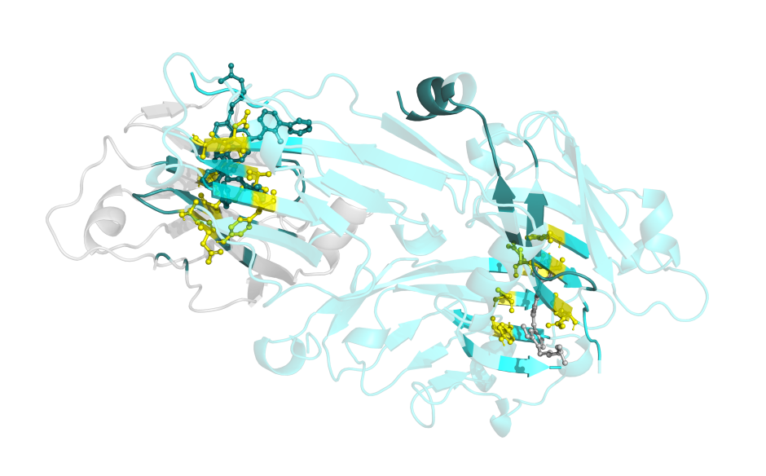
Figure S1. Benchmark redocking of a co-crystallized small-molecule ligand at the PD-L1 dimer interface. The crystallographic ligand pose (gray) and the redocked pose (colored) show close spatial overlap within the inter-protomer interface pocket. Key interface residues are shown for structural reference. This result supports the suitability of the selected grid and docking protocol for PD-L1 interface-focused docking.
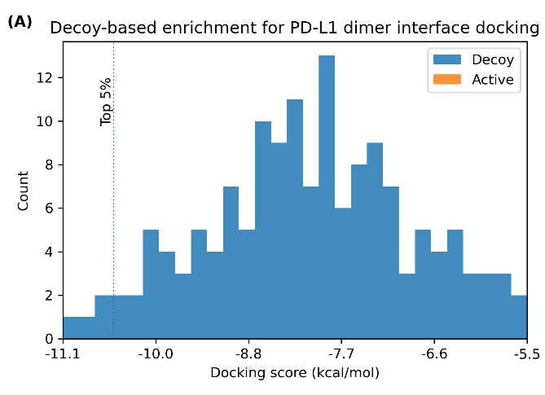
Figure S2. Docking scores of physicochemically matched decoy compounds and selected polyphenolic actives are shown as score distributions. Actives correspond to gnetin C, quercetin, and resveratrol. The dashed vertical line indicates the top 5 percent ranked fraction based on docking score. One active compound was recovered within the top 5 percent, corresponding to an enrichment factor of approximately 6.4, indicating non-random ranking behavior of the docking protocol at the PD-L1 dimer interface.
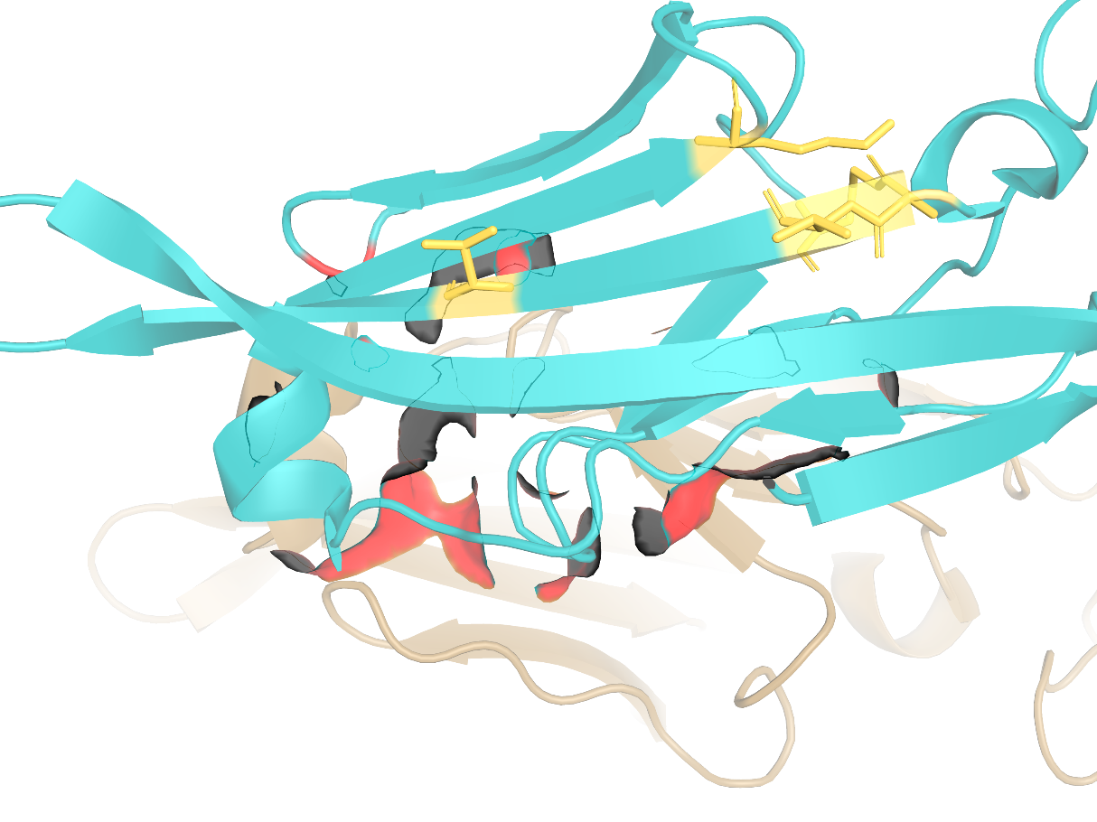
Figure S3. Structural mapping of the predicted CTLA-4 docking site relative to the physiological B7-1 binding interface. The docking cavity is adjacent to, but not fully overlapping with, the B7-1 interaction surface, supporting classification as an interface-compatible exploratory site.

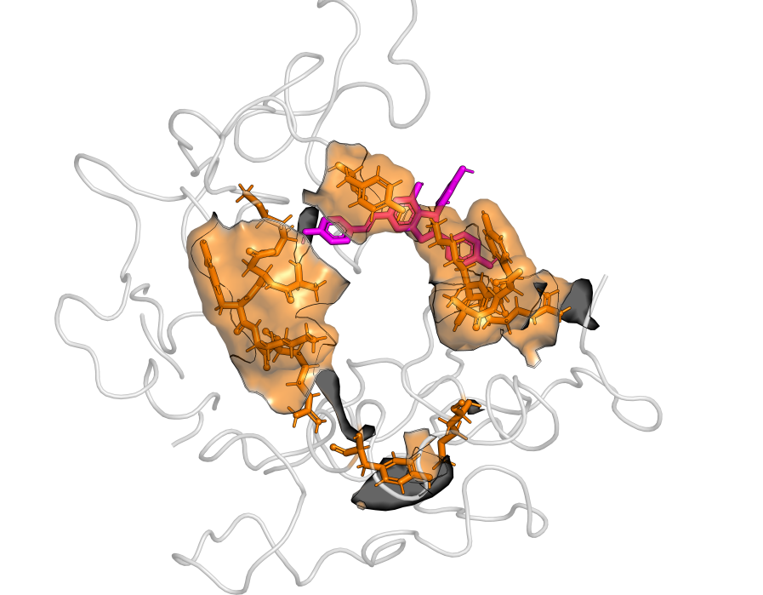
Figure S4. Illustrative structural overlay of the docking-predicted ligand pose with a representative molecular dynamics snapshot of the PD-L1 dimer. The MD-derived PD-L1 structure is shown as a semi-transparent cartoon (gray), with interface residues highlighted as orange sticks. The docking-predicted ligand pose is shown as magenta sticks. This overlay is intended for qualitative structural context and is not intended for quantitative RMSD or stability assessment.
Figure S5. Distribution of predicted target protein classes for representative polyphenols based on SwissTargetPrediction output.
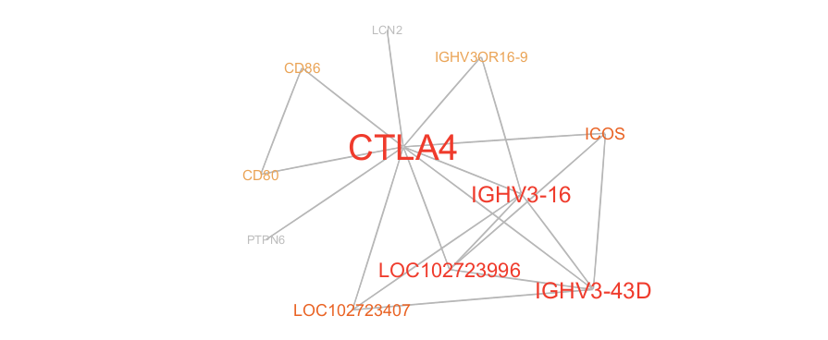
Figure S6. Protein–protein interaction network centered on CTLA-4 constructed using STRING. Nodes represent predicted targets and seed proteins, while edges denote high-confidence protein–protein interactions. Node size reflects node degree, and edges represent experimentally supported, curated database, and co-expression interactions.
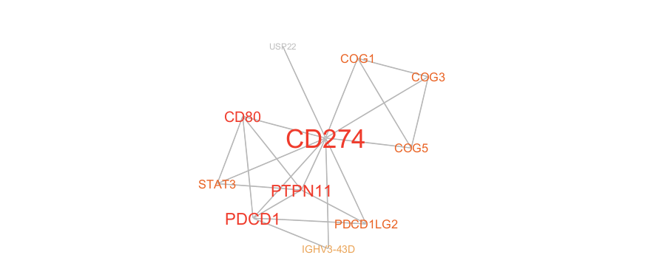
Figure S7. Protein–protein interaction network centered on PD-L1 (CD274). Nodes represent predicted targets and seed proteins, while edges denote high-confidence protein–protein interactions. Node size reflects node degree, and edges represent experimentally supported, curated database, and co-expression interactions.

Figure S8. Functional enrichment of the CTLA-4–centered network showing Gene Ontology Biological Process terms (A), KEGG pathways (B), and Reactome pathways (C). Bubble size corresponds to gene count, and −log10(FDR) indicates enrichment significance.

Figure S9. Functional enrichment of the PD-L1–centered network showing Gene Ontology Biological Process terms (A), KEGG pathways (B), and Reactome pathways (C). Bubble size corresponds to gene count, and −log10(FDR) indicates enrichment significance.

