SUPPLEMENTARY MATERIALS

Evaluating the relevance of sequence conservation
in the prediction of pathogenic missense variants

Emidio Capriotti ¹* and Piero Fariselli ²*

¹ BioFold Unit, Department of Pharmacy and Biotechnology (FaBiT), University of Bologna,
Via F. Selmi 3, 40126 Bologna, Italy.
² Department of Medical Sciences, University of Torino,
Via Santena 19, 10126, Torino, Italy.

Contacts: emidio.capriotti@unibo.it, piero.fariselli@unito.it

Performance measures for binary classifiers

For each prediction, the binary classification (Pathogenic/Benign) is made at the threshold t. Thus, if a selected score foc Pathogenic classification is >t the variant is predicted to be Pathogenic. For single feature-based predictors the classification threshold is optimized on the CommonClinvar dataset (Table S2) while for the gradient boosting algorithm the output threshold is set to 0.5. For CADD a raw score threshold of 3,1 was used to calculate the performance.
In all the performance measures - assuming that positives indicate Pathogenic and negatives indicate Benign - TP (true positives) are correctly predicted Pathogenic Single Nucleotide Variants (SNVs), TN (true negatives) are correctly predicted Benign variants, FP (false positives) Benign SNVs annotated as Pathogenic, and FN (false negatives) are Pathogenic variants predicted to be Benign. Predictor performance was evaluated using the following metrics: true positive and negative rates (TPR, TNR), positive and negative predicted values (PPV, NPV), F1 score and overall accuracy (Q₂)
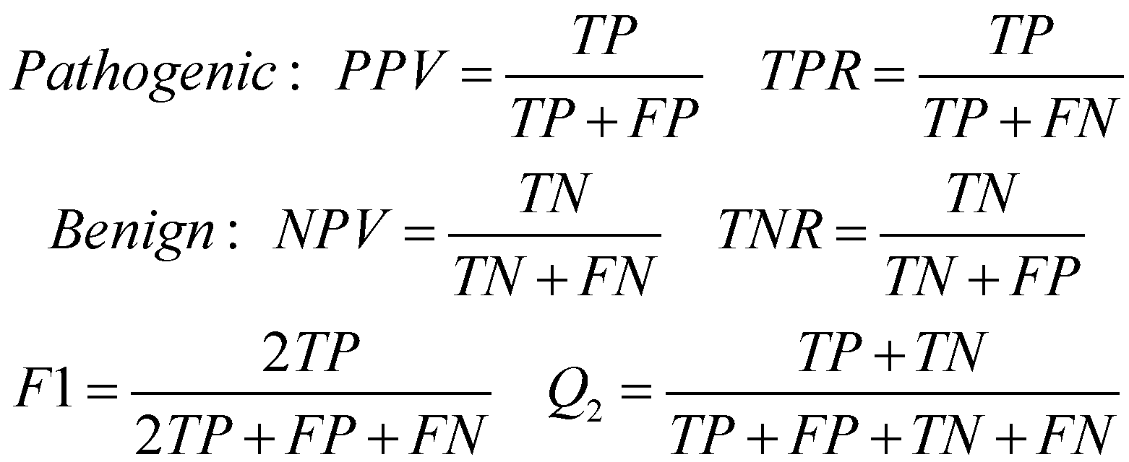
[Eq. 1]

We computed the Matthew’s correlation coefficient MCC (Eq. 2) as:
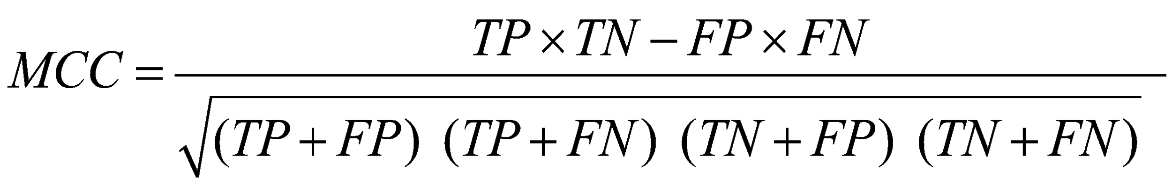
[Eq. 2]

We also calculated the area under the receiver operating characteristic (ROC) curve (AUC), by plotting the True Positive Rate as a function of the False Positive Rate and the Area and the Precision Recall Curve (AUP) at different probability thresholds of annotating a variant as Pathogenic or Benign. Sensitivity = Recall = TPR, Precision = PPV.
For each method, the reported scoring measures are obtained averaging the performance on ten randomly selected sets from CommonClinvar and NewClinvar datasets. The selection procedure is performed for generating balanced datasets of Pathogenic and Benign variants downscaling the most abundant class of variants.

Supplementary Tables

Dataset | Annotation | Proteins | Mutations
CommonClinvar | All | 7,582 | 36,751
 | Benign | 6,444 | 19,659 (53.5%)
 | Pathogenic | 3,117 | 17,092 (46.5%)
NewClinvar | All | 1,855 | 5,172
 | Benign | 935 | 2,247 (43.4%)
 | Pathogenic | 1,119 | 2,925 (56.6%)
Table S1. Composition of the datasets extracted from Clinvar database (https://www.ncbi.nlm.nih.gov/clinvar/),

Dataset | Features | Pathogenic |  |  | Benign |  |  | KSD
 |  | Mean | Median | SD | Mean | Median | SD
CommonClinvar | PC | 0.957 | 1.000 | 0.185 | 0.562 | 0.893 | 0.466 | 0.529
 | PP | 6.523 | 7.521 | 2.794 | 2.120 | 1.374 | 2.789 | 0.573
 | f_{ref} | 0.956 | 1.000 | 0.108 | 0.739 | 0.830 | 0.270 | 0.579
 | f_{alt} | 0.008 | 0.000 | 0.036 | 0.147 | 0.047 | 0.226 | 0.598
 | f_{wt} | 0.797 | 0.945 | 0.261 | 0.414 | 0.362 | 0.270 | 0.545
 | f_{mut} | 0.011 | 0.000 | 0.043 | 0.092 | 0.037 | 0.143 | 0.609
NewClinvar | PC | 0.951 | 1.000 | 0.198 | 0.598 | 0.966 | 0.460 | 0.473
 | PP | 6.461 | 7.509 | 2.861 | 2.301 | 1.521 | 2.782 | 0.548
 | f_{ref} | 0.953 | 1.000 | 0.109 | 0.734 | 0.836 | 0.283 | 0.563
 | f_{alt} | 0.008 | 0.000 | 0.037 | 0.159 | 0.047 | 0.244 | 0.590
 | f_{wt} | 0.802 | 0.943 | 0.257 | 0.420 | 0.378 | 0.273 | 0.546
 | f_{mut} | 0.010 | 0.000 | 0.038 | 0.096 | 0.037 | 0.148 | 0.632
Table S2. Statistics of the distribution of six conservation features for the subset of Pathogenic and Benign variants in the CommonClinvar and NewClinvar datasets. PC: PhastCons100way score. PP: PhyloP100way score, f_{ref} and f_{alt}: frequencies of the reference and alternate alleles in the multiz100way genomic alignment, f_{wt} and f_{mut} : frequencies of the wild-type and mutant residues from a multiple protein sequence alignment. KSD is the distance between two cumulative distributions calculated through the Kolmogoeov-Smirnov test.

Feature | Threshold | Q2 | TNR | NPV | TPR | PPV | MC | F1 | AUC | AUP
PCPC | 1.000 | 0.764 | 0.655 | 0.838 | 0.874 | 0.717 | 0.541 | 0.787 | 0.782 | 0.836
PP | 4.704 | 0.786 | 0.815 | 0.771 | 0.758 | 0.804 | 0.574 | 0.780 | 0.856 | 0.844
f_{ref} | 0.977 | 0.789 | 0.825 | 0.770 | 0.754 | 0.812 | 0.580 | 0.781 | 0.844 | 0.848
f_{alt} | 0.000 | 0.798 | 0.758 | 0.824 | 0.838 | 0.776 | 0.598 | 0.806 | 0.832 | 0.865
f_{wt} | 0.702 | 0.773 | 0.822 | 0.748 | 0.723 | 0.802 | 0.548 | 0.761 | 0.842 | 0.831
f_{mut} | 0.005 | 0.805 | 0.807 | 0.803 | 0.802 | 0.807 | 0.609 | 0.804 | 0.851 | 0.850

Table S3. Performance of the basic predictors based on a single feature on the CommonClinvar dataset Prediction threshold are optimized maximizing both the True Positive Rate (TPR) and the True Negative Rate (TNR) dataset. Q2: Overall Accuracy, TNR: True negative rate, NPV: Negative predicted value, TPR: True Positive Rate, PPV: Positive Predicted Value, MC: Matthews Correlation Coefficient, F1: harmonic mean of precision and sensitivity, AUC: Area Under the Receiver Operator Characteristic Curve, AUP Area under the Precision Recall Curve. All the performance measures are defined above.

Method | Q2 | TNR | NPV | TPR | PPV | MC | F1 | AUC | AUP
CADD | 0.841 | 0.819 | 0.857 | 0.864 | 0.826 | 0.683 | 0.845 | 0.910 | 0.904
ProtProf | 0.833 | 0.868 | 0.811 | 0.798 | 0.858 | 0.667 | 0.827 | 0.906 | 0.901
DNAProf | 0.821 | 0.791 | 0.842 | 0.851 | 0.803 | 0.644 | 0.827 | 0.888 | 0.879
PPScore | 0.792 | 0.798 | 0.788 | 0.785 | 0.796 | 0.583 | 0.790 | 0.868 | 0.859

Table S4: Prediction in cross-validation of the CommonClinvar dataset.Q2: Overall Accuracy, TNR: True negative rate, NPV: Negative predicted value, TPR: True Positive Rate, PPV: Positive Predicted Value, MC: Matthews Correlation Coefficient, F1: harmonic mean of precision and sensitivity, AUC: Area Under the Receiver Operator Characteristic Curve, AUP Area under the Precision Recall Curve. All the performance measures are defined in Supplementary Materials. For CADD a raw score classification threshold of 3.1 was considered.

Supplementary figures

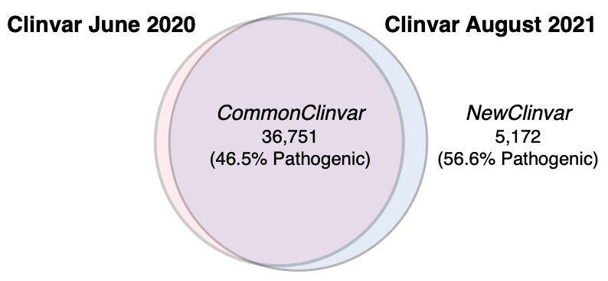
Figure S1. Venn diagram showing the intersection and difference between the two versions (August 2021 and June 2020) of Clinvar database (https://www.ncbi.nlm.nih.gov/clinvar/) used for generating the CommonClinvar and NewClinvar datasets

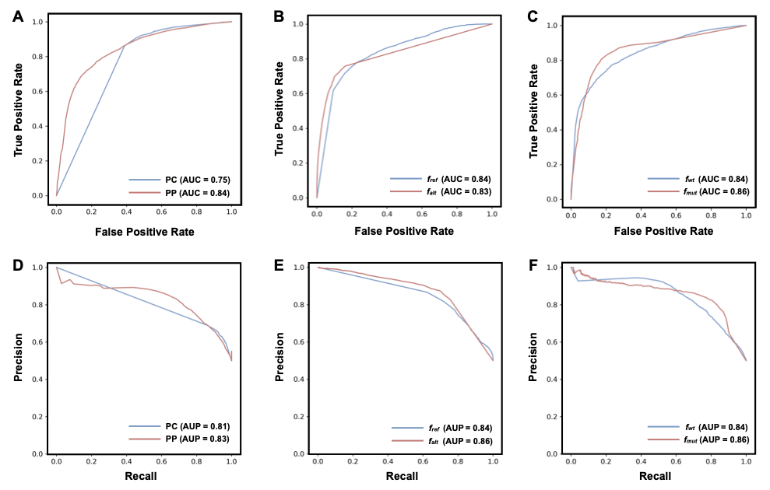
Figure S2. Receiver Operating Characteristic (A,B,C) and Precision Recall (D,E,F) curves for single feature predictors on the NewClinvar dataset. PC: PhastCons100way score. PP: PhyloP100way score, f_{ref} and f_{alt}: frequencies of the reference and alternate alleles in the multiz100way genomic alignment, f_{wt} and f_{mut} : frequencies of the wild-type and mutant residues from a multiple protein sequence alignment.

