Supplementary Information
Core fucosylation was elevated in pericyte activation and RIF. Pericyte activation is the major source of myofibroblasts during renal fibrosis. Pericytes detach from endothelial cells and migrate into the renal interstitium, where they transition into myofibroblasts after activation. Here, we were interested in the change of CF during pericyte activation and renal fibrosis.
To define the CF levels during pericyte activation, C57BL/6 mouse kidney pericytes were isolated and cultured in vitro. After 24-h TGF-β1 induction, myofibroblast-like morphological changes were observed in the pericytes, and these changes were more evident upon 48-h incubation with TGF-β1 (Supplementary Fig. 1a), along with upregulated expression of α-SMA (the myofibroblast marker) (Supplementary Fig. 1b). As FUT8 is the unique fucosyltransferase responsible for CF, we detected FUT8 protein expression and FUT8 activity via western blotting and HPLC, respectively, and found that FUT8 activity and protein expression levels were substantially increased in pericytes upon 48-h incubation with TGF-β1 (Supplementary Fig. 1d, e). The CF levels were detected by LCA, which specifically recognizes core fucose. Immunofluorescence co-staining showed obvious elevation of CF during pericyte activation and transition to myofibroblasts (Supplementary Fig. 1c).
To investigate FUT8 protein expression in vivo, a UUO mouse model was used as a model of pericyte activation and RIF. The results were similar to that observed in vitro. Masson and PAS staining in the UUO mouse model showed that the renal tubular epithelial cells underwent vacuolar degeneration, and we observed a large amount of shedding necrosis, tubular lumen atrophy, inflammation around the renal tubules, and widespread invasive renal interstitial fibrosis (Supplementary Fig. 1f). Immunofluorescence staining showed that the pericytes gradually separated from the vascular endothelial cells, migrated into the renal interstitium, and expressed α-SMA simultaneously (Supplementary Fig. 1g). In the meantime, LCA fluorescence was greatly increased (Supplementary Fig. 1h). The data indicate that CF was obviously increased during pericyte activation in RIF.
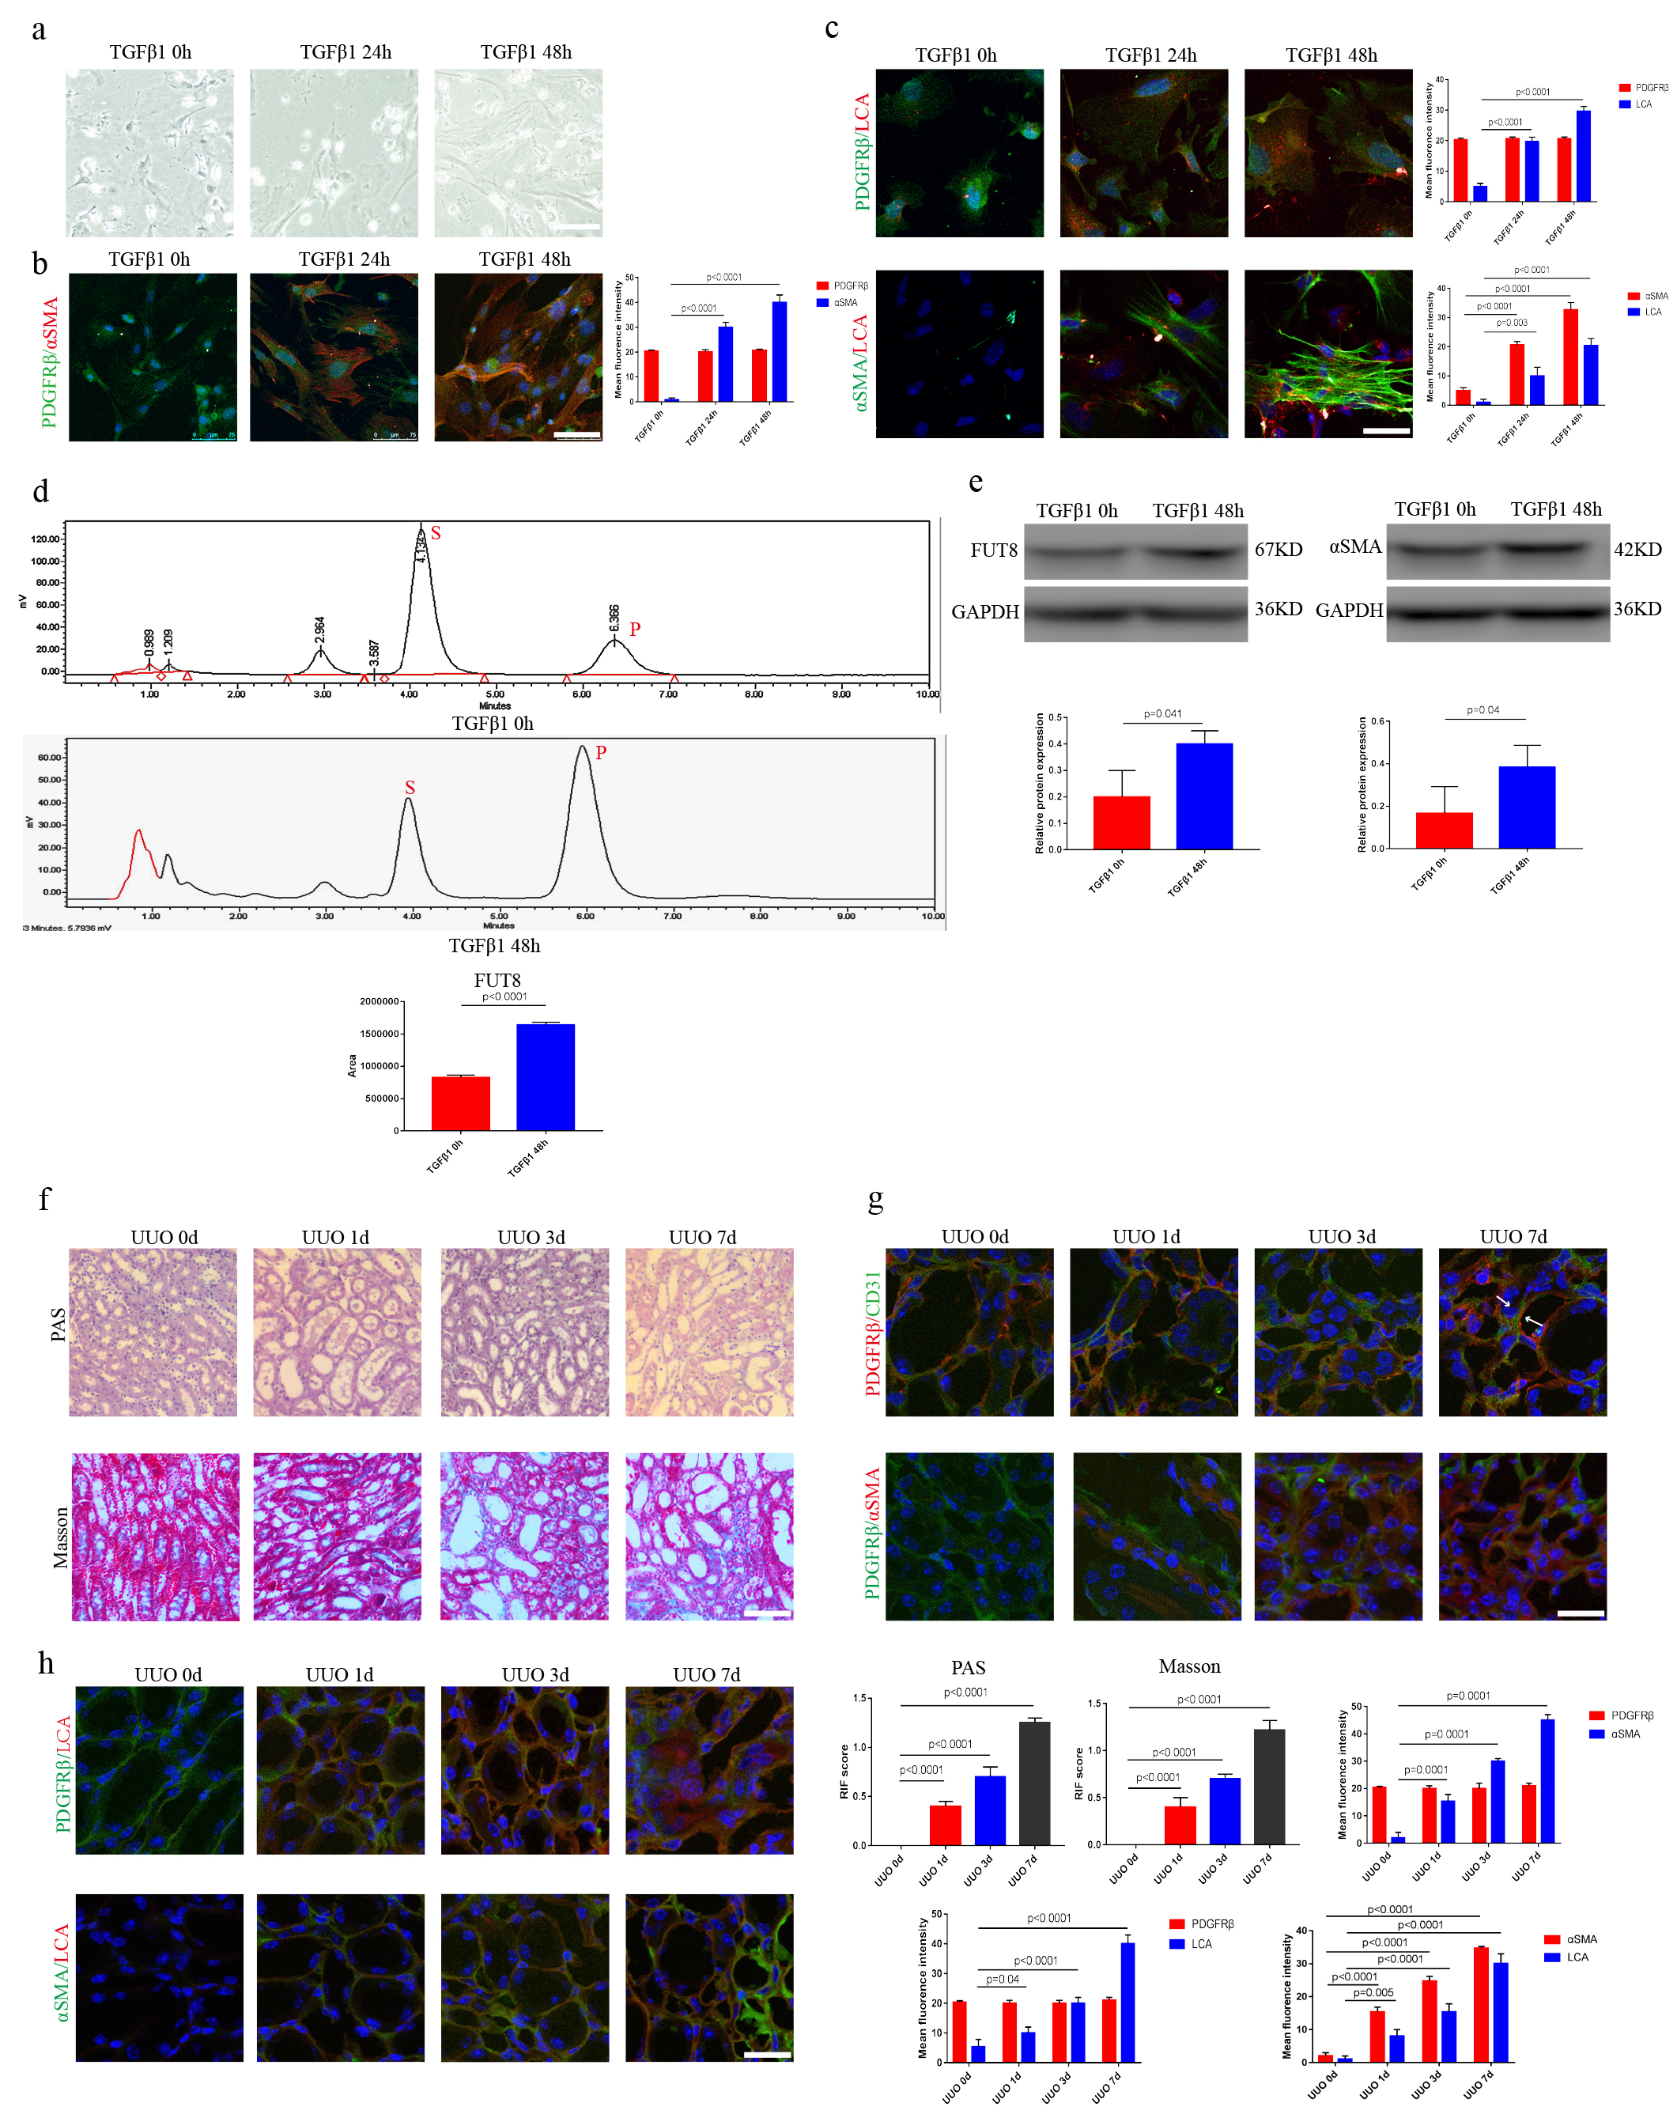
Supplementary Fig. 1 CF was elevated in pericyte activation and RIF. a Representative morphological alterations in pericytes. Scale bar, 200 μm. b Representative images of PDGFRβ (green) and α-SMA (red) staining. The right panel shows the quantification. Scale bar, 75 μm. Data are the mean ± SD (n = 3). c Representative images of PDGFRβ (green) and LCA (red) staining, and α-SMA (green) and LCA (red) staining. The right panel shows the quantification. Scale bar, 75 μm. Data are the mean ± SD (n = 3). d FUT8 activity tested by HPLC. Data are the mean ± SD (n = 3); S indicates the peptide substrate; P is the fucosylation product. e α-SMA and FUT8 levels were assessed using western blotting. The bottom panel shows the quantification. Scale bar, 50 μm. Data are the mean ± SD (n = 3). f Representative images of Masson’s trichrome and PAS staining of UUO mouse kidney sections. The lower right panel shows the quantification. Scale bar, 200 μm. Data are the mean ± SD (n = 3). g Representative images of PDGFRβ (green) and CD31 (red) staining, and PDGFRβ (green) and α-SMA (red) staining. The lower right panel shows the quantification. Scale bar, 75 μm. Data are the mean ± SD (n = 3). h Representative images of PDGFRβ (green) and LCA (red) staining, and α-SMA (green) and LCA (red) staining. The lower right panel shows the quantification. Scale bar, 75 μm. Data are the mean ± SD (n = 3).
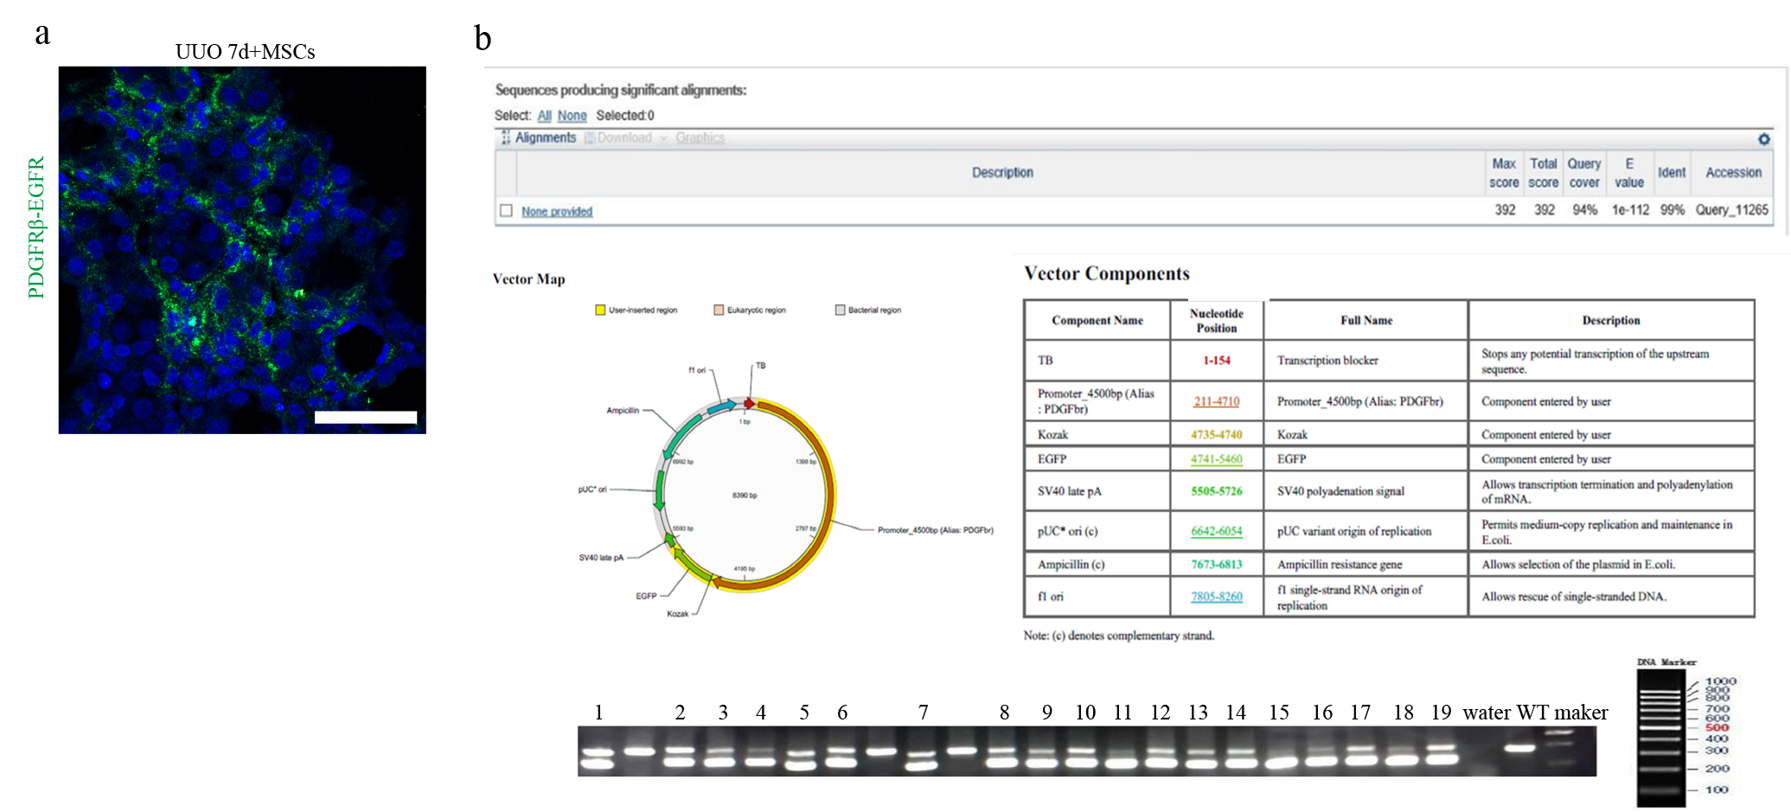
Supplementary Fig. 2 Identification of MSC/RFP and PDGFRβ-EGFP fluorescent reporter mice. a Representative images of PDGFRβ (green). Scale bar, 75 μm (n = 3). b EGFR levels were assessed using PCR. Scale bar, 50 μm (n = 3).
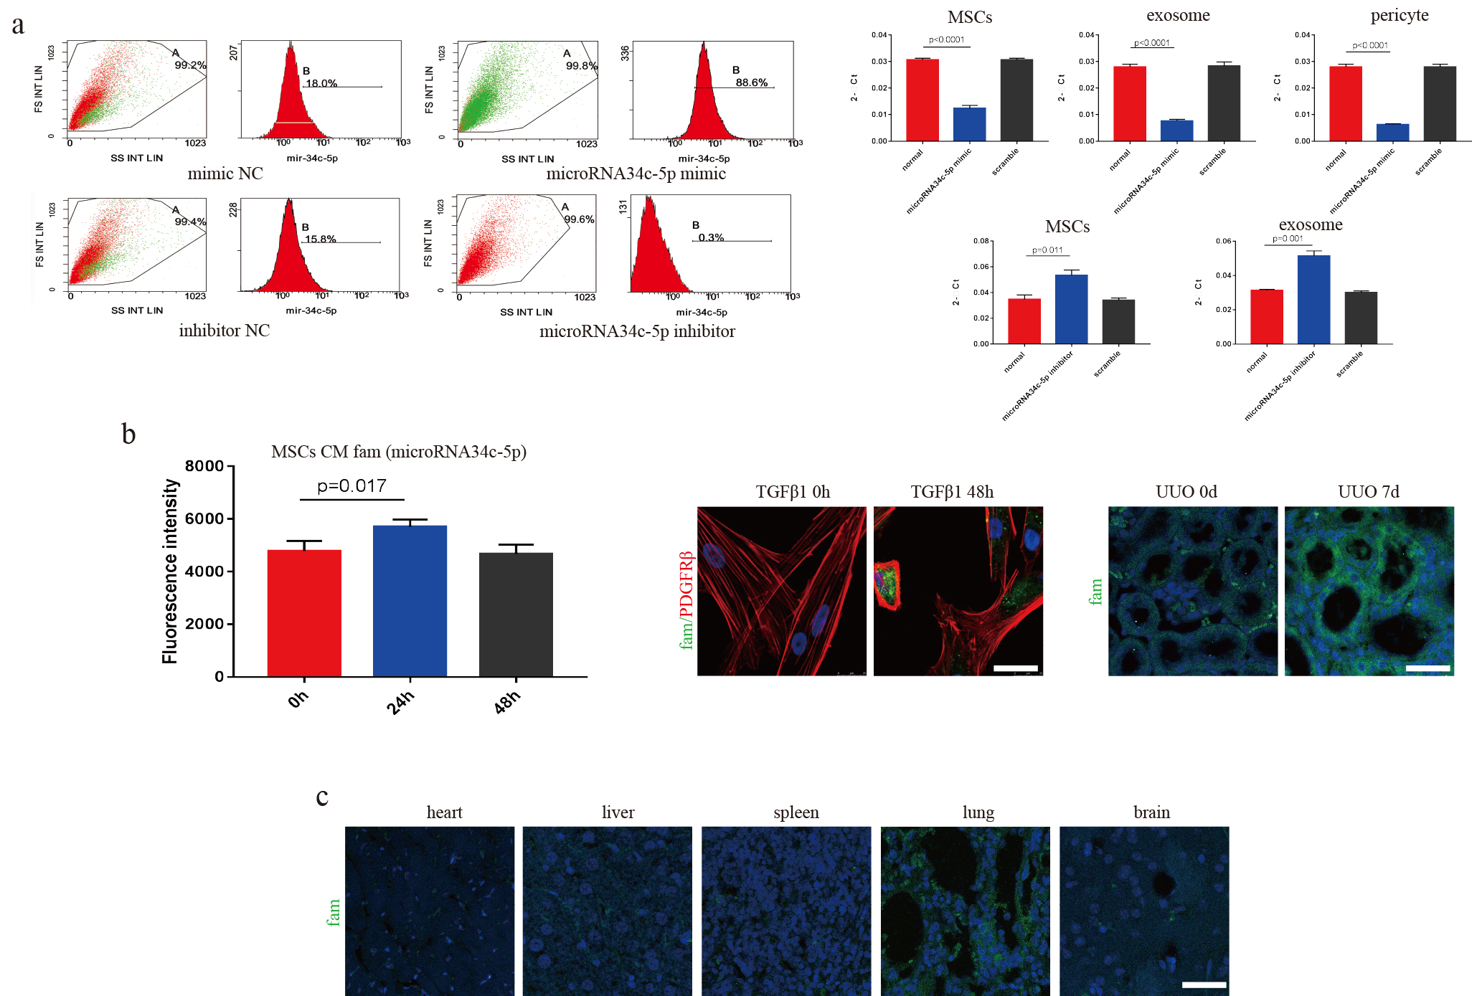
Supplementary Fig. 3 a miR-34c-5p mimic and inhibitor transfection into cells was verified by RT-PCR and flow cytometry. Data are the mean ± SD (n = 3). b miR-34c-5p (fam) was observed using the luciferase marker, and representative images of fam (green) and PDGFRβ (red) staining are shown. The left panel shows the quantification. Scale bar, 75 μm. Data are the mean ± SD (n = 3). c Representative images of fam (green) staining in the heart, liver, spleen, lung, and brain. Scale bar, 75 μm (n = 3).
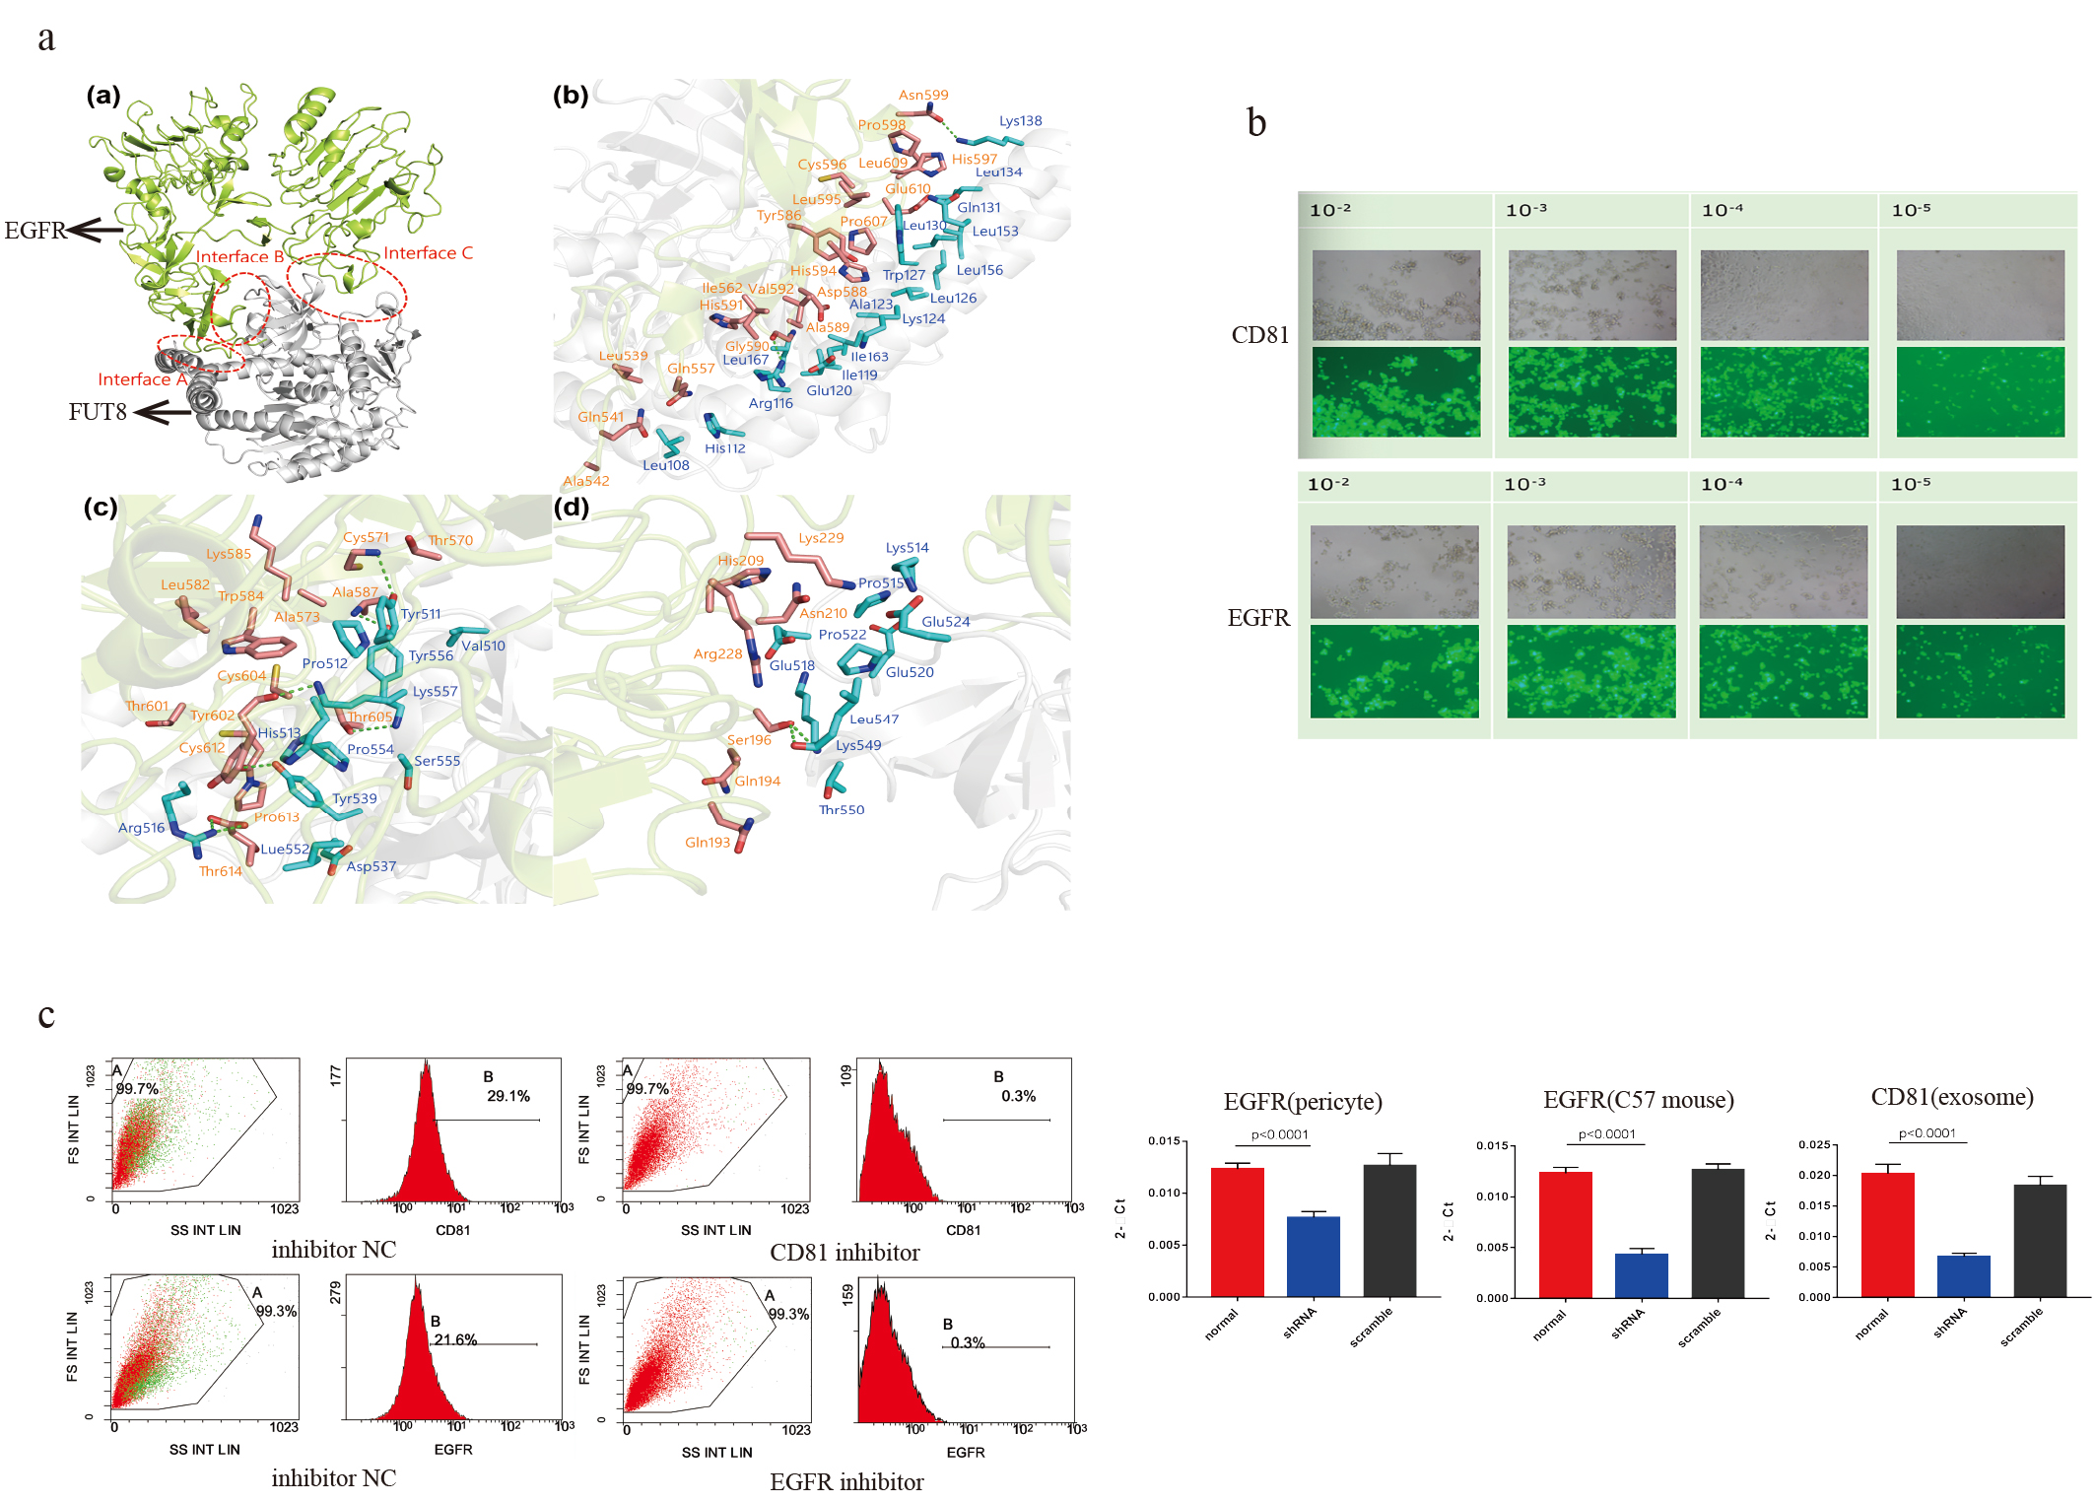
Supplementary Fig. 4 a Computer simulation of FUT8 and EGFR complex structure. b Detection of CD81 and EGFR adenovirus titers. c CD81 and EGFR adenovirus efficiency was tested by RT-PCR and flow cytometry. Data are the mean ± SD (n = 3).

