Oregano Oil Fumigation Suppresses Postharvest Yellowing in Broccoli by Enhancing Antioxidant Capacity
Supplementary Figure
Lin Yu ^{a, b,1} , Xiaozhen Yue ^{a,1}, Bangjin Yan ^{b,c}, Xiaodi Xu ª, Shuzhi Yuan ª, Guiqin Qu ^{b, *}, Qing Wang ^{a, *}

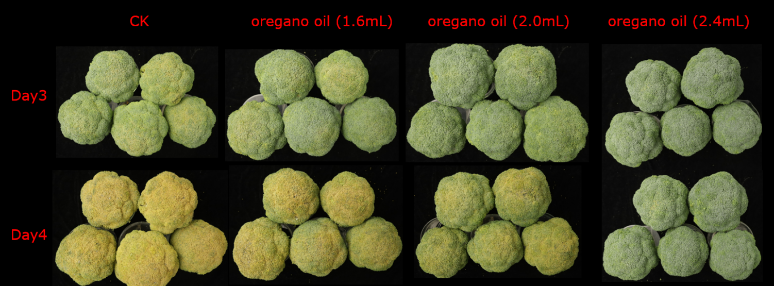
Supplementary Figure 1. Phenotypic Images from the Pretreatment Trial of Broccoli Heads with Oregano Oil Fumigation

Supplementary Figure 2. Transcriptomic profiling and functional characterization of DEGs in broccoli florets under different treatments. (A) Principal component analysis (PCA) plot showing distinct clustering of sample groups. (B) Heatmap of KEGG pathway enrichment analysis for DEGs identified in the OO4d vs. CK4d comparison. (C) Bar plot displaying the number of DEGs from all pairwise comparisons among the three groups. (D) Upset plot illustrating the distribution and overlap of DEGs across the three pairwise comparisons. (E) Histogram of Cluster of Orthologous Groups (COG) classification for the DEGs. (F) KEGG pathway classification and annotation of the DEGs.

Supplementary Figure 3. Systematic metabolomic characterization of broccoli florets in response to oregano oil fumigation. (A, B) Supervised OPLS-DA score plot (A) and Pearson correlation heatmap (B) demonstrating distinct clustering between control (CK) and OO-treated groups, with model parameters (R²Y, Q²Y) validating robustness. (C) Statistical summary of DAMs identified across three pairwise comparisons. (D) Upset plot visualizing the abundance changes of metabolites in the CK4d vs. OO4d comparison (2,270 upregulated, 1,904 downregulated). (E) KEGG pathway enrichment analysis of DAMs, highlighting anthocyanin biosynthesis and phenylpropanoid biosynthesis among the top 20 enriched pathways. (F, G) Integrated multi-omics analysis of co-enriched pathways: (F) KEGG enrichment bar plot and (G) bubble chart from the conjoint analysis of DEGsand DAMs.

Supplementary Figure 4. Mechanistic diagram of differentially expressed genes and differentially abundant metabolites in the ASA metabolic pathway.

Supplementary Figure 5. Mechanistic diagram of differentially expressed genes and differentially abundant metabolites in the flavonoid and anthocyanin metabolic pathway.
Supplementary Figure 6. NADPH/NADP⁺ ratio of broccoli in sample group comparisons of the CK0d, OO4d, and CK4d. Different lowercase letters indicate significant differences (P < 0.05) among treatment groups at the same time point as determined by a Student’s t-test.
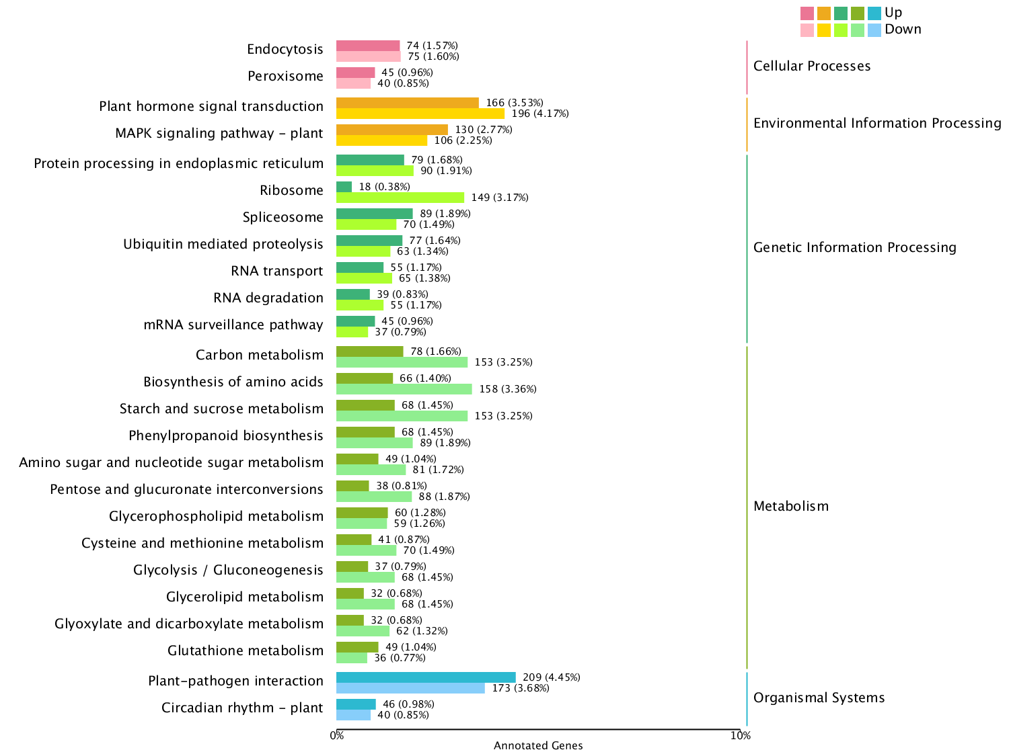
Supplementary Figure 7. KEGG enrichment analysis of DEGs from the OO4d vs. CK4d comparison.

