Supplementary Information

Multimodal Representation Learning for Blind Acoustic Classification

Xiao Tan¹[0000-0003-0191-9185] and Prof. Siu Ming Yiu²[0000-0002-3975-8500]*
Dept of Computer Science, University of Hong Kong
Hong Kong SAR, China
¹xtan@cs.hku.hk, ²smyiu@cs.hku.hk
Corresponding author: Prof. SM Yiu and Xiao TAN

Supplementary figures and tables referenced in the main text.
Table S1. Performance summary when predicting low and high EBRs

Audio Ref No | Actual Acoustic Event | Acoustic Scene | EBR | Captions | Prediction
0 | Baby cry | City center | 6.0 | Baby cry in City Center | Baby cry
1 | Baby cry | Café / Restaurant | -6.0 | Baby cry in a café or restaurant | Baby cry
2 | Glass-break | Beach | 6.0 | Glass break on beach | Glass-break
3 | Glass-break | Train | -6.0 | Glass break in train | Glass-break
4 | Gunshot | Residential area | 6.0 | Gunshot in residential area | Gunshot
5 | Gunshot | Beach | -6.0 | Gunshot on beach | Gunshot

Table S2. Performance metrics of proposed TMRL for AEC task with SNR=-3.0103dB and -10dB

Event Class | SNR=-3.0103dB |  |  | SNR=-10dB
Event Class | F-score (%)  (with 95% CI) | MSE | AUC | F-score (%)  (with 95% CI) | MSE | AUC
Baby cry | 98.18  (97.00-99.36) | 0.02 | 0.97 | 95.00  (93.07-96.92) | 0.04 | 0.93
Glass break | 90.47  (86.76-92.19) | 0.10 | 0.90 | 96.67*  (95.08-98.25) | 0.03 | 0.96
Gunshot | 88.00  (84.57-90.42) | 0.12 | 0.87 | 85.00  (81.84-88.16) | 0.14 | 0.86

* The observed increase in the F-score for glass break, from 90.47% at −3.0103 dB to 96.67% at −10 dB, may be associated with the added white noise partially masking other environmental sounds that could otherwise be misclassified as the glass break event. The result is not definitive.

Table S3. Class-wise performance of top-5 accuracy comparison: Proposed TMRL for ASC Task with SNR=-3.0103dB and SNR= -10dB

Environments | TMRL  (SNR = -3.0103dB) | TMRL  (SNR = -10dB)
Environments | top-5 Accuracy (%) | top-5 Accuracy (%)
Beach | 100.00 | 100.00
Bus | 100.00 | 100.00
Café/Restaurant | 100.00 | 100.00
Car | 100.00 | 100.00
City center | 100.00 | 80.00
Forest path | 50.00 | 50.00
Grocery store | 33.33 | 100.00
Home | 100.00 | 100.00
Library | 100.00 | 100.00
Metro station | 100.00 | 42.86
Office | 100.00 | 100.00
Park | 100.00 | 80.00
Residential area | 100.00 | 60.00
Train | 100.00 | 64.29
Tram | 66.67 | 100.00
Total  (with 95% CI) | 91.67  (90.67-92.67) | 88.89  (87.60-90.17)

Table S4. Class-wise performance of TMRL on DESED 2019 for AEC Task

Event Class | TMRL
Event Class | F-score (%)
Alarm bell ringing | 70.00
Blender | 90.91
Cat | 93.33
Dishes | 77.27
Dog | 93.33
Electric shaver / toothbrush | 77.78
Frying | 90.00
Running water | 87.5
Speech | 100.00
Vacuum cleaner | 71.43
Total  (with 95% CI) | 90.17  (88.60 – 91.74)

Table S5. Class-wise performance of TMRL on TAU Urban Acoustic Scene Mobile 2020 for ASC Task on top-1 level

Event Class | TMRL
Event Class | top-1 F-score (%)
Airport | 75.00
Indoor shopping mall | 80.00
Metro station | 85.71
Pedestrian street | 71.43
Public square | 57.14
Street with medium level of traffic | 93.33
Travelling by a tram | 77.78
Travelling by a bus | 93.33
Travelling by an underground metro | 91.30
Urban Park | 50.00
Total  (with 95% CI) | 83.33  (82.27-84.40)

Fig. S1.
a)
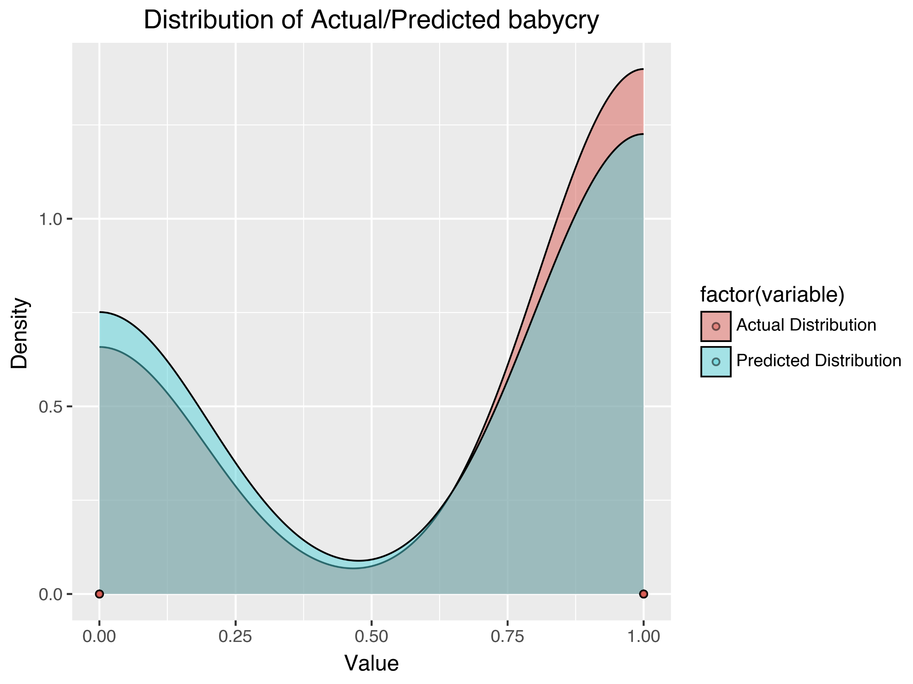

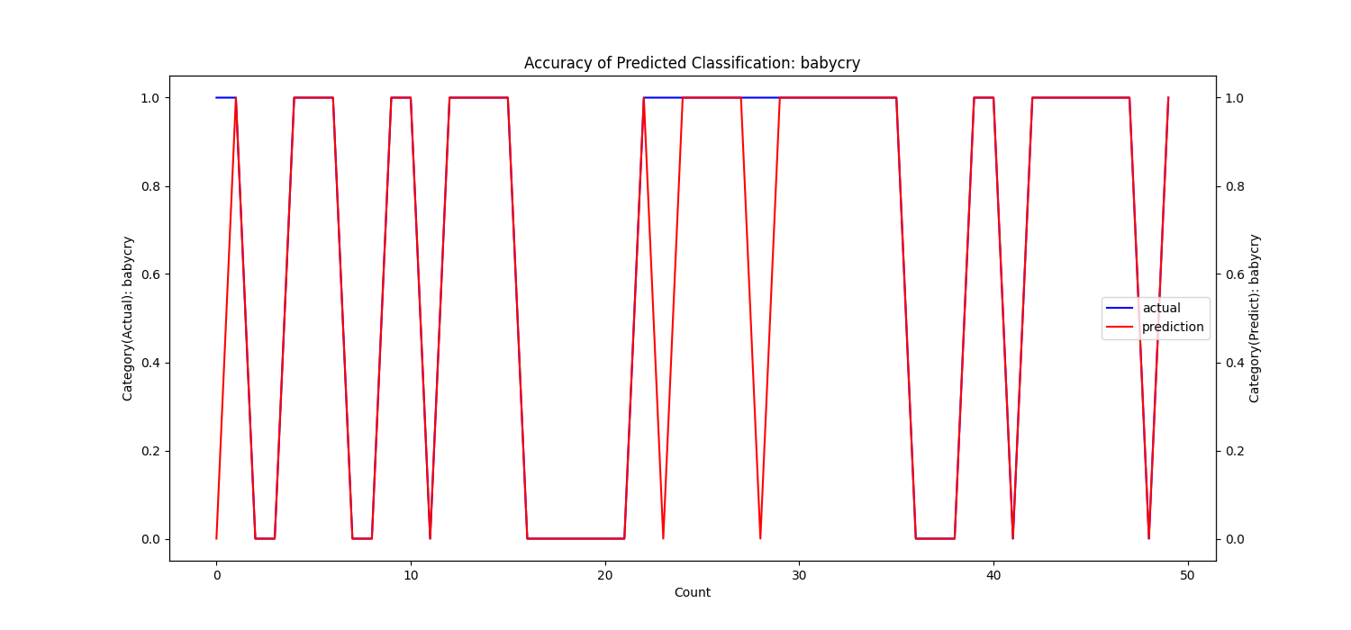

b)
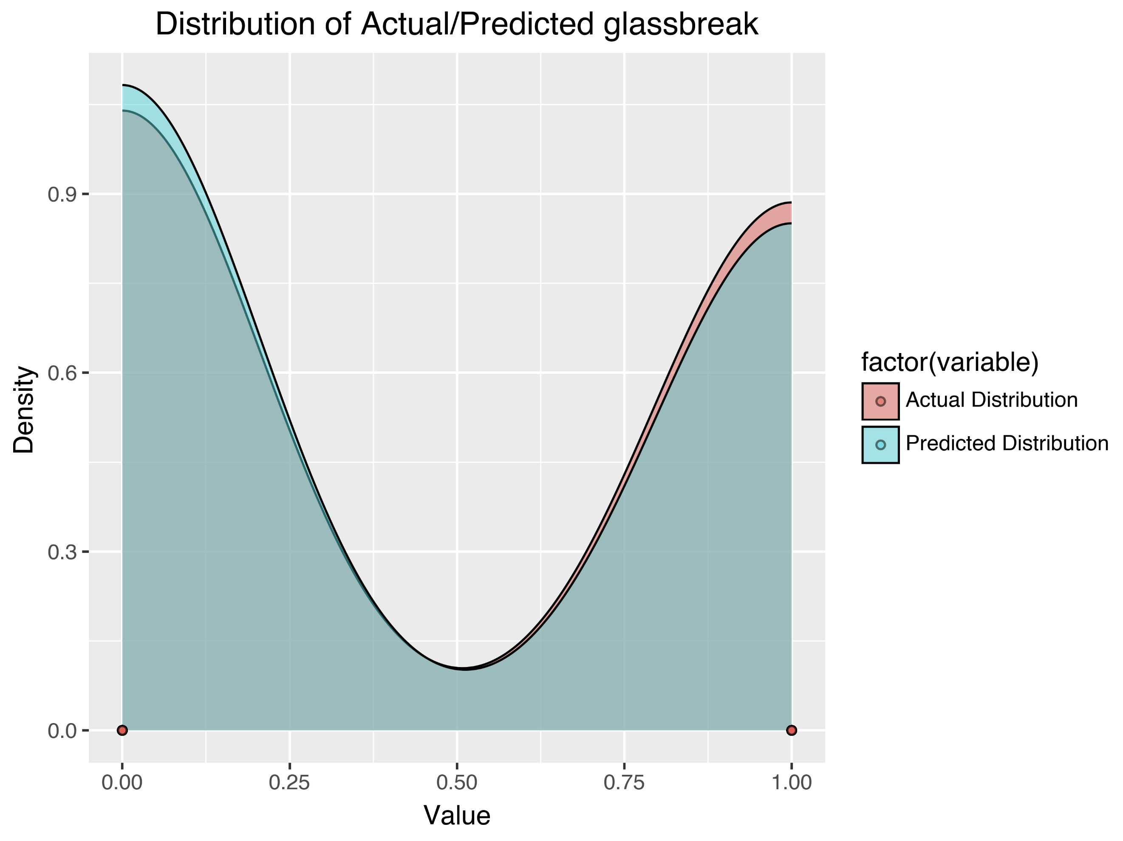

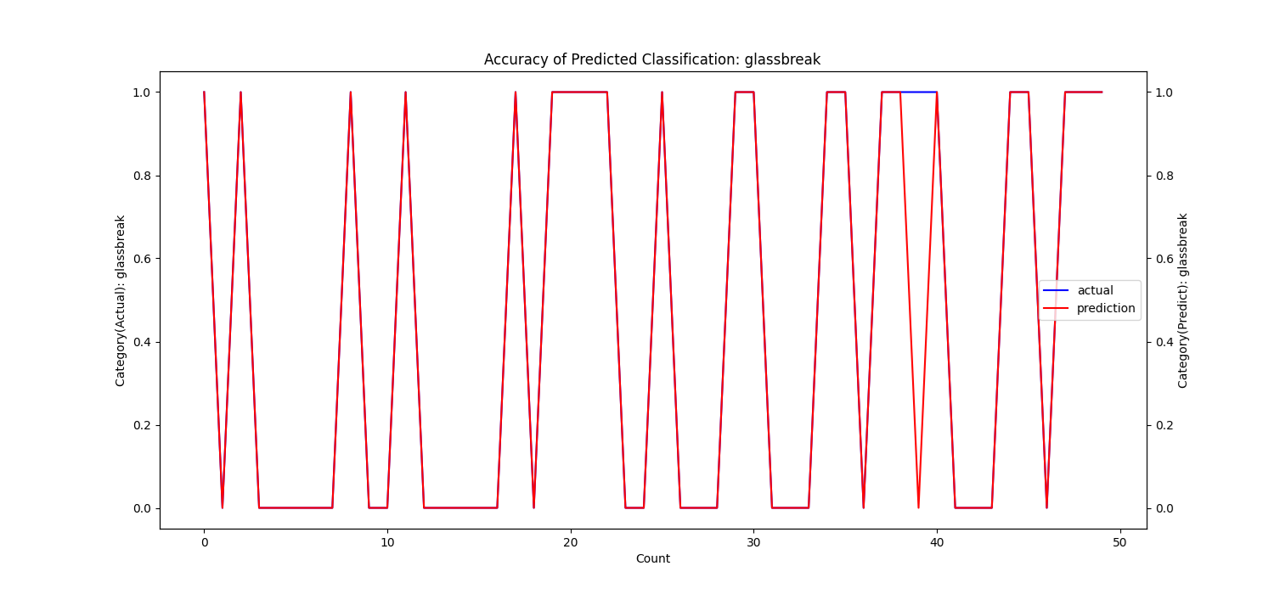

Fig. S1. Accuracy and distribution of AEC predictions. We show two illustrative examples: a) Baby cry and b) Glass break.

Fig. S2.
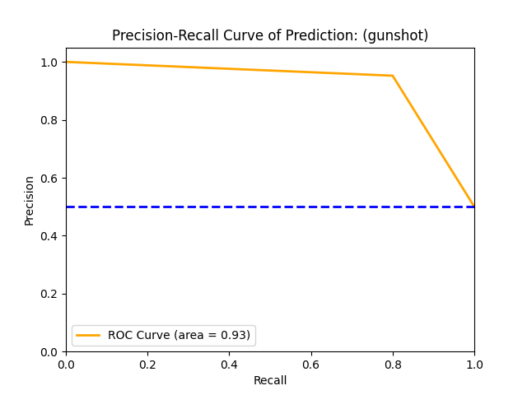
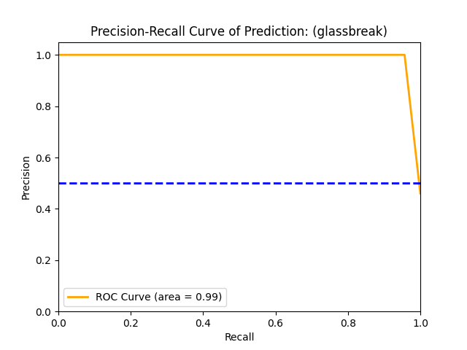
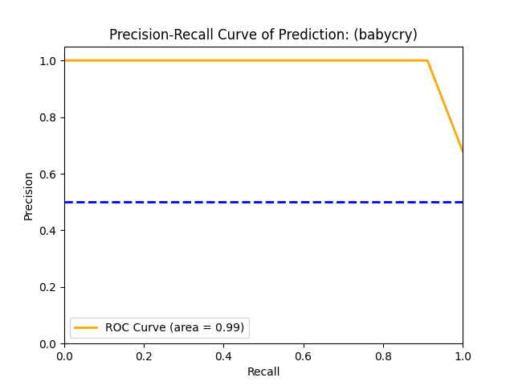

Fig. S2. PR-AUC comparisons of AEC predictions on three noise-free samples—baby cry, glass break, and gunshot (left to right).

Fig. S3
a)
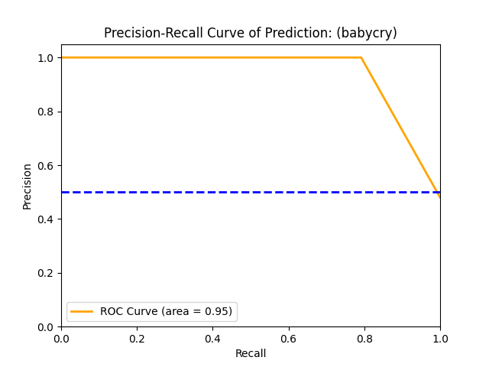
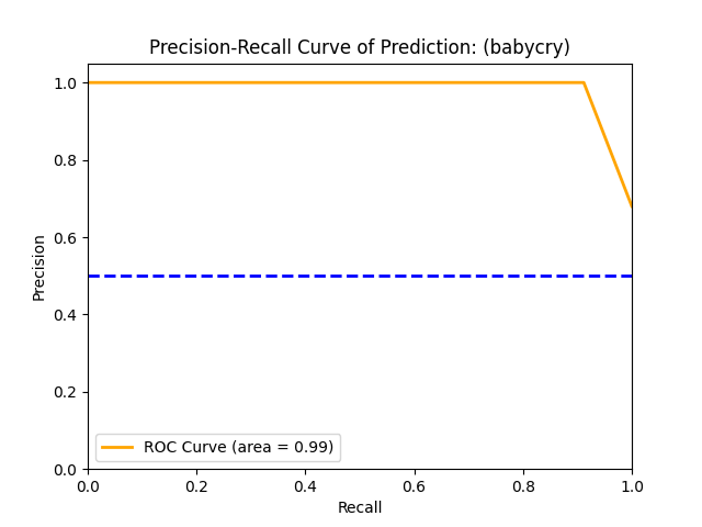

b)
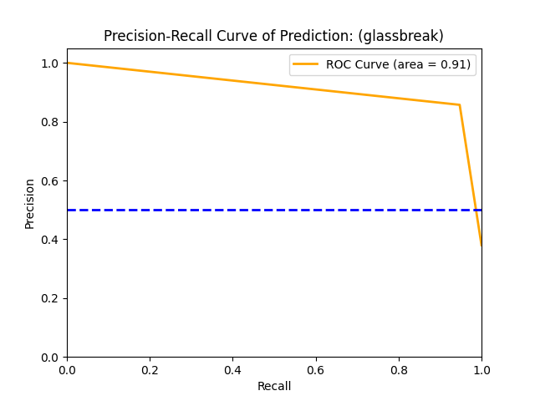

c)
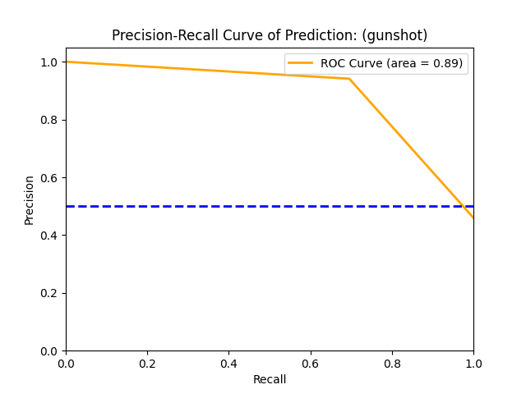

Fig. S3 PR-AUC for acoustic event classification: (a) Baby cry, (b) Glass break, and (c) Gunshot. The left is clean without noise, and the right is with noise of SNR=-3.0103dB or 0.5.
References
(1) Fischer, Gerald, et al. "Converting spectral evoked-to-background ratio into time-domain signal-to-noise ratio–validation for high frequency oscilla-tions." MethodsX (2025): 103617.
(2) Naidu, Gireen, Tranos Zuva, and Elias Mmbongeni Sibanda. "A review of evaluation metrics in machine learning algorithms." Computer science on-line conference. Cham: Springer International Publishing, 2023.
(3) N. Turpault, R. Serizel, A. P. Shah, and J. Salamon, “Sound event detection in domestic environments with weakly labeled data and soundscape synthesis,” in Proc. Detection Classification Acoust. Scenes Events Wokshop, 2019, pp. 253–257.
(4) Heittola, Toni, Annamaria Mesaros, and Tuomas Virtanen. "TAU Urban Acoustic Scenes 2020 3Class, Development dataset." (No Title) (2020). Zeno-do. https://zenodo.org/records/3685828.

