Supplementary materials
Effects of a multi-faceted intervention to improve intrapartum care: A stepped-wedge, cluster-randomized trial in 16 hospitals in Benin, Malawi, Tanzania and Uganda
Hanson C, Akuze C, Sidney Annerstedt K; Mölsted Alvesson H, Sun S, Straneo M, Orsini N, Benova L, Gross MM, Marchal B, Snijders R, Chipeta E,Waiswa P, Kidanto H, Dossou J-P; Pembe AB

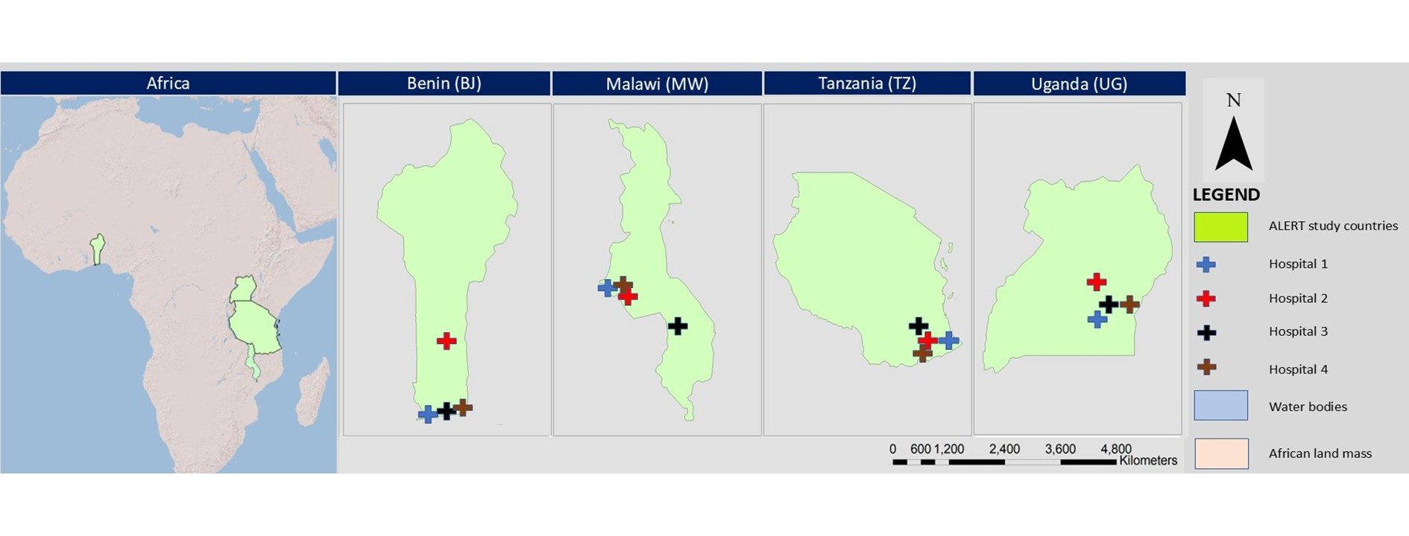Figure S1: Map showing the ALERT trial countries and key indicators for the study hospitals

Table S1. Implementation context
Indicator | Benin | Malawi | Tanzania | Uganda
National Indicators
Region in Africa | West | East | East | East
Real Gross Domestic Product per capita (US$) (2023) ¹ | 3,700 | 1,600 | 3,600 | 2,800
Population (million) (2023) ¹ | 14.2 | 21.3 | 65.6 | 47.7
Neonatal Health Indicators
Neonatal Mortality Rate (per 1,000 live births) (2021) ² | 29 | 19 | 20 | 19
Stillbirth Rate (per 1,000 live births) (2021) ² | 20 | 16 | 18 | 15
Maternal Health Indicators
Maternal Mortality Ratio (per 100,000 live births) (2020) ³ | 523 | 381 | 238 | 284
Antenatal Care²
≥1 Visits (%) (2022)² | 78.1% | 96.8% ⁽²⁰²⁰⁾ | 89.7% | 95% ⁽²⁰¹⁸⁾
≥4 Visits (%) (2022)² | 52.6% | 51% ⁽²⁰²⁰⁾ | 65.1% | 57% ⁽²⁰¹⁸⁾
Deliveries by Skilled Birth Attendant (%) (2022)² | 80.8% | 96.4% ⁽²⁰²⁰⁾ | 85% | 91%
Institutional Deliveries (%) (2022)² | 90.6% | 96.7% ⁽²⁰²⁰⁾ | 81.2% | 83.9% ⁽²⁰¹⁸⁾
Cesarean Section Deliveries (%) (2022)² | 5.7% | 7.7% ⁽²⁰²⁰⁾ | 10.8% | 6.2% ⁽²⁰¹⁶⁾
Official User Fees for Childbirth | Yes | No | No | No
Total Fertility (2022)² | 4.5 | 3.6 | 4.6 | 4.3
Unmet Need for Family Planning (2022)⁴ | 16.9% | 64.7% (2020) | 31.1% | 38%
Health System Indicators⁵
Medical Doctors (per 10,000 population) (2022) | 2.16 | 0.54 | 1.34 | 1.91
Nursing and Midwifery (per 10,000 population) (2023) | 6.11 | 5.1 (2022) | 6.93 | 22.65 (2022)
Current Health Expenditure per Capita (USD) (2022) | 33.88 | 39.66 | 37.56 | 51.03
Current Health Expenditure / % of Gross Domestic Product (2022) | 2.7% | 6.5% | 3.1% | 4.3%
Out of Pocket Expenditure / % of Current Health Expenditure (2020) | 42.5% | 12.1% | 28.7% | 34.1%
Hospital characteristics
Public hospital / private-not-for-non-profit hospitals | 3 / 1 | 3 / 1 | 3 / 1 | 3 / 1
Hospital with dedicated Cesarean section theatre | 4 | 1 | 4 | 0
Providers of Cesarean section services ^ | MD / specialists | Clinician | Clinician* / MD | MD
Midwifery providers | Midwives | Nurse/Midwivessss | Nurse/Midwives | Midwives

1. CIA. The Global Factbook. 2024. https://www.cia.gov/the-world-factbook/africa/ (accessed 22 Dec 2024).
2. UN Inter-agency Group for Child Mortality Estimation. Levels and Trends in Child Mortality. 2024. https://childmortality.org/ (accessed 26 Nov 2024).
3. World Health Organization. Trends in maternal mortality 2000 to 2020: estimates by WHO, UNICEF, UNFPA, World Bank Group and UNDESA/Population Division. Geneva, 2023.
4. United Nations Population Fund. Population Data Portal [Internet]. 2022. Available from: https://www.unfpa.org/data
5. World Health Organization. Global Health Observatory: Data Repository [Internet]. WHO. World Health Organization; Available from: https://apps.who.int/gho/data/node.main
^MD Medical Doctor, Clinic related to non-physician clinicians

Table S2: Baseline data
 | Benin | Malawi | Tanzania | Uganda
 | N=27867 | N=47176 | N=21579 | N=38008
Maternal Age (122 missing)
<20 | 2852 (10.2%) | 15149 (32.1%) | 4319 (20.0%) | 6792 (17.8%)
20-24 | 7243 (26.0%) | 14499 (30.7%) | 5965 (27.6%) | 12849 (33.8%)
25-29 | 7672 (27.5%) | 8084 (17.1%) | 4165 (19.3%) | 9336 (24.6%)
30-34 | 5914 (21.2%) | 5141 (10.9%) | 3677 (17.0%) | 5573 (14.7%)
35+ | 4171 (15.0%) | 4205 (8.9%) | 3453 (16.0%) | 3449 (9.0%)
Women referred into facility | 14770 (53.0%) | 10595 (22.5%) | 1259 (5.8%) | 6836 (18.1%)
Stage of labor when referred in (74 missing) | n=14770 | n=10595 | n=1259 | n=6836
Pregnancy-not in labor | 2015 (13.6%) | 826 (7.8%) | 235 (18.7%) | 315 (4.6%)
Labor | 12725 (86.2%) | 9755 (92.1%) | 1021 (81.1%) | 6494 (95.0%)
Referring facility (31 missing) | n=14770 | n=10595 | n=1259 | n=6836
Home / community | 97 (0.7%) | 6290 (59.4%) | 207 (16.4%) | 1473 (21.6%)
Lower-level facility | 13261 (89.8%) | 4276 (40.4%) | 966 (76.7%) | 4635 (67.8%)
Other hospital | 1399 (9.5%) | 25 (0.2%) | 79 (6.3%) | 721 (10.6%)
Gravidity, median (IQR) (95 missing) | 3.0 (1.0, 4.0) | 2.0 (1.0, 3.0) | 2.0 (1.0, 3.0) | 2.0 (1.0, 4.0)
Parity – categorized
Nullipara | 8922 (32.0%) | 22202 (47.1%) | 8177 (37.9%) | 13863 (36.5%)
1-2 | 10160 (36.5%) | 16786 (35.6%) | 9280 (43.0%) | 14568 (38.3%)
3-4 | 6194 (22.2%) | 6470 (13.7%) | 3481 (16.1%) | 6696 (17.6%)
5+ | 2591 (9.3%) | 1718 (3.6%) | 641 (3.0%) | 2881 (7.6%)
Previous Cesarean section | 6526 (32.7%) | 3207 (12.3%) | 2266 (16.3%) | 4625 (18.3%)
Number of ANC visits, current pregnancy (1107 missing)
<4 | 7581 (27.2%) | 22863 (48.5%) | 1860 (8.6%) | 16297 (42.9%)
4+ | 20051 (72.0%) | 23968 (50.8%) | 19717 (91.4%) | 21186 (55.7%)
Multiple pregnancy | 2549 (9.2%) | 1494 (3.2%) | 371 (1.7%) | 995 (2.6%)
Maternal comorbidities
Hypertensive disorders | 4763 (17.1%) | 522 (1.1%) | 875 (4.1%) | 1642 (4.3%)
Preterm labor | 3223 (11.6%) | 1678 (3.6%) | 585 (2.7%) | 1659 (4.4%)
Augmentation of labor | 931 (4.5%) | 164 (0.4%) | 544 (2.9%) | 401 (1.2%)
*Missing data distribution: Maternal age 15 (0.1%) in Benin; 98 (0.2%) in Malawi; 0 (0.0%) in Tanzania and 9 (<1%) in Uganda. Also by study arm 62 (0.1%) missing in the comparison arm compared to 60 (0.1%) in the intervention arm

Table S3: Maternal outcome and process indicators data from e-registry and exit interviews

 | Benin | Malawi | Tanzania | Uganda | Comparison Arm | Intervention Arm
Primary and secondary outcomes
Primary outcomes (from e-registry; child attributes)
Number of births recorded | N=30160 | N=47998 | N=21999 | N=39143 | N=62244 | N=77056
Fresh stillbirths | 1192 (4.0%) | 458 (1.0%) | 149 (0.7%) | 1069 (2.7%) | 1223 (2.0%) | 1645 (2.1%)
Early perinatal mortality | 1517 (5.0%) | 855 (1.8%) | 323 (1.5%) | 1582 (4.0%) | 1905 (3.1%) | 2372 (3.1%)
Secondary outcomes (from e-registry; child attributes)
Hypoxic-ischemic event measured as low Apgar score (<7) | 3379 (11.2%) | 2157 (4.5%) | 616 (2.8%) | 3219 (8.2%) | 4063 (6.5%) | 5308 (6.9%)
Neonatal seizures | 108 (0.4%) | 65 (0.1%) | 118 (0.5%) | 86 (0.2%) | 142 (0.2%) | 235 (0.3%)
Cesarean section | 13552 (44.9%) | 8499 (17.7%) | 6502 (29.6%) | 11150 (28.5%) | 17075 (27.4%) | 22628 (29.4%)
Secondary outcomes (from e-registry; maternal attributes)
Number of women recorded | N=27867 | N=47176 | N=21579 | N=38008 | N=60403 | N=74227
Severe maternal morbidity | 1486 (5.3%) | 591 (1.3%) | 428 (2.0%) | 768 (2.0%) | 1544 (2.6%) | 1729 (2.3%)
Maternal Attributes: Secondary outcomes from exit interviews
Number of women recorded | N=1003 | N=1004 | N=996 | N=1004 | N=2036 | N=1971
Responsiveness score, median (IQR) | 39.2 (33.8, 51.5) | 61.3 (52.0, 81.6) | 45.0 (37.7, 51.9) | 62.7 (50.5, 76.6) | 49.4 (38.6, 63.9) | 54.5 (42.3, 71.6)
Respectful treatment score, median (IQR) | 86.1 (83.7, 90.1) | 90.9 (86.9, 91.7) | 87.7 (84.5, 90.1) | 86.9 (84.5, 90.9) | 88.5 (85.3, 90.9) | 87.7 (84.5, 90.9)
Process indicators
Process indicators (from e-registry, maternal attributes)
Number of women recorded | N=27867 | N=47176 | N=21579 | N=38008 | N=60403 | N=74227
Fetal heart check at admission done | 24107 (86.5%) | 44996 (95.4%) | 19911 (92.3%) | 35126 (92.4%) | 53635 (88.8%) | 70505 (95.0%)
Fetal monitoring done and documented in 1st stage of labor | 20313 (72.9%) | 32486 (68.9%) | 20259 (93.9%) | 22377 (58.9%) | 40488 (67.0%) | 54947 (74.0%)
Resuscitation for babies with Apgar < 7 | 1216 (36.0%) | 1386 (64.3%) | 223 (36.2%) | 1089 (33.8%) | 1565 (38.5%) | 2349 (44.3%)
Maternal Attributes: Process indicators from exit interviews
 | N=1003 | N=1004 | N=996 | N=1004 | N=2036 | N=1971
Companion of choice first or second stage* | 90 (9.0%) | 419 (41.7%) | 43 (4.3%) | 955 (95.2%) | 743 (36.5%) | 764 (38.8%)
Companion of choice in 2nd stage* | 48 (4.8%) | 337 (33.6%) | 20 (2.0%) | 688 (68.5%) | 527 (25.9%) | 566 (28.7%)
Early ambulation /Woman encouraged to walk during labor* | 142 (14.2%) | 682 (67.9%) | 362 (36.4) | 719 (71.6%) | 958 (47.1%) | 947 (48.1%)
Initiated breastfeeding within 1 hour* | 41 (4.1%) | 813 (81.0%) | 529 (53.1%) | 701 (69.8%) | 1090 (53.5%) | 994 (50.4%)
*Missing data distribution: Companion of choice first or second stage in Uganda 1(0.1%) and comparison arm 1 (0.1%); Companion of choice in 2nd stage in Benin 185 (18.5%), Malawi 21 (2.1%), Tanzania 137 (13.8%) and Uganda 100 (10.0%) and overall in comparison arm 168 (8.3%) and intervention arm 275 (13.9%); Early ambulation /Woman encouraged to walk during labor in Benin 122 (12.2%), Malawi 121 (12.1%), Tanzania 459 (46.1%), and Uganda 102 (10.2%) and overall in comparison arm 382 (18.8%) and intervention arm 422 (21.4%); Initiated breastfeeding within 1 hour in Benin 46 (4.6%), Malawi 41 (4.1%), Tanzania 39 (3.9%), and Uganda 45 (4.5%) and overall in comparison arm 95 (4.7%) and intervention arm 76 (3.9%)

Figure S2: Sensitivity analysis Indicator (exclusion of hospitals with data quality concerns)
In this analysis we excluded hospital 3 in Tanzania because the stillbirth rate and the perinatal mortality was judged by the team as implausible low and increased when the implementation started. The ALERT implementation team reported that the hospital team felt under pressure fearing blame and shame. When implementation started the ALERT team was able to assure that underreporting of deaths were counterproductive to improvement and that the aim of the project was to support improvement and not to pin-point individual responsibilities for adverse outcome.
We also included hospital
Fresh stillbirth rate | Early perinatal mortality rate
Hypoxic-ischemic events rate | Cesarean section rate

Figure S3: Per-protocol analysis
Fresh stillbirth rate | Early perinatal mortality rate
Hypoxic-ischemic events rate | Cesarean section rate
Figure S4: Comparison of outcomes, changes over time by hospital
Fresh stillbirth rate | Early perinatal mortality rate
Hypoxic-ischemic event rate (measured as Apgar < 7) | Cesarean section rate (%)
Responsiveness score (%) | Respectful treatment score (absence of mistreatment, %)

Table S4: Hospitals excluded in sensitivity analysis
Country | Hospitals excluded | Primary Reason for Exclusion | Implementation Barriers | Impact on Outcomes
Benin | (None excluded) | N/A | - Variable engagement across hospitals but good data quality  - Parallel improvements at Hospital 3 due to external investments (infrastructure and equipment) | - Variability reflected true contextual differences; no exclusion applied
Malawi | Hospital 3 | Lack of fetal monitoring equipment | - No functional fetal monitoring equipment  - Community hospital with severe resource constraints  - Governance issues and weak supervision  - Referred complicated cases elsewhere | - “Complete outlier” for fetal monitoring indicators  - Process indicators “not applicable”  - Core intervention components unimplementable
Tanzania | Hospital 3 | Lack of staff engagement and weak data quality | - Staff poorly accountable and not committed to change  - Fetal monitoring severely limited  - Least engaged facility in the intervention  - Frequent power shortages | - Fresh stillbirth rate increased ~5-fold  - Very small numbers and wide confidence intervals  - Removal increased overall intervention effect
Tanzania | Hospital 4 | Very low case volume and missing outcome data | - Small hospital with few births and neonatal events  - Weak documentation and incomplete reporting  - Minimal staff participation in QI activities | - Contributed negligible cases to outcome estimates  - Removal improved model stability for neonatal outcomes
Uganda | (None excluded) | N/A | - All differences attributed to contextual and staffing variation  - Hospital 1 constrained by space for companions.  - Hospital 4 had short intervention duration | - No hospitals identified as statistical or qualitative outliers, therefore, all retained in analysis

Table S5: Ethics approval and consent to participate
- Benin: Comité National d'Ethique pour la Recherche en Santé, Cotonou, Bénin—(CNERS 068/MS/DRFMT/CNERS/SA).
- Malawi: College of Medicine Research and Ethics Committee (COMREC), Malawi—(COMREC P.04/20/3038).
- Tanzania: National Institute of Medical Research Tanzania, Tanzania—(NIMR/HQ/R.8a/Vol.IX/3493). Muhimbili University of Health and Allied Sciences, Tanzania—(REC No. MUHAS-REC-4-2020-11 8). Aga Khan University Ethical Review Committee, Tanzania—(AKU-ERC, EA/2019/044/fb).
- Uganda: The Institutional Review Board at the Makerere University School of Public Health, Higher Degrees, Research and Ethics Committee, Uganda—(HDREC 808)
- Belgium: Institute of Tropical Medicine Antwerp and The Ethics Committee at the University Hospital Antwerp, Belgium—(ITG 1375/20. B3002020000116).
- Sweden: (Etikprövningsmyndigheten—Dnr 2020–01587)
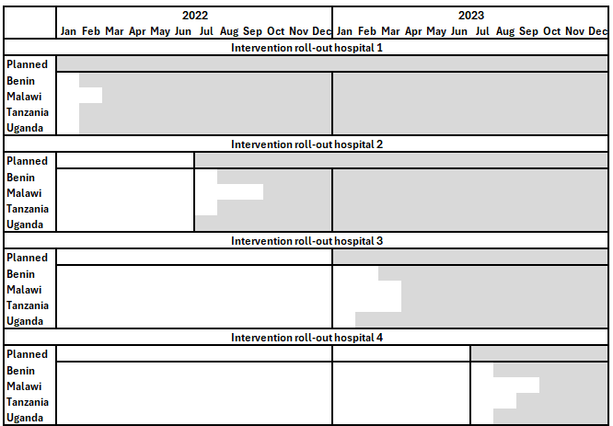
Figure S5: Intended and effective implementation

Table S6: Definitions of ALERT trial outcomes
Indicators | Definitions | Methods
Primary outcome
Fresh stillbirth rate | Number of fresh stillbirths of at least 1000g per 1000 live- and stillbirth | e-registry
Early perinatal mortality rate | Number of fresh stillbirths and 24-hour neonatal deaths per 1000 live- and stillbirths (composite indicator) | e-registry
Secondary outcomes
Hypoxic-ischemic event rate | No of neonates with Apgar < 7 at 5 min per 1000 live- and stillbirths | e-registry
Neonatal seizures | No of neonates diagnosed with seizures per 1000 live- and stillbirths | e-registry
Cesarean section (%) | No of Cesarean section per 100 live- and stillbirths | e-registry
Severe maternal morbidity (%) | No of women with morbidities # per 100 live- and stillbirths  (women with hysterectomy, laparotomy, blood transfusion, admission to intensive care unit or referral to higher level facility) | e-registry
Responsiveness score (%) | Validated score (%) | Exit interviews
Respectful treatment score (%) | Validated score (%) | Exit interviews
Process indicators
Admission standards and procedures
Fetal heart check on admission (%) | Percentage of babies with fetal check at admission done | e-registry
Intrapartum monitoring
Fetal monitoring in 1st stage of labor | Percentage of babies with fetal monitoring done and documented in 1st stage | e-registry
Emergency preparedness
Resuscitation for babies with Apgar < 7 | Percentage of babies with Apgar < 7 who were resuscitated | e-registry
Responsiveness-focused
Companion present during labor or birth | Percentage of women who reported having a companion during labor or birth | Exit interviews
Early newborn care
Breastfeeding within 1 hour | Breastfeeding within 1 hour after birth | Exit interviews

