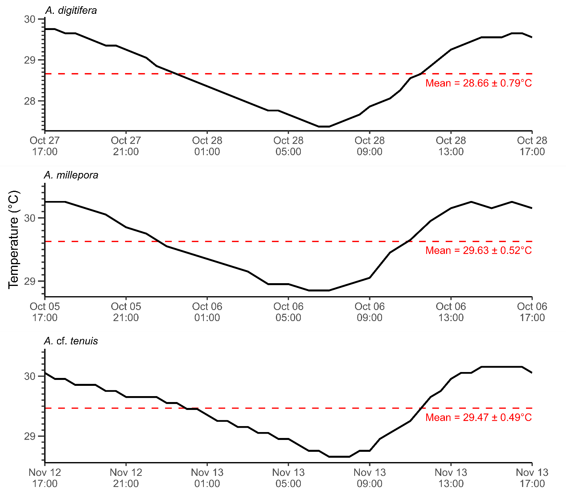
Fig. S1 Temperature in flow-through seawater tanks (°C). Black solid lines represent temperature through a one-day holding period prior to preparation of coral fragments. Horizontal dashed line represents mean temperature and standard deviation.

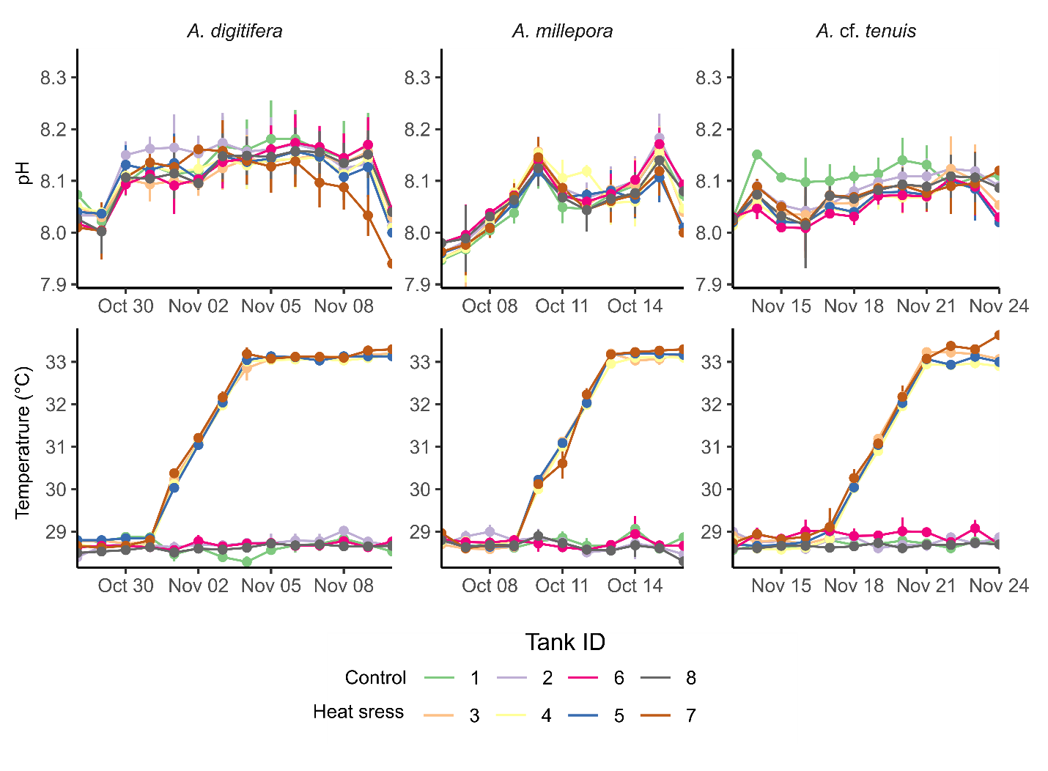
Fig. S2 pH and temperature (°C) in experimental tanks. Mean values (± standard deviation) recorded for each experimental run are shown. Colors correspond to tank IDs.
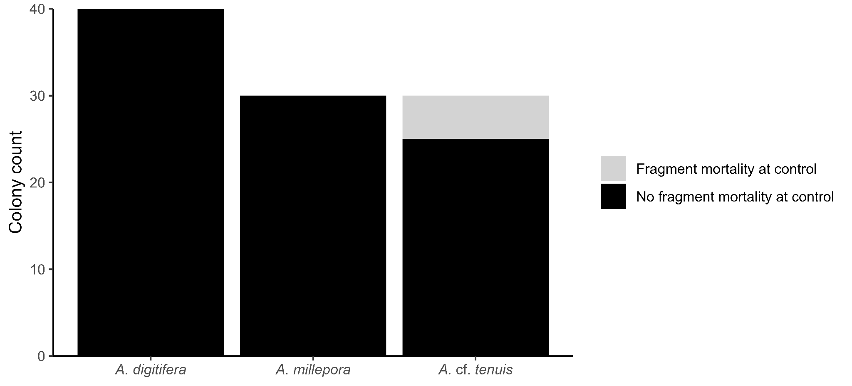
Fig. S3 Number of colonies of A. digitifera, A. millepora and A. cf. tenuis used in the experiment. Colonies with fragments that exhibited bleaching in control tanks (29 °C) during the course of the experiment are shown in gray.
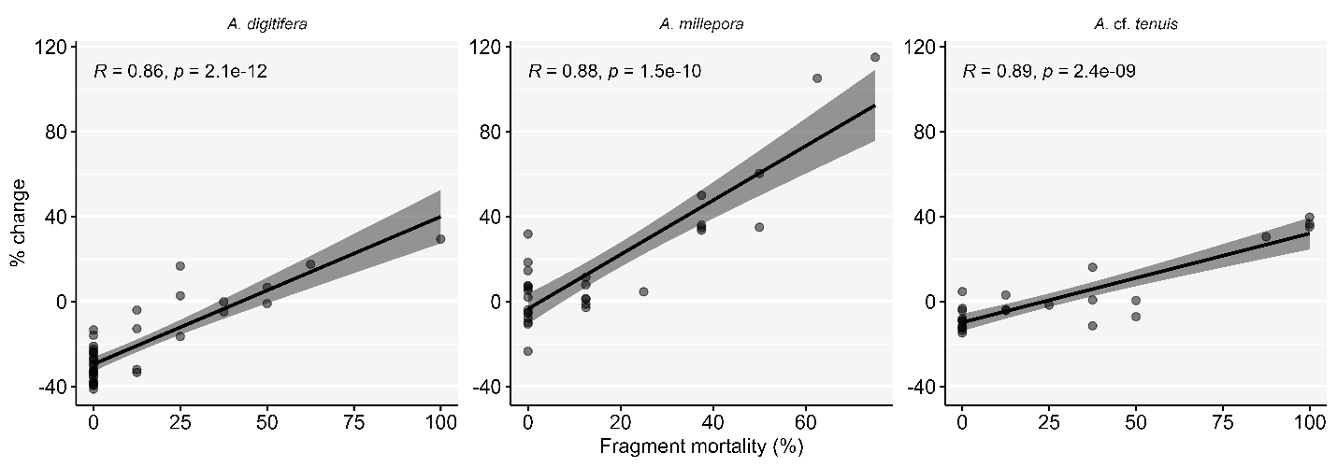
Fig. S4 Correlation of fragment mortality and % color change in A. digitifera, A. millepora, and A. cf. tenuis. Black line represents regression line with shadow denoting confidence interval. Points represent each colony.
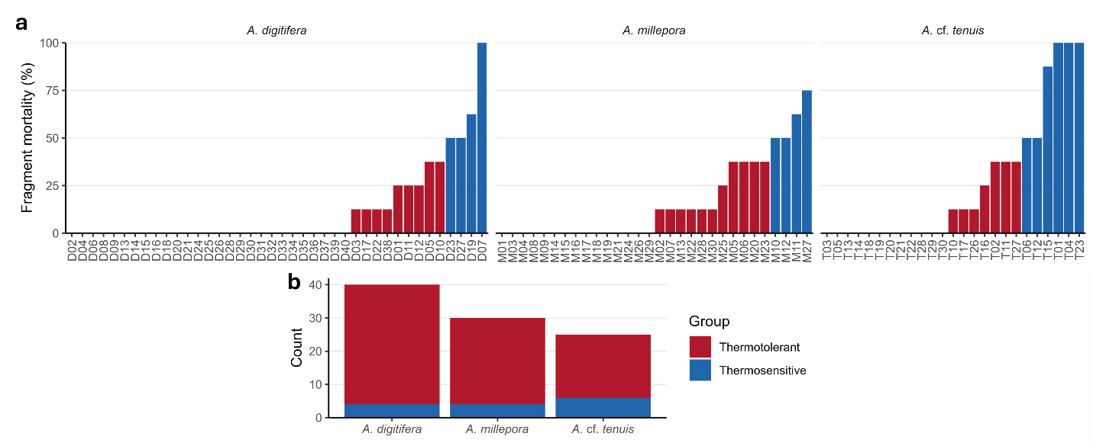Fig. S5 Thermotolerance classification based on fragment mortality of A. digitifera, A. millepora and A. cf. tenuis. (a) Bar plots of colonies ranked from lowest to highest proportion of fragment mortality. (b) Colonies classified as thermotolerant or thermosensitive based on fragment mortality (red, thermotolerant < 50% fragment mortality; blue, thermosensitive ≥ 50% fragment mortality).

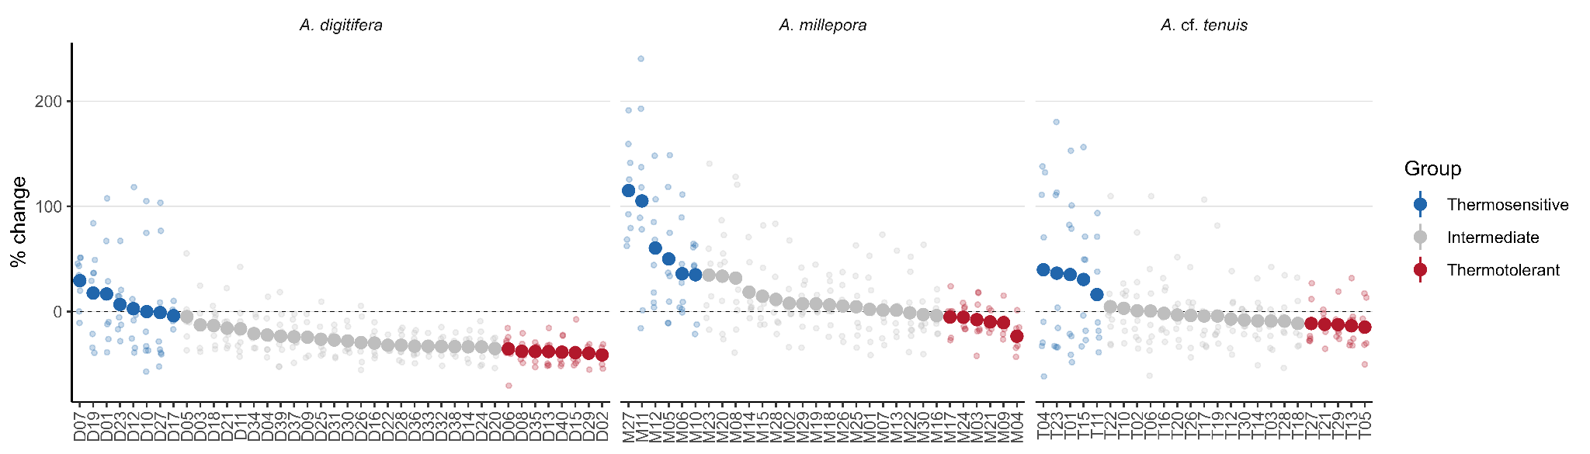
Fig. S6 Scatterplots of A. digitifera, A. millepora and A. cf. tenuis colonies ranked from highest to lowest % color change. Colors represent thermosensitive (blue, 20% of colony population with greatest color change), intermediate (gray, middle 60%), or thermotolerant colonies (red, 20% with least color change). Big circles represent mean values.
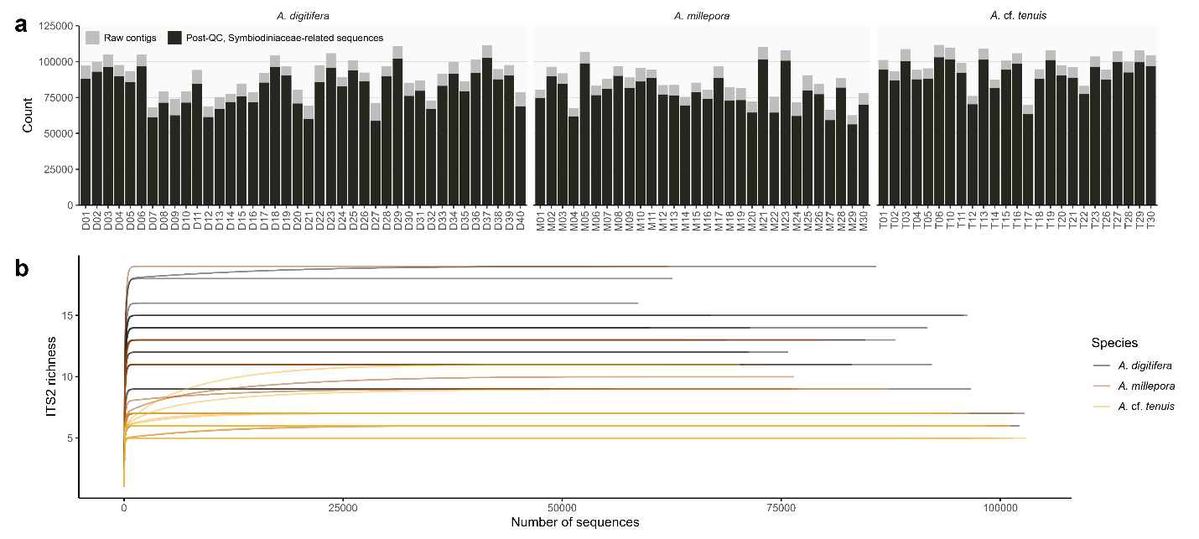
Fig. S7 ITS2 sequencing of acroporids. (a) Bar plots of ITS2 sequences extracted from A. digitifera, A. millepora, and A. cf. tenuis. Colors represent raw ITS2 contigs (gray) and post-quality checking, Symbiodiniaceae-related ITS2 sequences (black). (b) Rarefaction curves of ITS2 sequences per Acropora colony.
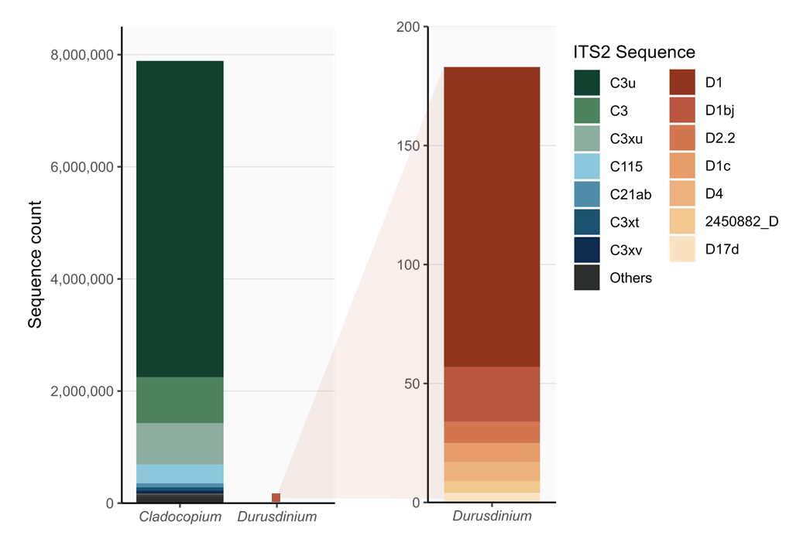
Fig. S8 Identity of Cladocopium and Durusdinium-related ITS2 sequences. Colors represent sequence identity.

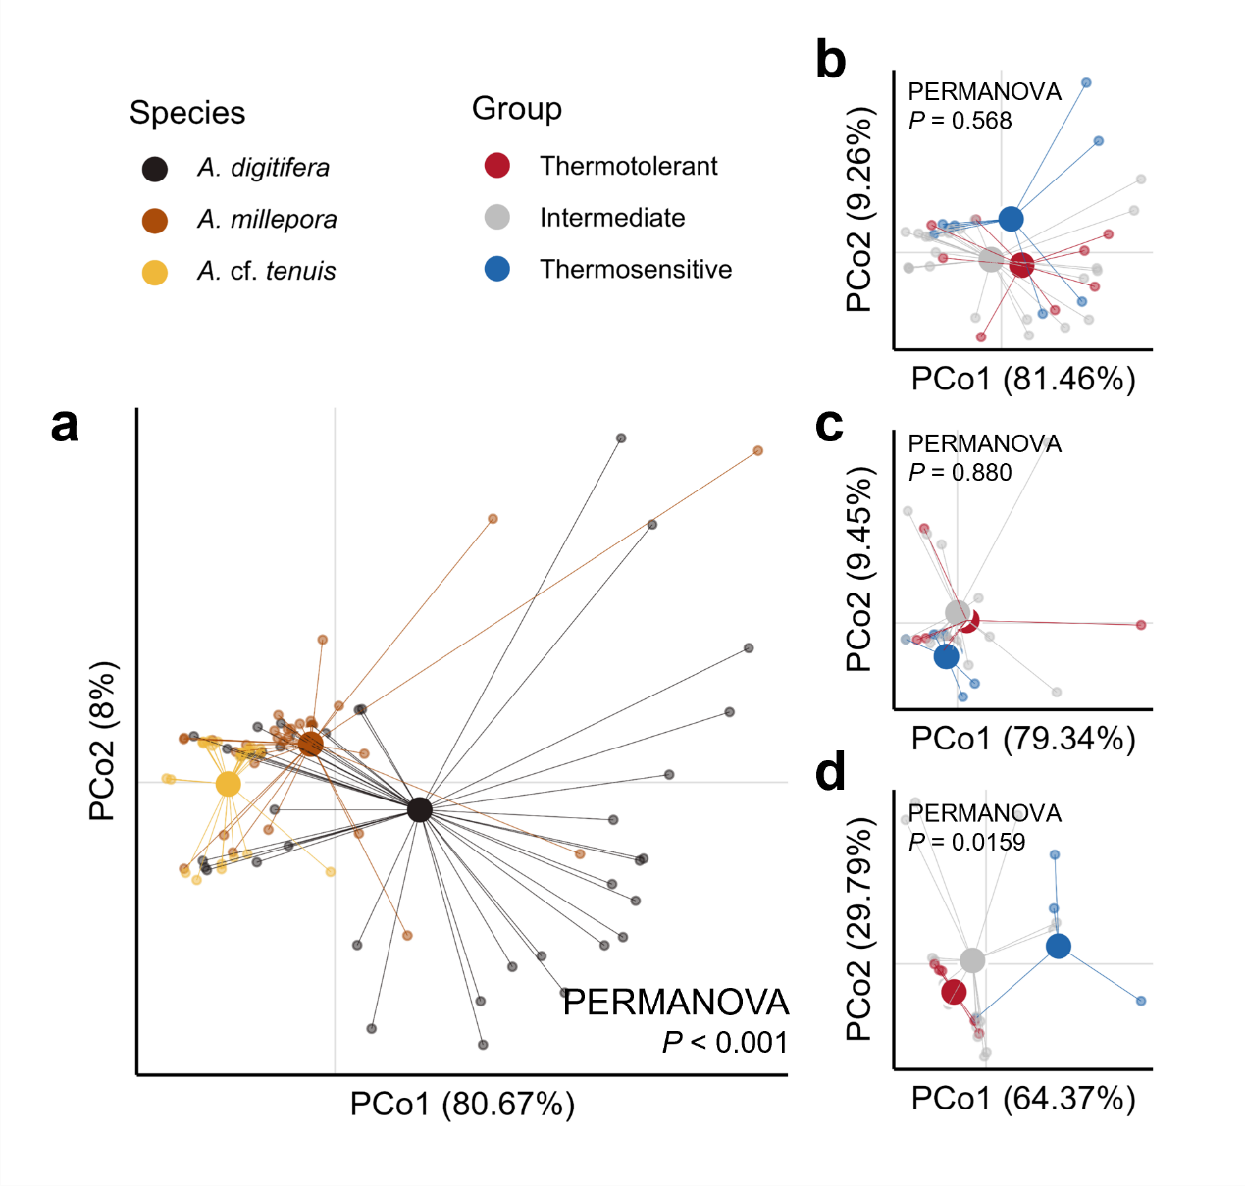
Fig. S9 PCoA plots based on percentage difference (Bray-Curtis dissimilarity) of ITS2 sequences among (a) Acropora species, and among individuals of (b) Acropora digitifera, (c) A. millepora and (d) A. cf. tenuis. Colors in A denote Acropora species, while colors in B-D indicate thermotolerance classification. Lines denote the distance of each sample (small circle) to the group centroid (big circle).
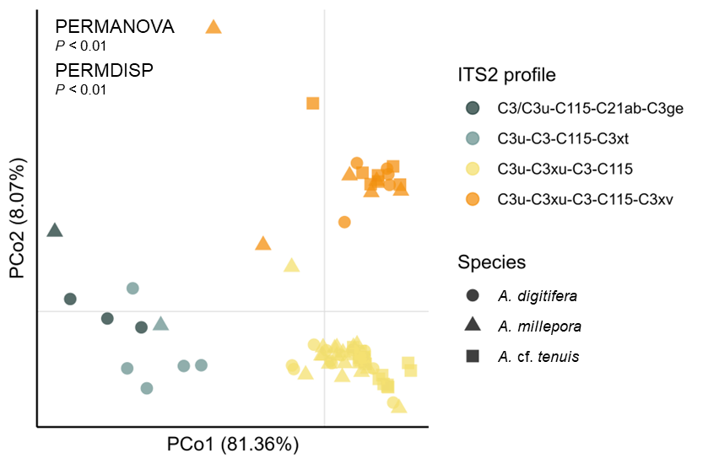
Fig. S10 PCoA plot based on weighted Unifrac of ITS2 sequences among subsampled Acropora species (25 per species). Colors depict ITS2 profiles while shapes represent host coral species.
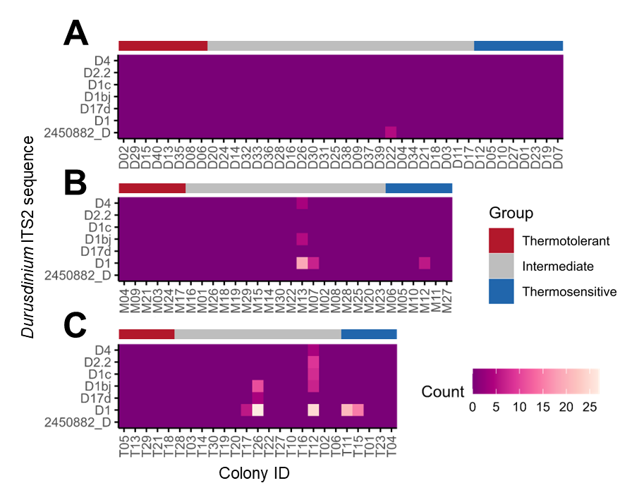
Fig. S11 Durusdinium ITS2 sequences in (A) Acropora digitifera, (B) A. millepora and (C) A. cf. tenuis colonies. Heatmaps represent sequence counts. Color bars on top of each heatmap denotes thermotolerance group.

