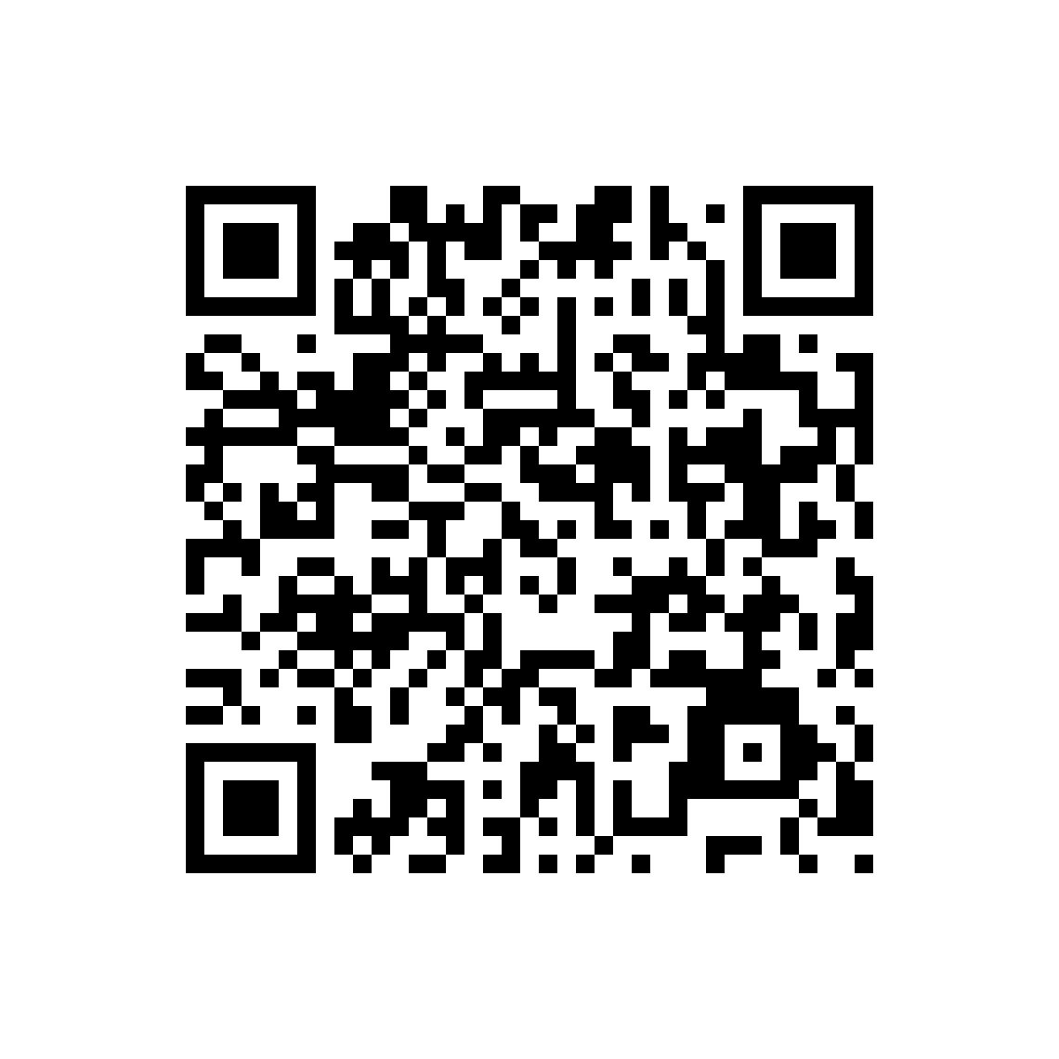 1.The comprehensive dataset of control variables for listed companies (1413+ indicators) from 1990 to 2023 has been saved as a .dta file and stored in the Baidu Cloud Drive database. Link: https://pan.baidu.com/s/1oHrhRsnM0LPR40dQfZmSrA?pwd=lmx1, Extraction code: lmx1;
2.Original data source: CSMAR (Guotaian Database) https://data.csmar.com/

