Table S1. Vegetation characteristics (height, coverage, density, and aboveground biomass) under different combined treatment regimes.
Year | Treatment | Vegetation height/cm | Vegetation coverage/% | Vegetation density/(plants·m⁻²) | Aboveground biomass/(g·m⁻²)
 | CK | 16.53±0.93 d | 58.81±1.42 d | 345.33±8.35 c | 198.33±8.19 c
 | W1J1 | 21.11±0.70 c | 63.47±0.98 c | 385.67±7.36 b | 223.33±8.17 c
 | W1J2 | 26.31±1.10 b | 64.98±1.45 c | 408.67±8.65 ab | 266.33±12.17 b
 | W1J3 | 34.29±0.63 a | 75.32±2.54 a | 424.00±11.33 a | 325.00±21.08 a
2023 | W2J1 | 31.51±2.25 a | 69.67±1.47 b | 413.67±10.99 a | 315.33±11.05 a
 | W2J2 | 32.03±1.45 a | 71.02±1.63 ab | 420.67±5.24 a | 322.33±12.86 a
 | W2J3 | 32.74±1.40 a | 72.51±1.94 ab | 414.00±4.04 a | 339.67±9.61 a
 | W3J1 | 34.92±1.68 a | 74.31±0.61 a | 428.00±9.07 a | 342.67±11.89 a
 | W3J2 | 31.68±0.78 a | 72.49±1.77 ab | 411.33±5.84 a | 331.33±3.76 a
 | W3J3 | 31.72±0.90 a | 71.14±0.92 ab | 406.33±13.38 a | 326.67±11.92 a
 | CK | 17.86±1.06 e | 59.14±0.96 d | 342.67±10.48 c | 195.67±4.84 f
 | W1J1 | 22.71±0.75 d | 65.13±1.64 c | 389.00±4.04 b | 233.33±1.86 e
 | W1J2 | 26.64±1.15 c | 68.98±0.89 bc | 422.00±17.62 a | 273.00±6.08 d
 | W1J3 | 35.16±0.46 ab | 76.98±0.91a | 440.33±5.33 a | 351.33±7.22 a
2024 | W2J1 | 32.18±1.64 b | 73.33±2.03 ab | 437.00±14.36 a | 321.00±5.77 c
 | W2J2 | 33.70±0.67 ab | 72.72±2.30 ab | 434.00±12.5 a | 329.00±10.69 bc
 | W2J3 | 34.07±1.84 ab | 73.84±1.57 a | 424.00±8.14 a | 339.67±3.53 abc
 | W3J1 | 35.87±1.78 a | 77.31±1.13 a | 434.67±3.67 a | 352.67±4.98 a
 | W3J2 | 33.01±0.55 ab | 73.49±2.65 ab | 421.33±8.99 a | 344.67±10.37 ab
 | W3J3 | 32.72±0.61 ab | 72.47±1.27 ab | 409.67±13.38 a | 323.33±7.22 c
Note: W represents the application level of forage-specific fertilizer (W1: 225.00 kg·hm⁻²; W2: 300.00 kg·hm⁻²; W3: 375.00 kg·hm⁻²); J represents the application level of composite microbial inoculant (J1: 350.00 kg·hm⁻²; J2: 500.00 kg·hm⁻²; J3: 650.00 kg·hm⁻²). Data are presented as mean ± standard deviation (n = 3). Lowercase letters (e.g., “a”, “b”) within each column indicate significant differences among treatments at the 0.05 probability level.

Figure S1. Relative abundance of soil fungal communities under different treatments. (a) Phylum level; (b) Genus level.
Figure S2. Linear Discriminant Analysis Effect Size (LEfSe) analysis identifying discriminant fungal taxa across different treatments.
Figure S3. Network analysis of soil fungal communities at the genus level, highlighting shifts in dominant hub taxa.
Figure S4. FUNGuild functional classification of soil fungal communities under different fertilization treatments.
Figure S1. Relative abundance of soil fungal communities under different treatments. (a) Phylum level; (b) Genus level.
Note: W represents forage-specific fertilizer level (W1: 225.00 kg·hm⁻²; W2: 300.00 kg·hm⁻²; W3: 375.00 kg·hm⁻²); J represents composite microbial inoculant level (J1: 350.00 kg·hm⁻²; J2: 500.00 kg·hm⁻²; J3: 650.00 kg·hm⁻²).
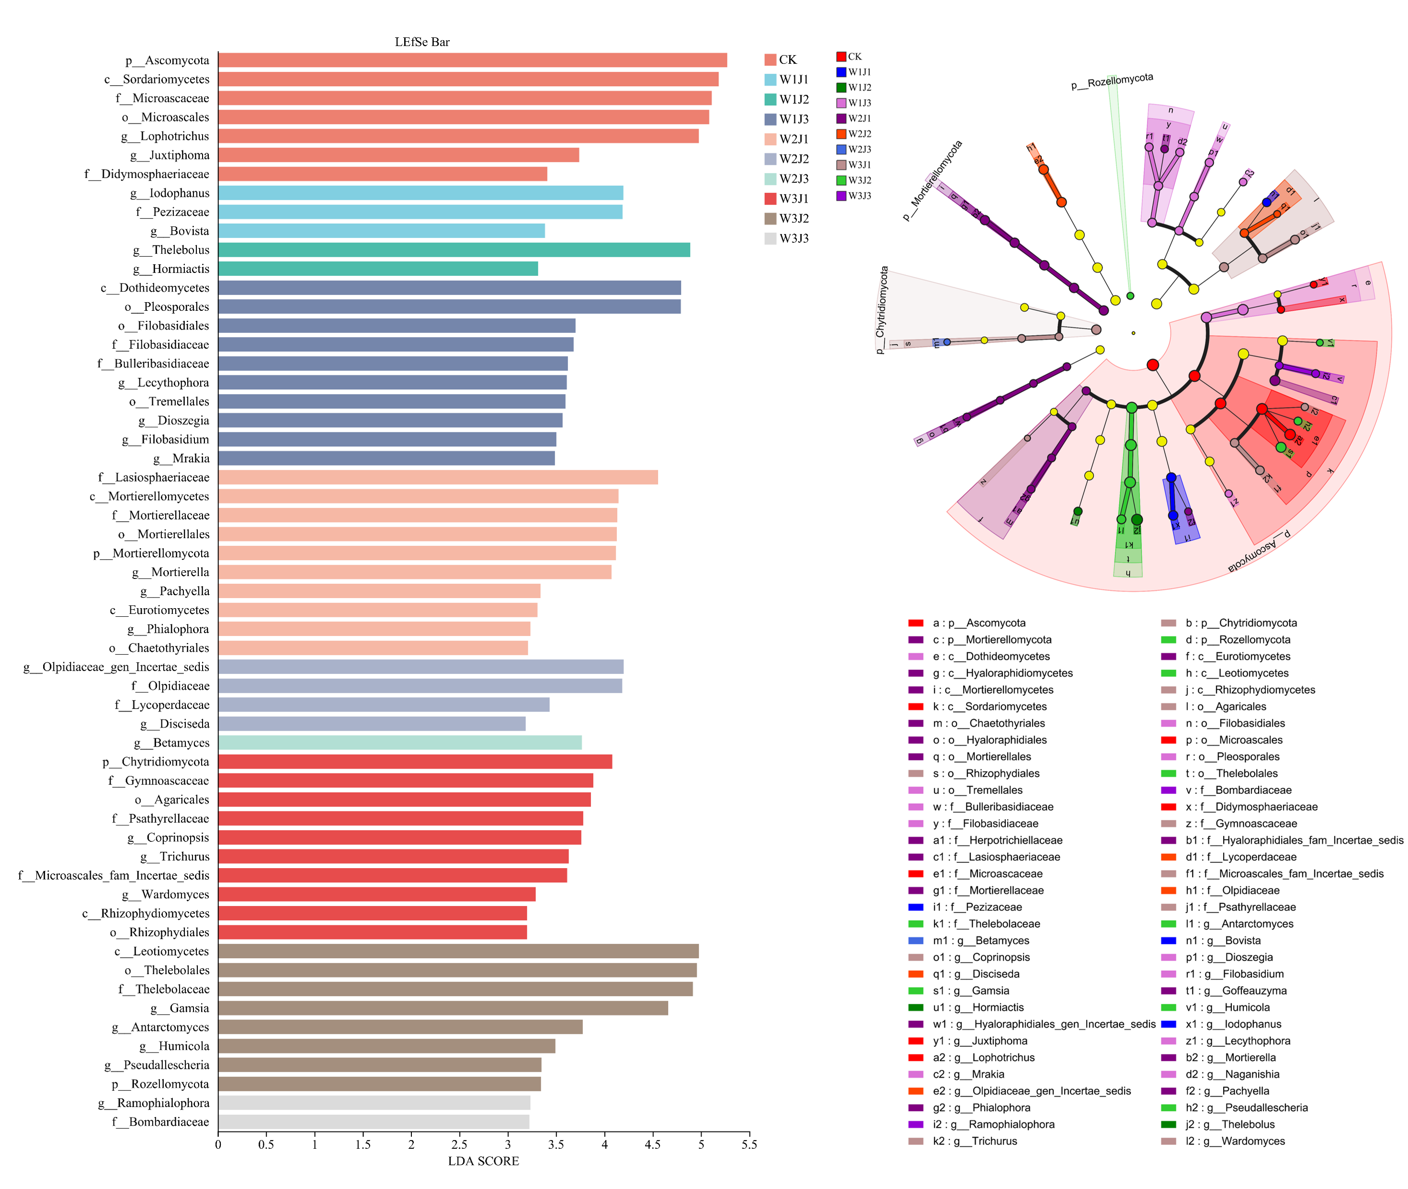
Figure S2. Linear Discriminant Analysis Effect Size (LEfSe) analysis identifying discriminant fungal taxa across different treatments.
Note: W represents forage-specific fertilizer level (W1: 225.00 kg·hm⁻²; W2: 300.00 kg·hm⁻²; W3: 375.00 kg·hm⁻²); J represents composite microbial inoculant level (J1: 350.00 kg·hm⁻²; J2: 500.00 kg·hm⁻²; J3: 650.00 kg·hm⁻²).
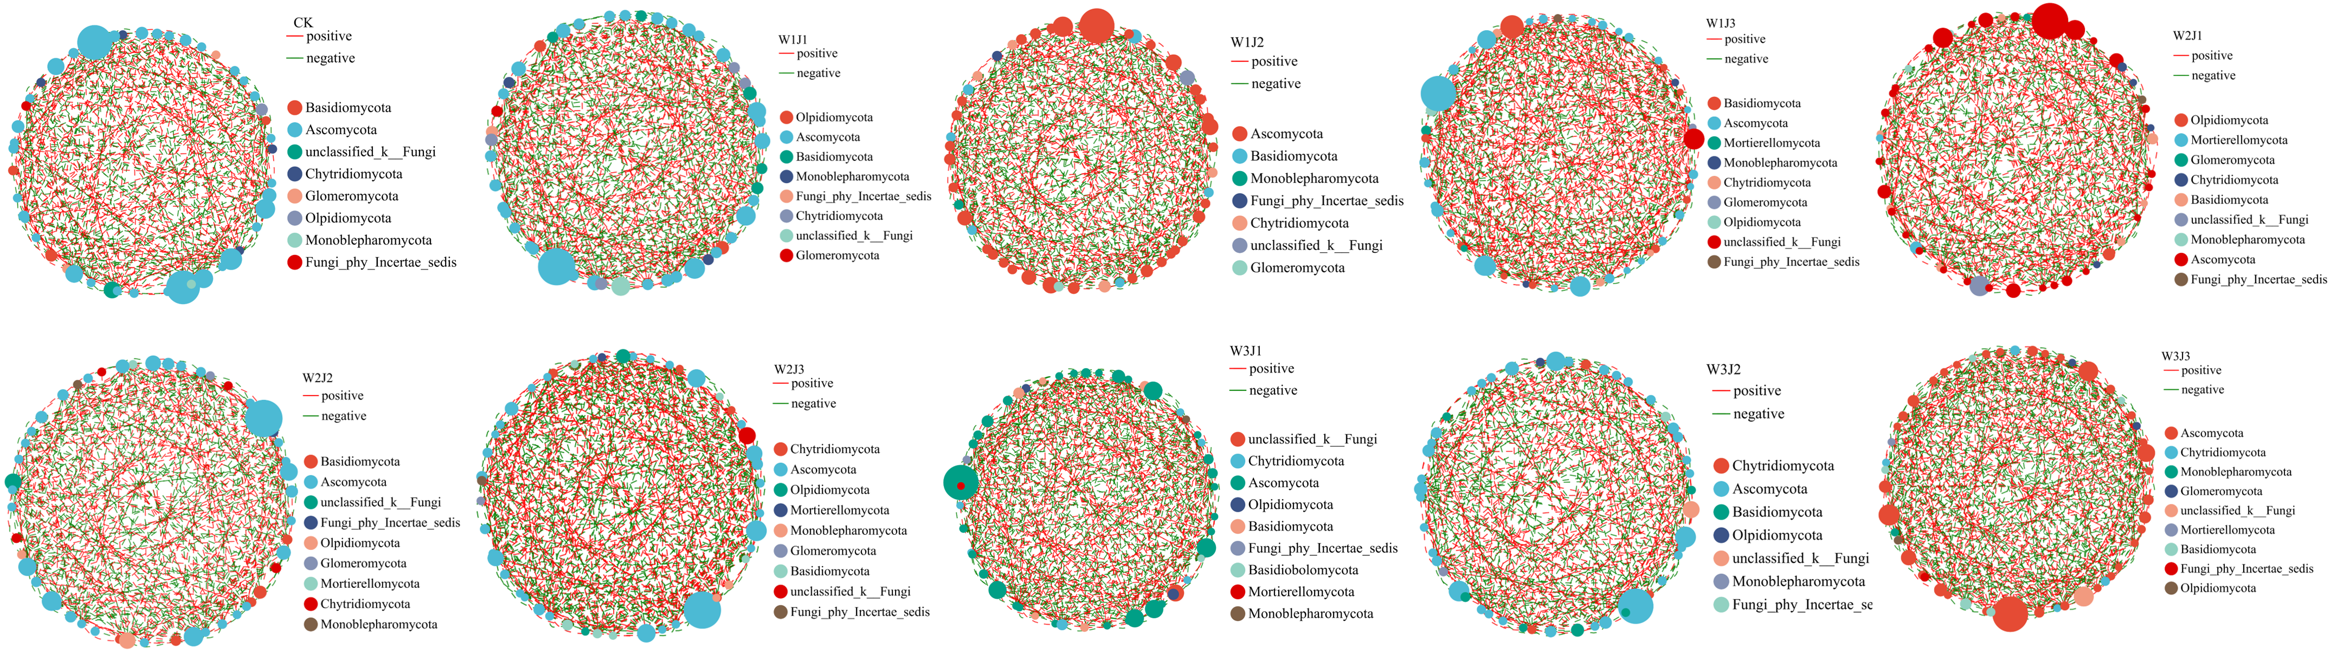
Figure S3. Network analysis of soil fungal communities at the genus level, highlighting shifts in dominant hub taxa.
Note: W represents forage-specific fertilizer level (W1: 225.00 kg·hm⁻²; W2: 300.00 kg·hm⁻²; W3: 375.00 kg·hm⁻²); J represents composite microbial inoculant level (J1: 350.00 kg·hm⁻²; J2: 500.00 kg·hm⁻²; J3: 650.00 kg·hm⁻²).
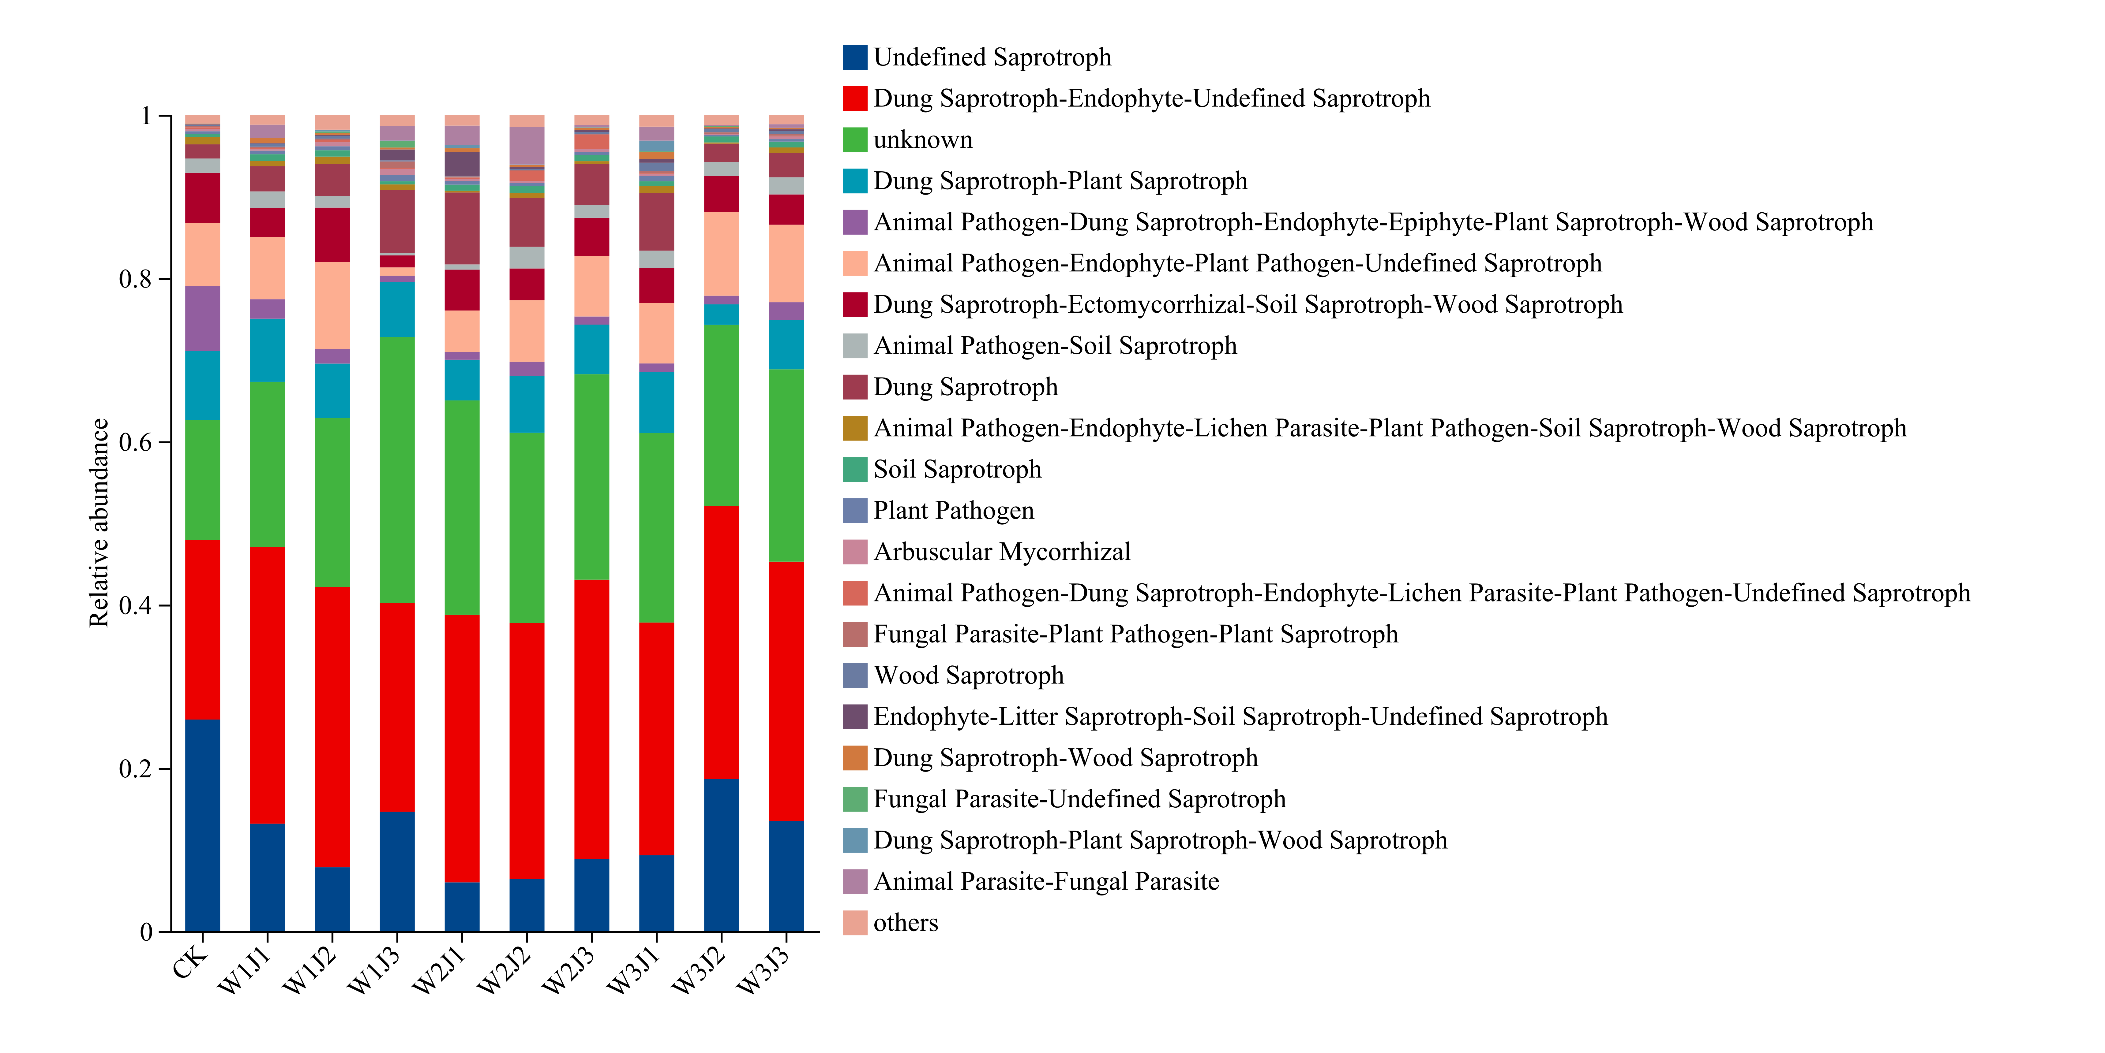
Figure S4. FUNGuild functional classification of soil fungal communities under different fertilization treatments.
Note: W represents forage-specific fertilizer level (W1: 225.00 kg·hm⁻²; W2: 300.00 kg·hm⁻²; W3: 375.00 kg·hm⁻²); J represents composite microbial inoculant level (J1: 350.00 kg·hm⁻²; J2: 500.00 kg·hm⁻²; J3: 650.00 kg·hm⁻²).

