A novel 2-hydroxyisobutyrylation signaling pathway drives fluoroquinolone resistance in Staphylococcus aureus

Yun Liu, Zhen Wang, Jiamin Qiu, Haiming Wu, Jiayi Wu, Tairan Zhong, Yundan Zheng, Nan Li, Yunpeng Yang, Zhenghua Sun, Qing-Yu He, Xuesong Sun,

Supplementary Information

This Supplementary Information file contains:
Fig. S1: Enrichment analyses of 2-hydroxyisobutyrylated proteins in S. aureus.
Fig. S2: Peptide motif with conserved residues around Khib sites was analyzed using the Motif-X tool.
Fig. S3: Preliminary exploration of AcuA as a lysine 2-hydroxyisobutyryltransferase.
Fig. S4: Enrichment analysis of differentially expressed proteins in CIP-R ΔacuA versus CIP-R strain.
Fig. S5: AcuA regulates the biofilm operon of S. aureus.
Fig. S6: 2-hydroxyisobutyrylation alters the conformation of the CodY DNA-binding domain (DBD).
Table S1: MIC of clinical multidrug-resistant (MDR) strains.
Table S2: The transcription regulatory factors with differentiate Khib modification levels in CIP-R are listed.
Table S3: Bacterial strains and plasmids used in this study.
Table S4: Oligonucleotides used in this study.

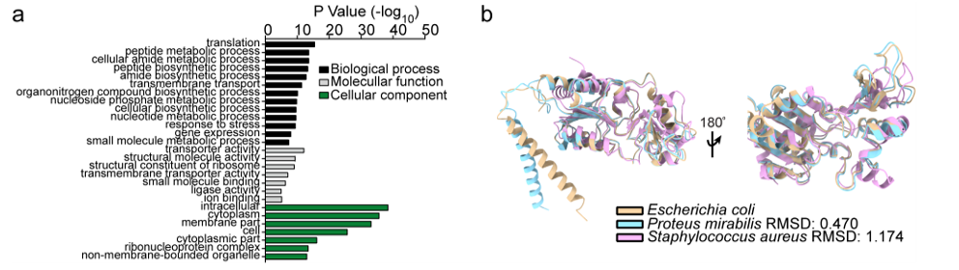
Fig. S1: Enrichment analyses of 2-hydroxyisobutyrylated proteins in S. aureus.
a. GO-based enrichment analysis of identified proteins. The value of -log10 (Fisher’s test p-value) is shown. b. Structure alignment of CobB from S. aureus, E. coli, and P. mirabilis using ChimeraX.

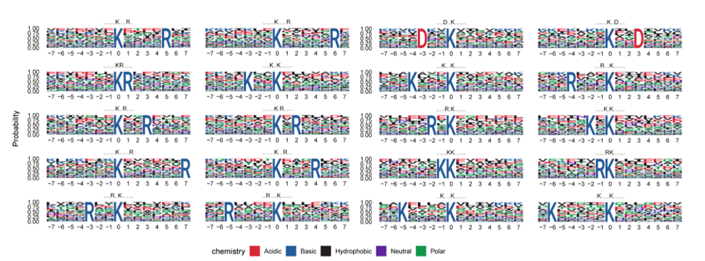
Fig. S2: Peptide motif with conserved residues around Khib sites was analyzed using the Motif-X tool.

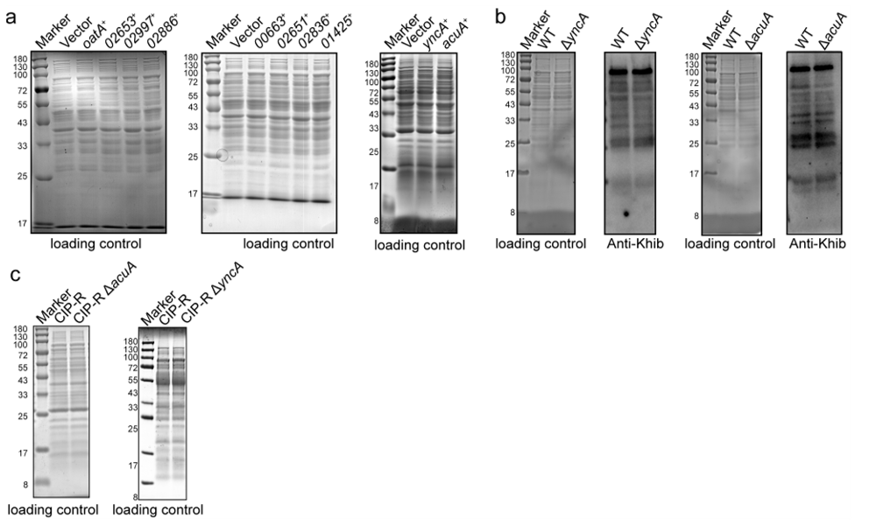
Fig. S3: Preliminary exploration of AcuA as a lysine 2-hydroxyisobutyryltransferase.
a. SDS-PAGE showing the loading control for whole-cell lysates from S. aureus NCTC 8325 strains containing overexpression plasmids. b. Western blot detection of Khib levels in whole-cell lysates of the WT knockout strains (ΔyncA and ΔacuA) and compared with those of the WT strain. c. SDS-PAGE showing the loading control for whole-cell lysates from CIP-R and knockout strains (CIP-R ΔyncA and CIP-R ΔacuA).

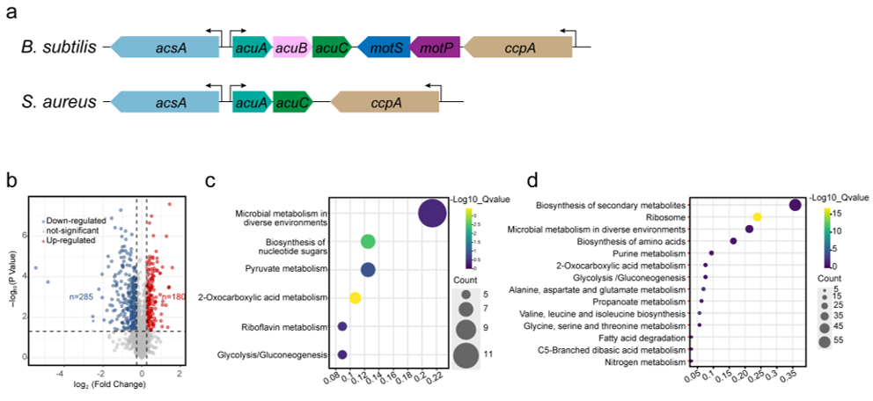
Fig. S4: Enrichment analysis of differentially expressed proteins in CIP-R ΔacuA versus CIP-R strain.
a. Schematics of the acuABC operon in S. aureus and B. subtilis. b. Volcano plot displaying differential proteins in CIP-R ΔacuA compared to the control strain (CIP-R). c-d. KEGG pathway enrichment analysis of upregulated (c) and downregulated (d) proteins in CIP-R ΔacuA.

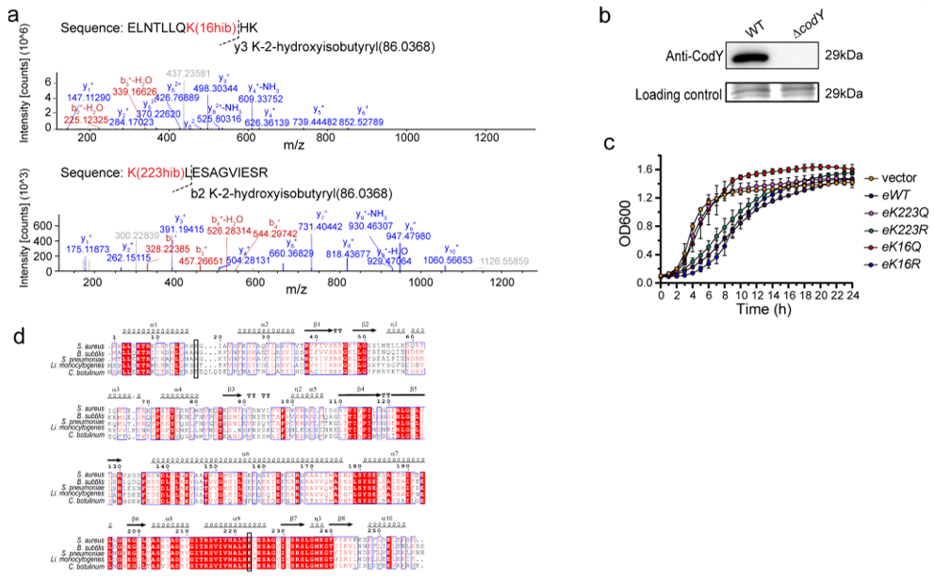
Fig. S5: AcuA regulates the biofilm operon of S. aureus.
a. MS/MS spectrum of the peptides (ELNTLLQK(16hib)HK) and (K(223hib)LESAGVIESR) from the CIP-R proteome. b. Western blot analysis of CodY knockout in S. aureus. c. Growth curves of CodY and its mutant strains in CD medium. d. Multiple sequence alignment of CodY from different species by Clustal W and visualized using ESPript3.

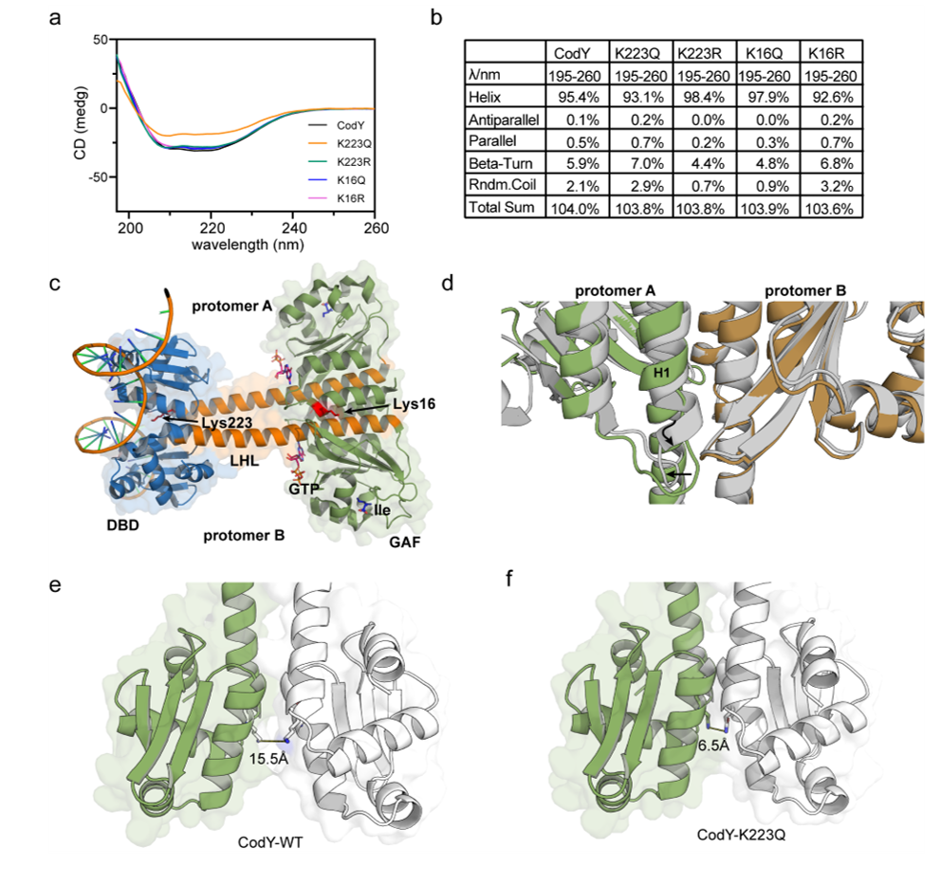
Fig. S6: 2-hydroxyisobutyrylation alters the conformation of the CodY DNA-binding domain (DBD).
a-b. Circular dichroism (CD) analysis evaluating the conformation of CodY mutant proteins. c. Lys16 and Lys223 of CodY are located within the GAF domain and DBD domain. d. Ligand-binding induces extension of the H1 chain (marked with a wavy arrow), causing displacement of the Glu 15-Lys 18 residues to promote dimer formation (marked with a straight arrow). Two ligand-free CodY monomers (green and yellow) were overlayed with an Ile/GTP-bound CodY dimer (grey). e-f. Structural and distant changes in the DBD domain induced by the K223Q mutation. (e) Wild-type CodY. (f) K223Q mutant. K223 is shown in red.

Table S1. MIC of clinical multidrug-resistant (MDR) strains.
MIC (μg/mL) | Clinical multidrug-resistant S. aureus
MIC (μg/mL) | C1 | C2 | C3 | C4 | C5
Oxacillin | 4 | 4 | >2 | >4 | 2
Penicillium | 0.5 | 0.5 | >0.25 | >0.5 | 0.25
Gentamicin | 16 | 16 | >8 | >16 | 8
Levofloxacin | 8 | 8 | ND | >8 | ND
Moxifloxaicn | 1 | 8 | ND | ND | ND
Ciprofloxacin | ND | ND | >4 | ND | 4
Clindamycin | 4 | 4 | >2 | >4 | 2
Erythromycin | 8 | 8 | >4 | >8 | 4
ND: Not detected

Table S2. The transcription regulatory factors with differentiate Khib modification levels in CIP-R are listed.

 | Gene name | Uniprot ID | Fold Change (CIP-R/WT) | Protein description
 | codY | Q2FZ27 | 1.63 | Global transcriptional regulator CodY
 | SAOUHSC_02913 | Q2FV26 | 1.71 | HTH tetR-type domain-containing protein
 | SAOUHSC_02852 | Q2FV83 | 2.32 | HTH lysR-type domain-containing protein
 | SAOUHSC_02585 | Q2FVV6 | 1.50 | HTH deoR-type domain-containing protein
 | cspA | Q2FUQ9 | 0.42 | Cold shock protein CspA
 | rex | Q2FWL6 | 1.41 | Redox-sensing transcriptional repressor Rex
 | nreC | Q2FVM7 | 1.78 | Oxygen regulatory protein NreC
 | SAOUHSC_01285 | Q2FYY7 | 0.48 | HTH merR-type domain-containing protein
 | SAOUHSC_01490 | Q2FYG2 | 1.55 | DNA-binding protein HU, putative
 | SAOUHSC_00892 | Q2FZU8 | 1.65 | S1 motif domain-containing protein
 | birA | Q2G258 | 1.80 | Bifunctional ligase/repressor BirA
 | SAOUHSC_00638 | Q2G2L0 | 1.61 | Manganese transport regulator
 | walR | Q2G2U6 | 0.65 | Transcriptional regulatory protein WalR
 | graR | Q2G0E0 | 1.43 | Response regulator protein GraR
 | vraR | Q2FX09 | 1.48 | Response regulator protein VraR
 | SAOUHSC_00679 | Q2G0C6 | 1.41 | HTH lysR-type domain-containing protein
 | SAOUHSC_00673 | Q2G0D2 | 2.65 | HTH araC/xylS-type domain-containing protein
 | SAOUHSC_00434 | Q2G0U3 | 2.01 | Transcriptional regulator, lysR family, putative
 | SAOUHSC_00706 | Q2G240 | 1.82 | HTH deoR-type domain-containing protein
sarA |  | Q2G2U9 | 1.86 | Transcriptional regulator SarA
 | SAOUHSC_00631 | Q2G2W4 | 2.14 | HTH tetR-type domain-containing protein
 | rot | Q9RFJ6 | 0.43 | HTH-type transcriptional regulator rot
SAOUHSC_02961 |  | Q2FUY4 | 1.82 | HTH marR-type domain-containing protein
sarX |  | Q2G0D1 | 3.14 | HTH-type transcriptional regulator SarX
Potential interacting proteins of AcuA are indicated in bold.

Table S3. Bacterial strains and plasmids used in this study.

 | Strains/plasmids | Relevant genotype and property | Source/reference
 | E. coli
 | DH5α | endA1 recA1 gyrA96 thi-1 hsdR17 (rKmK+) relA1 supE44 (lacZYA-argF) U169 F-80dlacZM15 deoR phoA | Invitrogen
 | BL21 (DE3) | Expression strain, F-, ompT, hsdS (rBB-mB－), gal, dcm(DE3) | Invitrogen
 | DC10B | mcrA ∆(mrr-hsdRMS-mcrBC) ϕ80lacZ∆M15 ∆lacX74 recA1 araD139 ∆(ara-leu)7697 galU galK rpsL endA1 nupG dcm- | BEI Resources
 | S. aureus
 | NCTC8325 | Rrototypical strain for all genetic manipulation | Laboratory stock
 | NCTC8325 (pCN51) | NCTC8325 transformed with pCN51, ermR | This study
 | NCTC8325 (pCN51-oatA) | NCTC8325 transformed with pCN51-oatA, ermR | This study
NCTC8325 (pCN51-oatA) |  | NCTC8325 transformed with pCN51-oatA, ermR | This study
NCTC8325 (pCN51-02653) |  | NCTC8325 transformed with pCN51-02653, ermR | This study
NCTC8325 (pCN51-02997) |  | NCTC8325 transformed with pCN51-02997, ermR | This study
NCTC8325 (pCN51-02886) |  | NCTC8325 transformed with pCN51-02886, ermR | This study
NCTC8325 (pCN51-00663) |  | NCTC8325 transformed with pCN51-00663, ermR | This study
NCTC8325 (pCN51-02651) |  | NCTC8325 transformed with pCN51-02651, ermR | This study
NCTC8325 (pCN51-02836) |  | NCTC8325 transformed with pCN51-02836, ermR | This study
NCTC8325 (pCN51-01425) |  | NCTC8325 transformed with pCN51-01425, ermR | This study
NCTC8325 (pCN51-acuA) |  | NCTC8325 transformed with pCN51-acuA, ermR | This study
NCTC8325 (pCN51-yncA) |  | NCTC8325 transformed with pCN51-yncA, ermR | This study
NCTC8325 (pCN51-acuA^{H139A}) |  | NCTC8325 transformed with pCN51-acuA^{H139A}, ermR | This study
NCTC8325 (pCN51-acuA^{W140A}) |  | NCTC8325 transformed with pCN51-acuA^{W140A}, ermR | This study
 | ΔcobB | cobB mutant through homologous recombination derived from NCTC8325 | This study
 | ΔacuA | acuA mutant through homologous recombination derived from NCTC8325 | This study
 | ΔyncA | yncA mutant through homologous recombination derived from NCTC8325 | This study
 | CIP-R | Derived from NCTC8325; Ciprofloxacin resistance | This study
 | CIP-R ΔacuA | acuA mutant through homologous recombination derived from CIP-R | This study
 | CIP-R ΔyncA | yncA mutant through homologous recombination derived from CIP-R | This study
 | CIP-R (pCN51) | CIP-R transformed with pCN51, ermR | This study
 | CIP-R (pCN51-cobB) | CIP-R transformed with pCN51-cobB, ermR | This study
 | RMSA24 | foodborne | ¹
 | ΔcodY | codY mutant through transposon mutagenesis derived from RMSA24 | ¹
 | ΔcodY (pWWW412) | ΔcodY transformed with pWWW412, cmR | This study
 | ΔcodY (WWW412-codY) | ΔcodY transformed with pWWW412-CodY, cmR | This study
 | ΔcodY (pWWW412-CodY^{K6R}) | ΔcodY transformed with pWWW412-CodY^{K6R}, cmR | This study
 | ΔcodY (WWW412- CodY^{K16R}) | ΔcodY transformed with pWWW412- CodY^{K16R}, cmR | This study
 | ΔcodY (WWW412 CodY^{K223R}) | ΔcodY transformed with pWWW412 CodY^{K223R}, cmR | This study
 | ΔcodY (pWWW412 CodY^{K16Q}) | ΔcodY transformed with pWWW412 CodY^{K16Q}, cmR | This study
 | ΔcodY (pWWW412 CodY^{K223Q}) | ΔcodY transformed with pWWW412 CodY^{K223Q}, cmR | This study
 | C1-C5 | clinical isolate | This study
 | Plasmids
 | pWWW412 | E. coli/Staphylococcus shuttle cloning plasmid, cmR, ampR | ²
 | pKOR1 | cmR and ampR, temperature-sensitive vector for allelic replacement via lambda recombination and ccdB selection | NovoPro
 | pCN51 | E. coli/Staphylococcus shuttle cloning plasmid, ermR, ampR | NovoPro
pET28a |  | Expression vector with His-tag, kanR | Novagen
 | pGEX-4T-1 vector | Expression vector with GST-tag, ampR | Solarbio
 | pET28a-acuA | acuA cloned into pET28a, kanR | This study
pET28a-acuA^{H139A} |  | acuA (139H→A) cloned into pET28a, kanR | This study
 | pET28a-acuA^{W140A} | acuA (140W→A) cloned into pET28a, kanR | This study
pET28a-codY |  | codY cloned into pET28a, kanR | This study
pET28a-codY^{K6R} |  | codY (6K→R) cloned into pET28a, kanR | This study
pET28a-codY^{K16R} |  | codY (16K→R) cloned into pET28a, kanR | This study
pET28a-codY^{K223R} |  | codY (223K→R) cloned into pET28a, kanR | This study
pET28a-codY^{K16Q} |  | codY (16Q→R) cloned into pET28a, kanR | This study
pET28a-codY^{K223Q} |  | codY (223Q→R) cloned into pET28a, kanR | This study
 | pGEX-4T-1-acuA | acuA cloned into PGEX-4T-1, ampR | This study

Table S4. Oligonucleotides used in this study.

Oligonucleotide | Sequence
Oligonucleotides for isogenic deletion mutants
cobB-up-F | GGGGACAAGTTTGTACAAAAAAGCAGGCTAATTTAGTCGACTACTTCAATATATGTTTTAAT
cobB-up-R | GCTTTTTACATACTGACCCATCAAAATAATGAATGATTTATAACG
cobB-down-F | TGGGTCAGTATGTAAAAAGCATTTCCCG
cobB-down-R | GGGGACCACTTTGTACAAGAAAGCTGGGTACATGGTGGTTCTTATTGGAAGTTAA
yncA-up-F | GGGGACAAGTTTGTACAAAAAAGCAGGCTAAGTAGAAAGAGATGGTTGAAAATC
yncA -up-R | GGGAATTAACATGGTTGTCTTGGCGTATCTAATCATATCAATTCCCC
yncA -down-F | CAAGACAACCATGTTAATTCCCGTGTTATGAGAAATGCAATTGG
yncA -down-R | GGGGACCACTTTGTACAAGAAAGCTGGGT
acuA-up-F | GGGGACAAGTTTGTACAAAAAAGCAGGCTCCAGCTATACAATTTGTAGCGCC
acuA -up-R | AATCCCTCCGATATTCCAAAAAATTTTCAACTCCTCAATCGAC
acuA -down-F | TTTTTGGAATATCGGAGGGATTATATG
acuA -down-R | GGGGACCACTTTGTACAAGAAAGCTGGGTGATCAATTAAACTTAAGAATACATGACTCC
Oligonucleotides for constructing AcuA and its mutants expression strains
pET28a-acuA-F | GGGGATCCATGAATCATTTAAAGACGTATCAA
pET28a-acuA-R | GGGAGCTCTTAAAAGAAAAACCGATTCATATAAC
H140A-F | CTGGCATGCGGATTTAAAAAATTCAAAG
H140A-R | TTAAATCCGGATGCCAGTAATATTCTGTAG
H139A-F | TTACTGGGCTTGGGATTTAAAAAATTCAAAG
H139A-R | AATCCCAAGCCCAGTAATATTCTGTAGTTAT
pGEX-acuA-F | GGGGATCCATGAATCATTTAAAGACGTATCAA
pGEX-acuA-R | GCTCGAGTTAAAAGAAAAACCGATTCATATAAC
Oligonucleotides for constructing CodY and its mutants expression and complementary strains
pET28a-codY-F | GGGGATCCATGAGCTTATTATCTAAAACGAG
pET28a-codY-R | GGGAGCTCTTATTTACTTTTTTCTAATTCATCTAAG
pWWW412-codY-F | ACAATTGAGGTGAACATATGATGAGCTTATTATCTAAAACGAG
pWWW412-codY-R | CAAGCTTGTCGACGGAGCTCTTATTTACTTTTTTCTAATTCATCTAAG
K6R-F | ATTATCTACAACGAGAGAGTTAAACACGTTAC
K6R-R | CTCTCTCGTTCTAGATAATAAGCTCATGGATCCG
K16R-F | ACTTCAAAGACACAAAGGTATTGCGGTTGA
K16R-R | CTTTGTGTCTTTGAAGTAACGTGTTTAACTCTCTC
K16Q-F | ACTTCAACAACACAAAGGTATTGCGGTTGA
K16Q-R | CTTTGTGTTGTTGAAGTAACGTGTTTAACTCTCTCG
K223R-F | ACTACGTAGATTAGAAAGTGCTGGTGTAATTG
K223R-R | TTTCTAATCTACGTAGTGCATTTACAATTAC
K223Q-F | ACTACGTCAATTAGAAAGTGCTGGTGTAATTG
K223Q-R | TTTCTAATTGACGTAGTGCATTTACAATTAC
Oligonucleotides for constructing overexpression strains containing GNATs in S. aureus
pCN51-oatA-F | CGGGATCCATGGATACAAAAGACTTTAAACGTT
pCN51-oatA-R | CGGAATTCTCATTTCTTATTTGTAGCATGTGTTTCC
pCN51-02653-F | CGGGATCCATGAGTCCAAAGACGCGCGAA
pCN51-02653-R | CGGAATTCTCAGTATTTGATATACATACCGCCTGAATCTGGT
pCN51-02997-F | CGGGATCCATGGTATTAAGAAAAGTAATCATGCAG
pCN51-02997-R | CGGAATTCTTACACCTCATCATCCTTTTTTAT
pCN51-02886-F | CGGGATCCATGGCTATAAACATAATTGAATATAATAG
pCN51-02886-R | CGGAATTCTTAATCTTTTAAATTTCTGTAATAAAACC
pCN51-00663-F | CGGGATCCATGGCCCATATTATACGTAGAGTT
pCN51-00663-R | CGGAATTCTTAATTAAGAATTTTAGCCATCATATAGTC
pCN51-02651-F | CGGGATCCATGGCTGGGATAATCAAAGAAATT
pCN51-02651-R | CGGAATTCTAACTCTTTTTCCATAATTAAATCTGTATCC
pCN51-02836-F | CGGGATCCATGATTAGATACGCTAAAAAAGAG
pCN51-02836-R | CGGAATTCTCAATTTTACGAATTAGATTTACAAGAC
pCN51-01425-F | CGGGATCCATGATCCGTCTAGGTAAAATGTCAG
pCN51-01425-R | CGGAATTCCTATTCTTTTAAATTTTTATAATATGC
pCN51-acuA-F | CGGGATCCATGAATCATTTAAAGACGTATCAA
pCN51-acuA-R | CGGAATTCTTAAAAGAAAAACCGATTCATATAAC
pCN51-yncA-F | CGGGATCCATGATTAGATACGCTAAAAAAGAGG
pCN51-yncA-R | CGGAATTCCTAGTCTTGTAAATCTAATTCGT
Oligonucleotides for constructing CobB overexpression strains
pCN51-cobB-F | CGGGATCCGTGTTTAACTTGAAACATGATTTAGAG
pCN51-cobB-R | CGGAATTCTTACTCTGTCATTAATGATTTTACAAC
Oligonucleotides for EMSAs analysis
cap-EMSA-F | GTCGATAATCATTATACGGTTATCGGC
cap-EMSA-R | GACGAAAAATGTAACAATAGCGC
ica-EMSA-F | GAGATTCAAATTGTGATTGACTAACAC
ica-EMSA-R | GCAAATGCAGATGACGATTC
Oligonucleotides for qRT-PCR analysis
icaA-qP-F | GACGTTGGCTACTGGGATAC
icaA-qP-R | ATACTTCGTGTCCCCCTTGAG
icaB qP-F | CGGTAATCAAAAAAGCTGGG
icaB-qP-R | TTCATGGAATCCGTCCCATC
icaR-qP-F | CTTTCTTCCACTGCTCCAAA
icaR-qP-R | TTCAATTATCTAATACGCCTGAGG

Supplementary references
1. Pei, H. et al. CodY: An Essential Transcriptional Regulator Involved in Environmental Stress Tolerance in Foodborne Staphylococcus aureus RMSA24. Foods 12, 3166 (2023).
2. Bobrovskyy, M., Oh, S. Y. & Missiakas, D. Contribution of the EssC ATPase to the assembly of the type 7b secretion system in Staphylococcus aureus. JBC 298, 102318 (2022).

