Supplementary material
A chelation-enhanced fluorescence assay using thiourea capped carbonaceous fluorescent nanoparticles for As (III) detection in water samples

Susan Mohammadiª, Somayeh Mohammadi^{a*}, Abdollah Salimi^{a,b*}, Rezgar Ahmadi ^{a,b}

ª Department of Chemistry, University of Kurdistan, 66177-15175, Sanandaj, Iran
^{b} Research Center for Nanotechnology, University of Kurdistan, 66177-15175, Sanandaj, Iran

Corresponding authors:
Tel-fax: +98 8733624001
E-mail addresses: smhmohammadi4@gmail.com (Somayeh Mohammadi) and absalimi@uok.ac.ir, absalimi@yahoo.com (Abdollah Salimi)

Figure and Table captions
Table 1. Comparison of the performance of presented sensor with different reported sensors for Arsenic detection
Table 2. Recovery experiments using the proposed sensor for As (III) determination in the water samples
Scheme 1. Schematic illustration for the fabrication of thiourea functionalized CFNs and proposed binding approach with As (III)
Figure 1. (a) UV–vis absorption spectra of CFNs, Thiourea, CFNs-Thiourea, CFNs-Thiourea-As (III) and As (III); (b) FT-IR spectra of CFNs and Thiourea-CFNs;
Figure 2. (a) Representative TEM image of the synthesized CFNs and their related particle size distribution histogram was inserted; (b) The typical absorption, excitation and emission of the obtained CFNs.
Figure 3. (a) Investigating the effect of functionalization of CFNs with different ligands for arsenic (III) determination; (b) The Fluorescence spectra of CFNs-Thiourea scanned at different excitation wavelengths; (c) The effect of various concentrations of thiourea used to modify CFNs on fluorescence intensity changes; (d) Effect of different pH (range 3-10) on the stability and performance of CFNs-Thiourea; (e) Effect of time on the stability of CFNs-Thiourea; (f) Effect of time on the stability of CFNs-Thiourea after adding As (III).
Figure 4. Emission spectra of CFNs-Thiourae probe toward the increasing varied concentrations of As (III) (3.3, 19.9, 52.8, 118.4, 216.4, 330.6, 475.6, 636, 828.5 µg L⁻¹) and corresponding calibration plot.
Figure 5. Selectivity investigation of the CFNs-Thiourae probe for As³⁺ detection against other metal ions as interfering agents. As³⁺, 7×10⁻⁶ M; other ions, 7×10⁻⁴ M. All measurements were managed in triplicate.

Table 1. Comparison of the performance of presented sensor with different reported sensors for Arsenic detection
Detection system | Nanomaterials | Linear range | LOD | Ref.
Electrochemical | gold nanotextured electrode (Au/GNE) | 0.1 to 9 µgL⁻¹ | 0.1 µgL⁻¹ | 1
Fluorescence | Magnetic bead | 10 pM to 1μM | 2 pM | 2
Fluorescence | Carbon quantum dots | 5 to 100 µgL⁻¹ | 0.086 µgL⁻¹ | 15
Ratiometric fluorescence | Reduced carbon dot/graphene quantum dot nanohybrid | 0.5 to 100.0 µgL⁻¹ | <0.5 µgL⁻¹ | 30
Electrochemiluminescence | Polydopamine nanospheres | 2×10⁻³ to 2×10³ µgL⁻¹ | 1.2×10⁻³ µgL⁻¹ | 31
Electrochemical | carbon nanotubes and graphene | 1 to 10 µgL⁻¹ | 20 μgL⁻¹ | 32
Colorimetric and smartphone | gold nanoparticles | 10 to 800 μgL⁻¹ | 4 μgL⁻¹ | 33
Fluorescence | CFNs-Thiourea probe | 3.3 to 828.5 µgL⁻¹ | 0.48 μgL⁻¹ | This work

Table 2. Recovery experiments using the proposed sensor for As (III) determination in the water samples
Samples | Added concentration (µg L⁻¹) | Found concentration (µg L⁻¹) | Recovery% | RSD%  (n=3)
Baneh tap water | 0  10  30  60  80  100  120 | 1.08  11.11  31.1  62.02  81.02  99.58  118.01 | -  100.3  100.06  101.6  99.92  98.5  97.44 | 2.3  6.09  3.7  2.8  4.75  3.68  4.2
Qorveh tap water | 0  20  30  40 | 0.56  19.25  29.23  41.36 | -  93.45  95.60  102.00 | 3.2  6.79  5.42  0.67
Sanandaj tap water | 0  6  9  12 | 0.52  6.32  9.58  11.4 | -  96.67  100.67  90.67 | 3.67  2.80  3.09  6.83

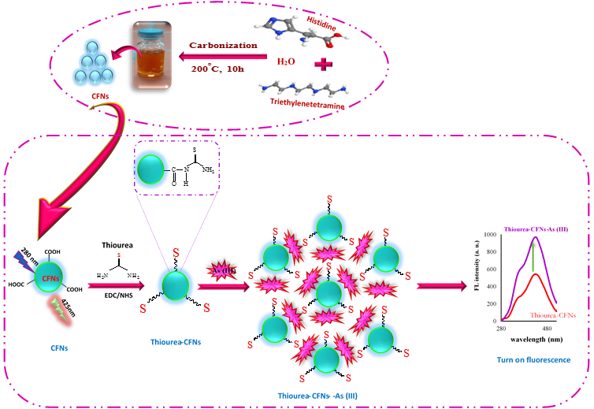
Scheme 1

Absorbance (a. u.)
a
b
Thiourea-CFNs

Figure 1

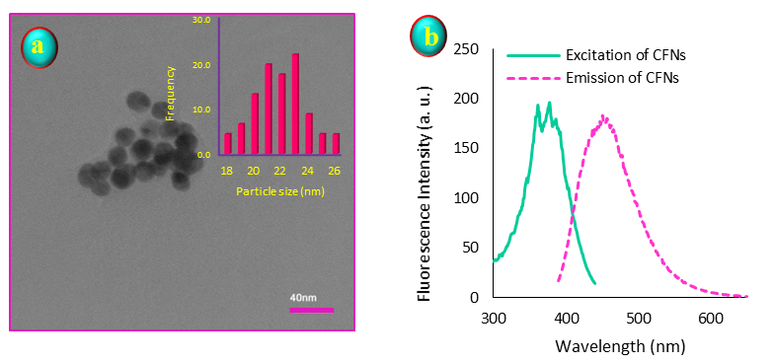

Figure 2

(a)
(b)
(e)
(f)

Figure 3

As (III) concentration (µg /L)

Figure 4

Fig.5

Highlights
*A sensitive and selective “Turn-On” fluorescence assay developed for As(III) detection.
*Carbonaceous fluorescent nanomaterials (CFNs) functionalized with thiourea (CFNs-thiourea) used as fluorophore.
*The proposed assay applied for As(III) detection at concentration range 3.3–828.5 µg L⁻¹and DL of 0.48 µg L⁻¹.
*The prepared thiourea -CFNs exhibited high selectivity for As (III) compared to various cations and anions.
*As detected in water samples at low ppb level concentration with satisfactory results.

A chelation-enhanced fluorescence assay using thiourea capped carbonaceous fluorescent nanoparticles for As (III) detection in water samples
Susan Mohammadi, Somayeh Mohammadi*, Abdollah Salimi*, Rezgar Ahmadi

A sensitive and selective “Turn-On” fluorescence nanosensor was constructed using water-soluble carbonaceous fluorescent nanomaterials (CFNs) functionalized with thiourea (CFNs-thiourea) for efficient detection of trace amounts of arsenic (III) in aqueous samples.
