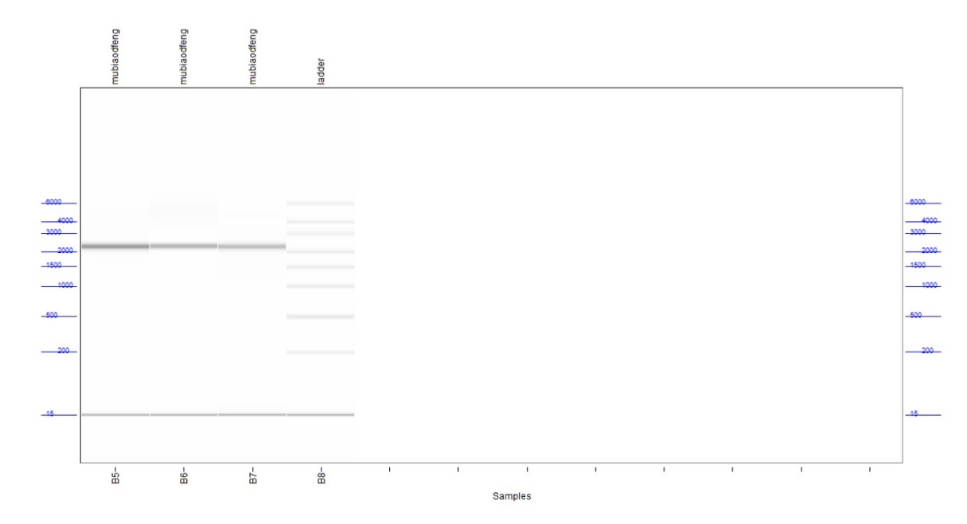
1 2 3 4

Additional file: Fig. S1 The length of mRNA-UreB was determined by capillary gel electrophoresis (CGE). Lane 1-3: mRNA-UreB: 2,200 nt; Lane 4: RNA marker.

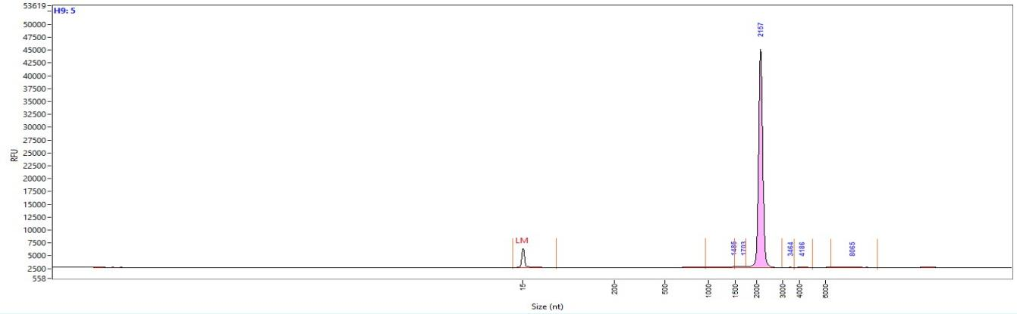

Additional file: Fig. S2 The integrity of mRNA-UreB was also detected by CGE. The integrity was approximately 97%.

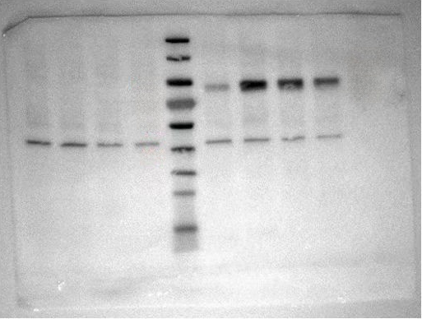
Additional file: Fig. S3 Uncut map of Western blotting.

LNP/mRNA-UreB Assay Specification
Encapsulation efficiency  Capping efficacy  Particle size  PDI  Zeta potential | ELISA 92.4%  LC-MS 96.2%  DLS 90-120nm  DLS ≤ 0.2  DLS 0-50 mV
Additional file: Table 1 The quality control of LNP/mRNA-UreB.

