Supporting Information
Model Smoke Stream Adsorption over Cellulose Acetate Stick with Three-dimensional Temperature Gradient by combining in-situ DRIFTS with Infrared Thermal Imaging Technology
Xin Xu • Xi Du • Feng Zheng • Lisheng Guo • Panwei Shi • Mengmeng Li • Zhengyu Fang • Jiuyi Liu • Mengdie Cai • Song Sun

Xin Xu • Feng Zheng
Anhui Tobacco Industrial Company Limited, Hefei, 230088, China

Lisheng Guo • Mengmeng Li • Zhengyu Fang • Jiuyi Liu • Mengdie Cai ()• Song Sun
School of Chemistry and Chemical Engineering, Anhui University, Hefei, Anhui 230601, China
E-mail: caimengdie1987@163.com (M. Cai)

Xi Du • Panwei Shi ()
Eastman Shuangwei Fibers Company Limited, Hefei, Anhui 230601, China
E-mail: shipw@esfcl.com (P. Shi)

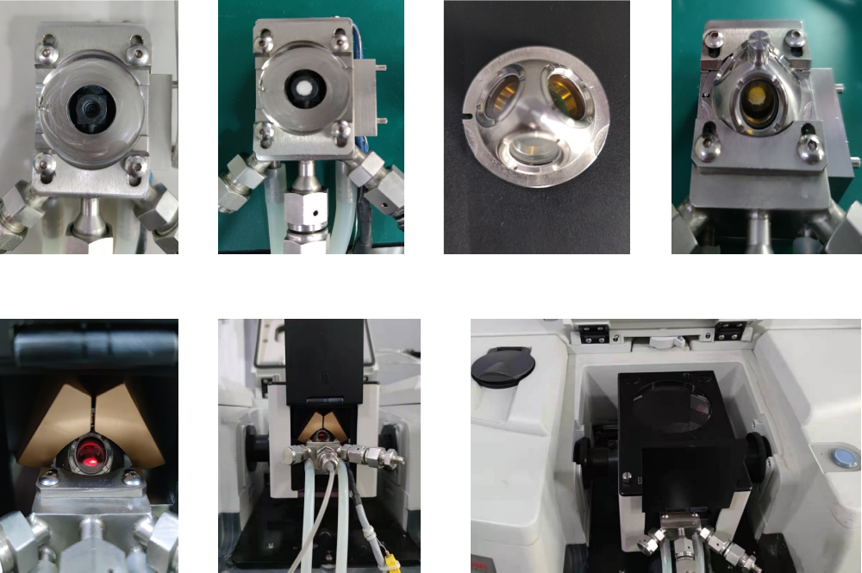
Fig. S1 The images of the accessory for in situ DRIFTS measurements.

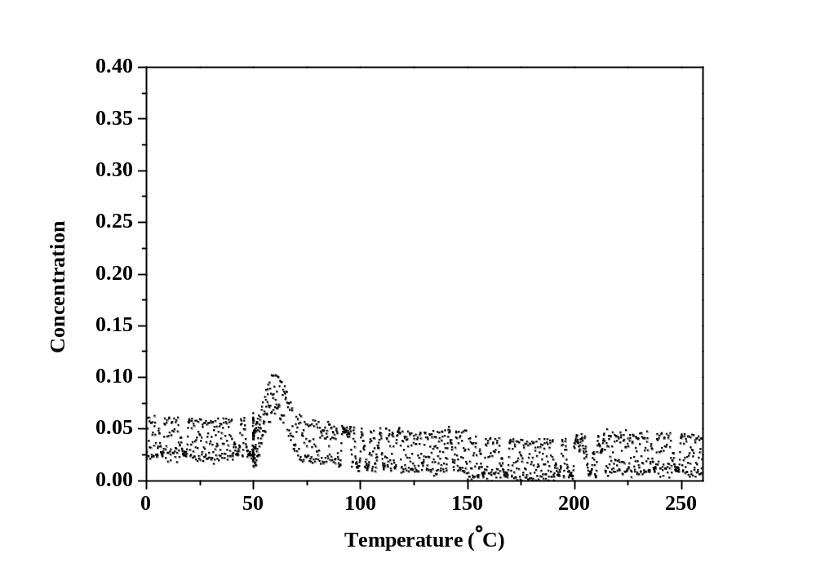
Fig. S2 CO-TPD profile of the cellulose acetate stick.

