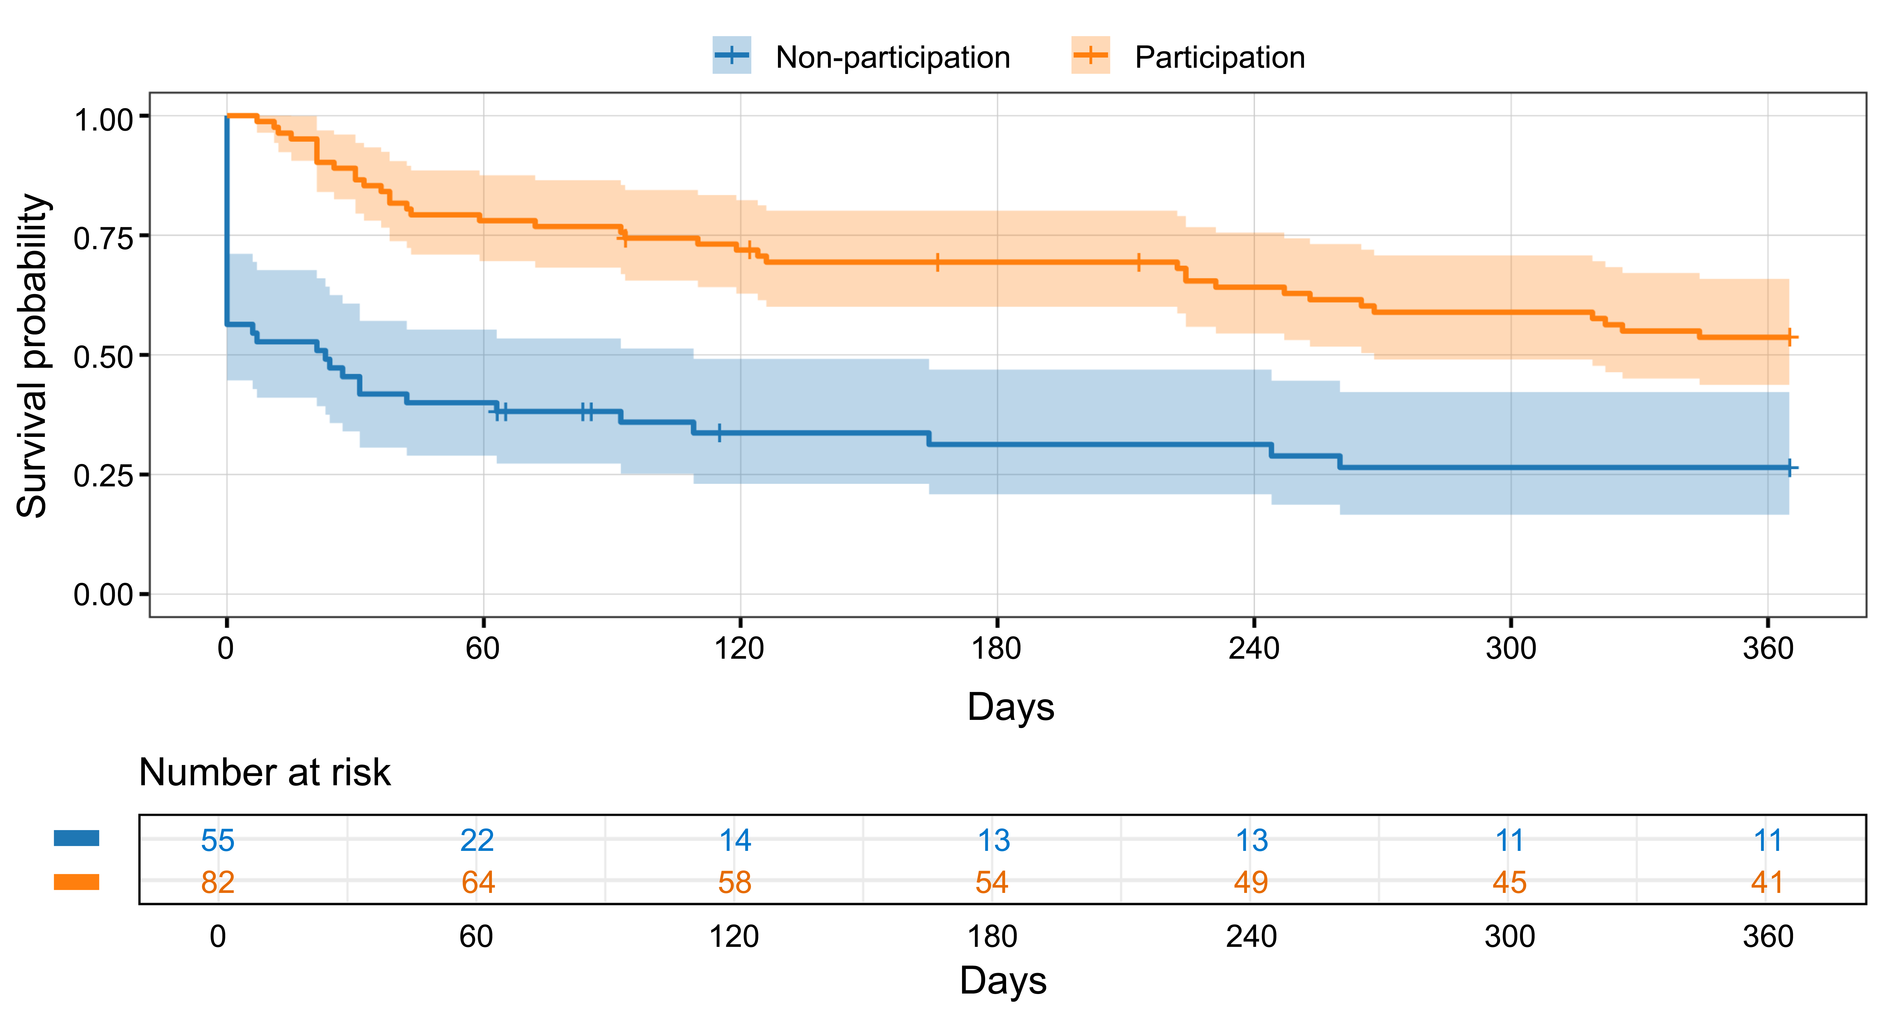
Additional file 4. Kaplan–Meier curves for treatment retention censored at 1 year. The orange line represents the program participation group, and the blue line represents the non-participation group. Shaded areas indicate 95% confidence intervals (CI). Short vertical ticks indicate censoring. The numbers of patients at risk are shown below the x-axis. Treatment retention was significantly longer in the participation group than in the non-participation group (log-rank test, p < 0.001). In a Cox proportional hazards model adjusted for age and sex, program participation was associated with a lower hazard of treatment discontinuation (adjusted hazard ratio = 0.33, 95% CI 0.21–0.52, p < 0.001).

