Supporting Information
A radiation-resistant supermacroporous aerogels for ultrafast and high-capacity gaseous iodine capture
Meng Ji¹, Dagang Li^{1,2,}*, Zilei Zhang¹, Haocun Tan¹, Xiyue Zhang¹, Yingjun Dong¹, Chuanle Lu¹，Jinying Li^{3,4}, Dongxiang Zhang^{1,3,}*
¹ School of Chemistry and Chemical Engineering, Beijing Institute of Technology, Beijing 102488, China
² School of New Materials and Shoes & Clothing Engineering, Liming Vocational University, Quanzhou 362000, China
³ Department of Chemistry, Shenzhen MSU-BIT University, Shenzhen 517182, China
⁴ China National Nuclear Corporation, Beijing 100822, China
*Dagang Li. E-mail: dagangli@lmu.edu.cn; *Dongxiang Zhang. E-mail:boris@bit.edu.cn
- Materials
Acrylic acid (AA, AR, 99%), polyethyleneimine (PEI, 600, AR, 99%), ammonium persulfate (APS, AR), ascorbic acid (VC, AR, ≥99%), N,N-methylenebisacrylamide (MBA, AR, 98%), N-hydroxysuccinimide (NHS, AR, 98%), and 1-(3-dimethylaminopropyl)-3-ethylcarbodiimide salt (EDC, AR，98%) were all supplied by vendors. All chemicals were used directly without purification unless otherwise stated.
2. Characterization
The crystal structure of the samples was analyzed using X-ray diffraction (XRD) (Ultima IV, Rigaku, Japan) with a scanning range of 10–80° and a scanning speed of 5°/min. Fourier transform infrared spectroscopy (Thermo IS5, USA, 400–4000 cm⁻¹) was employed to characterize the changes in functional groups in the samples. Field emission scanning electron microscopy (Zeiss GeminiSEM 360, Germany) and energy-dispersive spectroscopy (EDS) were used to observe the surface morphology and element distribution of the samples. A contact angle meter (JC200d Zhongchen Digital Technology, China) was utilized to test the permeability of the samples. The specific surface area, pore size distribution, and pore volume of the materials were measured using a Brunauer-Emmett-Teller analyzer (ASAP 2020, Micromeritics, USA). X-ray photoelectron spectroscopy (XPS) (ESCALAB 250XI, Thermo Fisher, USA) was applied to compare the changes in element binding energy before and after iodine capture. Time-gated Raman spectroscopy (LabRAM HR Evolution, HORIBA, Japan) was used to record the changes in iodine morphology after adsorption. A thermogravimetric analyzer (STA 449f3, Netzsch, Germany) was employed to evaluate the thermal stability of the materials under a nitrogen atmosphere (30–600°C, heating rate of 10 K/min). In the radiation resistance experiments, β-rays were generated by an industrial electron irradiation accelerator (DD2.5 MeV-40 mA, maximum tube voltage 40 kV, maximum beam current 40 mA); γ-rays were provided by a cobalt-60 industrial irradiation device (CN-101, actual activity 125,000 Ci).
3. DFT calculation simulation
In this study, the Gaussian 16 [1] program was used to perform theoretical simulations on the I₂, PEI@PAA (a representative repeating segment of the polymer was selected), and PEI@PAA-I₂ systems (four conformations where I₂ is close to different amino groups in the segment). The adsorption energy (E_{ads}) during the adsorption process, electrostatic potential (ESP) distribution, and weak interactions based on the interaction region indicator (IRI) analysis were systematically investigated to gain insight into the adsorption mechanism of PEI@PAA for I₂.
The geometric configurations of the reactants and products were further optimized. The geometry optimization calculations were performed using the B3LYP hybrid functional and the def2-SVPP basis set. This basis set belongs to the split-valence double-polarization basis set, which uses an all-electron basis set for elements in the first four periods of the periodic table, while the Stuttgart pseudopotential basis set was adopted for elements in the fifth period (iodine) [2].
Single point energy calculations were performed using the M06-2X global hybrid functional, which belongs to the Minnesota series [3]. It contains 54% Hartree-Fock exchange component and exhibits superior performance in accurately describing halogen bonds and non-covalent interactions [4]. The def2-TZVPP basis set was selected for the calculations, with its pseudopotential configuration consistent with that of def2-SVPP [2]. To correct for the basis set superposition error (BSSE), all energies were calculated using the counterpoise method. In addition, DFT-D3 dispersion correction was introduced throughout the calculation process to accurately describe van der Waals interactions [5]. Finally, the adsorption energy of the adsorbent for iodine was obtained using the formula: E_{ads} = E_{t}- (E_{m}+E_{I}), where E_{ads} (kJ·mol⁻¹) represents the adsorption energy, E_{t} (kJ·mol⁻¹) is the total electronic energy of the system after adsorption, and E_{m} (kJ·mol⁻¹) and E_{I} (kJ·mol⁻¹) are the electronic energies of the adsorbent molecules and iodine molecules before adsorption, respectively.
To deeply explain the mechanism of the adsorption process and reveal the nature of chemical bond strength and weak interactions, this study employed the Interaction Region Indicator (IRI) defined by Equation (S1) for interaction analysis [6]. The corresponding data were processed using Visual Molecular Dynamics (VMD) [7] and the open-source Gnuplot software package for generating color scatter plots to obtain visual images. The electrostatic potential (ESP) [8] analysis was conducted via the wavefunction analysis software Multiwfn [9].
$\text{IRI}=\frac{\left|∇ρ(r)\right|}{{\left[ρ(r)\right]}^{a}}$ (1)
In the equation, a is an adjustable parameter, and the standard definition of IRI uses a = 1. ρ represents the electron density, and r denotes the interatomic distance.
4. Iodine Adsorption Experiments
4.1 Iodine Adsorption Capacity Test
The PEI@PAA aerogel was dried in a vacuum drying oven at 100 °C for 12 h. Then, a PEI@PAA aerogel with a mass of m₁ was weighed and placed in a 5 mL beaker. The beaker was transferred to a 200 mL quartz jar (with internal threads and a polytetrafluoroethylene lid). Subsequently, iodine powder with a mass of m₃ was weighed and poured into the quartz jar, and the jar mouth was quickly tightened. After that, the sealed quartz jar was transferred to a thermostat at temperature T for the static gaseous iodine adsorption experiment. When the predetermined time t was reached, the quartz jar was taken out of the thermostat, and the mass of the aerogel after adsorption was weighed and recorded as m₂. The adsorbed sample was denoted as PEI@PAA-I₂.
To ensure the reliability and repeatability of the data, the adsorption experiments under each condition were independently conducted three times, and the final results were taken as the average value. The iodine adsorption capacity (q, g·g⁻¹) of the aerogel was calculated according to the following formula:
$\text{q }\text{= }\frac{{\text{m}}_{\text{2}}\text{-}{\text{m}}_{\text{1}}}{{\text{m}}_{\text{1}}}$ (2)
where q (g·g⁻¹) is the adsorption capacity of the sample, m₁ (g) is the mass of the sample before adsorption, and m₂ (g) is the mass of the sample after adsorption.
The initial concentration of iodine vapor was calculated using Equation (2).
$\text{C }\text{=} \frac{{\text{m}}_{\text{3}}}{\text{V}}$ (3)
Where C (g·L⁻¹) is the initial concentration of iodine vapor, m₃ (g) is the mass of iodine powder, and V (L) is the volume of the quartz sealed jar.
4.2 Batch Experiments - Effect of Reaction Conditions on Adsorption Capacity
To determine the optimal synthesis conditions for PEI@PAA, we sequentially investigated the effects of the contents of EDC, NHS, and PEI, as well as the grafting time of PEI, on the adsorption capacity.
Approximately 0.2 g of dried PAA was weighed into a 15 mL sample vial, and 10 mL of deionized water was added. Then, following the procedure for modifying PAA with PEI, m(EDC), m(NHS), and m(PEI) were added in sequence. The dosages of the reagents and the grafting time are shown in Tables S2, S3, S4, and S5. After a constant-temperature water bath (60 °C), the product was washed with deionized water (5 times), sonicated (15 min), washed again (3 times), and air-dried at room temperature (24 h) to obtain the PEI@PAA aerogel.
50 mg of each resulting sample was weighed into a 50 mL beaker, then placed together with 1 g of iodine powder in a 200 mL quartz jar. After sealing, the jar was incubated at 80 °C for 12 h. Upon completion, the weight of the sample was recorded, and the adsorption capacity was calculated according to Equation (1).
4.3 Adsorption Kinetics
The adsorption kinetics of PEI@PAA for gaseous iodine was investigated at 80 °C. Eight 200 mL quartz sealed jars (with polytetrafluoroethylene lids) were prepared. 50 mg of PEI@PAA was weighed into a 5 mL beaker using an electronic balance, and the beaker was placed in a corresponding sealed jar. Then, 1 g of iodine powder was weighed and poured into the sealed jar, which was then capped tightly. The sealed jars were placed in an oven at 80 °C, and taken out at 1, 2, 3, 4, 6, 8, 10, and 18 h respectively to weigh the mass change of the adsorbent in the beaker. Thus, the adsorption kinetic curve of the adsorbent for iodine could be obtained. The adsorption process was fitted using the pseudo-first-order kinetics, pseudo-second-order kinetics, and Weber-Morris intraparticle diffusion models, with their equations as follows:
$\text{ln}\left({\text{q}}_{\text{e}}\text{-}{\text{q}}_{\text{t}}\right)\text{ = }\text{ln}{\text{q}}_{\text{e}}\text{-}{\text{k}}_{\text{1}}\text{t}$ (4)
$\frac{\text{t}}{{\text{q}}_{\text{t}}}\text{ = }\frac{\text{1}}{{\text{k}}_{\text{2}}{\text{q}}_{\text{e}}^{\text{2}}}\text{+}\frac{\text{t}}{{\text{q}}_{\text{e}}}$ (5)
${\text{q}}_{\text{t}}\text{ = }{\text{k}}_{\text{3}}{\text{t}}^{{\text{1}}/{\text{2}}}\text{+C}$ (6)
k₁: pseudo-first-order rate constant, h⁻¹;
k₂: pseudo-second-order rate constant, [g (mg·h)⁻¹];
k₃: intraparticle diffusion rate constant, g·g⁻¹ h^{-0.5};
q_{e}: equilibrium adsorption capacity, g·g⁻¹;
q_{t}: adsorption capacity within t h, g·g⁻¹。
C: constant, reaction boundary layer effect (liquid film resistance); C > 0 indicates that liquid film diffusion is involved in the control.
4.4 Adsorption isotherm
The adsorption isotherms of PEI@PAA aerogel for gaseous iodine were measured at 80, 100, and 120 °C. 50 mg of adsorbent was added into the sealed jar, where the equilibrium concentration of iodine vapor varied from 0 to 1200 mg·L⁻¹. The adsorption time was 20 h. The adsorption process was fitted using Langmuir, Freundlich, and Temkin isothermal adsorption models, with the equations as follows:
${\text{q}}_{\text{e}}\text{ = }\frac{{\text{k}}_{\text{L}} {\text{C}}_{\text{e}} {\text{q}}_{\text{m}}}{\text{1}\text{+}{\text{k}}_{\text{L}}{\text{C}}_{\text{e}}}$ (7)
${\text{q}}_{\text{e}}\text{ = }{\text{k}}_{\text{F}}{\text{C}}_{\text{e}}^{{\text{1}}/{\text{n}}}$ (8)
${\text{q}}_{\text{e}}\text{ = }\text{Bln}\text{(}\text{A}{\text{C}}_{\text{e}}\text{)}$ (9)
q_{m}: Theoretical maximum adsorption capacity, g·g⁻¹;
q_{e}: Equilibrium adsorption capacity, g·g⁻¹ ;
C_{e}: Concentration of iodine vapor at adsorption equilibrium, g·L⁻¹;
k_{L}: Langmuir adsorption constant, L·g⁻¹;
k_{F}: Freundlich adsorption constant, (g·g⁻¹) (L·g⁻¹)^{1/n};
n: Adsorption intensity index, which characterizes surface heterogeneity and adsorption affinity (dimensionless);
A: Aonstant related to adsorption heat, with the unit of L·g⁻¹, reflecting adsorption affinity;
B: Aonstant related to adsorption free energy, J·mol⁻¹.
5. Radiation resistance test
5.1 Setting of Irradiation Conditions
Two radiation sources β and γ rays (with a radiation dose of 50 kGy), were used to irradiate PEI@PAA and BiMgO-2MBD materials for 24 h in sequence.
5.2 Stability Analysis after Irradiation
The microstructure of PEI@PAA aerogel after irradiation was observed by SEM, and the element distribution and content changes were tested by EDS. FT-IR was used to test the effect of irradiation on the functional groups in PEI@PAA.
5.3 Iodine Adsorption Performance Test after Irradiation
Static iodine adsorption experiments were carried out on the irradiated materials. Among them, the conditions for PEI@PAA aerogel were 80 ℃ for 12 h; and the conditions for BiMgO-2MBD were 150 ℃ for 12 h.
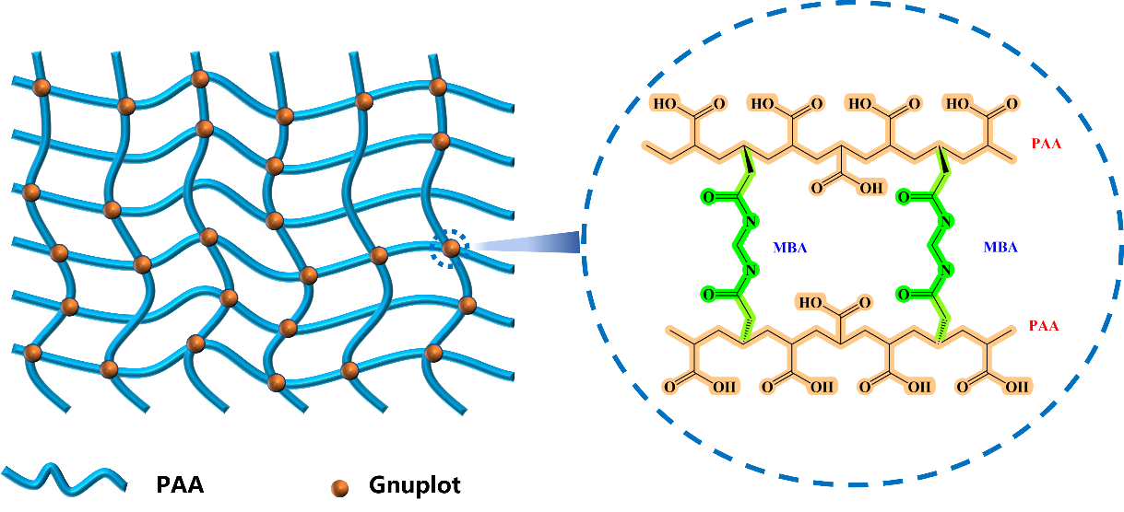
Fig. S1 MBA crosslinks the PAA molecular chains to form a three-dimensional network structure.
AA copolymerizes with MBA. Since both ends of MBA have C=C groups, they can connect two PAA molecular chains, leading to crosslinking and thus forming a PAA network structure.
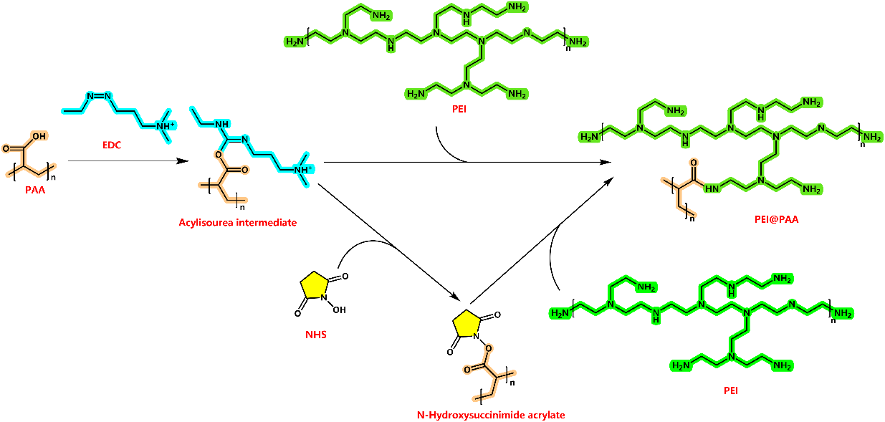
Fig. S2 PAA is grafted with PEI via the EDC/NHS reaction.
PEI is rich in amino groups, which can serve as active sites for iodine adsorption. The covalent cross-linking of polyethyleneimine (PEI) and polyacrylic acid (PAA) via the EDC/NHS reaction ensures the stability of the active sites. Meanwhile, in the following text, we further improve the grafting rate and enhance the adsorption capacity of the material by optimizing the reaction conditions.
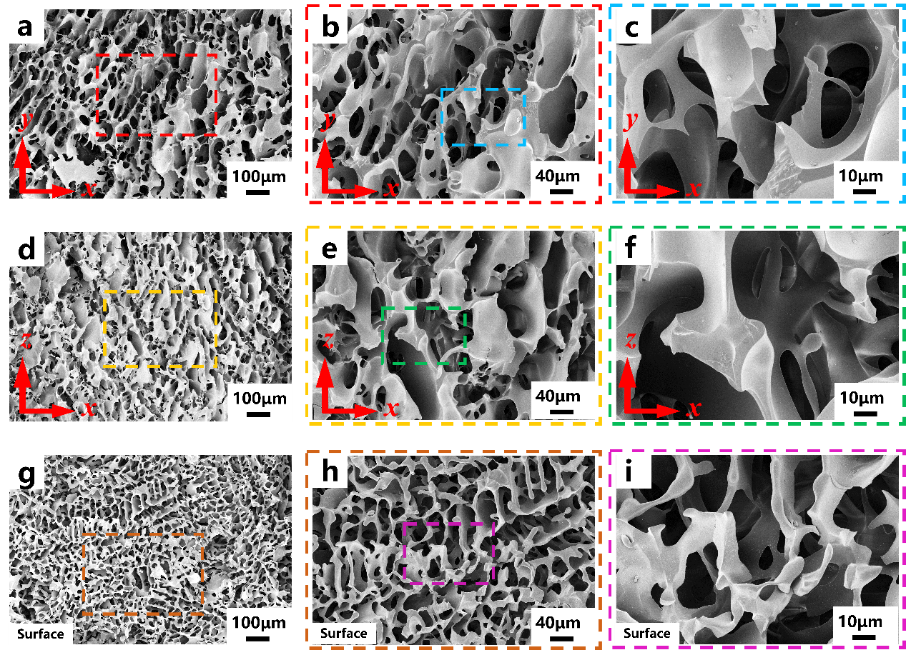
Fig. S3 Microscopic pore structure of PAA. a~c. SEM images of the PAA xy cross-section with gradual magnification. c~e. SEM images of the PAA xz cross-section with gradual magnification. g~h. SEM images of the PAA surface with gradual magnification.
The surface and internal cross-sections in different directions (xy-plane and xz-plane) of the PAA bulk were observed using SEM. Continuous and uniform pore structures were observed in all cross-sections, indicating that a three-dimensional interconnected macroporous structure was formed inside PAA.
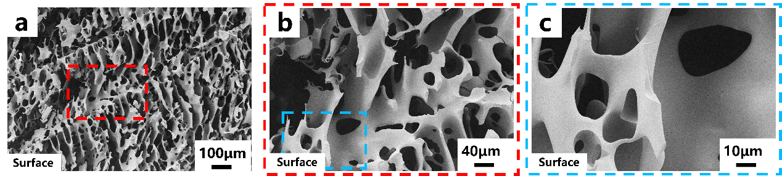
Fig. S4 Microscopic pore structure on the surface of PEI@PAA. a~c. SEM images of the PEI@PAA surface with gradual magnification.
The SEM images of the surface of PEI@PAA aerogel, which are supplementary to the main text, are provided. On the sample surface, the pores are also uniformly and continuously distributed.
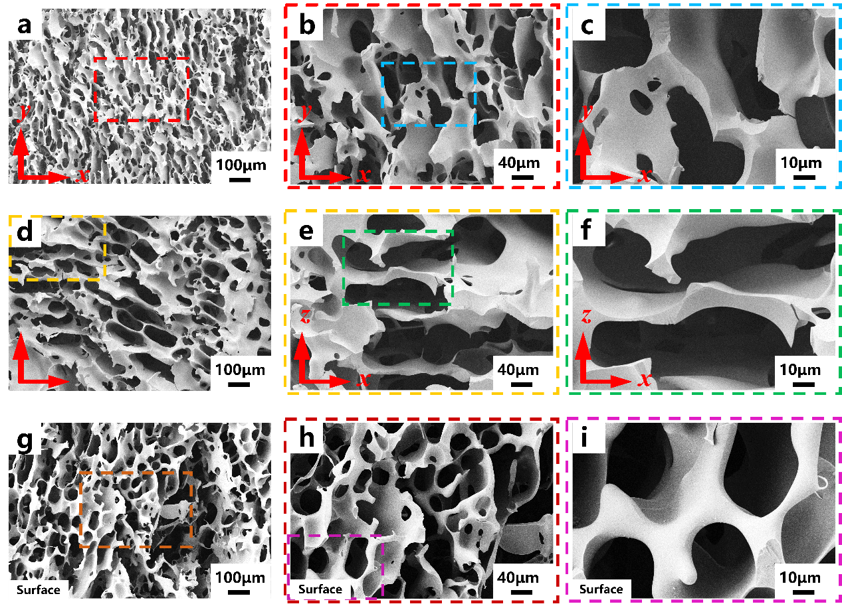
Fig. S5 Microscopic pore structure of the post-adsorption material PEI@PAA-I₂. a~c. SEM images of the PEI@PAA-I₂ xy cross-section with gradual magnification. d~f. SEM images of the PEI@PAA-I₂ xz cross-section with gradual magnification. g~i. SEM images of the PEI@PAA-I₂ surface with gradual magnification.
After iodine adsorption, the pore structure of PEI@PAA remains undistorted and unbroken, exhibiting good stability during the adsorption process.
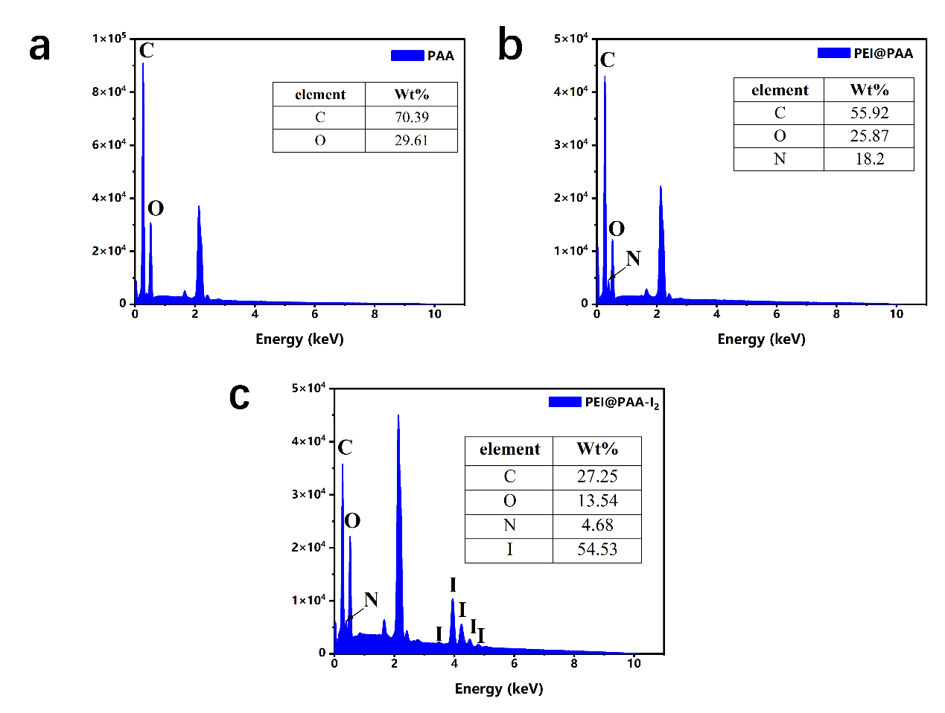
Fig. S6 a. Elemental content of the PAA matrix corresponding to EDS. b. Elemental content of the PEI@PAA aerogel corresponding to EDS. c. Elemental content of the PEI@PAA-I₂ aerogel corresponding to EDS.
After grafting with PEI, the increase in nitrogen content serves as evidence of successful grafting. After iodine adsorption, the appearance of multiple characteristic peaks of iodine is direct evidence of iodine adsorption.
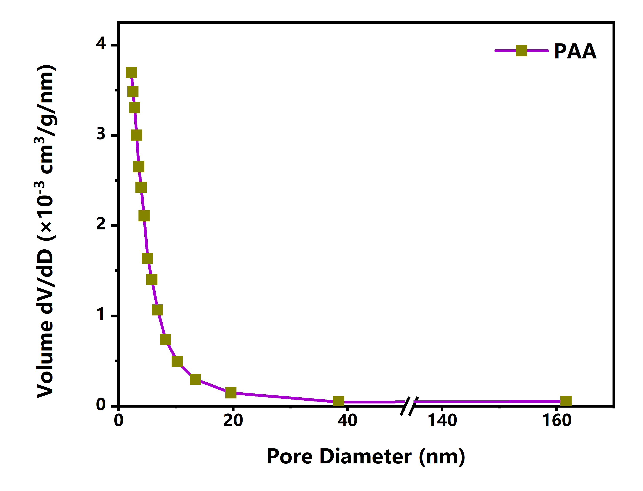
Fig. S7 Pore size distribution curve of PAA obtained by BET test.
There are a large number of mesopores with a size of 2–50 nm in PAA. These fine pores are distributed throughout the surface of the PAA framework, increasing the contact area with adsorbates.
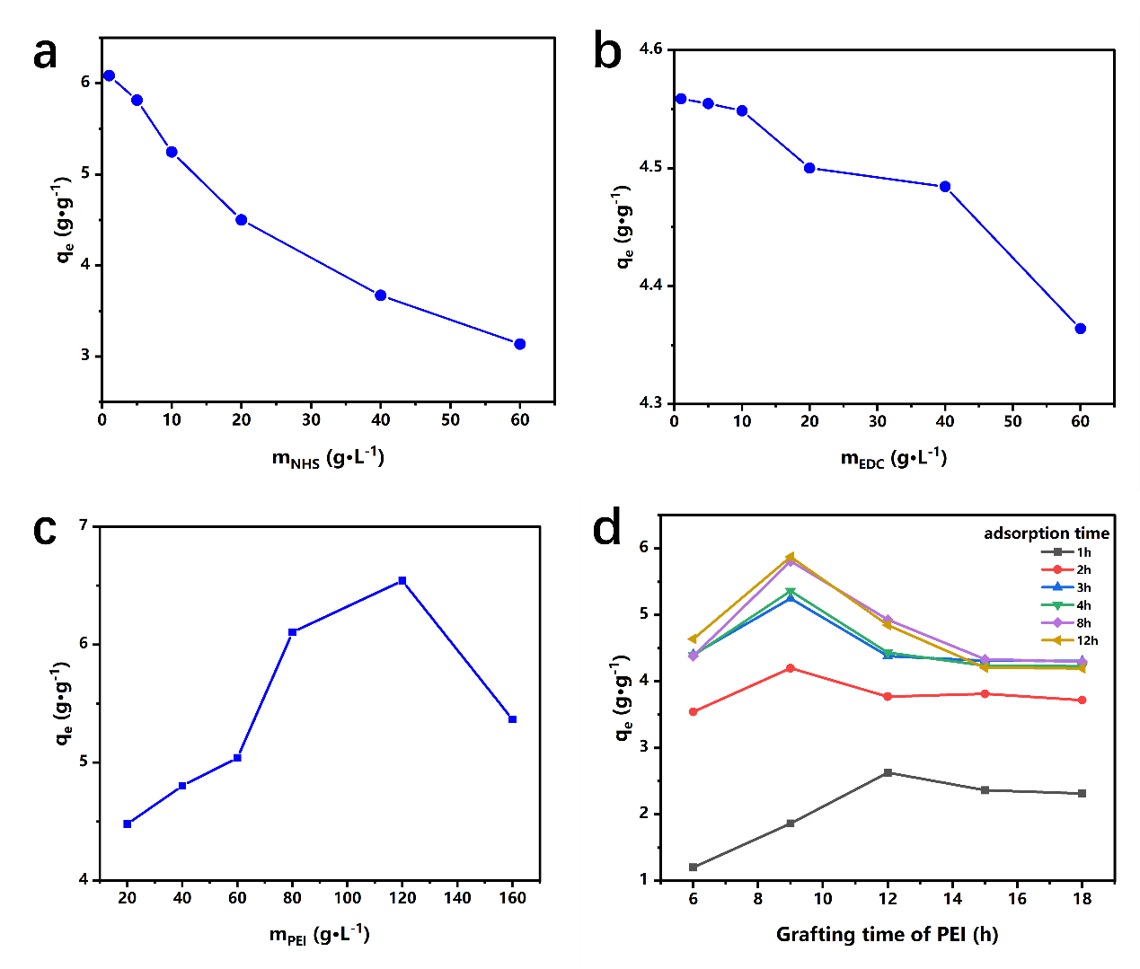
Fig. S8 Effects of reaction conditions on adsorption capacity. a. Effect of NHS content on adsorption capacity. b. Effect of EDC content on adsorption capacity. c. Effect of PEI content on adsorption capacity. d. Effect of PEI grafting time on adsorption capacity under different adsorption times. (Adsorption temperature: 80℃)
In the coupling reaction, the increase in the contents of NHS and EDC leads to a decrease in iodine adsorption capacity, which may be due to the fact that the increased concentration of the reagents affects the grafting density. There exists an optimal point for the effect of PEI content on iodine adsorption capacity; beyond this optimal point, the adsorption capacity decreases. This might be because the diffusion of high-concentration PEI in the aqueous phase slows down, and more by-products are generated with excessively long reaction time, ultimately resulting in a reduction in grafting efficiency.

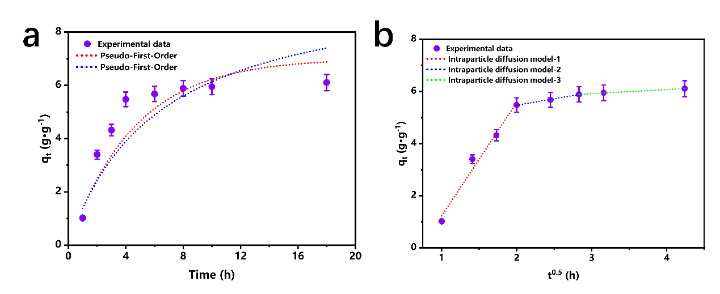
Fig. S9 Fitting of adsorption kinetic models for I₂ adsorption by PEI@PAA aerogel. a. Pseudo-first-order adsorption kinetic fitting (red curve) and pseudo-second-order adsorption kinetic fitting (blue curve). b. Fitting of the Webber-Morris intraparticle diffusion kinetic model.
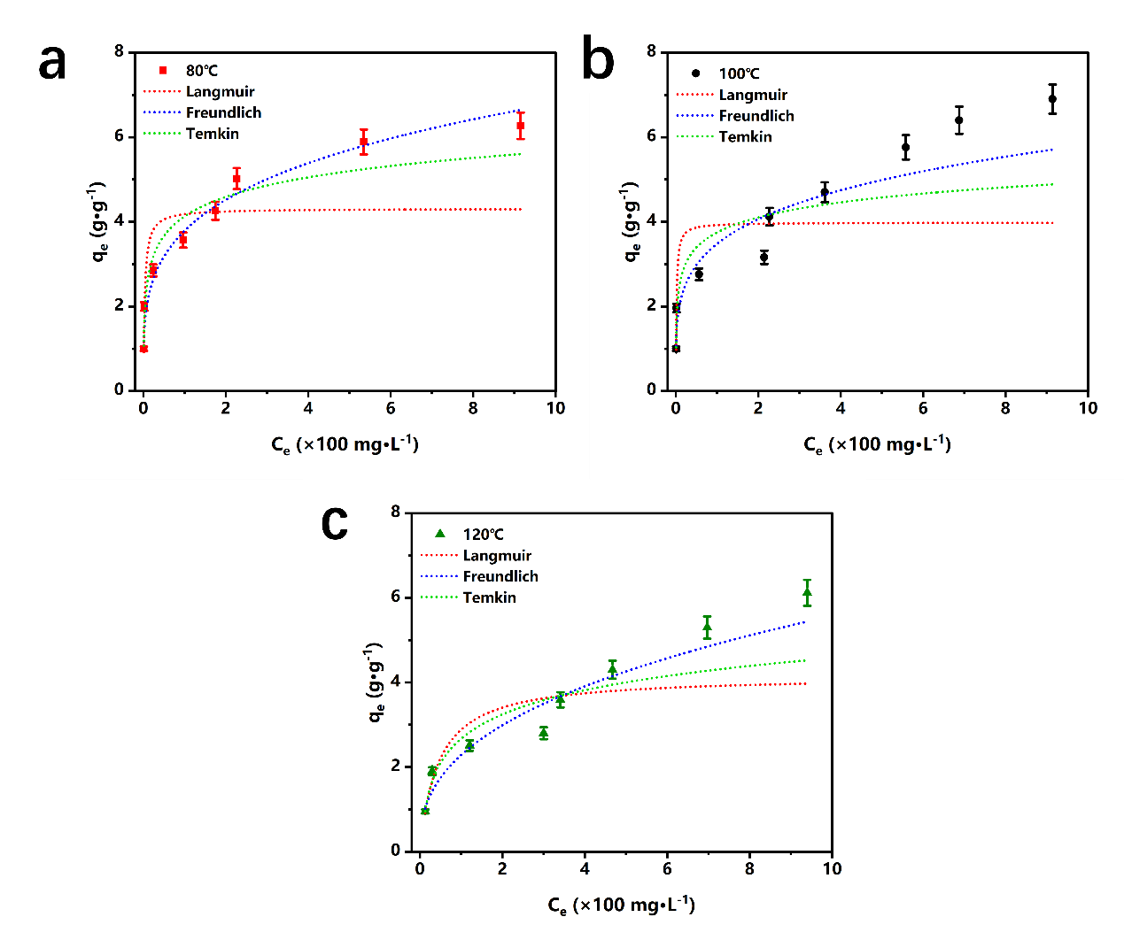
Fig. S10 Adsorption isotherm fitting (Langmuir/Freundlich/Temkin) of I₂ by PEI@PAA. a. Isotherm fitting at 80℃. b. Isotherm fitting at 100℃. c. Isotherm fitting at 120℃

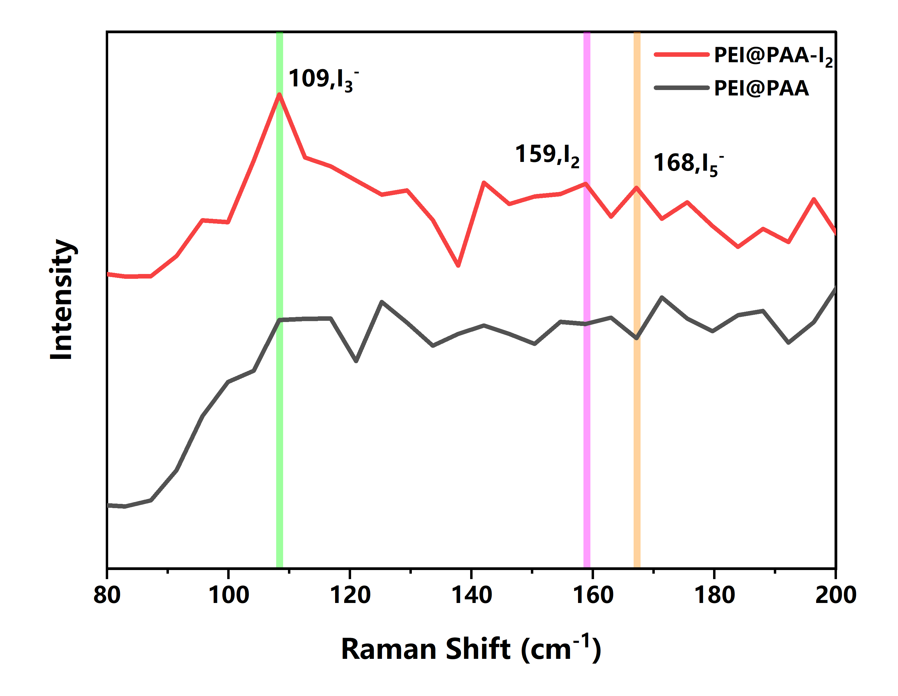
Fig. S11 Raman spectra of PEI@PAA before and after adsorption.
After adsorption, a peak of I₂ appears at 159 cm⁻¹, the characteristic peak at 109 cm⁻¹ corresponds to I-3, and the characteristic peak at 168 cm⁻¹ corresponds to I-5. The Raman spectra reveal the form of iodine in the adsorbent.
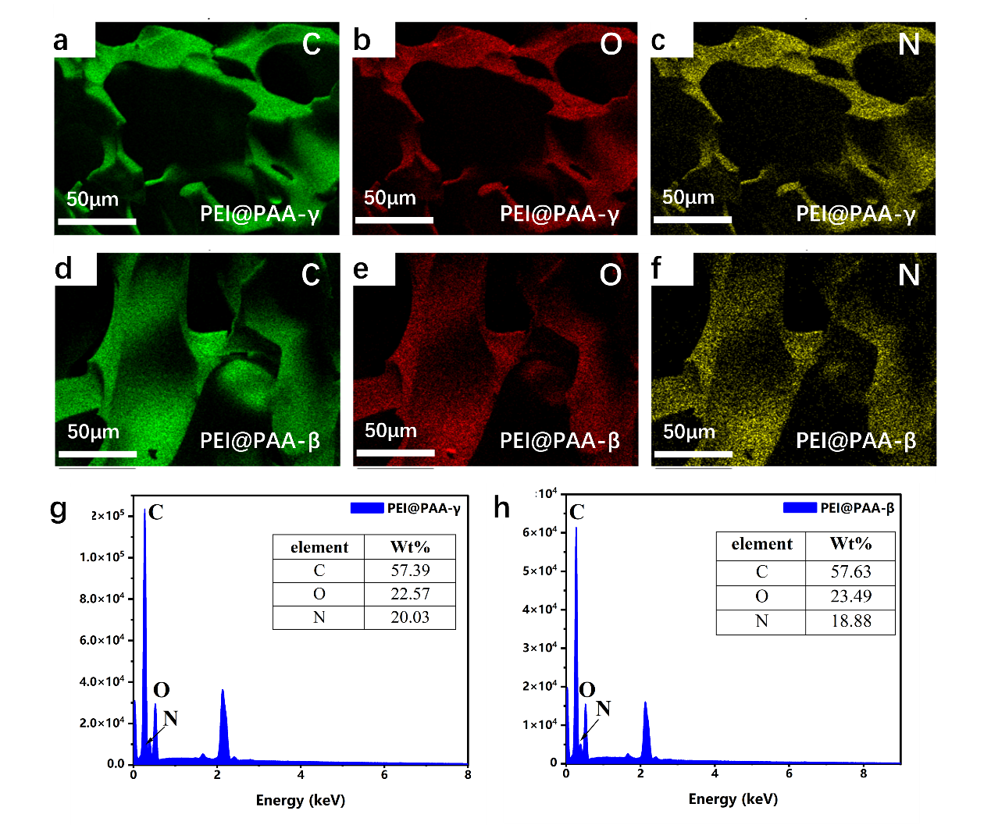
Fig. S12 Element distribution maps and contents of PEI@PAA after irradiation. a~c are EDS-Mapping elemental analyses of C, N, O in PEI@PAA-γ, respectively. d~f are the Mapping maps of PEI@PPA-β, respectively. g, h are the element distributions of PEI@PAA-γ and PEI@PAA-β, respectively.
It can be seen from the element distribution maps that after irradiation with γ and β rays, the elements (especially N element) of the PEI@PAA aerogel are still uniformly distributed, and the element contents are basically consistent with those of the unirradiated sample. This further confirms the irradiation stability of the PEI@PAA aerogel.
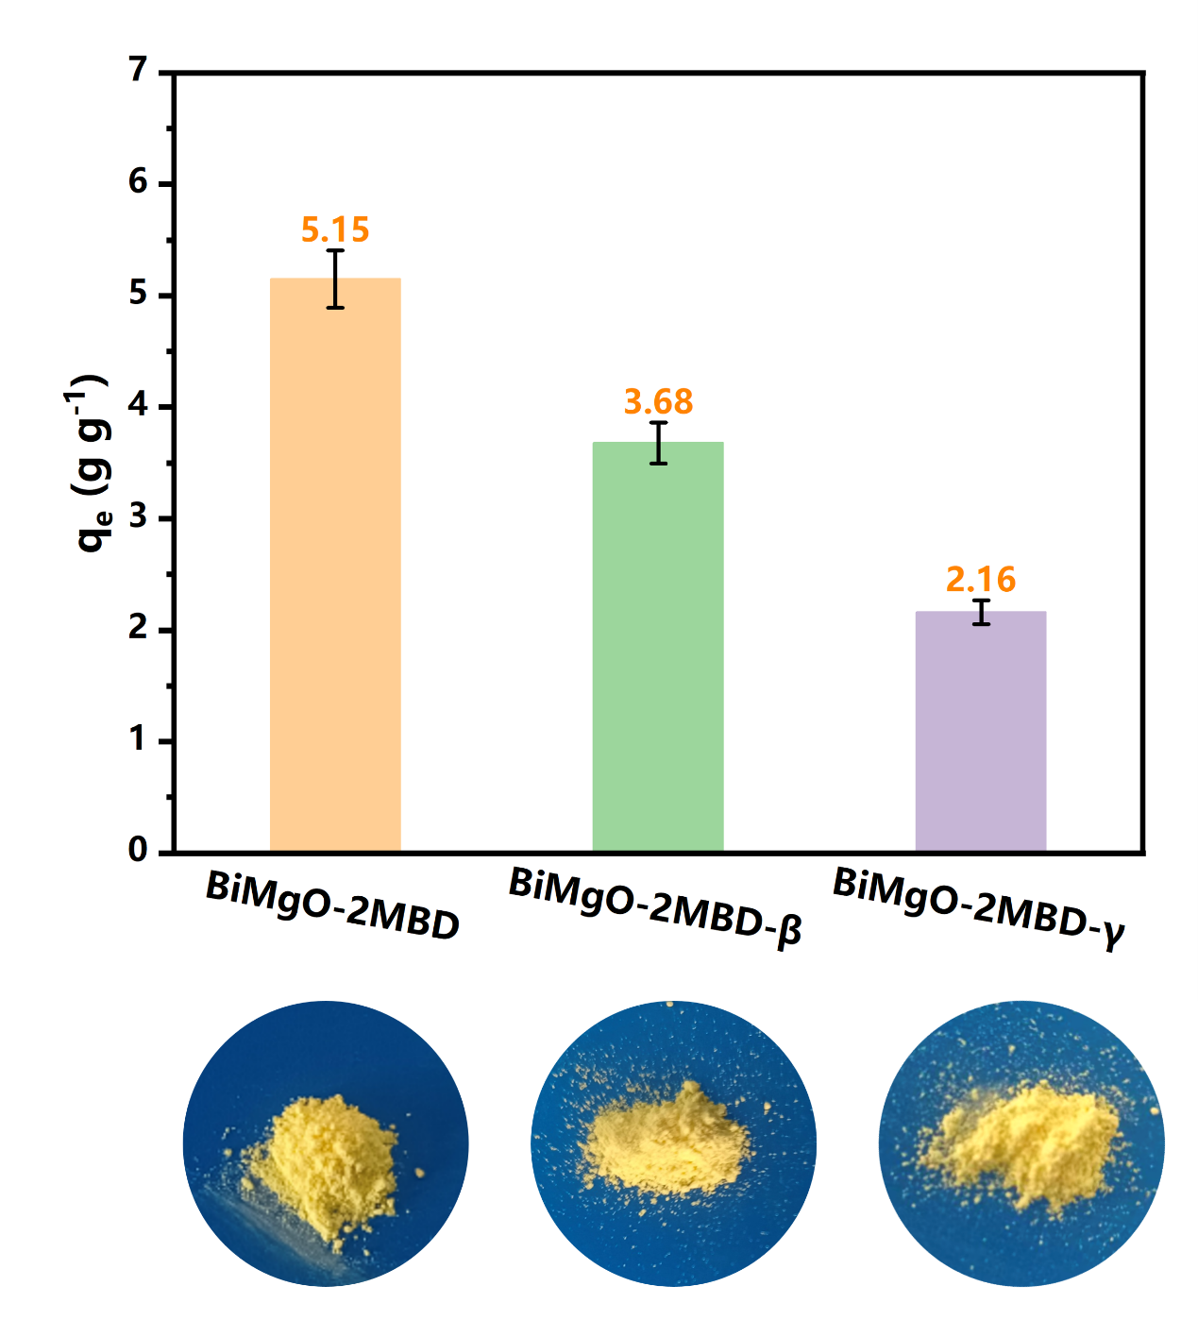
Fig. S13 Comparison of adsorption capacities of iodine adsorbent BiMgO-2MBD before and after irradiation, with the adsorption temperature being 150℃ in all cases. Among them, BiMgO-2MBD-β was irradiated with β-rays, and BiMgO-2MBD-γ was irradiated with γ-rays, with an irradiation dose of 50 kGy for both.
After being irradiated with β-rays, the adsorption capacity of BiMgO-2MBD is 3.68 g·g⁻¹, a decrease of 28.5%. After being irradiated with γ-rays, the adsorption capacity of BiMgO-2MBD is 2.16 g·g⁻¹, a decrease of 58.1%.

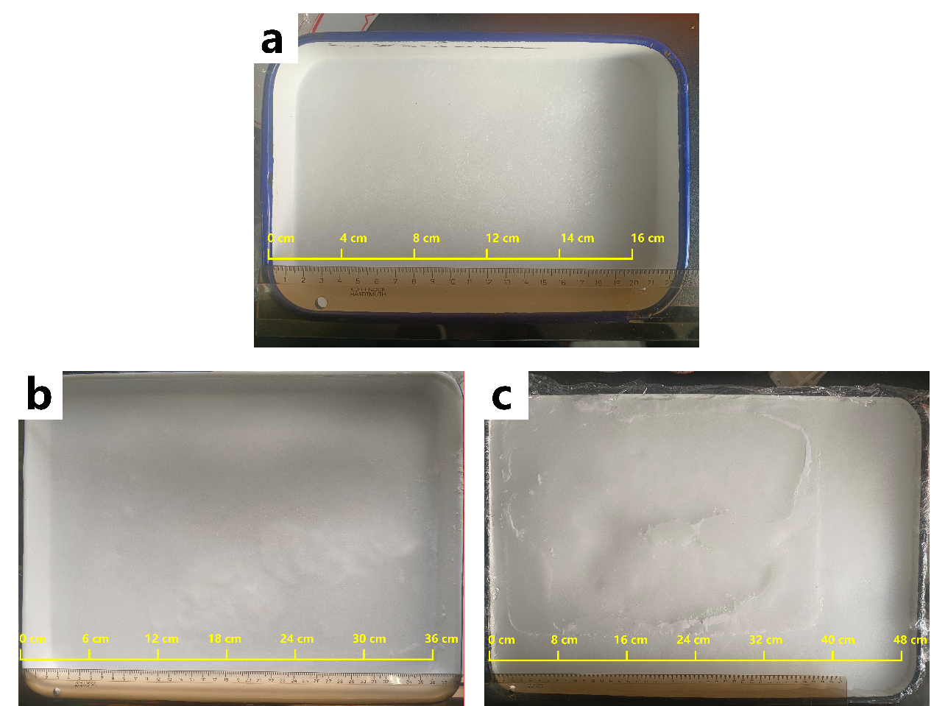
Fig. S14 The scalable preparation of PEI@PAA aerogel. a length × width × height = 22. cm×15 cm×1.5 cm. b length × width × height = 37 cm×27 cm×2 cm. c length × width × height = 50 cm×35 cm×4 cm
The large-scale preparation of PEI@PAA aerogel has been realized, ensuring uniform polymerization through a layer-by-layer casting method, achieving kilogram-level production in the laboratory.
Table S1 Material Price List [10]
Material | Chemical formula | Molecular structural formula | Unit Price ($ g⁻¹) | CAS
Silver nitrate[11] | AgNO₃ |  | 71.29 | 7761-88-8
benzene-1,2,4,5-tetrol | C₆H₆O₄ | 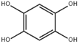 | 150.37 | 636-32-8
1,3,5-Tris(4-aminophenyl)benzene)[12]  (TAPB) | C₂₄H₂₁N₃ | 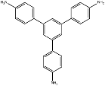 | 43.16 | 118727-34-7
4,4',4''-(1,3,5-Triazine-2,4,6-triyl)trainiline  (TAPT)[13] | C₂₁H₁₈N₆ | 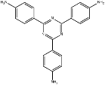 | 18.66 | 14544-47-9
Tris(4-aminophenyl)amine  (TAPA)[13] | C₁₈H₁₈N₄ | 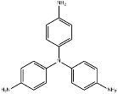 | 16.71 | 5981-09-9
Tris(4-formylphenyl)amine  (TFPA)[14] | C₂₁H₁₅NO₃ | 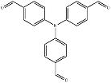 | 63.35 | 119001-43-3
1,3,5-Benzenetricarboxaldehyde  (Tb)[15] | C₉H₆O₃ | 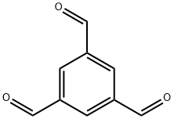 | 54.30 | 3163-76-6
2,5-Dimethoxy-1,4-benzenedicarboxaldehyde  (DMTP)[16] | C₁₀H₁₀O₄ | 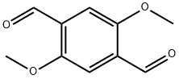 | 64.61 | 7310-97-6
Tetraphenylporphyrin  (TPP)[17] | C₄₄H₃₀N₄ | 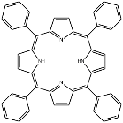 | 71.29 | 917-23-7
AA | C₃H₆O₂ | 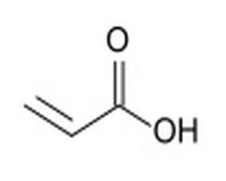 | 5.15 | 9003-01-4
PEI | H(NHCH₂CH₂)_{n}NH₂ | 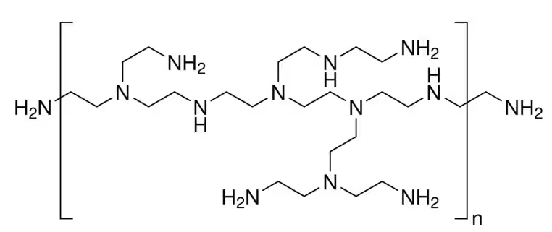 | 0.25 | 9002-98-6
Tetrakis(4-aminophenyl)ethene)  (ETTA)[18] | C₂₆H₂₄N₄ | 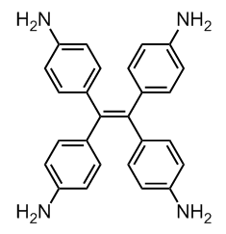 | 36.76 | 78525-34-5
2,3,5,6-tetrafluoroterephthalaldehyde  (TFA)[19] | C₈H₂F₄O₂ | 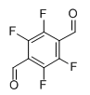 | 18.24 | 3217-47-8
1,3,5-Tris(4-aminophenyl)benzene)  (TPA)[13] | C₂₄H₂₁N | 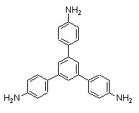 | 19.49 | 118727-34-7
Table S2 Effect of EDC content on adsorption capacity
C_{EDC}/g·L⁻¹ | C_{NHS}/g·L⁻¹ | C_{PEI}/g·L⁻¹ | t/h
1 | 20 | 20 | 12
5 | 20 | 20 | 12
10 | 20 | 20 | 12
20 | 20 | 20 | 12
40 | 20 | 20 | 12
60 | 20 | 20 | 12
Table S3 Effect of NHS content on adsorption capacity
C_{EDC}/g·L⁻¹ | C_{NHS}/g·L⁻¹ | C_{PEI}/g·L⁻¹ | t/h
20 | 1 | 20 | 12
20 | 5 | 20 | 12
20 | 10 | 20 | 12
20 | 20 | 20 | 12
20 | 40 | 20 | 12
20 | 60 | 20 | 12
Table S4 Effect of PEI content on adsorption capacity
C_{EDC}/g·L⁻¹ | C_{NHS}/g·L⁻¹ | C_{PEI}/g·L⁻¹ | t/h
20 | 20 | 20 | 12
20 | 20 | 40 | 12
20 | 20 | 60 | 12
20 | 20 | 80 | 12
20 | 20 | 120 | 12
20 | 20 | 160 | 12

Table S5 Effect of PEI grafting time on adsorption capacity
C_{EDC}/g·L⁻¹ | C_{NHS}/g·L⁻¹ | C_{PEI}/g·L⁻¹ | t/h
1 | 1 | 120 | 6
1 | 1 | 120 | 9
1 | 1 | 120 | 15
1 | 1 | 120 | 12
1 | 1 | 120 | 18
Table S6 The average pore size and specific surface area of the adsorbent
Sample | Specific surface area (m² ·g⁻¹) | Average pore size(nm)
PAA | 26.66 | 1.31
PEI@PAA | 15.52 | 6.85
Table S7 The E_{ad} per molecular conformation
Electronic energy | E/Hartree | E_{ads}/kJ·mol⁻¹
E_{I} | -595.28
E_{m b} | -688.47
E_{t}(RNH₂) | -1283.75 | -14.08
E_{t}(R₂NH) | -1283.76 | -22.78
E_{t}(R₃N) | -1283.76 | -20.61
E_{t}(RCONH₂) | -1283.75 | -18.74

Table S8 Pseudo-first-order and pseudo-second-order kinetic fitting parameters
Measured q_{e} (g·g⁻¹) | Pseudo-first-Order |  |  | Pseudo-second-Order
Measured q_{e} (g·g⁻¹) | k₁(h⁻¹), | q_{e} (g·g⁻¹) | R² | k₂ [g (mg h) ⁻¹] |  | q_{e} (g·g⁻¹) | R²
6.01 | 0.218 | 8.04 | 0.91 | 0.016 | 7.02 |  | 0.95
Table S9 Kinetic parameters of the Webber-Morris intraparticle diffusion mode
 | k_{p}  (g·g⁻¹·h^{-0.5}) | C  (g·g⁻¹) |  | R²
Stage 1 | 4.352 | 3.125 | 0.99
Stage 2 | 0.493 | 4.488 | 0.99
Stage 3 | 0.154 | 5.458 | 0.99

Table S10 Langmuir fitting parameters at different temperatures
T (℃) | k_{L} (L g⁻¹) | q_{m} (g·g⁻¹) | R²
80 | 0.317 | 4.31 | 0.87
100 | 0.650 | 3.98 | 0.79
120 | 0.023 | 4.16 | 0.86
Table S11 Freundlich fitting parameters at different temperatures
T (℃) | k_{F}  ((g·g⁻¹) (L·g⁻¹)^{1/n}) | n | R²
80 | 0.395 | 3.95 | 0.95
100 | 1.244 | 4.48 | 0.91
120 | 0.385 | 2.59 | 0.94
Table S12 Temkin fitting parameters at different temperatures
T (℃) | B (J·mol⁻¹) | A (L·g⁻¹) | R ²
80 | 0.664 | 5.01 | 0.95
100 | 0.513 | 15.00 | 0.88
120 | 0.826 | 0.25 | 0.91

Table S13 Comparison of iodine adsorption with different materials
Series Number | Adsorbents | T(℃) | 90% eq time(h) | q_{e}(g·g⁻¹) | Ref
a | COF-N⁺ | 80 | 15 | 5.11 | [18]
b | PTC-2H | 75 | 60 | 5.46 | [20]
c | (Ppy)-Sb₂S₃ | 80 | 10 | 2.77 | [21]
d | DKP-4B | 75 | 120 | 3.9 | [22]
e | CAU-1 | 130 | 18 | 1.28 | [23]
f | TFA-COF | 150 | 30 | 2.36 | [19]
g | CTAPA | 75 | 20 | 3.96 | [13]
h | PAN-AO | 80 | 10 | 1.53 | [24]
i | MoS₂/CoS₂/Ni₃S₂ | 80 | 8 | 1.8 | [25]
g | iCOFs-ABS-2 | 77 | 84 | 4.26 | [14]
k | MgAl-LDH | 80 | 15 | 3.03 | [26]
l | UiO-66-NH@WCA | 80 | 14 | 0.7 | [27]
m | NH₂-MIL-101-on-NH₂-UiO-66 | 80 | 25 | 1.93 | [28]
n | Zn-Vlm6 | 200 | 10 | 2.47 | [29]
o | POP-T | 75 | 20 | 0.394 | [30]
p | H₂CuY | 75 | 23 | 0.450 | [31]
q | CoFe@CA-D | - | 100 | 0.458 | [32]
r | TTA-TTB COF | 77 | 100 | 0.626 | [16]
s | AzoPPN | 77 | 12 | 0.290 | [17]
t | PEI@PAA | 80 | 4 | 6.8 | This work

References
[1] Frisch M J , Trucks G W , Schlegel H B, et al., Gaussian 16 Revision A.03, Wallingford CT: Gaussian Inc, 2016.
[2] F. Weigend, R. Ahlrichs, Balanced basis sets of split valence, triple zeta valence and quadruple zeta valence quality for H to Rn: Design and assessment of accuracy, Phys. Chem. Chem. Phys. 7 (2005) 3297. https://doi.org/10.1039/b508541a.
[3] Y. Zhao, D.G. Truhlar, The M06 suite of density functionals for main group thermochemistry, thermochemical kinetics, noncovalent interactions, excited states, and transition elements: two new functionals and systematic testing of four M06-class functionals and 12 other functionals, Theor. Chem. Acc. 120 (2008) 215–241. https://doi.org/10.1007/s00214-007-0310-x.
[4] L. Goerigk, S. Grimme, A thorough benchmark of density functional methods for general main group thermochemistry, kinetics, and noncovalent interactions, Phys. Chem. Chem. Phys. 13 (2011) 6670. https://doi.org/10.1039/c0cp02984j.
[5] S. Grimme, J. Antony, S. Ehrlich, H. Krieg, A consistent and accurate ab initio parametrization of density functional dispersion correction (DFT-D) for the 94 elements H-Pu, J. Chem. Phys. 132 (2010) 154104. https://doi.org/10.1063/1.3382344.
[6] T. Lu, Q. Chen, Interaction Region Indicator: A Simple Real Space Function Clearly Revealing Both Chemical Bonds and Weak Interactions**, Chemistry–Methods 1 (2021) 231–239. https://doi.org/10.1002/cmtd.202100007.
[7] W. Humphrey, A. Dalke, K. Schulten, VMD: Visual molecular dynamics, J. Mol. Graph. 14 (1996) 33–38. https://doi.org/10.1016/0263-7855(96)00018-5.
[8] J. Zhang, T. Lu, Efficient evaluation of electrostatic potential with computerized optimized code, Phys. Chem. Chem. Phys. 23 (2021) 20323–20328. https://doi.org/10.1039/d1cp02805g.
[9] T. Lu, F. Chen, Multiwfn: A multifunctional wavefunction analyzer, J. Comput. Chem. 33 (2012) 580–592. https://doi.org/10.1002/jcc.22885.
[10] Macklin Reagent, (n.d.). https://www.macklin.cn/ (accessed August 8, 2025).
[11] Z. Shen, A.I. Wiechert, A.P. Ladshaw, A. Greaney, C. Tsouris, S. Yiacoumi, Adsorption of molecular iodine and alkyl iodides from spent-nuclear-fuel-reprocessing off-gas using reduced silver mordenite, Chem. Eng. J. 482 (2024) 149083. https://doi.org/10.1016/j.cej.2024.149083.
[12] Y. Xie, T. Pan, Q. Lei, C. Chen, X. Dong, Y. Yuan, W.A. Maksoud, L. Zhao, L. Cavallo, I. Pinnau, Y. Han, Efficient and simultaneous capture of iodine and methyl iodide achieved by a covalent organic framework, Nat. Commun. 13 (2022) 2878. https://doi.org/10.1038/s41467-022-30663-3.
[13] H. Zhu, Y. Qin, Y. Guo, Z. Shen, M. Imran, M. Asim Mushtaq, Z. Zhang, C. Ni, Y. Chen, Y. Ding, H. Gul, J. Zou, P. Tsiakaras, H.-Y. Hsu, J. Zhao, Covalent organic polymers for efficient removal of iodine from gas- and liquid-phase environments, Chem. Eng. J. 484 (2024) 149739. https://doi.org/10.1016/j.cej.2024.149739.
[14] L.-Y. Ren, T.-M. Geng, Constructing cationic flexible covalent organic frameworks through post-functionalization for enhancing the iodine adsorption capacity, Chem. Eng. J. 480 (2024) 148076. https://doi.org/10.1016/j.cej.2023.148076.
[15] Z. Duan, Y. Zhang, L. Li, M. Wang, Synthesis of One Covalent Organic Framework (COF) Based on C=N Bonds and Its Excellent Performance of Iodine Adsorption, HETEROCYCLES 102 (2021) 1395. https://doi.org/10.3987/COM-21-14463.
[16] P. Wang, Q. Xu, Z. Li, W. Jiang, Q. Jiang, D. Jiang, Exceptional Iodine Capture in 2D Covalent Organic Frameworks, Adv. Mater. 30 (2018) 1801991. https://doi.org/10.1002/adma.201801991.
[17] H. Li, X. Ding, B. Han, Porous Azo‐Bridged Porphyrin–Phthalocyanine Network with High Iodine Capture Capability, Chem. – Eur. J. 22 (2016) 11863–11868. https://doi.org/10.1002/chem.201602337.
[18] S. Zhang, D. Mei, K. Li, B. Yan, Constructing fluorescent nitrogen-containing covalent organic frameworks for visual monitoring and efficient adsorbing iodine with increasing adsorption capacity by post-synthesis ionic modification, Chem. Eng. J. 510 (2025) 161825. https://doi.org/10.1016/j.cej.2025.161825.
[19] Y. Zhu, Y. Li, D. Luo, Y. He, J. Zhou, D. Jiang, X. Zhang, X. Chi, Enhanced high-temperature iodine capture through band-edge control in covalent organic frameworks, Chem. Eng. J. 496 (2024) 153777. https://doi.org/10.1016/j.cej.2024.153777.
[20] Z. Wang, J. Li, Z. Du, L. Pang, C. Liu, Metal-free porphyrin porous organic cage for efficient iodine capture, Chem. Eng. J. 509 (2025) 161326. https://doi.org/10.1016/j.cej.2025.161326.
[21] B. Qiao, W. Li, C. Wang, Z. Song, C. Miao, S. Ma, H. Yao, Fan-shaped polypyrrole(Ppy)-Sb2S3 composite for synergistic capture of iodine vapor via complexation and REDOX reactions, Chem. Eng. J. 506 (2025) 160096. https://doi.org/10.1016/j.cej.2025.160096.
[22] S. Li, X. Wang, X. Liu, Y. Zhang, C. Wang, J. Yang, Y. Hao, Z. Zhu, X. Yan, T. Chang, Applied investigation of novel dual-anionic imidazolium-based organic polymers for CO2 conversion and iodine vapor adsorption, Chem. Eng. J. 507 (2025) 160676. https://doi.org/10.1016/j.cej.2025.160676.
[23] G. Chen, L. Wu, Z. Wang, R. Liu, C. Tan, Y. Tan, Y. Liu, M. He, H. Zhang, Y. Huang, J. Zhu, T. Duan, L. Zhu, Aluminum-based MOF for efficient iodine and methyl iodide capture from NO2-containing gas streams, Chem. Eng. J. 507 (2025) 160829. https://doi.org/10.1016/j.cej.2025.160829.
[24] L. Zhang, M. Li, X. Liu, J. Feng, Y. Liu, Y. Tu, S. Li, T. Duan, Fabrication of amidoxime grafted polyacrylonitrile for iodine vapor capture from off-gas, Chem. Eng. J. 493 (2024) 152618. https://doi.org/10.1016/j.cej.2024.152618.
[25] C. Wang, H. Yao, J. Sun, T. Tong, Z. Ye, H. Dong, C. Li, S. Ma, Nanoscale assembly of MoS₂/CoS₂/Ni₃S₂ grown on Ni foam for synergistic capture of iodine, Chem. Eng. J. 493 (2024) 152514. https://doi.org/10.1016/j.cej.2024.152514.
[26] B. Qiao, H. Yao, J. Sun, Z. Wang, Y. Guo, C. Miao, C. Wang, Y. Li, S. Ma, Highly efficient capture of iodine vapor by S₂O₃²⁻ intercalated MgAl-LDH and facile insertion of I₃⁻/I₅⁻ anions into LDH gallery, Chem. Eng. J. 498 (2024) 155493. https://doi.org/10.1016/j.cej.2024.155493.
[27] S. Tian, Z. Yi, J. Chen, S. Fu, In situ growth of UiO-66-NH₂ in wood-derived cellulose for iodine adsorption, J. Hazard. Mater. 443 (2023) 130236. https://doi.org/10.1016/j.jhazmat.2022.130236.
[28] L. Liu, L. Chen, K. Thummavichai, Z. Ye, Y. Wang, T. Fujita, X. Wang, Amino-functionalized MOF-on-MOF architectural nanocomplexes composed for radioactive-iodine efficient adsorption, Chem. Eng. J. 474 (2023) 145858. https://doi.org/10.1016/j.cej.2023.145858.
[29] X. Gao, Q.-H. Hu, Y.-Z. Shi, R.-P. Liang, J.-D. Qiu, Rationally designing imidazole-based coordination polymers with high adsorption capacity for removing iodine, Chem. Eng. J. 468 (2023) 143838. https://doi.org/10.1016/j.cej.2023.143838.
[30] P. Tian, Z. Ai, H. Hu, M. Wang, Y. Li, X. Gao, J. Qian, X. Su, S. Xiao, H. Xu, F. Lu, Y. Gao, Synthesis of Electron-Rich Porous Organic Polymers via Schiff-Base Chemistry for Efficient Iodine Capture, Molecules 27 (2022) 5161. https://doi.org/10.3390/molecules27165161.
[31] J. Zhou, Q. Chen, T. Li, T. Lan, P. Bai, F. Liu, Z. Yuan, W. Zheng, W. Yan, T. Yan, Porous Copper-Loaded Zeolites for High-Efficiency Capture of Iodine from Spent Fuel Reprocessing Off-Gas, Inorg. Chem. 61 (2022) 7746–7753. https://doi.org/10.1021/acs.inorgchem.1c03986.
[32] Y. Wu, Y. Xie, F. Zhong, J. Gao, J. Yao, Fabrication of bimetallic Hofmann-type metal-organic Frameworks@Cellulose aerogels for efficient iodine capture, Microporous Mesoporous Mater. 306 (2020) 110386. https://doi.org/10.1016/j.micromeso.2020.110386.

