Supplementary Materials for

Magnetic Proximity Effect and Valley Manipulation in 2D CrSBr/TMD Heterostructures

Kaixuan Zhang et al.

*Corresponding author. Email: zhaowj@seu.edu.cn; phtan@semi.ac.cn; jlwang@seu.edu.cn

This PDF file includes:
Supplementary Text
Section S1. Theoretical Calculations of the Electronic Band Structures
Section S2. Magnetic Proximity Effect Induced Spin-selective Interlayer Charge Transfer
Fig. S1. Morphology characterization of the CrSBr/WSe₂ heterostructure.
Fig. S2. Optical properties of the CrSBr/WSe₂ heterostructure on quartz substrates.
Fig. S3. Optical properties of the CrSBr/MoSe₂ heterostructure.
Fig. S4. TAS dynamics of 1L WSe₂.
Fig. S5. Temperature- and polarization-dependent TAS of the CrSBr/WSe₂ heterostructure.
Fig. S6. TAS of 1-3L CrSBr
Fig. S7. The 1L-CrSBr/1L-WSe₂ supercell.

Supplementary Text
Section S1: Theoretical Calculations of the Electronic Band Structures
All the calculations were carried out using DFT as implemented in the Vienna ab initio simulation package (VASP).¹ The projector augmented wave (PAW) method was employed,² and the generalized gradient approximation (GGA) exchange-correlation functional developed by Perdew, Burke, and Ernzerhof (PBE) was applied.³ The CrSBr/WSe₂ heterostructure was constructed by using Hetbuilder.⁴ An energy cutoff of 400 eV was set, and all the structures were fully optimized until satisfying a force criterion of 0.02 eV/Å. K-point meshes of 1 × 1 × 1 and 3 × 3 × 1 were used for geometry optimization and electronic structure calculations, respectively. The structure was inserted a large distance of vacuum space greater than 15 Å to eliminate the interaction between two periodic units. The semiempirical correction scheme of Grimme, DFT-D3 (BJ),⁵ was applied to treat the vdW weak interaction. In order to better describe the correlation effects for Cr-d orbitals, the PBE + U approach introduced by Liechtenstein was used, with the values of U and J are 3 eV and 1.5 eV, respectively.⁶ The supercell was generated using a lattice-matching algorithm via the Schwalbe-Koda method, ⁷ which systematically searches integer matrix pairs that minimize lattice mismatch under rotation. The supercell is generated by $M=\left(\frac{8}{6}\frac{−1}{1}\right)$ and $N=\left(\frac{−5}{−1}\frac{−10}{−7}\right)$ for CrSBr and WSe₂ (Fig. S7), respectively, resulting in a supercell containing 159 atoms with 1% deformation. The unfolded band structures were obtained by using VASPKIT toolkit.⁸

Section S2. Magnetic Proximity Effect Induced Spin-selective Interlayer Transfer
The magnetic order in monolayer and fewlayer CrSBr
The magnetism of CrSBr originates from localized Cr³⁺ moments (3d³, S=3/2). Its magnetic properties are well described by a Heisenberg-type Hamiltonian,
$$\begin{aligned}H_{CrSBr}=−\sum_{\left\langle i⋅j\right\rangle }{J_{ij}S_{i}}⋅S_{j}−gμ_{B}\sum_{i}{B⋅S_{i}}+\sum_{i}{A{\left(S_{i}^{Z}\right)}^{2}}\#\left(S1\right)\end{aligned}$$
Previous studies show the ferromagnetic exchange within each layer and antiferromagnetic coupling between adjacent layers, resulting in an A-type antiferromagnetic ground state with strong in-plane easy-axis anisotropy.⁹⁻¹¹ In the monolayer limit, CrSBr therefore exhibits a net in-plane magnetization.

Electronic band structure of monolayer WSe₂
At the band extreme of K and K' valleys of monolayer WSe₂, the electronic states are described by an effective k· p Hamiltonian. When retaining only the spin- and valley-dependent terms,
$$\begin{aligned}H_{τ}=ε\left(k\right)+\frac{Δ}{2}σ_{z}+λτs_{z}\#\left(S2\right)\end{aligned}$$
where $τ=±1$ labels the K/K' valleys, respectively, and λ denotes the spin–orbit coupling. The SOC term has opposite signs in opposite valleys, giving rise to the spin–valley locking and valley-selective optical selection rules.¹²

Magnetic-proximity-induced exchange interaction
In a CrSBr/WSe₂ heterostructure, interfacial exchange coupling between electrons of WSe₂ and localized Cr spins of CrSBr can be written as
$$\begin{aligned}H_{int}=−J_{⊥}\sum_{\left\langle i⋅j\right\rangle }{s_{i}}⋅S_{j}\#\left(S3\right)\end{aligned}$$
Within a mean-field approximation, this interaction can be reduced to an effective exchange field acting on the WSe₂ electrons,
$$\begin{aligned}H_{prox}=−Δ_{ex}n⋅s\#\left(S4\right)\end{aligned}$$
where n is the magnetization direction of CrSBr and △_{ex} is the proximity-induced exchange splitting. This equation is commonly used for magnetic proximity effects in 2D magnets/TMDs heterostructures.¹³⁻¹⁵ For monolayer CrSBr, n lies predominantly in its xy crystal plane.

Effective spin model and spin-selective interlayer coupling
Combining the intrinsic spin–orbit coupling in 1L WSe₂ with the proximity-induced exchange field, the effective spin Hamiltonian at valley τ is
$$\begin{aligned}H_{eff}=λτs_{z}−Δ_{ex}s_{x}\#\left(S5\right)\end{aligned}$$
where the exchange field is assumed to be in-plane. Diagonalization yields eigenenergies and spin polarization:
$$\begin{aligned}E_{±}=±\frac{1}{2}⋅\sqrt{{\left(λτ\right)}^{2}+Δ_{ex}}\#\left(S6\right)\end{aligned}$$
$$\begin{aligned}{\left\langle S_{z}\right\rangle }_{±}=±\frac{λτ}{2\sqrt{{\left(λτ\right)}^{2}+Δ_{ex}}}\#\left(S7\right)\end{aligned}$$
While the energy spectrum depends only on τ, the spin polarization remains valley dependent. Increasing △_{ex} rotates the electron spin from out-of-plane toward the in-plane direction, which results in a gradual suppressing of the valley-selective optical responses.
In a CrSBr/WSe₂ heterostructure with the type-II band alignment, interlayer charge or exciton transfer can be described within the framework of Fermi’s golden rule. The spin-selective interlayer transfer rate ($η$) is given by
$\begin{aligned}\begin{matrix} & η_{inter}\left(σ\right)∝∣t_{0}∣^{2}D_{a}\left(E\right)D_{b}\left(E\right){∣\left\langle χ_{σ}^{\left(a\right)} ∣ χ_{σ}^{\left(b\right)}\right\rangle ∣}^{2} & & \end{matrix}\#\left(S8\right)\end{aligned}$where $t_{0}$is the interlayer tunneling matrix element, $D_{a,b}(E)$are the densities of states of the two layers, and $∣χ_{σ}^{\left(a , b\right)}⟩$denote the spin eigenstates. The overlap term explicitly depends on the relative spin orientation; for a canting angle $θ$ between the spin quantization axes, it scales as ${cos⁡}^{2}(θ/2)$.¹⁴⁻¹⁶
Consequently, magnetic-proximity-induced spin canting in 1L WSe₂ leads to the spin-selective interlayer charge transfer and polarization-dependent photoluminescence in CrSBr/WSe₂ heterostructures, even in the absence of an out-of-plane magnetic field.

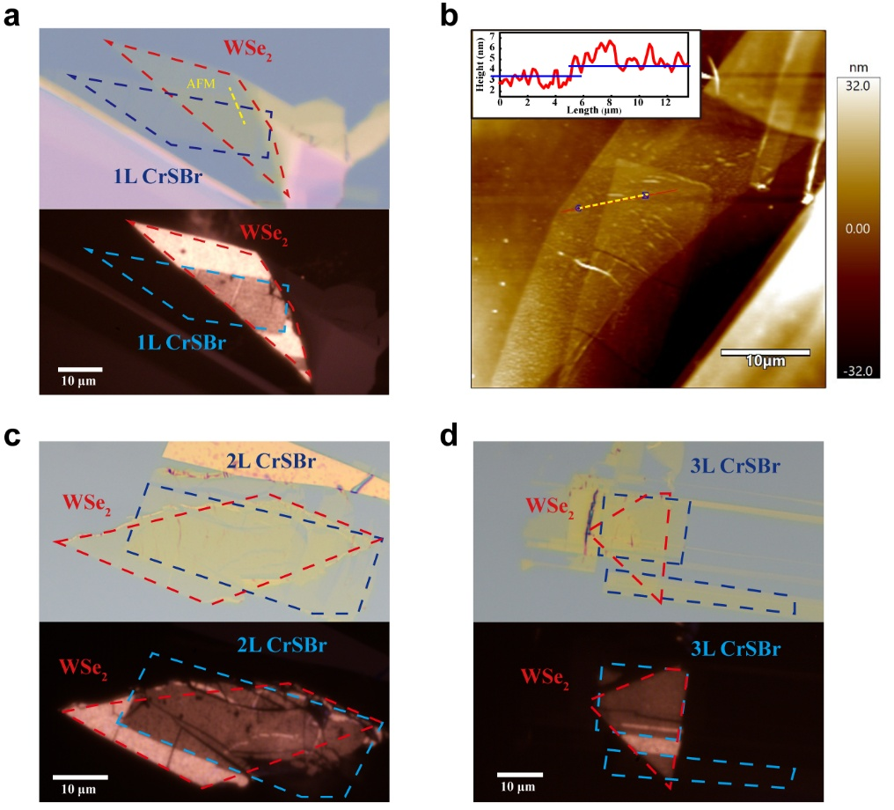

Fig. S1. Morphology characterization of the CrSBr/WSe₂ heterostructure.
a Optical (upper) and fluorescence (lower) images of the 1L-CrSBr/1L-WSe₂ heterostructure shown in Fig. 1a. The uniform fluorescence at different region shows a high quality of this sample. b Atomic force microscopy (AFM) image of the same heterostructure. The height measured along the yellow-dashed line is ~1nm which indicates a close contact between CrSBr and WSe₂ in the heterostructure region. c and d Optical images (upper) and fluorescence (lower) images of the 2L-CrSBr/1L-WSe₂ and 3L-CrSBr/1L-WSe₂ heterostructure, respectively.

Fig. S2. Optical properties of the CrSBr/WSe₂ heterostructure on quartz substrates.
a Optical image of the 1L-CrSBr/1L-WSe₂ heterostructure fabricated on a quartz substrate. b Absorption spectra for this sample at different regions at 4 K. c Circularly-polarized PL spectra of 1L WSe₂ at different regions at 4 K.

Fig. S3. Optical properties of the CrSBr/MoSe₂ heterostructure.
a Optical image of a typical 1L-CrSBr/1L-MoSe₂ heterostructure fabricated on the Si/SiO₂ substrate. b Circularly-polarized PL spectra of 1L MoSe₂ at different regions at 4 K. c Circularly-polarized PL spectra of individual 1L CrSBr at 4 K.

Fig. S4. TAS dynamics of 1L WSe₂.
a TAS of 1L WSe₂ on a quartz substrate measured under the σ+σ+ polarization configuration. b The decay dynamics of excitons at a probe energy of 1.78 eV for individual 1L WSe₂. c The decay dynamics of excitons at a probe energy of 1.78 eV for 1L WSe₂ at the heterostructure region. All the decay curves are fitted with a biexponential function, representing the fast and slow decay processes as discussed in the main text.

Fig. S5. Temperature- and polarization-dependent TAS of the CrSBr/WSe₂ heterostructure.
TAS of the 1L-CrSBr/1L-WSe₂ heterostructure a and 1L WSe₂ b measured at 4 K under the σ+σ+ configuration. TAS measured at room temperature under the σ-σ- c and σ+σ+ d polarization configurations. The pump photon energy was ~1.36 eV with a pump fluence of 113.2 μJ cm⁻².

Fig. S6. TAS of 1-3L CrSBr.
TAS of 1L CrSBr measured under the pump photon energy of ~1.36 eV a and ~1.96 eV b, respectively. TAS of 2L CrSBr c and 3L CrSBr d measured under a pump photon energy of ~1.96 eV. The pump fluence was kept at ~33.96 μJ cm⁻².

Fig. S7. The 1L-CrSBr/1L-WSe₂ supercell.
Top a and side b views of 1L-CrSBr/1L-WSe₂ heterostructure. The dotted arrows indicate the lattice vectors a and b for the unit cell of the heterostructure.

References
1 Kresse, G. & Furthmüller, J. Efficient iterative schemes for ab initio total-energy calculations using a plane-wave basis set. Physical Review B 54, 11169-11186, doi:10.1103/PhysRevB.54.11169 (1996).
2 Blöchl, P. E. Projector augmented-wave method. Physical Review B 50, 17953-17979, doi:10.1103/PhysRevB.50.17953 (1994).
3 Perdew, J. P., Burke, K. & Ernzerhof, M. Generalized Gradient Approximation Made Simple [Phys. Rev. Lett. 77, 3865 (1996)]. Physical Review Letters 78, 1396-1396, doi:10.1103/PhysRevLett.78.1396 (1997).
4 Bobzien, L. et al. Layer-Dependent Charge-State Lifetime of Single Se Vacancies in WSe2. Physical Review Letters 134, 076201, doi:10.1103/PhysRevLett.134.076201 (2025).
5 Grimme, S., Ehrlich, S. & Goerigk, L. Effect of the damping function in dispersion corrected density functional theory. Journal of Computational Chemistry 32, 1456-1465, doi:https://doi.org/10.1002/jcc.21759 (2011).
6 Liechtenstein, A. I., Anisimov, V. I. & Zaanen, J. Density-functional theory and strong interactions: Orbital ordering in Mott-Hubbard insulators. Physical Review B 52, R5467-R5470, doi:10.1103/PhysRevB.52.R5467 (1995).
7 R. Kempt, Hetbuilder-builds heterostructure interfaces. GitHub repository, doi:10.5281/zenodo.4721346 (2021).
8 Wang, V., Xu, N., Liu, J.-C., Tang, G. & Geng, W.-T. VASPKIT: A user-friendly interface facilitating high-throughput computing and analysis using VASP code. Computer Physics Communications 267, 108033, doi:https://doi.org/10.1016/j.cpc.2021.108033 (2021).
9 Scheie, A. et al. Spin Waves and Magnetic Exchange Hamiltonian in CrSBr. Advanced Science 9, 2202467, doi:https://doi.org/10.1002/advs.202202467 (2022).
10 Ziebel, M. E. et al. CrSBr: An Air-Stable, Two-Dimensional Magnetic Semiconductor. Nano Letters 24, 4319-4329, doi:10.1021/acs.nanolett.4c00624 (2024).
11 Lee, J.-U. et al. Ising-Type Magnetic Ordering in Atomically Thin FePS3. Nano Letters 16, 7433-7438, doi:10.1021/acs.nanolett.6b03052 (2016).
12 Xiao, D., Liu, G.-B., Feng, W., Xu, X. & Yao, W. Coupled Spin and Valley Physics in Monolayers of MoS2 and Other Group-VI Dichalcogenides. Physical Review Letters 108, 196802, doi:10.1103/PhysRevLett.108.196802 (2012).
13 Zollner, K., Faria Junior, P. E. & Fabian, J. Proximity exchange effects in MoSe2 and WSe2 heterostructures with CrI3: Twist angle, layer, and gate dependence. Physical Review B 100, 085128, doi:10.1103/PhysRevB.100.085128 (2019).
14 Scharf, B., Xu, G., Matos-Abiague, A. & Žutić, I. Magnetic Proximity Effects in Transition-Metal Dichalcogenides: Converting Excitons. Physical Review Letters 119, 127403, doi:10.1103/PhysRevLett.119.127403 (2017).
15 Zhong, D. et al. Layer-resolved magnetic proximity effect in van der Waals heterostructures. Nature Nanotechnology 15, 187-191, doi:10.1038/s41565-019-0629-1 (2020).
16 Zhang, X.-X. et al. Magnetic brightening and control of dark excitons in monolayer WSe2. Nature Nanotechnology 12, 883-888, doi:10.1038/nnano.2017.105 (2017).

