Supplementary Information
Multi-omic Longitudinal Profiling Reveals Coordinated Gut Microbiota, Metabolomics, and Host Proteomics Signatures Predictive of Antidepressant Response in Drug-Naïve Depression

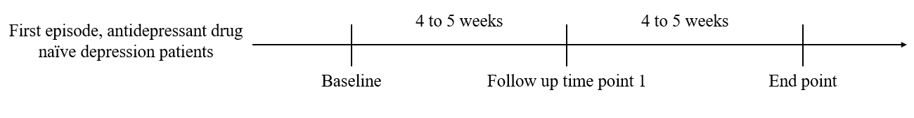
 | Baseline | Follow up time point 1 | End point
SADS-L (Schedual for Affective Disorder and Schizophrenia) | V
FFQ (Food-Frequency Questionnaire | V
HAMD (Hamilton Depression Rating Scale) | V | V | V
Stool / Blood | V | V | V

Figure S1. Subjects’ longitudinal follow-up and data collection workflow

A
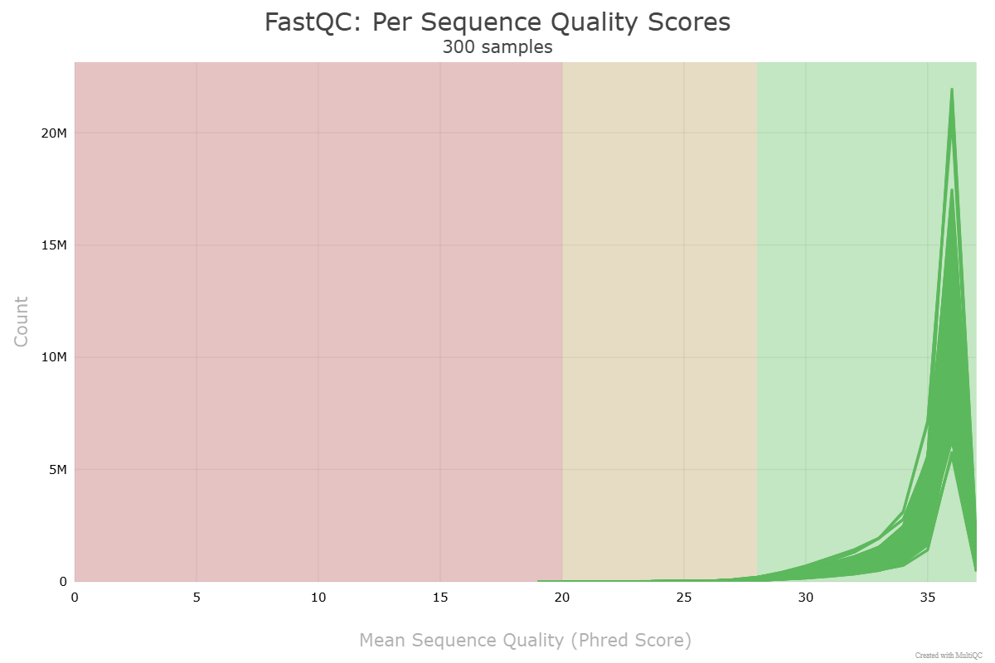
B
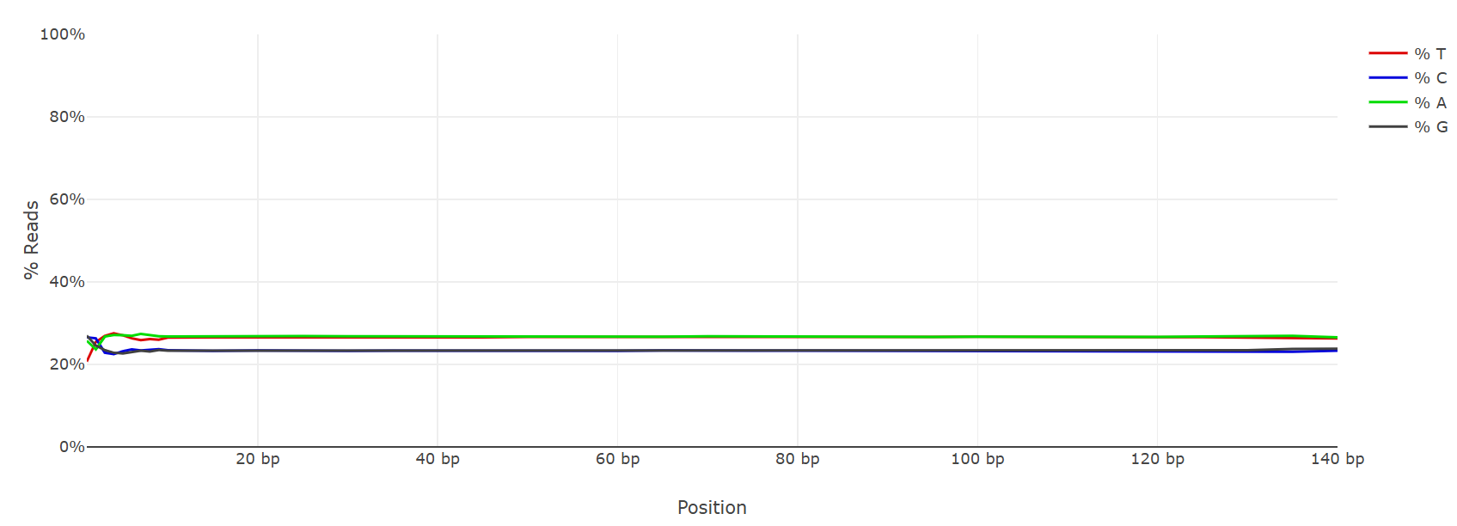
C
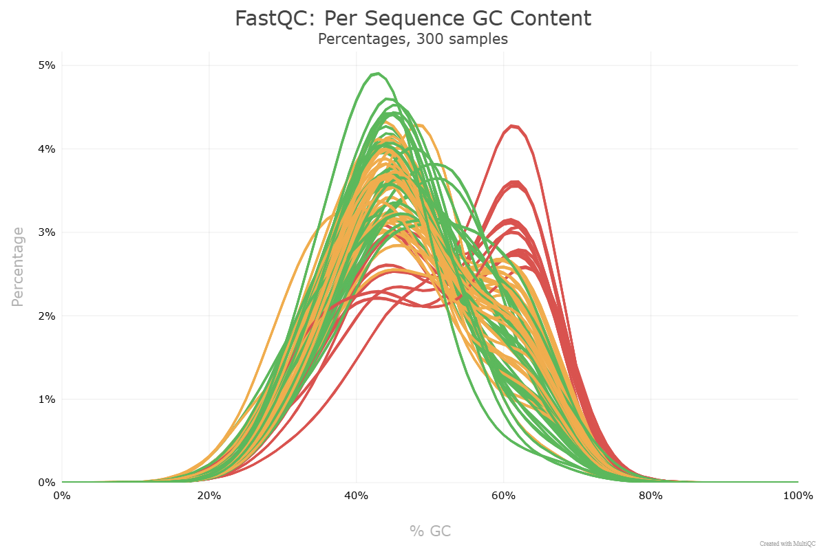

Figure S2. Quality assessment of shotgun metagenomic sequencing reads. (A) Distribution of per-sequence quality scores across 300 samples, showing that the majority of reads have Phred scores >30, indicating high sequencing accuracy. (B) Per-base sequence content plot demonstrating uniform nucleotide composition along read positions, suggesting minimal sequencing bias. (C) Per-sequence GC content distribution across samples, showing expected bimodal GC patterns consistent with gut microbial communities.

A
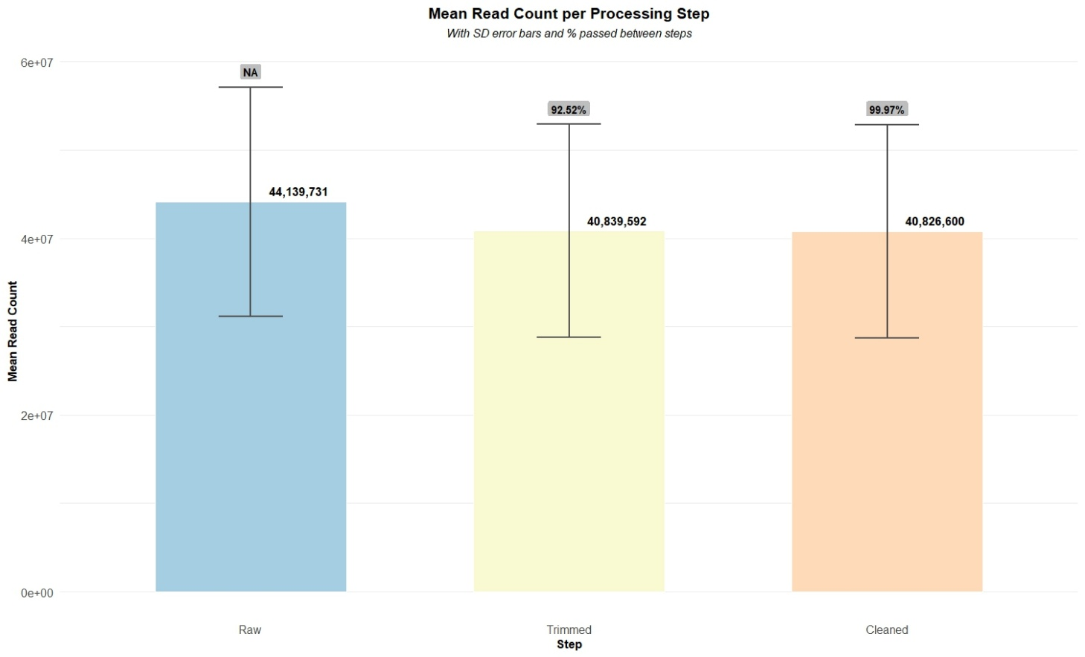
B
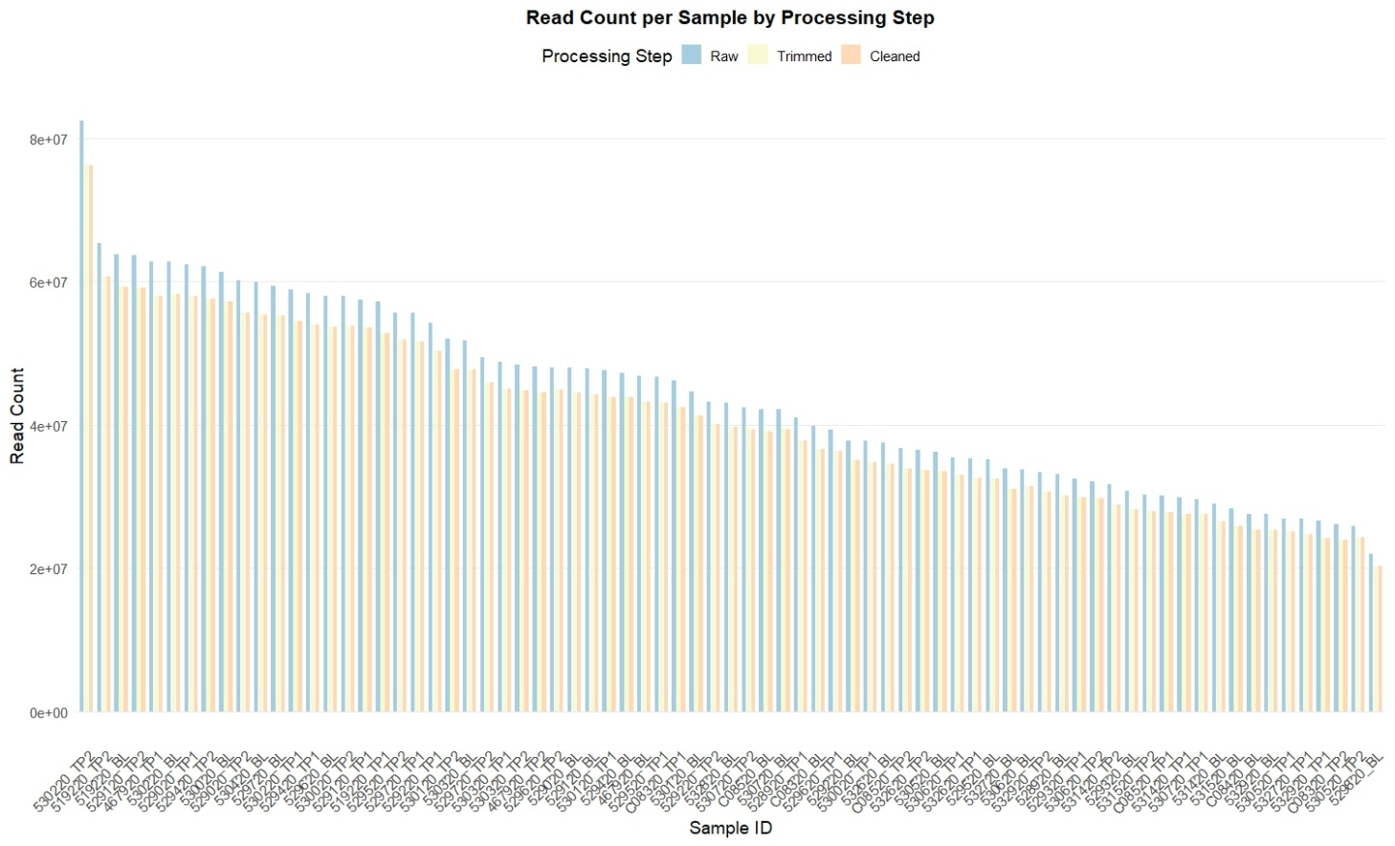

Figure S3. Summary of shotgun metagenomic read counts across processing steps. (A) Mean read counts (± SD) at each processing step. (B) Per-sample read count distribution across processing steps.

A
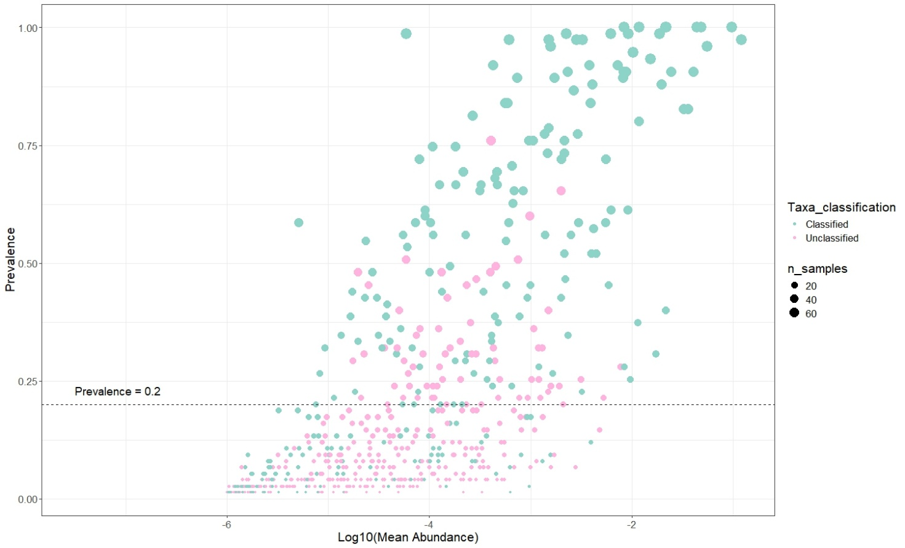
B
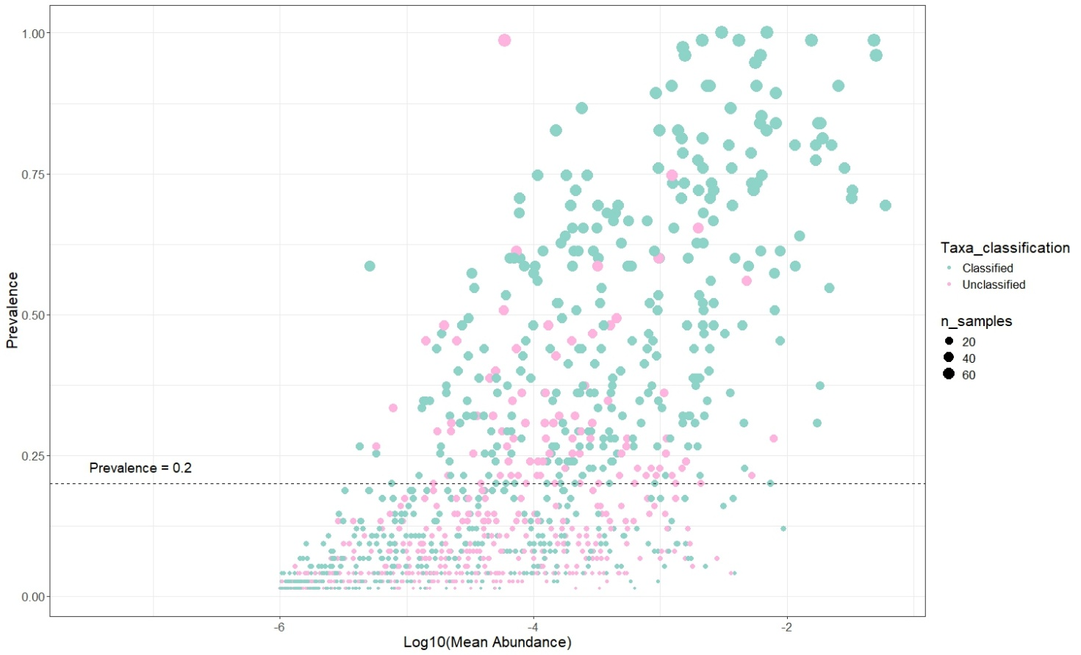

Figure S4. Prevalence–abundance relationship and taxonomic classification status of identified taxa. Each point represents a taxon, with size proportional to the number of samples in which it was detected. Scatter plot showing the relationship between mean relative abundance (x-axis, log10-transformed) and prevalence (y-axis) of identified taxa. (A) Genue level; (B) Species level.

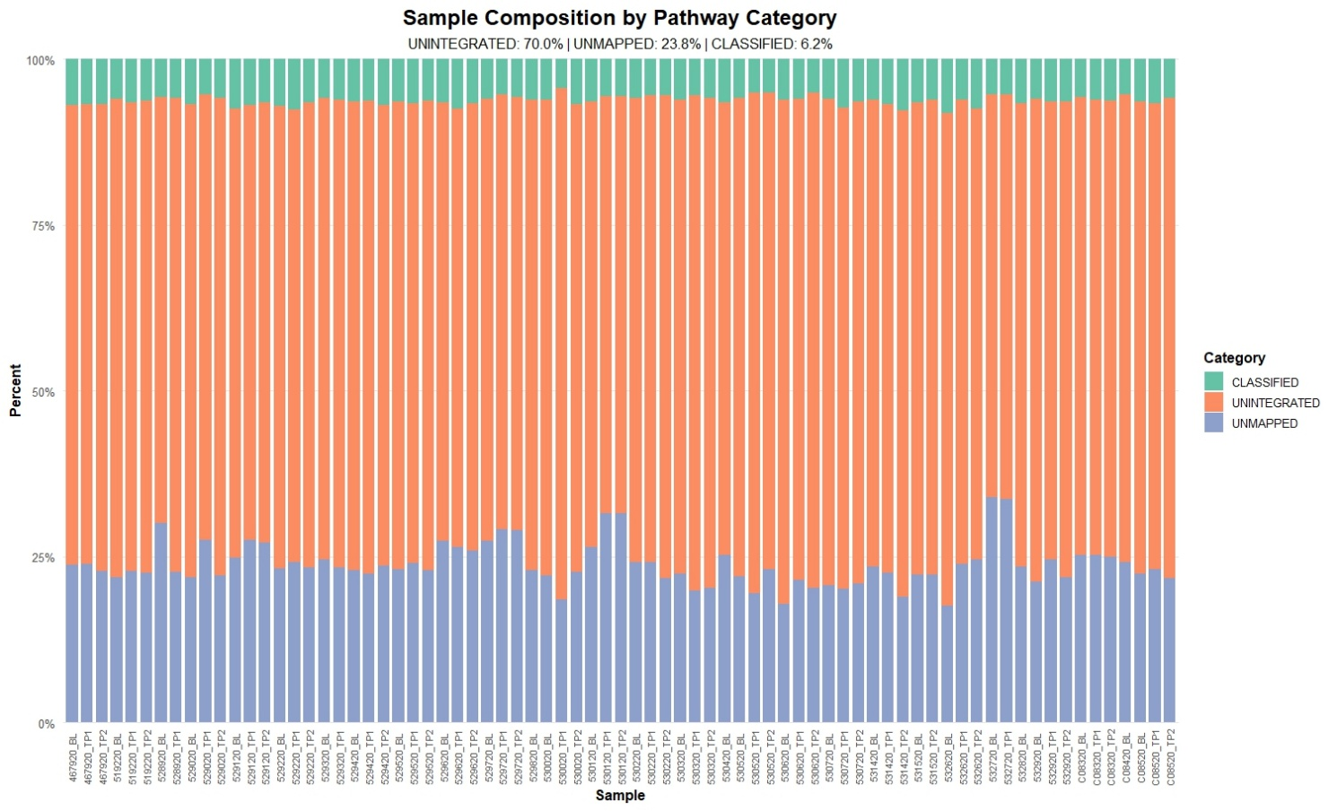

Figure S5. Distribution of pathway classification categories across samples. Stacked bar plots show the relative proportion of classified, unintegrated, and unmapped pathways per sample generated by HUMAnN3 functional profiling.
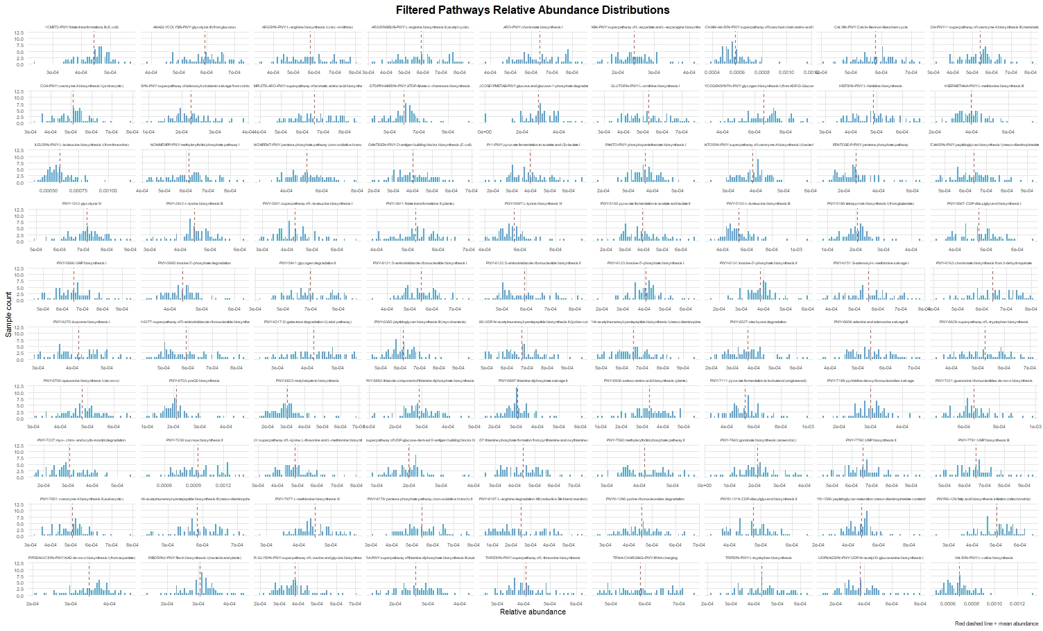

Figure S6. Distribution of relative abundances of filtered microbial pathways. Histogram plots show the relative abundance distributions of pathways retained after coverage filtering (median coverage > 30%). Each panel represents a single pathway, with the red dashed line indicating the mean abundance across all samples.

A
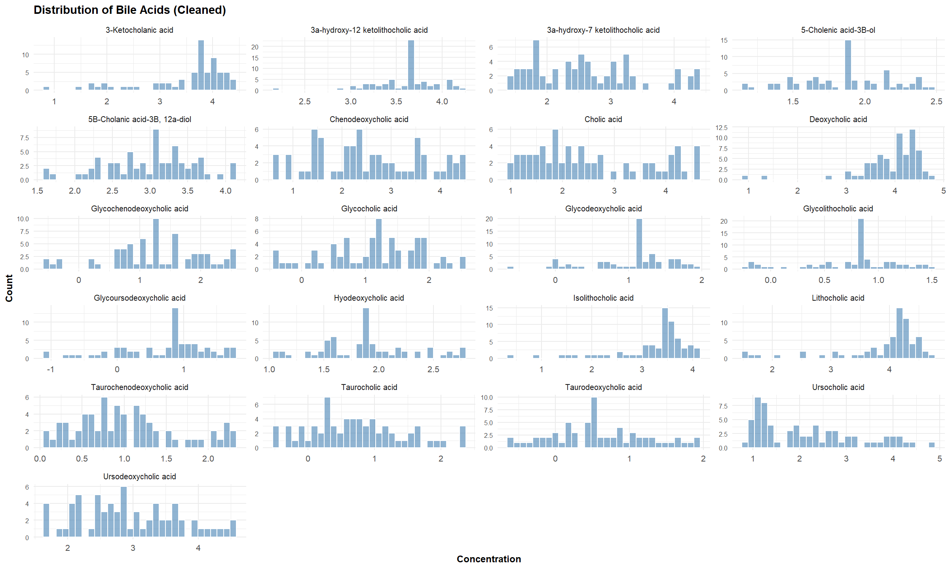
B
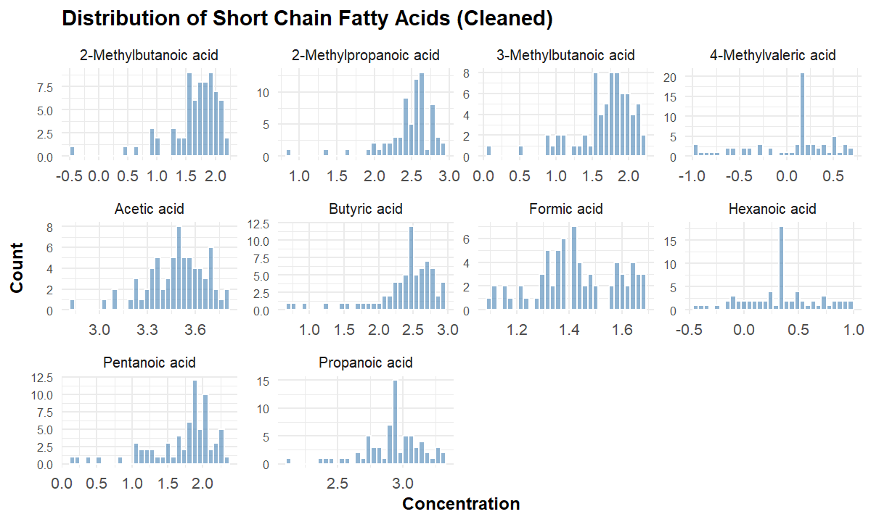

Figure S7. Distributions of cleaned metabolite concentration data. Histogram plots illustrate the distribution of measured metabolite concentrations after data cleaning and normalization. (A) Bile acids; (B) Short chain fatty acids.

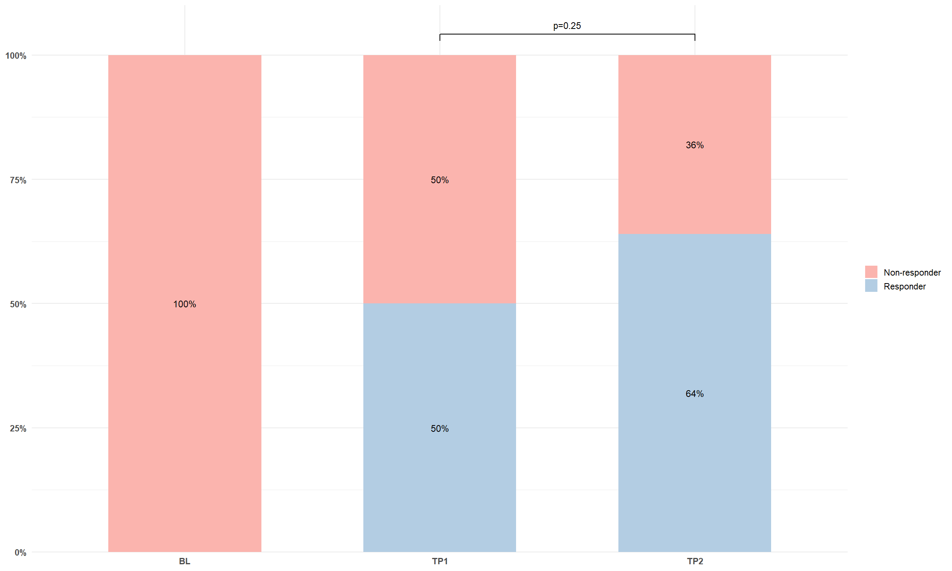

Figure S8. Proportion of treatment responders across time points. Stacked bar plots illustrate the proportion of participants classified as responders and non-responders at each study time point (BL, TP1, TP2).

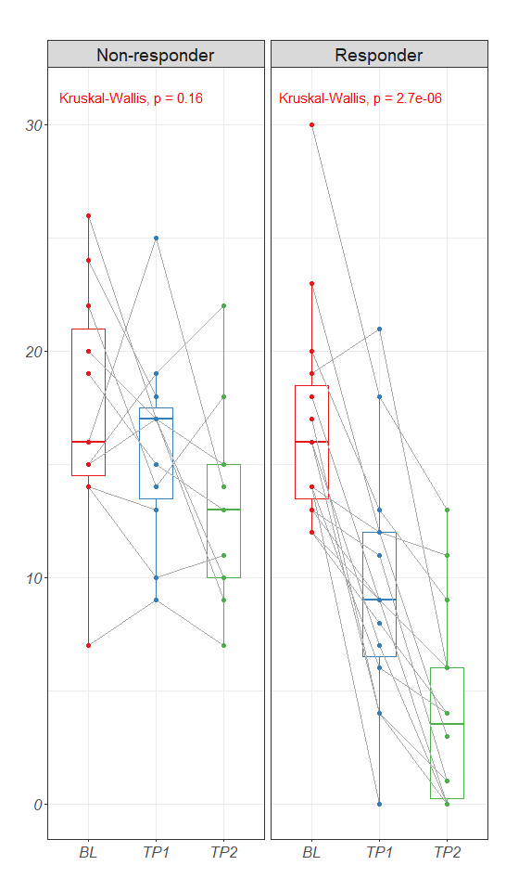

Figure S9. Changes in symptom severity (HAMD) scores between groups over time. Individual trajectories are connected by grey lines, and boxplots represent score distributions at each time point. Statistical comparisons were performed using Kruskal–Wallis tests within each group.

A
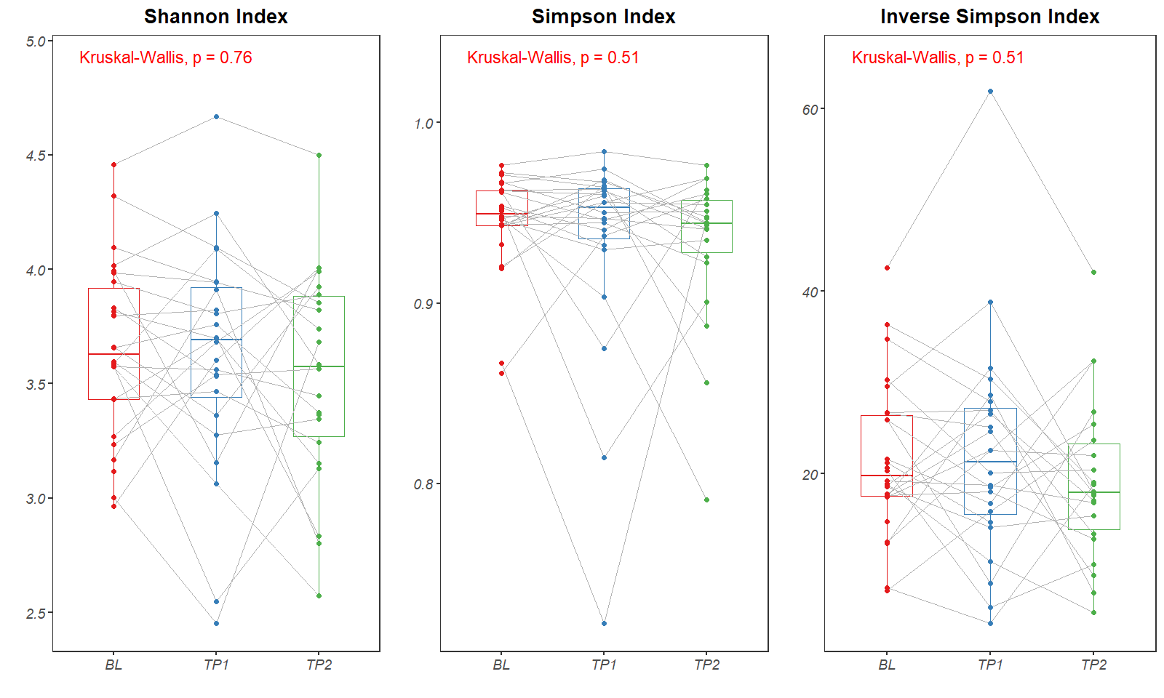
B
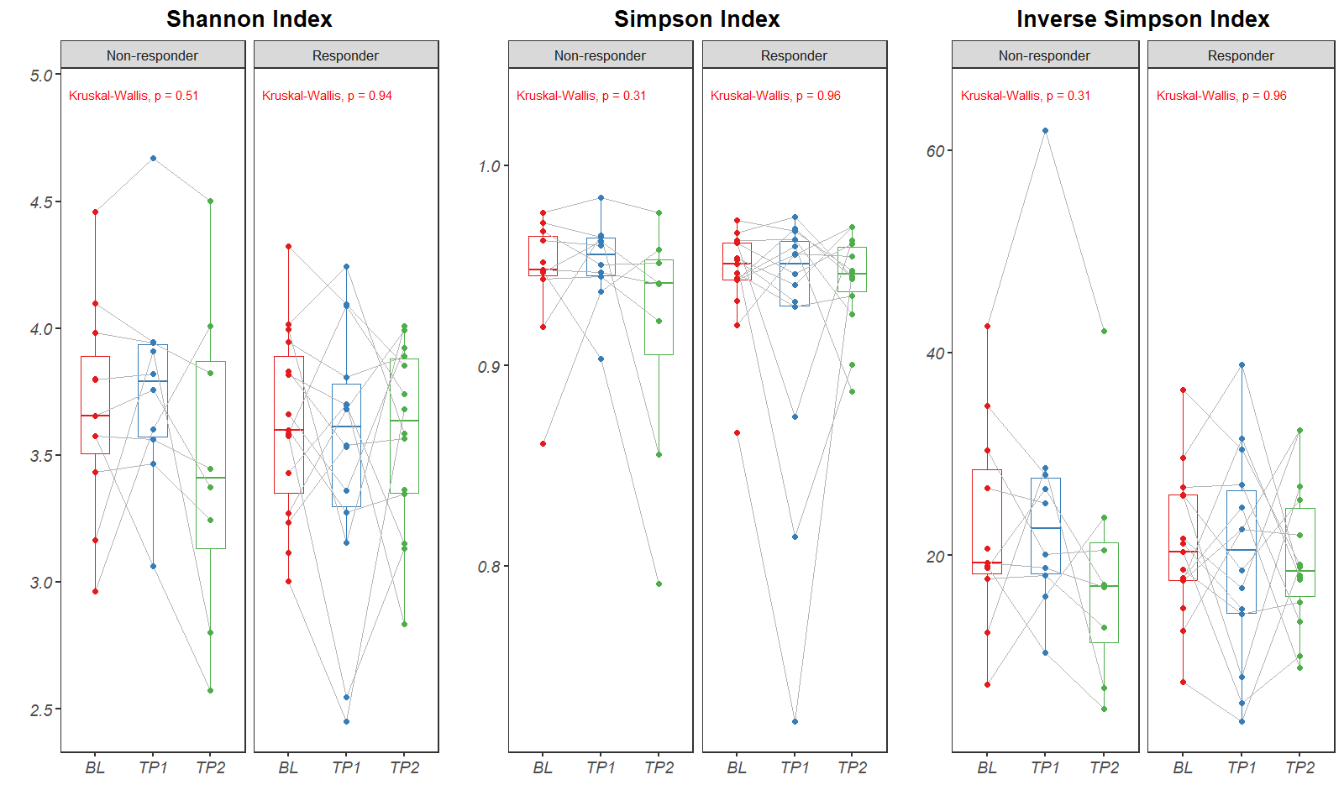
C
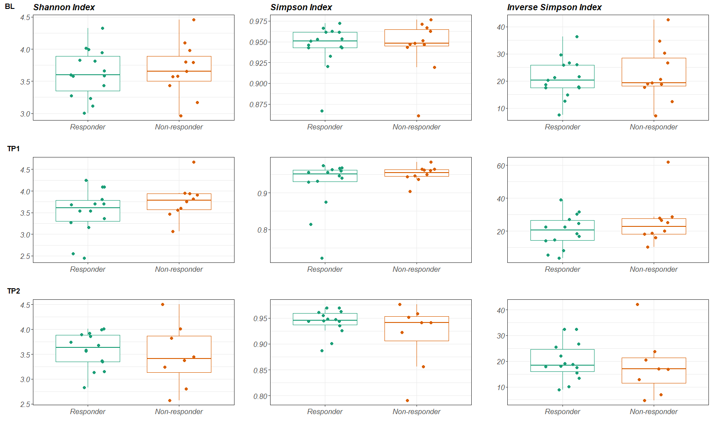

Figure S10. Alpha diversity comparison across time points and treatment response groups. (A) Longitudinal changes of alpha diversity indices (Shannon, Simpson, and Inverse Simpson) across baseline (BL), TP1, and TP2 for all participants. (B) Changes in alpha diversity indices within responder and non-responder groups over time. (C) Cross-sectional comparison of alpha diversity indices between responders and non-responders at each time point. Kruskal–Wallis tests were applied to assess within-group temporal differences.

A
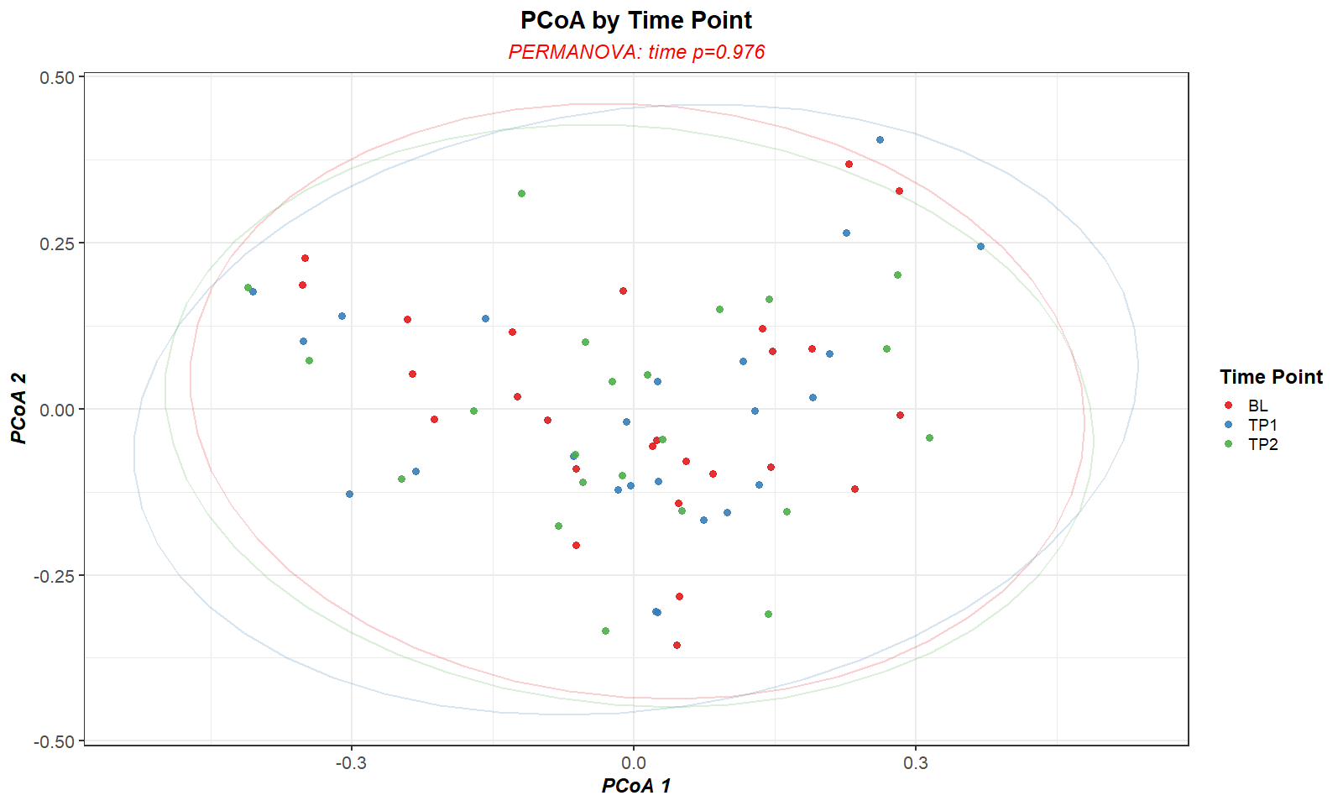
B
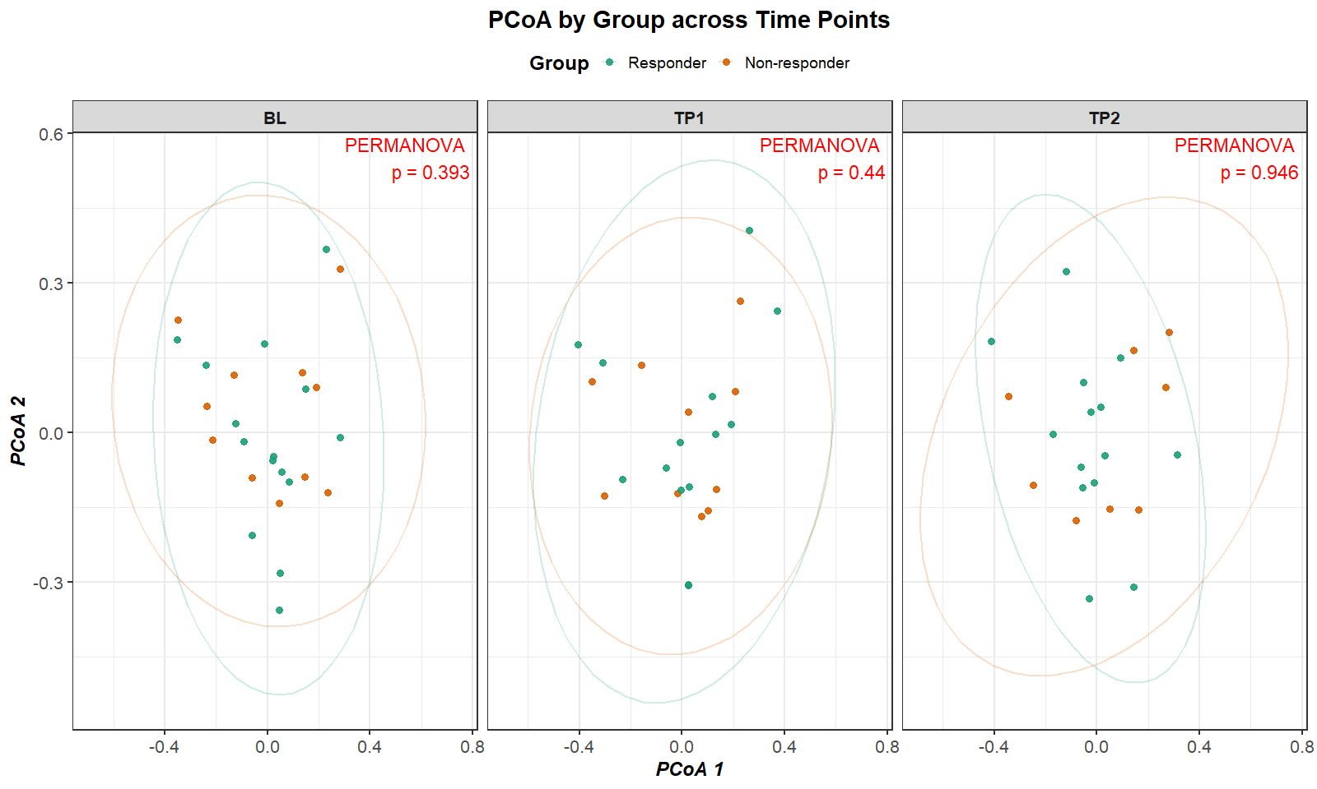
C
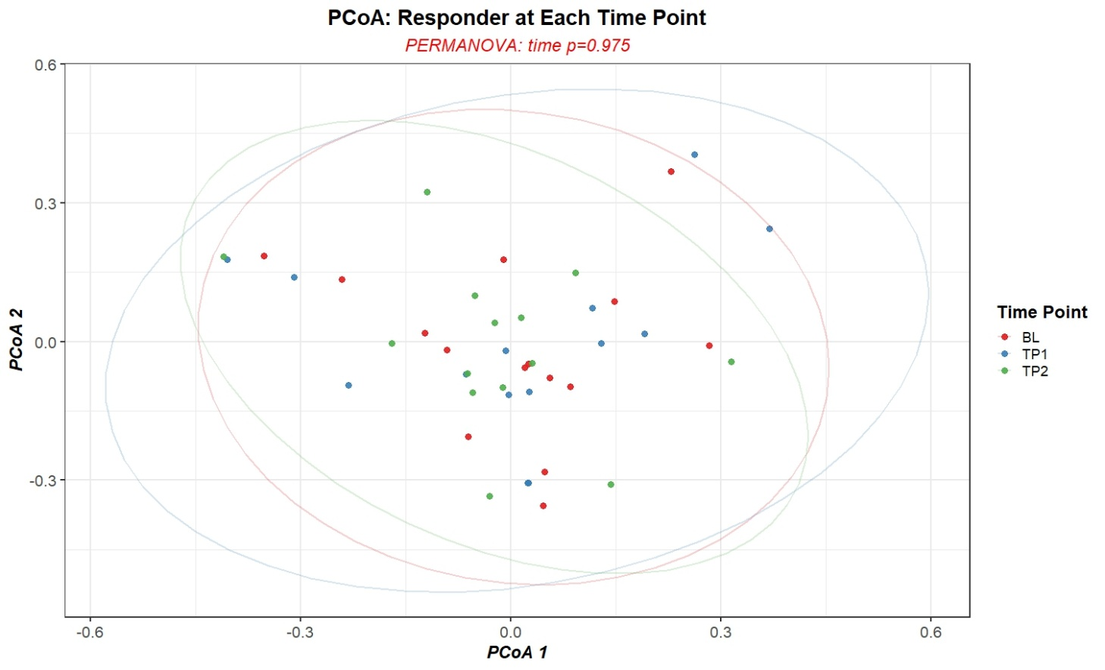
D
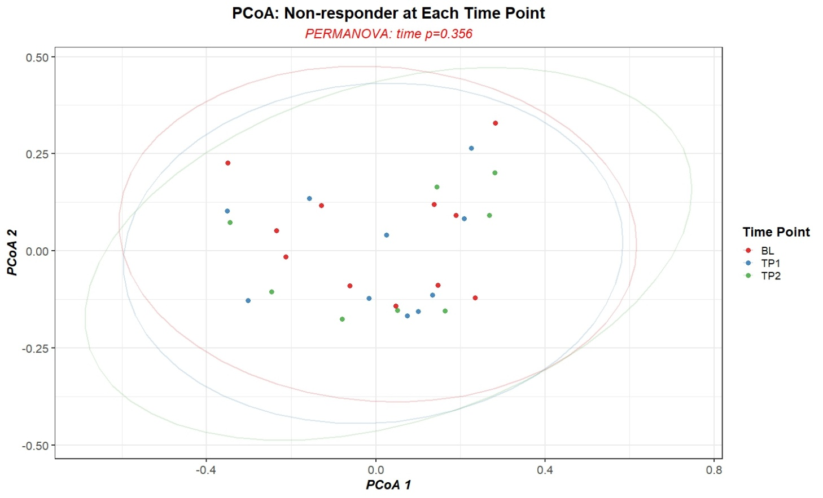

Figure S11. Beta diversity PCoA plots based on Bray–Curtis distance. (A) Overall ordination plot showing the distribution of microbial community composition by time point. (B) Stratified PCoA plots at each time point (BL, TP1, TP2) comparing responders and non-responders. (C, D) Longitudinal PCoA plots illustrating temporal shifts within the responder and non-responder groups, respectively.

A
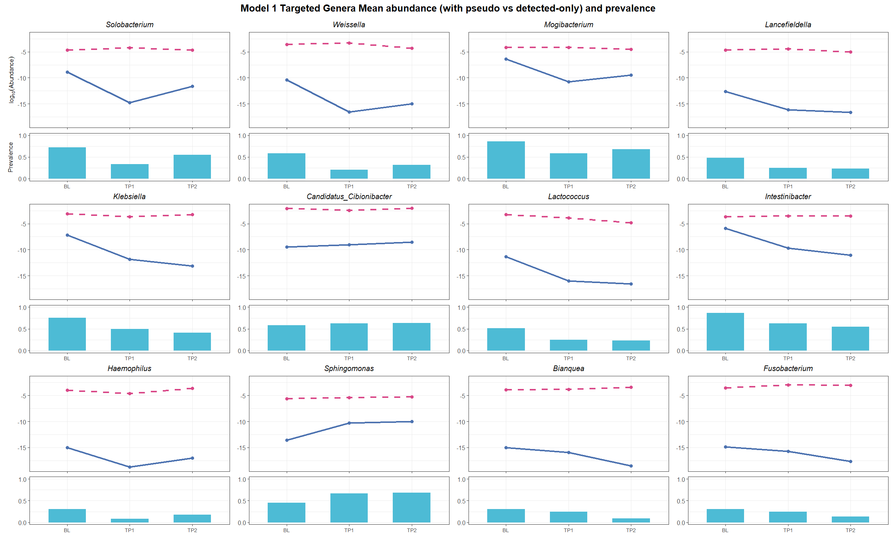
B
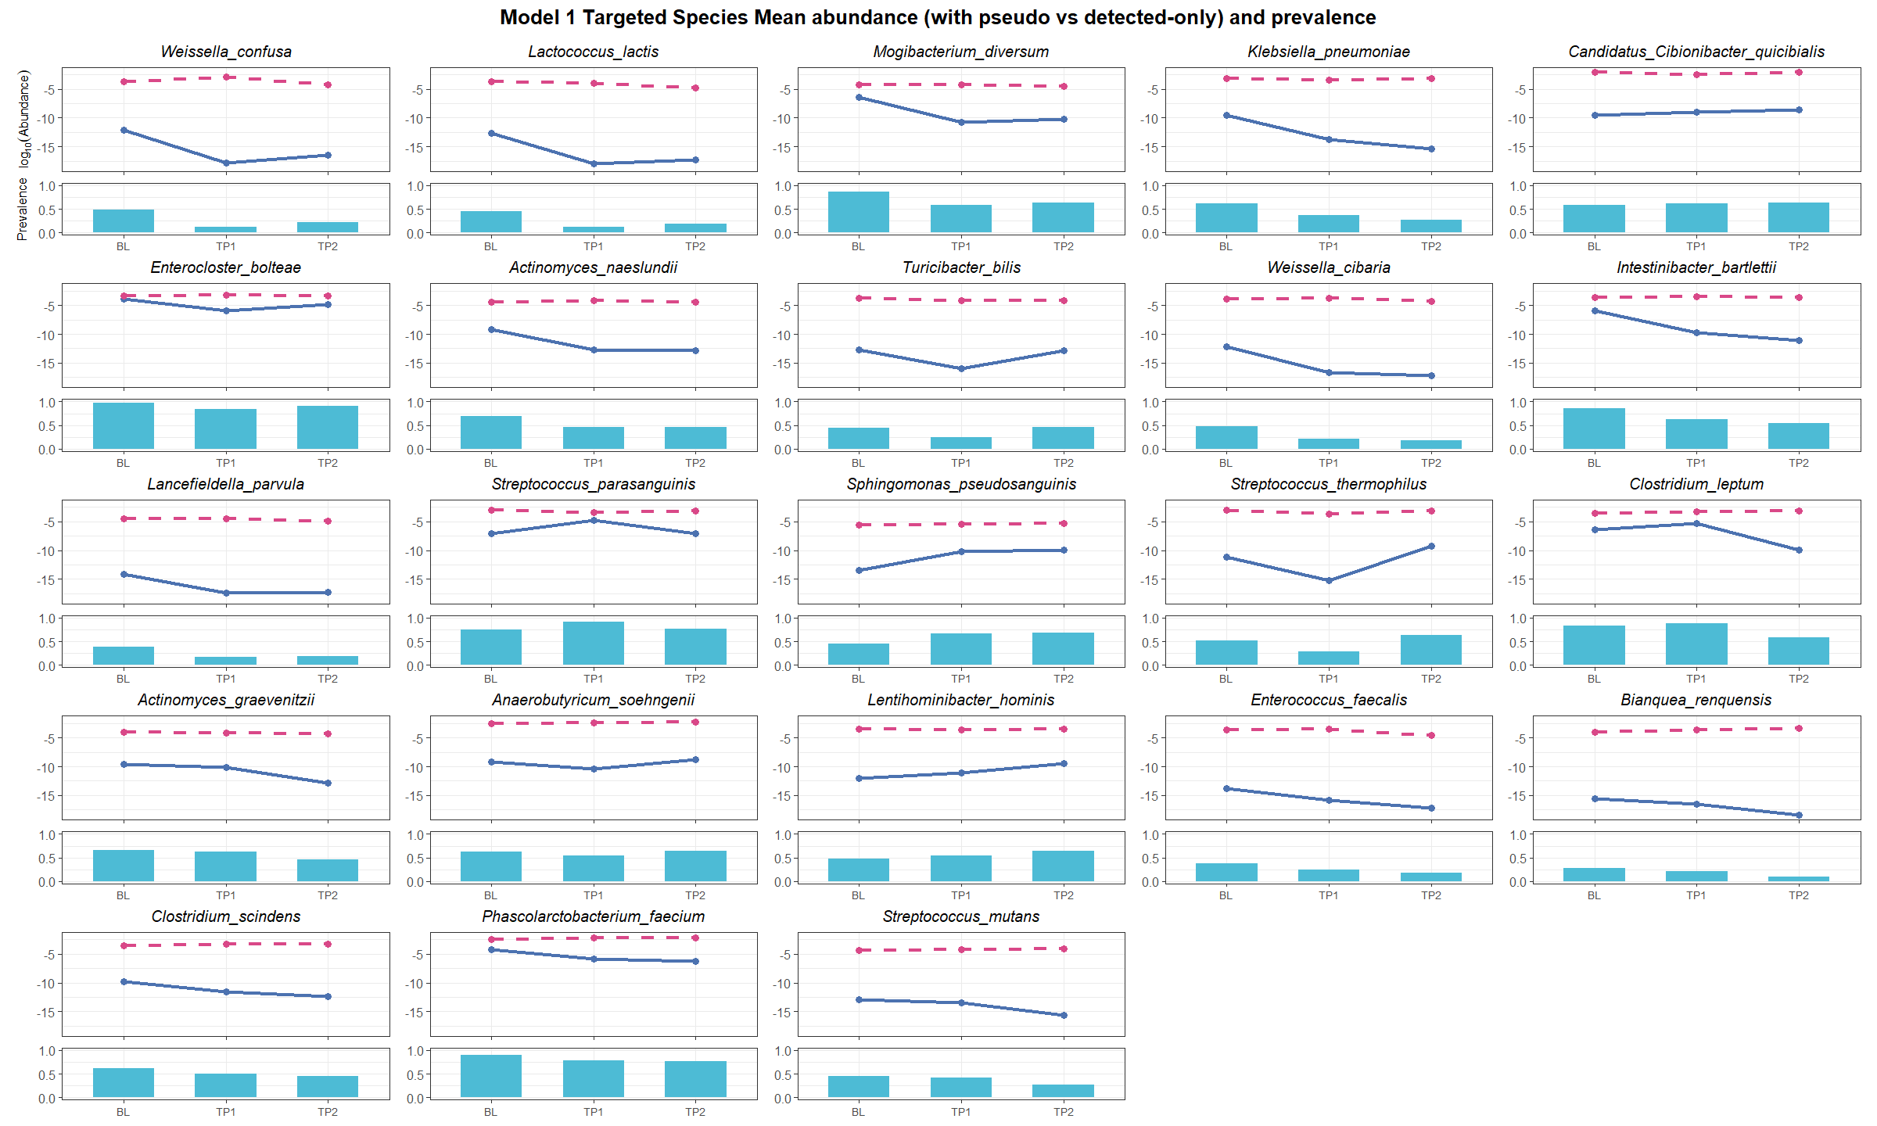

Figure S12. Longitudinal trends of targeted genera and species in Model I. Each panel shows the mean log-transformed abundance (line plots) and prevalence (bar plots) of targeted genera (A) and species (B) across three time points (BL, TP1, and TP2). Solid blue lines represent abundance including zero values (pseudo-count applied), while dashed pink lines represent abundance calculated from detected-only samples (excluding zeros). The prevalence bars indicate the proportion of samples in which each taxon was detected at each time point.

A
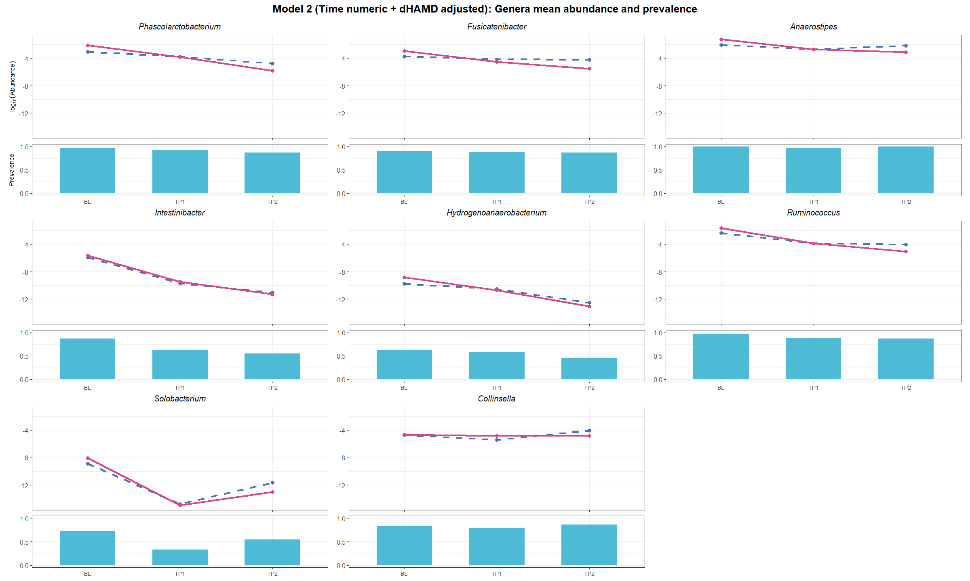
B
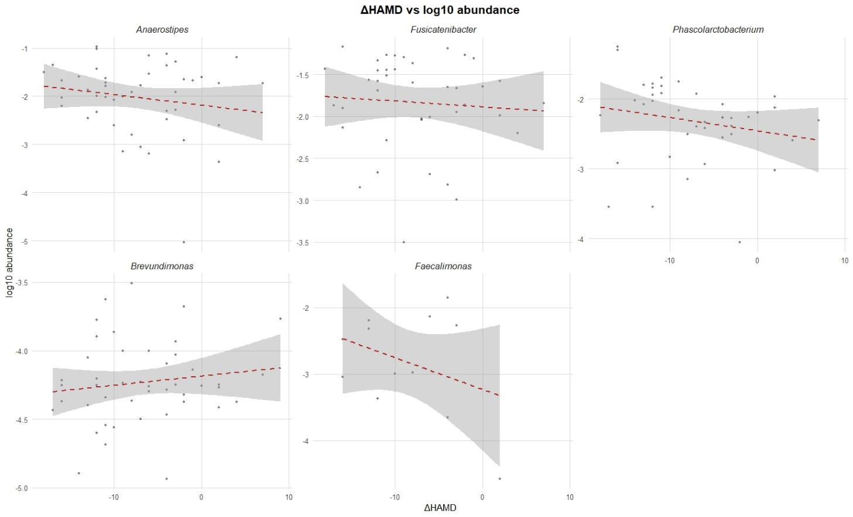
C
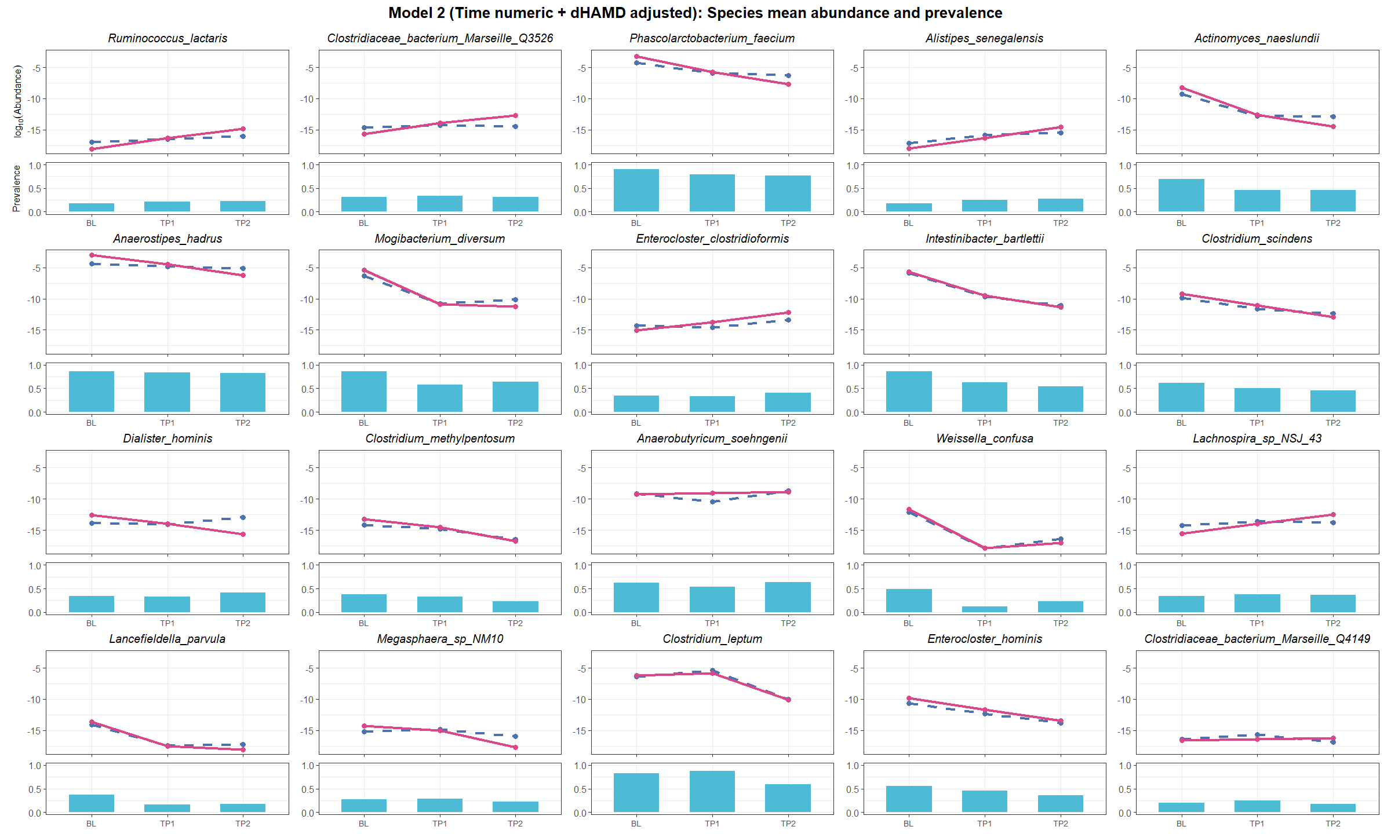
D
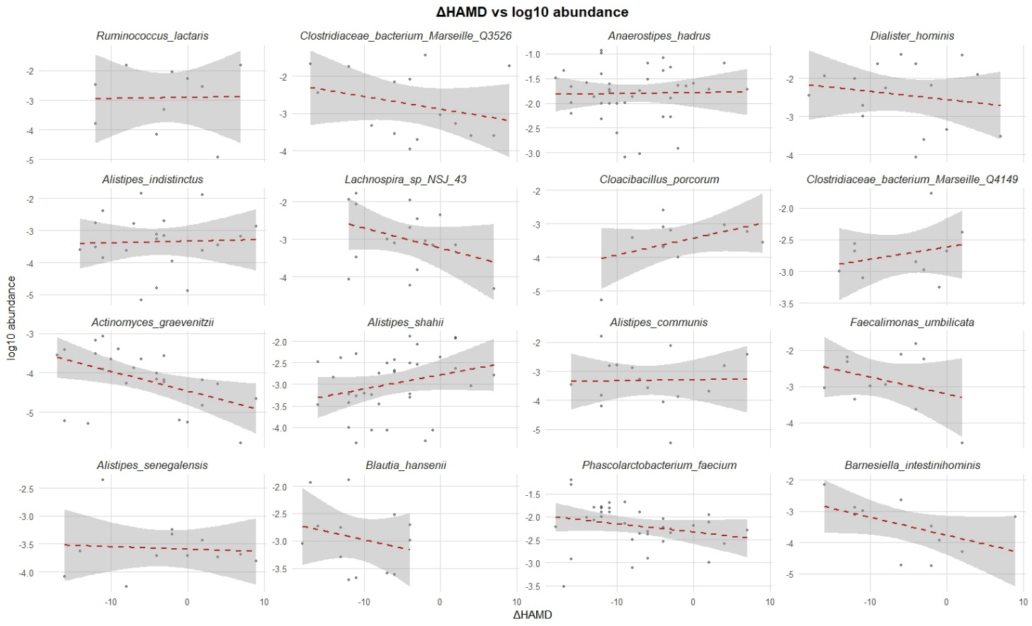

Figure S13. Targeted genera and species associations from Model II (time + ΔHAMD adjusted). (A, C) Mean log-transformed abundance (solid blue lines: including zero values; dashed pink lines: detected-only samples) and prevalence (bar plots) of genera / species significantly associated with time in Model II. (B, D) Scatter plots showing correlations between ΔHAMD and log₁₀-transformed abundances of selected genera / species.

A
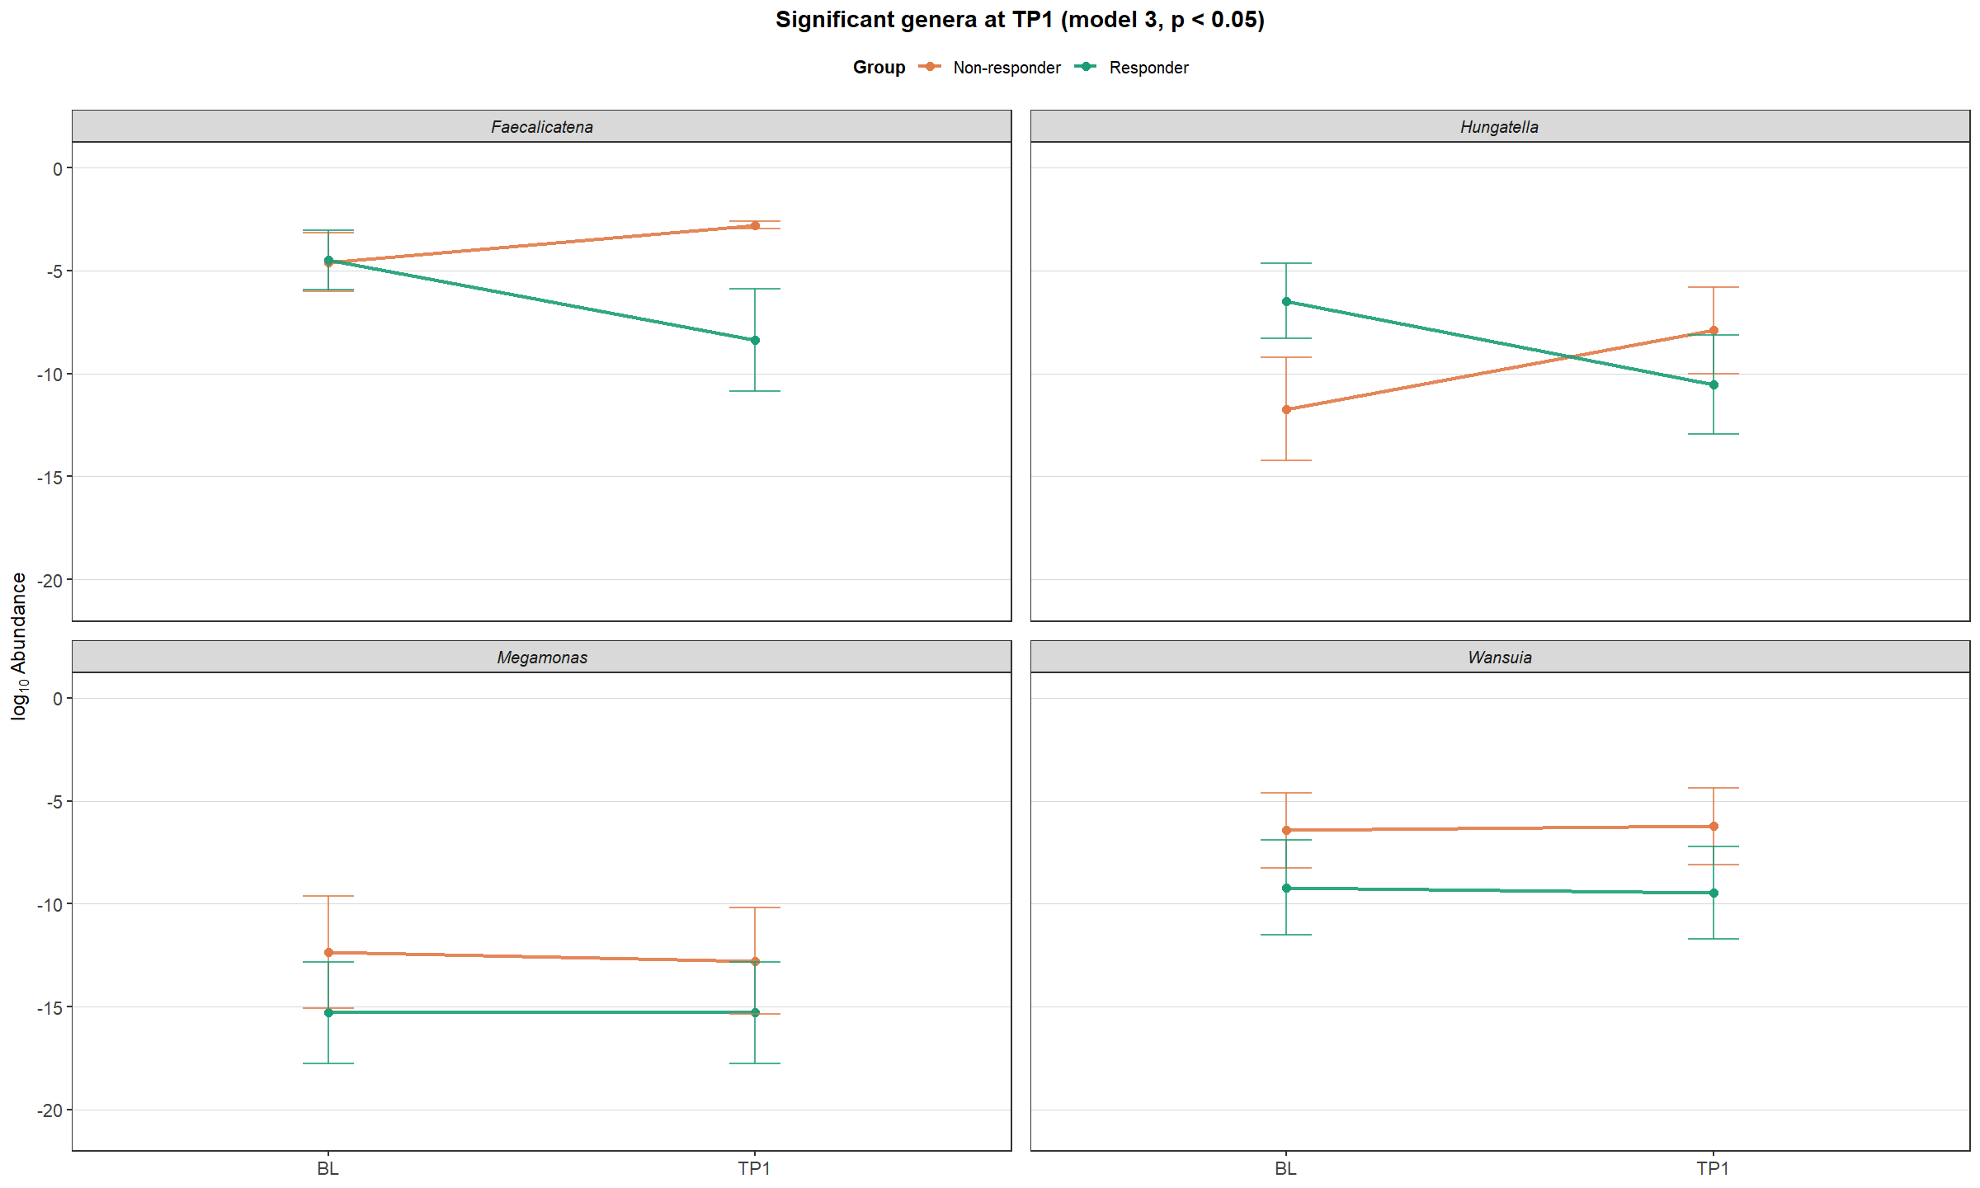
B
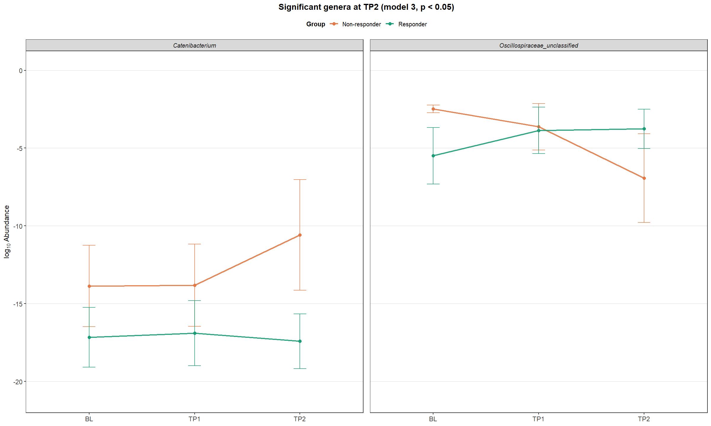
C
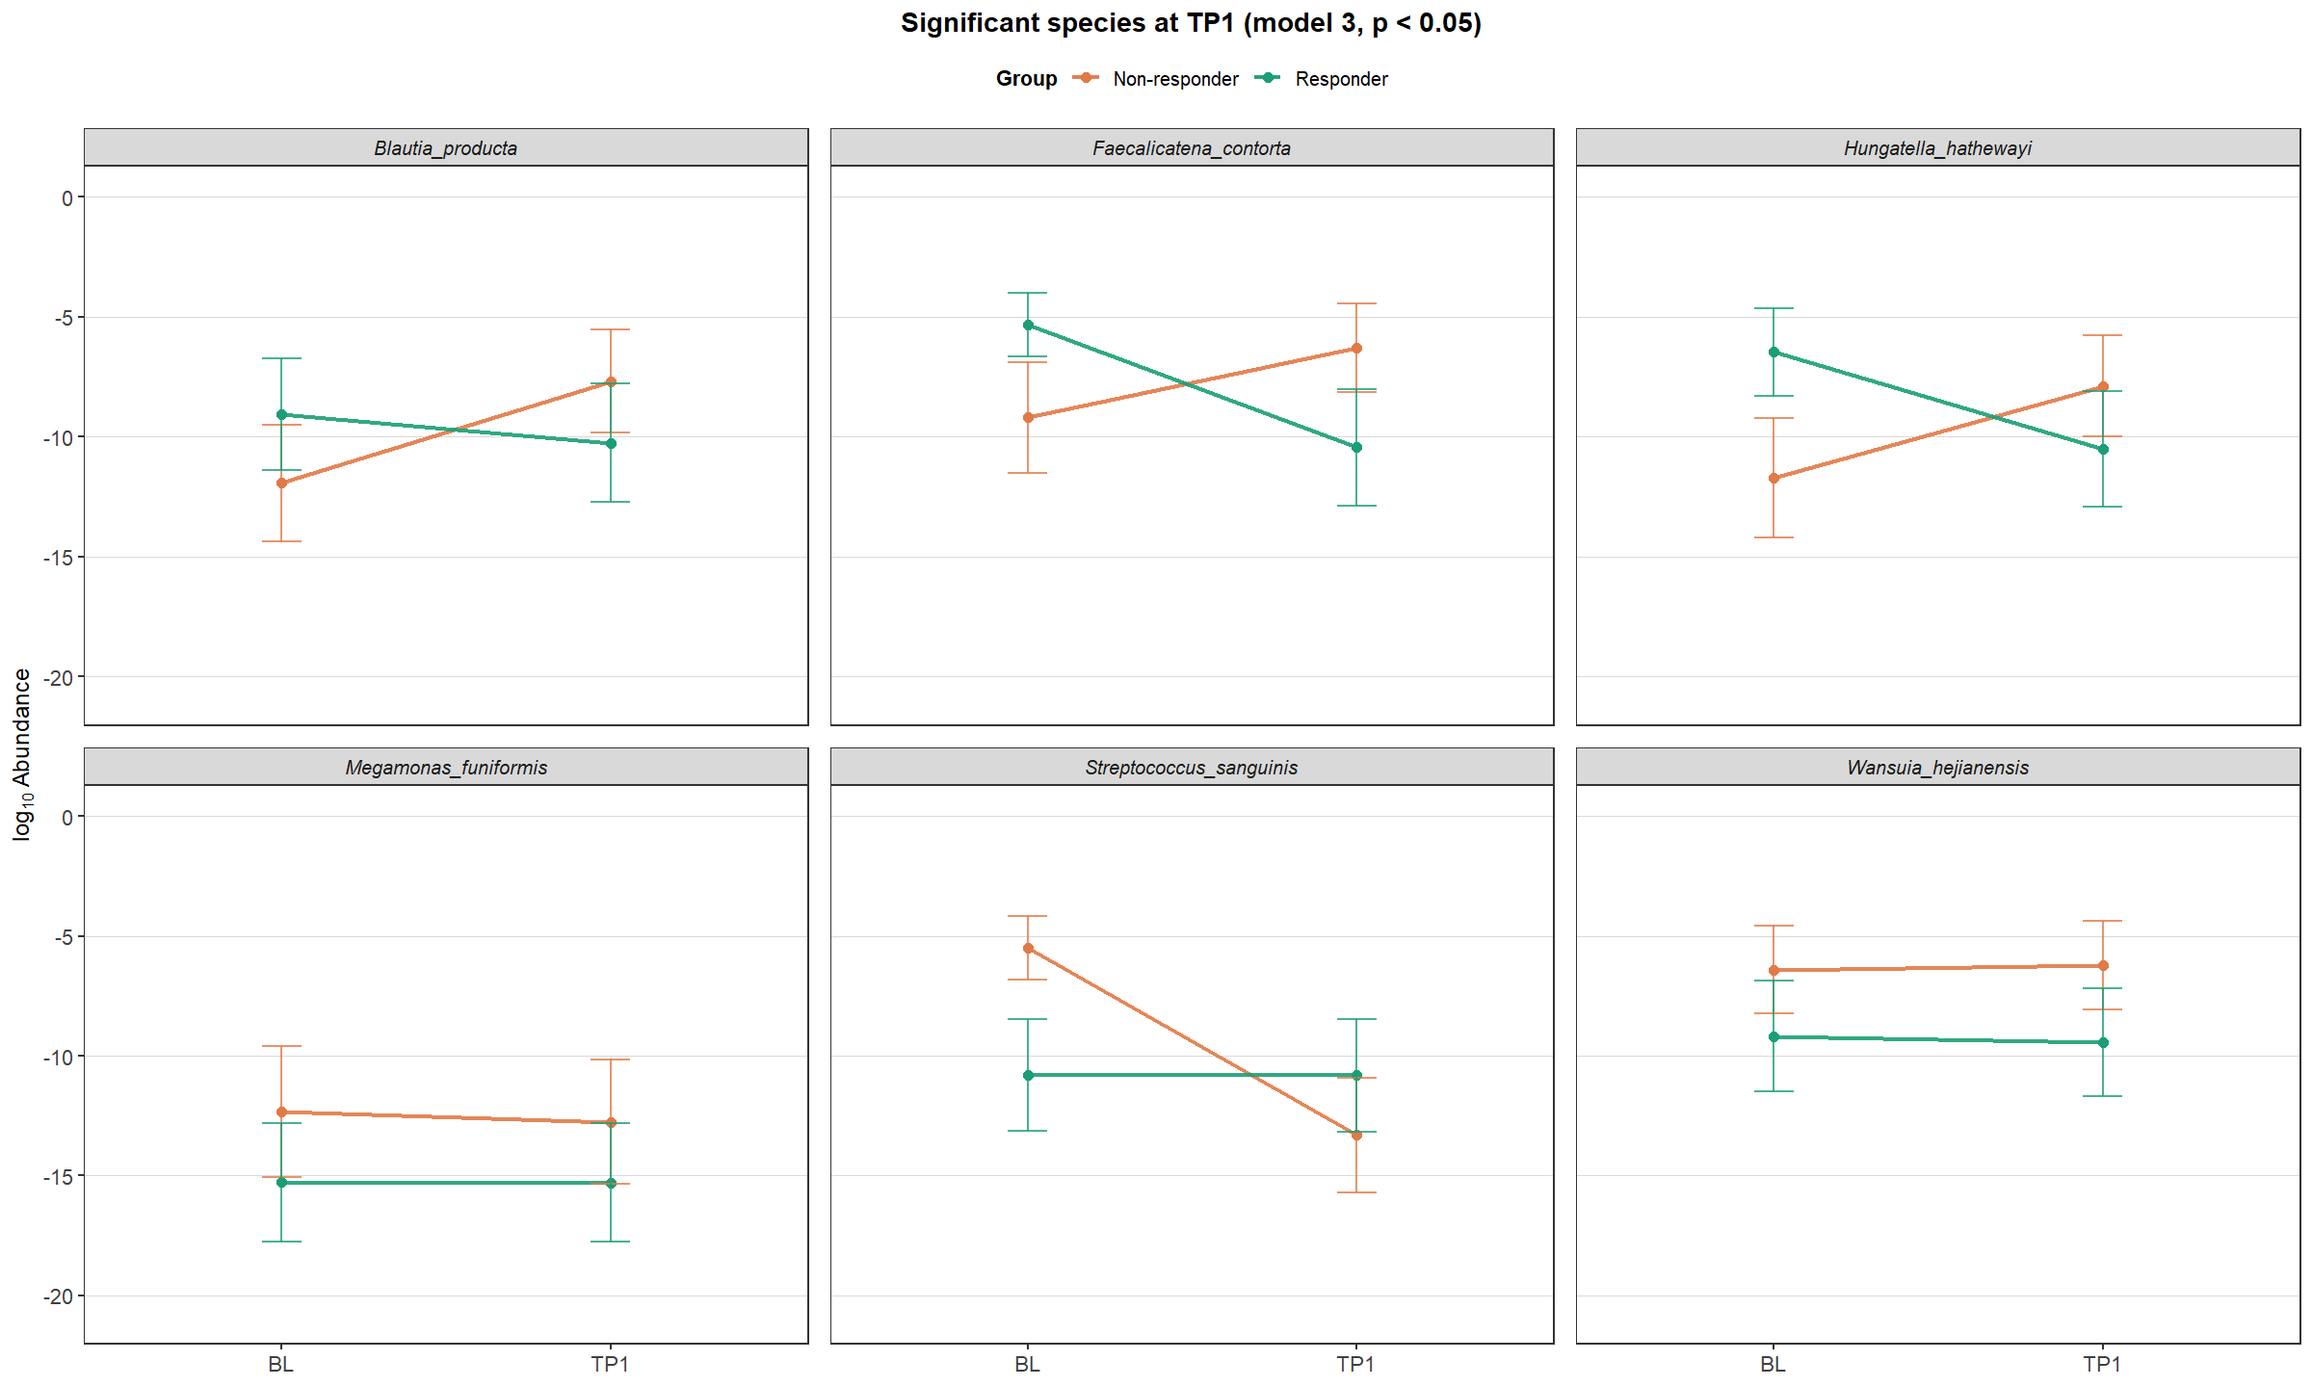
D
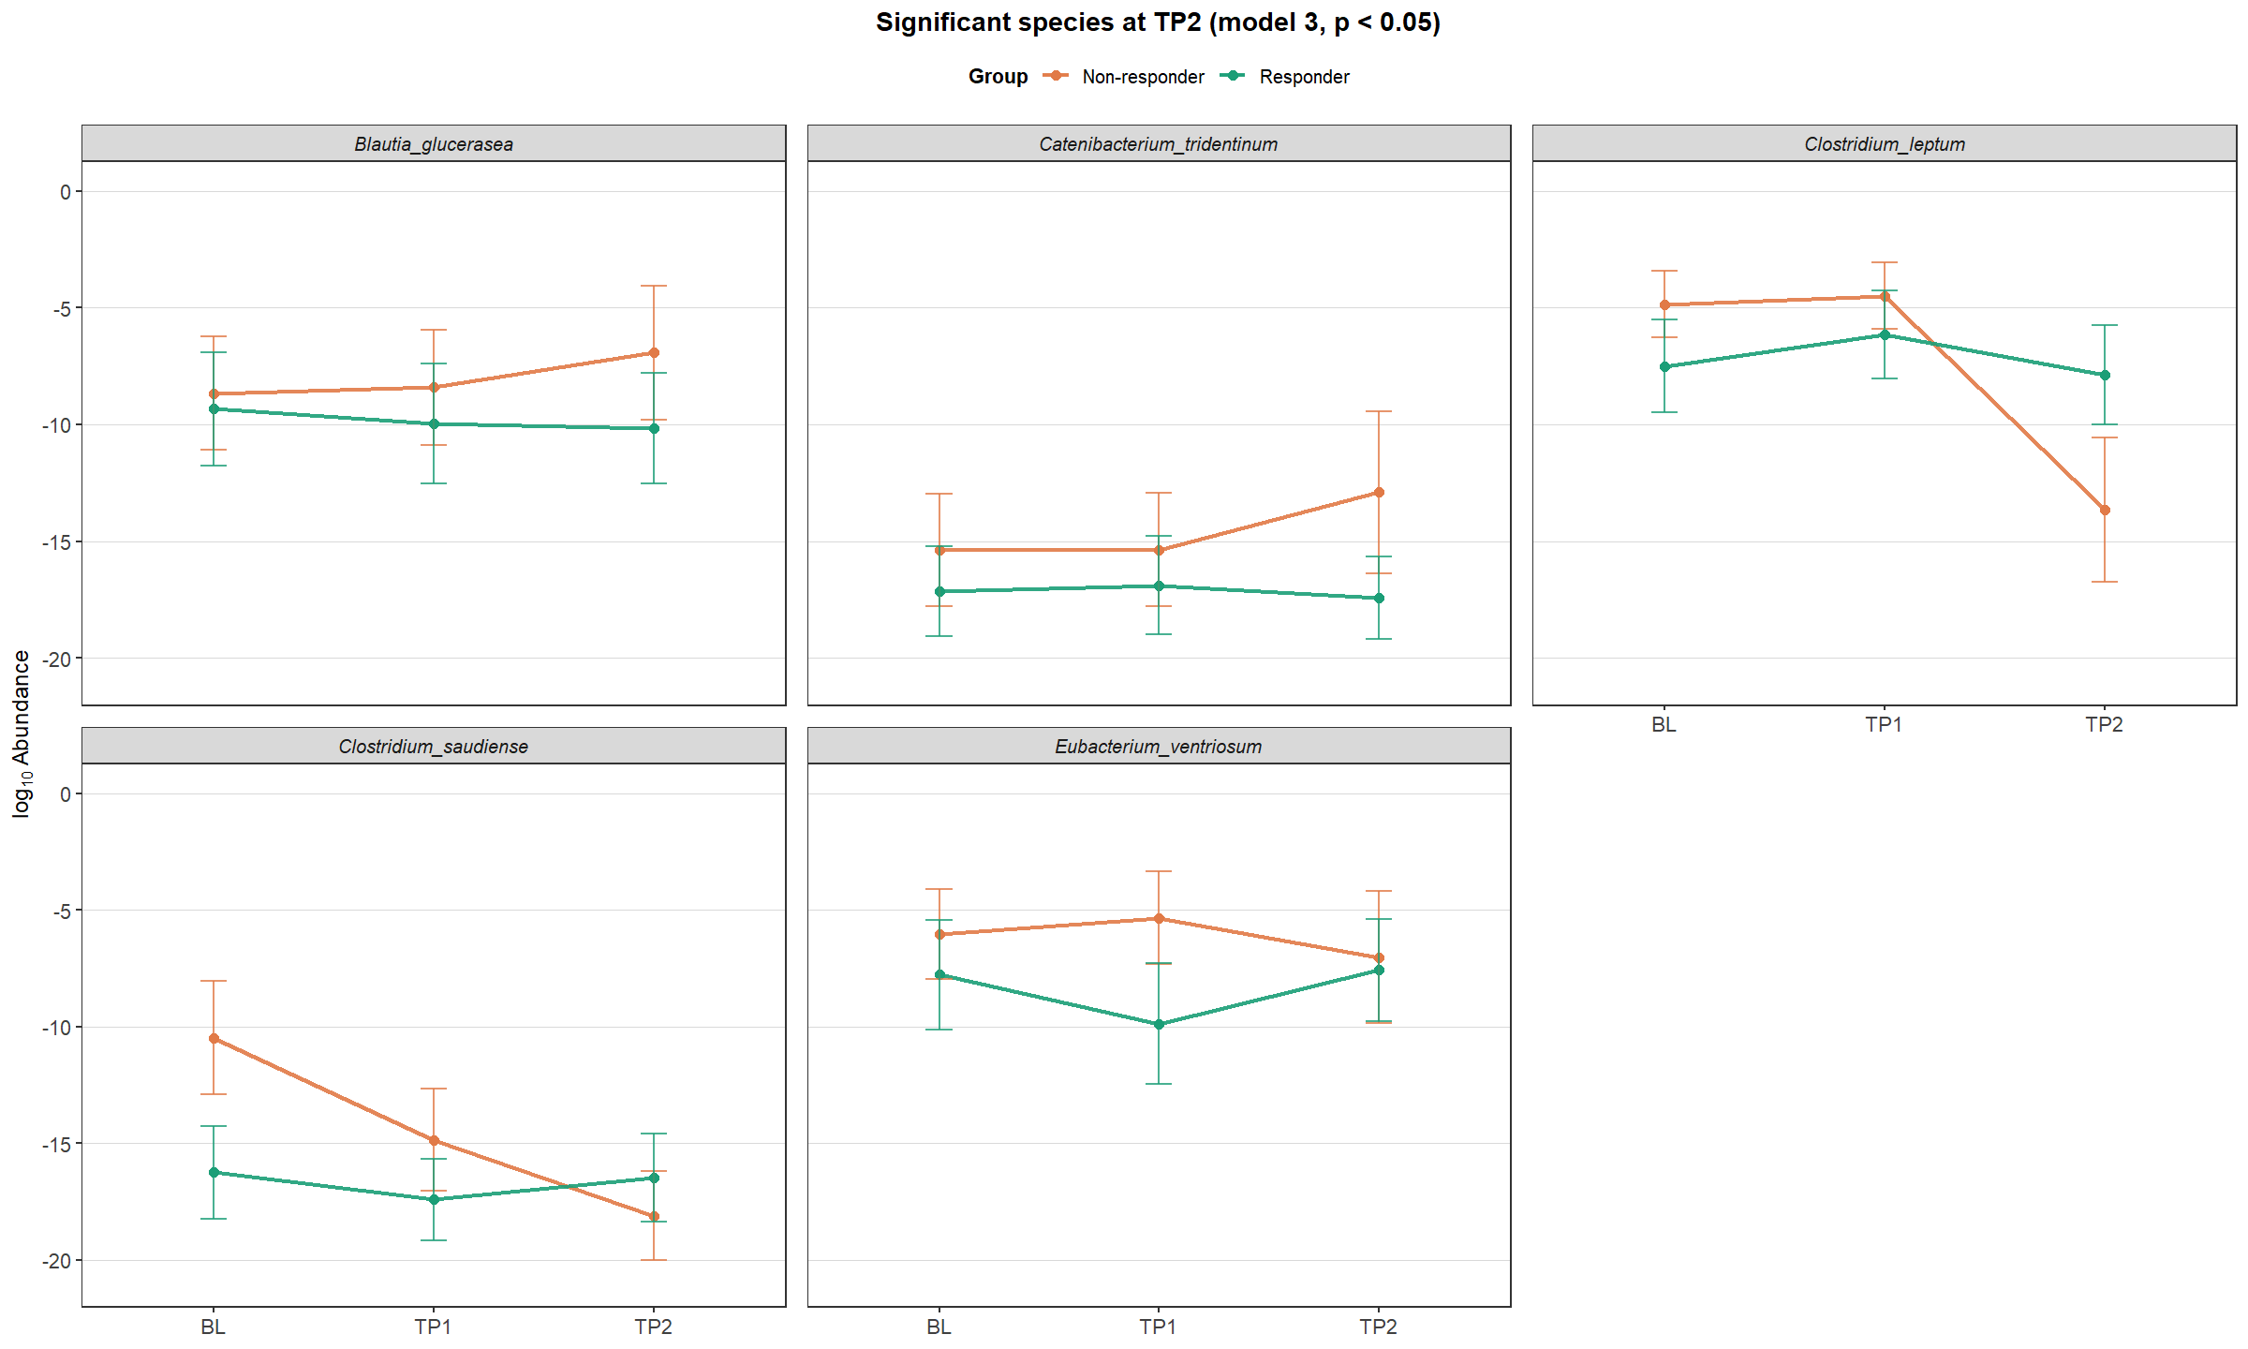

Figure S14. Differentially abundant genera and species identified in Model III. The figure shows genera (A–B) and species (C–D) that displayed significant group-by-time interactions (p < 0.05) between responders and non-responders. The response group was defined at each corresponding time point rather than treated as a fixed classification across the entire follow-up period.

A
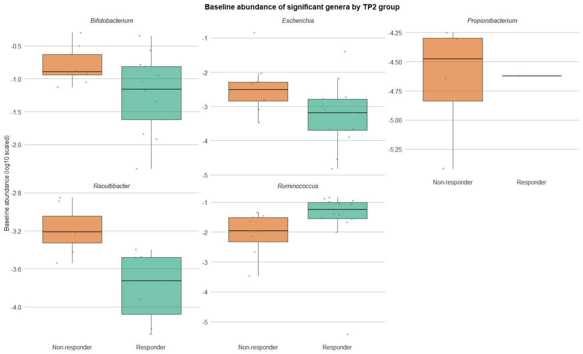

B
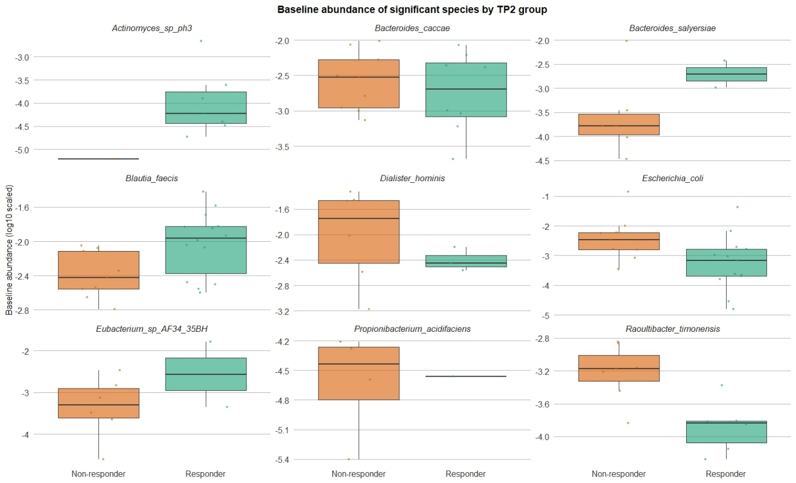

Figure S15. Differential baseline abundance of targeted genera and species identified in Model IV. The figure shows baseline (BL) abundances of genera (A) and species (B) that were significantly associated with treatment response group (Responder vs. Non-responder). Group classification was defined based on the response status at TP2. Boxplots represent log₁₀-transformed relative abundance values at baseline, compared between participants who were later classified as responders or non-responders.

A
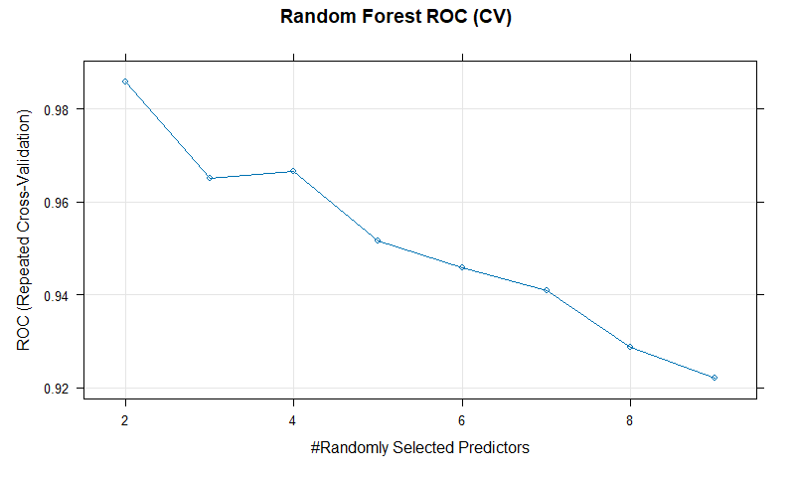
B
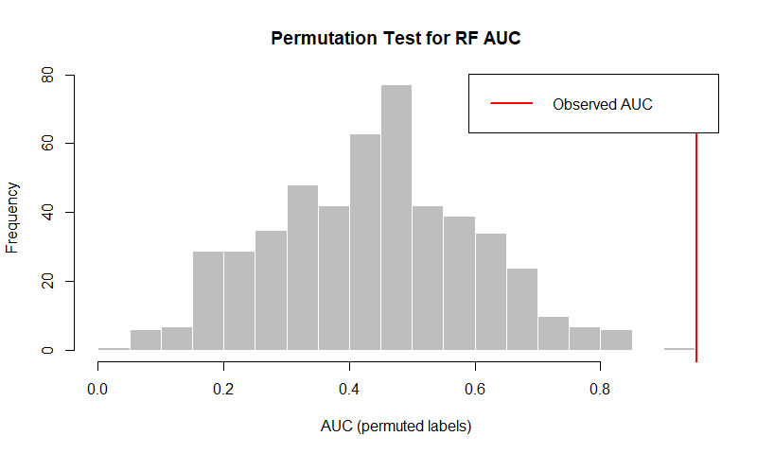

Figure S16. Random forest model for baseline species predicting treatment response. Group classification (Responder vs. Non-responder) was defined based on treatment outcome at TP2. (A) Random forest cross-validation results showing mean ROC values across models with different numbers of randomly selected predictors. (B) Permutation test of the random forest model’s AUC performance, where the observed AUC (red line) is compared against the null distribution of AUC values generated from 500 permutations.

A
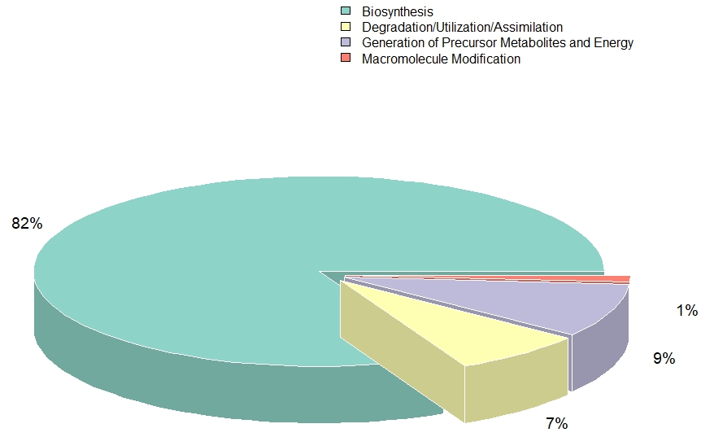
B
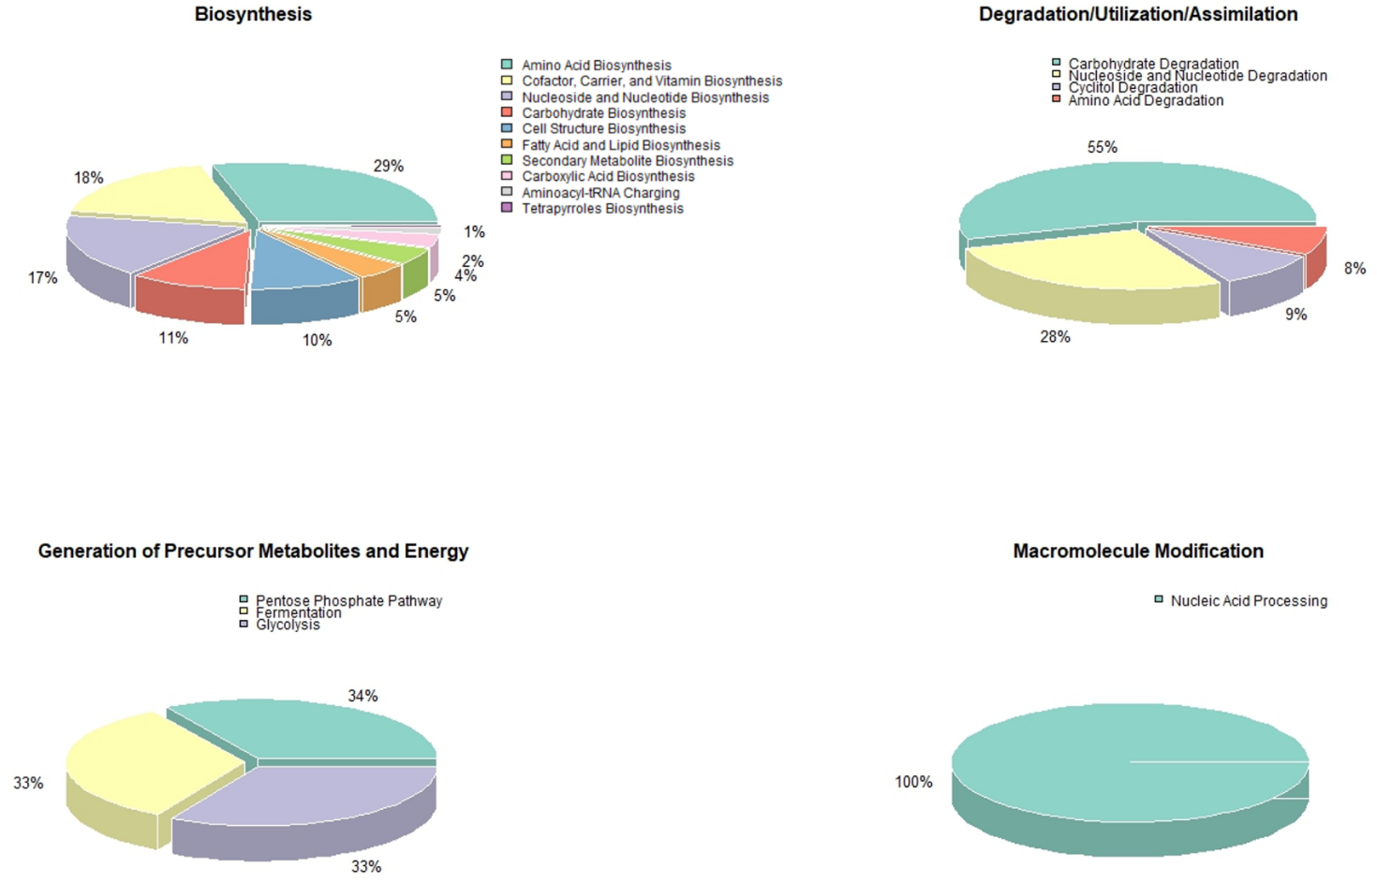

Figure S17. Functional classification of metabolic pathways. (A) Distribution of pathway categories at the highest hierarchical level based on MetaCyc classification. (B) Subcategory distributions within each major functional class are shown in separate panels.

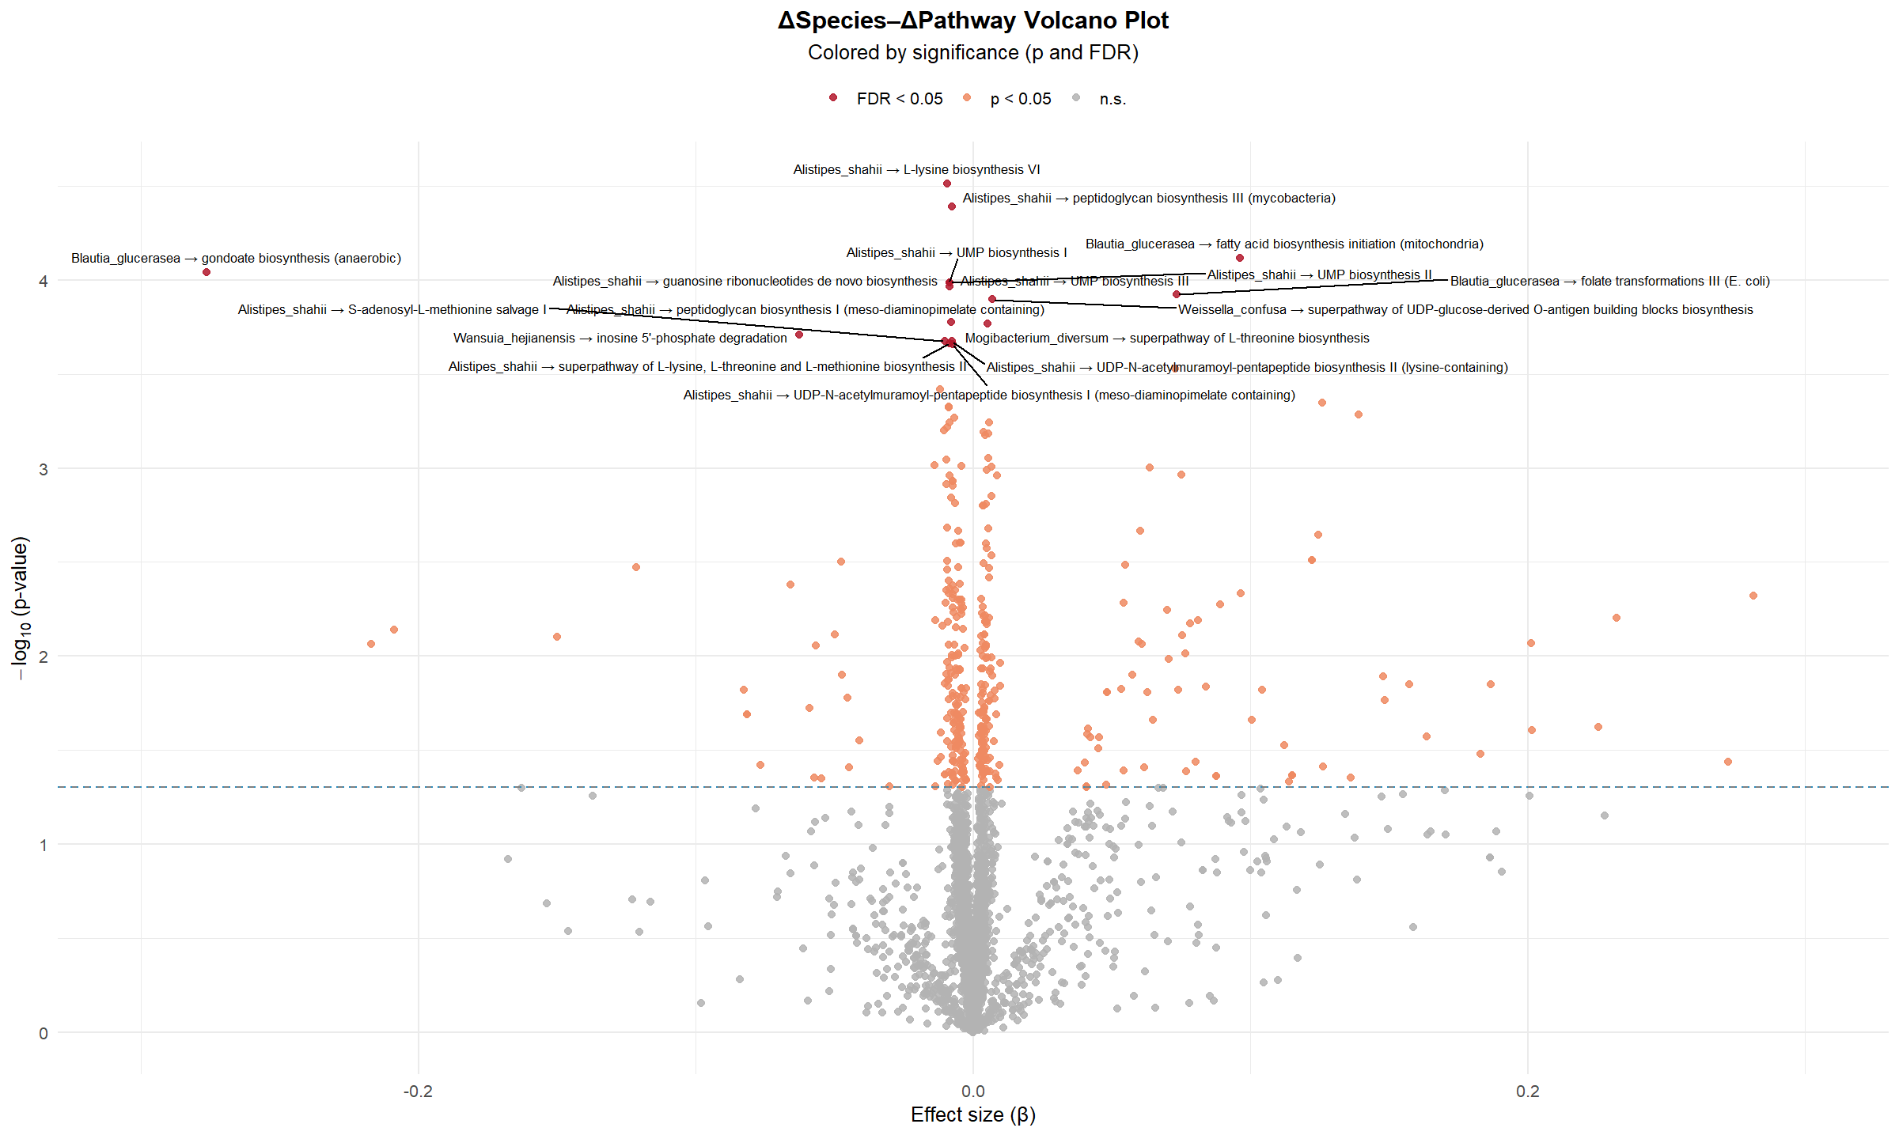

Figure S18. Volcano plot of targeted microbial functional pathways associated with targeted species. Volcano plots depict the association between targeted microbial functional pathways and targeted species by the time-resolved causal model. Each dot represents a pathway, plotted by its estimated effect size (x-axis) and –log₁₀(p-value) (y-axis). Pathways with q-value < 0.05 are highlighted. The species and pathway abundance were log-transformed before fitted into the model.

A
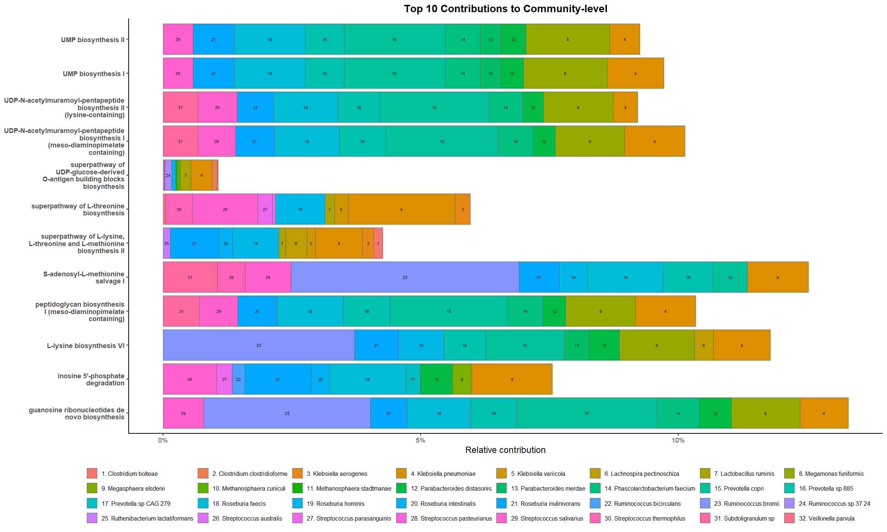
B
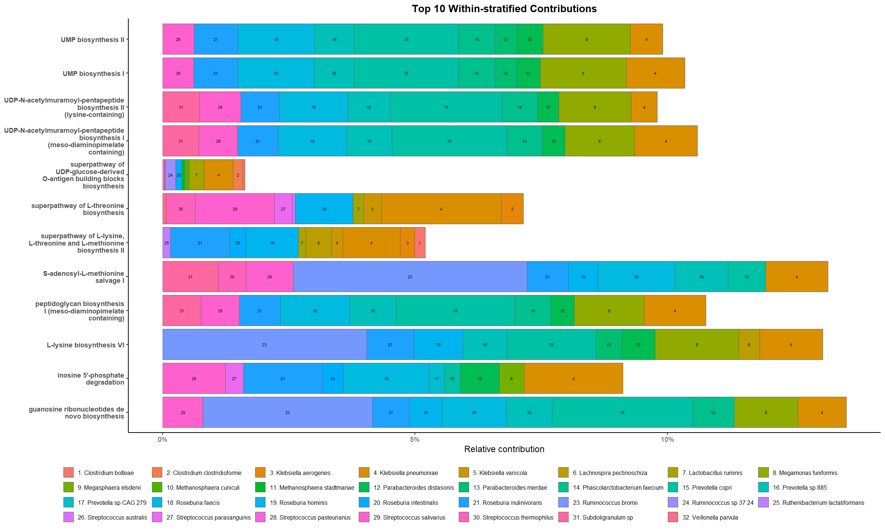

Figure S19. Species-level contributions to targeted pathway abundances. Raw relative contributions were calculated using the HUMAnN3 gene family–to–pathway mapping framework, normalized to total pathway abundance. (A) Top 10 species contributing to the community-level abundance of each targeted MetaCyc pathway. (B) Top 10 species contributing within group-stratified (responder vs. non-responder) communities.

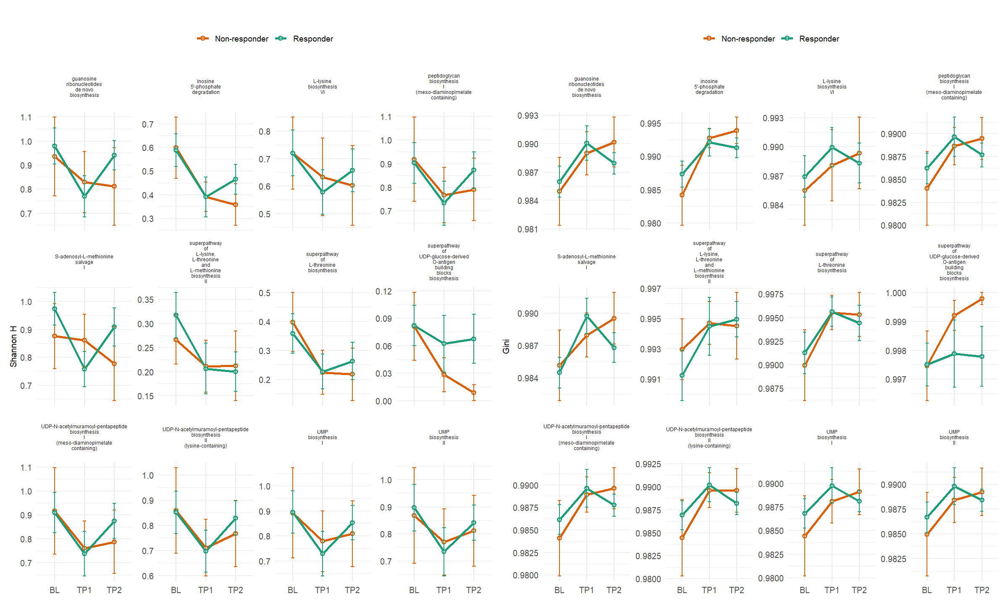

Figure S20. Functional complementation of targeted pathways stratified by treatment response groups. Longitudinal trajectories of functional complementation indices (Shannon H and Gini coefficient) for targeted microbial pathways are shown by treatment response group (green, responders; orange, non-responders) across baseline (BL), treatment week 1 (TP1), and week 2 (TP2). Each panel represents one pathway identified in the causal and association models. Lines indicate mean values ± standard error.

A
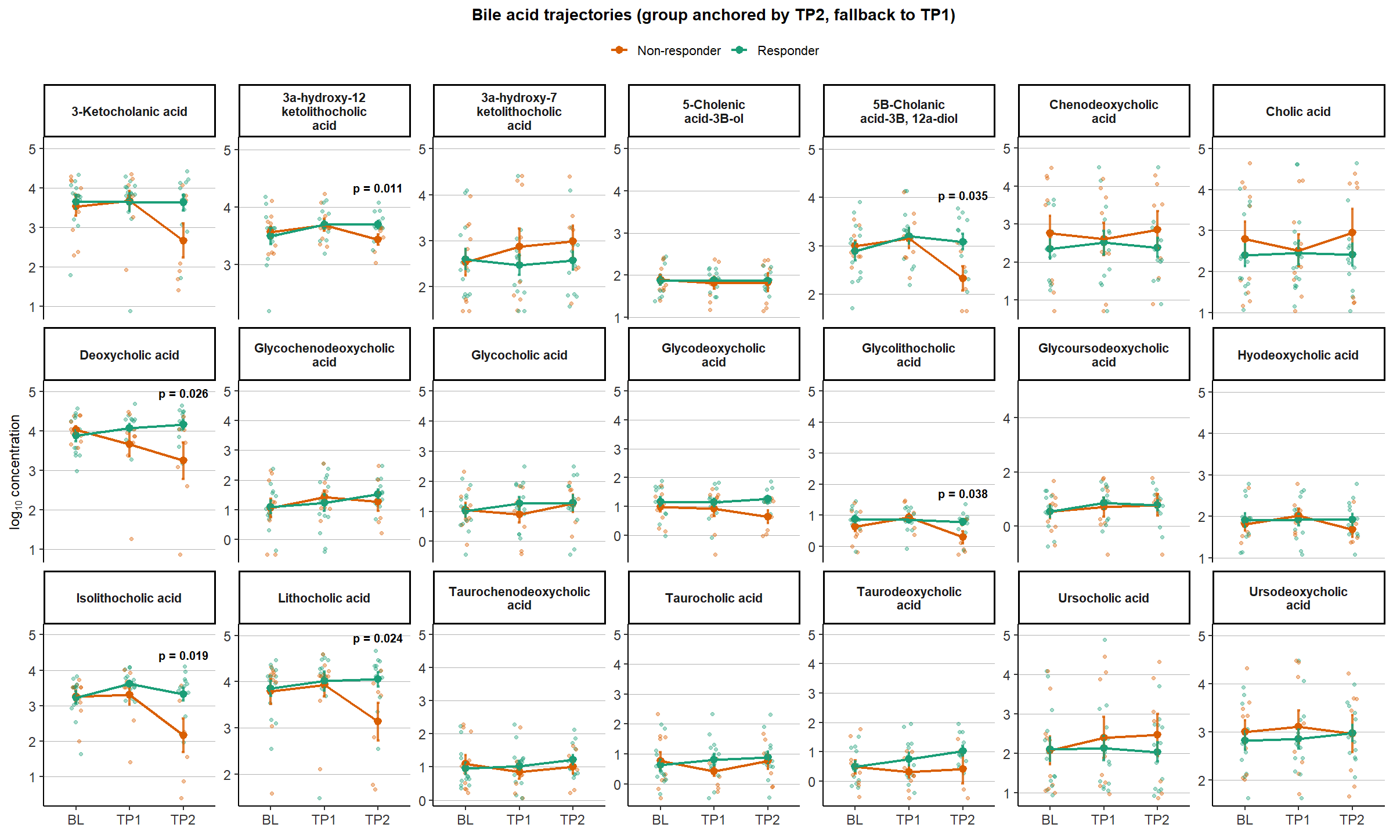
B
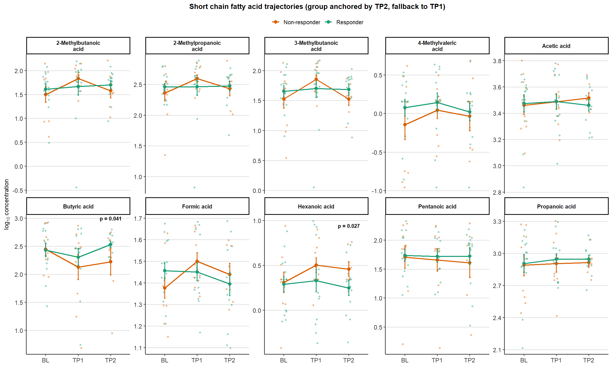

Figure S21. Longitudinal trajectories of all fecal metabolites stratified by treatment response groups. Line plots illustrate the temporal trends of representative bile acids and short-chain fatty acids (SCFAs) across baseline (BL), time point one (TP1), and time point two (TP2) in responders (green) and non-responders (orange). Each point represents the group mean with 95% confidence intervals. P-values of Limma-trend cross sectional tests were labeled if significant. (A) Bile acids; (B) Short chain fatty acids.

A.
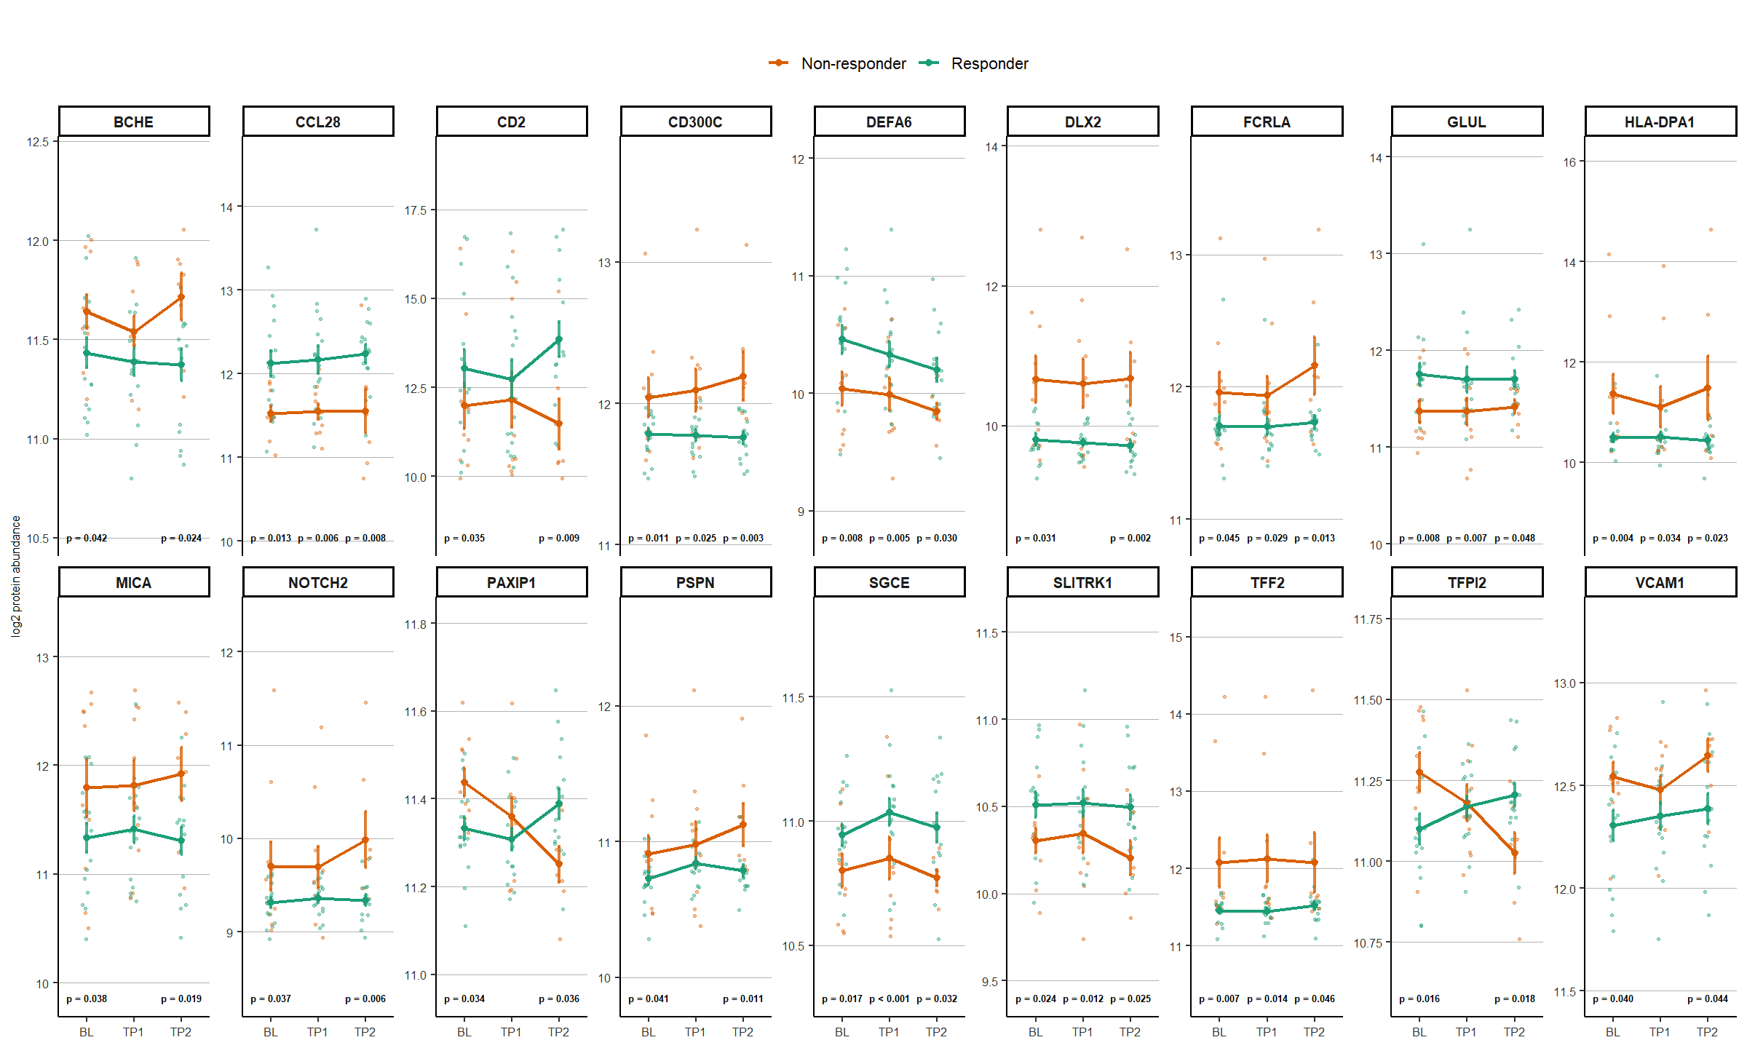
B.
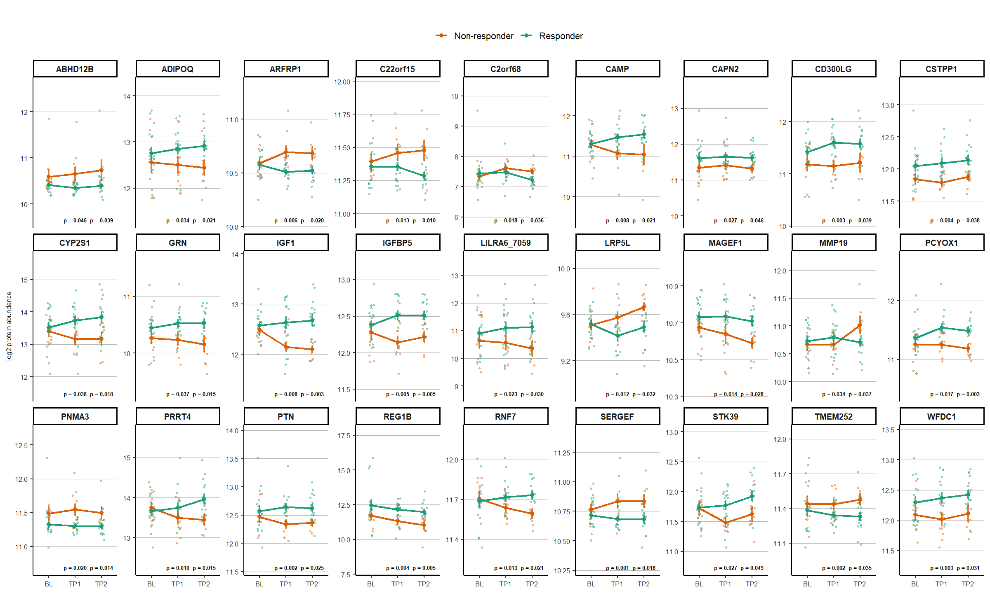

Figure S22. Longitudinal trajectories of proteins with significant responder–non-responder differences at TP2. Each panel shows the trajectory of an individual protein identified as significant in a cross-sectional limma comparison between responders and non-responders at TP2. Points represent individual participants, and solid lines indicate group-wise mean trajectories across baseline (BL), TP1, and TP2. Protein abundance is displayed on the log2 scale. P-values of Limma-trend cross sectional tests were labeled if significant. (A) Significant differences at both BL and TP2. (B) BL no difference, but significant differences at both TP1 and TP2.

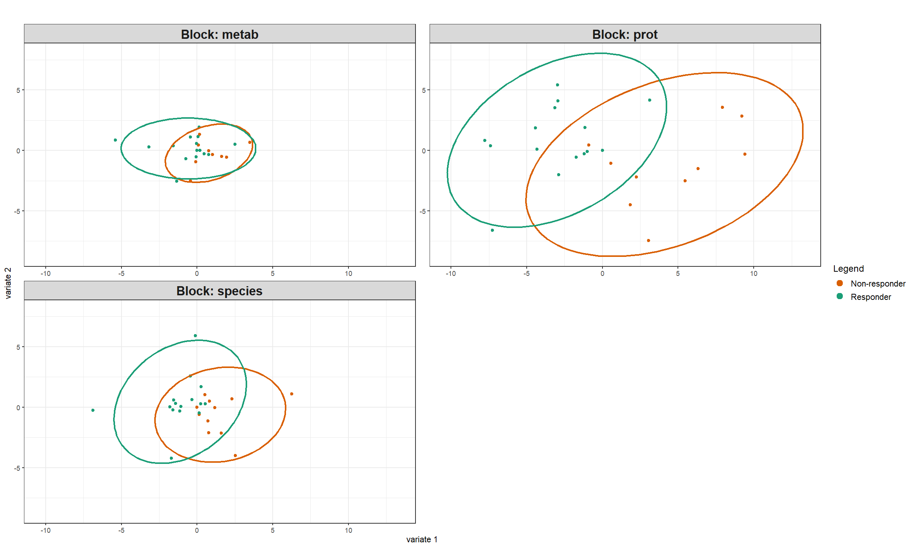

Figure S23. Multi-omics sample projections derived from DIABLO analysis. Sample projections from the DIABLO multi-omics integration model across individual data blocks. Samples are projected onto the first two latent components (Component 1 and Component 2) for the metabolite (metab), protein (prot), and microbial species (species) blocks. Points represent individual participants and are colored by treatment response status (Responder vs. Non-responder). Ellipses indicate the 95% confidence regions for each group within each data block. The plots illustrate block-specific separation patterns between responders and non-responders captured by the DIABLO latent structure.

Table S1. Quality control summary statistics for shotgun sequencing reads. Summary of read counts before and after trimming and host-decontamination. Passed % indicates the proportion of reads retained at each step.
Stats | Raw | Trimmed | Cleaned (Decontaminated)
Mean | 44,139,731 | 40,839,592 | 40,826,600
Sd | 12,953,592 | 12,071,141 | 12,070,437
Minimum | 21,975,329 | 20,254,505 | 20,253,372
Median | 43,116,650 | 39,735,970 | 39,695,047
Maximum | 82,393,374 | 76,271,337 | 76,238,338
Passed % | NA | 92.52% | 99.97%
Sd: Standard Deviation.

Table S2. Summary statistics of all quantified metabolites. Detection rate, concentration, and percentage below LOQ are shown for all measured bile acids and short chain fatty acids.
Metabolites | Categories | ND (%) | Mean (nM) | Sd | < LOQ (%)
Ursocholanic Acid | BA | 88.57 | 67.37 | 19.81 | 0.00
5-Cholenic Acid-3β-ol | BA | 8.57 | 208.51 | 716.97 | 0.00
3-Ketocholanic Acid | Free BA | 1.43 | 13459.48 | 18267.25 | 0.00
Lithocholic acid | Secondary, free BA | 0.00 | 25196.95 | 30533.16 | 0.00
Isolithocholic Acid | Secondary, free BA | 2.86 | 7195.02 | 10441.58 | 1.47
3α,12α, 23-Nordeoxycholic Acid | Free BA | 58.57 | 25.28 | 46.81 | 3.45
9(11), (5β)-Cholenic Acid-3α-ol-12-one | BA | 94.29 | 117.93 | 75.15 | 0.00
3,7-Diketocholanic Acid | BA | 90.00 | 1098.74 | 1375.61 | 0.00
5β-Cholenic Acid-7α-ol-3-one | BA | 31.43 | 842.40 | 1282.29 | 0.00
5α-Cholanic Acid-3α-ol-6-one | BA | 90.00 | 4.50 | 3.67 | 14.29
3α-Hydroxy-7 Ketolithocholic Acid | Secondary, free BA | 1.43 | 3653.91 | 8558.92 | 0.00
3α-Hydroxy-12 Ketolithocholic Acid | Secondary, free BA | 8.57 | 15644.62 | 43449.93 | 0.00
Murocholic Acid | BA | 100.00 | NA | NA | NA
Isodeoxycholic Acid | Free BA | 100.00 | NA | NA | NA
5β-Cholanic Acid-3β, 12α-diol | BA | 7.14 | 3189.66 | 6624.83 | 0.00
Deoxycholic Acid | Secondary, free BA | 4.29 | 22744.77 | 29218.89 | 0.00
Chenodeoxycholic Acid | Primary, free BA | 2.86 | 4261.94 | 8387.13 | 0.00
Hyodeoxycholic acid | Secondary, free BA | 14.29 | 186.23 | 402.02 | 0.00
3,7,12 Dehydrocholic acid | Free BA | 64.29 | 144.45 | 265.45 | 4.00
3α-Hydroxy-6,7-DiketoCholanic Acid | Secondary, free BA | 95.71 | 11.69 | 2.89 | 0.00
5β-Cholanic Acid-3α, 6α-diol-7-one | Secondary, free BA | 30.00 | 3742.48 | 7331.21 | 0.00
3 Dehydrocholic Acid | Free BA | 58.57 | 1076.86 | 1407.55 | 0.00
Ursodeoxycholic acid | Secondary, free BA | 1.43 | 5099.36 | 10590.20 | 0.00
β Muricholic Acid | Primary, free BA | 100.00 | NA | NA | NA
Cholic acid | Primary, free BA | 0.00 | 6374.74 | 14380.95 | 0.00
Hyocholic acid (λ-MCA) | Primary, free BA | 35.71 | 167.85 | 260.59 | 0.00
α Muricholic Acid | Primary, free BA | 100.00 | NA | NA | NA
Ursocholic acid | Free BA | 2.86 | 3777.16 | 10988.22 | 0.00
Glycolithocholic Acid | Secondary, conjugated BA | 15.71 | 18.06 | 27.46 | 0.00
Glycohyodeoxycholic Acid | Secondary, conjugated BA | 84.29 | 4.72 | 8.04 | 0.00
Glycochenodeoxycholic Acid | Primary, conjugated BA | 5.71 | 105.73 | 224.76 | 6.06
Glycodeoxycholic acid | Secondary, conjugated BA | 7.14 | 80.76 | 184.47 | 1.54
Glycoursodeoxycholic Acid | Secondary, conjugated BA | 14.29 | 16.96 | 25.21 | 3.33
3,7,12 Glycodehydrocholic acid | Conjugated BA | 100.00 | NA | NA | NA
Glycocholic Acid | Primary, conjugated BA | 4.29 | 105.05 | 283.09 | 8.96
Glycohyocholic acid | Primary, conjugated BA | 84.29 | 0.54 | 0.66 | 18.18
Tauro-ursocholanic acid | BA | 100.00 | NA | NA | NA
Taurolithocholic acid | Secondary, conjugated BA | 27.14 | 6.83 | 12.21 | 1.96
Tauro-ursodeoxycholic acid | Secondary, conjugated BA | 22.86 | 5.35 | 12.75 | 16.67
Taurohyodeoxycholic acid | Secondary, conjugated BA | 94.29 | 1.50 | 0.79 | 0.00
Taurochenodeoxycholic acid | Secondary, conjugated BA | 1.43 | 44.11 | 84.63 | 2.9
Taurodeoxycholic acid | Secondary, conjugated BA | 11.43 | 18.22 | 33.39 | 6.45
3,7,12 Taurodehydrocholic acid | BA | 98.57 | 0.01 | NA | 100.00
Taurohyocholic acid | BA | 85.71 | 0.47 | 0.27 | 0.00
Tauro alpha-Muricholic acid | Primary, conjugated BA | 74.29 | 2.31 | 3.67 | 0.00
Taurocholic acid | Primary, conjugated BA | 0.00 | 31.79 | 69.18 | 0.00
Formic acid | SCFA | 0.00 | 29.56 | 11.18 | NA
Acetic acid | SCFA | 0.00 | 3382.66 | 1522.80 | NA
Propanoic acid | SCFA | 0.00 | 1108.40 | 696.59 | NA
Butyric acid | SCFA | 0.00 | 422.59 | 435.35 | NA
2-Methylpropanoic acid | SCFA | 0.00 | 382.65 | 218.12 | NA
Pentanoic acid | SCFA | 0.00 | 95.73 | 91.84 | NA
3-Methylbutanoic acid | SCFA | 0.00 | 66.97 | 44.44 | NA
2-Methylbutanoic acid | SCFA | 0.00 | 65.60 | 42.76 | NA
3-Methylpentanoic acid | SCFA | 100.00 | NA | NA | NA
4-Methylvaleric acid | SCFA | 12.86 | 2.52 | 3.25 | NA
Hexanoic acid | SCFA | 0.00 | 11.18 | 18.38 | NA
BA: Bile Acid; SCFA: Short Chain Fatty Acid; ND: Non-Detected; Sd: Standard Deviation; LOQ: Limit of Quantification.

Table S3. Filtered and cleaned metabolites statistics. Detection rate, concentration, and percentage below LOQ are shown for all measured bile acids and short chain fatty acids after filtering and imputation.
Metabolites | Categories | ND (%) | Mean (nM) | Sd | < LOQ (%)
5-Cholenic Acid-3β-ol | BA | 8.57 | 95.48 | 68.28 | 0.00
3-Ketocholanic Acid | Free BA | 1.43 | 7437.11 | 6335.44 | 0.00
Lithocholic acid | Secondary, free BA | 0.00 | 14116.48 | 10504.29 | 0.00
Isolithocholic Acid | Secondary, free BA | 2.86 | 3533.22 | 3070.69 | 1.47
3α-Hydroxy-7 Ketolithocholic Acid | Secondary, free BA | 1.43 | 2918.71 | 6427.75 | 0.00
3α-Hydroxy-12 Ketolithocholic Acid | Secondary, free BA | 8.57 | 5114.55 | 3616.78 | 0.00
5β-Cholanic Acid-3β, 12α-diol | BA | 7.14 | 2181.61 | 3000.21 | 0.00
Deoxycholic Acid | Secondary, free BA | 4.29 | 14357.10 | 11532.09 | 0.00
Chenodeoxycholic Acid | Primary, free BA | 2.86 | 3771.29 | 7750.55 | 0.00
Hyodeoxycholic acid | Secondary, free BA | 14.29 | 139.48 | 161.81 | 0.00
Ursodeoxycholic acid | Secondary, free BA | 1.43 | 3696.55 | 7066.51 | 0.00
Cholic acid | Primary, free BA | 0.00 | 5113.08 | 10897.46 | 0.00
Ursocholic acid | Free BA | 2.86 | 3228.71 | 10402.77 | 0.00
Glycolithocholic Acid | Secondary, conjugated BA | 15.71 | 8.41 | 6.90 | 0.00
Glycochenodeoxycholic Acid | Primary, conjugated BA | 5.71 | 60.64 | 90.88 | 6.06
Glycodeoxycholic acid | Secondary, conjugated BA | 7.14 | 19.58 | 18.37 | 1.54
Glycoursodeoxycholic Acid | Secondary, conjugated BA | 14.29 | 12.76 | 15.70 | 3.33
Glycocholic Acid | Primary, conjugated BA | 4.29 | 41.66 | 65.41 | 8.96
Taurochenodeoxycholic acid | Secondary, conjugated BA | 1.43 | 30.12 | 50.45 | 2.90
Taurodeoxycholic acid | Secondary, conjugated BA | 11.43 | 12.73 | 21.10 | 6.45
Taurocholic acid | Primary, conjugated BA | 0.00 | 21.12 | 46.89 | 0.00
Formic acid | SCFA | 0.00 | 28.68 | 10.08 | NA
Acetic acid | SCFA | 0.00 | 3287.05 | 1261.76 | NA
Propanoic acid | SCFA | 0.00 | 935.16 | 419.59 | NA
Butyric acid | SCFA | 0.00 | 335.00 | 218.93 | NA
2-Methylpropanoic acid | SCFA | 0.00 | 363.49 | 184.98 | NA
Pentanoic acid | SCFA | 0.00 | 75.92 | 52.68 | NA
3-Methylbutanoic acid | SCFA | 0.00 | 63.18 | 38.72 | NA
2-Methylbutanoic acid | SCFA | 0.00 | 62.46 | 39.33 | NA
4-Methylvaleric acid | SCFA | 12.86 | 1.59 | 1.20 | NA
Hexanoic acid | SCFA | 0.00 | 2.90 | 2.28 | NA
BA: Bile Acid; SCFA: Short Chain Fatty Acid; ND: Non-Detected; Sd: Standard Deviation; LOQ: Limit of Quantification.

Table S4. Cramer’s V correlations between treatment group and categorical variables. Associations were tested using Fisher’s exact or Chi-square tests. Cramer’s V indicates effect size, and p < 0.05 was considered significant.
Group vs. Var | N | Method | chisq | Cramer’s V | p-value | OR
Antidepressant type  (SSRI_SNRI, Others) | 28 | Fisher’s exact | NA | 0.123 | 0.689 | 0.612
Anxiolytics | 28 | Fisher’s exact | NA | 0.284 | 0.197 | 4.726
Var: variable; N: sample size.

Table S5. Demographic and Clinical Characteristics. Continuous variables are presented as mean ± SD; categorical variables as number (%). All characteristics were measured at baseline, and group classification (Responder vs. Non-responder) was determined based on treatment response at subjects’ last visit (TP1/TP2).
Characteristics | Non-responder  (N = 11, 39.29%) | Responder  (N = 17, 60.71%) | p-value
Age (Mean, Sd) | 34.50 (13.90) | 37.9 (14.7) | 0.544
Gender (female, %) | 6 (54.55) | 12 (70.59) | 0.563
BMI (Mean, Sd) | 22.18 (5.28) | 21.29 (4.97) | 0.648
Antidepressant type (SSRI/SNRI, n, %) | 5 (45.45) | 7 (41.18) | 0.826
Other psychotropics use |  |  | 0.536
Anxiolytics (n, %) | 10 (90.91) | 12 (70.59)
Antipsychotics (n, %) | 2 (18.18) | 0 (0.00)
Mood stabilizers (n, %) | 0 (0.00) | 0 (0.00)
Total energy (kcal, Mean, Sd) | 1513.67 (810.64) | 1599.71 (752.21) | 0.959
Protein intake (g, Mean, Sd) | 55.74 (22.77) | 60.04 (24.08) | 0.946
Animal protein intake (g, Mean, Sd) | 30.33 (12.95) | 32.55 (16.03) | 0.914
Plant protein intake (g, Mean, Sd) | 24.16 (14.22) | 25.97 (12.12) | 0.969
Fat intake (g, Mean, Sd) | 48.28 (21.39) | 56.78 (29.38) | 0.602
Animal fat intake (g, Mean, Sd) | 23.82 (9.75) | 26.16 (12.31) | 0.810
Plant fat intake (g, Mean, Sd) | 6.20 (2.83) | 7.76 (3.65) | 0.416
Carbohydrate intake (g, Mean, Sd) | 216.52 (142.82) | 217.59 (109.81) | 0.799
Sugar intake (g, Mean, Sd) | 4.55 (0.99) | 6.21 (3.68) | 0.131
Fructose intake (g, Mean, Sd) | 1.32 (0.92) | 2.34 (1.67) | 0.094
Lactose intake (g, Mean, Sd) | 1.38 (1.30) | 4.17 (5.39) | 0.089
Crude fiber intake (g, Mean, Sd) | 0.27 (0.13) | 0.31 (0.17) | 0.686
Dietary fiber intake (g, Mean, Sd) | 9.65 (4.20) | 12.4 (6.72) | 0.360
HAMD baseline (Mean, Sd) | 17.45 (5.41) | 16.73 (4.85) | 0.729
HAMD time point 1 (Mean, Sd) | 15.82 (4.42) | 9.53 (5.37) | 0.003
HAMD time point 2 (Mean, Sd) | 13.22 (4.68) | 4.14 (4.35) | <0.001
Sd: Standard Deviation; N: number of participants; BMI: Body Mass Index; HAMD: Hamilton Depression Rating Scale; BDI: Beck Depression Inventory; PSS: Perceived Stress Scale.

Table S6. Targeted taxa identified in Model I at the genus and species levels. The table summarizes the regression coefficients (Coef.) and p-values (p) of targeted taxa associated with two time points (TP1 and TP2). HAMD score at baseline was controlled by the variable HAMD_BL. Dietary factors were adjusted in the model. The bacterial abundance was normalized through MetaPhlAn and log transformed before fitted into the model.
Model: ${log⁡(Abund}_{ij})=β_{0}+{β_{1}{HAMD_BL}_{i}+β}_{2}{tp1}_{ ij}+β_{3}{tp2}_{ ij}+β_{n}*Diet+u_{i}+ε_{ij}, u\sim N\left(0, σ_{u}^{2}\right), ε_{ij}\sim N(0,σ^{2})$
Level | Taxa | TP1 |  | TP2
Level | Taxa | Coef. | p | Coef. | p
Genus | Solobacterium | -5.908 | < 0.001 | -2.990 | 0.074
Genus | Weissella | -6.121 | 0.005 | -4.603 | 0.038
Genus | Mogibacterium | -4.466 | 0.008 | -3.063 | 0.072
Genus | Lancefieldella | -3.695 | 0.021 | -4.503 | 0.007
Genus | Klebsiella | -4.853 | 0.026 | -6.170 | 0.006
Genus | Candidatus_Cibionibacter | -0.256 | 0.027 | 0.035 | 0.765
Genus | Lactococcus | -4.596 | 0.031 | -5.171 | 0.019
Genus | Intestinibacter | -3.622 | 0.034 | -5.132 | 0.004
Genus | Haemophilus | -3.755 | 0.035 | -2.062 | 0.254
Genus | Sphingomonas | 2.218 | 0.045 | 1.861 | 0.100
Genus | Bianquea | -1.204 | 0.190 | -2.177 | 0.024
Genus | Fusobacterium | -1.068 | 0.400 | -2.792 | 0.037
Species | Weissella confusa | -5.670 | 0.005 | -4.216 | 0.041
Species | Lactococcus lactis | -5.284 | 0.007 | -4.519 | 0.023
Species | Mogibacterium diversum | -4.461 | 0.011 | -3.773 | 0.035
Species | Klebsiella pneumoniae | -4.542 | 0.021 | -6.010 | 0.004
Species | Candidatu_Cibionibacter quicibialis | -0.263 | 0.024 | 0.030 | 0.798
Species | Enterocloster_bolteae | -1.928 | 0.031 | -0.966 | 0.286
Species | Actinomyces naeslundii | -3.375 | 0.032 | -4.049 | 0.013
Species | Turicibacter bilis | -3.774 | 0.032 | -0.612 | 0.730
Species | Weissella cibaria | -4.347 | 0.033 | -4.892 | 0.020
Species | Intestinibacter bartlettii | -3.637 | 0.034 | -5.146 | 0.004
Species | Lancefieldella parvula | -3.297 | 0.036 | -3.317 | 0.040
Species | Streptococcus parasanguinis | 2.536 | 0.040 | -0.144 | 0.908
Species | Sphingomonas pseudosanguinis | 2.215 | 0.045 | 1.870 | 0.099
Species | Streptococcus thermophilus | -4.226 | 0.047 | 1.589 | 0.460
Species | Clostridium leptum | 0.517 | 0.645 | -3.493 | 0.004
Species | Actinomyces graevenitzii | -0.812 | 0.539 | -3.495 | 0.013
Species | Anaerobutyricum soehngenii | 0.128 | 0.191 | 0.233 | 0.024
Species | Lentihominibacter hominis | 1.402 | 0.223 | 2.717 | 0.025
Species | Enterococcus faecalis | -2.558 | 0.134 | -3.995 | 0.025
Species | Bianquea renquensis | -1.172 | 0.202 | -2.106 | 0.029
Species | Clostridium scindens | -1.164 | 0.266 | -2.364 | 0.032
Species | Phascolarctobacteriums faecium | -1.341 | 0.178 | -2.139 | 0.040
Species | Streptococcus mutans | -1.029 | 0.456 | -2.975 | 0.041
g_: genera; s_: species; TP1: time point one; TP2: time point two; p: p-value

Table S7. Targeted taxa in Model II at the genus and species levels. Regression coefficients (Coef.) and p-values (p) are shown for each taxon with respect to time_numeric (reflecting temporal trajectories) and ΔHAMD (representing changes in depression severity). Dietary factors were adjusted in the model. The bacterial abundance was normalized through MetaPhlAn and log transformed before fitted into the model.
Model: ${log⁡(Abund}_{ij})=β_{0}+{β_{1}+β_{1}∆HAMD_{ij}+β}_{2}t_{ ij}+β_{n}*Diet+u_{i}+ε_{ij}, u\sim N\left(0, σ_{u}^{2}\right), ε_{ij}\sim N(0,σ^{2})$
Level | Taxa | Time numeric |  | △HAMD
Level | Taxa | Coef. | p | Coef. | p
Genus | Phascolarctobacterium | -1.842 | 0.003 | -0.226 | 0.017
Genus | Fusicatenibacter | -1.335 | 0.006 | -0.206 | 0.008
Genus | Anaerostipes | -0.949 | 0.010 | -0.186 | < 0.001
Genus | Intestinibacter | -2.886 | 0.020 | -0.065 | 0.722
Genus | Hydrogenoanaerobacterium | -2.096 | 0.029 | -0.224 | 0.134
Genus | Ruminococcus | -1.731 | 0.038 | -0.165 | 0.190
Genus | Solobacterium | -2.649 | 0.039 | -0.200 | 0.293
Genus | Collinsella | -0.084 | 0.049 | -0.011 | 0.113
Genus | Brevundimonas | 0.246 | 0.435 | 0.103 | 0.029
Genus | Faecalimonas | -1.030 | 0.191 | -0.266 | 0.036
Species | Ruminococcus lactaris | 1.636 | < 0.001 | 0.255 | < 0.001
Species | Clostridiaceae bacterium Marseille Q3526 | 1.478 | 0.001 | 0.228 | 0.001
Species | Phascolarctobacterium faecium | -2.256 | 0.004 | -0.241 | 0.044
Species | Alistipes senegalensis | 1.709 | 0.006 | 0.203 | 0.037
Species | Actinomyces naeslundii | -3.166 | 0.007 | -0.232 | 0.188
Species | Anaerostipes hadrus | -1.649 | 0.013 | -0.336 | 0.002
Species | Mogibacterium diversum | -3.057 | 0.014 | -0.220 | 0.221
Species | Enterocloster clostridioformis | 1.436 | 0.018 | 0.172 | 0.073
Species | Intestinibacter bartlettii | -2.893 | 0.019 | -0.065 | 0.722
Species | Clostridium scindens | -1.830 | 0.028 | -0.132 | 0.310
Species | Dialister hominis | -1.508 | 0.028 | -0.297 | 0.007
Species | Clostridium methylpentosum | -1.726 | 0.029 | -0.207 | 0.096
Species | Anaerobutyricum soehngenii | 0.174 | 0.029 | 0.012 | 0.351
Species | Weissella confusa | -2.912 | 0.031 | -0.131 | 0.469
Species | Lachnospira sp NSJ 43 | 1.512 | 0.040 | 0.294 | 0.013
Species | Lancefieldella parvula | -2.336 | 0.041 | -0.121 | 0.467
Species | Megasphaera sp NM10 | -1.644 | 0.042 | -0.205 | 0.107
Species | Clostridium leptum | -1.823 | 0.047 | -0.040 | 0.774
Species | Enterocloster hominis | -1.807 | 0.048 | -0.187 | 0.191
Species | Clostridiaceae bacterium Marseille Q4149 | 0.158 | 0.049 | 0.032 | 0.016
Species | Alistipes indistinctus | 1.683 | 0.053 | 0.365 | 0.009
Species | Cloacibacillus porcorum | 0.957 | 0.293 | 0.354 | 0.014
Species | Actinomyces graevenitzii | 0.032 | 0.973 | 0.366 | 0.018
Species | Alistipes shahii | 1.039 | 0.114 | 0.231 | 0.029
Species | Alistipes communis | -1.429 | 0.053 | -0.253 | 0.033
Species | Faecalimonas umbilicata | -1.036 | 0.189 | -0.267 | 0.035
Species | Blautia hansenii | -0.370 | 0.558 | -0.208 | 0.043

Table S8. Targeted taxa identified by the extended Model II (Mundlak approach). The extended Model II decomposed symptom improvement (ΔHAMD) into within-person (ΔHAMD_within) and between-person (ΔHAMD_between) components following the Mundlak specification to separate within- and between-subject effects. The taxa abundance was log-transformed before fitted into the model.
Level | Taxa | Time numeric |  | △HAMD_within
Level | Taxa | Coef. | p | Coef. | p
Genus | Phascolarctobacterium | -1.747 | 0.006 | -0.211 | 0.040
Genus | Intestinibacter | -3.521 | 0.009 | -0.192 | 0.376
Genus | Fusicatenibacter | -1.272 | 0.009 | -0.190 | 0.016
Genus | Oscillibacter | -2.650 | 0.018 | -0.499 | 0.008
Genus | Slackia | -1.985 | 0.022 | -0.264 | 0.059
Genus | Anaerostipes | -0.955 | 0.023 | -0.193 | 0.006
Genus | Ruminococcus | -1.976 | 0.026 | -0.222 | 0.123
Genus | Lawsonibacter | -2.252 | 0.028 | -0.318 | 0.057
Genus | Collinsella | -0.085 | 0.046 | -0.011 | 0.106
Genus | Lactococcus | -3.230 | 0.046 | -0.142 | 0.597
Genus | Oscillospiraceae unclassified | -1.473 | 0.047 | -0.227 | 0.061
Genus | Lachnospira | -0.376 | 0.407 | -0.354 | 0.023
Genus | Faecalimonas | -1.113 | 0.165 | -0.290 | 0.028
Genus | Rothia | 2.248 | 0.114 | 0.512 | 0.032
Species | Ruminococcus lactaris | 1.526 | < 0.001 | 0.236 | 0.001
Species | Clostridiaceae bacterium Marseille Q3526 | 1.449 | 0.001 | 0.219 | 0.002
Species | Actinomyces naeslundii | -3.848 | 0.002 | -0.370 | 0.062
Species | Phascolarctobacterium faecium | -2.084 | 0.009 | -0.208 | 0.101
Species | Intestinibacter bartlettii | -3.531 | 0.009 | -0.193 | 0.375
Species | Enterocloster clostridioformis | 1.560 | 0.011 | 0.194 | 0.048
Species | Dialister hominis | -1.734 | 0.013 | -0.345 | 0.003
Species | Mogibacterium diversum | -3.355 | 0.015 | -0.294 | 0.192
Species | Clostridium leptum | -2.323 | 0.015 | -0.137 | 0.368
Species | Alistipes senegalensis | 1.473 | 0.018 | 0.160 | 0.108
Species | Anaerostipes hadrus | -1.592 | 0.019 | -0.328 | 0.003
Species | Alistipes communis | -1.753 | 0.020 | -0.321 | 0.009
Species | Enterocloster hominis | -2.129 | 0.023 | -0.263 | 0.082
Species | Oscillibacter valericigenes | -2.530 | 0.024 | -0.479 | 0.010
Species | Clostridium methylpentosum | -1.820 | 0.025 | -0.227 | 0.082
Species | Streptococcus mutans | -2.453 | 0.027 | -0.210 | 0.237
Species | Clostridium scindens | -1.826 | 0.031 | -0.139 | 0.302
Species | Parabacteroides distasonis | 0.914 | 0.032 | 0.152 | 0.033
Species | Anaerobutyricum soehngenii | 0.170 | 0.032 | 0.011 | 0.380
Species | Megasphaera sp NM10 | -1.640 | 0.047 | -0.206 | 0.121
Species | Weissella confusa | -3.095 | 0.048 | -0.189 | 0.468
Species | Actinomyces graevenitzii | 0.316 | 0.750 | 0.422 | 0.011
Species | Clostridiaceae bacterium Marseille Q4149 | 0.156 | 0.052 | 0.031 | 0.017
Species | Lachnospira sp NSJ 43 | 1.392 | 0.062 | 0.274 | 0.025
Species | Faecalimonas umbilicata | -1.120 | 0.163 | -0.291 | 0.028
Species | Alistipes shahii | 1.002 | 0.133 | 0.225 | 0.039
Species | Alistipes indistinctus | 1.313 | 0.137 | 0.291 | 0.044
Species | Barnesiella intestinihominis | -0.103 | 0.101 | -0.020 | 0.047
Species | Fusicatenibacter sp CLA AA H277 | -1.055 | 0.115 | -0.215 | 0.049

Table S9. Targeted taxa in Model IV at the genus and species levels. Wilcoxon rank sum test for targeting the differential taxa between responder and non-responder at baseline only. Responder and non-responder labels were anchored at TP2. The bacterial abundance was normalized through MetaPhlAn and log transformed before the Wilcoxon test.
Level | Taxa | W_stat | W_AUC | W_p.value
Genus | Raoultibacter | 101.0 | 0.802 | 0.015
Genus | Ruminococcus | 26.0 | 0.206 | 0.021
Genus | Escherichia | 98.0 | 0.778 | 0.030
Genus | Propionibacterium | 86.5 | 0.687 | 0.045
Genus | Bifidobacterium | 95.0 | 0.754 | 0.047
Species | Raoultibacter timonensis | 102.0 | 0.810 | 0.011
Species | Blautia faecis | 25.0 | 0.198 | 0.018
Species | Escherichia coli | 99.0 | 0.786 | 0.025
Species | Dialister hominis | 94.5 | 0.750 | 0.027
Species | Eubacterium sp AF34 35BH | 93.0 | 0.738 | 0.029
Species | Bacteroides caccae | 97.0 | 0.770 | 0.033
Species | Bacteroides salyersiae | 92.0 | 0.730 | 0.035
Species | Actinomyces sp ph3 | 35.0 | 0.278 | 0.042
Species | Propionibacterium acidifaciens | 86.5 | 0.687 | 0.045
g_: genera; s_: species; W_stat: Wilcoxon statistic; W_AUC: the area under the receiver operating characteristic curve (AUC); W_p.value: the p-value of the test.

Table S10. Importance scores of Model IV targeted species in the random forest classification model. Random forest analysis was conducted using the species identified in Model IV to evaluate their predictive importance for treatment response classification. Importance scores are normalized to the maximum value of 100. Higher scores indicate greater contribution to distinguishing responders from non-responders.
Species | Importance score
Raoultibacter_timonensis | 100.00
Blautia_faecis | 99.19
Escherichia_coli | 77.67
Dialister_hominis | 52.22
Eubacterium_sp_AF34_35BH | 62.13
Bacteroides_caccae | 76.53
Bacteroides_salyersiae | 20.86
Actinomyces_sp_ph3 | 7.31

Table S11. Bidirectional Δ-based cross-lagged panel model between targeted species and depressive symptom changes. The model evaluated reciprocal temporal effects between changes in microbial abundance and HAMD score across follow-up intervals. The species abundance was log-transformed before fitted into the model.
Species | lhs, op, rhs | Coef. | p
Clostridiaceae_bacterium_Marseille_Q3526 | TP2 Abund~∆HAMD BL-TP2 | 3.957 | < 0.001*
Clostridiaceae_bacterium_Marseille_Q3526 | TP2 HAMD~∆Abund BL-TP2 | 3.785 | 0.001*
Ruminococcus_lactaris | TP2 HAMD~∆Abund BL-TP2 | 3.877 | 0.001*
Ruminococcus_lactaris | TP2 Abund~∆HAMD TP1-TP2 | 2.260 | 0.036
Ruminococcus_lactaris | TP2 Abund~∆HAMD BL-TP2 | 3.803 | 0.001*
Ruminococcus_lactaris | TP2 HAMD~∆Abund TP1-TP2 | 2.486 | 0.023
Actinomyces_graevenitzii | TP2 Abund~∆HAMD TP1-TP2 | 3.891 | 0.001*
Actinomyces_graevenitzii | TP2 HAMD~∆Abund TP1-TP2 | 2.889 | 0.010
Anaerostipes_hadrus | TP1 Abund~∆HAMD BL-TP1 | -3.681 | 0.001*
Anaerostipes_hadrus | TP1 HAMD~∆Abund BL-TP1 | -3.162 | 0.005*
Lachnospira_sp_NSJ_43 | TP2 HAMD~∆Abund BL-TP2 | 3.715 | 0.001*
Lachnospira_sp_NSJ_43 | TP2 Abund~∆HAMD BL-TP2 | 3.529 | 0.002*
Alistipes_indistinctus | TP2 Abund~∆HAMD BL-TP2 | 3.603 | 0.002*
Alistipes_indistinctus | TP2 HAMD~∆Abund BL-TP2 | 2.235 | 0.038
Cloacibacillus_porcorum | TP1 Abund~∆HAMD BL-TP1 | 3.529 | 0.002*
Cloacibacillus_porcorum | TP1 HAMD~∆Abund BL-TP1 | 2.919 | 0.008
Dialister_hominis | TP1 HAMD~∆Abund BL-TP1 | -3.200 | 0.004*
Dialister_hominis | TP2 HAMD~∆Abund TP1-TP2 | -2.486 | 0.023
Dialister_hominis | TP1 Abund~∆HAMD BL-TP1 | -2.362 | 0.028
Dialister_hominis | TP2 HAMD~∆Abund BL-TP2 | -2.163 | 0.043
Eubacterium_ventriosum | TP2 HAMD~∆Abund BL-TP2 | 3.129 | 0.007
Alistipes_communis | TP1 HAMD~∆Abund BL-TP1 | -2.736 | 0.012
Blautia_hansenii | TP2 Abund~∆HAMD TP1-TP2 | -2.596 | 0.018
Blautia_hansenii | TP2 HAMD~∆Abund TP1-TP2 | -2.292 | 0.034
Megasphaera_sp_NM10 | TP1 Abund~∆HAMD BL-TP1 | -2.431 | 0.024
Megasphaera_sp_NM10 | TP1 HAMD~∆Abund BL-TP1 | -2.103 | 0.048
Phascolarctobacterium_faecium | TP1 Abund~∆HAMD BL-TP1 | -2.404 | 0.026
Phascolarctobacterium_faecium | TP1 HAMD~∆Abund BL-TP1 | -2.125 | 0.046
Mogibacterium_diversum | TP2 HAMD~∆Abund BL-TP2 | -2.341 | 0.030
Alistipes_shahii | TP2 Abund~∆HAMD BL-TP2 | 2.336 | 0.031
Enterocloster_clostridioformis | TP2 HAMD~∆Abund BL-TP2 | 2.280 | 0.034
Blautia_glucerasea | TP2 HAMD~∆Abund BL-TP2 | 5.535 | 0.042
lhs: Left-hand Side (Dependent variable); op: Operator; rhs: Right-hand Side (Independent variable); Abund: log-Abundance; BL: Baseline; TP1: Time Point One; TP2: Time Point Two; Coef: coefficient of the model; p: p-value. *p.FDR by Benjamini–Hochberg adjustment significant.

Table S12. Pathways and targeted species time-resolved causal modeling. Regression coefficients (Coef.), nominal p-values (p), and FDR-adjusted q-values (q) are shown. The bacterial and pathway abundance were normalized and log transformed before fitted into the model. The Y represents the pathway abundance fold-change; the X represents the targeted species abundance fold-change .
Model: $∆Y_{it}=β_{0}+β_{1}∆X_{it}+b_{i}+ε_{it}, b_{i}\sim N\left(0, σ_{b}^{2}\right); ε_{it}\sim N(0, σ^{2})$
Y: Pathway | X: Species | Coef. | p
guanosine ribonucleotides de novo biosynthesis | Alistipes_shahii | -0.009 | < 0.001*
inosine 5'-phosphate degradation | Wansuia_hejianensis | -0.063 | < 0.001*
L-lysine biosynthesis VI | Alistipes_shahii | -0.009 | < 0.001*
peptidoglycan biosynthesis I (meso-diaminopimelate containing) | Alistipes_shahii | -0.008 | < 0.001*
S-adenosyl-L-methionine salvage I | Alistipes_shahii | -0.010 | < 0.001*
superpathway of L-lysine, L-threonine and L-methionine biosynthesis II | Alistipes_shahii | -0.008 | < 0.001*
superpathway of L-threonine biosynthesis | Mogibacterium_diversum | 0.005 | < 0.001*
superpathway of UDP-glucose-derived O-antigen building blocks biosynthesis | Weissella_confusa | 0.007 | < 0.001*
UDP-N-acetylmuramoyl-pentapeptide biosynthesis I (meso-diaminopimelate containing) | Alistipes_shahii | -0.007 | < 0.001*
UDP-N-acetylmuramoyl-pentapeptide biosynthesis II (lysine-containing) | Alistipes_shahii | -0.008 | < 0.001*
UMP biosynthesis I | Alistipes_shahii | -0.008 | < 0.001*
UMP biosynthesis II | Alistipes_shahii | -0.008 | < 0.001*
Coef: Coefficient; p: p-value; *p.FDR by Benjamini–Hochberg adjustment significant.

Table S13. Top species-level functional contributions to targeted metabolic pathways. Species-level contributions to key (targeted) functional pathways were estimated using HUMAnN3. Only species with ≥ 1% contribution are shown.
Pathways | Species | mean_frac | mean_prop
guanosine ribonucleotides de novo biosynthesis | Ruminococcus bromii | 0.034 | 0.032
guanosine ribonucleotides de novo biosynthesis | Prevotella copri | 0.028 | 0.027
guanosine ribonucleotides de novo biosynthesis | Roseburia faecis | 0.013 | 0.012
guanosine ribonucleotides de novo biosynthesis | Megamonas funiformis | 0.013 | 0.013
inosine 5'-phosphate degradation | Klebsiella pneumoniae | 0.020 | 0.016
inosine 5'-phosphate degradation | Roseburia faecis | 0.017 | 0.015
inosine 5'-phosphate degradation | Roseburia inulinivorans | 0.016 | 0.013
inosine 5'-phosphate degradation | Streptococcus salivarius | 0.012 | 0.010
L-lysine biosynthesis VI | Ruminococcus bromii | 0.040 | 0.037
L-lysine biosynthesis VI | Prevotella copri | 0.018 | 0.015
L-lysine biosynthesis VI | Megamonas funiformis | 0.017 | 0.014
L-lysine biosynthesis VI | Klebsiella pneumoniae | 0.013 | 0.011
peptidoglycan biosynthesis I (meso-diaminopimelate containing) | Prevotella copri | 0.023 | 0.023
 | Megamonas funiformis | 0.014 | 0.013
 | Roseburia faecis | 0.014 | 0.013
 | Klebsiella pneumoniae | 0.012 | 0.012
S-adenosyl-L-methionine salvage I | Ruminococcus bromii | 0.046 | 0.044
S-adenosyl-L-methionine salvage I | Roseburia faecis | 0.015 | 0.015
S-adenosyl-L-methionine salvage I | Klebsiella pneumoniae | 0.012 | 0.012
S-adenosyl-L-methionine salvage I | Subdoligranulum sp | 0.011 | 0.011
S-adenosyl-L-methionine salvage I | Prevotella sp 885 | 0.010 | 0.010
superpathway of L-lysine, L-threonine and L-methionine biosynthesis II | Roseburia inulinivorans | 0.012 | 0.009
 | Klebsiella pneumoniae | 0.011 | 0.009
 | Roseburia hominis | 0.010 | 0.009
superpathway of L-threonine biosynthesis | Klebsiella pneumoniae | 0.024 | 0.021
superpathway of L-threonine biosynthesis | Streptococcus salivarius | 0.016 | 0.013
superpathway of L-threonine biosynthesis | Roseburia hominis | 0.011 | 0.010
UDP-N-acetylmuramoyl-pentapeptide biosynthesis I (meso-diaminopimelate containing) | Prevotella copri | 0.023 | 0.022
 | Megamonas funiformis | 0.014 | 0.013
 | Roseburia faecis | 0.014 | 0.013
 | Klebsiella pneumoniae | 0.012 | 0.012
UDP-N-acetylmuramoyl-pentapeptide biosynthesis II (lysine-containing) | Prevotella copri | 0.022 | 0.021
 | Megamonas funiformis | 0.014 | 0.014
 | Roseburia faecis | 0.014 | 0.012
UMP biosynthesis I | Prevotella copri | 0.021 | 0.020
UMP biosynthesis I | Megamonas funiformis | 0.017 | 0.016
UMP biosynthesis I | Roseburia faecis | 0.015 | 0.014
UMP biosynthesis I | Klebsiella pneumoniae | 0.012 | 0.011
UMP biosynthesis II | Prevotella copri | 0.021 | 0.020
UMP biosynthesis II | Megamonas funiformis | 0.017 | 0.016
UMP biosynthesis II | Roseburia faecis | 0.015 | 0.014
mean_frac: the mean fractional contribution per sample; mean_prop: the average proportional abundance across subjects.

Table S14. Functional contribution of targeted species to targeted pathways. Species-level targeted taxa contributions to key (targeted) functional pathways were estimated using HUMAnN3.
Pathways | Species | mean_frac | mean_prop
guanosine ribonucleotides de novo biosynthesis | Clostridium scindens | 0.000377 | 0.000366
guanosine ribonucleotides de novo biosynthesis | Megamonas funiformis | 0.012615 | 0.013263
guanosine ribonucleotides de novo biosynthesis | Phascolarctobacterium faecium | 0.008273 | 0.008269
guanosine ribonucleotides de novo biosynthesis | Ruminococcus lactaris | 0.001023 | 0.000985
guanosine ribonucleotides de novo biosynthesis | Streptococcus sanguinis | 0.000052 | 0.000050
guanosine ribonucleotides de novo biosynthesis | Weissella confusa | 0.000215 | 0.000206
inosine 5'-phosphate degradation | Clostridium scindens | 0.000222 | 0.000193
inosine 5'-phosphate degradation | Streptococcus sanguinis | 0.000089 | 0.000077
L-lysine biosynthesis VI | Clostridium scindens | 0.000436 | 0.000381
L-lysine biosynthesis VI | Megamonas funiformis | 0.016548 | 0.014499
L-lysine biosynthesis VI | Ruminococcus lactaris | 0.001244 | 0.001159
peptidoglycan biosynthesis I (meso-diaminopimelate containing) | Clostridium scindens | 0.000346 | 0.000333
 | Megamonas funiformis | 0.013832 | 0.013493
 | Phascolarctobacterium faecium | 0.007128 | 0.006846
 | Ruminococcus lactaris | 0.001134 | 0.001033
 | Streptococcus sanguinis | 0.000047 | 0.000046
 | Weissella confusa | 0.000236 | 0.000229
S-adenosyl-L-methionine salvage I | Clostridium scindens | 0.00035 | 0.000344
S-adenosyl-L-methionine salvage I | Ruminococcus lactaris | 0.001592 | 0.001539
S-adenosyl-L-methionine salvage I | Streptococcus sanguinis | 0.000059 | 0.000057
S-adenosyl-L-methionine salvage I | Weissella confusa | 0.000339 | 0.000321
superpathway of L-lysine, L-threonine and L-methionine biosynthesis II | Clostridium scindens | 0.000554 | 0.000421
superpathway of L-threonine biosynthesis | Streptococcus sanguinis | 0.000074 | 0.000064
UDP-N-acetylmuramoyl-pentapeptide biosynthesis I (meso-diaminopimelate containing) | Clostridium scindens | 0.000344 | 0.000323
 | Megamonas funiformis | 0.01382 | 0.013462
 | Phascolarctobacterium faecium | 0.007015 | 0.006689
 | Ruminococcus lactaris | 0.001148 | 0.001047
 | Streptococcus sanguinis | 0.000045 | 0.000044
 | Weissella confusa | 0.000238 | 0.000234
UDP-N-acetylmuramoyl-pentapeptide biosynthesis II (lysine-containing) | Clostridium scindens | 0.000335 | 0.000314
 | Megamonas funiformis | 0.014298 | 0.013584
 | Phascolarctobacterium faecium | 0.006942 | 0.006547
 | Ruminococcus lactaris | 0.001142 | 0.001031
 | Streptococcus sanguinis | 0.000046 | 0.000045
 | Weissella confusa | 0.000242 | 0.000221
UMP biosynthesis I | Clostridium scindens | 0.000391 | 0.000364
UMP biosynthesis I | Megamonas funiformis | 0.017017 | 0.016227
UMP biosynthesis I | Phascolarctobacterium faecium | 0.007214 | 0.006809
UMP biosynthesis I | Ruminococcus lactaris | 0.001388 | 0.001256
UMP biosynthesis I | Streptococcus sanguinis | 0.000033 | 0.000032
UMP biosynthesis I | Weissella confusa | 0.000239 | 0.000213
UMP biosynthesis II | Clostridium scindens | 0.000398 | 0.000364
UMP biosynthesis II | Megamonas funiformis | 0.017306 | 0.016227
UMP biosynthesis II | Phascolarctobacterium faecium | 0.007218 | 0.006809
UMP biosynthesis II | Ruminococcus lactaris | 0.001398 | 0.001256
UMP biosynthesis II | Streptococcus sanguinis | 0.000042 | 0.000041
UMP biosynthesis II | Weissella confusa | 0.000233 | 0.000213
mean_frac: the mean fractional contribution per sample; mean_prop: the average proportional abundance across subjects.

Table S15. Functional contribution of targeted species to targeted pathways by groups. Species-level targeted taxa contributions to key (targeted) functional pathways were estimated using HUMAnN3.
Pathways | Species | group | mean_prop
guanosine ribonucleotides de novo biosynthesis | Clostridium_leptum | NR | 0.000425
guanosine ribonucleotides de novo biosynthesis | Clostridium_leptum | R | 0.000747
guanosine ribonucleotides de novo biosynthesis | Clostridium_scindens | R | 0.000174
guanosine ribonucleotides de novo biosynthesis | Megamonas_funiformis | NR | 0.015739
guanosine ribonucleotides de novo biosynthesis | Megamonas_funiformis | R | 0.020339
guanosine ribonucleotides de novo biosynthesis | Phascolarctobacterium_faecium | NR | 0.004124
guanosine ribonucleotides de novo biosynthesis | Phascolarctobacterium_faecium | R | 0.014828
guanosine ribonucleotides de novo biosynthesis | Ruminococcus_lactaris | NR | 0.002281
guanosine ribonucleotides de novo biosynthesis | Ruminococcus_lactaris | R | 0.001219
guanosine ribonucleotides de novo biosynthesis | Streptococcus_sanguinis | R | 0.000060
inosine 5'-phosphate degradation | Streptococcus_sanguinis | R | 0.000067
L-lysine biosynthesis VI | Clostridium_leptum | NR | 0.000559
L-lysine biosynthesis VI | Clostridium_leptum | R | 0.001000
L-lysine biosynthesis VI | Clostridium_scindens | R | 0.000214
L-lysine biosynthesis VI | Megamonas_funiformis | NR | 0.016817
L-lysine biosynthesis VI | Megamonas_funiformis | R | 0.020520
L-lysine biosynthesis VI | Ruminococcus_lactaris | NR | 0.002829
L-lysine biosynthesis VI | Ruminococcus_lactaris | R | 0.001417
peptidoglycan biosynthesis I (meso-diaminopimelate containing) | Clostridium_leptum | NR | 0.000432
 | Clostridium_leptum | R | 0.000754
 | Clostridium_scindens | R | 0.000198
 | Megamonas_funiformis | NR | 0.017150
 | Megamonas_funiformis | R | 0.018487
 | Phascolarctobacterium_faecium | NR | 0.003487
 | Phascolarctobacterium_faecium | R | 0.011571
 | Ruminococcus_lactaris | NR | 0.002601
 | Ruminococcus_lactaris | R | 0.001268
 | Streptococcus_sanguinis | R | 0.000053
S-adenosyl-L-methionine salvage I | Clostridium_leptum | NR | 0.000502
S-adenosyl-L-methionine salvage I | Clostridium_leptum | R | 0.001062
S-adenosyl-L-methionine salvage I | Clostridium_scindens | R | 0.000215
S-adenosyl-L-methionine salvage I | Ruminococcus_lactaris | NR | 0.003966
S-adenosyl-L-methionine salvage I | Ruminococcus_lactaris | R | 0.001776
S-adenosyl-L-methionine salvage I | Streptococcus_sanguinis | R | 0.000110
superpathway of L-lysine, L-threonine and L-methionine biosynthesis II | Clostridium_leptum | NR | 0.000599
 | Clostridium_leptum | R | 0.001028
 | Clostridium_scindens | R | 0.000260
superpathway of L-threonine biosynthesis | Streptococcus_sanguinis | R | 0.000078
UDP-N-acetylmuramoyl-pentapeptide biosynthesis I (meso-diaminopimelate containing) | Clostridium_leptum | NR | 0.000418
 | Clostridium_leptum | R | 0.000729
 | Clostridium_scindens | R | 0.000186
 | Megamonas_funiformis | NR | 0.016958
 | Megamonas_funiformis | R | 0.018240
 | Phascolarctobacterium_faecium | NR | 0.003426
 | Phascolarctobacterium_faecium | R | 0.011217
 | Ruminococcus_lactaris | NR | 0.002611
 | Ruminococcus_lactaris | R | 0.001275
 | Streptococcus_sanguinis | R | 0.000052
 | Clostridium_leptum | NR | 0.000431
 | Clostridium_leptum | R | 0.000727
 | Clostridium_scindens | R | 0.000172
 | Megamonas_funiformis | NR | 0.016818
 | Megamonas_funiformis | R | 0.018454
 | Phascolarctobacterium_faecium | NR | 0.003330
 | Phascolarctobacterium_faecium | R | 0.011045
 | Ruminococcus_lactaris | NR | 0.002527
 | Ruminococcus_lactaris | R | 0.001273
 | Streptococcus_sanguinis | R | 0.000047
UMP biosynthesis I | Clostridium_leptum | NR | 0.000357
UMP biosynthesis I | Clostridium_leptum | R | 0.000573
UMP biosynthesis I | Clostridium_scindens | R | 0.000204
UMP biosynthesis I | Megamonas_funiformis | NR | 0.019206
UMP biosynthesis I | Megamonas_funiformis | R | 0.020712
UMP biosynthesis I | Phascolarctobacterium_faecium | NR | 0.003290
UMP biosynthesis I | Phascolarctobacterium_faecium | R | 0.011481
UMP biosynthesis I | Ruminococcus_lactaris | NR | 0.003100
UMP biosynthesis I | Ruminococcus_lactaris | R | 0.001420
UMP biosynthesis I | Streptococcus_sanguinis | R | 0.000043
UMP biosynthesis II | Clostridium_leptum | NR | 0.000357
UMP biosynthesis II | Clostridium_leptum | R | 0.000573
UMP biosynthesis II | Clostridium_scindens | R | 0.000204
UMP biosynthesis II | Megamonas_funiformis | NR | 0.019206
UMP biosynthesis II | Megamonas_funiformis | R | 0.020712
UMP biosynthesis II | Phascolarctobacterium_faecium | NR | 0.003290
UMP biosynthesis II | Phascolarctobacterium_faecium | R | 0.011481
UMP biosynthesis II | Ruminococcus_lactaris | NR | 0.003100
UMP biosynthesis II | Ruminococcus_lactaris | R | 0.001420
UMP biosynthesis II | Streptococcus_sanguinis | R | 0.000053

Table S16. Spearman correlation between targeted bacterial species and fecal metabolites. Significant Spearman correlations (p < 0.05) are presented for targeted bacterial species versus metabolites, including bile acids and short chain fatty acids. The species abundance and the metabolite levels were log-transformed before conducting the correlation analysis.
Metabolites | Species | Rho | p
3α-hydroxy-12 ketolithocholic acid | Blautia_producta | 0.383 | 0.022
3α-hydroxy-12 ketolithocholic acid | Intestinibacter_bartlettii | 0.334 | 0.049
3α-hydroxy-7 ketolithocholic acid | Weissella_confusa | -0.546 | < 0.001*
3-Ketocholanic acid | Alistipes_indistinctus | 0.384 | 0.022
3-Ketocholanic acid | Alistipes_shahii | 0.390 | 0.020
3-Ketocholanic acid | Blautia_producta | 0.425 | 0.010
3-Ketocholanic acid | Catenibacterium_tridentinum | -0.356 | 0.035
3-Ketocholanic acid | Clostridium_methylpentosum | 0.424 | 0.011
3-Ketocholanic acid | Faecalicatena_contorta | 0.357 | 0.035
5-Cholenic acid-3β-ol | Ruminococcus_lactaris | -0.336 | 0.048
Chenodeoxycholic acid | Blautia_producta | -0.432 | 0.013
Chenodeoxycholic acid | Clostridium_leptum | -0.366 | 0.039
Chenodeoxycholic acid | Wansuia_hejianensis | -0.392 | 0.026
Chenodeoxycholic acid | Weissella_confusa | -0.501 | 0.003
Cholic acid | Blautia_producta | -0.457 | 0.005
Cholic acid | Intestinibacter_bartlettii | -0.373 | 0.027
Cholic acid | Wansuia_hejianensis | -0.388 | 0.021
Cholic acid | Weissella_confusa | -0.437 | 0.008
Deoxycholic acid | Clostridiaceae_bacterium_Marseille_Q3526 | -0.460 | 0.005
Glycochenodeoxycholic acid | Anaerobutyricum_soehngenii | -0.383 | 0.036
Glycochenodeoxycholic acid | Clostridiaceae_bacterium_Marseille_Q3526 | -0.377 | 0.039
Glycochenodeoxycholic acid | Phascolarctobacterium_faecium | -0.501 | 0.004*
Glycocholic acid | Blautia_producta | -0.376 | 0.033
Glycocholic acid | Hungatella_hathewayi | -0.351 | 0.049
Glycocholic acid | Phascolarctobacterium_faecium | -0.415 | 0.017
Glycodeoxycholic acid | Alistipes_senegalensis | -0.368 | 0.029
Glycodeoxycholic acid | Dialister_hominis | 0.361 | 0.032
Glycolithocholic acid | Clostridium_saudiense | -0.492 | 0.002
Glycolithocholic acid | Intestinibacter_bartlettii | -0.342 | 0.044
Glycolithocholic acid | Lachnospira_sp_NSJ_43 | 0.380 | 0.024
Glycolithocholic acid | Mogibacterium_diversum | -0.375 | 0.026
Glycoursodeoxycholic acid | Hungatella_hathewayi | -0.563 | 0.003
Glycoursodeoxycholic acid | Lachnospira_sp_NSJ_43 | -0.418 | 0.037
Glycoursodeoxycholic acid | Streptococcus_sanguinis | -0.407 | 0.043
Glycoursodeoxycholic acid | Weissella_confusa | -0.571 | 0.002
Hyodeoxycholic acid | Phascolarctobacterium_faecium | -0.487 | 0.008
Isolithocholic acid | Alistipes_shahii | 0.484 | 0.003
Isolithocholic acid | Blautia_producta | 0.372 | 0.027
Isolithocholic acid | Catenibacterium_tridentinum | -0.403 | 0.016
Isolithocholic acid | Clostridium_leptum | 0.380 | 0.024
Isolithocholic acid | Clostridium_scindens | 0.375 | 0.026
Lithocholic acid | Alistipes_shahii | 0.347 | 0.040
Lithocholic acid | Blautia_hansenii | -0.473 | 0.004
Lithocholic acid | Faecalicatena_contorta | 0.353 | 0.037
Lithocholic acid | Megasphaera_sp_NM10 | -0.337 | 0.048
Taurochenodeoxycholic acid | Blautia_hansenii | 0.526 | 0.001
Taurochenodeoxycholic acid | Blautia_producta | -0.347 | 0.044
Taurochenodeoxycholic acid | Faecalicatena_contorta | -0.381 | 0.026
Taurochenodeoxycholic acid | Phascolarctobacterium_faecium | -0.519 | 0.001
Taurocholic acid | Blautia_hansenii | 0.483 | 0.003
Taurocholic acid | Blautia_producta | -0.347 | 0.041
Taurocholic acid | Clostridiaceae_bacterium_Marseille_Q3526 | -0.469 | 0.004
Taurocholic acid | Enterocloster_hominis | -0.340 | 0.045
Taurocholic acid | Hungatella_hathewayi | -0.391 | 0.020
Taurocholic acid | Phascolarctobacterium_faecium | -0.378 | 0.025
Taurodeoxycholic acid | Wansuia_hejianensis | -0.488 | 0.006
Ursocholic acid | Weissella_confusa | -0.473 | 0.005
Formic acid | Alistipes_indistinctus | 0.336 | 0.042
Formic acid | Hungatella_hathewayi | 0.514 | < 0.001
Formic acid | Weissella_confusa | 0.350 | 0.033
Acetic acid | Clostridium_leptum | -0.341 | 0.038
Acetic acid | Clostridium_methylpentosum | -0.364 | 0.026
Acetic acid | Eubacterium_ventriosum | 0.328 | 0.047
Acetic acid | Megamonas_funiformis | 0.413 | 0.010
Propanoic acid | Alistipes_indistinctus | -0.491 | 0.002
Propanoic acid | Faecalicatena_contorta | -0.338 | 0.040
Propanoic acid | Mogibacterium_diversum | -0.329 | 0.046
Butyric acid | Alistipes_indistinctus | -0.435 | 0.007
Butyric acid | Faecalicatena_contorta | -0.353 | 0.031
Butyric acid | Intestinibacter_bartlettii | -0.325 | 0.049
Butyric acid | Wansuia_hejianensis | -0.486 | 0.002
2-Methylpropanoic acid | Blautia_producta | 0.451 | 0.005
2-Methylpropanoic acid | Catenibacterium_tridentinum | -0.325 | 0.049
2-Methylpropanoic acid | Clostridium_leptum | 0.343 | 0.037
2-Methylpropanoic acid | Hungatella_hathewayi | 0.341 | 0.038
Pentanoic acid | Enterocloster_hominis | 0.342 | 0.038
Pentanoic acid | Hungatella_hathewayi | 0.375 | 0.022
3-Methylbutanoic acid | Blautia_producta | 0.581 | < 0.001*
3-Methylbutanoic acid | Clostridium_scindens | 0.328 | 0.047
3-Methylbutanoic acid | Faecalicatena_contorta | 0.347 | 0.035
3-Methylbutanoic acid | Hungatella_hathewayi | 0.432 | 0.007
2-Methylbutanoic acid | Blautia_producta | 0.575 | < 0.001*
2-Methylbutanoic acid | Clostridium_scindens | 0.380 | 0.020
2-Methylbutanoic acid | Faecalicatena_contorta | 0.397 | 0.014
2-Methylbutanoic acid | Hungatella_hathewayi | 0.503 | 0.001
2-Methylbutanoic acid | Megamonas_funiformis | -0.368 | 0.024
2-Methylbutanoic acid | Wansuia_hejianensis | 0.347 | 0.035
4-Methylvaleric acid | Anaerobutyricum_soehngenii | 0.366 | 0.025
4-Methylvaleric acid | Blautia_hansenii | -0.411 | 0.011
4-Methylvaleric acid | Intestinibacter_bartlettii | -0.446 | 0.005
Hexanoic acid | Clostridium_leptum | -0.416 | 0.010
p: p-value; *p.FDR by Benjamini–Hochberg adjustment significant.

Table S17. Mediation analysis of multiomics features. The table summarizes the serial mediation analyses evaluating whether changes in targeted metabolites (M₁) and proteins (M₂) sequentially mediated the association between microbial fold-changes (X) and treatment response (Y). Delta values were calculated as the difference between the final follow-up and baseline. P-values were obtained from nonparametric bootstrap resampling (n = 1000). Pairs with effective sample size < 10 or zero delta variation were excluded. Microbial abundances, metabolite levels, and protein intensities were normalized and log-transformed prior to analysis.
X | M1 | M2 | Est. | p
Barnesiella_intestinihominis | Glycolithocholic_acid | CD2 | 0.728 | 0.023
Barnesiella_intestinihominis | Glycolithocholic_acid | DEFA6 | -0.627 | 0.039
Barnesiella_intestinihominis | Hexanoic_acid | LILRA6 | 0.546 | 0.032
Barnesiella_intestinihominis | Lithocholic_acid | CD2 | 0.553 | 0.039
Barnesiella_intestinihominis | Lithocholic_acid | DEFA6 | 1.312 | 0.026
Barnesiella_intestinihominis | Lithocholic_acid | KLK3 | 0.958 | 0.005
Cloacibacillus_porcorum | 3α-Hydroxy-12 Ketolithocholic Acid | CDH17 | 1.414 | 0.007
Cloacibacillus_porcorum | 3α-Hydroxy-12 Ketolithocholic Acid | REG1B | 0.835 | 0.041
Cloacibacillus_porcorum | 5β-Cholanic Acid-3β, 12α-diol | ABHD12B | 0.786 | 0.019
Cloacibacillus_porcorum | 5β-Cholanic Acid-3β, 12α-diol | AIRE | 0.910 | 0.029
Cloacibacillus_porcorum | 5B_Cholanic_acid_3B_12a_diol | CD2 | -0.756 | 0.033
Cloacibacillus_porcorum | Glycolithocholic_acid | AATK | 0.990 | 0.032
Cloacibacillus_porcorum | Glycolithocholic_acid | DLX2 | 0.644 | 0.041
Cloacibacillus_porcorum | Hexanoic_acid | CCL28 | 1.142 | 0.040
Cloacibacillus_porcorum | Hexanoic_acid | HSPA1L | -0.916 | 0.019
Cloacibacillus_porcorum | Hexanoic_acid | IGF1 | 0.917 | 0.017
Cloacibacillus_porcorum | Hexanoic_acid | NRG1 | -1.137 | 0.006
Cloacibacillus_porcorum | Hexanoic_acid | PGLYRP1 | 0.843 | 0.027
Cloacibacillus_porcorum | Hexanoic_acid | PLVAP | -1.702 | 0.016
Cloacibacillus_porcorum | Isolithocholic_acid | ABHD12B | 0.988 | 0.029
Cloacibacillus_porcorum | Isolithocholic_acid | GCA | -1.187 | 0.037
Cloacibacillus_porcorum | Isolithocholic_acid | HOXB8 | 1.589 | 0.000*
Cloacibacillus_porcorum | Isolithocholic_acid | NRG1 | -1.455 | 0.027
Clostridiaceae_bacterium_Marseille_Q4149 | 5β-Cholanic Acid-3β, 12α-diol | ABHD12B | 1.697 | 0.041
Clostridiaceae_bacterium_Marseille_Q4149 | Butyric_acid | AATK | -0.882 | 0.024
Clostridiaceae_bacterium_Marseille_Q4149 | Butyric_acid | ADIPOQ | 1.066 | 0.033
Clostridiaceae_bacterium_Marseille_Q4149 | Butyric_acid | HOXB8 | -1.489 | 0.030
Clostridiaceae_bacterium_Marseille_Q4149 | Butyric_acid | IGF1 | -0.749 | 0.039
Clostridiaceae_bacterium_Marseille_Q4149 | Butyric_acid | PGLYRP1 | -1.416 | 0.016
Clostridiaceae_bacterium_Marseille_Q4149 | Deoxycholic_acid | SRSF6 | 2.087 | 0.044
Dialister_hominis | 3α-Hydroxy-12 Ketolithocholic Acid | SHKBP1 | -0.696 | 0.036
Dialister_hominis | Hexanoic_acid | ADIPOQ | 1.036 | 0.020
Dialister_hominis | Hexanoic_acid | CYP2S1 | 1.575 | 0.001*
Dialister_hominis | Hexanoic_acid | LILRA6 | 1.063 | 0.011
Dialister_hominis | Hexanoic_acid | PZP | 1.018 | 0.031
Dialister_hominis | Hexanoic_acid | REG1B | 1.287 | 0.005
Dialister_hominis | Hexanoic_acid | SRP19 | 1.552 | 0.008
Faecalimonas_umbilicata | 5β-Cholanic Acid-3β, 12α-diol | CD2 | 1.090 | 0.020
Faecalimonas_umbilicata | 5β-Cholanic Acid-3β, 12α-diol | NRG1 | 0.953 | 0.045
Faecalimonas_umbilicata | Butyric_acid | AATK | -0.689 | 0.043
Faecalimonas_umbilicata | Glycolithocholic_acid | ADIPOQ | 0.471 | 0.048
Megamonas_funiformis | Lithocholic_acid | AIRE | 1.339 | 0.009
Megamonas_funiformis | Lithocholic_acid | CD2 | 0.736 | 0.047
Megamonas_funiformis | Lithocholic_acid | LILRA6 | -0.681 | 0.049
Megasphaera_sp_NM10 | 5β-Cholanic Acid-3β, 12α-diol | PZP | 0.751 | 0.027
Megasphaera_sp_NM10 | Deoxycholic_acid | PZP | 0.668 | 0.033
Megasphaera_sp_NM10 | Glycolithocholic_acid | CAMP | 0.767 | 0.049
Megasphaera_sp_NM10 | Glycolithocholic_acid | FAM86C1P | 0.945 | 0.013
Megasphaera_sp_NM10 | Glycolithocholic_acid | HSPA1L | 2.077 | 0.004
Megasphaera_sp_NM10 | Glycolithocholic_acid | KLK3 | 1.273 | 0.008
Megasphaera_sp_NM10 | Glycolithocholic_acid | SHKBP1 | 1.657 | 0.015
Megasphaera_sp_NM10 | Hexanoic_acid | CAMP | 0.821 | 0.009
Megasphaera_sp_NM10 | Hexanoic_acid | CDH17 | 0.798 | 0.046
Megasphaera_sp_NM10 | Hexanoic_acid | FAM86C1P | 0.917 | 0.006
Megasphaera_sp_NM10 | Hexanoic_acid | KLK3 | 1.879 | 0.001*
Megasphaera_sp_NM10 | Hexanoic_acid | NRG1 | 0.866 | 0.024
Megasphaera_sp_NM10 | Hexanoic_acid | PLVAP | 2.023 | 0.011
Megasphaera_sp_NM10 | Hexanoic_acid | PZP | 0.779 | 0.037
M1: Mediator 1 (Metabolites); M2: Mediator 2 (Proteins); Est: Estimates; p: p-value; *p.FDR by Benjamini–Hochberg adjustment significant.

Table S18. Reactome pathway enrichment analysis of targeted proteins. Enrichment statistics include the number of overlapping proteins (Overlap), the odds ratio (OR), which quantifies the over-representation of proteins in each pathway relative to background expectation, and a combined score that integrates the magnitude of enrichment (OR) with pathway size to prioritize robust signals. P-values were derived from the enrichment test, and pathways shown meet the significance threshold (p < 0.05).
Pathwyas | Overlap | OR | Score | p | Protein Genes
Immune System | 46/2150 | 1.910 | 16.715 | < 0.001* | SERPINB10;FCN1;REG3A;GRN;CUL2;IL5RA;SLA;RNF7;UBE2J1;MUC1;RACGAP1;PSMB1;TIFA;  ABL1;IL12B;CTSH;PGLYRP1;PRSS3;RNF130;CD300LG;CAMP;MICA;HLA-DPA1;IL13RA1;AOC1;  DEFB104A;IFNA14;VCAM1;CR1;HSPA1L;GCA;DEFA6;KIR2DS2;UBE2G1;KCTD6;FBXO30;GH2;  UBE2S;IL1B;IRF1;CD207;IL3RA;TLR10;CD300C;FTL;NFKBIB
Uptake of Dietary Cobalamins Into Enterocytes | 3/10 | 34.539 | 292.176 | < 0.001* | PRSS1;CTRB2;PRSS3
Degradation of the Extracellular Matrix | 8/140 | 4.955 | 39.215 | < 0.001* | MMP12;PRSS1;SCUBE1;MMP7;CTRB2;CAPN2;MMP19;PLG
Activation of Matrix Metalloproteinases | 4/33 | 11.149 | 80.808 | 0.001* | PRSS1;MMP7;CTRB2;PLG
Antimicrobial Peptides | 6/95 | 5.478 | 36.908 | 0.001* | REG3A;DEFB104A;DEFA6;PGLYRP1;PRSS3;CAMP
Cobalamin (Cbl, Vitamin B12) Transport and Metabolism | 3/22 | 12.717 | 76.521 | 0.002 | PRSS1;CTRB2;PRSS3
Glycerophospholipid Catabolism | 2/7 | 32.109 | 185.612 | 0.003 | GDPD1;PNPLA6
HS-GAG Degradation | 3/24 | 11.505 | 66.292 | 0.003 | IDUA;GPC2;SGSH
Regulation of IGF Transport and Uptake by Insulin-like Growth Factor Binding Proteins (IGFBPs) | 6/124 | 4.125 | 22.267 | 0.005 | IGFBP5;KLK3;PLG;APOE;IGF1;MSLN
Alpha-defensins | 2/10 | 20.065 | 101.190 | 0.006 | DEFA6;PRSS3
Nuclear Signaling by ERBB4 | 3/32 | 8.328 | 41.127 | 0.007 | NRG1;APOE;GFAP
Mucopolysaccharidoses | 2/11 | 17.835 | 86.509 | 0.008 | IDUA;SGSH
Adaptive Immune System | 19/854 | 1.880 | 8.600 | 0.010 | VCAM1;KIR2DS2;CUL2;UBE2G1;RNF7;KCTD6;FBXO30;UBE2J1;RACGAP1;UBE2S;CD207;PSMB1;  CTSH;CD300C;RNF130;CD300LG;MICA;HLA-DPA1;NFKBIB
RHO GTPase Effectors | 9/291 | 2.600 | 11.793 | 0.011 | SGO2;NUDC;DVL1;CTNNA1;ABL1;KLK3;B9D2;CFTR;NDEL1
Antigen Processing Ubiquitination & Proteasome Degradation | 9/296 | 2.554 | 11.322 | 0.012 | UBE2S;PSMB1;CUL2;UBE2G1;RNF7;RNF130;KCTD6;FBXO30;UBE2J1
Mitotic Spindle Checkpoint | 5/111 | 3.814 | 16.722 | 0.012 | SGO2;NUDC;UBE2S;B9D2;NDEL1
Extracellular Matrix Organization | 9/300 | 2.518 | 10.962 | 0.013 | MMP12;PRSS1;SCUBE1;VCAM1;MMP7;CTRB2;CAPN2;MMP19;PLG
Interleukin-4 and Interleukin-13 Signaling | 5/112 | 3.778 | 16.430 | 0.013 | MUC1;VCAM1;IL1B;IL12B;IL13RA1
Innate Immune System | 23/1149 | 1.691 | 6.963 | 0.016 | SERPINB10;FCN1;REG3A;GRN;AOC1;DEFB104A;IFNA14;CR1;GCA;DEFA6;KIR2DS2;MUC1;IL1B;  PSMB1;TIFA;ABL1;CTSH;TLR10;PGLYRP1;PRSS3;CAMP;FTL;NFKBIB
Neutrophil Degranulation | 12/478 | 2.104 | 8.626 | 0.017 | SERPINB10;FCN1;GRN;AOC1;CR1;GCA;PSMB1;CTSH;PGLYRP1;PRSS3;CAMP;FTL
MAPK Family Signaling Cascades | 9/314 | 2.401 | 9.805 | 0.017 | SPRED2;PSPN;GDNF;PSMB1;IL3RA;IL5RA;MAPKAPK5;NRG1;FGF1
Cytokine Signaling in Immune System | 17/776 | 1.842 | 7.502 | 0.017 | IFNA14;VCAM1;HSPA1L;IL5RA;SLA;RNF7;GH2;MUC1;IL1B;IRF1;PSMB1;IL3RA;TIFA;IL12B;  HLA-DPA1;IL13RA1;NFKBIB
RAF MAP Kinase Cascade | 8/265 | 2.529 | 10.172 | 0.018 | SPRED2;PSPN;GDNF;PSMB1;IL3RA;IL5RA;NRG1;FGF1
Class I MHC Mediated Antigen Processing & Presentation | 10/373 | 2.244 | 8.963 | 0.018 | UBE2S;CD207;PSMB1;CUL2;UBE2G1;RNF7;RNF130;KCTD6;FBXO30;UBE2J1
MAPK1 MAPK3 Signaling | 8/271 | 2.470 | 9.642 | 0.020 | SPRED2;PSPN;GDNF;PSMB1;IL3RA;IL5RA;NRG1;FGF1
Pre-NOTCH Processing in Golgi | 2/18 | 10.028 | 38.955 | 0.021 | NOTCH2;RFNG
Signal Transduction | 44/2613 | 1.443 | 5.588 | 0.021 | NOTCH2;CCL13;PLXND1;PTH;IL5RA;KLK3;PLG;PTN;RFNG;FGF1;NTF4;SPRED2;RACGAP1;NPW;  DNER;PSMB1;DVL1;CTNNA1;ABL1;RGS21;APOE;E2F5;NDEL1;UTS2R;MED1;NUDC;GPR37;MMP7;PSPN;FST;NRG1;IGF1;KCTD6;GFAP;SGO2;KAT2A;GDNF;SHKBP1;IL3RA;MAPKAPK5;B9D2;CCL28;CFTR;CDC42SE2
Other Semaphorin Interactions | 2/19 | 9.438 | 35.688 | 0.023 | PLXND1;SEMA3E
Scavenging by Class A Receptors | 2/19 | 9.438 | 35.688 | 0.023 | APOE;FTL
Synthesis, Secretion, and Deacylation of Ghrelin | 2/19 | 9.438 | 35.688 | 0.023 | BCHE;IGF1
Defensins | 3/49 | 5.246 | 19.827 | 0.023 | DEFB104A;DEFA6;PRSS3
Separation of Sister Chromatids | 6/177 | 2.839 | 10.677 | 0.023 | SGO2;NUDC;UBE2S;PSMB1;B9D2;NDEL1
NOTCH4 Intracellular Domain Regulates Transcription | 2/20 | 8.913 | 32.837 | 0.025 | NOTCH2;KAT2A
Epigenetic Regulation by WDR5-containing Histone Modifying Complexes | 5/135 | 3.106 | 11.261 | 0.027 | MED1;KAT2A;PAXIP1;ADIPOQ;ABL1
Proteasome Assembly | 3/52 | 4.924 | 17.847 | 0.027 | POMP;PSMB1;PSMG2
Neddylation | 7/234 | 2.498 | 9.014 | 0.027 | PSMB1;CUL2;COPS7B;MUL1;RNF7;KCTD6;FBXO30
Amplification of Signal From Unattached Kinetochores via a MAD2 Inhibitory Signal | 4/94 | 3.581 | 12.610 | 0.030 | SGO2;NUDC;B9D2;NDEL1
Amplification of Signal From the Kinetochores | 4/94 | 3.581 | 12.610 | 0.030 | SGO2;NUDC;B9D2;NDEL1
RHO GTPases Activate Formins | 5/139 | 3.012 | 10.594 | 0.030 | SGO2;NUDC;DVL1;B9D2;NDEL1
Chaperone Mediated Autophagy | 2/22 | 8.021 | 28.113 | 0.030 | CFTR;GFAP
Heparan Sulfate Heparin (HS-GAG) Metabolism | 3/57 | 4.467 | 15.136 | 0.034 | IDUA;GPC2;SGSH
Signaling by ERBB4 | 3/58 | 4.385 | 14.666 | 0.035 | NRG1;APOE;GFAP
RUNX2 Regulates Osteoblast Differentiation | 2/24 | 7.291 | 24.374 | 0.035 | BGLAP;ABL1
Metabolism of Vitamins and Cofactors | 6/198 | 2.526 | 8.308 | 0.037 | PRSS1;CTRB2;GPC2;APOE;PRSS3;COQ6
NOTCH3 Intracellular Domain Regulates Transcription | 2/25 | 6.974 | 22.788 | 0.038 | KAT2A;PLXND1
Interleukin-1 Signaling | 4/102 | 3.288 | 10.733 | 0.038 | IL1B;PSMB1;TIFA;NFKBIB
Epigenetic Regulation of Adipogenesis Genes by MLL3 and MLL4 Complexes | 4/103 | 3.254 | 10.526 | 0.039 | MED1;PAXIP1;ADIPOQ;ABL1
Epigenetic Regulation of Gene Expression by MLL3 and MLL4 Complexes | 4/103 | 3.254 | 10.526 | 0.039 | MED1;PAXIP1;ADIPOQ;ABL1
MLL4 and MLL3 Complexes Regulate Expression of PPARG Targets in Adipogenesis and Hepatic Steatosis | 4/103 | 3.254 | 10.526 | 0.039 | MED1;PAXIP1;ADIPOQ;ABL1
Phase I - Functionalization of Compounds | 4/105 | 3.190 | 10.127 | 0.042 | AOC1;NQO2;CYP2S1;ADH7
Cargo Recognition for Clathrin-Mediated Endocytosis | 4/105 | 3.190 | 10.127 | 0.042 | COPS7B;VAMP4;KIAA0319;CFTR
Transcriptional Regulation by RUNX2 | 4/106 | 3.158 | 9.936 | 0.043 | ESRRA;BGLAP;PSMB1;ABL1
Pyroptosis | 2/27 | 6.415 | 20.059 | 0.044 | IL1B;IRF1
Interleukin Receptor SHC Signaling | 2/27 | 6.415 | 20.059 | 0.044 | IL3RA;IL5RA
Collagen Degradation | 3/64 | 3.953 | 12.244 | 0.045 | MMP12;MMP7;MMP19
Signaling by NOTCH | 6/209 | 2.388 | 7.330 | 0.046 | NOTCH2;KAT2A;PLXND1;DNER;PSMB1;RFNG
RSV-host Interactions | 4/109 | 3.067 | 9.389 | 0.047 | MED1;IFNA14;GPC2;MED15
Notch-HLH Transcription Pathway | 2/28 | 6.168 | 18.879 | 0.047 | NOTCH2;KAT2A
Factors Involved in Megakaryocyte Development and Platelet Production | 5/158 | 2.636 | 8.045 | 0.047 | IFNA14;RACGAP1;IRF1;ABL1;GATA2
Myogenesis | 2/29 | 5.939 | 17.802 | 0.049 | ABL1;CTNNA1
OR: Odds Ration; p: p-value; *p.FDR by Benjamini–Hochberg adjustment significant.

