Supplementary Information
Nickel(II) and Zinc(II) Binding to Tau Protein Fragments Containing Histidine and Cysteine
Faareha Mazhar ^{1,2}, Noémi Piskolti ¹, Viktória Kovács ¹ and Katalin Várnagy ^{1,}*
¹ Department of Inorganic and Analytical Chemistry, University of Debrecen, H-4032 Debrecen, Hungary
² Doctoral School of Chemistry
University of Debrecen
H-4032, Debrecen, Egyetem tér 1, Hungary
* Correspondence: varnagy.katalin@science.unideb.hu;

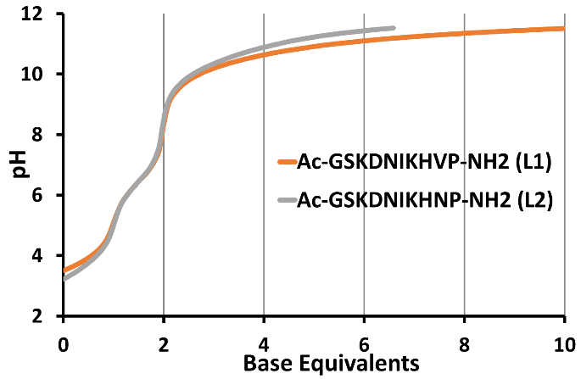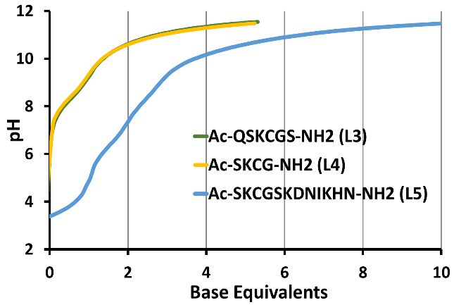
(a) (b)
Figure S1. Titration curves of ligands in function of equivalent of titrant: (cL = 2 mM) L1 and L2 (a), L3, L4, and L5 (b).

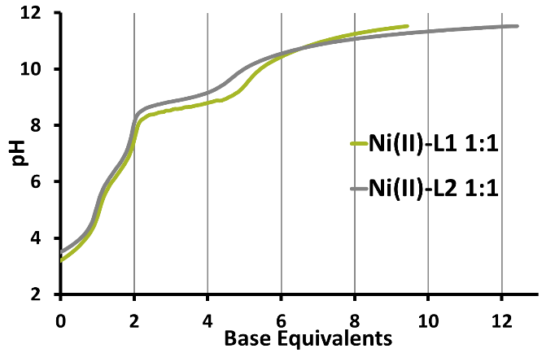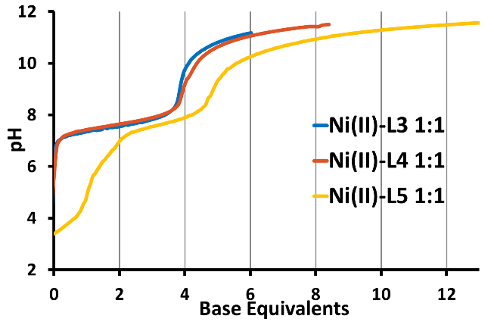
(a) (b)
Figure S2. Titration curves of equimolar Ni(II)-ligands solution in function of equivalent of titrant (cL = 2 mM) L = L1 and L2 (a); L = L3, L4 and L5 (b).

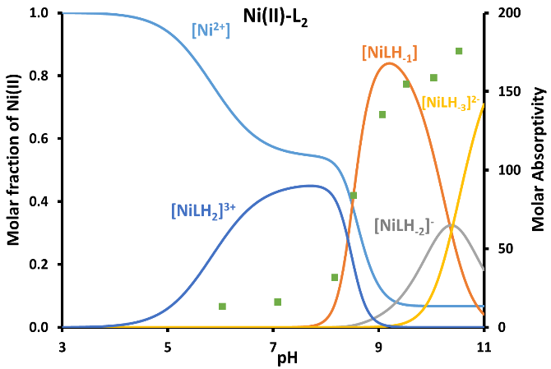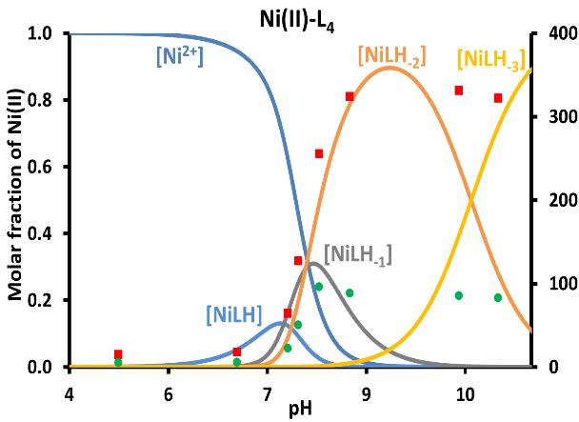
(a) (b)
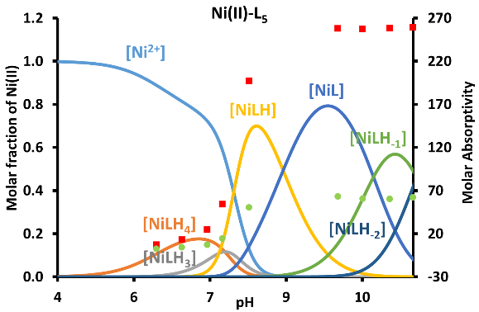
(e)
Figure S3. The distribution curves of the Ni(II) complexes formed at equimolar concentration ratio (c(L) = 2 mM) are plotted together with the change of absorption maxima at: L2 at 445 nm (●) (a), L3 at 446 nm (●) and 540 nm (●) (b) and L5 at 448 nm (●) and 543 nm (●) (c).

