Supporting information

Title: A First-Principles Study of the Structure and Electronic Properties of Bridged Cofacial Phenylene–Vinylene Oligomers

Richard A. Ugland¹, Thu Joanna M. Tran¹, Briley P. Kiehl¹, Melissa S. Aplet¹, Arjun Kafle², Rishi R. Pandit², Ananta R. Adhikari³, and Mahesh Dawadi^{1*}

¹Department: Natural Sciences and Engineering, University of South Carolina Upstate, Spartanburg, SC 29303

²Chemistry, Physics, and Environmental Health Science, Benedict College, Columbia SC 29229
³Department of Natural Sciences, University of Maryland Eastern Shore, MD 21853

Table of Contents

- Optimized geometries of 1-6 (S1-S2) and alternative structures of 1-6 (S3)
- Gas phase-TDDFT calculated UV-vis spectra for 1-6 (S4)
- TDDFT predicted UV-vis spectra in methylene chloride for 1-6 (S5-S9)
- PCM-TDDFT calculated MO diagrams and individual energies for 1-6 (S10-S18)
- Gas-Phase TD-DFT calculated electronic absorption parameters of compounds 1-6 (Table S1)
- Gas-phase TDDFT-expansion coefficients for 1-6.
- PCM- TDDFT-expansion coefficients for 1-6.
- References

Hydrogen atoms have been removed from optimized geometries of 1-6 and also from alternative structures of 1-6 for clarity. The terms (syn/ anti) refer in this perspective to differences in the vector direction of the dimer chain. The dimer or tetramer structures on S1 -S2 refer to “syn” and the structures on S3 refer to “anti”.
Fig. S1. Optimized geometries of 1-3 using the DFT method with functional B3LYP and B3LYP/6-31G(d) basis sets.

Fig. S2. Optimized geometries of 4-6, using the DFT method with functional B3LYP and B3LYP/6-31G(d) basis sets.

Fig. S3. Optimized geometries of 2,3,5, and 6 using the DFT method with functional B3LYP and B3LYP/6-31G(d) basis sets.
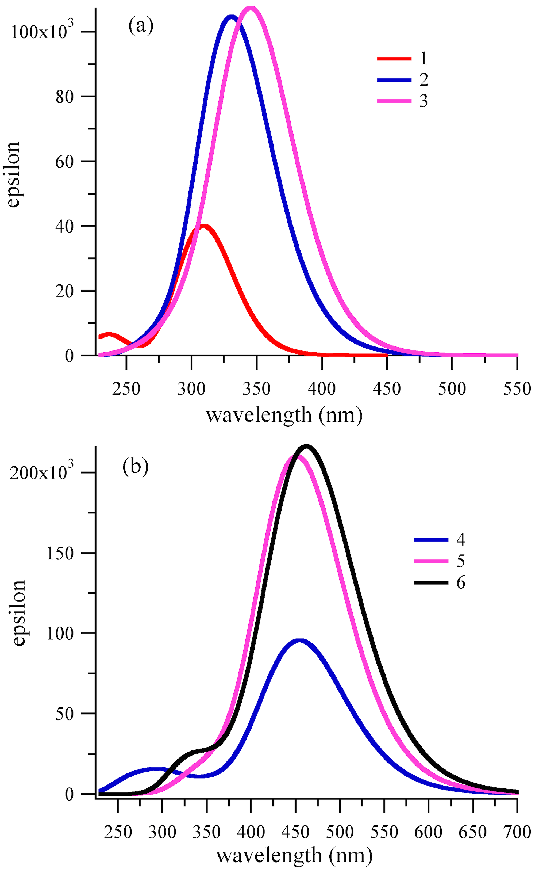

Fig. S4. Gas phase TDDFT predicted UV-vis spectra for 1-6.

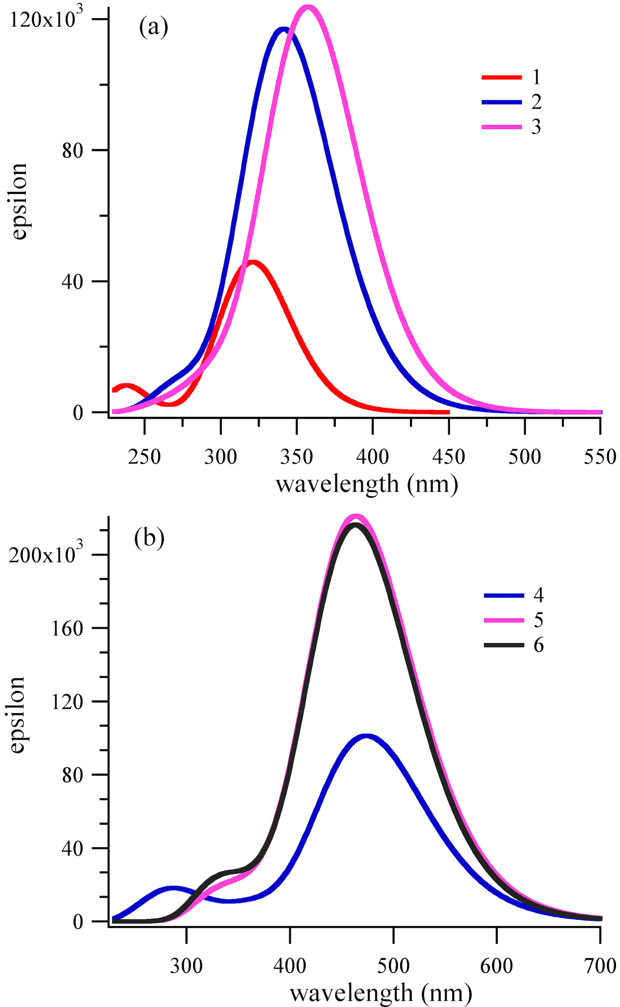

Fig. S5. TDDFT predicted UV-vis spectra in methylene chloride of (a) 1-3, (b) 4-6, where R = H.

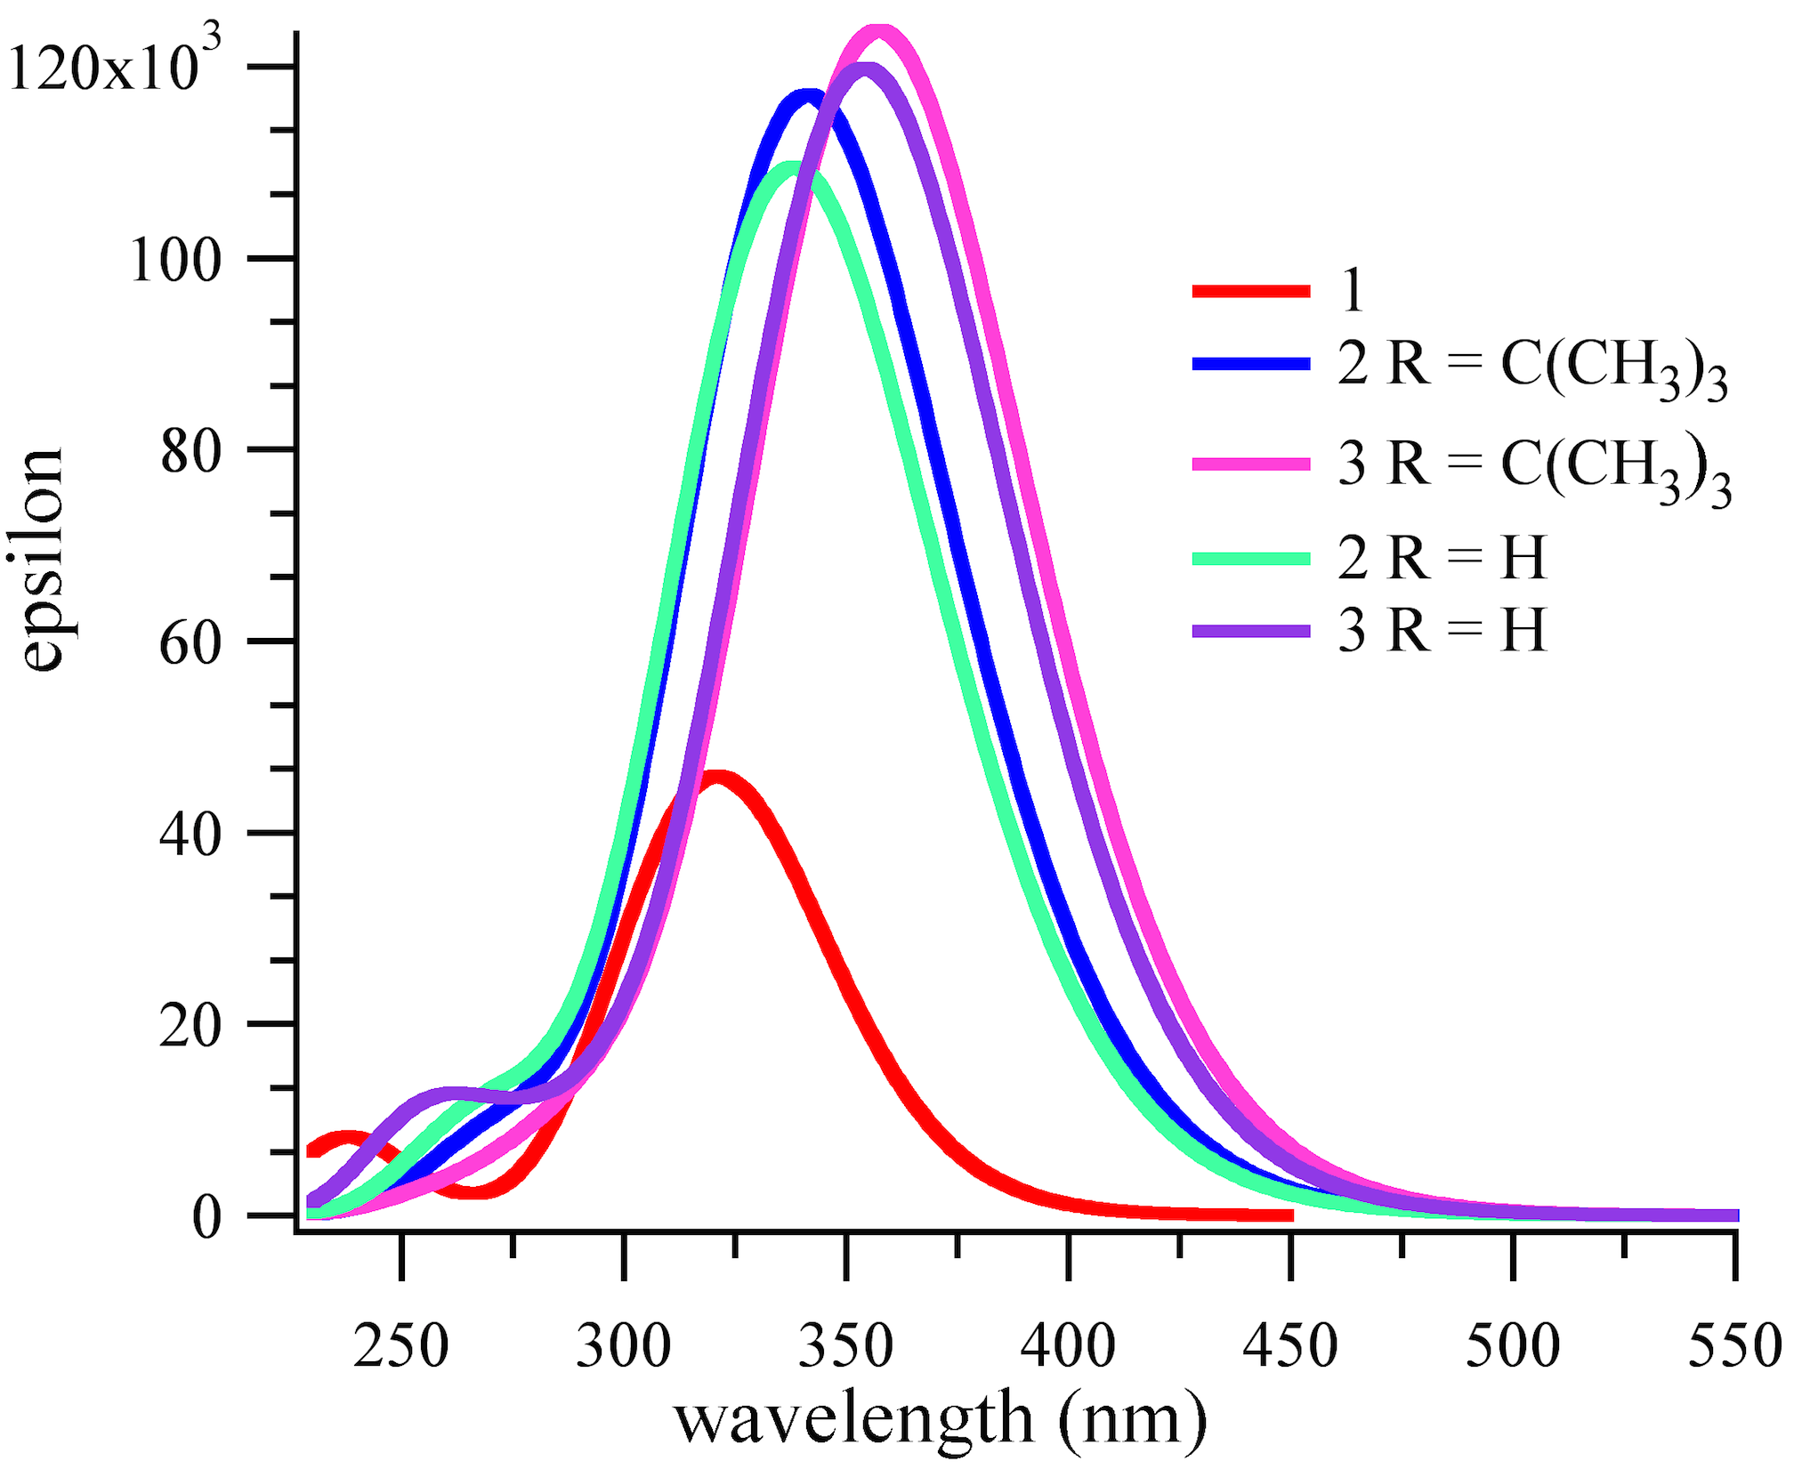

Fig. S6. PCM-TDDFT predicted UV-vis spectra for 1-3 and compare the results with R = H and with R = C(CH₃)₃ for 2 and 3.
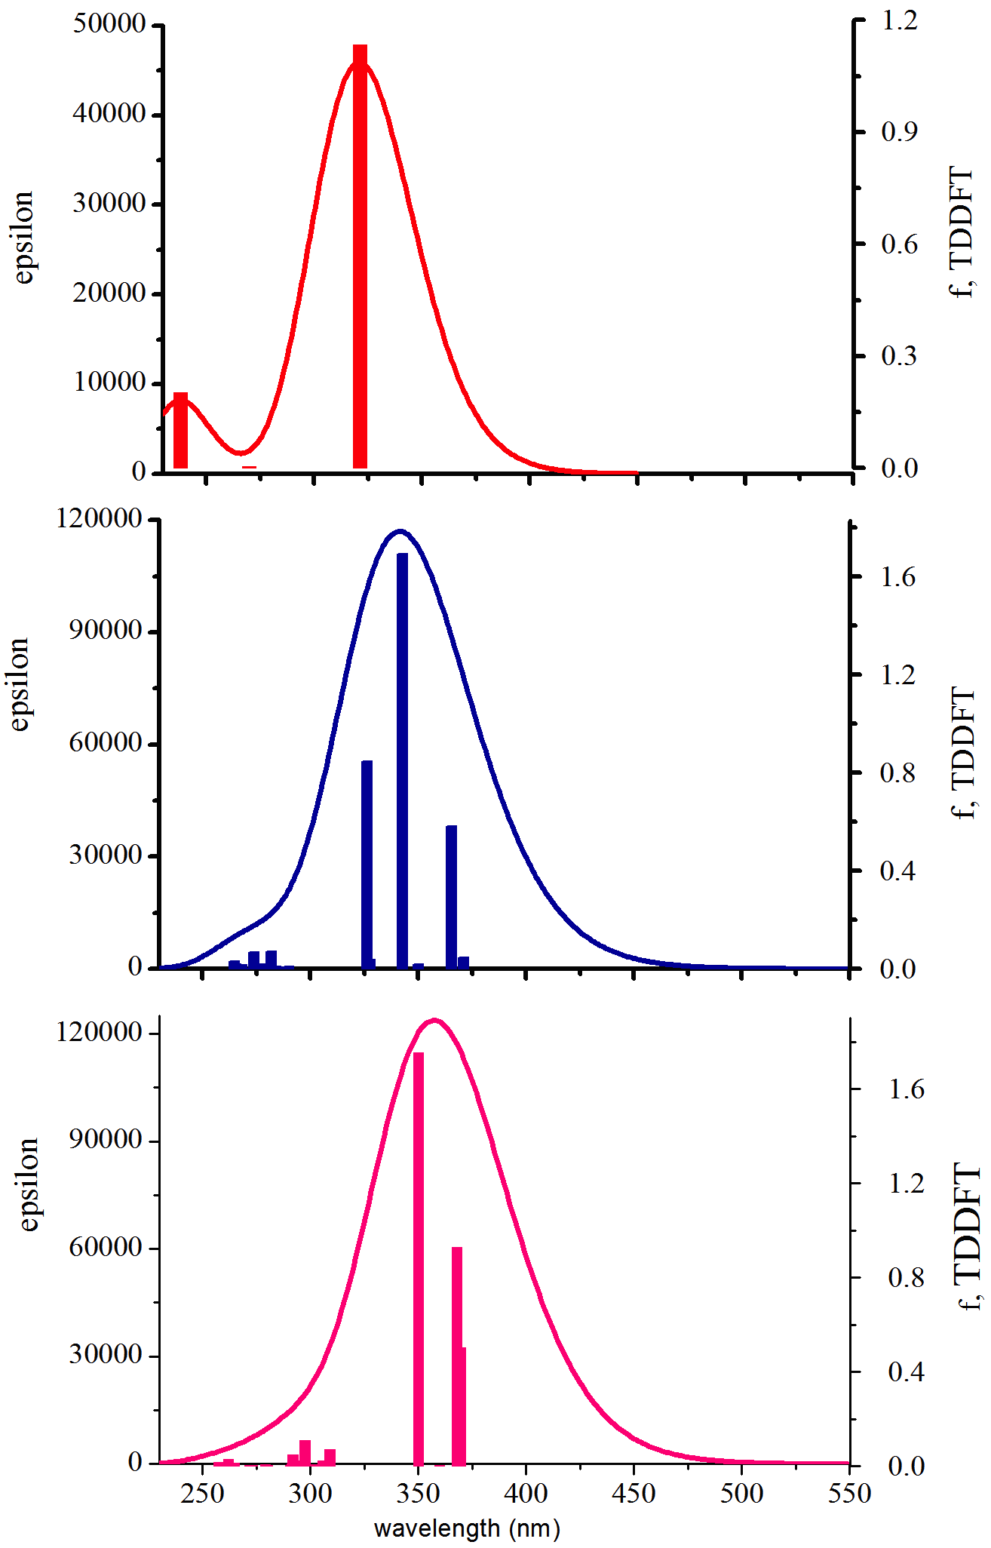

Fig. S7. PCM-TDDFT predicted UV-vis spectra for 1-3 showing the oscillator strength.

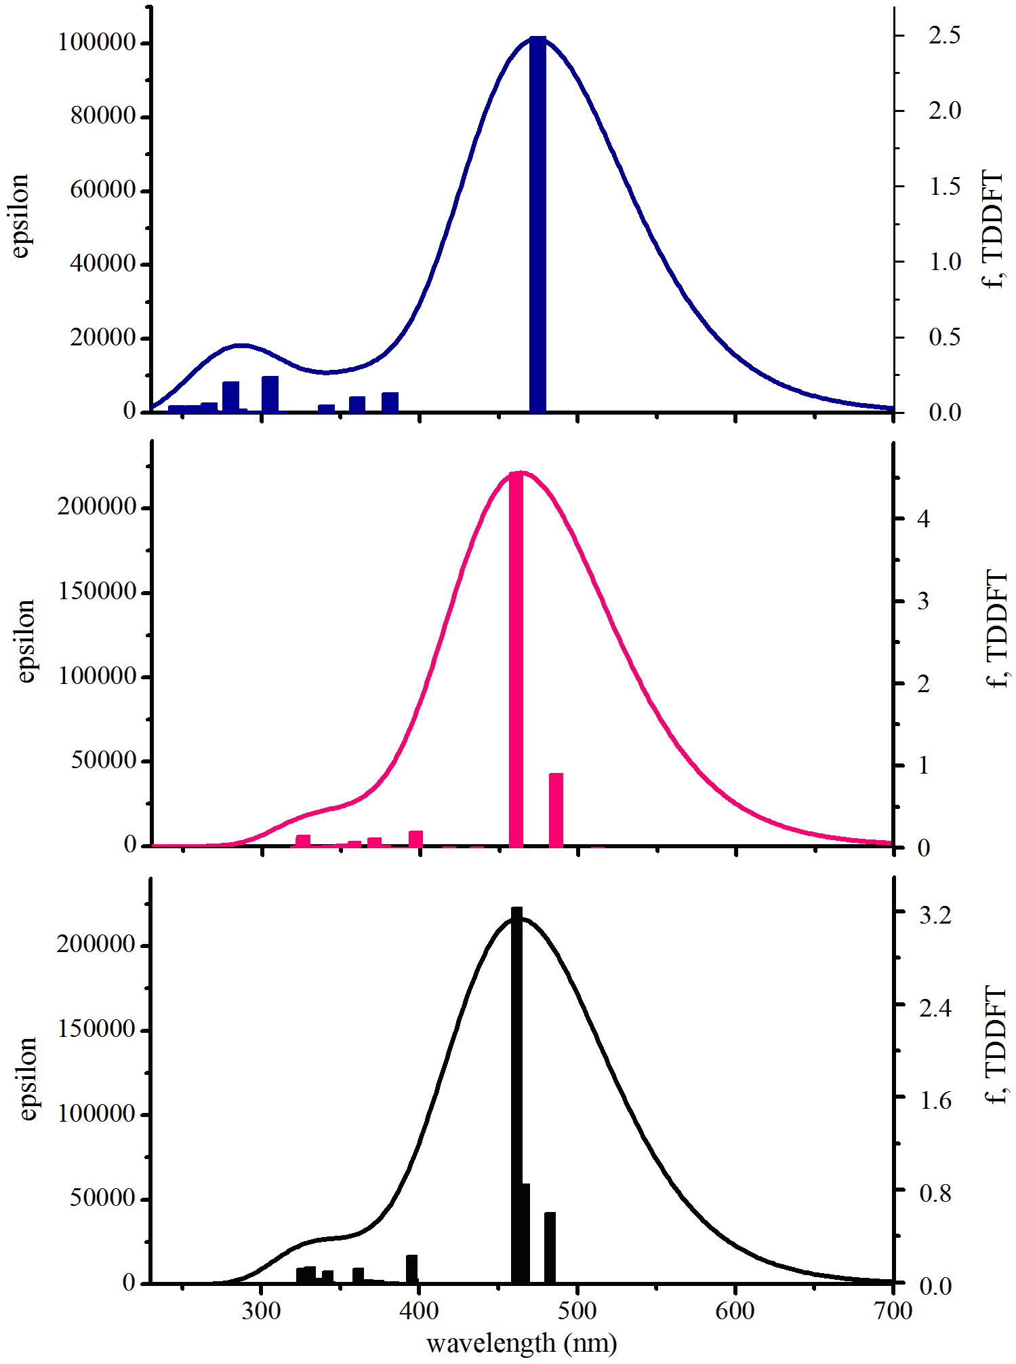

Fig. S8. PCM-TDDFT predicted UV-vis spectra for 4-6 showing the oscillator strength.

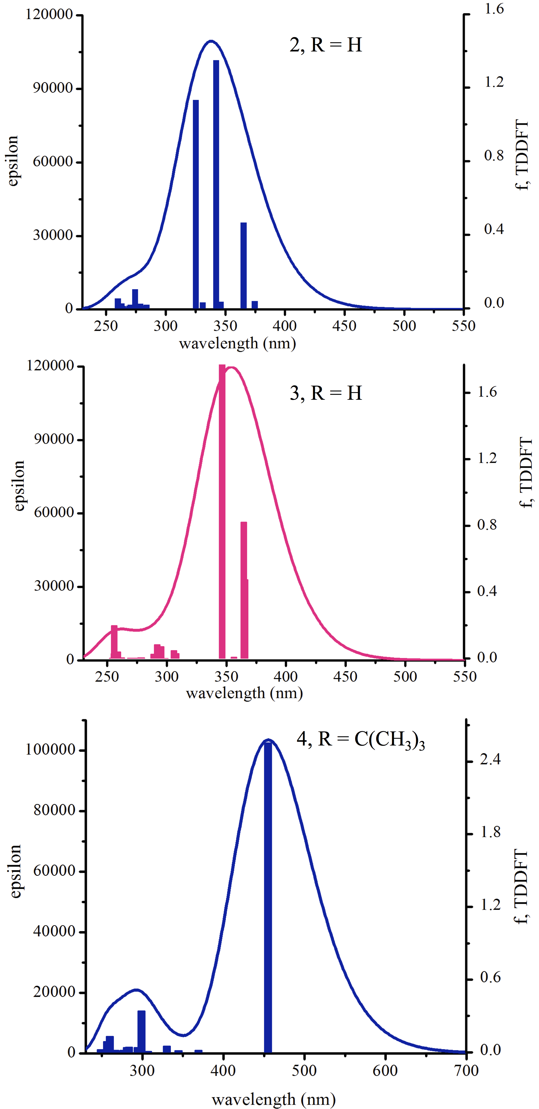
Fig. S9. PCM-TDDFT predicted UV-vis spectra for 2-4 showing the oscillator strength.

Fig. S10. PCM-DFT calculated frontier MO energies (eV) of compound 1.

Fig. S11. PCM-DFT calculated frontier MO energies (eV) of compound 2, R = C(CH₃)₃.

Fig. S12. PCM-DFT calculated frontier MO energies (eV) of compound 2, R = H.

Fig. S13. PCM-DFT calculated frontier MO energies (eV) of compound 3, R = C(CH₃)₃.

Fig. S14. PCM-DFT calculated frontier MO energies (eV) of compound 3, R = H.

Fig. S15. PCM-DFT calculated frontier MO energies (eV) of compound 4, R = H.

Fig. S16. PCM-DFT calculated frontier MO energies (eV) of compound 4, R = C(CH₃)₃.

Fig. S17. PCM-DFT calculated frontier MO energies (eV) of compound 5, R = H.

Fig. S18. PCM-DFT calculated frontier MO energies (eV) of compound 6, R = H.

Table S1. Gas-phase TD-DFT calculated electronic absorption parameters of compounds 1–6, including computed excitation wavelengths (λ), oscillator strengths (f), and dominant electronic transitions with % orbital contributions from TD-B3LYP/6-31+G(d)//B3LYP/6-31G(d) calculations.
Compound | R group | Conformation | λ (nm) | ªf | Major Electronic Transition | Orbital Contribution (%)^{c}
1 | – | – | 309.05  236.57  187.70 | 0.9886  0.1616  0.3968 | ^{b}H → L  H → L+1  H−2 → L+2 | 100.0  57.6  40.9
2 | H | syn | 361.71 | 0.1602 | H → L+1 | 81.0
2 | H | syn | 336.26 | 0.8471 | H−1 → L | 33.2
2 | H | syn | 326.74 | 0.1151 | H−2 → L | 79.2
2 | H | syn | 317.05 | 1.4280 | H−2 → L+1 | 66.1
2 | H | anti | 359.32 | 0.1100 | H → L+1 | 77.3
2 | H | anti | 344.59 | 0.3518 | H−1 → L | 47.5
2 | H | anti | 334.34 | 0.4972 | H−1 → L+1 | 61.2
2 | H | anti | 326.78 | 0.3599 | H−2 → L | 70.9
2 | H | anti | 315.61 | 1.2992 | H−2 → L+1 | 67.6
2 | t-Bu | syn | 364.49 | 0.2595 | H → L+1 | 48.9
2 | t-Bu | syn | 336.90 | 1.3716 | H−1 → L+1 | 53.2
2 | t-Bu | syn | 319.77 | 1.1862 | H−2 → L | 56.0
2 | t-Bu | anti | 363.09 | 0.2281 | H → L+1 | 81.2
2 | t-Bu | anti | 338.10 | 1.5124 | H−1 → L | 70.8
2 | t-Bu | anti | 319.12 | 1.1046 | H−2 → L+1 | 83.6
3 | H | syn | 363.54 | 0.2961 | H → L | 85.5
3 | H | syn | 360.74 | 0.2572 | H → L+1 | 100.0
3 | H | syn | 356.51 | 0.1600 | H−1 → L | 100.0
3 | H | syn | 337.52 | 1.9312 | H−1 → L+1 | 85.9
3 | H | syn | 290.12 | 0.1316 | H−2 → L+1 | 50.0
3 | H | anti | 361.43 | 0.3183 | H → L | 86.9
3 | H | anti | 357.05 | 0.3503 | H → L+1 | 100.0
3 | H | anti | 354.52 | 0.1324 | H−1 → L | 100.0
3 | H | anti | 335.43 | 1.8375 | H−1 → L+1 | 88.4
3 | H | anti | 289.66 | 0.1331 | H−2 → L+1 | 53.6
3 | t-Bu | syn | 362.99 | 0.4271 | H → L | 90.7
3 | t-Bu | syn | 360.83 | 0.4346 | H → L+1 | 50.7
3 | t-Bu | syn | 338.55 | 1.8689 | H−1 → L+1 | 90.8
3 | t-Bu | syn | 307.39 | 0.1177 | H → L+2 | 69.8
3 | t-Bu | anti | 365.15 | 0.3842 | H → L | 86.5
3 | t-Bu | anti | 363.27 | 0.4158 | H−1 → L+1 | 73.2
3 | t-Bu | anti | 340.65 | 1.9701 | H−1 → L+1 | 88.8
3 | t-Bu | anti | 308.28 | 0.1261 | H → L+2 | 67.8
4 | H | – | 455.12 | 2.3443 | H → L | 100.0
4 | H | – | 350.99 | 0.1209 | H−2 → L | 54.6
4 | H | – | 302.96 | 0.2605 | H−1 → L+1 | 81.3
4 | H | – | 275.51 | 0.1382 | H−2 → L+1 | 27.7
4 | t-Bu | – | 437.21 | 2.2713 | H → L | 100.0
4 | t-Bu | – | 298.56 | 0.3260 | H−1 → L+1 | 78.7
4 | t-Bu | – | 255.80 | 0.1315 | H → L+6 | 30.8
5 | H | syn | 489.57 | 0.2966 | H → L+1 | 68.9
5 | H | syn | 457.88 | 4.0618 | H−1 → L | 63.0
5 | H | syn | 453.46 | 0.7200 | H−2 → L | 83.2
5 | H | anti | 484.49 | 0.1686 | H−1 → L | 62.2
5 | H | anti | 452.74 | 4.8394 | H → L+1 | 62.1
5 | H | anti | 423.01 | 0.1464 | H−2 → L | 88.5
5 | H | anti | 400.17 | 0.1055 | H → L+2 | 75.5
5 | H | anti | 350.79 | 0.2400 | H−5 → L+1 | 43.7
6 | H  H  H  H  H  H  H | syn  syn  syn  syn  syn  syn  syn | 480.87 | 0.6172 | H → L+1 | 41.5
6 | H  H  H  H  H  H  H | syn  syn  syn  syn  syn  syn  syn | 464.07 | 1.3973 | H → L | 81.4
6 | H  H  H  H  H  H  H | syn  syn  syn  syn  syn  syn  syn | 459.99 | 3.2486 | H−1 → L+1 | 87.4
6 | H  H  H  H  H  H  H | syn  syn  syn  syn  syn  syn  syn | 393.71 | 0.2213 | H−2 → L | 24.3
6 | H  H  H  H  H  H  H | syn  syn  syn  syn  syn  syn  syn | 360.37 | 0.1227 | H−1 → L+3 | 51.7
6 | H  H  H  H  H  H  H | syn  syn  syn  syn  syn  syn  syn | 329.67 | 0.1314 | H−2 → L+2 | 53.6
6 | H  H  H  H  H  H  H | syn  syn  syn  syn  syn  syn  syn | 324.97 | 0.1347 | H−5 → L | 44.2
6 | H | anti | 486.67 | 0.7193 | H−1 → L | 52.5
6 | H | anti | 473.89 | 0.2417 | H → L | 100.0
6 | H | anti | 467.82 | 4.1112 | H → L+1 | 52.2
6 | H | anti | 461.92 | 0.2468 | H−1 → L+1 | 100.0
6 | H | anti | 398.21 | 0.1259 | H−2 → L+1 | 41.1
6 | H | anti | 365.00 | 0.1449 | H−1 → L+3 | 45.4
6 | H | anti | 329.69 | 0.1487 | H−4 → L | 49.6
6 | H | anti | 326.57 | 0.1882 | H−6 → L | 22.8
ªO Str, oscillator strength. Only transitions with oscillator strengths more than 0.1 are shown.
^{b}H=HOMO and L=LUMO

^{c} normalized contribution (%). The percentage of the individual contribution (contribution %) to the vertical excited states was calculated using the following expression².
$$normalized contribution (\%)= \frac{{\left\lfloor c_{i}\right\rfloor }^{2}}{\sum_{i=1}^{n}{{\left\lfloor c_{i}\right\rfloor }^{2}}}×100$$

6. Gas-TDDFT expansion coefficients for 1-6.

Compound 1

Excited State 1: Singlet-A 4.0118 eV 309.05 nm f=0.9886 <S**2>=0.000
48 -> 49 0.70591
This state for optimization and/or second-order correction.
Total Energy, E(TD-HF/TD-KS) = -540.562532176
Copying the excited state density for this state as the 1-particle RhoCI density.

Excited State 2: Singlet-A 4.6046 eV 269.26 nm f=0.0065 <S**2>=0.000
47 -> 49 0.52808
48 -> 50 0.45387

Excited State 3: Singlet-A 4.6143 eV 268.70 nm f=0.0000 <S**2>=0.000
46 -> 49 0.53031
48 -> 51 -0.45022

Excited State 4: Singlet-A 5.1450 eV 240.98 nm f=0.0000 <S**2>=0.000
45 -> 49 0.54793
48 -> 51 -0.12812
48 -> 52 0.41913

Excited State 5: Singlet-A 5.2408 eV 236.57 nm f=0.0000 <S**2>=0.000
45 -> 49 0.12139
46 -> 49 0.44165
47 -> 52 -0.10579
48 -> 51 0.51060

Excited State 6: Singlet-A 5.2455 eV 236.36 nm f=0.1616 <S**2>=0.000
47 -> 49 -0.44672
48 -> 50 0.52070

Excited State 7: Singlet-A 5.8021 eV 213.69 nm f=0.0000 <S**2>=0.000
45 -> 49 -0.37077
46 -> 50 -0.22421
47 -> 51 0.21028
48 -> 52 0.51133

Excited State 8: Singlet-A 6.3265 eV 195.97 nm f=0.0000 <S**2>=0.000
45 -> 50 0.40941
46 -> 50 0.27671
47 -> 51 0.34152
47 -> 52 -0.33977

Excited State 9: Singlet-A 6.3460 eV 195.37 nm f=0.0164 <S**2>=0.000
44 -> 49 -0.13889
45 -> 51 0.43688
46 -> 51 -0.16883
46 -> 52 0.36342
47 -> 50 -0.32290

Excited State 10: Singlet-A 6.3825 eV 194.26 nm f=0.0481 <S**2>=0.000
44 -> 49 0.59758
45 -> 51 0.13106
46 -> 51 -0.20210
47 -> 50 0.10554
48 -> 53 -0.25237

Excited State 11: Singlet-A 6.4384 eV 192.57 nm f=0.0041 <S**2>=0.000
45 -> 51 0.21841
46 -> 51 0.42199
46 -> 52 0.27950
47 -> 50 0.43495

Excited State 12: Singlet-A 6.4544 eV 192.09 nm f=0.0000 <S**2>=0.000
45 -> 50 -0.30195
46 -> 50 0.42235
47 -> 51 0.36077
47 -> 52 0.30436

Excited State 13: Singlet-A 6.6054 eV 187.70 nm f=0.3968 <S**2>=0.000
44 -> 49 0.10896
45 -> 52 -0.21731
46 -> 51 0.44797
47 -> 50 -0.38412
48 -> 53 -0.28815

Excited State 14: Singlet-A 6.6315 eV 186.96 nm f=0.0000 <S**2>=0.000
43 -> 49 0.69333

Excited State 15: Singlet-A 6.8466 eV 181.09 nm f=0.0000 <S**2>=0.000
42 -> 49 0.69584

Excited State 16: Singlet-A 6.9641 eV 178.03 nm f=0.0001 <S**2>=0.000
41 -> 49 0.68997
43 -> 52 0.13235

Excited State 17: Singlet-A 7.0369 eV 176.19 nm f=0.0560 <S**2>=0.000
44 -> 49 -0.14329
45 -> 51 -0.29138
45 -> 52 0.38165
46 -> 52 0.29588
48 -> 53 -0.38067

Excited State 18: Singlet-A 7.0806 eV 175.10 nm f=0.0000 <S**2>=0.000
45 -> 49 0.18857
45 -> 50 0.14938
46 -> 50 -0.40160
47 -> 51 0.40533
47 -> 52 0.20862
48 -> 52 -0.20453

Excited State 19: Singlet-A 7.1779 eV 172.73 nm f=0.0000 <S**2>=0.000
44 -> 51 0.15794
45 -> 50 0.43093
46 -> 50 0.14732
47 -> 51 -0.18717
47 -> 52 0.43973
48 -> 52 0.10113

Excited State 20: Singlet-A 7.2075 eV 172.02 nm f=0.0000 <S**2>=0.000
48 -> 54 -0.40438
48 -> 56 0.57311

Excited State 1: Singlet-A 2.8435 eV 436.03 nm f=0.0182 <S**2>=0.000
73 -> 75 0.10520
74 -> 75 0.69179

Compound 2- syn ( R =H)

Excited State 1: Singlet-A 3.3200 eV 373.45 nm f=0.0349 <S**2>=0.000
182 ->183 0.69044
182 ->184 -0.11783
This state for optimization and/or second-order correction.
Total Energy, E(TD-HF/TD-KS) = -2048.67889871
Copying the excited state density for this state as the 1-particle RhoCI density.
Excited State 2: Singlet-A 3.4277 eV 361.71 nm f=0.1602 <S**2>=0.000
181 ->183 0.28539
181 ->184 -0.10665
182 ->184 0.62845
Excited State 3: Singlet-A 3.6002 eV 344.38 nm f=0.0882 <S**2>=0.000
180 ->183 -0.19740
181 ->183 0.37722
181 ->184 0.55332
Excited State 4: Singlet-A 3.6872 eV 336.26 nm f=0.8471 <S**2>=0.000
180 ->183 -0.20294
180 ->184 -0.30983
181 ->183 0.40291
181 ->184 -0.37854
182 ->184 -0.21571
Excited State 5: Singlet-A 3.7946 eV 326.74 nm f=0.1151 <S**2>=0.000
180 ->183 0.61470
180 ->184 -0.26482
181 ->183 0.16985
Excited State 6: Singlet-A 3.9105 eV 317.05 nm f=1.4280 <S**2>=0.000
180 ->183 0.17827
180 ->184 0.56609
181 ->183 0.27432
181 ->184 -0.15730
182 ->184 -0.18089

Excited State 7: Singlet-A 4.3513 eV 284.93 nm f=0.0074 <S**2>=0.000
177 ->183 0.18719
178 ->183 0.15834
179 ->183 -0.22599
182 ->185 0.50418
182 ->186 0.14694
182 ->189 -0.19415
Excited State 8: Singlet-A 4.3843 eV 282.79 nm f=0.0138 <S**2>=0.000
177 ->183 0.18628
179 ->183 -0.26578
179 ->184 0.18482
182 ->185 -0.34801
182 ->186 0.37536
182 ->189 -0.14823
Excited State 9: Singlet-A 4.4309 eV 279.82 nm f=0.0473 <S**2>=0.000
174 ->184 -0.11466
177 ->183 -0.30737
177 ->184 0.11169
180 ->186 0.12250
181 ->191 0.11159
182 ->185 0.12474
182 ->186 0.42106
182 ->187 -0.10341
182 ->189 0.30172

Excited State 10: Singlet-A 4.4418 eV 279.13 nm f=0.0033 <S**2>=0.000
174 ->183 0.18648
174 ->184 -0.11064
177 ->183 0.10891
177 ->184 0.39298
179 ->183 -0.15249
179 ->184 -0.25558
181 ->185 -0.12749
181 ->189 0.27560
182 ->191 0.23617
Excited State 11: Singlet-A 4.5150 eV 274.61 nm f=0.0491 <S**2>=0.000
173 ->183 -0.15964
175 ->183 0.11960
175 ->184 0.10482
177 ->183 0.15957
179 ->183 0.20893
179 ->184 -0.20359
181 ->185 0.29293
181 ->188 0.13726
182 ->186 0.21947
182 ->187 0.33654
Excited State 12: Singlet-A 4.5238 eV 274.07 nm f=0.0063 <S**2>=0.000
173 ->183 0.17309
173 ->184 0.16474
175 ->183 -0.34598
175 ->184 0.17486
179 ->183 0.12808
180 ->188 -0.14464
181 ->190 0.19752
182 ->188 0.37679

Excited State 13: Singlet-A 4.5585 eV 271.99 nm f=0.0087 <S**2>=0.000
173 ->183 0.17335
174 ->183 0.10012
175 ->184 -0.33437
177 ->183 0.11698
179 ->183 0.35394
180 ->190 0.10061
181 ->188 -0.26899
182 ->186 0.12400
182 ->189 -0.10482
182 ->190 -0.22047
Excited State 14: Singlet-A 4.5808 eV 270.66 nm f=0.0152 <S**2>=0.000
173 ->183 0.15087
175 ->184 -0.19269
178 ->184 -0.12603
179 ->183 -0.30297
179 ->184 -0.13357
181 ->188 -0.14644
182 ->187 0.43883
182 ->189 0.13542
182 ->190 -0.12836
Excited State 15: Singlet-A 4.6337 eV 267.57 nm f=0.0053 <S**2>=0.000
177 ->184 0.16873
179 ->184 0.45227
180 ->185 0.13470
181 ->185 -0.23473
181 ->187 -0.25110
182 ->187 0.26481
Excited State 16: Singlet-A 4.6621 eV 265.94 nm f=0.0045 <S**2>=0.000
178 ->183 0.49519
179 ->183 0.12491
180 ->185 -0.27523
181 ->185 -0.19759
181 ->186 0.18055
181 ->187 0.16149
182 ->187 0.14082
Excited State 17: Singlet-A 4.6901 eV 264.35 nm f=0.0286 <S**2>=0.000
174 ->184 -0.10627
177 ->183 0.16819
177 ->184 0.10092
178 ->183 0.14669
179 ->183 -0.16957
179 ->184 0.22372
181 ->185 0.43190
182 ->189 0.28267
Excited State 18: Singlet-A 4.7196 eV 262.70 nm f=0.0036 <S**2>=0.000
176 ->183 -0.17992
177 ->183 -0.16583
177 ->184 0.11336
178 ->183 -0.24046
178 ->184 -0.28851
180 ->185 -0.19517
181 ->186 0.35026
182 ->185 0.17478
182 ->189 -0.13253
Excited State 19: Singlet-A 4.7495 eV 261.05 nm f=0.0066 <S**2>=0.000
174 ->183 -0.12702
176 ->183 -0.27477
177 ->183 0.14572
178 ->183 -0.13359
178 ->184 0.47607
180 ->187 0.12110
181 ->186 0.22547
181 ->187 -0.12619
182 ->185 0.12065
Excited State 20: Singlet-A 4.7760 eV 259.60 nm f=0.0300 <S**2>=0.000
174 ->183 -0.25443
177 ->183 0.37713
178 ->184 -0.23634
180 ->186 -0.21223
180 ->187 -0.14019
181 ->185 -0.22302
182 ->187 -0.10954
182 ->188 -0.10495
182 ->189 0.20922

Compound 2- syn (R =C(CH₃)₃)

Excited State 1: Singlet-A 3.3457 eV 370.58 nm f=0.0379 <S**2>=0.000
246 -> 247 -0.44509
246 -> 248 0.54272
This state for optimization and/or second-order correction.
Total Energy, E(TD-HF/TD-KS) = -2677.69647110
Copying the excited state density for this state as the 1-particle RhoCI density.

Excited State 2: Singlet-A 3.4016 eV 364.49 nm f=0.2595 <S**2>=0.000
245 -> 247 -0.14132
245 -> 248 0.24679
246 -> 247 0.49235
246 -> 248 0.41470

Excited State 3: Singlet-A 3.5465 eV 349.59 nm f=0.0193 <S**2>=0.000
245 -> 247 0.60785
245 -> 248 0.33968

Excited State 4: Singlet-A 3.6801 eV 336.90 nm f=1.3716 <S**2>=0.000
244 -> 247 -0.28072
244 -> 248 -0.14194
245 -> 247 -0.27845
245 -> 248 0.51176
246 -> 247 -0.18944
246 -> 248 -0.13551

Excited State 5: Singlet-A 3.8329 eV 323.47 nm f=0.0241 <S**2>=0.000
244 -> 247 -0.36902
244 -> 248 0.58292
245 -> 247 0.10071

Excited State 6: Singlet-A 3.8773 eV 319.77 nm f=1.1862 <S**2>=0.000
244 -> 247 0.51803
244 -> 248 0.34540
245 -> 247 -0.12860
245 -> 248 0.23808
246 -> 247 -0.13463

Excited State 7: Singlet-A 4.3045 eV 288.04 nm f=0.0055 <S**2>=0.000
242 -> 247 0.13706
243 -> 247 0.55338
243 -> 248 -0.15834
245 -> 253 0.19275
246 -> 249 0.16307
246 -> 253 0.17543

Excited State 8: Singlet-A 4.3419 eV 285.55 nm f=0.0003 <S**2>=0.000
239 -> 248 -0.10114
240 -> 248 -0.11705
241 -> 247 -0.12774
242 -> 248 0.22117
243 -> 247 -0.14972
244 -> 249 0.10115
245 -> 250 0.10624
246 -> 249 0.54289

Excited State 9: Singlet-A 4.3537 eV 284.78 nm f=0.0063 <S**2>=0.000
242 -> 247 0.14532
242 -> 248 0.50504
243 -> 248 -0.20699
245 -> 254 -0.17800
246 -> 249 -0.23047
246 -> 254 0.19711

Excited State 10: Singlet-A 4.3686 eV 283.81 nm f=0.0651 <S**2>=0.000
241 -> 248 0.20660
244 -> 250 0.15433
246 -> 250 0.59303

Excited State 11: Singlet-A 4.4303 eV 279.85 nm f=0.0137 <S**2>=0.000
237 -> 247 -0.18551
237 -> 248 -0.11242
239 -> 247 0.18599
239 -> 248 -0.32568
241 -> 248 0.15515
245 -> 255 -0.17553
246 -> 249 -0.11620
246 -> 250 -0.16049
246 -> 252 0.41395

Excited State 12: Singlet-A 4.4469 eV 278.81 nm f=0.0037 <S**2>=0.000
237 -> 247 -0.11337
237 -> 248 0.19479
239 -> 247 0.35096
239 -> 248 0.19834
241 -> 247 -0.24654
245 -> 249 0.15547
245 -> 252 0.28900
246 -> 251 0.11141
246 -> 255 -0.25916

Excited State 13: Singlet-A 4.5158 eV 274.55 nm f=0.0378 <S**2>=0.000
239 -> 247 -0.15232
240 -> 247 0.16155
241 -> 248 0.32706
245 -> 249 0.37561
245 -> 252 -0.10091
246 -> 250 -0.18276
246 -> 251 0.33954

Excited State 14: Singlet-A 4.5452 eV 272.78 nm f=0.0000 <S**2>=0.000
242 -> 248 0.22049
243 -> 247 0.17783
243 -> 248 0.63714

Excited State 15: Singlet-A 4.5886 eV 270.20 nm f=0.0073 <S**2>=0.000
240 -> 247 0.12827
241 -> 247 0.30818
241 -> 248 -0.10453
245 -> 249 -0.31342
246 -> 251 0.47602

Excited State 16: Singlet-A 4.5966 eV 269.73 nm f=0.0000 <S**2>=0.000
242 -> 247 0.65051
242 -> 248 -0.17830
243 -> 247 -0.17770

Excited State 17: Singlet-A 4.6108 eV 268.90 nm f=0.0054 <S**2>=0.000
239 -> 247 0.13525
241 -> 247 0.45900
241 -> 248 0.22088
245 -> 249 0.19382
245 -> 251 -0.27079
246 -> 251 -0.20124

Excited State 18: Singlet-A 4.6484 eV 266.72 nm f=0.0113 <S**2>=0.000
240 -> 247 -0.16428
240 -> 248 0.18822
241 -> 247 -0.10932
244 -> 249 0.29401
245 -> 249 -0.13608
245 -> 250 0.48963
246 -> 249 -0.12447

Excited State 19: Singlet-A 4.6703 eV 265.48 nm f=0.0196 <S**2>=0.000
240 -> 247 -0.13917
240 -> 248 -0.15688
241 -> 247 -0.14176
241 -> 248 0.42655
245 -> 249 -0.34711
245 -> 250 -0.14333
246 -> 250 -0.10821
246 -> 252 -0.18512

Excited State 20: Singlet-A 4.7112 eV 263.17 nm f=0.0049 <S**2>=0.000
240 -> 247 0.53403
244 -> 250 0.16485
244 -> 251 -0.13131
245 -> 250 0.17556
245 -> 251 0.12950
246 -> 251 -0.15041
246 -> 252 -0.14183

Compound 2- anti (R =C(CH₃)₃)
Excited State 1: Singlet-A 3.3398 eV 371.23 nm f=0.0401 <S**2>=0.000
246 -> 247 0.69038
246 -> 248 -0.12391
This state for optimization and/or second-order correction.
Total Energy, E(TD-HF/TD-KS) = -2677.69630427
Copying the excited state density for this state as the 1-particle RhoCI density.

Excited State 2: Singlet-A 3.4147 eV 363.09 nm f=0.2281 <S**2>=0.000
245 -> 247 -0.30212
246 -> 248 0.62760

Excited State 3: Singlet-A 3.5637 eV 347.91 nm f=0.0187 <S**2>=0.000
244 -> 247 0.10358
245 -> 248 0.69025

Excited State 4: Singlet-A 3.6671 eV 338.10 nm f=1.5124 <S**2>=0.000
244 -> 248 0.28183
245 -> 247 0.58423
246 -> 248 0.24731

Excited State 5: Singlet-A 3.8146 eV 325.03 nm f=0.0012 <S**2>=0.000
244 -> 247 0.68969
245 -> 248 -0.10005

Excited State 6: Singlet-A 3.8852 eV 319.12 nm f=1.1046 <S**2>=0.000
244 -> 248 0.63610
245 -> 247 -0.23349
246 -> 248 -0.15800

Excited State 7: Singlet-A 4.3110 eV 287.60 nm f=0.0051 <S**2>=0.000
243 -> 247 0.42766
243 -> 248 -0.41970
244 -> 253 -0.10829
245 -> 253 -0.22388
246 -> 249 -0.12450
246 -> 253 0.17397

Excited State 8: Singlet-A 4.3498 eV 285.03 nm f=0.0064 <S**2>=0.000
240 -> 247 0.13664
242 -> 247 0.12577
242 -> 248 0.13221
244 -> 249 0.11366
246 -> 249 0.57921
246 -> 250 -0.17140
Excited State 9: Singlet-A 4.3676 eV 283.87 nm f=0.0561 <S**2>=0.000
239 -> 247 0.12125
242 -> 247 -0.19612
244 -> 250 0.14476
246 -> 249 0.15996
246 -> 250 0.55552
246 -> 252 0.11696

Excited State 10: Singlet-A 4.3919 eV 282.30 nm f=0.0048 <S**2>=0.000
241 -> 247 0.45218
241 -> 248 0.35706
245 -> 254 -0.18038
246 -> 249 -0.12582
246 -> 254 -0.23325

Excited State 11: Singlet-A 4.4239 eV 280.26 nm f=0.0050 <S**2>=0.000
237 -> 248 0.20297
239 -> 247 0.38380
245 -> 249 0.11004
245 -> 255 0.16489
246 -> 250 -0.16966
246 -> 251 -0.20435
246 -> 252 0.37946

Excited State 12: Singlet-A 4.4606 eV 277.95 nm f=0.0015 <S**2>=0.000
237 -> 247 0.24400
239 -> 248 0.39550
242 -> 248 -0.24743
245 -> 252 0.31401
246 -> 255 0.26137

Excited State 13: Singlet-A 4.5084 eV 275.01 nm f=0.0525 <S**2>=0.000
240 -> 248 0.13924
241 -> 247 -0.10908
242 -> 247 0.38840
245 -> 249 0.38225
246 -> 250 0.21844
246 -> 251 -0.28852
246 -> 252 -0.10296

Excited State 14: Singlet-A 4.5699 eV 271.31 nm f=0.0003 <S**2>=0.000
243 -> 247 0.50567
243 -> 248 0.48079

Excited State 15: Singlet-A 4.5955 eV 269.79 nm f=0.0165 <S**2>=0.000
240 -> 248 -0.13150
242 -> 247 0.16770
242 -> 248 -0.23316
245 -> 249 0.32086
246 -> 251 0.48415
246 -> 252 0.11862

Excited State 16: Singlet-A 4.6236 eV 268.16 nm f=0.0123 <S**2>=0.000
239 -> 248 0.11061
242 -> 248 0.48745
244 -> 249 -0.15699
245 -> 249 0.15042
245 -> 250 0.18770
245 -> 251 -0.30203
246 -> 251 0.18529

Excited State 17: Singlet-A 4.6491 eV 266.69 nm f=0.0098 <S**2>=0.000
240 -> 247 0.23244
241 -> 247 0.10521
241 -> 248 -0.12815
242 -> 247 0.22551
242 -> 248 -0.15490
244 -> 249 -0.20801
245 -> 249 -0.26834
245 -> 250 0.38092

Excited State 18: Singlet-A 4.6607 eV 266.02 nm f=0.0137 <S**2>=0.000
240 -> 247 -0.13683
240 -> 248 -0.14449
241 -> 248 -0.10437
242 -> 247 0.39633
244 -> 249 0.13544
245 -> 249 -0.26297
245 -> 250 -0.27940
245 -> 251 -0.10470
246 -> 249 -0.16096
246 -> 252 0.18872

Excited State 19: Singlet-A 4.6723 eV 265.36 nm f=0.0003 <S**2>=0.000
241 -> 247 -0.42761
241 -> 248 0.51479
245 -> 249 -0.11081

Excited State 20: Singlet-A 4.7154 eV 262.93 nm f=0.0076 <S**2>=0.000
240 -> 247 0.47838
240 -> 248 -0.15246
242 -> 248 -0.14550
244 -> 249 -0.12182
245 -> 250 -0.29486
245 -> 251 -0.21739
246 -> 249 -0.13503

Compound 3- Syn (R = H)

Excited State 1: Singlet-A 3.4105 eV 363.54 nm f=0.2961 <S**2>=0.000
137 ->140 0.26622
138 ->139 0.64634
This state for optimization and/or second-order correction.
Total Energy, E(TD-HF/TD-KS) = -1616.24065761
Copying the excited state density for this state as the 1-particle RhoCI density.

Excited State 2: Singlet-A 3.4369 eV 360.74 nm f=0.2572 <S**2>=0.000
138 ->140 0.69858

Excited State 3: Singlet-A 3.4777 eV 356.51 nm f=0.1600 <S**2>=0.000
137 ->139 0.70028

Excited State 4: Singlet-A 3.6734 eV 337.52 nm f=1.9328 <S**2>=0.000
137 ->140 0.65006
138 ->139 -0.26293

Excited State 5: Singlet-A 4.0194 eV 308.46 nm f=0.0636 <S**2>=0.000
136 ->140 -0.45090
138 ->141 0.50747

Excited State 6: Singlet-A 4.0552 eV 305.74 nm f=0.0212 <S**2>=0.000
136 ->139 0.60439
137 ->141 0.31735

Excited State 7: Singlet-A 4.1359 eV 299.77 nm f=0.0002 <S**2>=0.000
135 ->139 0.58453
136 ->140 0.20555
137 ->142 0.10036
138 ->141 0.29820

Excited State 8: Singlet-A 4.1946 eV 295.58 nm f=0.0637 <S**2>=0.000
135 ->140 -0.36986
136 ->139 -0.30487
137 ->141 0.49787

Excited State 9: Singlet-A 4.2736 eV 290.12 nm f=0.1316 <S**2>=0.000
135 ->139 -0.32320
136 ->140 0.48588
137 ->142 -0.10738
138 ->141 0.34710

Excited State 10: Singlet-A 4.3098 eV 287.68 nm f=0.0387 <S**2>=0.000
135 ->140 0.57082
136 ->139 -0.10622
137 ->141 0.36478

Excited State 11: Singlet-A 4.4303 eV 279.85 nm f=0.0034 <S**2>=0.000
130 ->139 0.26500
130 ->140 0.22929
131 ->139 -0.20351
131 ->140 -0.16465
132 ->139 0.18368
132 ->140 0.15555
133 ->139 0.12395
137 ->143 0.22736
137 ->145 0.15037
138 ->142 0.10807
138 ->143 -0.24664
138 ->144 0.10415
138 ->145 -0.17430

Excited State 12: Singlet-A 4.4390 eV 279.31 nm f=0.0063 <S**2>=0.000
130 ->139 0.26061
130 ->140 -0.23360
131 ->139 0.18464
131 ->140 -0.16734
132 ->139 -0.13835
132 ->140 0.12774
133 ->139 -0.16365
133 ->140 0.14941
137 ->143 -0.18360
137 ->144 -0.14769
137 ->145 0.10494
138 ->143 -0.23197
138 ->144 -0.18585
138 ->145 0.12842
138 ->146 0.10667

Excited State 13: Singlet-A 4.5246 eV 274.02 nm f=0.0007 <S**2>=0.000
131 ->139 -0.23766
132 ->140 -0.23997
133 ->139 -0.25516
133 ->140 0.25723
134 ->139 -0.14999
137 ->144 0.17387
137 ->145 0.19957
138 ->142 -0.20329
138 ->146 -0.24487

Excited State 14: Singlet-A 4.5284 eV 273.79 nm f=0.0026 <S**2>=0.000
131 ->139 0.14338
131 ->140 0.26977
132 ->139 0.31305
132 ->140 0.14421
133 ->139 -0.17016
133 ->140 0.19710
137 ->142 -0.10494
137 ->146 -0.25559
138 ->144 0.20925
138 ->145 0.18737

Excited State 15: Singlet-A 4.5829 eV 270.54 nm f=0.0012 <S**2>=0.000
131 ->139 -0.11434
132 ->140 -0.12358
133 ->139 -0.11205
134 ->139 0.42517
136 ->141 0.17691
137 ->147 0.10776
138 ->142 0.41054
138 ->146 -0.10967

Excited State 16: Singlet-A 4.7121 eV 263.12 nm f=0.0047 <S**2>=0.000
134 ->140 0.48648
135 ->139 0.13021
135 ->141 0.10783
137 ->142 -0.39653
138 ->147 -0.17013

Excited State 17: Singlet-A 4.7928 eV 258.69 nm f=0.0040 <S**2>=0.000
134 ->139 0.46846
138 ->142 -0.46299

Excited State 18: Singlet-A 4.8404 eV 256.15 nm f=0.0237 <S**2>=0.000
129 ->139 -0.14717
130 ->139 0.14227
130 ->140 0.18634
131 ->139 0.14680
132 ->139 -0.12315
133 ->139 -0.11600
135 ->141 0.47786
136 ->142 -0.16269
137 ->142 0.21425

Excited State 19: Singlet-A 4.8445 eV 255.93 nm f=0.0236 <S**2>=0.000
130 ->139 -0.25056
130 ->140 -0.26759
131 ->139 -0.22149
131 ->140 -0.13085
132 ->139 0.14437
133 ->139 0.21111
133 ->140 0.10584
134 ->140 -0.14293
135 ->141 0.35404
136 ->141 0.11192
136 ->142 -0.10604

Excited State 20: Singlet-A 4.8609 eV 255.06 nm f=0.0091 <S**2>=0.000
130 ->139 0.39066
130 ->140 -0.27089
131 ->139 -0.21800
131 ->140 0.26009
132 ->139 0.14953
132 ->140 -0.22548
133 ->140 -0.15754
136 ->141 -0.13342

Compound 3- anti (R = H)

Excited State 1: Singlet-A 3.4304 eV 361.43 nm f=0.3183 <S**2>=0.000
137 ->140 0.22878
138 ->139 0.65308
138 ->140 0.11090
This state for optimization and/or second-order correction.
Total Energy, E(TD-HF/TD-KS) = -1616.23862015
Copying the excited state density for this state as the 1-particle RhoCI density.

Excited State 2: Singlet-A 3.4725 eV 357.05 nm f=0.3503 <S**2>=0.000
138 ->140 0.68417

Excited State 3: Singlet-A 3.4972 eV 354.52 nm f=0.1324 <S**2>=0.000
137 ->139 0.69219

Excited State 4: Singlet-A 3.6963 eV 335.43 nm f=1.8380 <S**2>=0.000
137 ->140 0.65364
138 ->139 -0.23720

Excited State 5: Singlet-A 4.0332 eV 307.41 nm f=0.0594 <S**2>=0.000
136 ->140 0.43968
138 ->141 0.51573

Excited State 6: Singlet-A 4.0544 eV 305.80 nm f=0.0243 <S**2>=0.000
136 ->139 0.61864
137 ->141 -0.29090

Excited State 7: Singlet-A 4.1410 eV 299.41 nm f=0.0002 <S**2>=0.000
135 ->139 0.59339
136 ->140 -0.19815
138 ->141 0.28324

Excited State 8: Singlet-A 4.2049 eV 294.85 nm f=0.0684 <S**2>=0.000
135 ->140 -0.33866
136 ->139 0.28147
137 ->141 0.53021

Excited State 9: Singlet-A 4.2804 eV 289.66 nm f=0.1331 <S**2>=0.000
135 ->139 0.30774
136 ->140 0.49708
138 ->141 -0.34517

Excited State 10: Singlet-A 4.3253 eV 286.65 nm f=0.0387 <S**2>=0.000
135 ->140 0.59296
137 ->141 0.33832

Excited State 11: Singlet-A 4.4447 eV 278.95 nm f=0.0063 <S**2>=0.000
130 ->140 0.25132
131 ->139 0.37108
131 ->140 -0.21145
134 ->139 -0.12031
137 ->143 -0.21237
137 ->144 0.14788
138 ->144 0.32708

Excited State 12: Singlet-A 4.4456 eV 278.89 nm f=0.0036 <S**2>=0.000
130 ->139 0.39060
130 ->140 0.18777
131 ->140 0.25788
137 ->143 -0.22430
137 ->144 -0.18772
137 ->145 0.11848
138 ->143 0.31213

Excited State 13: Singlet-A 4.5324 eV 273.55 nm f=0.0008 <S**2>=0.000
132 ->139 0.13078
132 ->140 0.11599
133 ->139 -0.32308
133 ->140 0.34741
134 ->139 -0.12753
137 ->145 -0.15538
137 ->146 0.16733
138 ->142 -0.16601
138 ->146 0.28927

Excited State 14: Singlet-A 4.5362 eV 273.32 nm f=0.0024 <S**2>=0.000
132 ->139 0.36810
132 ->140 0.31574
133 ->139 0.14753
133 ->140 -0.12782
137 ->142 0.10085
137 ->145 -0.23790
137 ->146 -0.17227
138 ->145 0.24126

Excited State 15: Singlet-A 4.5965 eV 269.74 nm f=0.0015 <S**2>=0.000
131 ->139 0.11846
134 ->139 0.44288
136 ->141 -0.20140
137 ->147 0.10909
138 ->142 0.39613
138 ->146 0.10603

Excited State 16: Singlet-A 4.7325 eV 261.98 nm f=0.0062 <S**2>=0.000
134 ->140 0.46870
135 ->139 0.13228
135 ->141 0.14739
137 ->142 -0.38375
138 ->147 -0.17519

Excited State 17: Singlet-A 4.8064 eV 257.96 nm f=0.0005 <S**2>=0.000
134 ->139 0.45623
136 ->141 0.15190
138 ->142 -0.44774

Excited State 18: Singlet-A 4.8365 eV 256.35 nm f=0.0403 <S**2>=0.000
129 ->139 -0.13685
134 ->140 -0.14033
135 ->141 0.59639
136 ->142 0.18494
137 ->142 0.11455

Excited State 19: Singlet-A 4.8603 eV 255.09 nm f=0.0274 <S**2>=0.000
130 ->139 -0.27501
130 ->140 -0.16223
131 ->139 0.38966
131 ->140 0.28911
133 ->139 0.11470
134 ->140 -0.13829
136 ->141 -0.17654
137 ->142 -0.16833
138 ->142 -0.15205

Excited State 20: Singlet-A 4.8649 eV 254.85 nm f=0.1221 <S**2>=0.000
131 ->139 0.21772
136 ->141 0.56787
138 ->142 0.19555
138 ->148 0.12898

Compound 3- syn (R =C(CH₃)₃)

Excited State 1: Singlet-A 3.4157 eV 362.99 nm f=0.4271 <S**2>=0.000
201 ->204 0.21354
202 ->203 0.66492
This state for optimization and/or second-order correction.
Total Energy, E(TD-HF/TD-KS) = -2245.26001935
Copying the excited state density for this state as the 1-particle RhoCI density.

Excited State 2: Singlet-A 3.4361 eV 360.83 nm f=0.4346 <S**2>=0.000
201 ->203 -0.48863
202 ->204 0.49580

Excited State 3: Singlet-A 3.4736 eV 356.93 nm f=0.0158 <S**2>=0.000
201 ->203 0.50159
202 ->204 0.49085

Excited State 4: Singlet-A 3.6622 eV 338.55 nm f=1.8689 <S**2>=0.000
201 ->204 0.66848
202 ->203 -0.21278

Excited State 5: Singlet-A 4.0335 eV 307.39 nm f=0.1177 <S**2>=0.000
200 ->204 0.37368
202 ->205 0.56789

Excited State 6: Singlet-A 4.0702 eV 304.61 nm f=0.0071 <S**2>=0.000
199 ->204 0.11771
200 ->203 0.54919
201 ->205 -0.40084

Excited State 7: Singlet-A 4.1285 eV 300.31 nm f=0.0018 <S**2>=0.000
199 ->203 0.61367
200 ->204 -0.19131
201 ->206 0.11026
202 ->205 0.22266

Excited State 8: Singlet-A 4.1896 eV 295.93 nm f=0.0979 <S**2>=0.000
199 ->204 -0.26419
200 ->203 0.39562
201 ->205 0.49442

Excited State 9: Singlet-A 4.2823 eV 289.53 nm f=0.0536 <S**2>=0.000
197 ->203 -0.14024
198 ->203 -0.12310
198 ->204 0.14105
199 ->203 0.23473
200 ->204 0.50841
202 ->205 -0.30069

Excited State 10: Singlet-A 4.2928 eV 288.82 nm f=0.0038 <S**2>=0.000
197 ->203 -0.25893
197 ->204 -0.25328
198 ->203 0.33265
198 ->204 -0.24511
199 ->204 0.28033
201 ->205 0.18142
201 ->209 -0.14469
202 ->210 0.14637

Excited State 11: Singlet-A 4.3014 eV 288.24 nm f=0.0301 <S**2>=0.000
197 ->203 0.38724
197 ->204 0.23694
198 ->203 0.22408
198 ->204 -0.29480
199 ->203 0.12815
200 ->204 0.20783
201 ->210 0.17084
202 ->209 -0.13550
202 ->211 0.10575

Excited State 12: Singlet-A 4.3158 eV 287.28 nm f=0.0168 <S**2>=0.000
197 ->203 0.12503
197 ->204 0.14469
198 ->203 -0.18753
198 ->204 0.15605
199 ->204 0.55827
201 ->205 0.22093
201 ->211 -0.10179

Excited State 13: Singlet-A 4.4412 eV 279.17 nm f=0.0043 <S**2>=0.000
194 ->203 0.29935
194 ->204 0.21037
195 ->203 0.26528
195 ->204 0.21073
201 ->207 -0.24203
201 ->208 -0.19106
202 ->207 0.27909
202 ->208 0.19194

Excited State 14: Singlet-A 4.4492 eV 278.67 nm f=0.0073 <S**2>=0.000
194 ->203 -0.22439
194 ->204 0.22670
195 ->203 0.28568
195 ->204 -0.25161
201 ->207 -0.18401
201 ->208 0.22026
202 ->207 -0.21856
202 ->208 0.28698

Excited State 15: Singlet-A 4.5653 eV 271.58 nm f=0.0021 <S**2>=0.000
196 ->203 0.47083
197 ->204 -0.11353
198 ->203 -0.12510
198 ->204 -0.11661
200 ->203 -0.10169
200 ->205 -0.16195
202 ->206 0.38326

Excited State 16: Singlet-A 4.6077 eV 269.08 nm f=0.0001 <S**2>=0.000
197 ->203 0.14631
198 ->203 0.47466
198 ->204 0.46037
202 ->206 0.11299

Excited State 17: Singlet-A 4.6246 eV 268.10 nm f=0.0001 <S**2>=0.000
197 ->203 -0.42720
197 ->204 0.51099
198 ->203 0.13727
202 ->206 0.11795

Excited State 18: Singlet-A 4.7129 eV 263.07 nm f=0.0112 <S**2>=0.000
196 ->204 0.47527
199 ->203 0.12609
199 ->205 0.10357
201 ->206 -0.40931
202 ->209 -0.12481
202 ->211 -0.12891

Excited State 19: Singlet-A 4.7671 eV 260.08 nm f=0.0125 <S**2>=0.000
196 ->203 -0.42317
202 ->206 0.49601

Excited State 20: Singlet-A 4.8154 eV 257.47 nm f=0.0250 <S**2>=0.000
193 ->203 -0.16971
199 ->205 0.59464
200 ->206 0.18681
201 ->206 0.10612

Compound 3- anti (R =C(CH₃)₃)

Excited State 1: Singlet-A 3.3955 eV 365.15 nm f=0.3842 <S**2>=0.000
201 ->204 0.23486
202 ->203 0.65160
202 ->204 0.10709
This state for optimization and/or second-order correction.
Total Energy, E(TD-HF/TD-KS) = -2245.25783777
Copying the excited state density for this state as the 1-particle RhoCI density.

Excited State 2: Singlet-A 3.4130 eV 363.27 nm f=0.4158 <S**2>=0.000
201 ->203 -0.34651
202 ->203 -0.10018
202 ->204 0.59599

Excited State 3: Singlet-A 3.4483 eV 359.55 nm f=0.0109 <S**2>=0.000
201 ->203 0.60817
202 ->204 0.35390

Excited State 4: Singlet-A 3.6396 eV 340.65 nm f=1.9701 <S**2>=0.000
201 ->204 0.66171
202 ->203 -0.23558

Excited State 5: Singlet-A 4.0219 eV 308.28 nm f=0.1261 <S**2>=0.000
200 ->204 -0.38577
202 ->205 0.56007

Excited State 6: Singlet-A 4.0700 eV 304.63 nm f=0.0047 <S**2>=0.000
199 ->204 -0.13694
200 ->203 0.52204
201 ->205 0.43136

Excited State 7: Singlet-A 4.1263 eV 300.48 nm f=0.0041 <S**2>=0.000
199 ->203 0.60516
200 ->204 0.20250
201 ->206 0.11146
202 ->205 0.23973

Excited State 8: Singlet-A 4.1860 eV 296.19 nm f=0.0954 <S**2>=0.000
196 ->203 0.10318
199 ->204 -0.28800
200 ->203 -0.42551
201 ->205 0.45317

Excited State 9: Singlet-A 4.2769 eV 289.89 nm f=0.0429 <S**2>=0.000
198 ->203 0.24299
198 ->204 0.19247
199 ->203 -0.22941
199 ->204 -0.10932
200 ->204 0.45265
201 ->205 -0.10116
201 ->206 -0.10214
202 ->205 0.27811

Excited State 10: Singlet-A 4.2889 eV 289.08 nm f=0.0509 <S**2>=0.000
198 ->203 0.33880
198 ->204 0.26209
199 ->203 0.15824
199 ->204 -0.28689
200 ->204 -0.27365
201 ->205 -0.16162
201 ->210 0.11584
202 ->205 -0.14357
202 ->209 -0.10136

Excited State 11: Singlet-A 4.2958 eV 288.62 nm f=0.0082 <S**2>=0.000
197 ->203 0.43749
197 ->204 -0.42112
197 ->205 0.10226
198 ->204 0.10522
201 ->209 0.13684
201 ->210 -0.10720
202 ->210 -0.15740

Excited State 12: Singlet-A 4.3009 eV 288.28 nm f=0.0096 <S**2>=0.000
198 ->203 0.24512
198 ->204 0.20370
199 ->204 0.52409
201 ->205 0.24107

Excited State 13: Singlet-A 4.4298 eV 279.89 nm f=0.0036 <S**2>=0.000
194 ->203 0.25859
194 ->204 0.21116
195 ->203 0.29924
195 ->204 0.22923
201 ->207 -0.22254
201 ->208 -0.18922
202 ->206 -0.11991
202 ->207 0.25369
202 ->208 0.22430

Excited State 14: Singlet-A 4.4425 eV 279.09 nm f=0.0085 <S**2>=0.000
194 ->203 -0.25662
194 ->204 0.24032
195 ->203 0.26080
195 ->204 -0.24885
201 ->207 -0.21454
201 ->208 0.19511
202 ->207 -0.25786
202 ->208 0.23140

Excited State 15: Singlet-A 4.5555 eV 272.16 nm f=0.0026 <S**2>=0.000
196 ->203 0.46542
198 ->204 -0.13025
200 ->203 0.10262
200 ->205 0.14944
202 ->206 0.41778

Excited State 16: Singlet-A 4.6014 eV 269.45 nm f=0.0000 <S**2>=0.000
198 ->203 -0.45166
198 ->204 0.50249
202 ->206 0.12312

Excited State 17: Singlet-A 4.6084 eV 269.04 nm f=0.0000 <S**2>=0.000
197 ->203 0.51253
197 ->204 0.47799

Excited State 18: Singlet-A 4.6944 eV 264.11 nm f=0.0114 <S**2>=0.000
196 ->204 0.49256
199 ->203 0.12847
201 ->206 -0.41256
202 ->209 -0.11056
202 ->211 -0.13297

Excited State 19: Singlet-A 4.7586 eV 260.55 nm f=0.0103 <S**2>=0.000
196 ->203 -0.44039
202 ->206 0.48899

Excited State 20: Singlet-A 4.8234 eV 257.05 nm f=0.0244 <S**2>=0.000
193 ->203 -0.18660
199 ->205 0.56188
200 ->206 -0.19005
201 ->206 0.19866

Compound 4- (R =H)

Excited State 1: Singlet-A 2.7242 eV 455.12 nm f=2.3443 <S**2>=0.000
110 ->111 0.70471
This state for optimization and/or second-order correction.
Total Energy, E(TD-HF/TD-KS) = -1307.96360883
Copying the excited state density for this state as the 1-particle RhoCI density.

Excited State 2: Singlet-A 3.2667 eV 379.54 nm f=0.0930 <S**2>=0.000
109 ->111 0.54764
110 ->112 -0.43668

Excited State 3: Singlet-A 3.5324 eV 350.99 nm f=0.1209 <S**2>=0.000
108 ->111 0.50738
109 ->111 -0.26668
110 ->112 -0.37777

Excited State 4: Singlet-A 3.7579 eV 329.93 nm f=0.0257 <S**2>=0.000
108 ->111 0.46812
109 ->111 0.34183
110 ->112 0.39303

Excited State 5: Singlet-A 3.9945 eV 310.39 nm f=0.0098 <S**2>=0.000
104 ->111 -0.10405
107 ->111 -0.46384
110 ->113 0.50008

Excited State 6: Singlet-A 4.0924 eV 302.96 nm f=0.2605 <S**2>=0.000
107 ->111 -0.17848
109 ->112 0.62438
110 ->113 -0.24026

Excited State 7: Singlet-A 4.1837 eV 296.35 nm f=0.0039 <S**2>=0.000
104 ->111 0.46270
107 ->111 -0.18827
109 ->115 0.11538
110 ->114 -0.17029
110 ->115 -0.40784

Excited State 8: Singlet-A 4.3364 eV 285.92 nm f=0.0023 <S**2>=0.000
106 ->111 0.53534
106 ->112 0.17075
107 ->111 -0.10387
109 ->116 0.12191
110 ->116 0.34404

Excited State 9: Singlet-A 4.3623 eV 284.22 nm f=0.0044 <S**2>=0.000
104 ->111 -0.12050
105 ->111 0.39793
105 ->112 -0.14642
107 ->111 -0.18024
108 ->112 0.27782
109 ->114 0.14779
110 ->113 -0.17479
110 ->114 -0.29889
110 ->115 0.14129

Excited State 10: Singlet-A 4.3832 eV 282.86 nm f=0.0107 <S**2>=0.000
105 ->111 -0.33067
105 ->112 0.11126
107 ->111 -0.20261
108 ->112 0.45576
109 ->114 -0.10271
110 ->113 -0.18873
110 ->114 0.17209

Excited State 11: Singlet-A 4.5001 eV 275.51 nm f=0.1382 <S**2>=0.000
104 ->111 0.15165
105 ->111 0.10102
106 ->111 0.18222
107 ->111 0.29957
108 ->112 0.36565
109 ->112 0.24403
110 ->113 0.28297
110 ->116 -0.12767
110 ->117 0.19092

Excited State 12: Singlet-A 4.6223 eV 268.23 nm f=0.0064 <S**2>=0.000
104 ->111 0.16608
105 ->111 0.23316
106 ->111 -0.30516
110 ->114 0.39325
110 ->115 0.13118
110 ->116 0.35376

Excited State 13: Singlet-A 4.6397 eV 267.23 nm f=0.0235 <S**2>=0.000
104 ->111 0.20479
105 ->111 -0.33597
106 ->111 -0.14174
110 ->114 -0.32277
110 ->115 0.38666
110 ->116 0.20930

Excited State 14: Singlet-A 4.6713 eV 265.42 nm f=0.0269 <S**2>=0.000
103 ->111 -0.13192
104 ->111 -0.31830
106 ->111 -0.15713
107 ->111 0.11281
110 ->114 -0.13485
110 ->115 -0.30836
110 ->116 0.33330
110 ->117 0.27797

Excited State 15: Singlet-A 4.7656 eV 260.16 nm f=0.0351 <S**2>=0.000
103 ->111 -0.22278
107 ->111 -0.12319
107 ->112 -0.27999
108 ->112 -0.13384
109 ->113 0.40333
110 ->113 -0.13470
110 ->114 0.16473
110 ->115 0.10600
110 ->116 -0.12581
110 ->117 0.27402

Excited State 16: Singlet-A 4.8516 eV 255.55 nm f=0.0481 <S**2>=0.000
103 ->111 0.16790
104 ->111 -0.13152
107 ->112 -0.13928
108 ->112 0.13006
109 ->113 0.45079
110 ->117 -0.39450

Excited State 17: Singlet-A 4.9186 eV 252.07 nm f=0.0026 <S**2>=0.000
103 ->111 -0.34627
107 ->112 0.54603
109 ->113 0.21530

Excited State 18: Singlet-A 5.0630 eV 244.88 nm f=0.0238 <S**2>=0.000
103 ->111 0.32374
104 ->112 -0.23064
107 ->112 0.10492
108 ->113 -0.25649
109 ->114 0.20160
109 ->115 0.27454
110 ->117 0.24792
110 ->118 -0.18764

Excited State 19: Singlet-A 5.0842 eV 243.86 nm f=0.0007 <S**2>=0.000
104 ->112 -0.14632
105 ->111 0.19407
105 ->112 0.38426
105 ->113 -0.11146
107 ->114 0.10609
109 ->114 -0.33866
109 ->115 0.31016
110 ->114 -0.17526

Excited State 20: Singlet-A 5.1156 eV 242.36 nm f=0.0328 <S**2>=0.000
103 ->111 -0.14603
104 ->111 -0.10070
104 ->112 -0.32042
105 ->112 -0.12291
107 ->112 -0.11654
108 ->113 0.35967
109 ->113 -0.10688
109 ->114 0.19866
109 ->115 0.27487
110 ->118 0.20537

Compound 4- (R =C(CH₃)₃)

Excited State 1: Singlet-A 2.8358 eV 437.21 nm f=2.3281 <S**2>=0.000
142 ->143 0.70555
This state for optimization and/or second-order correction.
Total Energy, E(TD-HF/TD-KS) = -1622.46436343
Copying the excited state density for this state as the 1-particle RhoCI density.

Excited State 2: Singlet-A 3.3671 eV 368.22 nm f=0.0293 <S**2>=0.000
141 ->143 0.53166
142 ->144 0.45588

Excited State 3: Singlet-A 3.7054 eV 334.60 nm f=0.0353 <S**2>=0.000
140 ->143 -0.33819
141 ->143 -0.37262
142 ->144 0.45964

Excited State 4: Singlet-A 3.7990 eV 326.36 nm f=0.0205 <S**2>=0.000
140 ->143 0.56307
141 ->143 -0.26668
142 ->144 0.26767
142 ->149 -0.13801

Excited State 5: Singlet-A 4.0432 eV 306.65 nm f=0.0049 <S**2>=0.000
136 ->143 0.11505
139 ->143 0.46931
140 ->143 0.12302
142 ->145 0.47914

Excited State 6: Singlet-A 4.1528 eV 298.56 nm f=0.3260 <S**2>=0.000
139 ->143 0.20079
141 ->144 0.61256
142 ->145 -0.24710

Excited State 7: Singlet-A 4.2230 eV 293.59 nm f=0.0299 <S**2>=0.000
136 ->143 0.45260
139 ->143 -0.17974
141 ->144 0.17223
142 ->146 -0.27078
142 ->147 -0.31972
142 ->148 0.12143

Excited State 8: Singlet-A 4.3949 eV 282.11 nm f=0.0022 <S**2>=0.000
137 ->143 0.48761
137 ->144 -0.17597
141 ->146 -0.14377
141 ->147 0.12309
142 ->145 0.10382
142 ->146 -0.24229
142 ->147 0.26399

Excited State 9: Singlet-A 4.4020 eV 281.66 nm f=0.0032 <S**2>=0.000
137 ->143 0.10867
138 ->143 0.50346
138 ->144 0.19305
141 ->148 0.16423
142 ->146 -0.16219
142 ->148 -0.32184

Excited State 10: Singlet-A 4.4764 eV 276.97 nm f=0.0728 <S**2>=0.000
138 ->143 -0.13866
139 ->143 0.26483
140 ->143 -0.11965
140 ->144 0.37120
141 ->144 -0.19159
142 ->145 -0.19885
142 ->149 -0.37039

Excited State 11: Singlet-A 4.4860 eV 276.38 nm f=0.0149 <S**2>=0.000
136 ->143 -0.18005
137 ->143 -0.16406
138 ->143 0.10593
139 ->143 -0.27160
140 ->143 -0.11451
140 ->144 0.40119
141 ->144 0.15760
142 ->145 0.33896
142 ->149 -0.10526

Excited State 12: Singlet-A 4.6733 eV 265.30 nm f=0.0133 <S**2>=0.000
133 ->143 -0.28080
134 ->143 0.11983
135 ->143 0.21365
136 ->143 0.11026
137 ->143 0.19265
138 ->143 -0.10623
140 ->144 0.29304
142 ->146 0.24527
142 ->148 -0.18584
142 ->149 0.27290

Excited State 13: Singlet-A 4.6893 eV 264.40 nm f=0.0048 <S**2>=0.000
137 ->143 0.15114
138 ->143 0.39062
142 ->146 0.30862
142 ->148 0.44325

Excited State 14: Singlet-A 4.7118 eV 263.14 nm f=0.0201 <S**2>=0.000
133 ->143 -0.19889
135 ->143 0.18434
136 ->143 0.20752
137 ->143 -0.32243
142 ->146 -0.17756
142 ->147 0.44424
142 ->148 0.10048

Excited State 15: Singlet-A 4.7232 eV 262.50 nm f=0.0214 <S**2>=0.000
133 ->143 0.23214
134 ->143 0.27927
135 ->143 0.51278
135 ->144 0.12187
140 ->144 -0.16210
141 ->145 0.10050
142 ->149 -0.15075

Excited State 16: Singlet-A 4.7473 eV 261.17 nm f=0.0072 <S**2>=0.000
133 ->143 0.44112
134 ->143 0.18126
135 ->143 -0.18687
136 ->143 0.27849
142 ->146 0.19858
142 ->147 0.24308
142 ->148 -0.12088

Excited State 17: Singlet-A 4.7901 eV 258.84 nm f=0.0358 <S**2>=0.000
133 ->143 -0.10559
134 ->143 -0.25299
136 ->143 0.13822
139 ->143 -0.10872
139 ->144 -0.27694
141 ->145 0.39087
142 ->145 0.10173
142 ->146 0.23114
142 ->148 -0.15954
142 ->149 -0.13739

Excited State 18: Singlet-A 4.8470 eV 255.80 nm f=0.1315 <S**2>=0.000
133 ->143 0.14564
136 ->143 -0.19157
139 ->144 -0.25798
140 ->144 0.13035
141 ->145 0.35133
142 ->147 -0.10437
142 ->148 0.14948
142 ->149 0.36391

Excited State 19: Singlet-A 4.9125 eV 252.38 nm f=0.0025 <S**2>=0.000
133 ->143 0.18321
134 ->143 -0.32032
135 ->143 0.19578
139 ->144 0.48493
140 ->144 0.11562
141 ->145 0.22571

Excited State 20: Singlet-A 4.9866 eV 248.63 nm f=0.0219 <S**2>=0.000
133 ->143 -0.16344
134 ->143 0.30535
135 ->143 -0.12946
139 ->144 0.21514
141 ->145 0.30090
141 ->146 -0.11008
142 ->149 -0.14003
142 ->150 0.37281

Compound 5: syn ( R = H)
Excited State 1: Singlet-A 2.1609 eV 573.77 nm f=0.0006 <S**2>=0.000
306 -> 307 0.70574
This state for optimization and/or second-order correction.
Total Energy, E(TD-HF/TD-KS) = -3584.35196868
Copying the excited state density for this state as the 1-particle RhoCI density.
Excited State 2: Singlet-A 2.5325 eV 489.57 nm f=0.2966 <S**2>=0.000
305 -> 307 0.39025
306 -> 308 0.58152

Excited State 3: Singlet-A 2.7078 eV 457.88 nm f=4.0618 <S**2>=0.000
304 -> 307 0.21925
305 -> 307 0.55526
306 -> 308 -0.36447

Excited State 4: Singlet-A 2.7342 eV 453.46 nm f=0.7200 <S**2>=0.000
304 -> 307 0.63758
305 -> 307 -0.17807
306 -> 308 0.14359
306 -> 309 0.17187

Excited State 5: Singlet-A 2.9550 eV 419.58 nm f=0.0013 <S**2>=0.000
304 -> 307 -0.19271
306 -> 309 0.67431

Excited State 6: Singlet-A 2.9648 eV 418.19 nm f=0.0015 <S**2>=0.000
305 -> 308 0.70357

Compound 5: anti (R = H)
Excited State 1: Singlet-A 2.3389 eV 530.10 nm f=0.0016 <S**2>=0.000
306 -> 307 0.70573
This state for optimization and/or second-order correction.
Total Energy, E(TD-HF/TD-KS) = -3583.43073097
Copying the excited state density for this state as the 1-particle RhoCI density.

Excited State 2: Singlet-A 2.5591 eV 484.49 nm f=0.1686 <S**2>=0.000
305 -> 307 0.55241
306 -> 308 -0.43021

Excited State 3: Singlet-A 2.7385 eV 452.74 nm f=4.8394 <S**2>=0.000
305 -> 307 0.43160
306 -> 308 0.55261

Excited State 4: Singlet-A 2.8308 eV 437.99 nm f=0.0037 <S**2>=0.000
305 -> 308 0.70399

Excited State 5: Singlet-A 2.9310 eV 423.01 nm f=0.1464 <S**2>=0.000
303 -> 307 -0.12155
304 -> 307 0.65998
306 -> 309 -0.20417

Excited State 6: Singlet-A 3.0983 eV 400.17 nm f=0.1055 <S**2>=0.000
303 -> 307 0.27543
304 -> 307 0.22650
306 -> 309 0.59365

Excited State 7: Singlet-A 3.1573 eV 392.69 nm f=0.0311 <S**2>=0.000
303 -> 307 0.59399
305 -> 309 -0.15912
306 -> 309 -0.31577

Excited State 8: Singlet-A 3.1838 eV 389.43 nm f=0.0351 <S**2>=0.000
304 -> 308 0.61268
305 -> 309 0.10728
306 -> 310 -0.29607

Excited State 9: Singlet-A 3.2521 eV 381.25 nm f=0.0560 <S**2>=0.000
302 -> 307 0.49919
303 -> 307 -0.16795
305 -> 309 -0.43888
306 -> 310 -0.10565

Excited State 10: Singlet-A 3.3300 eV 372.32 nm f=0.0406 <S**2>=0.000
302 -> 307 0.15893
303 -> 308 0.42707
304 -> 308 0.23490
305 -> 310 -0.11107
306 -> 310 0.44154

Excited State 11: Singlet-A 3.4188 eV 362.65 nm f=0.0082 <S**2>=0.000
301 -> 307 0.69554

Excited State 12: Singlet-A 3.4370 eV 360.73 nm f=0.0297 <S**2>=0.000
301 -> 308 0.18485
302 -> 307 -0.24968
302 -> 308 0.10326
303 -> 308 0.45167
305 -> 309 -0.24414
305 -> 310 -0.13090
306 -> 310 -0.28455

Excited State 13: Singlet-A 3.5021 eV 354.03 nm f=0.0075 <S**2>=0.000
301 -> 308 -0.10830
302 -> 307 -0.18977
302 -> 308 -0.38941
304 -> 308 0.10579
305 -> 309 -0.22893
305 -> 310 0.45072

Excited State 14: Singlet-A 3.5344 eV 350.79 nm f=0.2407 <S**2>=0.000
299 -> 307 -0.11447
301 -> 308 0.36917
302 -> 307 0.26779
302 -> 308 -0.14849
303 -> 308 0.17796
305 -> 309 0.29215
305 -> 310 0.27180
306 -> 310 -0.15752

Excited State 15: Singlet-A 3.5947 eV 344.91 nm f=0.0012 <S**2>=0.000
301 -> 308 -0.13449
302 -> 308 0.53128
305 -> 310 0.42838

Excited State 16: Singlet-A 3.6390 eV 340.71 nm f=0.0059 <S**2>=0.000
299 -> 307 0.15646
300 -> 307 0.12132
304 -> 309 0.64502
306 -> 311 0.14094

Excited State 17: Singlet-A 3.7050 eV 334.64 nm f=0.0109 <S**2>=0.000
298 -> 307 -0.18726
299 -> 307 0.37590
301 -> 308 0.42536
302 -> 308 0.10712
303 -> 308 -0.16957
304 -> 308 0.10806
306 -> 310 0.21065

Excited State 18: Singlet-A 3.7551 eV 330.17 nm f=0.0426 <S**2>=0.000
298 -> 307 -0.23380
299 -> 307 0.30916
300 -> 307 -0.30370
301 -> 308 -0.25310
302 -> 307 0.15982
303 -> 308 0.11204
303 -> 309 0.24046
304 -> 308 -0.10086
305 -> 309 0.17010
306 -> 310 -0.16858

Excited State 19: Singlet-A 3.7731 eV 328.60 nm f=0.0275 <S**2>=0.000
298 -> 307 -0.20517
299 -> 307 0.20786
300 -> 307 0.51120
301 -> 308 -0.11308
302 -> 307 0.10461
303 -> 309 -0.19725
304 -> 309 -0.18180
305 -> 309 0.10091

Excited State 20: Singlet-A 3.8551 eV 321.61 nm f=0.0193 <S**2>=0.000
300 -> 307 -0.32298
303 -> 309 -0.38885
306 -> 311 0.46617
Compound 6: syn ( R = H)
Excited State 1: Singlet-A 2.5783 eV 480.87 nm f=0.6172 <S**2>=0.000
261 -> 263 -0.40874
261 -> 264 0.22056
262 -> 263 0.26364
262 -> 264 0.45000
This state for optimization and/or second-order correction.
Total Energy, E(TD-HF/TD-KS) = -3150.97898004
Copying the excited state density for this state as the 1-particle RhoCI density.

Excited State 2: Singlet-A 2.6717 eV 464.07 nm f=1.3973 <S**2>=0.000
261 -> 263 0.21076
262 -> 263 0.63172
262 -> 264 -0.21693

Excited State 3: Singlet-A 2.6791 eV 462.78 nm f=0.0480 <S**2>=0.000
261 -> 263 0.49667
262 -> 264 0.49077

Excited State 4: Singlet-A 2.6954 eV 459.99 nm f=3.2486 <S**2>=0.000
261 -> 263 0.19020
261 -> 264 0.65640
262 -> 263 -0.16211

Excited State 5: Singlet-A 3.1407 eV 394.77 nm f=0.0460 <S**2>=0.000
259 -> 263 0.29536
260 -> 263 0.28623
260 -> 264 0.37738
261 -> 265 -0.31314
262 -> 265 0.15904
262 -> 266 -0.22069

Excited State 6: Singlet-A 3.1491 eV 393.71 nm f=0.2213 <S**2>=0.000
259 -> 264 0.28279
260 -> 263 0.34307
260 -> 264 -0.29286
261 -> 265 0.15704
261 -> 266 0.25998
262 -> 265 0.33224

Excited State 7: Singlet-A 3.2427 eV 382.35 nm f=0.0032 <S**2>=0.000
259 -> 263 -0.19308
259 -> 264 -0.30135
260 -> 263 0.43659
261 -> 266 0.15336
262 -> 265 -0.36386

Excited State 8: Singlet-A 3.2607 eV 380.23 nm f=0.0002 <S**2>=0.000
259 -> 263 0.46493
259 -> 264 -0.22419
260 -> 264 -0.33967
261 -> 265 0.12709
262 -> 266 -0.28408

Excited State 9: Singlet-A 3.3052 eV 375.12 nm f=0.0022 <S**2>=0.000
260 -> 263 0.11667
260 -> 264 0.32561
261 -> 265 0.57619
262 -> 266 -0.15989

Excited State 10: Singlet-A 3.3268 eV 372.68 nm f=0.0205 <S**2>=0.000
259 -> 263 -0.13039
259 -> 264 -0.39884
260 -> 263 0.13263
261 -> 266 -0.34510
262 -> 265 0.41224

Excited State 11: Singlet-A 3.3851 eV 366.26 nm f=0.0201 <S**2>=0.000
257 -> 264 -0.11801
258 -> 263 -0.12707
259 -> 263 0.32019
259 -> 264 -0.11988
262 -> 266 0.55442

Excited State 12: Singlet-A 3.4405 eV 360.37 nm f=0.1227 <S**2>=0.000
257 -> 264 -0.20497
258 -> 263 0.21487
259 -> 264 -0.25127
260 -> 263 -0.20268
261 -> 266 0.47930
262 -> 265 0.14998

Excited State 13: Singlet-A 3.6197 eV 342.52 nm f=0.0087 <S**2>=0.000
257 -> 263 -0.20009
257 -> 264 0.30953
258 -> 263 0.44705
258 -> 264 0.25283
259 -> 263 0.11751
261 -> 267 -0.12045
262 -> 266 0.14118

Excited State 14: Singlet-A 3.6363 eV 340.96 nm f=0.0935 <S**2>=0.000
257 -> 263 -0.16806
257 -> 264 0.44482
258 -> 263 -0.30992
259 -> 264 -0.13064
261 -> 266 0.19229
262 -> 267 -0.25253

Excited State 15: Singlet-A 3.7065 eV 334.50 nm f=0.0104 <S**2>=0.000
255 -> 263 -0.30567
255 -> 264 -0.12641
256 -> 263 0.20073
256 -> 264 0.19675
261 -> 267 0.39121
262 -> 267 -0.30168
262 -> 268 0.10848

Excited State 16: Singlet-A 3.7118 eV 334.03 nm f=0.0243 <S**2>=0.000
255 -> 264 0.20175
256 -> 263 -0.18601
256 -> 264 0.33683
257 -> 264 0.12234
259 -> 264 -0.10636
260 -> 265 0.10391
261 -> 267 0.32348
262 -> 267 0.33385

Excited State 17: Singlet-A 3.7609 eV 329.67 nm f=0.1314 <S**2>=0.000
255 -> 264 0.28234
256 -> 263 0.31080
260 -> 265 0.48267
261 -> 268 -0.12188
262 -> 267 -0.10663

Excited State 18: Singlet-A 3.8034 eV 325.98 nm f=0.0809 <S**2>=0.000
255 -> 263 0.43481
255 -> 264 -0.15542
256 -> 263 0.12994
257 -> 263 0.14682
258 -> 264 0.13969
259 -> 265 0.27250
260 -> 266 -0.29404
261 -> 267 0.20681

Excited State 19: Singlet-A 3.8127 eV 325.18 nm f=0.0284 <S**2>=0.000
256 -> 264 0.13759
257 -> 263 0.11560
258 -> 263 -0.24182
258 -> 264 0.56074
259 -> 265 -0.17203
260 -> 265 0.13337
260 -> 266 0.10115
261 -> 267 -0.14404

Excited State 20: Singlet-A 3.8152 eV 324.97 nm f=0.1347 <S**2>=0.000
256 -> 263 0.24906
257 -> 263 0.44123
257 -> 264 0.21768
259 -> 265 -0.15425
260 -> 265 -0.28888
262 -> 267 0.17203
Compound 6: anti (R = H)
Excited State 1: Singlet-A 2.5476 eV 486.67 nm f=0.7193 <S**2>=0.000
261 -> 263 0.50426
262 -> 264 -0.48052
This state for optimization and/or second-order correction.
Total Energy, E(TD-HF/TD-KS) = -3150.97985254
Copying the excited state density for this state as the 1-particle RhoCI density.

Excited State 2: Singlet-A 2.6163 eV 473.89 nm f=0.2417 <S**2>=0.000
262 -> 263 0.70340

Excited State 3: Singlet-A 2.6502 eV 467.82 nm f=4.1112 <S**2>=0.000
261 -> 263 0.48617
262 -> 264 0.50820

Excited State 4: Singlet-A 2.6841 eV 461.92 nm f=0.2468 <S**2>=0.000
261 -> 264 0.70515

Excited State 5: Singlet-A 3.1076 eV 398.98 nm f=0.0332 <S**2>=0.000
259 -> 263 0.37364
260 -> 263 0.35335
260 -> 264 -0.22052
261 -> 265 0.35550
261 -> 266 0.18107
262 -> 266 0.10432

Excited State 6: Singlet-A 3.1135 eV 398.21 nm f=0.1259 <S**2>=0.000
259 -> 263 0.10479
259 -> 264 -0.19545
260 -> 263 0.17348
260 -> 264 0.44517
261 -> 266 0.12864
262 -> 265 0.35246
262 -> 266 -0.25233

Excited State 7: Singlet-A 3.1943 eV 388.14 nm f=0.0014 <S**2>=0.000
259 -> 263 -0.34484
260 -> 263 0.50842
261 -> 265 -0.10958
262 -> 265 -0.26495
262 -> 266 -0.16613

Excited State 8: Singlet-A 3.2542 eV 381.00 nm f=0.0030 <S**2>=0.000
259 -> 263 0.22435
259 -> 264 0.38007
260 -> 264 0.34448
261 -> 265 -0.14844
261 -> 266 0.24792
262 -> 265 -0.28952

Excited State 9: Singlet-A 3.2647 eV 379.77 nm f=0.0058 <S**2>=0.000
259 -> 264 0.25003
260 -> 263 0.21768
260 -> 264 -0.11235
261 -> 265 -0.36369
262 -> 265 0.40932
262 -> 266 0.24375

Excited State 10: Singlet-A 3.3062 eV 375.00 nm f=0.0159 <S**2>=0.000
257 -> 263 0.11718
259 -> 263 -0.24218
259 -> 264 0.31402
260 -> 264 0.20980
261 -> 265 0.40007
261 -> 266 -0.18373
262 -> 265 0.13128
262 -> 266 0.24771

Excited State 11: Singlet-A 3.3504 eV 370.06 nm f=0.0236 <S**2>=0.000
257 -> 263 0.10324
258 -> 264 -0.17031
259 -> 263 -0.17394
259 -> 264 -0.32319
261 -> 266 0.34696
262 -> 266 0.41949

Excited State 12: Singlet-A 3.3969 eV 365.00 nm f=0.1449 <S**2>=0.000
257 -> 263 0.24297
258 -> 264 0.20481
259 -> 263 -0.21013
259 -> 264 0.15132
260 -> 263 -0.12141
260 -> 264 -0.17416
261 -> 265 0.10090
261 -> 266 0.42737
262 -> 266 -0.23418

Excited State 13: Singlet-A 3.5816 eV 346.17 nm f=0.0024 <S**2>=0.000
257 -> 263 0.47526
258 -> 264 -0.40986
259 -> 263 0.12429
261 -> 265 -0.10462
261 -> 266 -0.10351
261 -> 267 0.10561
262 -> 266 -0.11584

Excited State 14: Singlet-A 3.6001 eV 344.39 nm f=0.0869 <S**2>=0.000
257 -> 263 0.36130
258 -> 264 0.42154
259 -> 263 0.10991
260 -> 264 0.10416
261 -> 266 -0.16213
262 -> 266 0.14076
262 -> 267 0.22530

Excited State 15: Singlet-A 3.6763 eV 337.25 nm f=0.0258 <S**2>=0.000
255 -> 263 -0.15199
255 -> 264 -0.10124
256 -> 264 0.34689
258 -> 264 -0.18969
260 -> 265 0.12539
262 -> 267 0.48028

Excited State 16: Singlet-A 3.6813 eV 336.79 nm f=0.0047 <S**2>=0.000
255 -> 263 -0.41403
255 -> 264 0.10475
256 -> 264 -0.11672
257 -> 263 -0.10938
261 -> 267 0.47074
261 -> 268 -0.10257

Excited State 17: Singlet-A 3.7267 eV 332.69 nm f=0.0725 <S**2>=0.000
255 -> 264 -0.13752
256 -> 263 0.40556
258 -> 263 -0.33058
260 -> 265 -0.37871

Excited State 18: Singlet-A 3.7607 eV 329.69 nm f=0.1487 <S**2>=0.000
255 -> 264 -0.14166
256 -> 263 -0.12881
256 -> 264 -0.12310
258 -> 263 0.46303
260 -> 265 -0.39967
260 -> 266 0.13953
262 -> 267 0.12908

Excited State 19: Singlet-A 3.7755 eV 328.40 nm f=0.0665 <S**2>=0.000
256 -> 263 0.35883
256 -> 264 0.17512
258 -> 263 0.35836
259 -> 265 -0.24134
260 -> 266 -0.26472
261 -> 267 0.20411
262 -> 267 -0.11865

Excited State 20: Singlet-A 3.7965 eV 326.57 nm f=0.1882 <S**2>=0.000
255 -> 263 -0.23063
256 -> 263 0.33676
256 -> 264 -0.11858
258 -> 263 0.16702
259 -> 265 0.31402
259 -> 266 0.13084
260 -> 265 0.27490
260 -> 266 0.14545
261 -> 267 -0.22025

- Frisch MJ et al (2009) Gaussian 09, Revision A.1. Gaussian Inc., Wallingford

- Herbert JM et al (2024) Visualizing and characterizing excited states from time-dependent density functional theory. Phys Chem Chem Phys 26:3755–3794
- Vogt RA, Gray TG, Crespo-Hernández CE (2012) Subpicosecond intersystem crossing in gold(I) naphthalene derivatives. J Am Chem Soc 134:14808–14817

