Supplementary Figure 1. Distribution of Clinical or Regional Characteristics
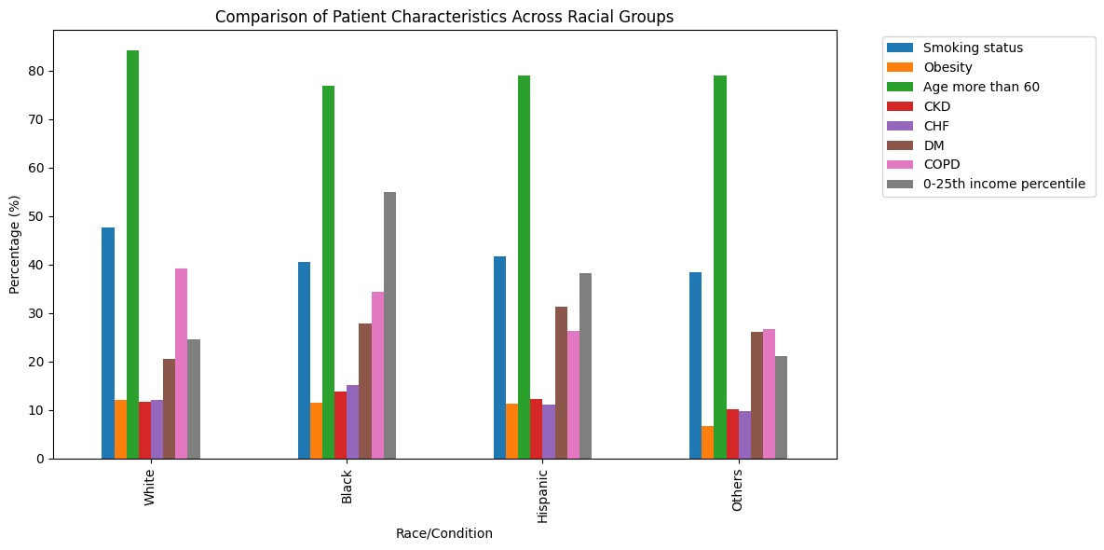

Supplementary Figure 2. Distribution of Clinical or Regional Characteristics
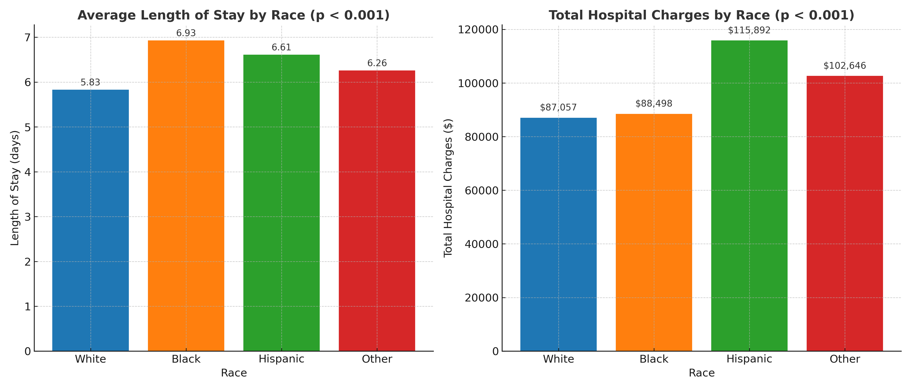

Supplementary Figure 3. Distribution of Clinical or Regional Characteristics
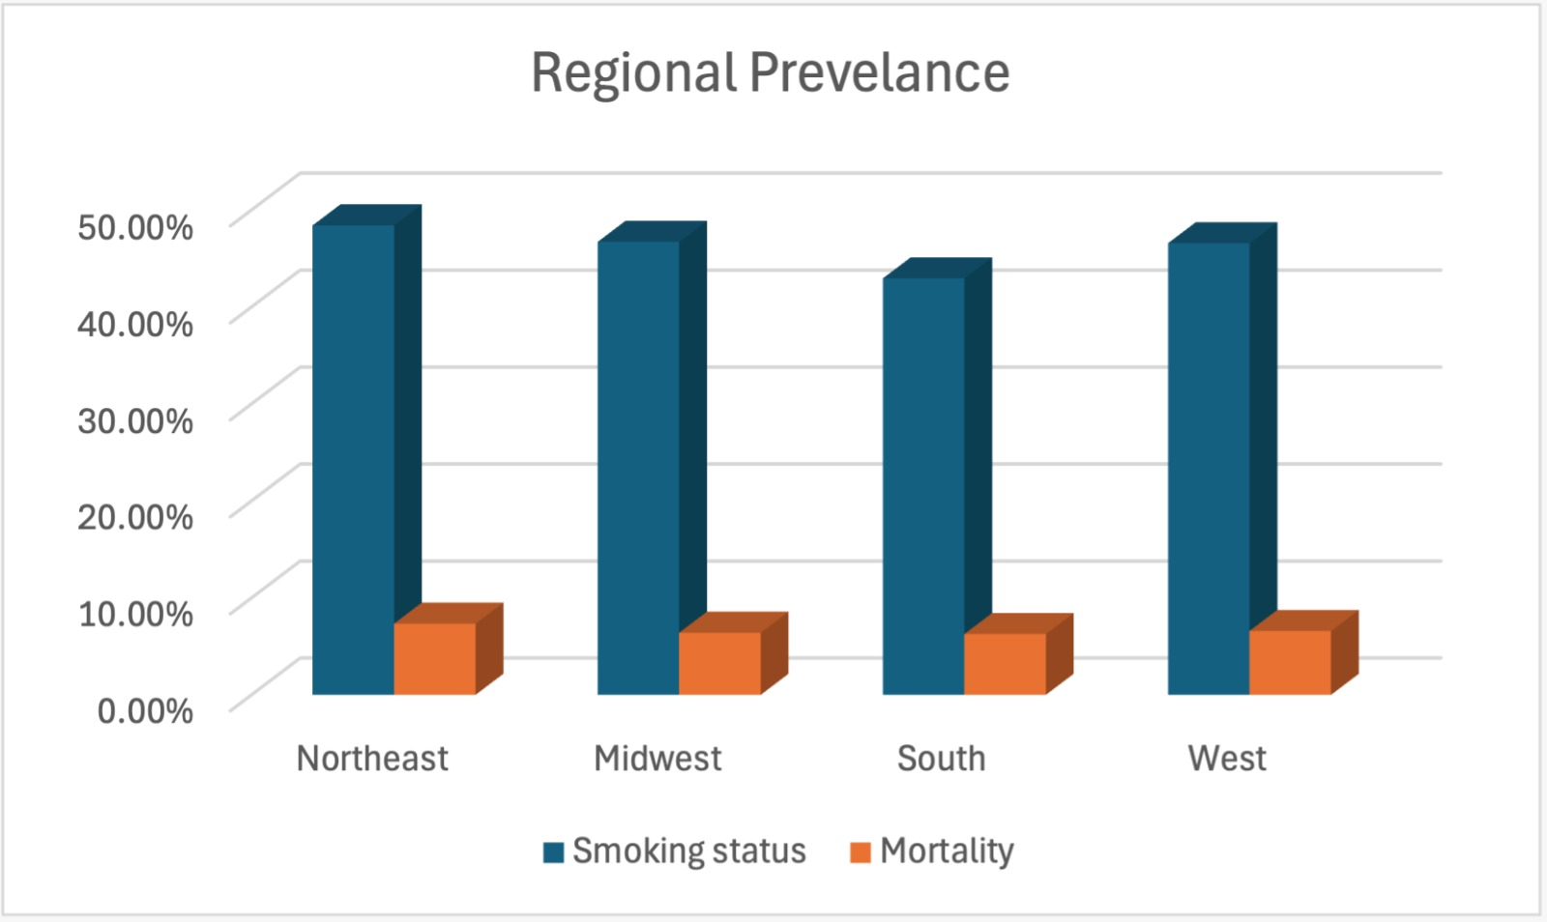

Supplementary Table 1. Regression Analysis of LOS by Race
Variable | Coefficient | Std. Error | 95% CI | P-value
Race (catgRACE) | 0.262 | 0.041 | 0.182–0.342 | <0.001
Supplementary Table 2. Multivariable Survey-Weighted Linear Regression for Length of Stay
Outcome: Length of stay (days)
Reference groups: White race, male sex, income quartile 1, hospital region 1
Variable | β (days) | 95% CI | P value
Race
Black vs White | +0.42 | 0.30–0.54 | <0.001
Hispanic vs White | +0.29 | 0.14–0.44 | <0.001
Other vs White | +0.21 | 0.08–0.34 | 0.002
Female sex | −0.37 | −0.49 to −0.25 | <0.001
COPD | +0.71 | 0.58–0.84 | <0.001
Congestive heart failure | +1.55 | 1.33–1.76 | <0.001
Diabetes mellitus | −0.03 | −0.17 to 0.11 | 0.651
Chronic kidney disease | +0.42 | 0.24–0.61 | <0.001
Smoking | −0.89 | −1.01 to −0.78 | <0.001
Age >60 years | −0.20 | −0.37 to −0.04 | 0.017
Obesity | +0.16 | −0.02 to 0.34 | 0.088
Income quartile 2 vs 1 | −0.36 | −0.53 to −0.20 | <0.001
Income quartile 3 vs 1 | −0.58 | −0.75 to −0.41 | <0.001
Income quartile 4 vs 1 | −0.62 | −0.82 to −0.43 | <0.001
Region 2 vs 1 | −0.30 | −0.60 to −0.01 | 0.043
Region 3 vs 1 | −0.07 | −0.36 to 0.21 | 0.616
Region 4 vs 1 | −0.40 | −0.72 to −0.07 | 0.016

Supplementary Table 3. Multivariable Survey-Weighted Linear Regression for Total Hospital Charges
Outcome: Total hospital charges (USD)
Reference groups: White race, male sex, income quartile 1, hospital region 1
Variable | β ($) | 95% CI | P value
Race
Black vs White | +3,920 | 2,100–5,740 | <0.001
Hispanic vs White | +12,860 | 9,320–16,400 | <0.001
Other vs White | +7,430 | 4,110–10,750 | <0.001
Female sex | −6,125 | −7,920 to −4,329 | <0.001
COPD | +7,688 | 5,542–9,834 | <0.001
Congestive heart failure | +7,259 | 3,949–10,569 | <0.001
Diabetes mellitus | −143 | −2,439 to 2,153 | 0.903
Chronic kidney disease | +1,414 | −1,609 to 4,437 | 0.359
Smoking | −7,497 | −9,426 to −5,568 | <0.001
Age >60 years | −2,678 | −5,562 to 205 | 0.069
Obesity | +13,644 | 10,703–16,586 | <0.001
Income quartile 2 vs 1 | +2,420 | −672 to 5,511 | 0.125
Income quartile 3 vs 1 | −861 | −3,814 to 2,092 | 0.568
Income quartile 4 vs 1 | +6,344 | 2,099–10,588 | 0.003
Region 2 vs 1 | −18,195 | −24,220 to −12,169 | <0.001
Region 3 vs 1 | −5,082 | −11,444 to 1,279 | 0.117
Region 4 vs 1 | +24,812 | 15,974–33,651 | <0.001

