SUPPLEMENTARY FIGURES
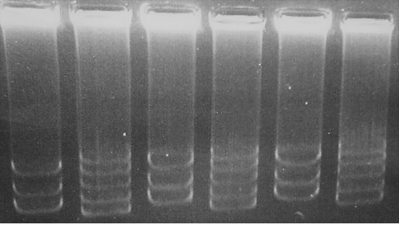
1
2
3
4
5
6

Supplementary Figure 1. Plasmid patterns in agarose gel stained with ethidium bromide obtained by the Eckhardt procedure. Lanes: 1, 3, 5 ACO34-A. Lanes 2, 4, 6 Rhizobium. etli CFN 42 as reference of profiles.

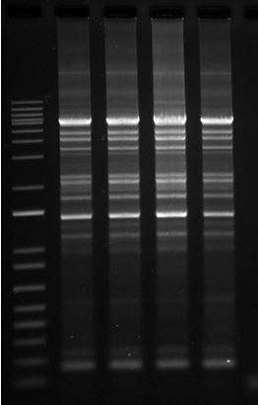
1
2
3
4
5

Supplementary Figure 2. Genomic fingerprints obtained by PCR and ERIC primers. Lanes 1) 1Kb molecular weight DNA ladder, 2) ACO-34A, 3), 4), 5) NifH mutants

