Supporting information

Performance Assessment and Challenges of Ammonia Stripping Technologies

Shaomin Guo^{1,2,*}, Francesco Tosini^{2,3} , Zifu Li¹, and Edoardo Borgomeo²

1.State Key Laboratory of Iron and Steel Industry Environmental Protection, School of Energy and Environmental Engineering, University of Science and Technology Beijing, Beijing, Beijing 100083, PR China
2. Centre for Sustainable Development, Department of Engineering, University of Cambridge, Trumpington St, Cambridge CB2 1PZ, United Kingdom of Great Britain and Northern Ireland
3. Department of Civil Engineering and Architecture (DICAr), University of Pavia, Pavia, 27100, Italy

* Corresponding author
Shaomin Guo
School of Energy and Environmental Engineering, University of Science and Technology Beijing, Beijing 100083, PR China 11.
E-mail: 18810983123@163.com
- Method
Identification of studies via databases and registers

Records removed before screening:
Duplicate records removed (n = 967)
Records removed for other reasons (n = 512)
Records identified from*:
Databases (n = 2217)

Identification

Records excluded**
(n = 221)
Records screened
(n = 738)

Reports not retrieved
(n = 4)
Reports sought for retrieval
(n = 517)
Screening

Reports excluded:
Not ammonia stripping (n=16)
Not for ammonia removal or recovery (n = 2)
Not in English (n = 12)
etc.
Reports assessed for eligibility
(n = 513)

Studies included in review
(n = 483)
Studies with energy consumption/economic data
(n = 131)
Included

Figure S 1 PRISMA flow diagram

- Traditional air stripping
Traditional air stripping is one of the most widely used and well-established technologies for ammonia removal in wastewater treatment, functioning either as a pre-treatment step or as a main treatment unit. In laboratory settings, air stripping is typically performed under batch conditions, where wastewater is placed in a beaker or tank and air is bubbled through it to transfer ammonia to an acid absorption vessel ¹, as illustrated in Figure 2 (A) (a). At pilot and industrial scales, the process generally employs a stripping tower (or column). Wastewater is pumped to the top of the tower and flows downward by gravity, enabling gas–liquid counter-current contact with air introduced from the bottom. During this process, ammonia (NH₃) is transferred from the liquid to the gas phase, as shown in Figure 2 (A) (b). The resulting gas stream is directed into a secondary tower, where ammonia is captured as ammonium salts via acid absorption, offering a sustainable fertilizer alternative to conventionally synthesized ammonia. Stripping towers are typically equipped with packing material designed to maximise the gas–liquid interfacial area, in order to increase ammonia removal efficiency. Column packings can be broadly classified into random and structured types. Random packings consist of discrete elements such as rings, saddles, or other modelled shapes, randomly distributed inside the column ². Their performance depends on characteristics such as element geometry, surface area, void fraction, and wetting behaviour, which collectively determine the effective interfacial area, pressure drop, hydraulic capacity, and overall stripping efficiency ³. By contrast, structured packings are composed of corrugated metal or plastic sheets or wire meshes assembled into ordered modules and stacked inside the column. Their regular geometry promotes uniform gas–liquid distribution and provides high specific surface area, large interfacial area, and enhanced mass-transfer efficiency. Structured packings typically result in significantly lower pressure drops and higher capacities than random packings, making them advantageous in applications requiring high energy efficiency, low hydraulic resistance, and a compact equipment footprint ⁴. However, the common packing depth of 6.1–7.6 m poses challenges for existing treatment plants in which expansion is constrained by limited space. Controlling both pH and temperature is essential for optimising ammonia stripping, as the equilibrium between ammonium (NH₄⁺) and free ammonia (NH₃) is strongly governed by these variables. Achieving the alkaline conditions required to shift the equilibrium toward gaseous NH₃ (typically pH > 9–10) generally requires chemical dosing with NaOH, Mg(OH)₂, or Ca(OH)₂. Temperature enhancement can be achieved by heating the influent liquid, the reactor vessel, or the stripping air, as illustrated in Figure 2. In addition, gas and liquid flow rates are key operational parameters influencing mass-transfer efficiency, although they also contribute to higher operating costs ⁵.

- Vacuum stripping
Vacuum stripping is a separation process driven by the force generated by vacuum pressure, which allows for the continuous extraction of volatile compounds such as ammonia ^{2,3}. In a typical setup, the pressure is held at a low vacuum of around 21–27 kPa, which lowers water’s boiling point to about 50–80 °C. Under these conditions, the wastewater is kept at its boiling point so that dissolved ammonium ions (NH₄⁺) convert readily into free ammonia (NH₃). As steam bubbles form and rise, they dramatically increase the interfacial area and enhance mass transfer, efficiently stripping NH₃ from the liquid. The ammonia-laden vapor is then pulled by the vacuum pump into an absorption vessel containing sulfuric acid, where it reacts to produce ammonium sulfate crystals (Figure 2 (B)-(a)). Alternatively, the vapor can be sent to a condenser to yield a concentrated ammonia-nitrogen liquid (Figure 2 (B)-(b)). By combining reduced boiling temperatures with continuous boiling under vacuum, this process achieves high removal efficiency with lower thermal energy demand.

An America patent ⁶ mentioned the concept of vacuum stripping and acid absorption to recover ammonia in 1974. However, the result of our literature review shows that by the end of the 20th century, the vacuum technology was only used for evaporation treatment for landfill leachate ⁷. With the advent of the 21st century, an upward trend in the application of vacuum stripping for ammonia recovery from wastewater can be seen, such as digestate liquid treatment ^{8–10}, human urine treatment ¹¹ , animal manure treatment ¹² and aquaculture waters treatment ¹³. The umber of publications using vacuum ammonia stripping is relatively low, and most of them appeared in the last 5 years.

Researchers believe vacuum stripping is a promising alternative to the traditional physio-chemical ammonia stripping method, offering advantages over the conventional stripping process ¹⁸. Firstly, lower energy consumption and higher removal efficiency can be achieved by controlling system temperature and pressure ¹⁶. The vacuum created by the vacuum pump enhances the volumetric mass transfer coefficient and maintains the driving force for ammonia mass transfer across the gas-liquid interface¹⁹. Low-temperature thermal and mild-alkaline requirements result from the boiling-point reduction caused by vacuum pressure²⁰. Moreover, the vacuum stripping process requires no additional stripping gas ^{10,18}, avoiding the air pump energy demand and air pollution that may occur in the traditional air stripping process²¹. Additionally, vacuum stripping can recover ammonia from solid-liquid digestate mixtures with high-solids percentage, while the other pilot-test ammonia stripping technologies require reduction of suspended solids in wastewater^{9,19,22}. Internally formed stripping bubbles remove the need for porous media, trays, or plates, while still achieving effective ammonia removal from wastewater with both low and high solids content¹⁹.

However, vacuum stripping becomes less effective when the depth of wastewater to be treated is too deep ²³. According to several studies, within a certain depth range, stable, large steam bubbles which are needed to carry ammonia out can form and escape from the stripper ²⁴. Vapor bubbles only appear once local vapor pressure exceeds the surrounding liquid pressure. Although NH₃ has a higher vapor pressure than water, it is transported mainly by mass transfer into water-vapor bubbles rather than by forming pure ammonia bubbles, because its concentration in boiler feed is relatively low ¹⁹. In deeper sections, higher hydrostatic pressure and the action of hydrophilic fibers break rising bubbles into smaller ones, limiting ammonia transfer ²⁵. To address this, some researchers have proposed a multi-pool boiling design in a single vacuum stripper: stacking several shallow pools in series lets each pool run at the ideal depth while sharing the same absorption column and vacuum pump ¹⁹. The trade-off is a larger footprint and slightly higher vacuum and heating requirement.
- Membrane Ammonia Stripping
- Overview
Membrane contactors (MC) stripping generally employ hydrophobic gas-permeable membranes (GPM) as a barrier between two phases, allowing only gases to transfer across the membrane while preventing the passage of aqueous solutions ³². In this way, pollutants are separated from wastewater in the gaseous state ³³. This approach is particularly suitable for removing highly volatile contaminants such as ammonia. For ammonia recovery, membrane contactors typically consist of a feed side and a permeate side, with the latter usually containing a strong acid. Through transmembrane chemical absorption (TMCA) processes, the unique properties of GPM enable the selective recovery of ammonia by absorbing it into the trapping solution flowing on the permeate side ³⁴. To enhance mass transfer efficiency, reduce processing costs, and improve environmental sustainability, researchers continue to optimize the structure and operating conditions of MC stripping. For instance, membrane distillation (MD) is a technology that is always discussed alongside MC. Beyond relying on partial pressure gradients as the driving force, the MD process further enhances ammonia mass transfer efficiency by leveraging vapor pressure gradients ³⁵. This is achieved through methods such as heating the feed side (direct contact membrane distillation, DCMD) ³⁶, employing vacuum pressure (vacuum membrane distillation, VMD) ³⁷, air sweeping (sweep gas membrane distillation, SGMD) ³⁸, air gap (air gap membrane distillation, AGMD) or condensation techniques ³⁹ on the opposite side to remove ammonia continuously. Driven by the partial pressure gradient, the vapor pressure gradient, and the chemical reactions, ammonia continuously transfers from the feed side to the permeate side, where it reacts to form NH₄⁺ - salt ⁴⁰. Generally, the NH3 transfer from aqueous solutions across a hydrophobic membrane is assumed to occur in 5 stages: : (1) transfer from the bulk feed to the feed-side boundary layer, (2) diffusion through this boundary layer to the feed-side liquid-gas interface, (3) gas-phase diffusion across the gas permeate membrane to the stripping side, (4) diffusion through the absorbent-side boundary layer, and (5) absorption into the receiving absorbent; in membrane distillation, steps (4) and (5) can be treated as a single step representing direct diffusion of NH₃ into the permeate due to the absence of a reactive absorbent as shown Figure 2 (C).
- Membrane materials
The membrane material decided the using lifetime and performance of the MC. As the first generation of commercialized hydrophobic membrane materials, polypropylene (PP) and polyethylene (PE) are inexpensive, easy to fabricate into hollow fibers, and allow for high packing density. However, their chemical resistance and thermal stability are relatively limited, and they are prone to fouling and pore wetting. Several studies have demonstrated that polytetrafluoroethylene (PTFE) membranes generally perform more robustly than PP membranes. In both hollow fiber membrane contactor (HFMC) and direct contact membrane distillation (DCMD) configurations, PTFE shows superior resistance to fouling when treating complex wastewaters such as oily effluents, coking wastewater, and digestates, and is therefore considered more “robust” ^{41,42}. Polyvinylidene fluoride (PVDF) represents another widely applied hydrophobic membrane material with superior processability. Its performance can be significantly enhanced by modification; for instance, Nafion-isomer coated PVDF membranes supported with multi-walled carbon nanotubes exhibit several-fold improvements in NH₃ flux and removal efficiency compared to conventional PVDF, while also enhancing antifouling properties⁴³. In addition, UV-treated polyethersulfone (PES) membranes have been reported to achieve improved durability and enhanced ammonia removal performance ⁴⁴.

- Electrochemical Ammonia Stripping (EAS)
Electrochemical Ammonia Stripping (EAS) is a technology that integrates an external electric field with ion-exchange membranes to achieve ammonia recovery. In a conventional EAS configuration, the anode chamber typically serves as the feed compartment for wastewater. Driven by the electric field, NH₄⁺ migrates from the anode chamber through a Cation Exchange Membrane (CEM) into the cathode chamber to maintain electro-neutrality, balancing the electron transfer occurring across the external circuit⁵⁴. The CEM only allow the transport of cations like NH₄⁺, while blocking the passage of anions. Concurrently, electrochemical reactions such as the Hydrogen Evolution Reaction (HER) or Oxygen Reduction Reaction (ORR) occur at the cathode, generating hydroxide ions (OH⁻). This in situ electro-generation of base elevates the pH within the catholyte, enhancing the NH₄⁺ transported into volatile free ammonia which can be recovered by coupling with other stripping methods ^{55,56}.

The CEM can also be replaced with an anion exchange membrane (AEM) in conjunction with a cathode-feed operation to utilize anode products to achieve higher purity ammonia nitrogen recovery. Usually, this kind of electrochemical configuration is separated by IEM as 2 compartments，which is named as 2-chambered electrochemical cell based on IEM(EC-IEM) in this study. Incorporating microorganisms enables bio-electrochemical systems (BESs) such as MECs (requiring an applied voltage)⁵⁷ and MFCs (power-generating)⁵⁸. In both cases, microbial anodic oxidation provides electrons for cathodic reactions, which can increase local cathodic pH and shift NH₄⁺ to NH₃​, facilitating subsequent ammonia capture. Positioning an AEM before the CEM effectively prevents NH₄⁺ from reaching the anode and being oxidized into N₂, thereby ensuring high ammonia recovery efficiency. Concurrently, this configuration promotes the migration of anions (e.g., SO₄²⁻，Cl⁻ or NO₃⁻) toward the anode chamber to facilitate authigenic acid production, which can be utilized for ammonia absorption⁵⁴. This arrangement constitutes the fundamental structural unit of electrodialysis (ED). Furthermore, stacks containing multiple pairs of AEMs and CEMs are employed in ED configurations to scale up ammonia enrichment and enhance wastewater treatment capacity. The emergence of bipolar membranes (BPMs) offers an alternative to the AEM/CEM combination, forming BPM-ED systems which utilize authigenic acids and bases to minimize external chemical consumption and improve ammonia enrichment efficiency^{59,60}. In this study, systems comprising single or multiple pairs of AEM and CEM, as well as those incorporating BPMs, are collectively referred to as ED. The fundamental principles of SEC-IEM, MECs, and multiple types of ED are illustrated in Figure 2 (D).

Different types of stripping reactors can be coupled with electrochemical cells to treat ammonia-rich cathode compartment effluent, either in an integrated or separated way ⁶¹ ^{54,62}. Connecting to a stripping column or tank paired with an acid trap to recover ammonium salts is the simplest configuration ^{63–65}, and air sweeping ⁶⁶ and direct condensation ⁶⁷ also can be employed to recover pure ammonia products occasionally. As shown in Figure S 2, the most prevalent method is electrochemical cells followed by gas-permeable membrane contactor ⁶⁸, which is descripted as MAS method in section 2.4. The synergy between electrochemical transmembrane migration and transmembrane chemical absorption via hydrophobic membranes maximizes the advantages of membrane-based ammonia recovery.

To further enhance the performance of EAS, researchers have optimized both the electrochemical and ammonia capture subsystems. For instance, strategies such as connecting multiple electrochemical cells in series to scale up the treatment capacity⁶⁹, using Donnan dialysis to reduce the energy consumption⁷⁰, employing novel electrode such as flow-electrode capacitive deionization (FCDI)⁷¹ or other microbial- or catalysts- modified electrode⁵⁷ to improve the cost-effectiveness, diversifying power sources⁶⁸ to enhance the energy and chemical efficiency, and integrating electrically conducting membranes^{72,73} or gas diffusion electrode⁷⁴ into the EAS process have been explored to achieve excellent ammonia capture performance.
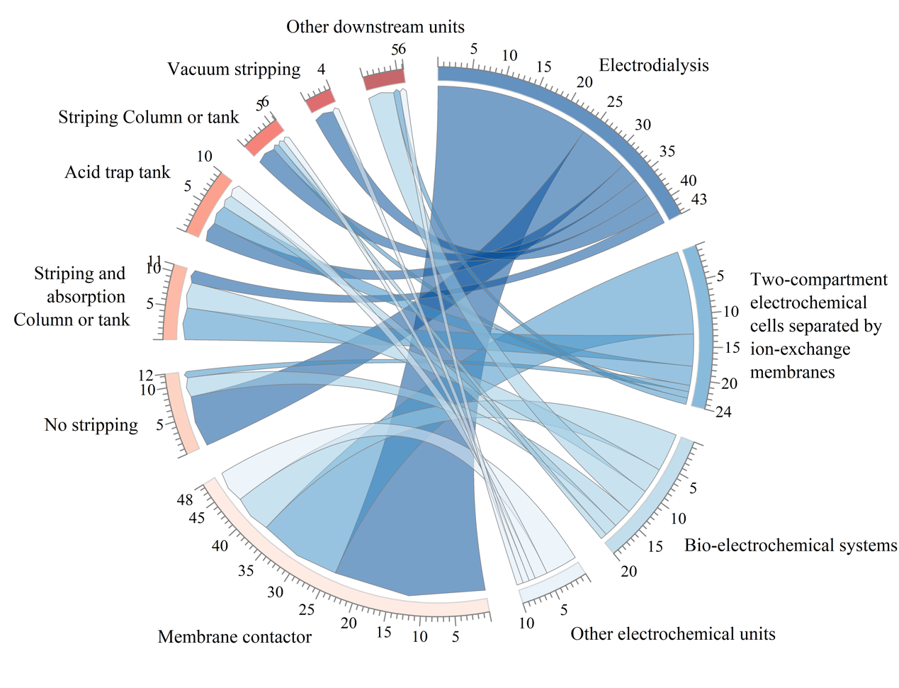
Figure S 2 Coupling map electrochemical unit and subsequent stripping unit. Chords show reported pairings between electrochemical cells units (blue) and subsequent stripping unit (red); chord width scales with the number of studies. Sector arc length and ticks indicate category totals.

Table S 1 The median SEC of different ECs types
ECs type | Removal-based SEC | Removal-based SEC
EC-IEM | 13.6 kWh/kg N | 19.3 kWh/kg N
BESs | 2.6 kWh/kg N | 2.5 kWh/kg N
ED | 6.8 kWh/kg N | 21.0 kWh/kg N
Other | 4.5 kWh/kg N | 20.45 kWh/kg N

Table S 2 Key parameters for specific energy consumption of electrochemical ammonia stripping
Key parameters for SEC | SEC | Ammonia removal performance
Electrode distance | Positive | Negative
Conductivity of electrolyte | Negative | Positive
Current density | Positive | Positive
NH3 separation rate | Negative | Positive
TAN in feed wastewater | Negative | Positive
- Novel stripping technology
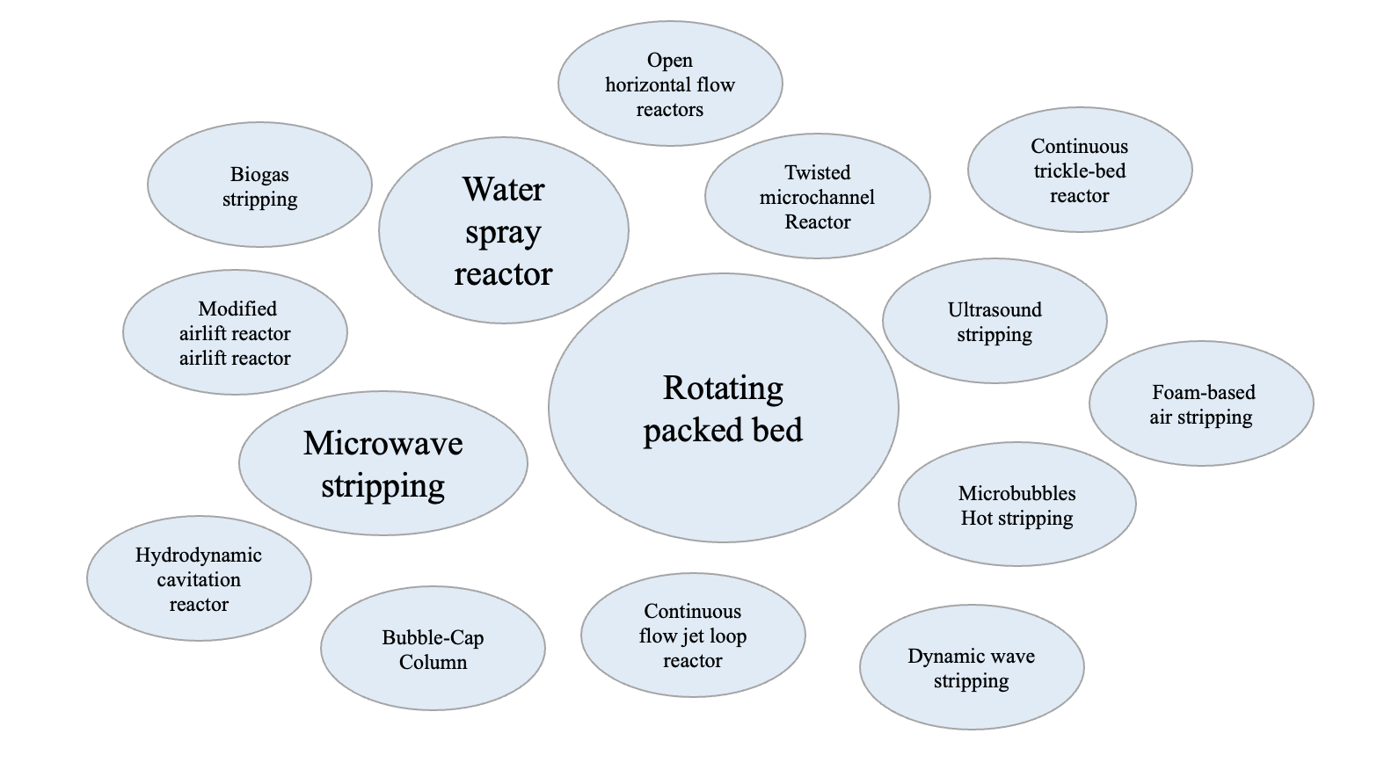
Figure S 3 Bubble chart of novel ammonia stripping technologies by literature frequency. Each bubble represents a technology, and bubble area is proportional to its occurrence frequency in the included studies (number of publications).

Reference
1. Finzi, A., Ferrari, O., Riva, E. & Provolo, G. Nitrogen recovery from intensive livestock farms using a simplified ammonia stripping process. Front. Sustain. Food Syst. 8, (2024).
2. Saracco, G. & Genon, G. High temperature ammonia stripping and recovery from process liquid wastes. J. Hazard. Mater. 37, 191–206 (1994).
3. Flagiello, D., Parisi, A., Lancia, A. & Di Natale, F. A Review on Gas-Liquid Mass Transfer Coefficients in Packed-Bed Columns. ChemEngineering 5, 43 (2021).
4. Flagiello, D., Parisi, A., Lancia, A. & Di Natale, F. A Review on Gas-Liquid Mass Transfer Coefficients in Packed-Bed Columns. ChemEngineering 5, 43 (2021).
5. Kasiński, S., Kowal, P. & Czerwionka, K. Advanced Technologies for Nitrogen Removal and Recovery from Municipal and Industrial Wastewater. Materials 18, 1422 (2025).
6. Blaine, L. I. & Corporation, E. Vacuum stripping of ammonia. (1974).
7. Marks, A. L., Luthy, R. G. & Diwekar, U. M. Semi‐continuous evaporation model for leachate treatment process evaluation. Environ. Prog. 13, 278–289 (1994).
8. Chiumenti, A., da Borso, F., Chiumenti, R., Teri, F. & Segantin, P. Treatment of digestate from a co-digestion biogas plant by means of vacuum evaporation: Tests for process optimization and environmental sustainability. Waste Manag. 33, 1339–1344 (2013).
9. Ukwuani, A. T. & Tao, W. Developing a vacuum thermal stripping – acid absorption process for ammonia recovery from anaerobic digester effluent. Water Res. 106, 108–115 (2016).
10. Chen, Q. et al. Vacuum ammonia stripping from liquid digestate: Effects of pH, alkalinity, temperature, negative pressure and process optimization. J. Environ. Sci. China 149, 638–650 (2025).
11. Tian, X. et al. Efficient nutrient recovery/removal from real source-separated urine by coupling vacuum thermal stripping with activated sludge processes. J. Clean. Prod. 220, 965–973 (2019).
12. Zhang, R. et al. Intermittent-vacuum assisted thermophilic co-digestion of corn stover and liquid swine manure: Salinity inhibition. Bioresour. Technol. 271, 16–23 (2019).
13. Singer, A., Parnes, S., Gross, A., Sagi, A. & Brenner, A. 新增-A novel approach to denitrification processes in a zero-discharge recirculating system for small-scale urban aquaculture. Aquac. Eng. 39, 72–77 (2008).
14. Lee, Y.-J. et al. Prediction and optimization of the efficiency and energy consumption of an ammonia vacuum thermal stripping process using experiments and machine learning models. Environ. Technol. Innov. 34, (2024).
15. Davey, C. J., Luqmani, B., Thomas, N. & McAdam, E. J. Transforming wastewater ammonia to carbon free energy: Integrating fuel cell technology with ammonia stripping for direct power production. Sep. Purif. Technol. 289, (2022).
16. Luqmani, B. et al. Transitioning through the vapour-liquid equilibrium for low energy thermal stripping of ammonia from wastewater: Enabling transformation of NH3 into a zero-carbon fuel. Water Res. 248, 120856 (2024).
17. Brienza, C. et al. Techno-economic assessment at full scale of a biogas refinery plant receiving nitrogen rich feedstock and producing renewable energy and biobased fertilisers. J. Clean. Prod. 308, (2021).
18. Sengur, O., Akgul, D., Bayrakdar, A. & Calli, B. Enhancing biogas production from chicken manure through vacuum stripping of digestate. Biomass Convers. Biorefinery https://doi.org/10.1007/s13399-023-04975-3 (2023) doi:10.1007/s13399-023-04975-3.
19. Tao, W., Badsha, M. A. H., Arachchilage, P. W. & Mostafa, A. Simultaneous ammonia recovery and treatment of sludge digestate using the vacuum stripping and absorption process: Scale-up design and pilot study. Chem. Eng. J. 480, (2024).
20. Han, Y., Agyeman, F., Green, H. & Tao, W. Stable, high-rate anaerobic digestion through vacuum stripping of digestate. Bioresour. Technol. 343, 126133 (2022).
21. Bousek, J., Scroccaro, D., Sima, J., Weissenbacher, N. & Fuchs, W. Influence of the gas composition on the efficiency of ammonia stripping of biogas digestate. Bioresour. Technol. 203, 259–266 (2016).
22. Reza, A. & Chen, L. Optimization and modeling of ammonia nitrogen removal from anaerobically digested liquid dairy manure using vacuum thermal stripping process. Sci. Total Environ. 851, (2022).
23. Cerrillo, M. et al. Low-Temperature Vacuum Evaporation of Ammonia from Pig Slurry at Laboratory and Pilot-Plant Scale. Processes 11, 2910 (2023).
24. Tao, W., Ukwuani, A. T. & Agyeman, F. Recovery of ammonia in anaerobic digestate using vacuum thermal stripping - Acid absorption process: Scale-up considerations. Water Sci. Technol. 78, 878–885 (2018).
25. Jiang, W.-T. et al. Mechanism of bubble cutting by fibers: Experiment and simulation. Chem. Eng. J. 478, 147225 (2023).
26. He, Q., Wang, W., Liu, L., Yu, G. & Yan, S. Ammonia nitrogen separation performance and kinetics from biogas slurry using vacuum distillation method. Nongye Gongcheng XuebaoTransactions Chin. Soc. Agric. Eng. 32, 191–197 (2016).
27. Zhang, R. et al. An innovative intermittent-vacuum assisted thermophilic anaerobic digestion process for effective animal manure utilization and treatment. Bioresour. Technol. 244, 1073–1080 (2017).
28. Emanuel, I. & Medy, M. Nitrogen Removal by Free Ammonia Stripping from High pH Ponds. Water Pollut. Control Fed. 9, (1981).
29. Nepfumbada, C., Tavengwa, N. T., Masindi, V., Foteinis, S. & Chatzisymeon, E. Recovery of phosphate from municipal wastewater as calcium phosphate and its subsequent application for the treatment of acid mine drainage. Resour. Conserv. Recycl. 190, (2023).
30. Ukwuani, A. T. & Tao, W. Developing a vacuum thermal stripping - acid absorption process for ammonia recovery from anaerobic digester effluent. WATER Res. 106, 108–115 (2016).
31. Anwar, S. W. & Tao, W. Cost benefit assessment of a novel thermal stripping – acid absorption process for ammonia recovery from anaerobically digested dairy manure. Water Pract. Technol. 11, 355–364 (2016).
32. Rongwong, W., Bae, T.-H. & Jiraratananon, R. Economic optimization of hollow fiber membrane contactors for ammonia nitrogen recovery from anaerobic digestion effluents. J. Environ. Chem. Eng. 10, 108631 (2022).
33. Lee, W., An, S. & Choi, Y. Ammonia harvesting via membrane gas extraction at moderately alkaline pH: A step toward net-profitable nitrogen recovery from domestic wastewater. Chem. Eng. J. 405, 126662 (2021).
34. Reyes Alva, R., Mohr, M., Tovar, G. E. M. & Zibek, S. Recovering Ammonia as Ammonium Citrate and Ammonium Sulfate from Sludge Digestion Liquors Using Membrane Contactors in a Pilot Plant. Membranes 15, (2025).
35. Zhu, Y. et al. Review of ammonia recovery and removal from wastewater using hydrophobic membrane distillation and membrane contactor. Sep. Purif. Technol. 328, 125094 (2024).
36. Ahmed, F. E., Lalia, B. S., Hashaikeh, R. & Hilal, N. Alternative heating techniques in membrane distillation: A review. Desalination 496, 114713 (2020).
37. Fang, M. et al. A novel method to recover ammonia loss in ammonia-based CO2 capture system: Ammonia regeneration by vacuum membrane distillation. Greenh. Gases Sci. Technol. 5, 487–498 (2015).
38. Jiang, H., Straub, A. P. & Karanikola, V. Ammonia Recovery with Sweeping Gas Membrane Distillation: Energy and Removal Efficiency Analysis. ACS ES T Eng. 2, 617–628 (2022).
39. Thomas, N., Mavukkandy, M. O., Loutatidou, S. & Arafat, H. A. Membrane distillation research & implementation: Lessons from the past five decades. Sep. Purif. Technol. 189, 108–127 (2017).
40. Brennan, B. et al. Pilot Scale Study: First Demonstration of Hydrophobic Membranes for the Removal of Ammonia Molecules from Rendering Condensate Wastewater. Int. J. Mol. Sci. 21, 3914 (2020).
41. Brennan, B. et al. Pilot scale study: First demonstration of hydrophobic membranes for the removal of ammonia molecules from rendering condensate wastewater. Int. J. Mol. Sci. 21, 1–20 (2020).
42. Lin, P.-H., Horng, R.-Y., Hsu, S.-F., Chen, S.-S. & Ho, C.-H. A Feasibility Study of Ammonia Recovery from Coking Wastewater by Coupled Operation of a Membrane Contactor and Membrane Distillation. Int. J. Environ. Res. Public. Health 15, 441 (2018).
43. Guo, J. et al. Enhanced ammonia recovery from wastewater by Nafion membrane with highly porous honeycomb nanostructure and its mechanism in membrane distillation. J. Membr. Sci. 590, 117265 (2019).
44. Ratman, I., Kusworo, T. D., Utomo, D. P., Azizah, D. A. & Ayodyasena, W. A. Petroleum Refinery Wastewater Treatment using Three Steps Modified Nanohybrid Membrane Coupled with Ozonation as Integrated Pre-treatment. J. Environ. Chem. Eng. 8, 103978 (2020).
45. van Linden, N., Spanjers, H. & van Lier, J. B. Fuelling a solid oxide fuel cell with ammonia recovered from water by vacuum membrane stripping. Chem. Eng. J. 428, (2022).
46. Pradhan, S., Mikola, A., Heinonen-Tanski, H. & Vahala, R. Recovery of nitrogen and phosphorus from human urine using membrane and precipitation process. J. Environ. Manage. 247, 596–602 (2019).
47. Zhang, J. et al. Ammonia capture from human urine to harvest liquid N-P compound fertilizer by a submerged hollow fiber membrane contactor: Performance and fertilizer analysis. Sci. Total Environ. 768, (2021).
48. Chen, B. et al. Anaerobic digestion of chicken manure coupled with ammonia recovery by vacuum-assisted gas-permeable membrane process. Biochem. Eng. J. 175, 108135 (2021).
49. Noriega-Hevia, G., Serralta, J., Seco, A. & Ferrer, J. Economic analysis of the scale-up and implantation of a hollow fibre membrane contactor plant for nitrogen recovery in a full-scale wastewater treatment plant. Sep. Purif. Technol. 275, 119128 (2021).
50. Reyes Alva, R., Mohr, M. & Zibek, S. Transmembrane Chemical Absorption Process for Recovering Ammonia as an Organic Fertilizer Using Citric Acid as the Trapping Solution. Membranes 14, (2024).
51. Rodriguez-Alegre, R. et al. Pilot scale on-site demonstration and seasonality assessment of nitrogen recovery and water reclamation from pig’s slurry liquid fraction. J. Environ. Manage. 370, 122597 (2024).
52. Im, S., Lee, H., Kim, T., Jeon, H. & Jang, A. Application of non-acid stripping solution in hydrophobic membrane process for high-purity ammonia recovery from high-strength ammonium wastewater. Sep. Purif. Technol. 357, (2025).
53. Kim, T., Nguyen, D. A. & Jang, A. Ultrahigh-purity ammonia recovery from synthetic coke wastewater via membrane contactor: Overcoming phenolic interference and assessing cost efficiency. Environ. Res. 263, (2024).
54. Aung, S. L., Choi, J., Cha, H., Woo, G. & Song, K. G. Ammonia-selective recovery from anaerobic digestate using electrochemical ammonia stripping combined with electrodialysis. Chem. Eng. J. 479, 147949 (2024).
55. Rodrigues, M. et al. Characterization of the organic micropollutants behavior during electrochemical ammonia recovery. J. Environ. Chem. Eng. 11, (2023).
56. Xie, A. & Popat, S. C. Electrochemical ammonia stripping from non-nitrified animal rendering wastewater. Chem. Eng. J. Adv. 3, (2020).
57. Hou, D. et al. Nickel-Based Membrane Electrodes Enable High-Rate Electrochemical Ammonia Recovery. Environ. Sci. Technol. 52, 8930–8938 (2018).
58. Qin, M., White, C., Zou, S. & He, Z. Passive separation of recovered ammonia from catholyte for reduced energy consumption in microbial electrolysis cells. Chem. Eng. J. 334, 2303–2307 (2018).
59. Chen, W., Grimberg, S., Rogers, S. & Kim, T. Bipolar membrane electrodialysis for nutrient recovery from anaerobic digestion dewatering sidestream. Chem. Eng. J. 488, 150834 (2024).
60. Li, Y. et al. Bipolar Membrane Electrodialysis for Ammonia Recovery from Synthetic Urine: Experiments, Modeling, and Performance Analysis. Environ. Sci. Technol. 55, 14886–14896 (2021).
61. Xu, L. et al. A novel electrocoagulation-membrane stripping hybrid system for simultaneous ammonia recovery and contaminant removal. Sep. Purif. Technol. 296, (2022).
62. Chen, W., Grimberg, S., Rogers, S. & Kim, T. Ammonia Recovery from Domestic Wastewater Using a Proton-Mediated Redox Couple. ACS Sustain. Chem. Eng. 9, 12699–12707 (2021).
63. Desloover, J., Abate Woldeyohannis, A., Verstraete, W., Boon, N. & Rabaey, K. Electrochemical resource recovery from digestate to prevent ammonia toxicity during anaerobic digestion. Environ. Sci. Technol. 46, 12209–12216 (2012).
64. Perera, M. K. & Englehardt, J. D. Simultaneous nitrogen and phosphorus recovery from municipal wastewater by electrochemical pH modulation. Sep. Purif. Technol. 250, (2020).
65. Wu, X. & Modin, O. Ammonium recovery from reject water combined with hydrogen production in a bioelectrochemical reactor. Bioresour. Technol. 146, 530–536 (2013).
66. Losantos, D. et al. Development and optimization of a bioelectrochemical system for ammonium recovery from wastewater as fertilizer. Clean. Eng. Technol. 4, (2021).
67. Luther, A. K., Desloover, J., Fennell, D. E. & Rabaey, K. Electrochemically driven extraction and recovery of ammonia from human urine. Water Res. 87, 367–377 (2015).
68. Coombs, O., Joo, T., Botelho, A. J., Chalise, D. & Tarpeh, W. Prototyping and modelling a photovoltaic-thermal electrochemical stripping system for distributed urine nitrogen recovery. Nat. WATER 3, (2025).
69. Choi, S. et al. Ammonia concentration and recovery in an up-scaled electrochemical cell through screening of cation exchange membrane. Front. Water 6, 1367315 (2024).
70. Rodrigues, M. et al. Donnan Dialysis for scaling mitigation during electrochemical ammonium recovery from complex wastewater. Water Res. 201, 117260 (2021).
71. Zhang, C., Ma, J., Song, J., He, C. & Waite, T. D. Continuous Ammonia Recovery from Wastewaters Using an Integrated Capacitive Flow Electrode Membrane Stripping System. Environ. Sci. Technol. 52, 14275–14285 (2018).
72. Iddya, A. et al. Efficient ammonia recovery from wastewater using electrically conducting gas stripping membranes. Environ. Sci. Nano 7, 1759–1771 (2020).
73. Wang, X. et al. Simple and Low-Cost Electroactive Membranes for Ammonia Recovery. Environ. Sci. Technol. 57, 9405–9415 (2023).
74. Lee, G., Kim, D. & Han, J.-I. Gas-diffusion-electrode based direct electro-stripping system for gaseous ammonia recovery from livestock wastewater. Water Res. 196, (2021).
75. Zico, M., Ricci, B., Reis, B., Magalhaes, N. & Amaral, M. Sustainable ammonia resource recovery from landfill leachate by solar-driven modified direct contact membrane distillation. Sep. Purif. Technol. 264, (2021).

