Target X built on Groovy: An unbiased and robust ligandability prediction model built and evaluated on non-redundant, well-curated dataset.

Authors: Neha Vithani^{1#}, David Wych¹, She Zhang¹, Phu Tang¹, Alex Demidov¹, A. Geoffrey Skillman¹, David N. LeBard^{1#}

OpenEye, Cadence Molecular Sciences, Santa Fe, New Mexico 87508, United States
# corresponding authors: vithanin@cadence.com, david.lebard@eyesopen.com

Figure S1
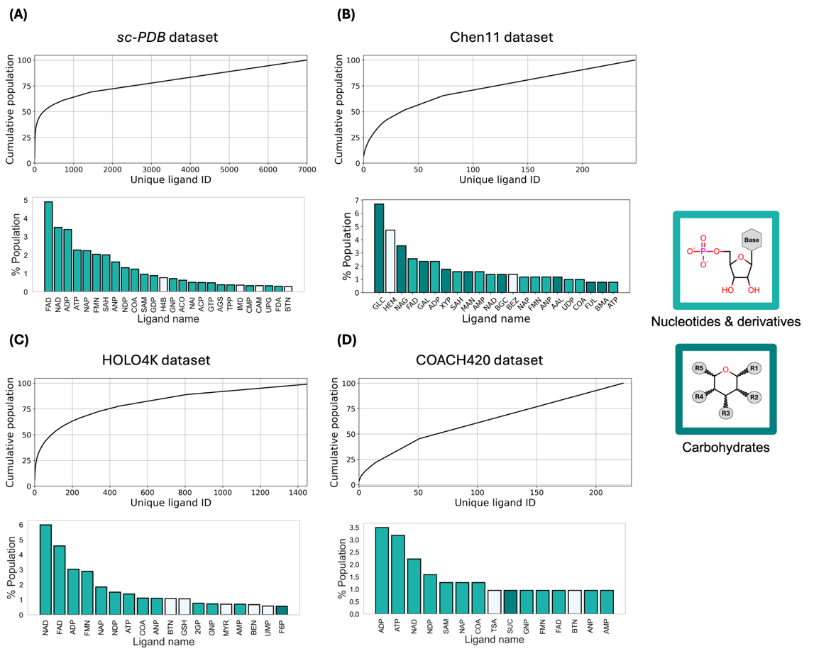
Figure 2. Distribution of ligands observed in protein-ligand datasets, sc-PDB, Chen11, HOLO4K, and COACH420. The cumulative population of pockets bound to unique ligand types is plotted in the top panels of (A) for sc-PDB, (B) for Chen11 dataset, (C) for HOLO4K, and (D) for COACH420 dataset. The lower panel in each sub-figure (A-D) shows most frequently observed ligands at the binding sites in these datasets. Population value bars for nucleotide and nucleotide derivatives are colored light turquoise, while those for the carbohydrates are colored dark teal. Population of ligands that do not fall under either of these categories are shown by white color-filled bar. The side panel shows schematic of the carbohydrate and nucleotide ligands with the color-coded borders. The x-tick labels are ligand codes. See table S1 for the full names of these ligands and their types.

Table S1. Details of the ligands that are frequently found in protein-ligand datasets, sc-PDB, Chen11, HOLO4K and COACH420.
Ligand code | Ligand name | Ligand type | Dataset(s) in which they are among the most frequently occurring ligands
FAD | Flavin-adenine dinucleotide | Nucleotide | sc-PDB  Chen11  HOLO4K  COACH420
NAD | Nicotinamide-adenine-dinucleotide | Nucleotide | sc-PDB  Chen11  HOLO4K  COACH420
ADP | Adenosine-5'-diphosphate | Nucleotide | sc-PDB  Chen11  HOLO4K  COACH420
ATP | Adenosine-5'-triphosphate | Nucleotide | sc-PDB  Chen11  HOLO4K  COACH420
NAP | NADP nicotinamide-adenine-dinucleotide phosphate | Nucleotide | sc-PDB  Chen11  HOLO4K  COACH420
FMN | Flavin mononucleotide | Nucleotide | sc-PDB  Chen11  HOLO4K  COACH420
SAH | S-adenosyl-l-homocysteine | Nucleotide | sc-PDB  Chen11
ANP | Phosphoaminophosphonic acid-adenylate ester | Nucleotide | sc-PDB  Chen11  HOLO4K  COACH420
NDP | NADPH dihydro-nicotinamide-adenine-dinucleotide phosphate | Nucleotide | sc-PDB  HOLO4K  COACH420
COA | Coenzyme A | Nucleotide | sc-PDB  Chen11  HOLO4K  COACH420
SAM | S-adenosylmethionine | Nucleotide | sc-PDB  COACH420
GDP | Guanosine-5'-diphosphate | Nucleotide | sc-PDB
H4B | 5,6,7,8-tetrahydrobiopterin | Other | sc-PDB
GNP | Phosphoaminophosphonic acid-guanylate ester | Nucleotide | sc-PDB  HOLO4K  COACH420
ACO | Acetyl coenzyme A | Nucleotide | sc-PDB
NAI | 1,4-dihydronicotinamide adenine dinucleotide | Nucleotide | sc-PDB
ACP | Phosphomethylphosphonic acid adenylate ester | Nucleotide | sc-PDB
GTP | Guanosine-5'-triphosphate | Nucleotide | sc-PDB
AGS | Phosphothiophosphoric acid-adenylate ester | Nucleotide | sc-PDB
TPP | Thiamine diphosphate | Nucleotide | sc-PDB
IMD | Imidazole | Other | sc-PDB
CMP | Adenosine-3',5'-cyclic-monophosphate | Nucleotide | sc-PDB
CAM | Camphor | Other | sc-PDB
UPG | Uridine-5'-diphosphate-glucose | Nucleotide | sc-PDB
FDA | Dihydroflavine-adenine dinucleotide | Nucleotide | sc-PDB
BTN | Biotin | Other | sc-PDB  Chen11  HOLO4K  COACH420
GLC | Alpha-D-glucose | Carbohydrate | Chen11
HEM | Protoporphyrin IX containing Fe (Heme) | Other | Chen11
NAG | 2-acetamido-2-deoxy-beta-D-glucopyranose | Carbohydrate | Chen11
GAL | Beta-D-galactose | Carbohydrate | Chen11
XYP | Beta-D-xylose | Carbohydrate | Chen11
MAN | Alpha-D-mannose | Carbohydrate | Chen11
AMP | Adenosine monophosphate | Nucleotide | Chen11  HOLO4K  COACH420
BGC | Beta-D-glucose | Carbohydrate | Chen11
BEZ | Benzoic acid | Other | Chen11  HOLO4K
AAL | 3,6-anhydro-galactose | Carbohydrate | Chen11
UDP | Uridine-5'-diphosphate | Nucleotide | Chen11
FUL | Beta-L-fucose | Carbohydrate | Chen11
BMA | Beta-D-mannose | Carbohydrate | Chen11
GSH | Glutathione | Other | HOLO4K
2GP | Guanosine-2'-monophosphate | Nucleotide | HOLO4K
MYR | Myristic acid | Other | HOLO4K
UMP | 2'-deoxyuridine 5'-monophosphate | Other | HOLO4K
F6P | Fructose-6-phosphate | Carbohydrate | HOLO4K
S3P | 8-hydroxy-2-oxa-bicyclo[3.3.1]non-6-ene-3,5-dicarboxylic acid | Other | COACH420
SUC | Sucrose | Carbohydrate | COACH420

Figure S2
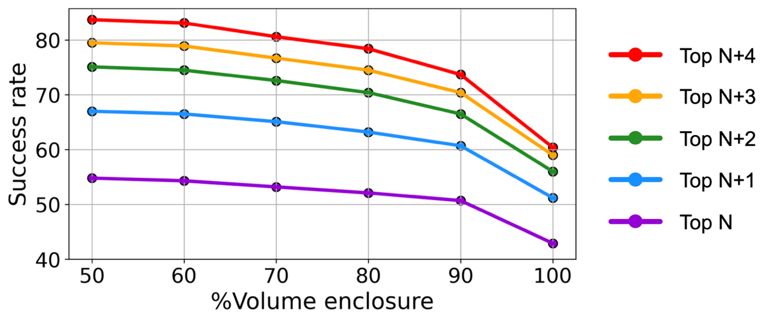
Figure S2. Pocket detection success rate measured by %volume enclosure of ligand inside the pocket. Success rates are measured for predicting known pockets among top N, N+1, N+2, N+3 and N+4 pockets ranked by normalized ligandability score, where N=total number of known pockets in a protein target.

Figure S3
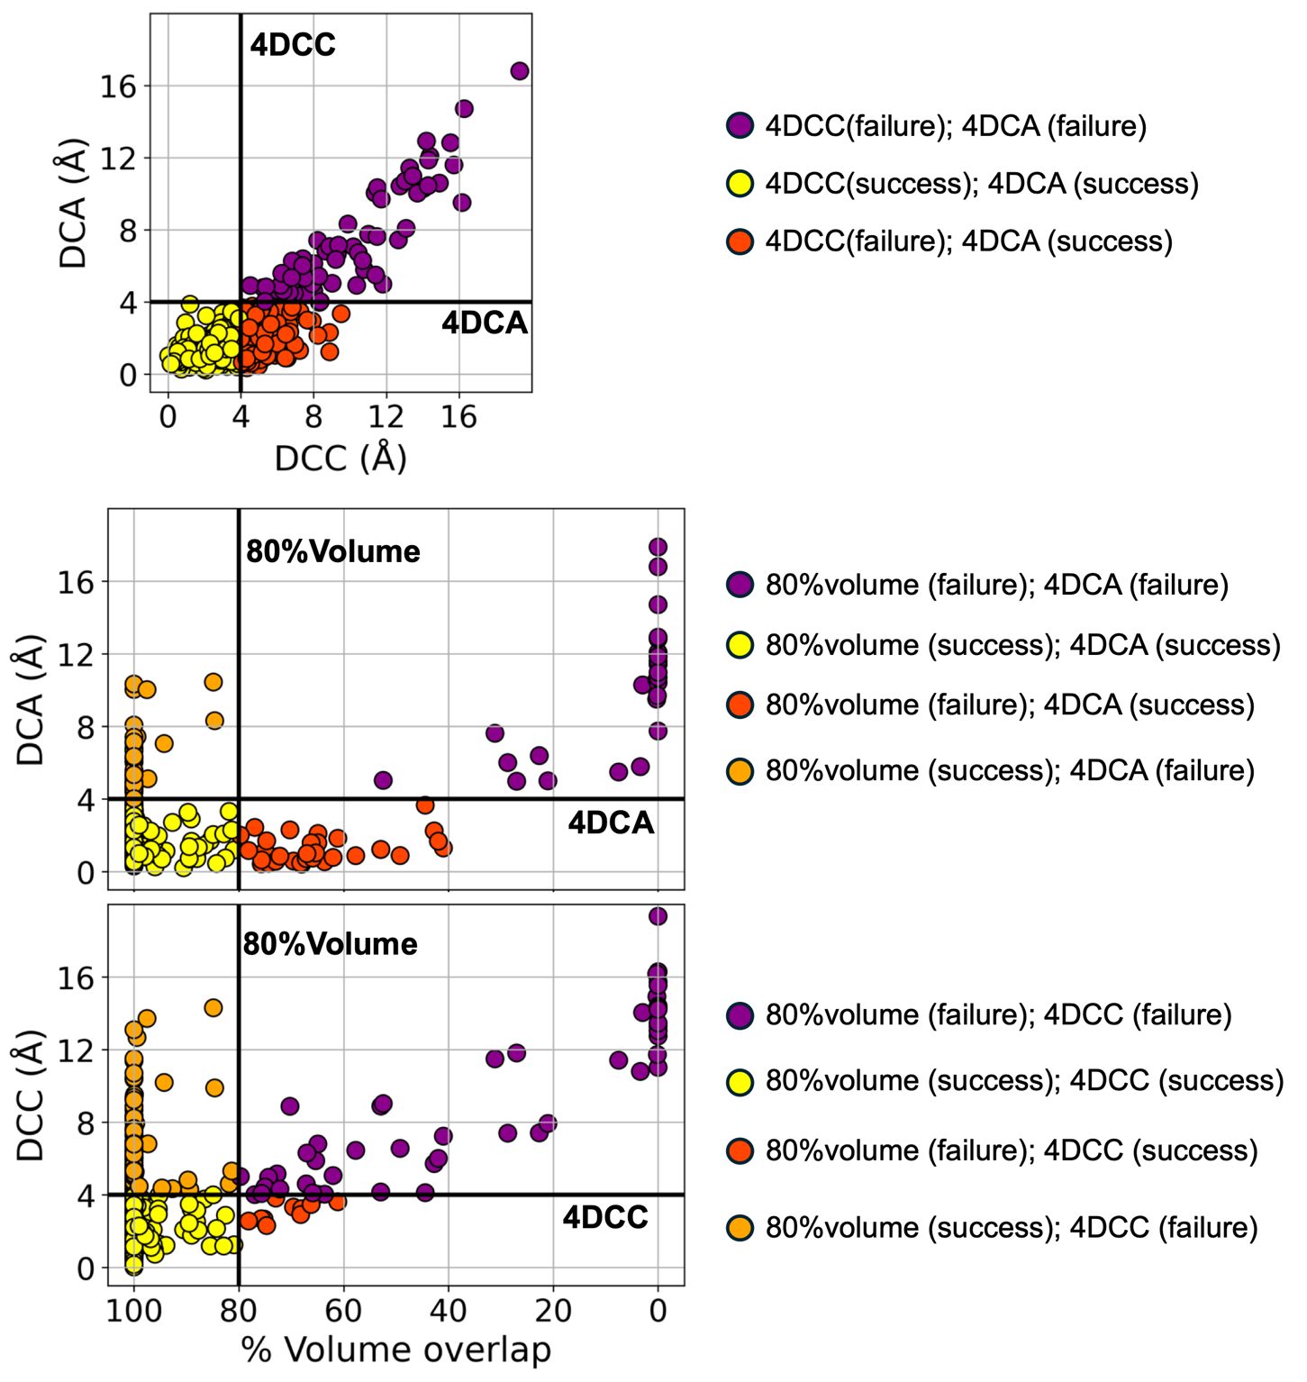
Figure S3. Comparison of pocket prediction evaluation metrics (DCA, DCC and %Volume overlap). (A) Scatter plot shows DCA and DCC values for retrospective prediction of known pockets in Groovy^{validation} dataset using PocketX^{RFR} model. The datapoints are shown as circles color-coded based on which metric(s) count them as success or failure. The circles shown in yellow are the predictions counted as success by both metrics. The vertical black line corresponds to 4DCC at 4 Å DCC, and the horizontal line corresponds to 4DCA (4 Å DCA cut-off) used for categorizing a prediction as success or failure. (B) Scatter plot showing DCA and %Volume overlap of ligand with the pocket receptor. The vertical black line corresponds to 80% volume overlap and the horizontal line corresponds to 4DCA (4 Å DCA cut-off). (C) Scatter plot showing DCC and %Volume overlap of ligand with the pocket receptor. The vertical black line corresponds to 80% volume overlap, and the horizontal line corresponds to 4DCC (4 Å DCC cut-off).

Figure S4.
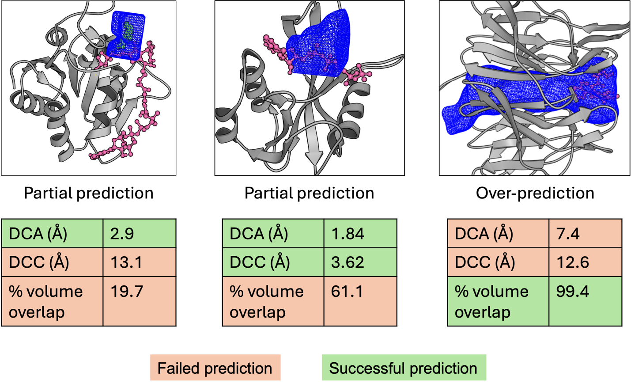
Figure S4. Examples of partial and over predictions by PocketX for known ligand binding pockets. Partial predictions are shown by the first two examples wherein the ligand (shown in pink) is not fully enclosed within the pocket receptor (shown as blue mesh) built after pocket prediction by PocketX. In an example of over-prediction shown in the third example, the predicted pocket receptor is significantly larger than a known ligand bound at the pocket. The values of assessment metrics DCA, DCC and %volume overlap for each example are tabulated highlighting whether a prediction is considered success or failure by each metric.

Table S2. List of protein-ligand complexes where PocketX models failed to predict FDA-approved drug binding pockets as ligandable sites.
PDB ID | Protein name | FDA-approved drug name  (Ligand code) | Ligand type/binding mode | Pocket buriedness  (%) | PocketX model predicting false negative | Normalized ligandability score
6IN1 | Bromodomain-containing protein 4 (BRD4) | Colchicine  (LOC) | Small molecule; protein-protein interaction inhibitor | 64.3 | PocketX^{RFR}  PocketX^{GPR} | 0.25  0.25
7VKO | Tyrosine-protein kinase receptor | Repotrectinib  (7GI) | Macrocycle | 92.3 | PocketX^{RFR}  PocketX^{GPR} | 0.26  0.29
7OTG | Multidrug resistance protein 1A | Ivacaftor (VX7) | Off-target binding site in a transporter protein | 48.3 | PocketX^{RFR}  PocketX^{GPR} | 0.14  0.15
1FKB | FK506 binding protein | Rapamycin  (RAP) | Macrocycle | 49.2 | PocketX^{RFR}  PocketX^{GPR} | 0.17  0.16
4X5S | Carbonic anhydrase | Sulfurihydrogenibium  (AZM) | Small molecule stabilized by Zn ion and a PEG excipient | 72.1 | PocketX^{RFR}  PocketX^{GPR} | 0.25  0.25
2Q5K | HIV-1 protease | Lopinavir  (AB1) | Peptidomimetic | 92.0 | PocketX^{RFR}  PocketX^{GPR} | 0.22  0.24
5AA8 | ALK tyrosine kinase receptor | Lorlatinib  (5P8) | Macrocycle | 83.9 | PocketX^{RFR}  PocketX^{GPR} | 0.21  0.22
6TFB | Frizzled-8 | Carbamazepine (N6W) | Small molecule | 71.6 | PocketX^{RFR}  PocketX^{GPR} | 0.22  0.22
1TLM | Transthyretin | Milrinone (MIL) | Small molecule – shows high B-factor, dual occupancy binding to the transporter protein | 52.3 | PocketX^{RFR}  PocketX^{GPR} | 0.23  0.24
1RL8 | HIV-1 protease | Ritonavir (RIT) | Peptidomimetic – dual occupancy and high B-factor | 81.9 | PocketX^{RFR}  PocketX^{GPR} | 0.19  0.21
1NYY | Beta-lactamase | Cloxacillin derivative (105) | Covalent binder | 74.7 | PocketX^{RFR}  PocketX^{GPR} | 0.18  0.19
1XZ3 | Ferritin | Isoflurane (ICF) | Small molecule anesthetic – shows high B-factor and dual occupancy | 53.6 | PocketX^{RFR}  PocketX^{GPR} | 0.19  0.17
2P16 | Coagulation factor X | Apixaban (GG2) | Non-peptide inhibitor binds to peptide-binding site | 78.8 | PocketX^{RFR}  PocketX^{GPR} | 0.26  0.26
4FWD | TTC1975 peptidase | Bortezomib (BO2) | Dipeptide, covalent binder | 76.7 | PocketX^{RFR}  PocketX^{GPR} | 0.15  0.16
5LBT | Ribosyldihydronicotinamide dehydrogenase | Imiquimod (6T0) | Small molecule stabilized by stacking interaction with FAD cofactor. Also, shows dual occupancy | 73.3 | PocketX^{RFR}  PocketX^{GPR} | 0.20  0.19
1MRL | Streptogramin A acetyltransferase | Dalfopristin (DOL) | Macrocycle | 57.4 | PocketX^{RFR}  PocketX^{GPR} | 0.21  0.22
1OQ5 | Carbonic anhydrase II | Celecoxib (CEL) | Small molecule stabilized by Zn; Off-target binding | 79.0 | PocketX^{RFR}  PocketX^{GPR} | 0.25  0.24
5VOF | Coagulation factor X | Rivaroxaban (RIV) | Non-peptide inhibitor binds to peptide-binding site | 82.2 | PocketX^{RFR}  PocketX^{GPR} | 0.27  0.26
3OWX | Ribosyldihydronicotinamide dehydrogenase | Prazosin (XRA) | Small molecule stabilized by stacking interaction with FAD cofactor. Also, shows dual occupancy | 61.0 | PocketX^{RFR}  PocketX^{GPR} | 0.23  0.22
5ZV2 | Fibroblast growth factor receptor 1 | Lenvatinib (LEV) | Small molecule | 94.9 | PocketX^{RFR}  PocketX^{GPR} | 0.26  0.29
3U5J | BRD4 | Alprazolam (08H) | Small molecule; protein-protein interaction inhibitor | 75.4 | PocketX^{RFR}  PocketX^{GPR} | 0.21  0.21
4K7Q | Acriflavine resistance protein B | Linezolid (ZLD) | Small molecule; Off-target binding to a transporter protein | 18.3 | PocketX^{RFR}  PocketX^{GPR} | 0.16  0.17
1V8Y | ADP-ribose pyrophosphatase | ADP-ribose (APR) | Nucleotide stabilized by Zn ion | 62.9 | PocketX^{RFR}  PocketX^{GPR} | 0.18  0.19
7KK3 | Poly [ADP-ribose] polymerase 1 | Talazoparib (2YQ) | Small molecule | 79.0 | PocketX^{GPR} | 0.29
2ZGW | Biotin protein ligase | Adenosine (ADN) | Nucleoside | 69.9 | PocketX^{GPR} | 0.28
1LUD | Dihydrofolate reductase | Trimethoprim (TRR) | Small molecule stabilized by stacking interaction with FAD cofactor | 83.7 | PocketX^{GPR} | 0.28
3G1R | Steroid 5beta-reductase | Finasteride (FIT) | Steroid; Makes stacking interaction with NADP cofactor | 77.3 | PocketX^{GPR} | 0.27
2AW1 | Carbonic anhydrase II | Valdecoxib  (COX) | Smal molecule stabilized by Zn ion | 80.4 | PocketX^{GPR} | 0.29
3A50 | Vitamin D hydroxylase | Vitamin D3 (VD3) | Vitamin bound to metabolizing enzyme | 79.0 | PocketX^{GPR} | 0.29
3LXK | Tyrosine-protein kinase JAK3 | Tofacitinib  (MI1) | Small molecule | 95.8 | PocketX^{GPR} | 0.29
3OZW | Flavohemoglobin | Ketoconazole (KKK) | Small molecule stabilized by hem cofactor | 72.0 | PocketX^{GPR} | 0.28
7DMC | Hsp90A | Dipyridamole (H9F) | Small molecule stabilized by Mg ion | 87.1 | PocketX^{GPR} | 0.28

