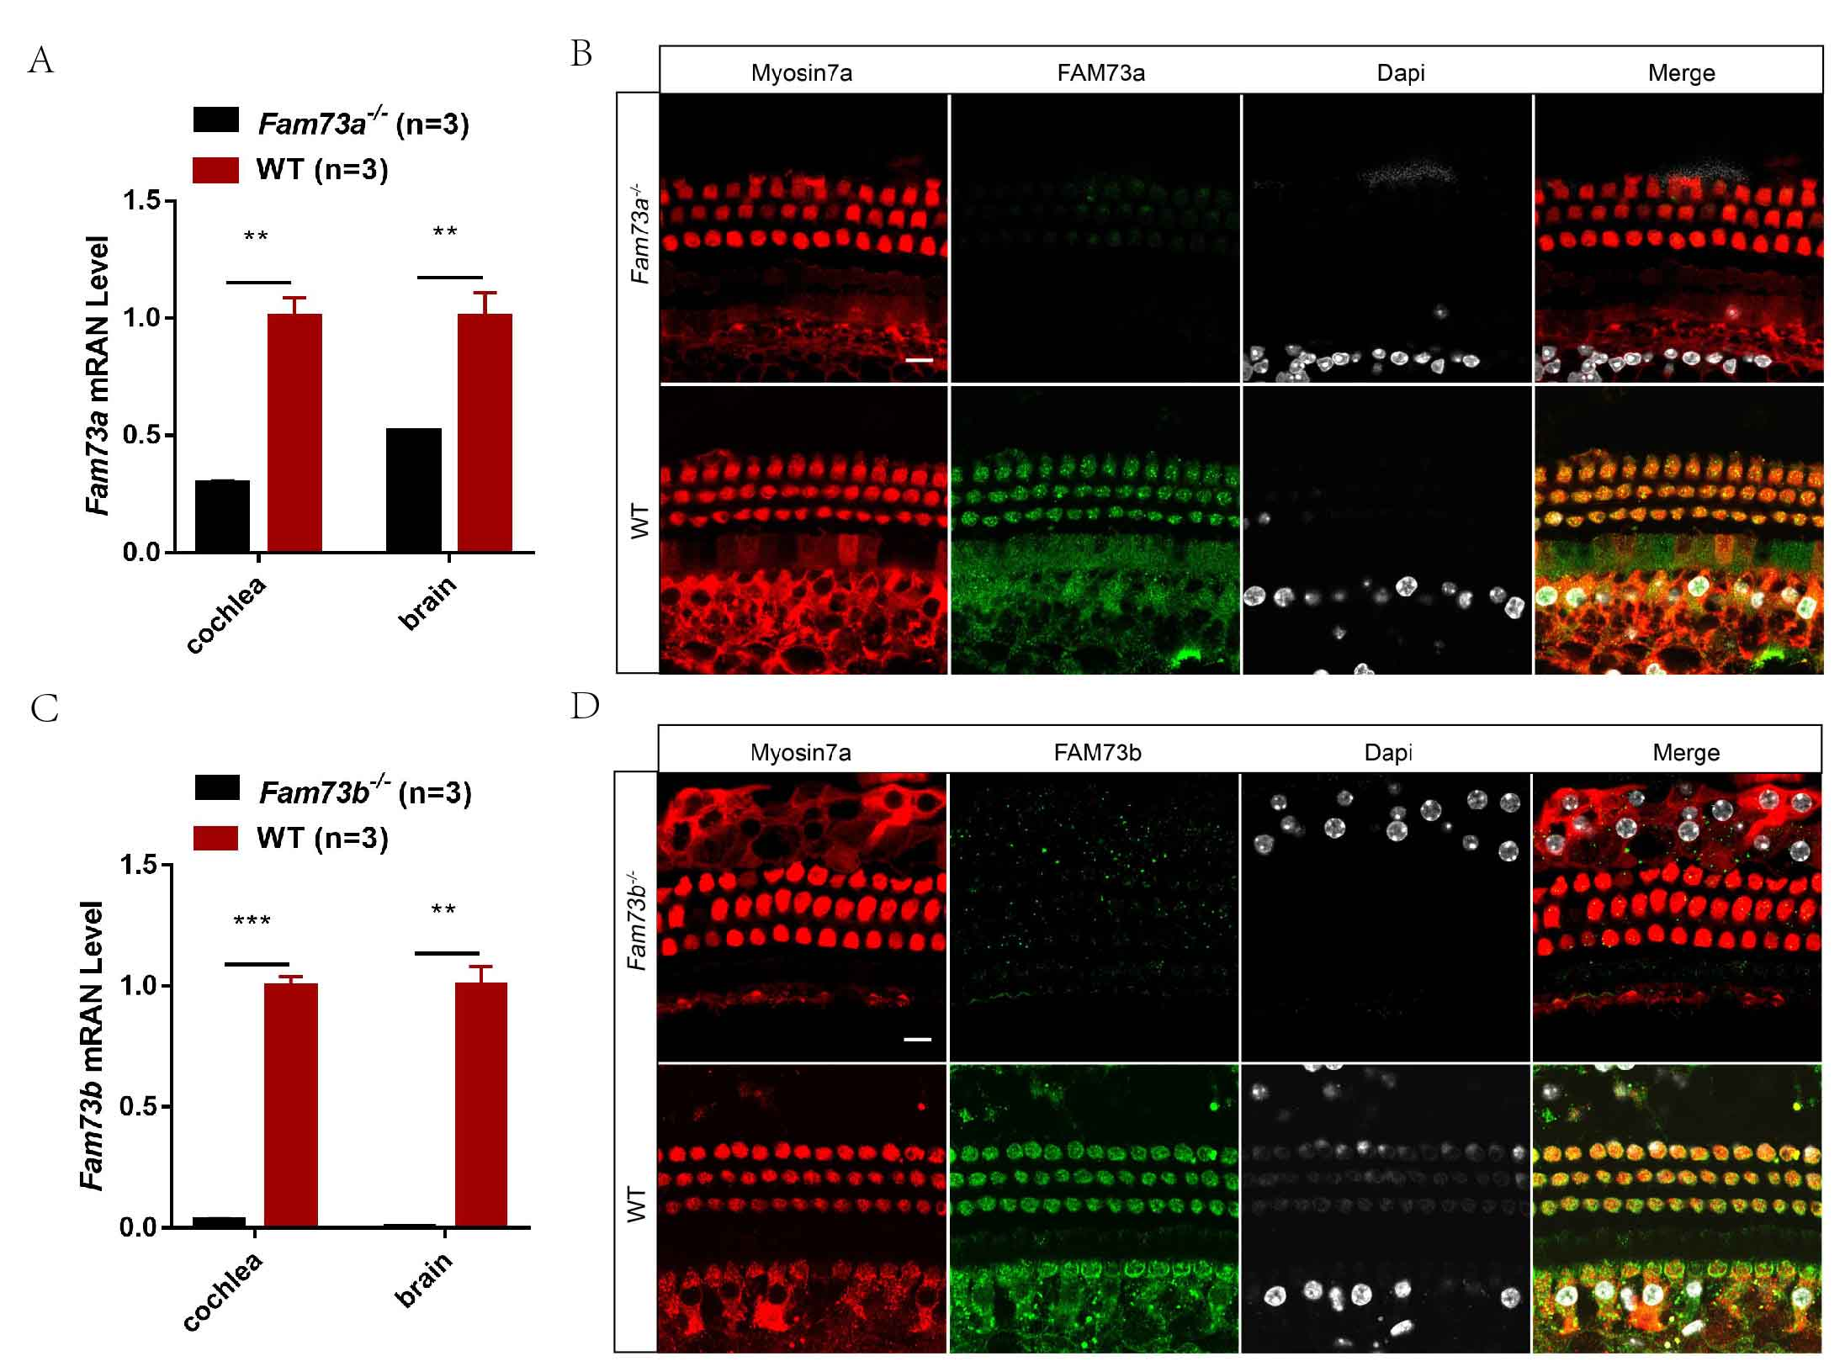
Supplementary Fig.1 Analysis of Fam73a and Fam73b expression in the KO mice. (A,C) The qRT-PCR analysis of the expression of Fam73a and Fam73b in the cochlea of P30 Fam73a and Fam73b KO mice and WT mice. (B,D) Representative images of the expression of FAM73a and FAM73b in the HCs of P30 Fam73a and Fam73b KO mice and WT mice. Scale bar: 10 µm.

