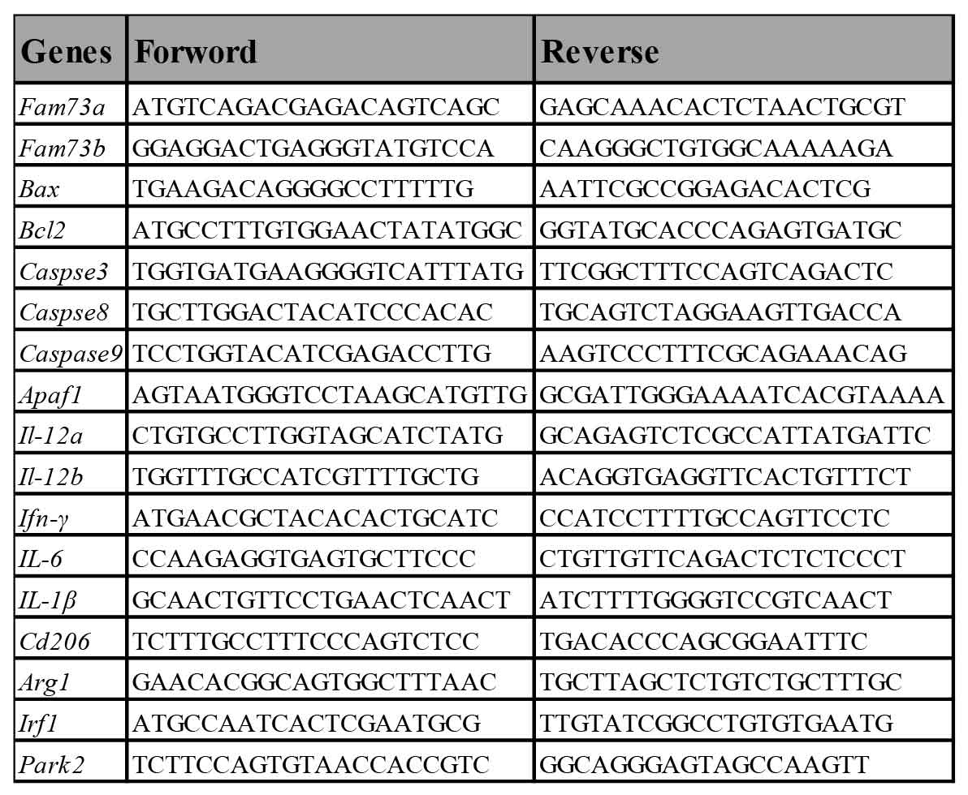
Table1. qRT-PCR gene primers used in the experiments.

