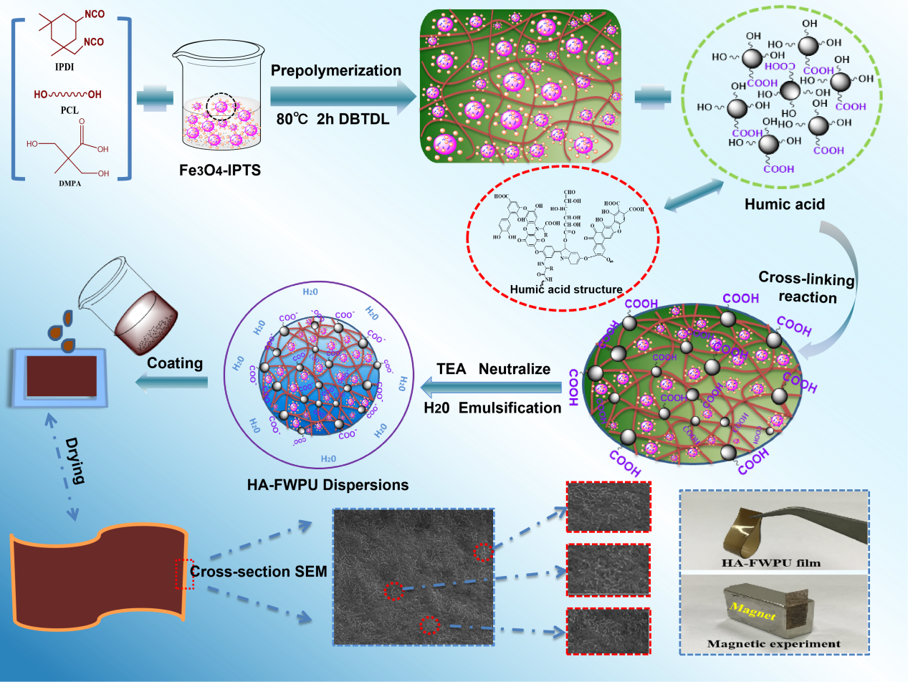
Scheme 1. Flow chart for the preparation of HA-FWPU nanocomposites
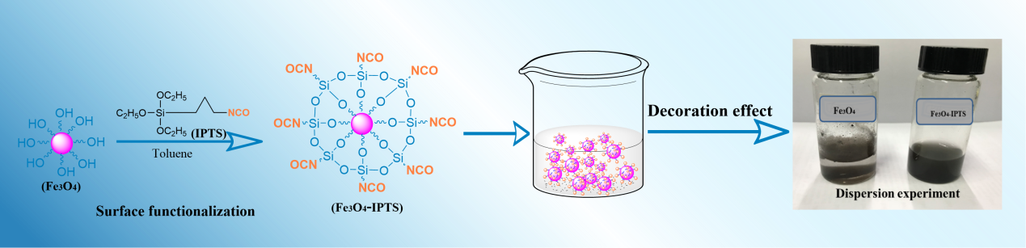
Scheme 2. Schematic illustration of synthesis of surface modified Fe₃O₄ (Fe₃O₄-IPTS).

