Notes
- Gender: 29 errors in labels (changed to NAs)
- Age: 2 errors (age=526, age=709 – changed to NAs)
- Height: Changed to metres
Changed values < 1.02m and >3m to Nas (15 values)
- Weight: Changed values <=20kg and > 198kg to Nas (9 values)
- BMI: Changed values > 60 to Nas (3 values – weight 175kg, 198kg, 162kg)
- BMI categories:
Underweight: <= 18.5
Normal: >18.5, <25
Overweight: >=25, <30
Obese: >=30
Obese Class 1: >=30, <35
Obese Class 2: >=35, <40
Obese Class 3: >=40

BMI note – 19 BMIs 10-15. Weight 31kg-50kg

Prof Declan Lyons checks:
- Blood pressure: Remove IDs (1, 6039, 8234, 8713, 8840, 9156, 10189, 12797, 14878) from Prof Declan Lyons unrealistic blood pressure checks.
- Weight: Removed ID 2260 unrealistic height/weight from Prof Declan Lyons checks.
- Blood pressure changes: Removed IDs (2048, 3489, 5495, 5626, 8713, 10189, 12797, 14854, 15167) from Prof Declan Lyons unrealistic blood pressure changes.

- Keep ages >=18 and <=95. (n=383 <18 or >95)
Remove ages NA (n=2731 NAs)
(n=15,919 to n=12,805)
- Keep height >= 130
Remove NAs
(n=12,676)
- Keep BMI <=60 (2 values above 60 – weight=198kg, 162kg)
Remove NAs (n=17 Nas)
(n=12,657)
- Syst Delta: Change signs
Change delta to NA if no post tilt measure
Remove NAs (113 Nas)
(n=12,544)

- HR delta: Change signs
Change delta to NA if no post tilt measure
Change extreme to NA (-577)
Filter baseline >=40 (n=12,528)
Filter post tilt >=20
Remove Nas (n=12,520)
- Keep syncope study no 1 or NA (ie remove repeat tilts. n=12,178)
- Sys delta: decrease only (n=6,614/12,178. 54% of data left)
- Diastolic blood pressure
Remove baseline=1001107, 1136, 500
Remove post tilt=717 (6,610)

Statistical analysis
Descriptive statistics were used to report patient characteristics. Categorical variables were summarised using counts and percentages. Numerical variables were tested for a normal distribution using visuals and were summarised using the mean (standard deviation) or median (quartile one, quartile three) as appropriate. Where variables were not normally distributed or assumptions were violated, non-parametric tests (i.e., Kruskal-Wallis) were used to compare results for subgroups. Pairwise comparisons were carried out with multiple testing corrections. Median scores and 95% confidence intervals were calculated using the exact method. A significance level of 5% was used for all analyses. Statistical analyses were carried out using R version 4.4.1 (2024-06-14).

Results
Patients with decrease in
systolic blood pressure
n = 6,610
Gender
Female | 3,706 (58%)
Male | 2,733 (42%)
Unknown | 171
Age
Median (Q1, Q3) | 78.0 (71.0, 84.0)
Min, Max | 18.0, 95.0
Height
Mean (SD) | 1.7 (0.1)
Min, Max | 1.4, 2.1
Weight
Mean (SD) | 71.6 (15.2)
Min, Max | 31.0, 185.0
BMI
Mean (SD) | 25.8 (4.7)
Min, Max | 12.3, 57.1
BMI Category
Underweight | 198 (3.0%)
Normal BMI | 3,058 (46%)
Overweight BMI | 2,249 (34%)
Obese BMI | 1,105 (17%)
Systolic Baseline
Mean (SD) | 124.9 (22.9)
Min, Max | 51.0, 256.0
Systolic Post Tilt
Mean (SD) | 103.4 (24.3)
Min, Max | 13.0, 220.0
Systolic Change
Mean (SD) | -21.6 (16.3)
Median (Q1, Q3) | -18.0 (-30.0, -9.0)
Min, Max | -145.0, -1.0
Heart Rate Baseline
Mean (SD) | 72.7 (13.7)
Median (Q1, Q3) | 71.0 (63.0, 81.0)
Min, Max | 40.0, 155.0
Heart Rate Post Tilt
Mean (SD) | 78.2 (16.0)
Median (Q1, Q3) | 77.0 (67.0, 88.0)
Min, Max | 21.0, 175.0
Heart Rate Change
Mean (SD) | 5.5 (10.4)
Median (Q1, Q3) | 4.0 (1.0, 9.0)
Min, Max | -92.0, 98.0
Diastolic Baseline
Mean (SD) | 70.9 (14.8)
Median (Q1, Q3) | 70.0 (61.0, 80.0)
Min, Max | 20.0, 189.0
Diastolic Post Tilt
Mean (SD) | 66.3 (18.3)
Median (Q1, Q3) | 66.0 (54.0, 79.0)
Min, Max | 10.0, 197.0
Diastolic Change
Mean (SD) | -4.6 (12.6)
Median (Q1, Q3) | -4.0 (-12.0, 3.0)
Min, Max | -76.0, 107.0
Data presented as n (%), mean (standard deviation) or median (quartile one, quartile three)
Table 1: Table of characteristics for those who decreased in systolic blood pressure
1 Is there a difference in decreases in systolic blood pressure across BMI categories?
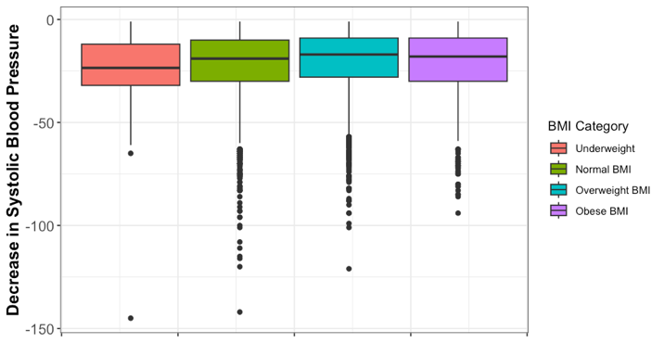
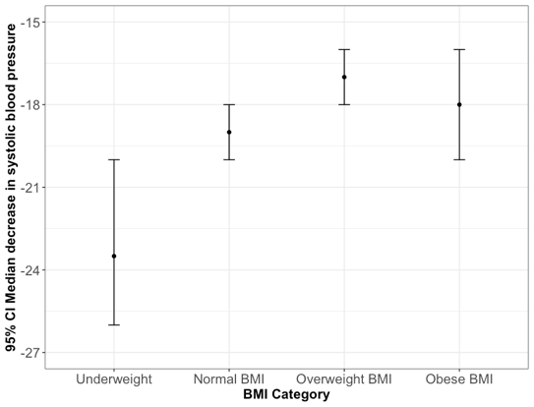
Figure 1: (Left) Boxplot and (Right) Median and 95% confidence interval for decrease in systolic blood pressure across BMI categories.
There was a statistically significant difference in decreases is systolic blood pressure across BMI categories (p=0.008, Table 2). The pairwise analysis indicated that the underweight category had a higher median decrease compared to the overweight category (median=-23 vs -17, respectively, p=0.01
 | Underweight  n = 198 | Normal BMI  n = 3,058 | Overweight BMI  n = 2,249 | Obese BMI  n = 1,105 | p-value
Decrease in systolic blood pressure | -23.5 (-32, -12) | -19 (-30, -10) | -17 (-28, -9) | -18 (-30, -9) | 0.008**
Data presented as median (quartile one, quartile three). ¹Kruskal Wallis Test. **p<0.01.
Table 2: Decrease in systolic blood pressure across BMI categories

2. Is there a difference in change in heart rate scores across BMI categories?
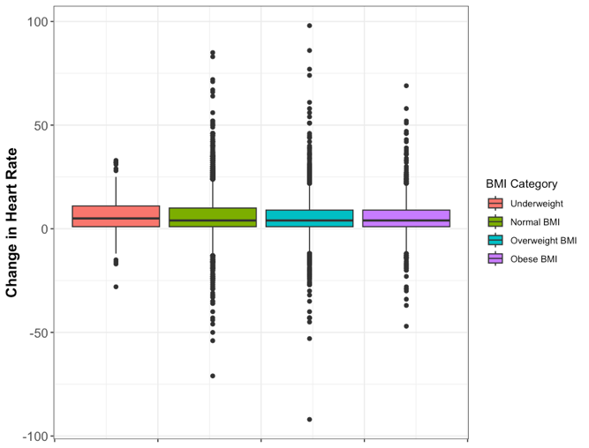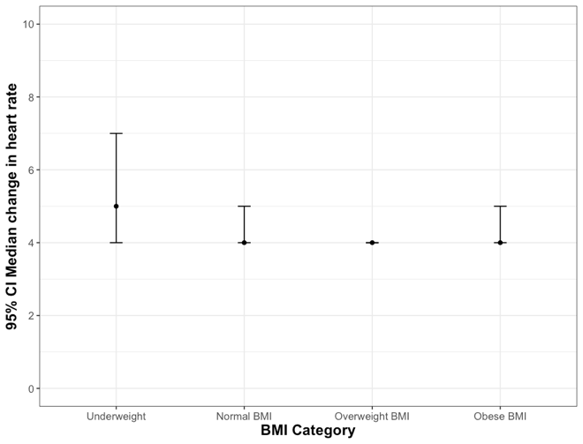
Figure 2: (Left) Boxplot and (Right) Median and 95% confidence interval for change in heart rate across BMI categories.
There was no statistically significant difference in change in heart rate across BMI categories (p=0.05, Table 4).

 | Underweight  n = 198 | Normal BMI  n = 3,058 | Overweight BMI  n = 2,249 | Obese BMI  n = 1,105 | p-value
Change in heart rate | 5 (1, 11) | 4 (1, 10) | 4 (1, 9) | 4 (1, 9) | 0.05
Data presented as median (quartile one, quartile three). ¹Kruskal Wallis Test.
Table 3: Change in heart rate across BMI categories.
3. Is there an association between orthostatic hypotension diagnosis (systolic drop of 20 or greater) and BMI category?
There was a statistically significant association between diagnosis and bmi category (p=0.004).

 | Underweight  n = 198 | Normal BMI  n = 3,058 | Overweight BMI  n = 2,249 | Obese BMI  n = 1,105 | p-value
Orthostatic hypotension |  |  |  |  | 0.004**
Diagnosis | 115 (58%) | 1,521 (50%) | 1,045 (46%) | 528 (48%)
No diagnosis | 83 (42%) | 1,537 (50%) | 1,204 (54%) | 577 (52%)
Data presented as n (%). ¹Chi-squared test. **p<0.01.
Table 4: Orthostatic hypotension diagnosis (systolic drop of 20 or greater) across BMI categories.

