Supplementary Figure 1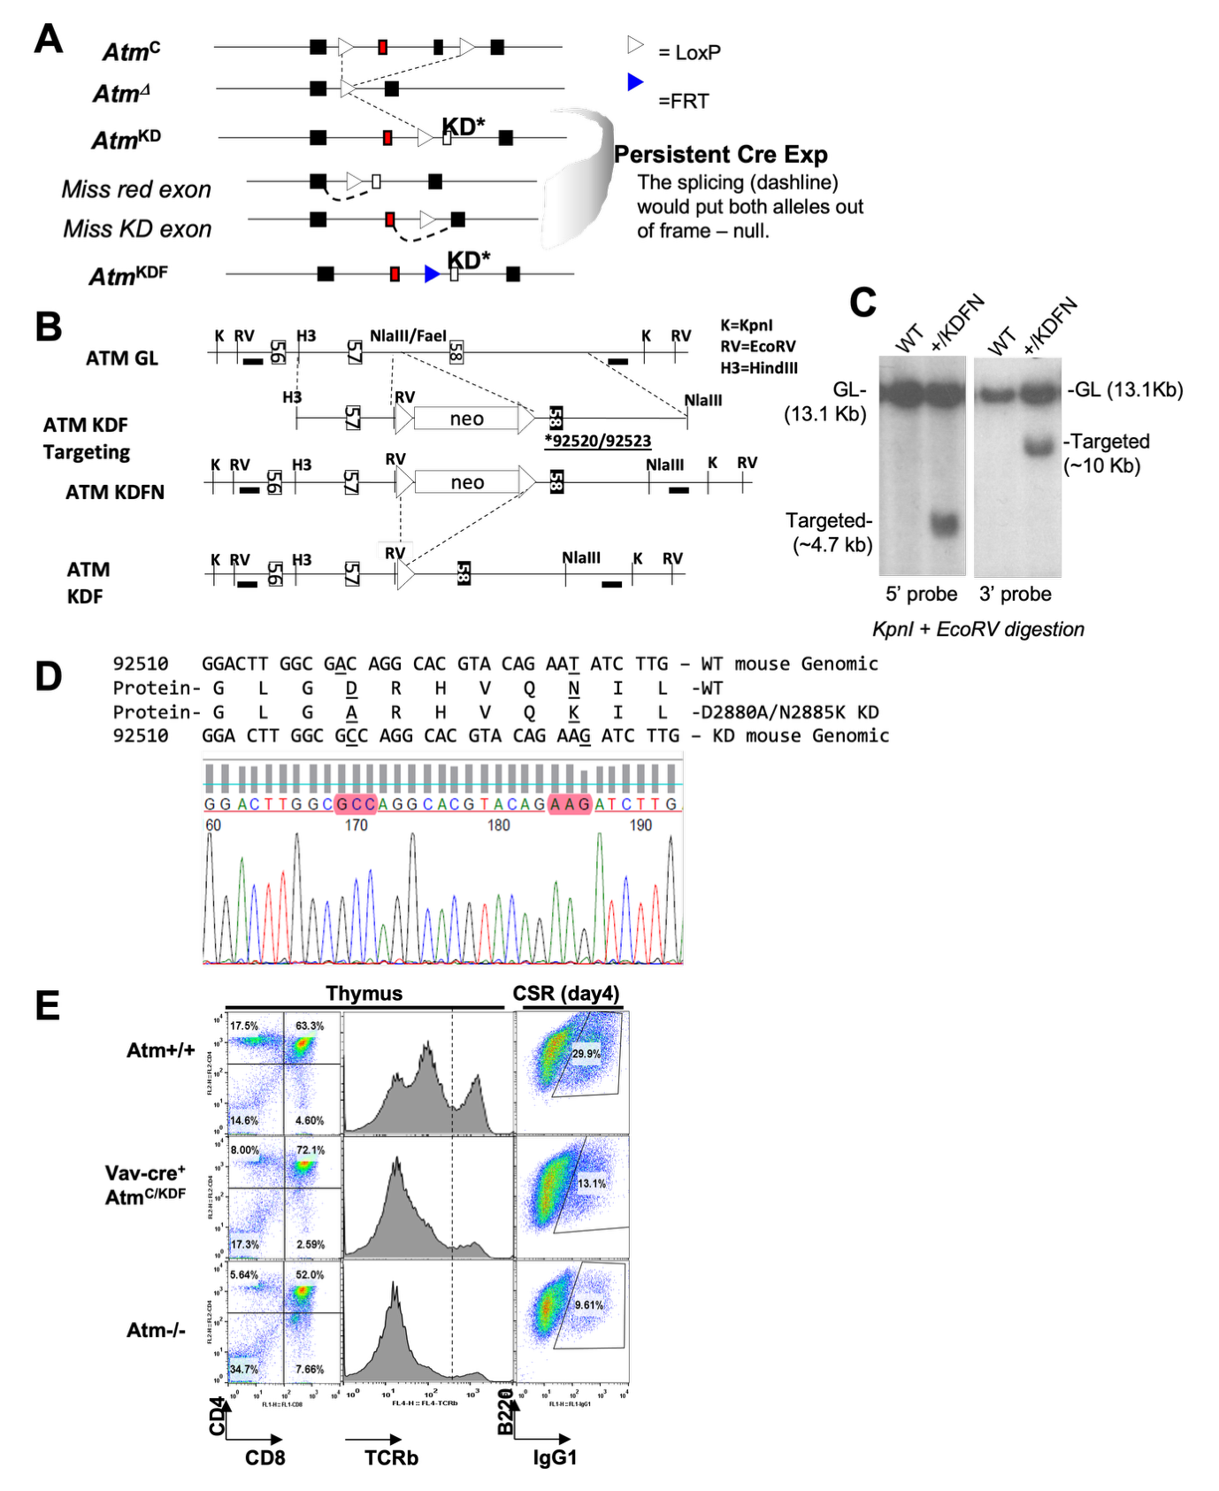
Supplementary Fig. 1. Generation and validation of the Atm^{KDF} allele. Schematic representation of the Atm^{KD} and Atm^{KDF} alleles and the predicted recombination products (a). Targeting strategy for the Atm^{KDF} allele. GL, germline allele; KDFN, targeted allele prior to NeoR cassette excision. Restriction sites are indicated as follows: K, KpnI; RV, EcoRV; H3, HindIII. Exon numbers are labeled. The exon harboring the kinase-dead mutations is shown as a filled box. The 5′ and 3′ Southern blot probes are indicated by thick black lines (b). Representative Southern blot analyses of correctly targeted ES cell clones. The expected sizes of germline (GL) and targeted alleles are indicated. Restriction enzyme digestions and probes used are shown below each blot (c). Representative sequencing chromatograms confirming the introduced mutations. Corresponding genomic DNA and predicted protein sequences are aligned above (d). The representative flow cytometry (FACS) analyses of lymphocyte development in VavCre+ Atm^{KDF/C} mice compared to Atm^{+/+} and Atm^{-/-} (null) mice (e).

Supplementary Figure 2
Supplementary Fig. 2. Atm^{KDF/CNS-KO} mice display preserved thickness of the molecular and granular layers of the cerebellum. Schematic representation of cerebellar layers (a). Quantification of the thickness of the molecular (b) and granular layers (c) in the cerebellar slices from both genotypes (wild type n = 8; Atm^{KDF/CNS-KO} n = 8). Data are represented as mean ± SEM. (p>0.05, Mann-Whitney test).

Supplementary Figure 3
Supplementary Fig. 3. The Sox10+ cell density is maintained in Atm^{KDF/CNS-KO} mice. Representative fluorescent images of the abundance of Sox10+ (red) oligodendrocytes and Dapi (blue) stained cerebellum and corpus callosum sections form wild type and Atm^{KDF/CNS-KO} mice (a). Scale bar, 50 μm. Quantification of Sox10+ cell density in the white matter of cerebellum (b) and corpus callosum (c) from both genotypes (wild type n = 6; Atm^{KDF/CNS-KO} n = 5 for cerebellum; and wild type n = 4; Atm^{KDF/CNS-KO} n = 4 for corpus callosum). Data are represented as mean ± SEM. (p>0.05, Mann-Whitney test).

Supplementary Figure 4
Supplementary Fig. 4. Preserved Purkinje cell spontaneous firing in Atm^{KDF/CNS-KO} mice. Representative traces recorded in cell-attached configuration for wild type (blue) and Atm^{KDF/CNS-KO} mice (red) (a). Histograms represent the mean interspike interval (ISI) (b), the ISI coefficient of variation (CV) (c) and the ISI CV2 (c) for wild type (n = 14) and Atm^{KDF/CNS-KO} (n = 8) PCs. No significant differences were observed between genotypes (p > 0.05, unpaired Student's t-test). Data are represented as mean ± SEM.

