Supplementary Figure S1

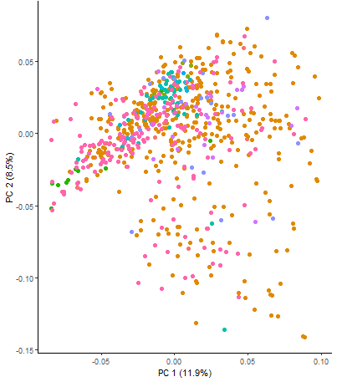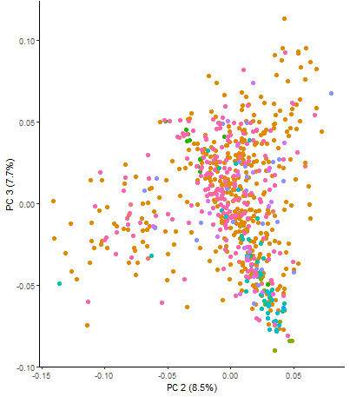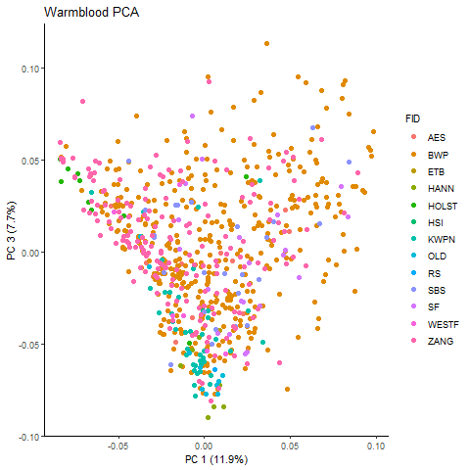

Principal component analysis. AES, Anglo European Warmblood horse; BWP, Belgian Warmblood horse; ETB, English Thoroughbred horse, HANN, Hanoverian horse; HOLST, Holsteiner horse; HSI, Irish Sport horse; KWPN, Royal Dutch Sport horse; OLD, Oldenburg horse; RS, Rheinlander horse; SBS, Belgian Sport horse; SF, Selle Français horse; WESTF, Westfalen horse; ZANG, Zangersheide horse.

