Supplementary Figures S2-S15

These figures present the Manhattan plots and Quantile-Quantile (Q-Q) plots of the case-control genome-wide association studies (GWAS) for equine osteochondrosis (OC), osteochondral fragments of the palmaro- /plantaroproximal aspect the proximal phalanx (POF) and osteochondral fragments of the dorsoproximal aspect of the proximal phalanx (DOF). These GWAS were conducted using a linear regression model including the sex and the first 6 principal components as fixed effects.

The Manhattan plots display the single nucleotide polymorphisms (SNPs) in relation to their position in the genome (X-axis) and significance of their association with the phenotype (Y-axis). The blue horizontal line indicates the genome-wide suggestive significance cutoff, and the red horizontal line represents the genome-wide significant cutoff. For each of the individual GWAS the used phenotype definition and number of cases and controls is presented in the figure caption. From A to D, the phenotype definitions become progressively stricter, with each subsequent case-control definition adding an extra requirement for both cases and controls. This results in fewer but more specific cases and controls.

The Quantile- Quantile (Q-Q) plots display the distribution of P-values of the SNPs obtained from the linear mixed model and linear regression analyses. The red line represents the expected distribution of P-values under the null hypothesis of no association, where the -log10 of the observed P-values are equal to the -log10 of the expected P-values. Points that deviate from this line suggest potential associations or may indicate systematic biases such as population stratification.

Supplementary Figure S2

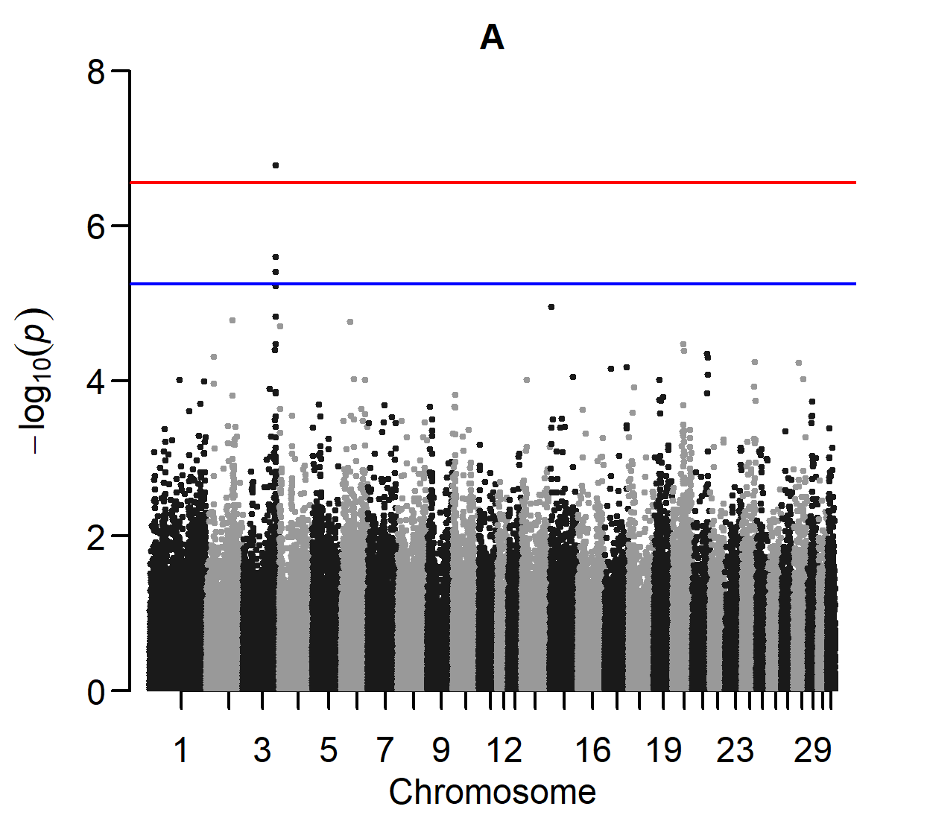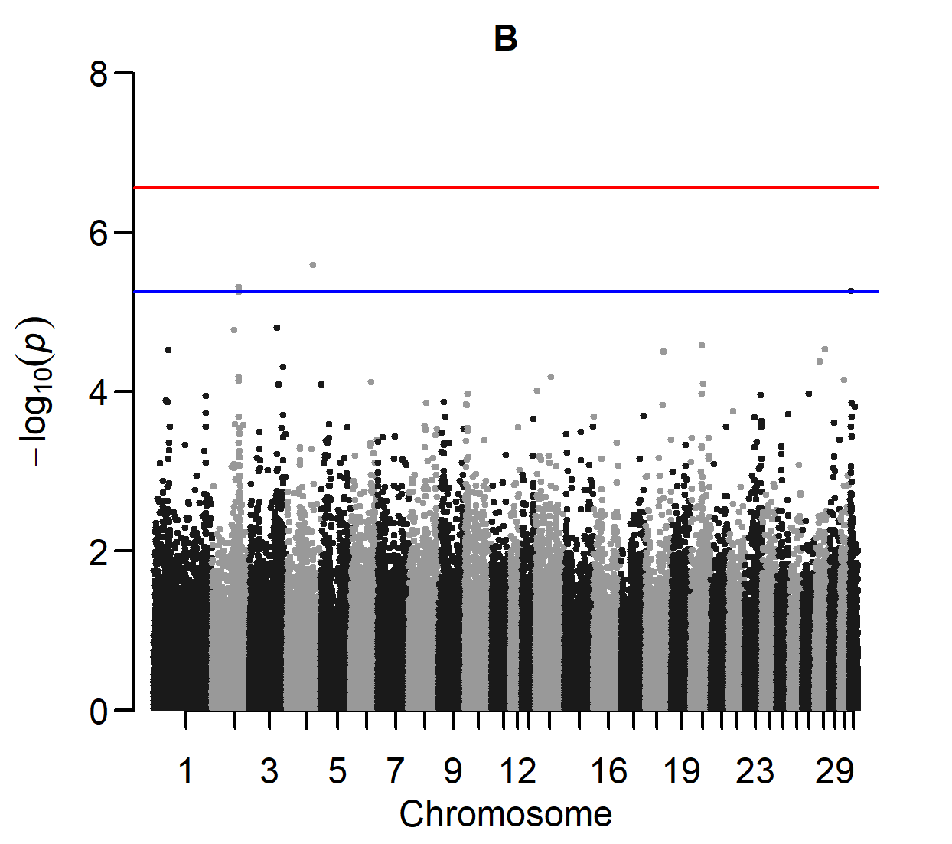

Manhattan plots of two GWAS for OC occurring at the hock and/or stifle and/or fetlock.
A: Cases are horses with OC (score ≥ 3) at the distal intermediate ridge of the tibia and/or lateral trochlear ridge of the talus and/or medial malleolus of the tibia and/or lateral trochlear ridge of the femur and/or dorsal part of the sagittal ridge of the third metacarpal/metatarsal bone. Controls are horses with a normal bone contour (score 0) at these sites (307 cases and 325 controls).
B: Absence of DOF, POF and other osteochondral fragments in the fetlock joint (score 0), together with a normal bone contour (score 0) at the medial trochlear ridge of the femur, medial trochlear ridge of the talus and articular surface of the patella, is additionally required (174 cases and 236 controls).

Supplementary Figure S3

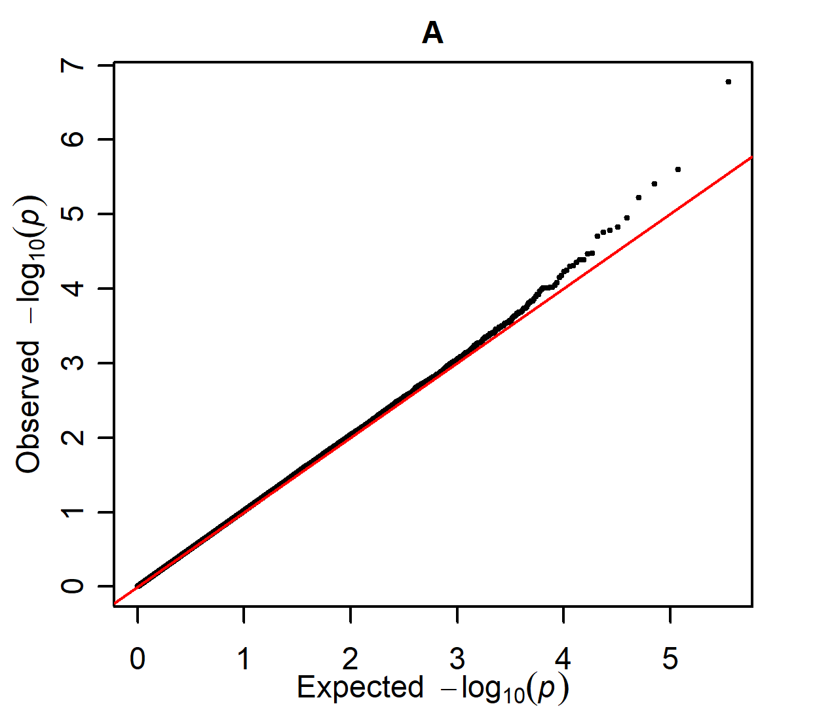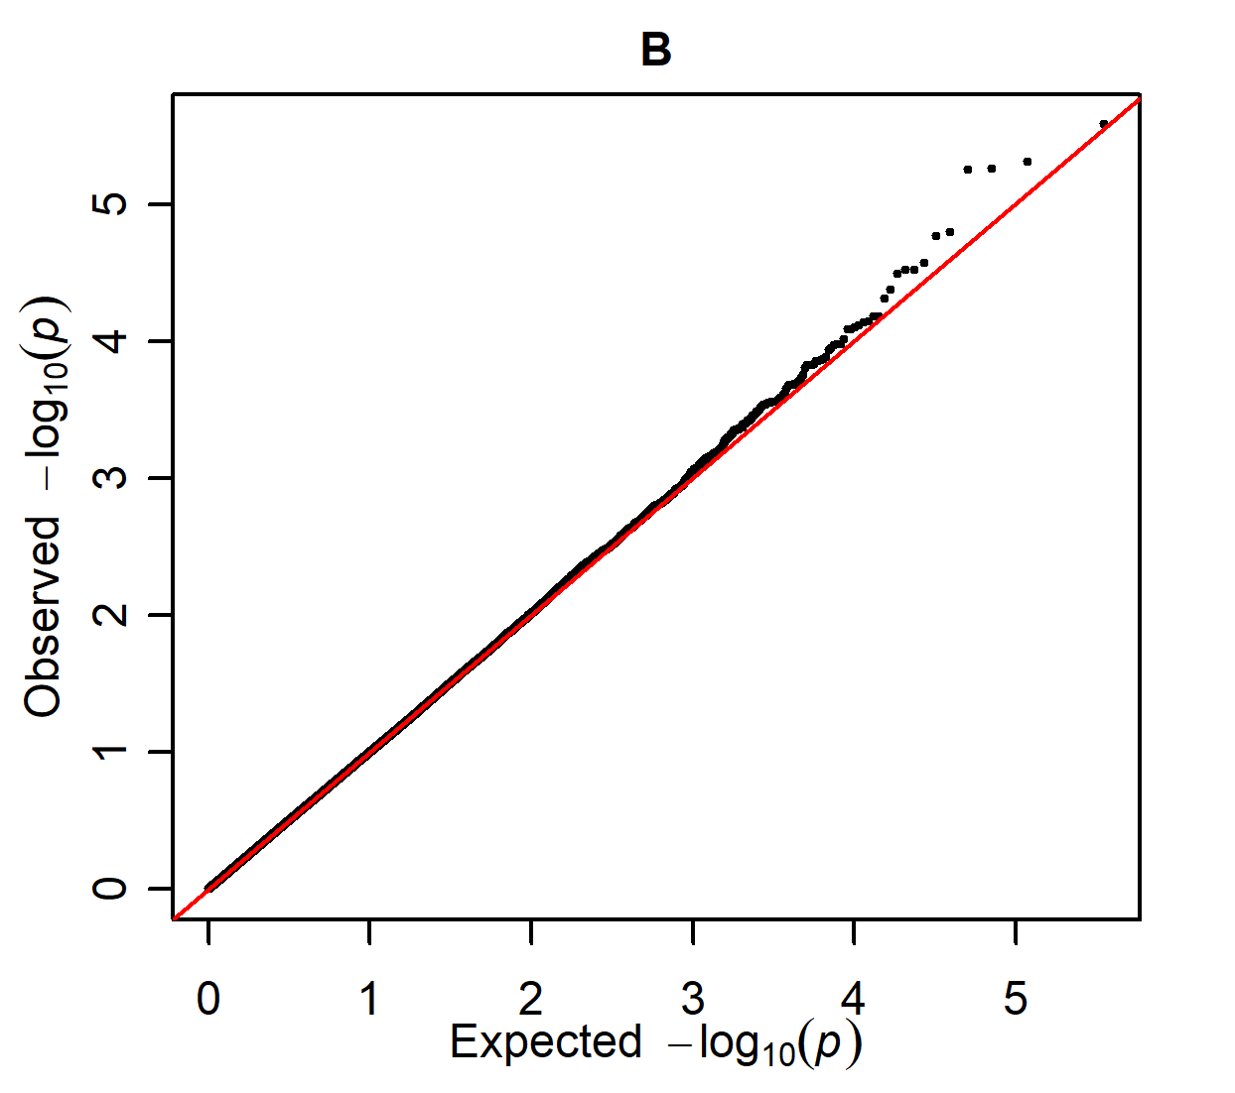

Q-Q plots of the two GWAS for OC occurring at the hock and/or stifle and/or fetlock, as presented in supplementary figure S2.

Supplementary Figure S4

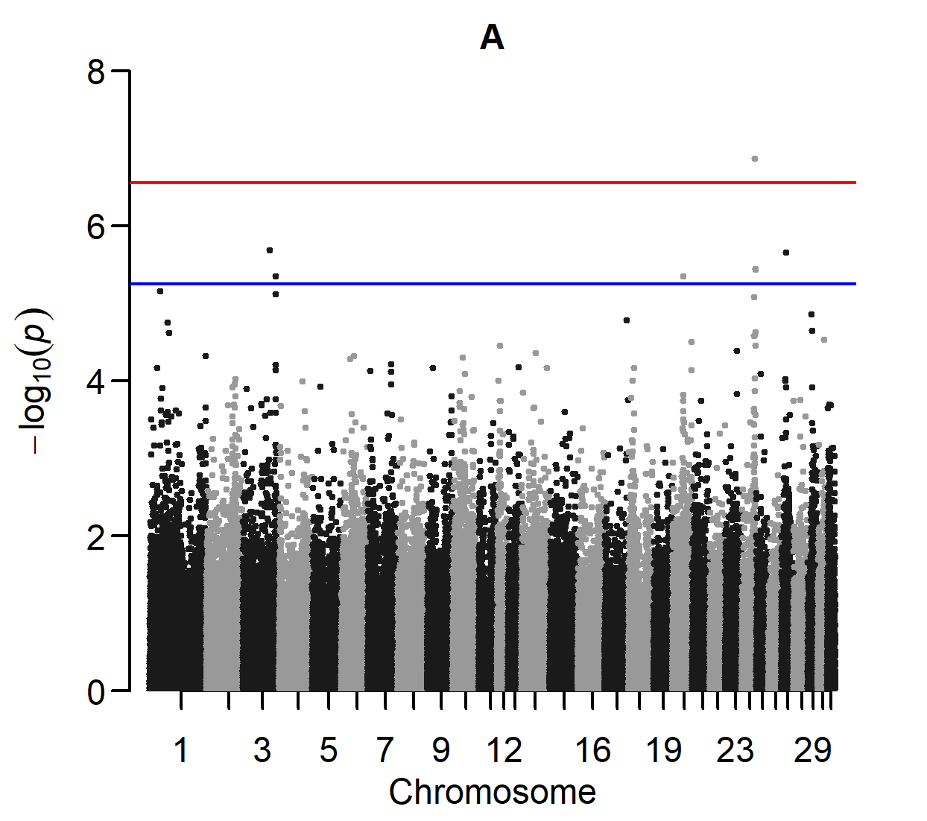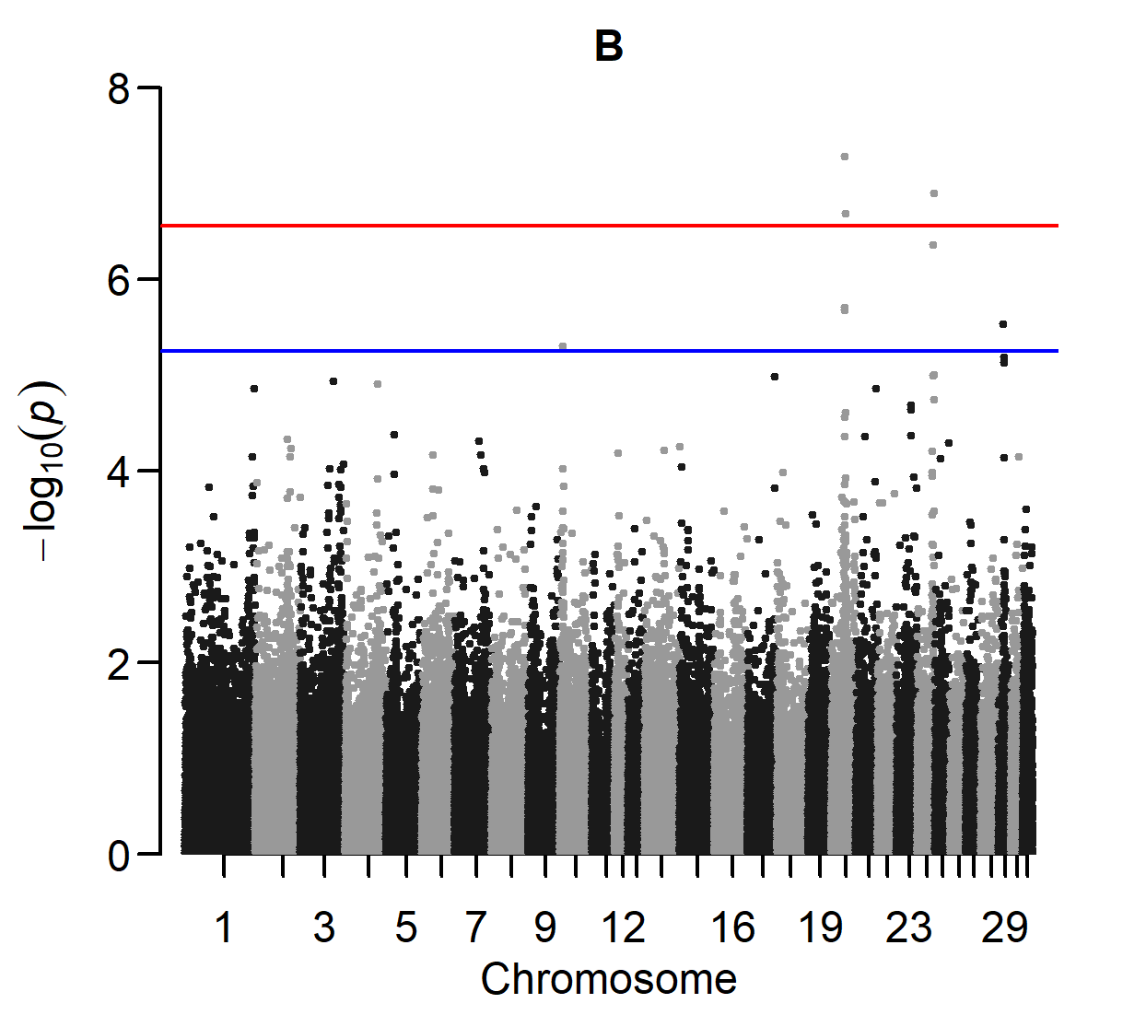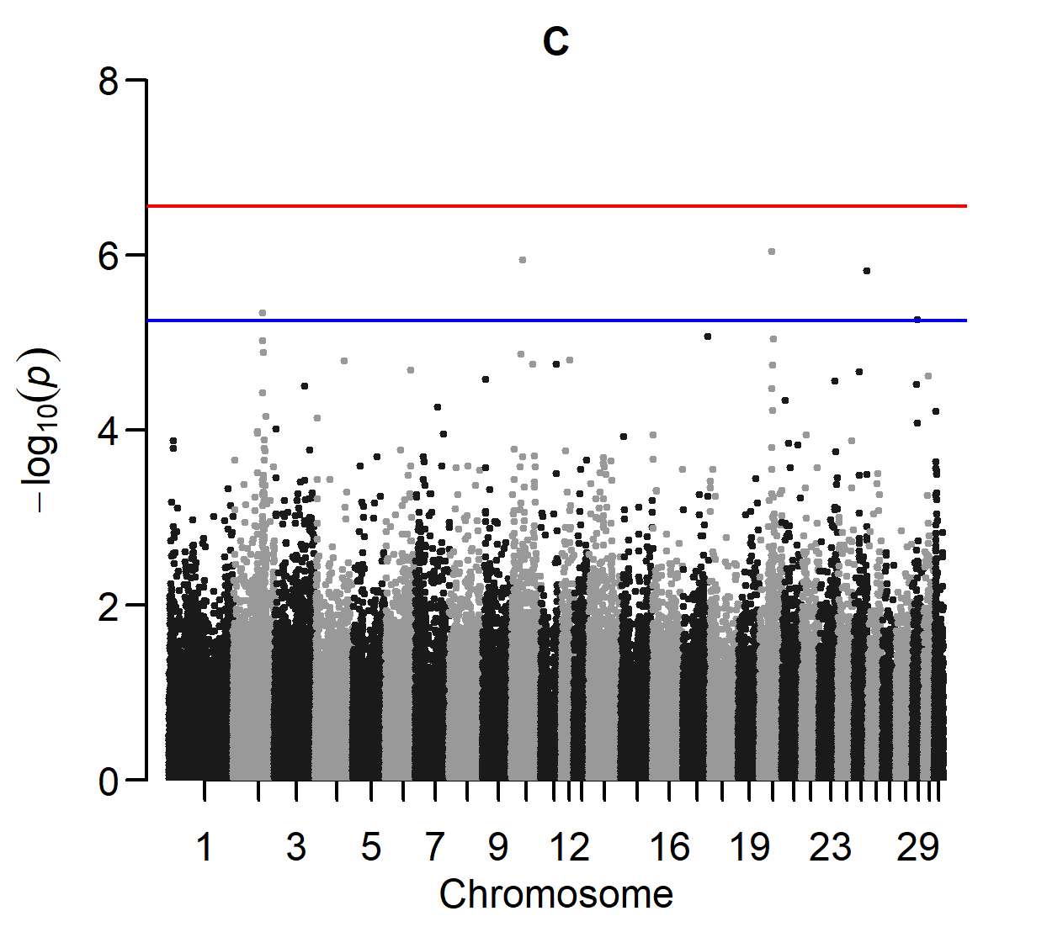

Manhattan plots of three GWAS for hock OC.
A: Cases are horses with OC (score ≥ 3) at the distal intermediate ridge of the tibia and/or lateral trochlear ridge of the talus and/or medial malleolus of the tibia. Controls are horses with a normal bone contour (score 0) at these sites (187 cases and 478 controls).
B: Normal bone contour (score 0) at the lateral trochlear ridge of the femur and the dorsal part of the sagittal ridge of the third metacarpal/metatarsal bone is additionally required (121 cases and 325 controls).
C: Absence of DOF, POF and other osteochondral fragments in the fetlock joint (score 0), together with a normal bone contour (score 0) at the medial trochlear ridge of the femur, medial trochlear ridge of the talus and articular surface of the patella, is additionally required (82 cases and 236 controls).

Supplementary Figure S5

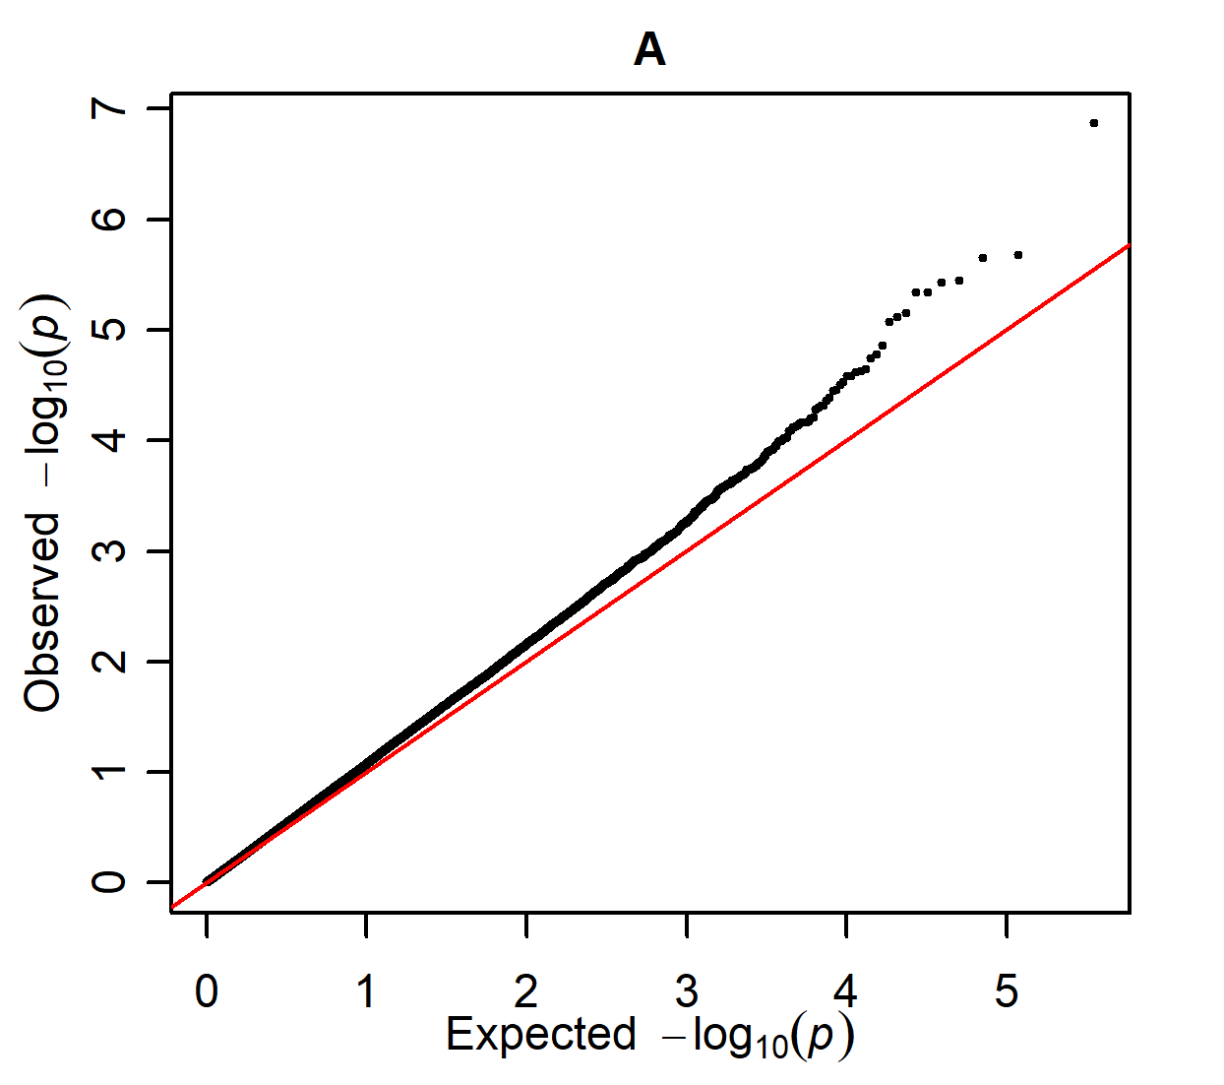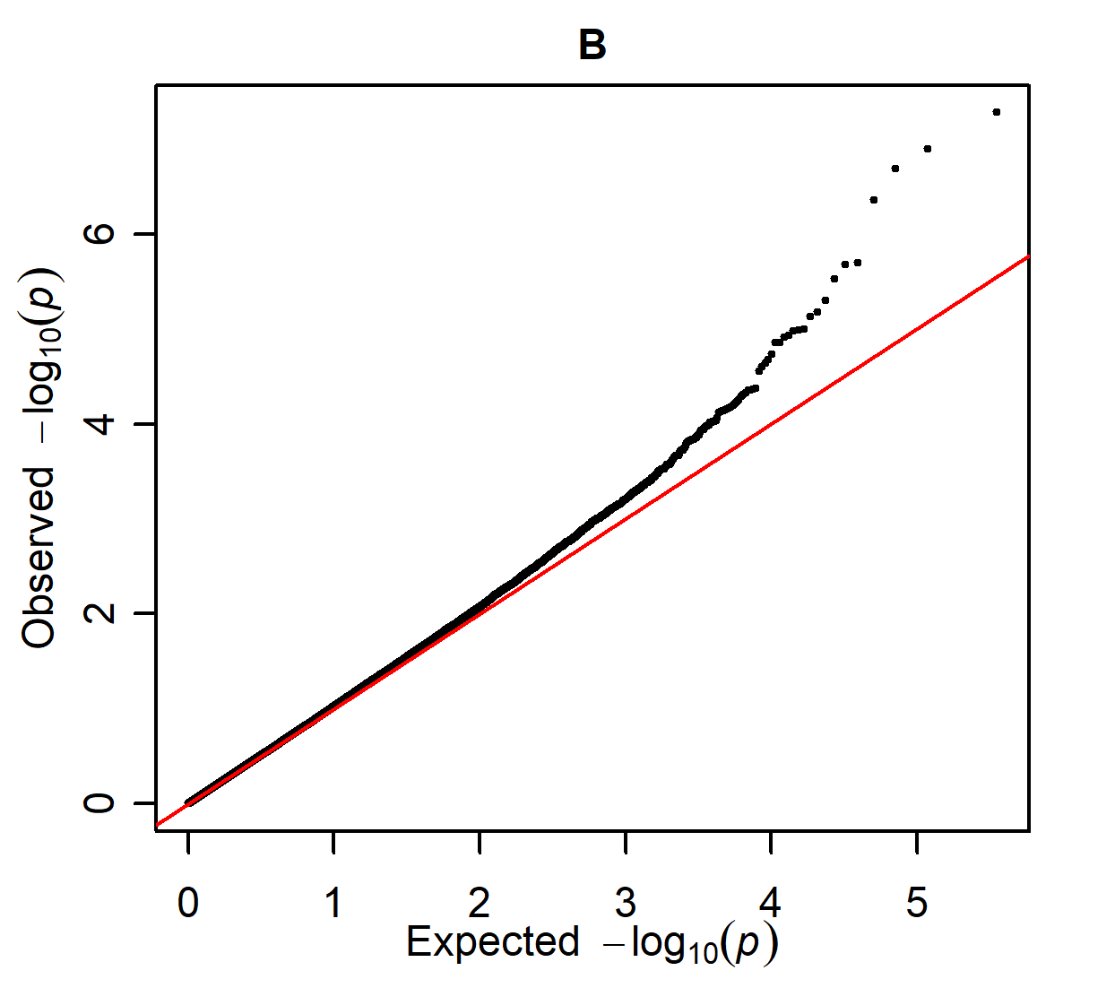
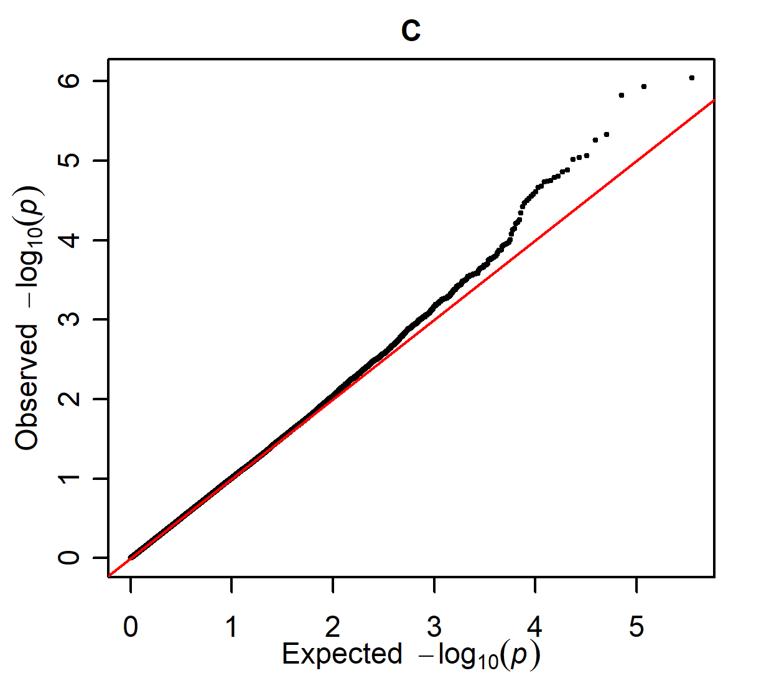

Q-Q plots of three GWAS for hock OC, as presented in supplementary figure S4.

Supplementary Figure S6

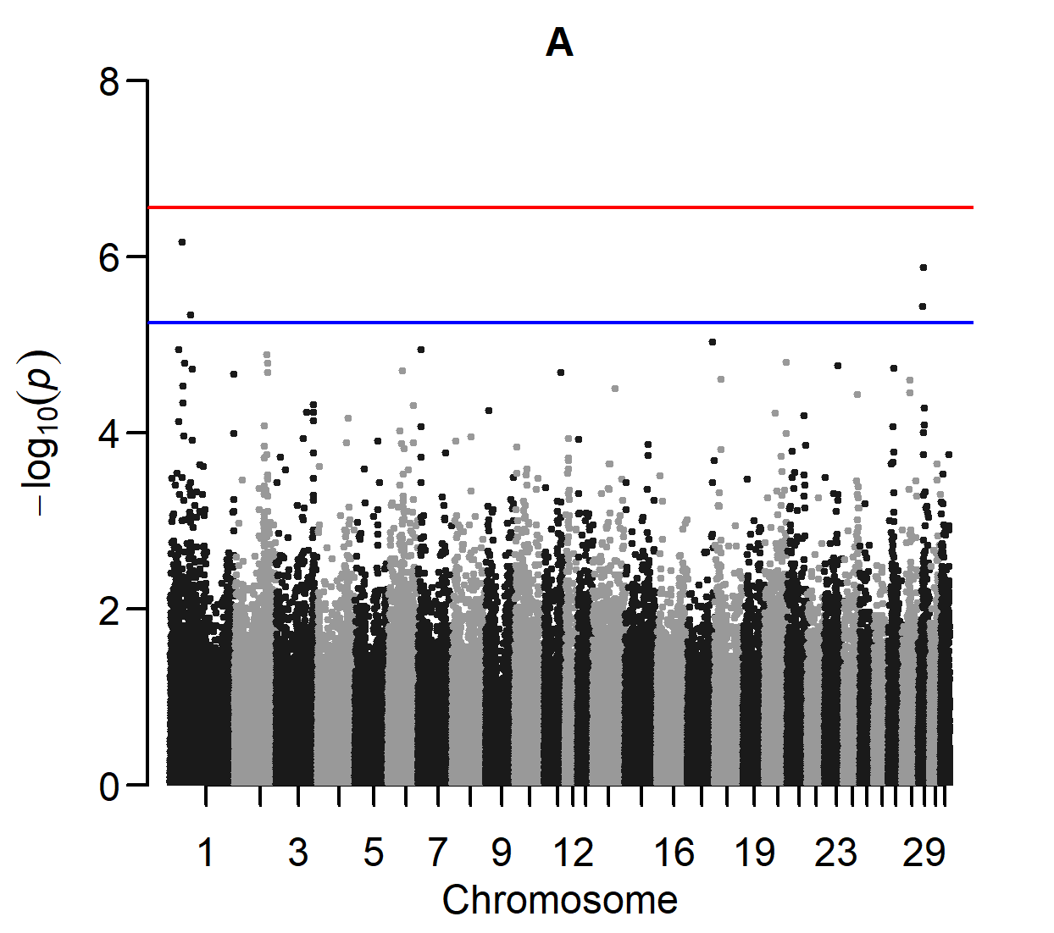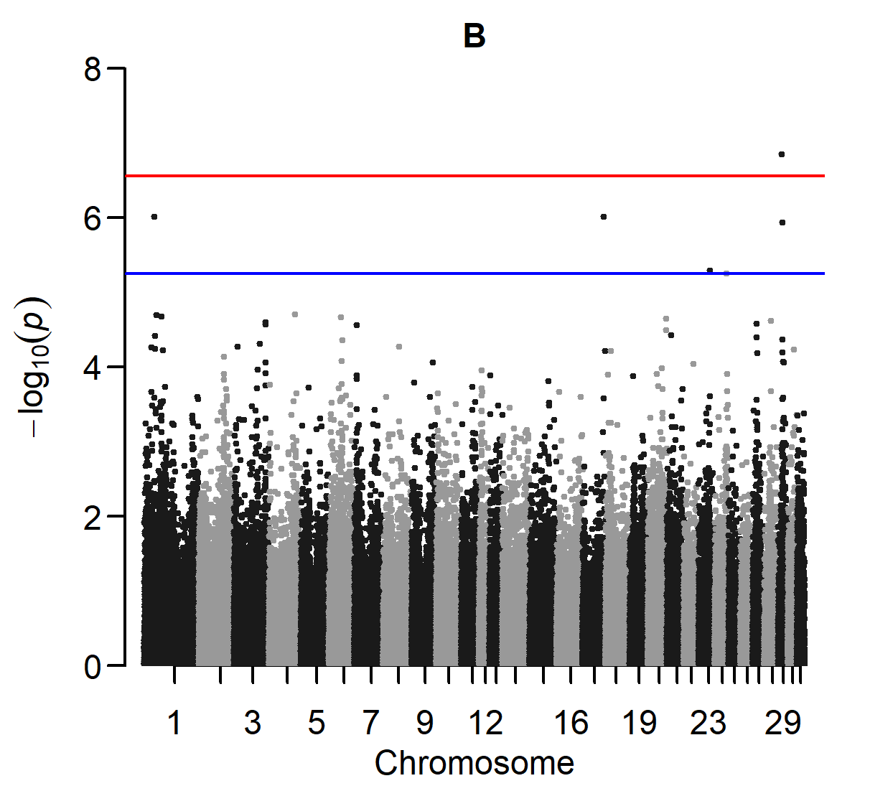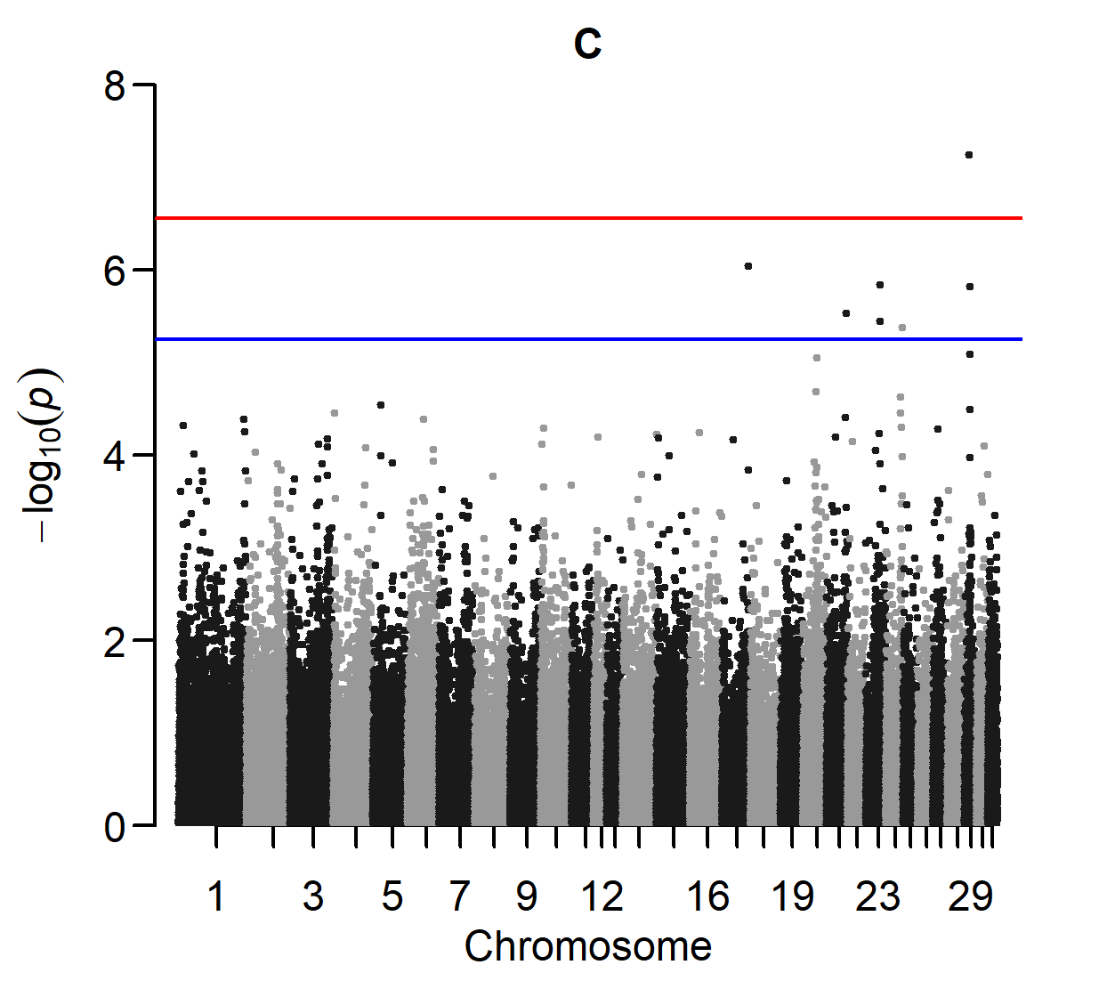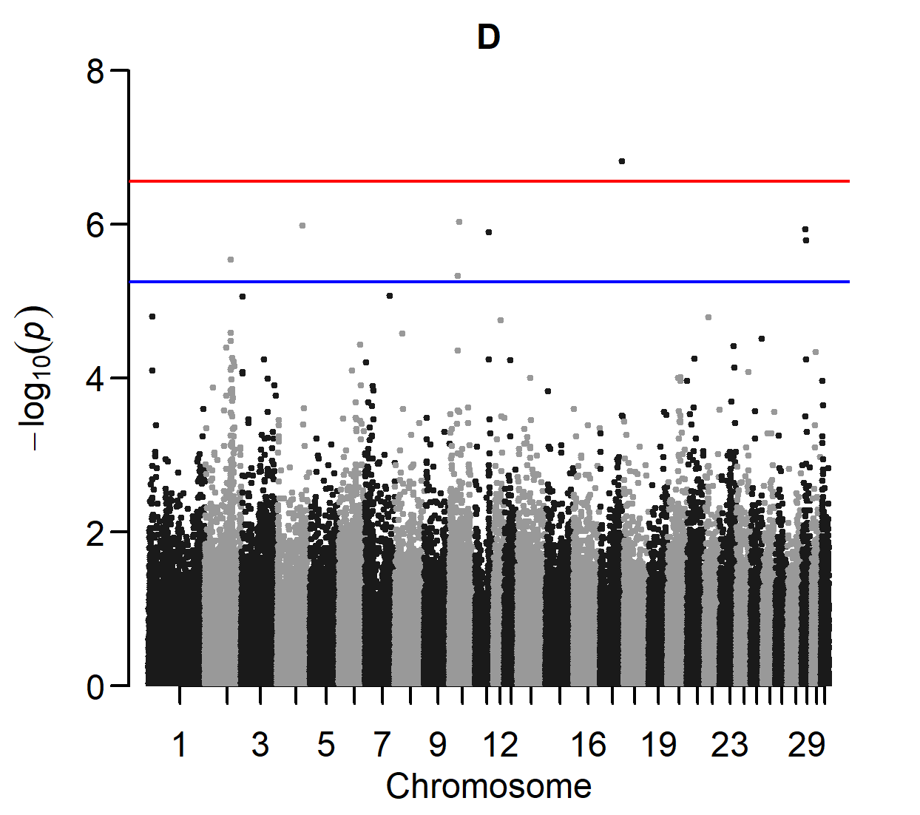

Manhattan plots of four GWAS for OC of the distal intermediate ridge of the tibia, the most common predilection site of hock OC.
A: cases are horses with OC (score ≥ 3) at the distal intermediate ridge of the tibia. Controls are horses with a normal bone contour (score 0) at this site (165 cases and 504 controls).
B: normal bone contour (score 0) at the lateral trochlear ridge of the talus and the medial malleolus of the tibia is additionally required (146 cases and 478 controls).
C: normal bone contour (score 0) at the lateral trochlear ridge of the femur and the dorsal part of the sagittal ridge of the third metacarpal/metatarsal bone is additionally required (100 cases and 325 controls).
D: Absence of DOF, POF, and other osteochondral fragments in the fetlock joint (score 0), together with a normal bone contour (score 0) at the medial trochlear ridge of the femur, medial trochlear ridge of the talus and articular surface of the patella, is additionally required (66 cases and 236 controls).

Supplementary Figure S7

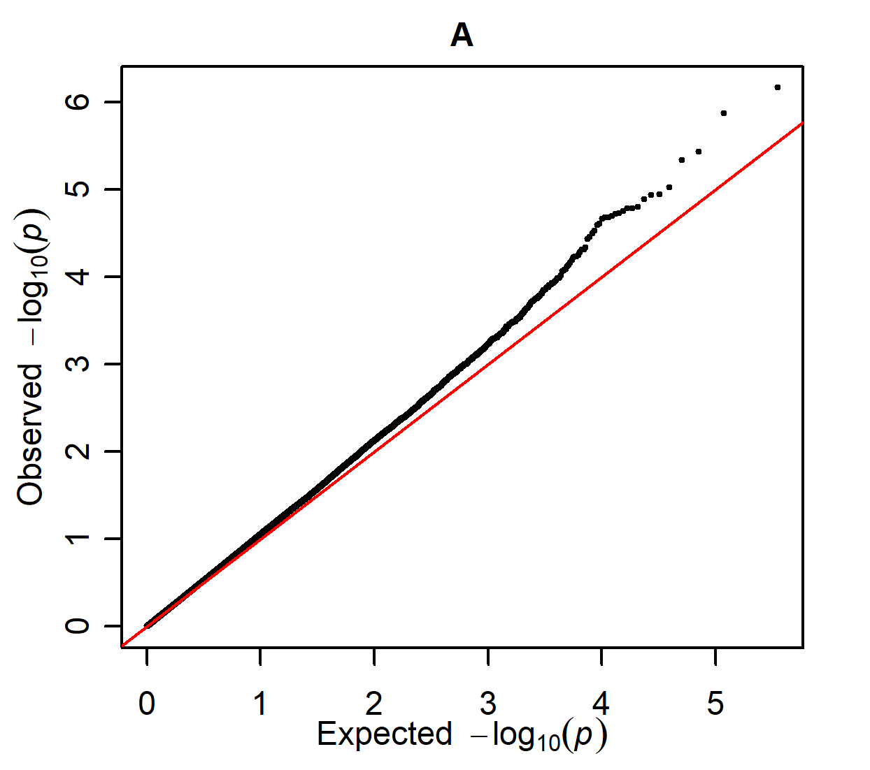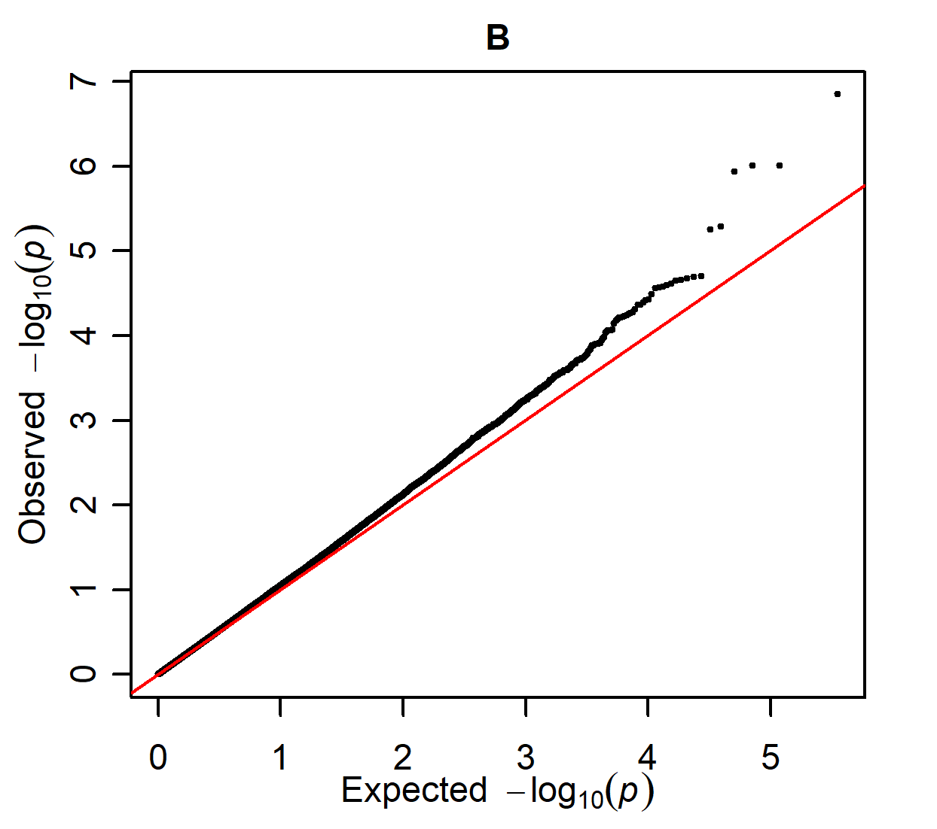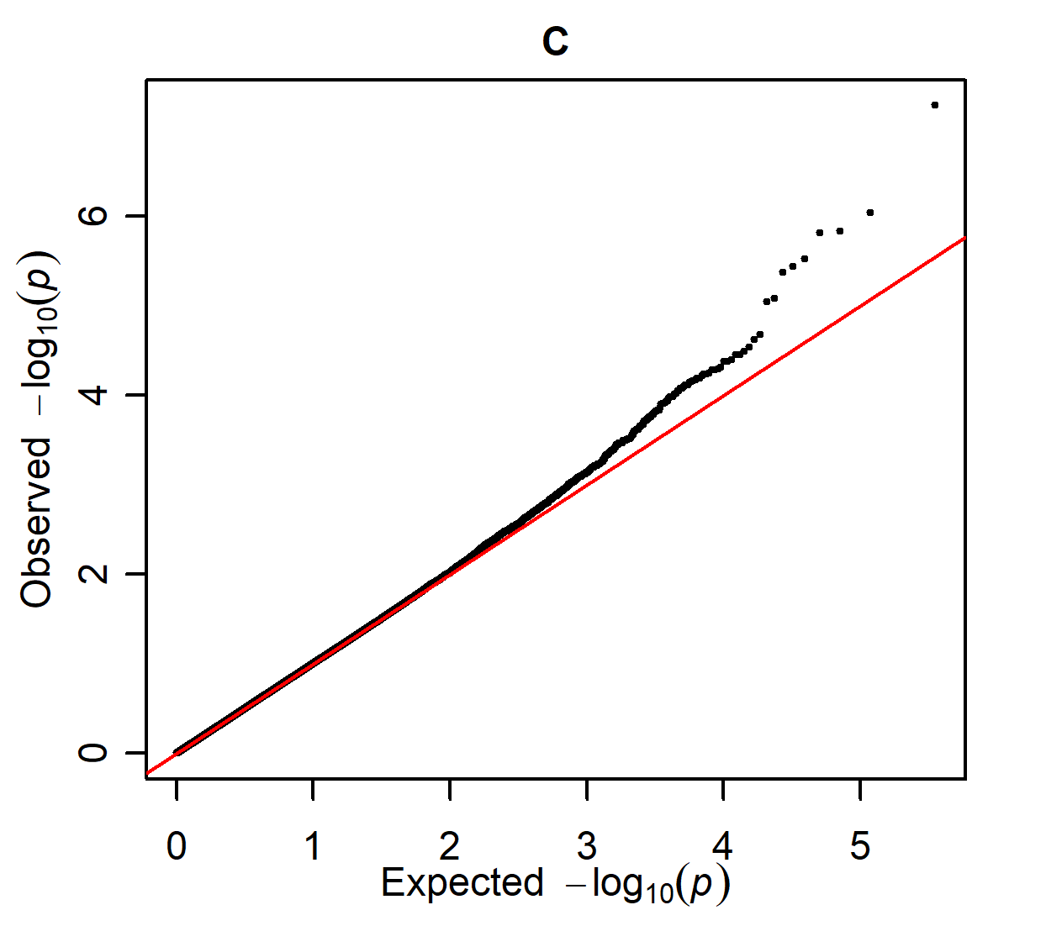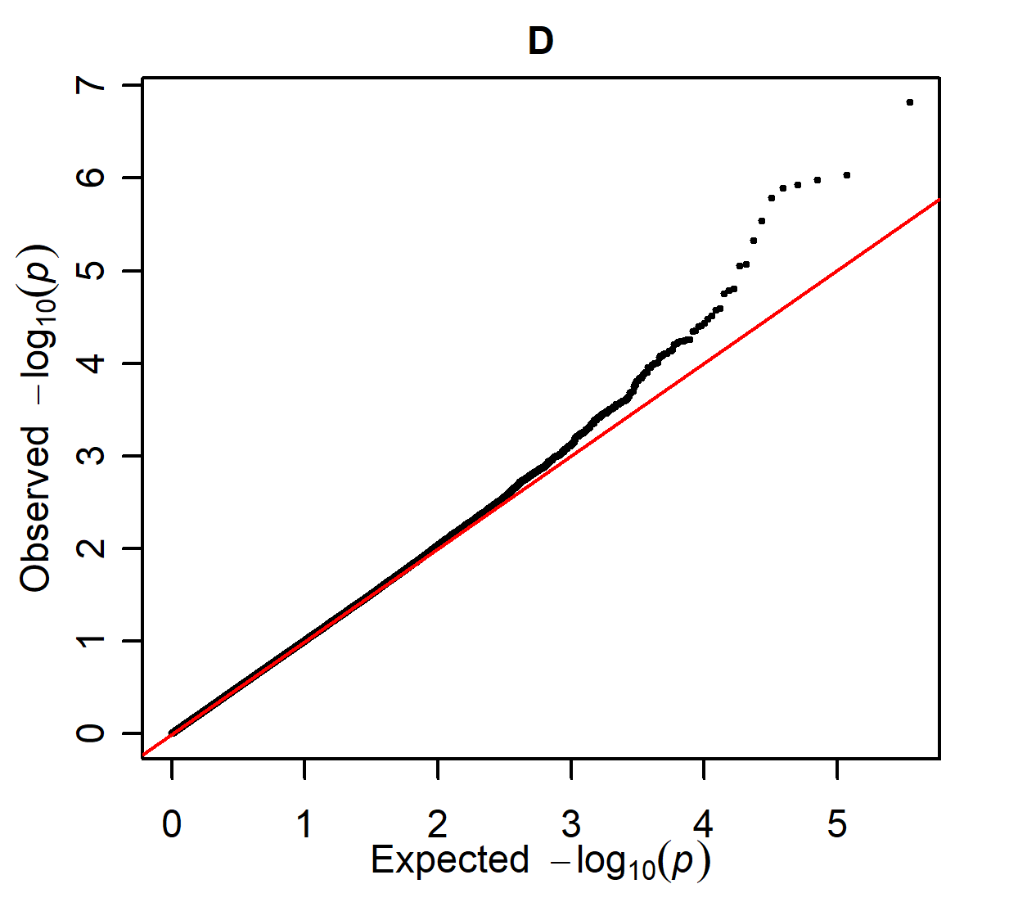

Q-Q plots of the four GWAS for OC of the distal intermediate ridge of the tibia, as presented in supplementary figure S6.

Supplementary Figure S8

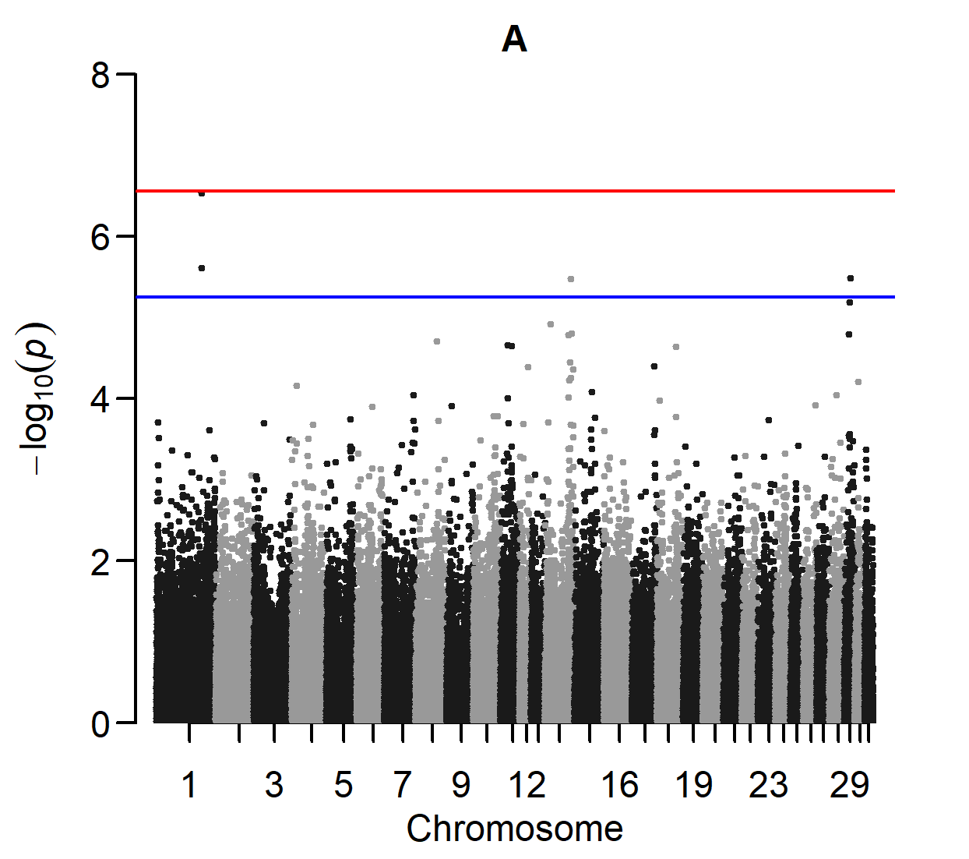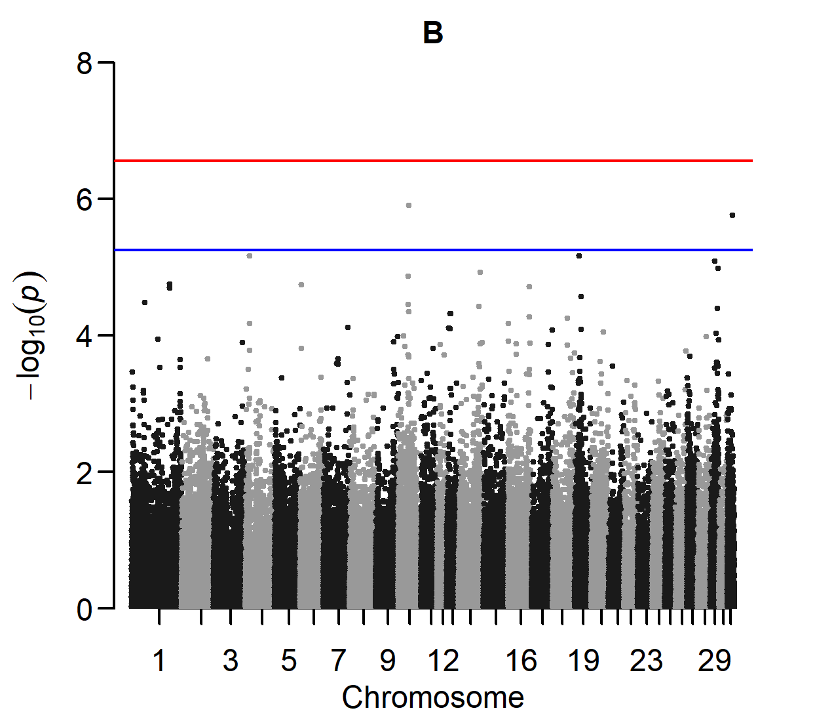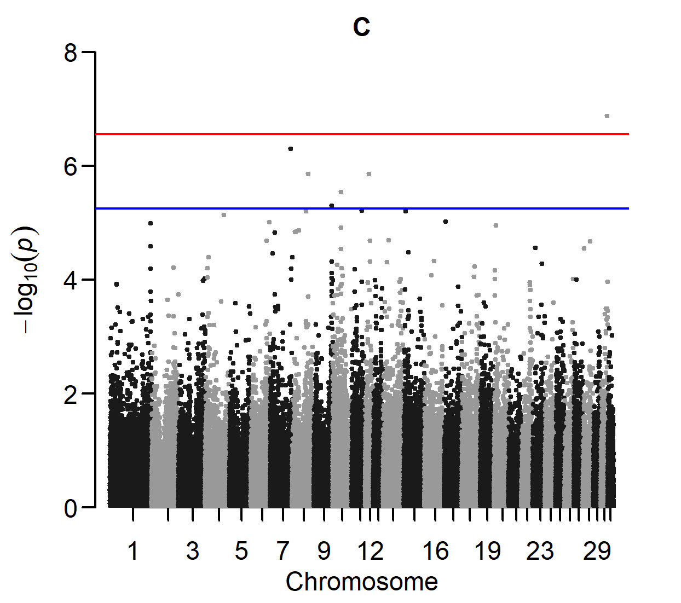

Manhattan plots of three GWAS for stifle OC.
A: Cases are horses with OC (score ≥ 3) at the lateral trochlear ridge of the femur. Controls are horses with a normal bone contour (score 0) at this site (110 cases and 588 controls).
B: Normal bone contour (score 0) at the distal intermediate ridge of the tibia, lateral trochlear ridge of the talus, medial malleolus of the tibia and the dorsal part of the sagittal ridge of the third metacarpal/metatarsal bone is additionally required (52 cases and 325 controls).
C: Absence of DOF, POF and other osteochondral fragments in the fetlock joint (score 0), together with a normal bone contour (score 0) at the medial trochlear ridge of the femur, medial trochlear ridge of the talus and articular surface of the patella, is additionally required (28 cases and 236 controls).

Supplementary Figure S9

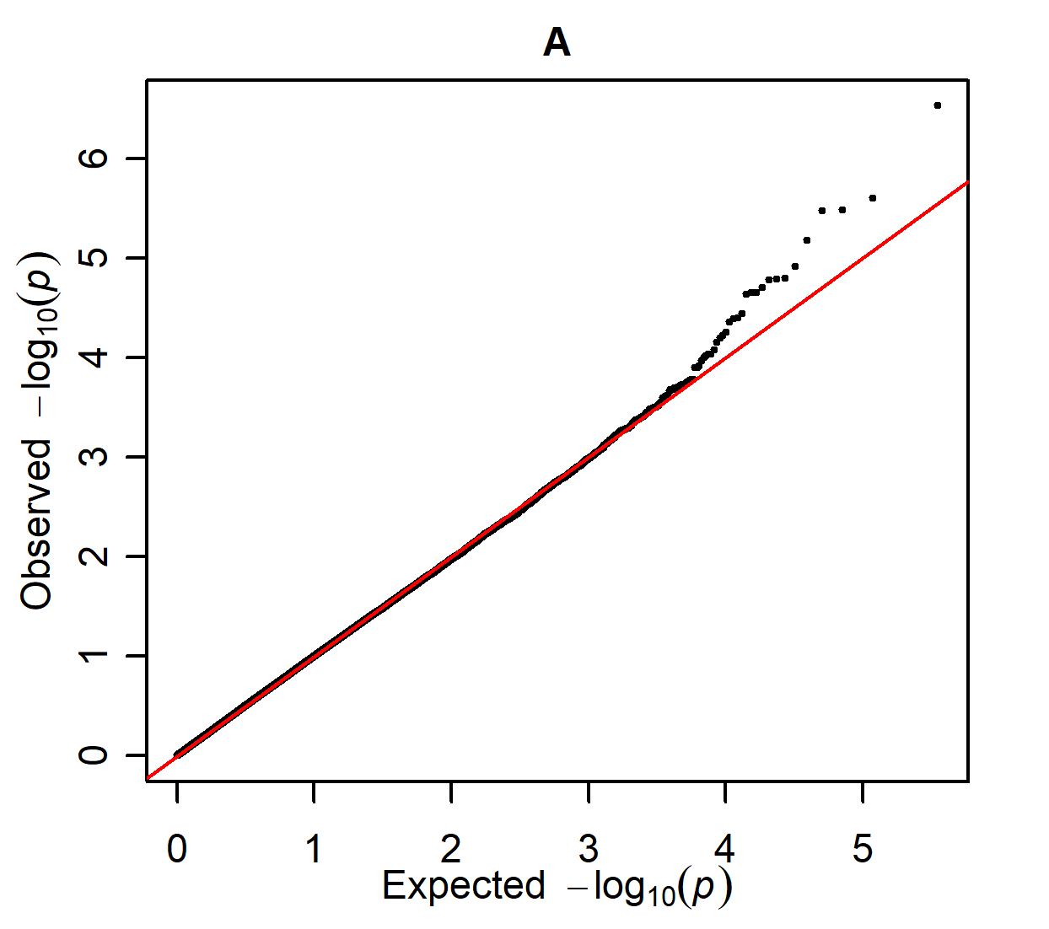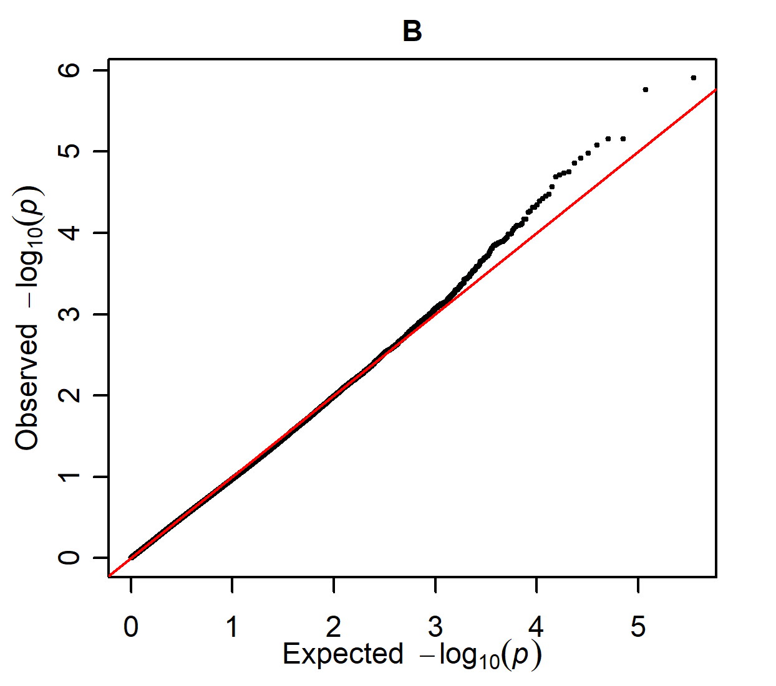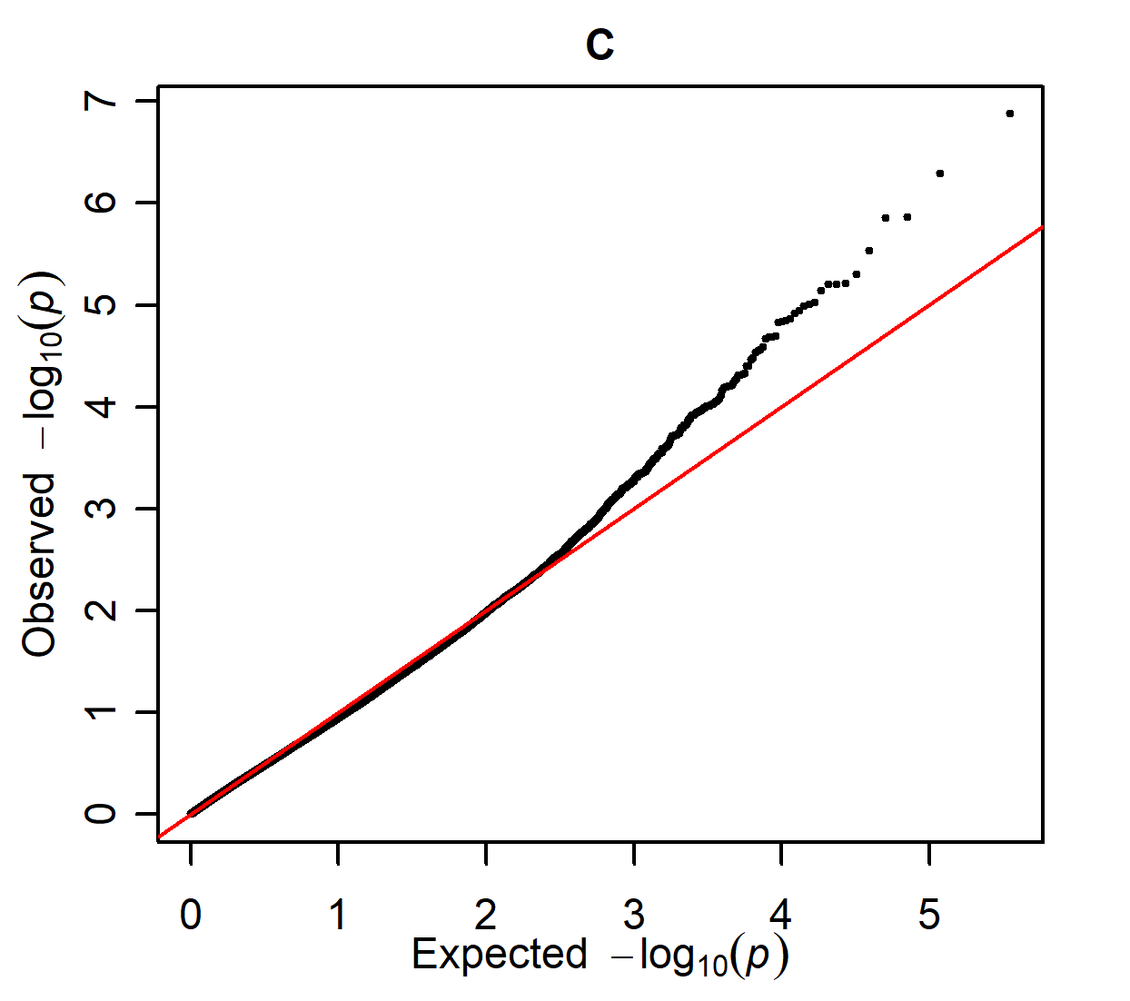

Q-Q plots of the three GWAS for stifle OC, as presented in supplementary figure S8.

Supplementary Figure S10

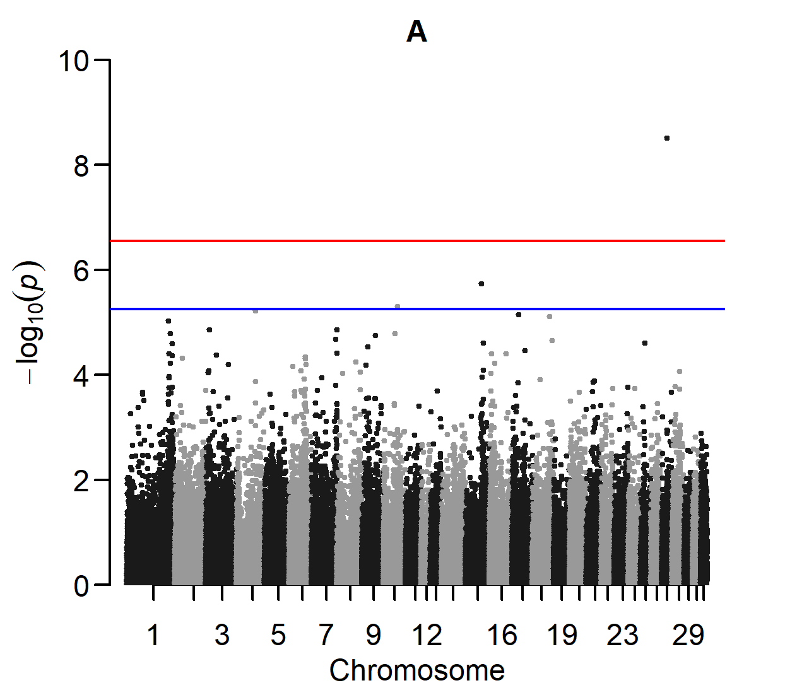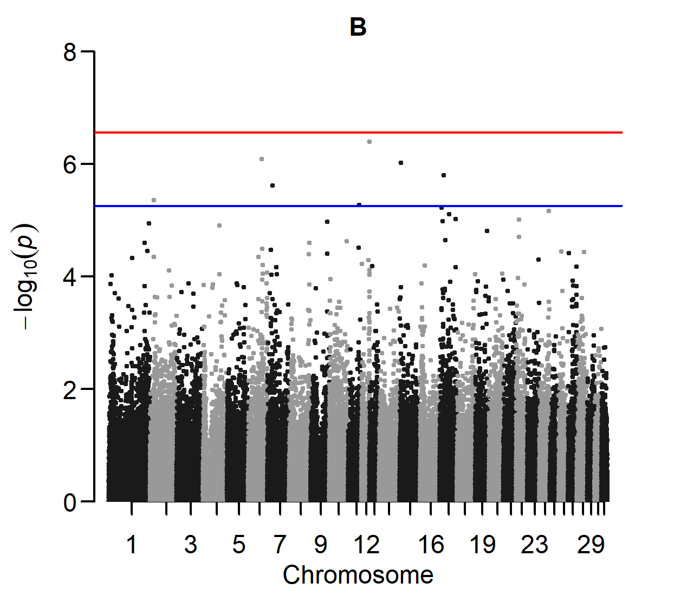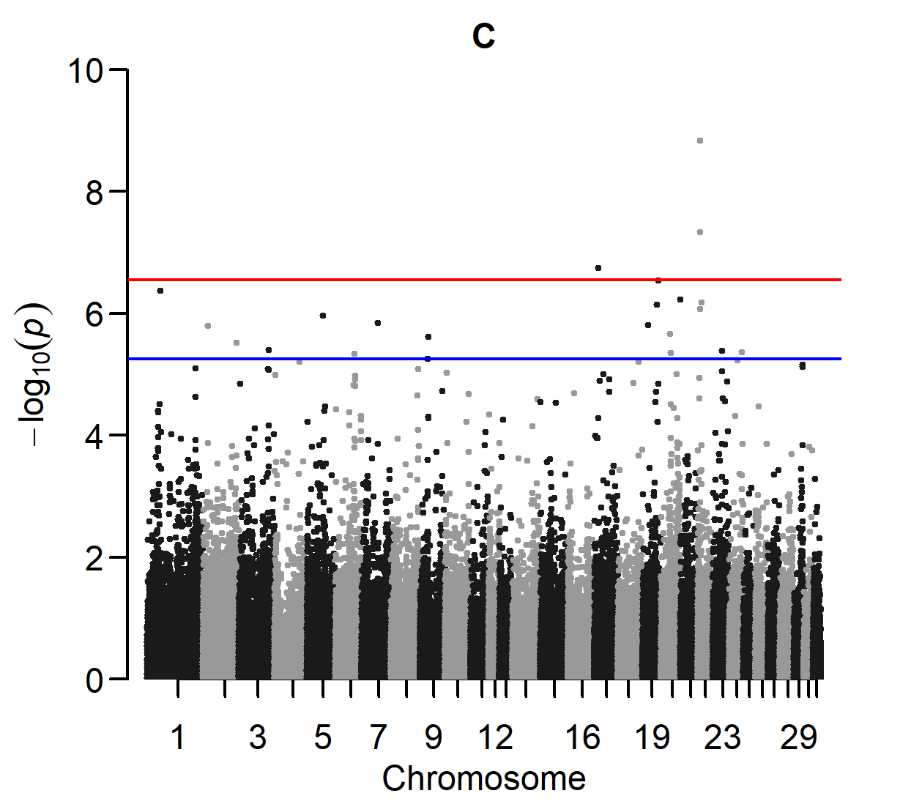

Manhattan plots of three GWAS for fetlock OC.
A: Cases are horses with OC (score ≥ 3) at the dorsal part of the sagittal ridge of the third metacarpal/metatarsal bone. Controls are horses with a normal bone contour (score 0) at this site (51 cases and 536 controls).
B: Normal bone contour (score 0) at the distal intermediate ridge of the tibia, lateral trochlear ridge of the talus, medial malleolus of the tibia and lateral trochlear ridge of the femur is additionally required (22 cases and 325 controls).
C: Absence of DOF, POF, and other osteochondral fragments in the fetlock joint (score 0), together with a normal bone contour (score 0) at the medial trochlear ridge of the femur, medial trochlear ridge of the talus and articular surface of the patella, is additionally required (13 cases and 236 controls).

Supplementary Figure S11

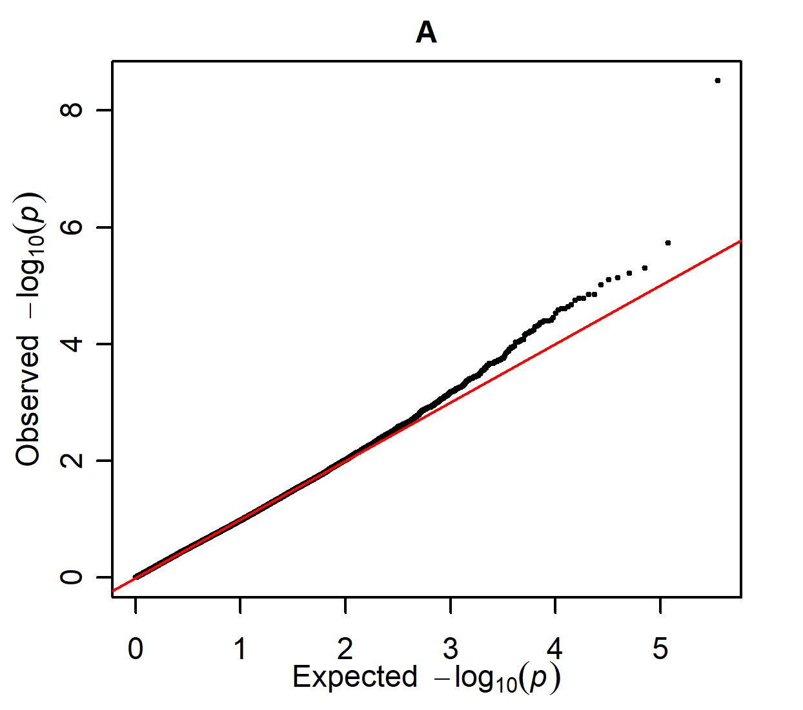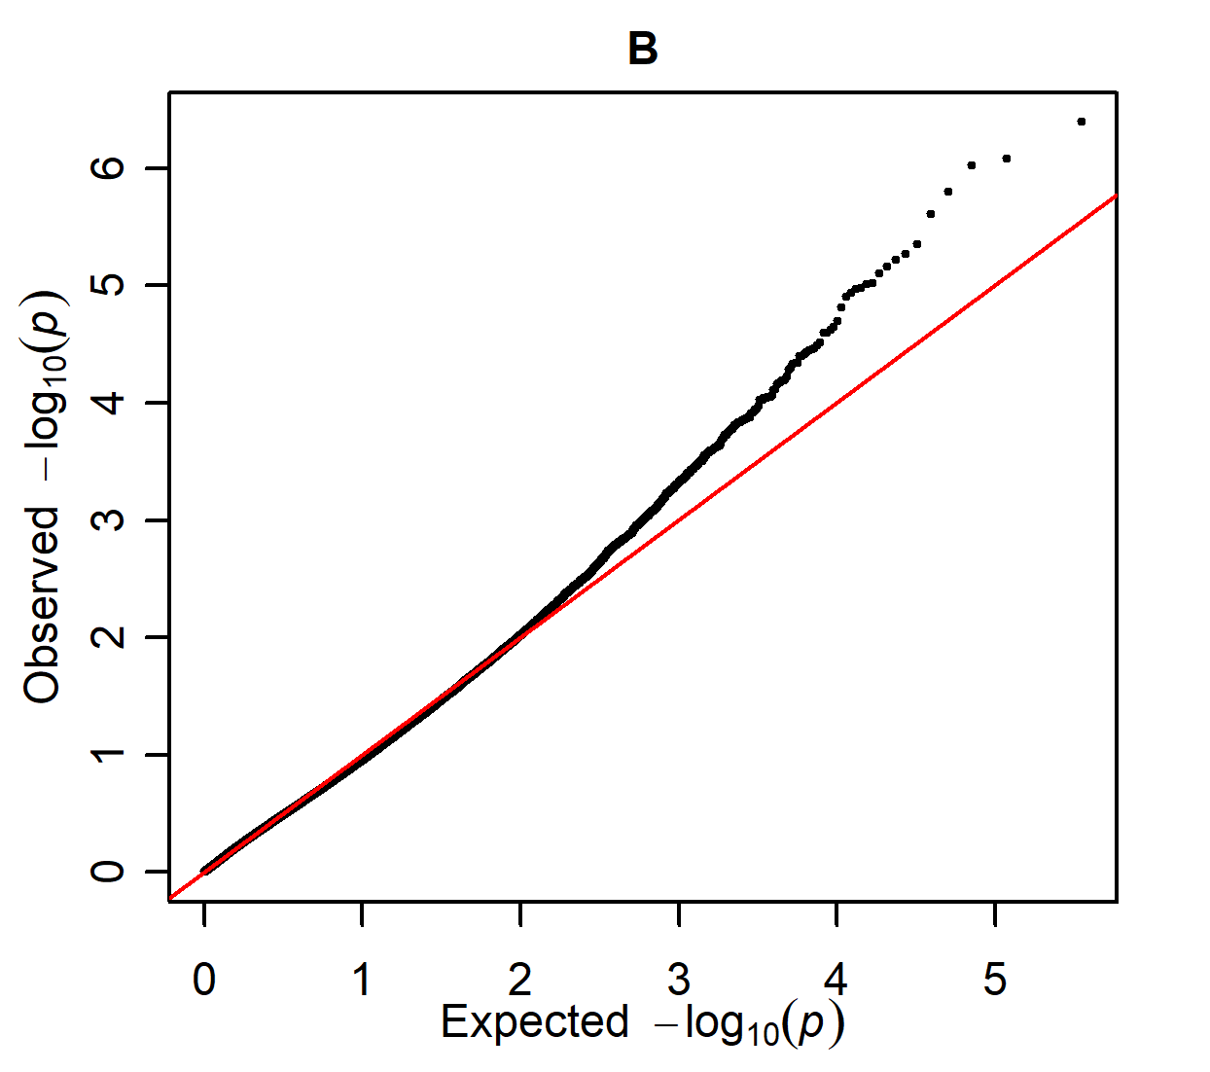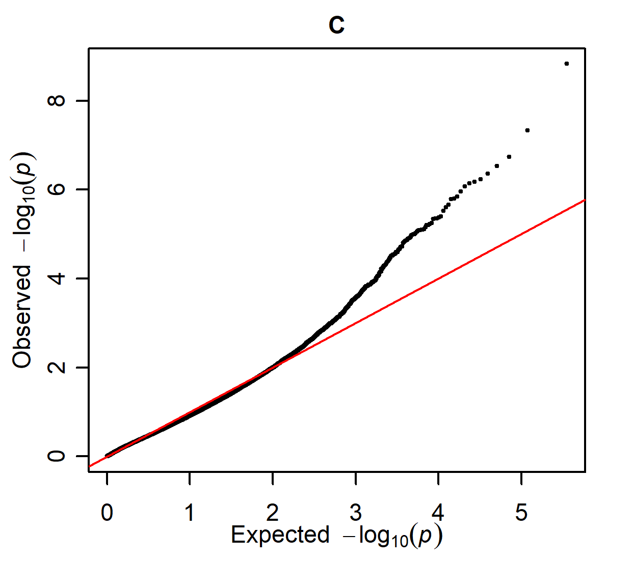

Q-Q plots of the three GWAS for fetlock OC, as presented in supplementary figure S10

Supplementary Figure S12

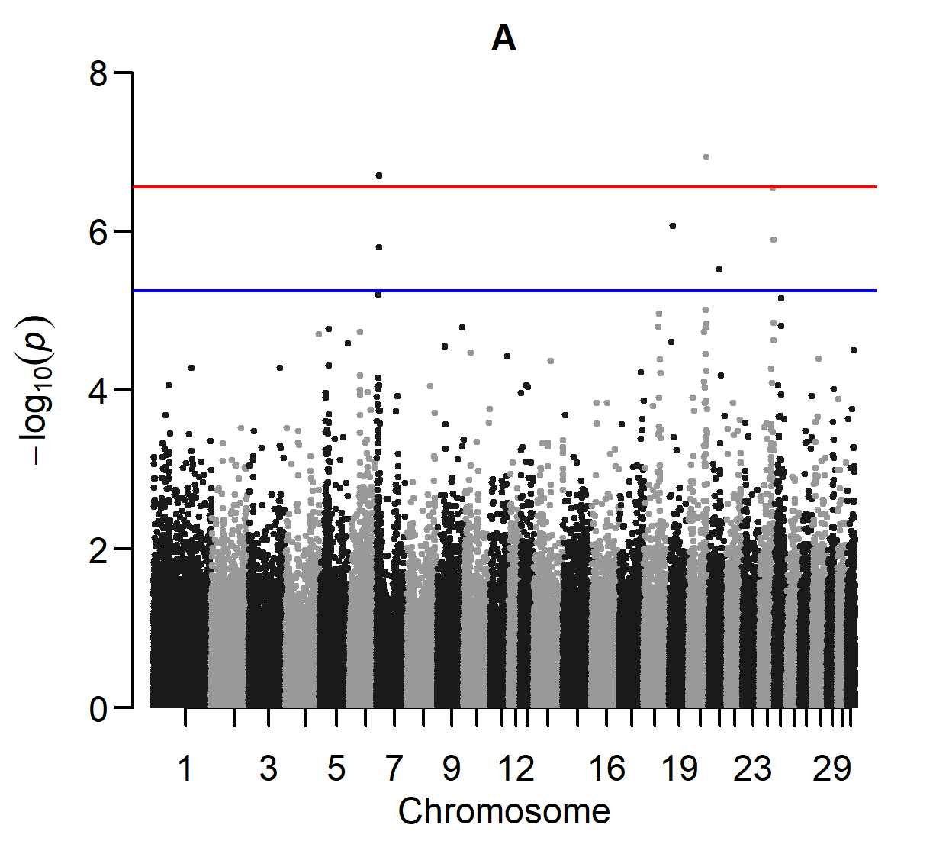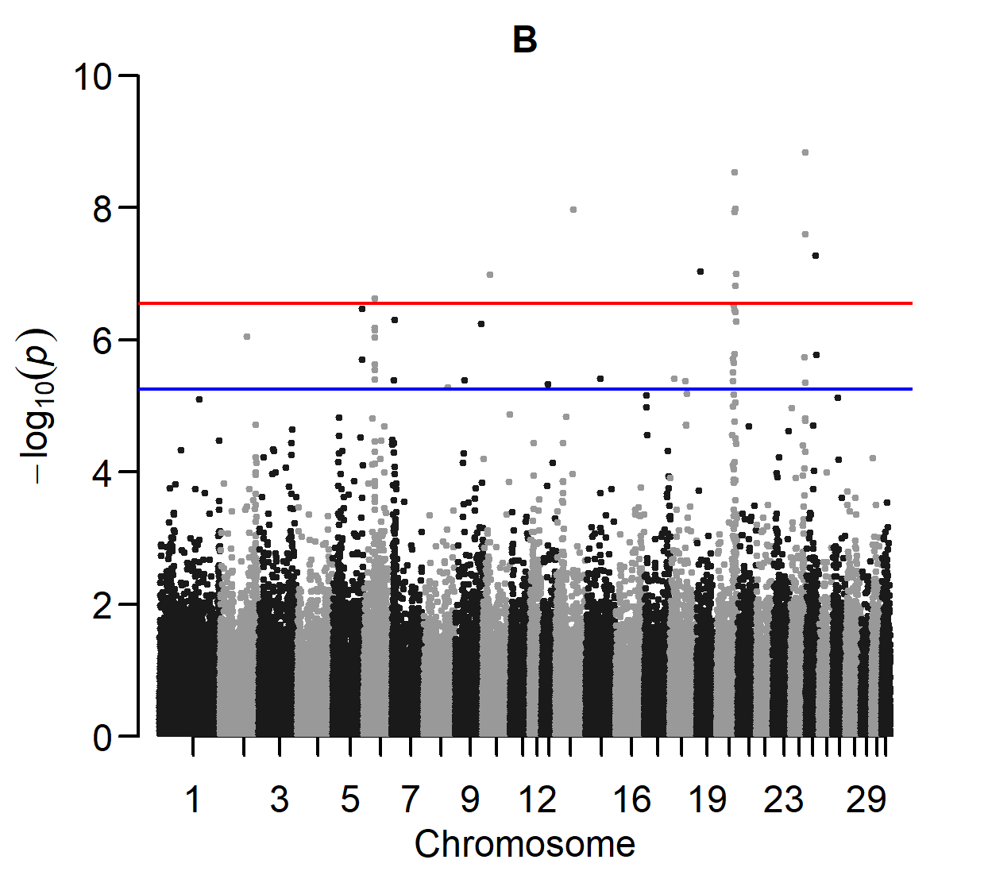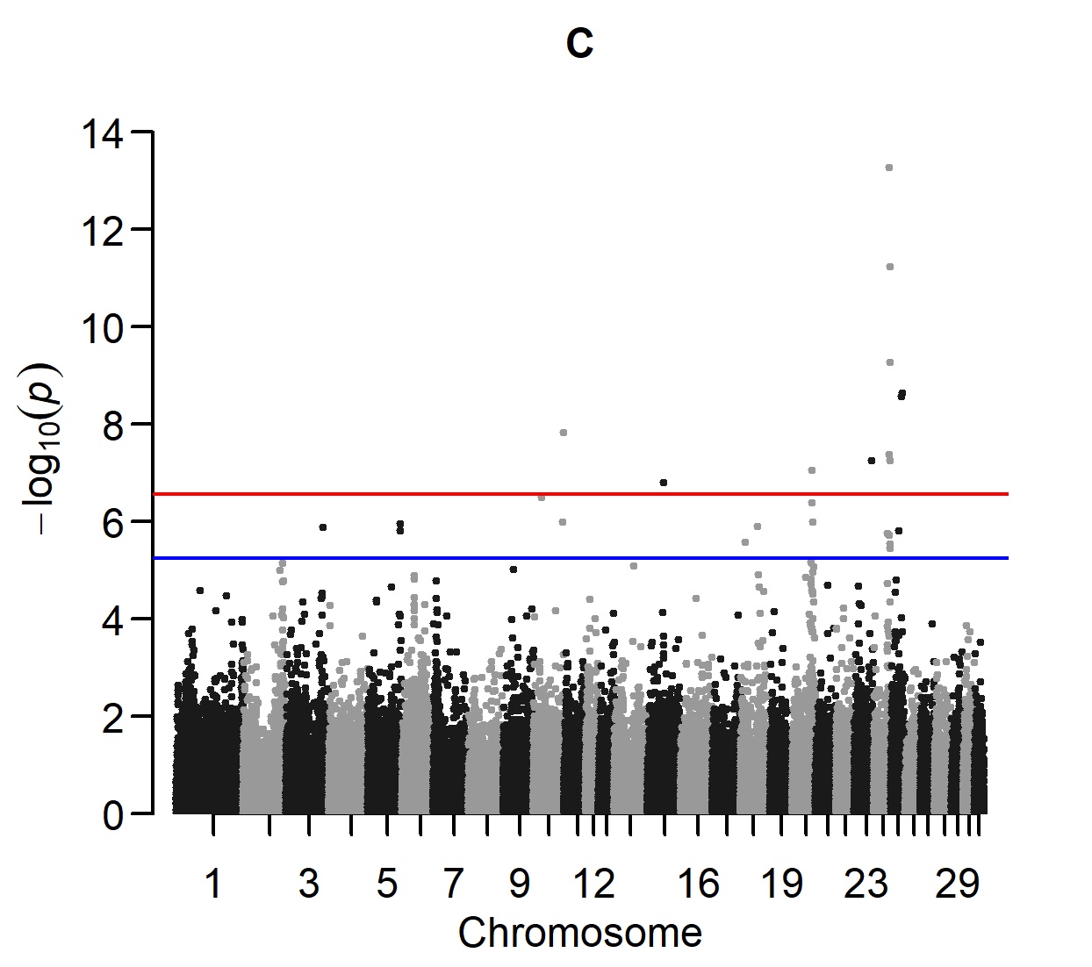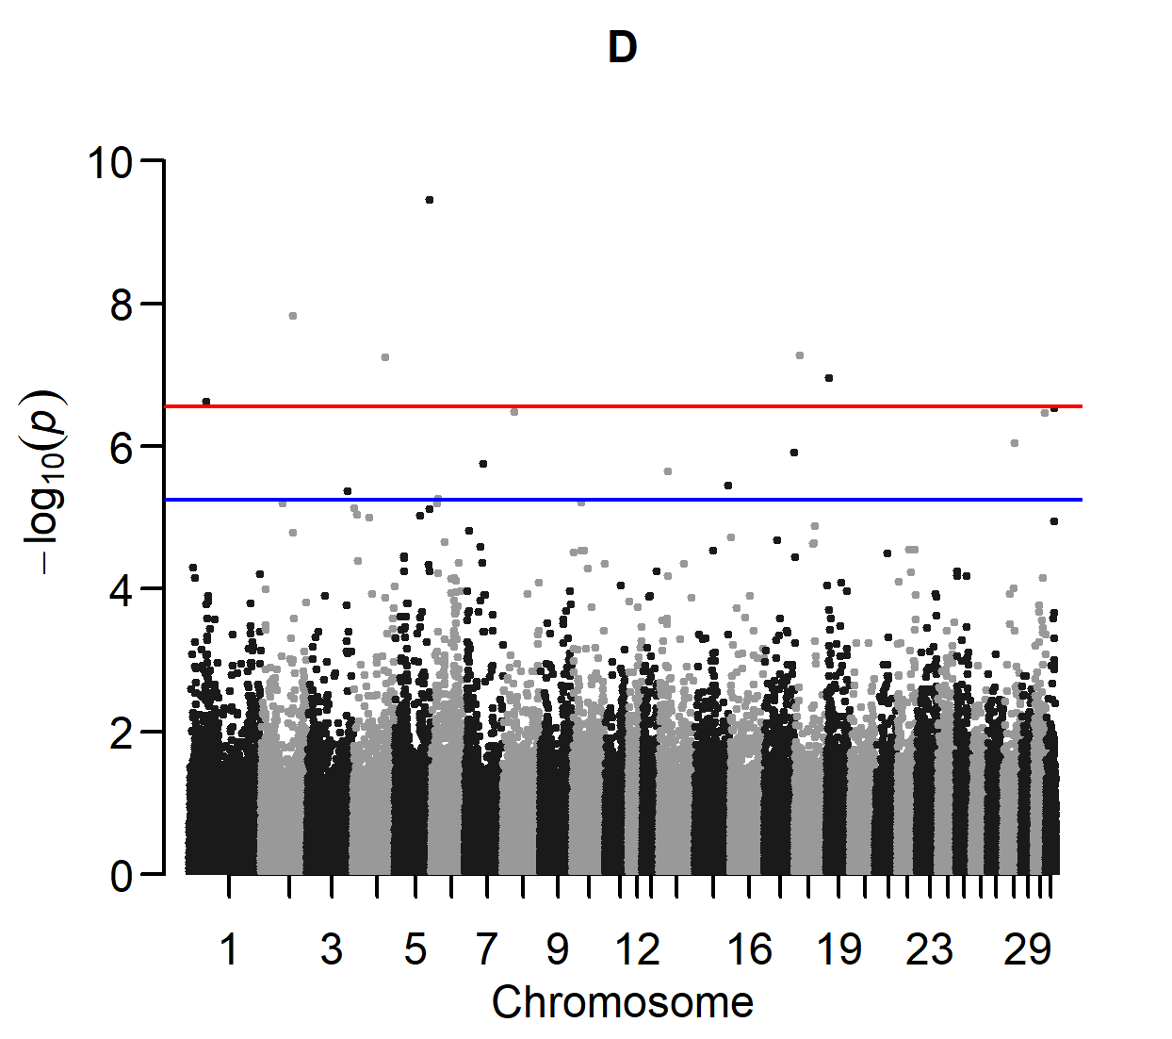

Manhattan plots of four GWAS for POF.
A: Cases are horses with POF in at least one of the fetlock joints. Controls are horses without POF (76 cases and 619 controls).
B: Absence of DOF and other osteochondral fragments in the fetlock joints is additionally required (47 cases and 486 controls).
C: Normal bone contour (score 0) at the dorsal part of the sagittal ridge of the third metacarpal/metatarsal bone is additionally required (40 cases and 394 controls).
D: Normal bone contour (score 0) at the distal intermediate ridge of the tibia, lateral trochlear ridge of the talus, medial malleolus of the tibia, lateral trochlear ridge of the femur, medial trochlear ridge of the femur, medial trochlear ridge of the talus and articular surface of the patella is additionally required (19 cases and 236 controls).

Supplementary Figure S13

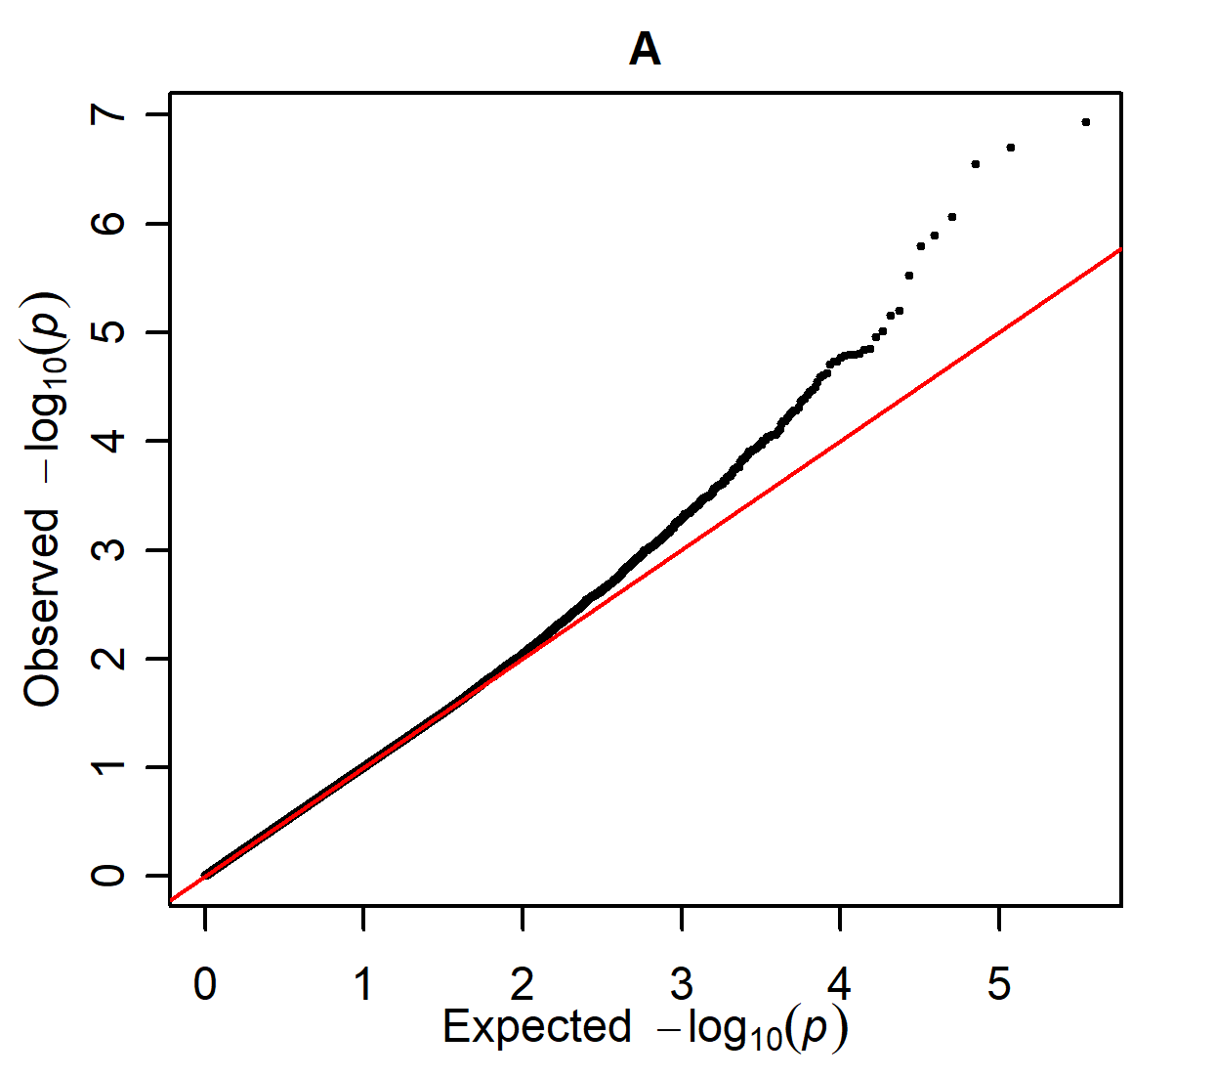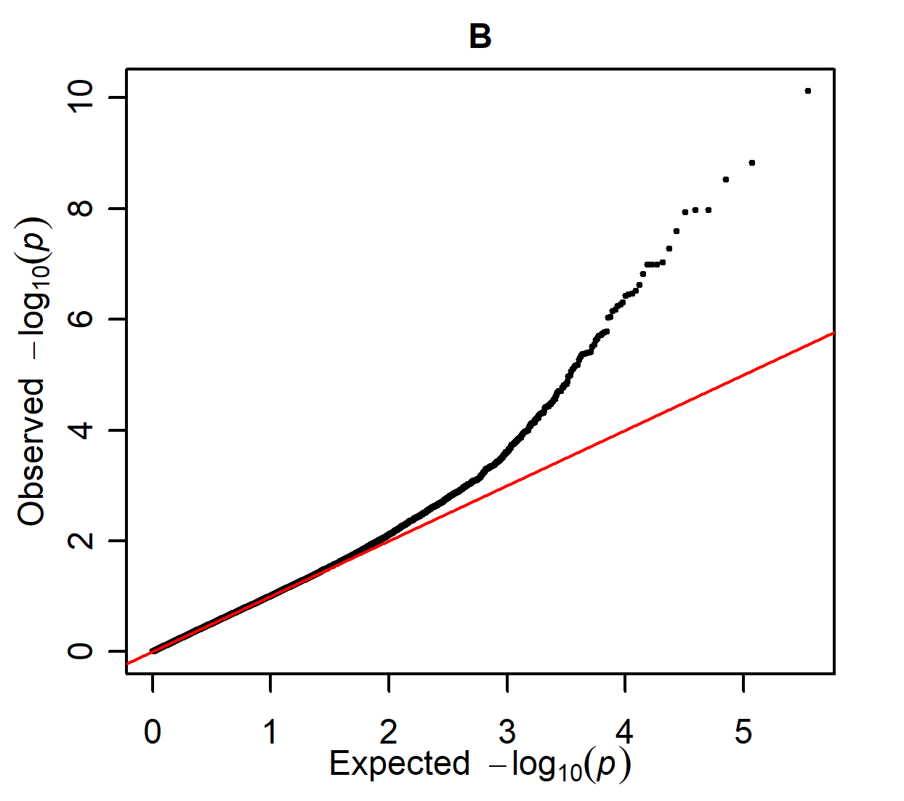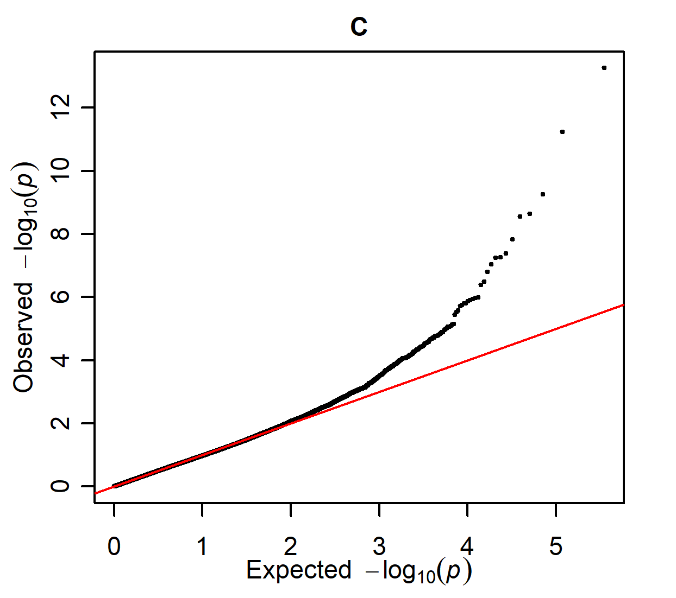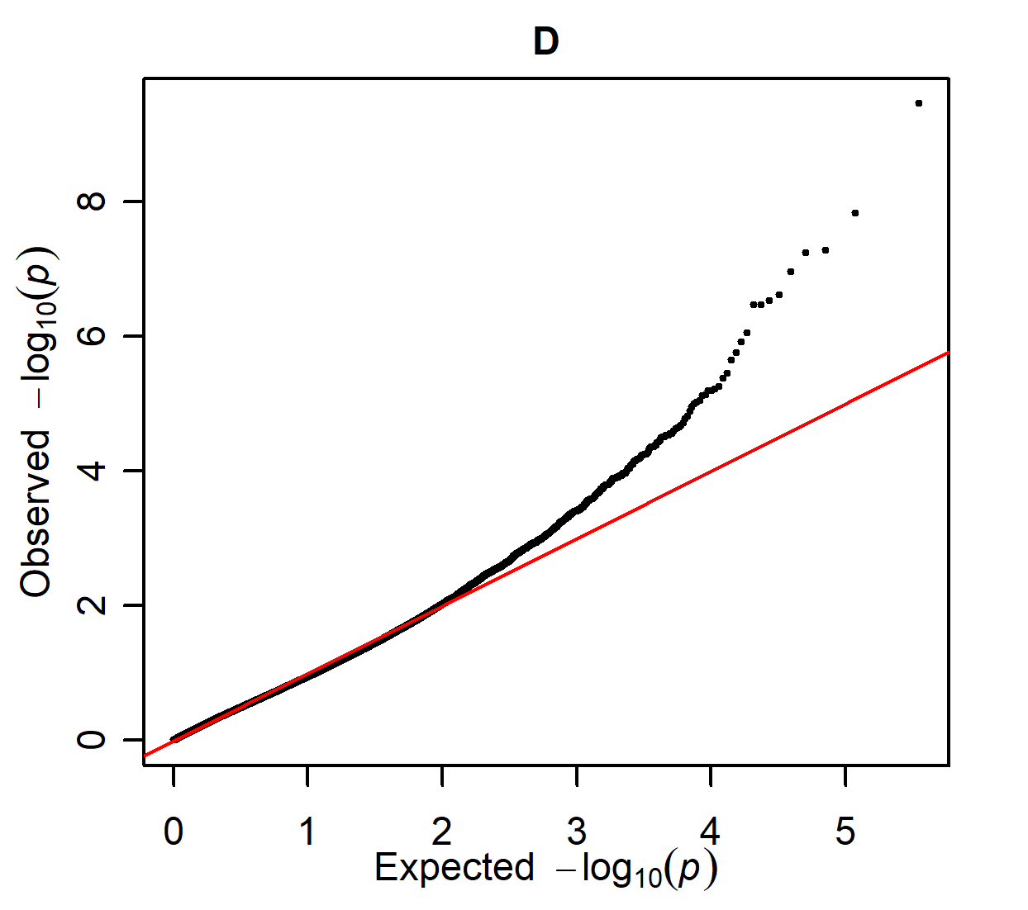

Q-Q plots of the four GWAS for POF, as presented in supplementary figure S12.

Supplementary Figure S14

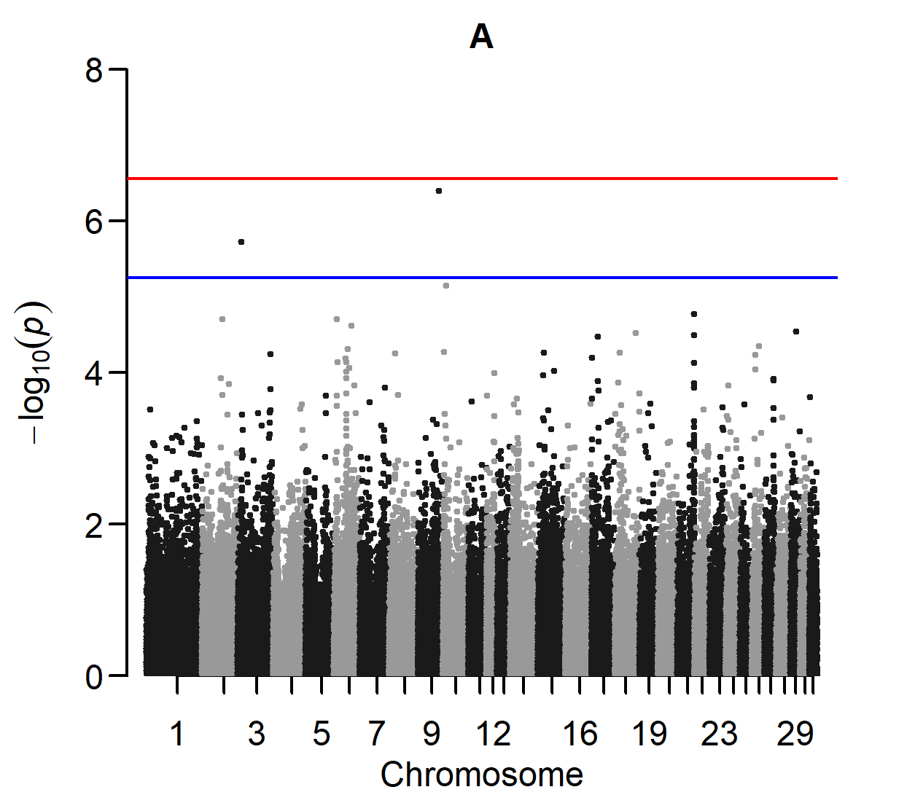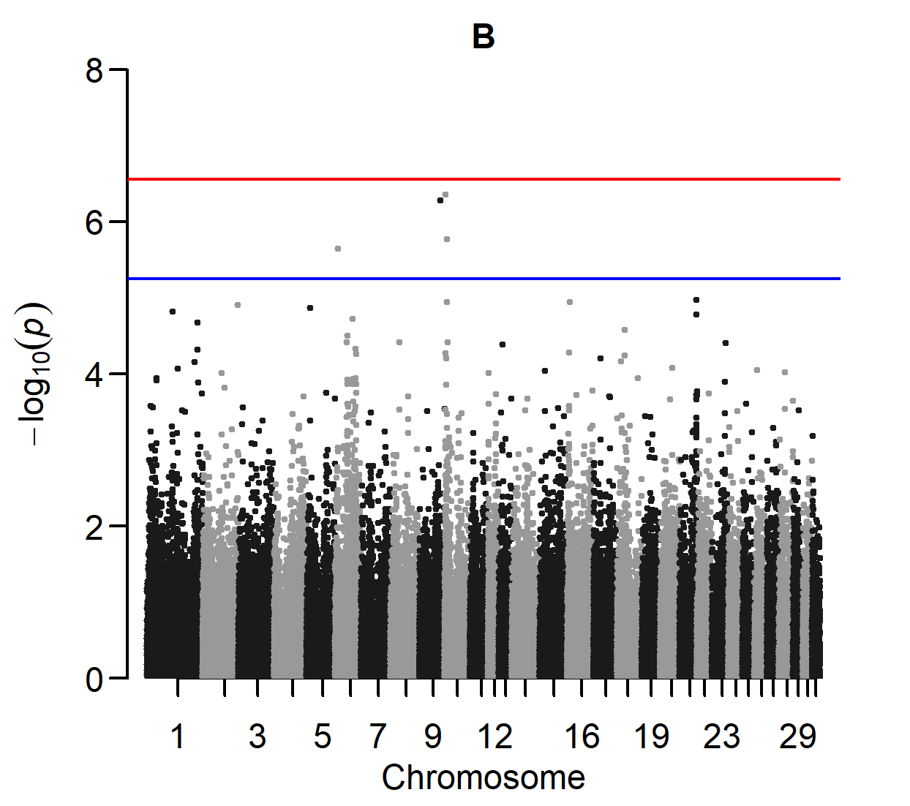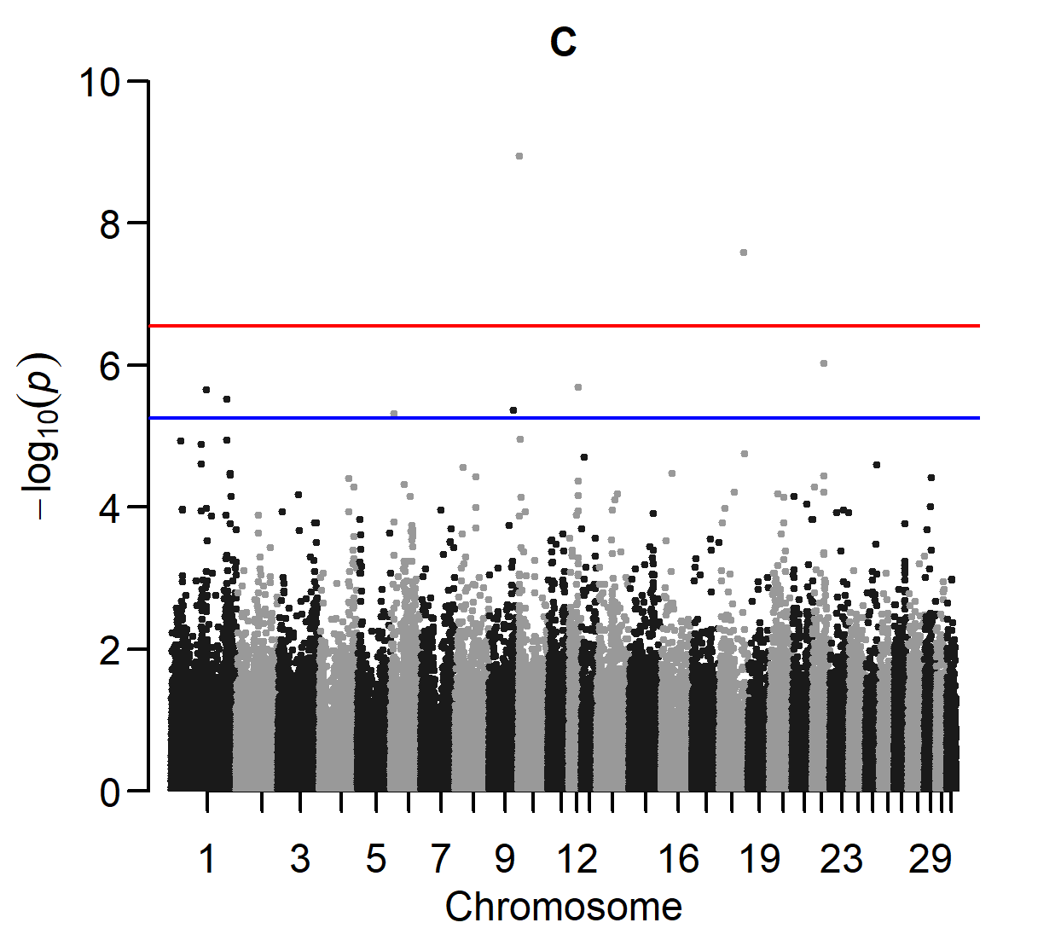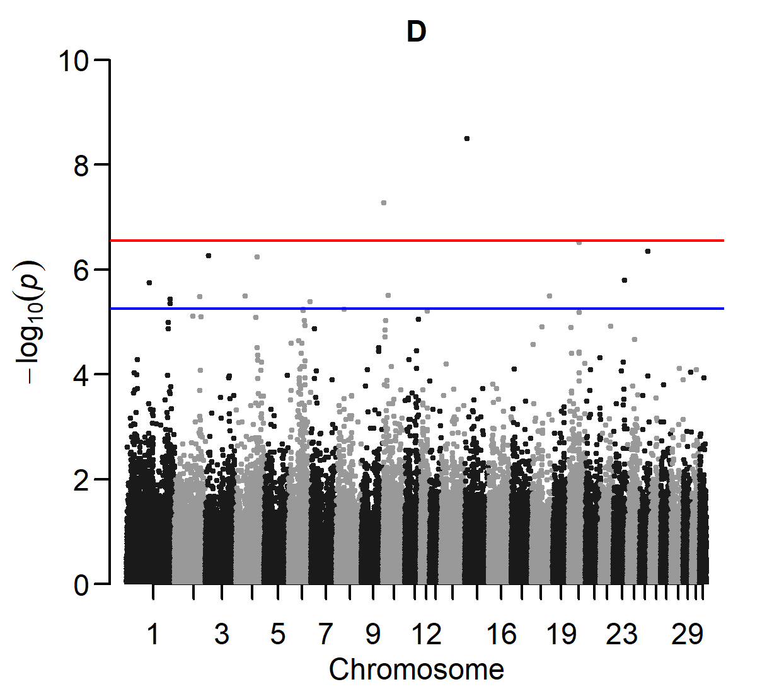

Manhattan plots of four GWAS for DOF.
A: Cases are horses with DOF in at least one of the fetlock joints. Controls are horses without DOF (100 cases and 590 controls).
B: Absence of POF and other osteochondral fragments in the fetlock joints is additionally required (65 cases and 486 controls).
C: Normal bone contour (score 0) at the dorsal part of the sagittal ridge of the third metacarpal/metatarsal bone is additionally required (42 cases and 394 controls).
D: Normal bone contour (score 0) at the distal intermediate ridge of the tibia, lateral trochlear ridge of the talus, medial malleolus of the tibia, lateral trochlear ridge of the femur, medial trochlear ridge of the femur, medial trochlear ridge of the talus and articular surface of the patella is additionally required (24 cases and 236 controls).

Supplementary Figure S15

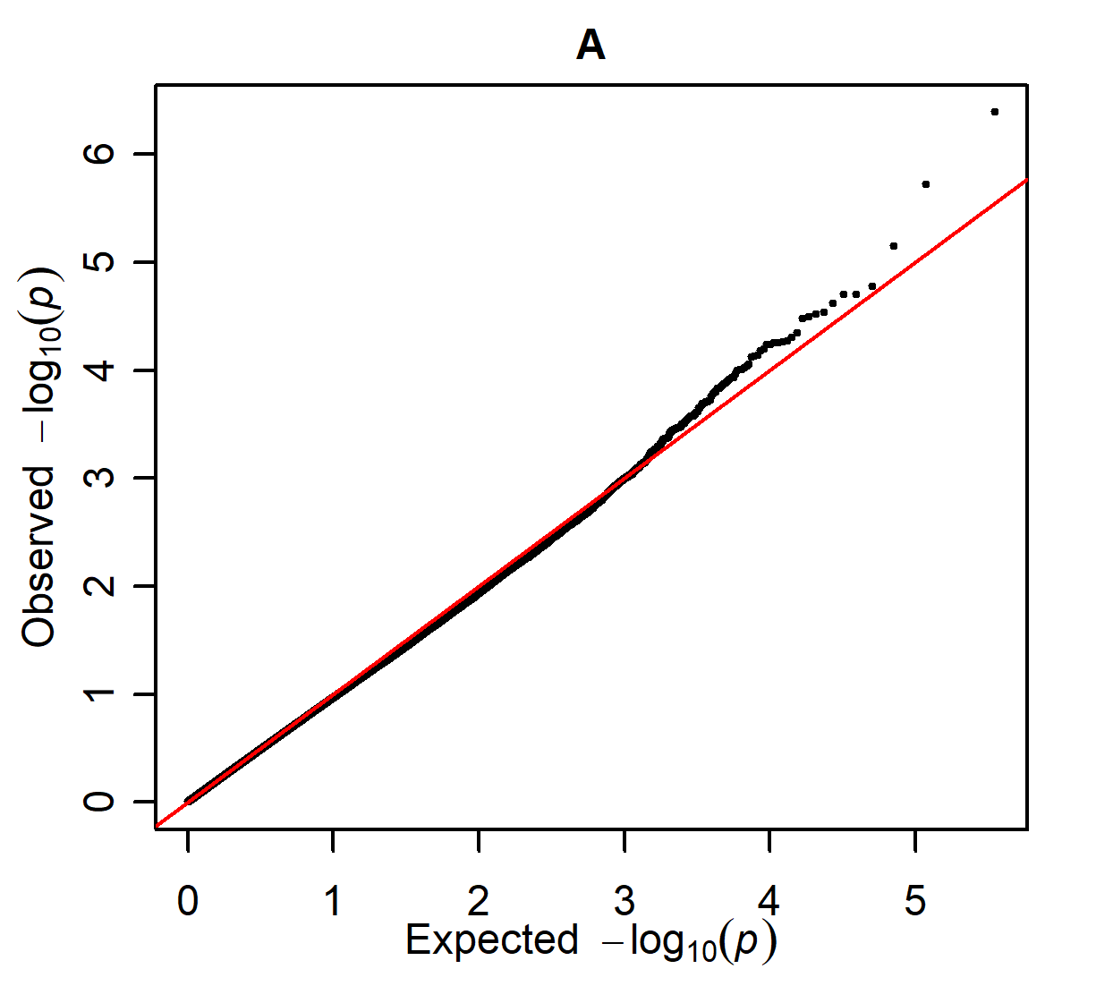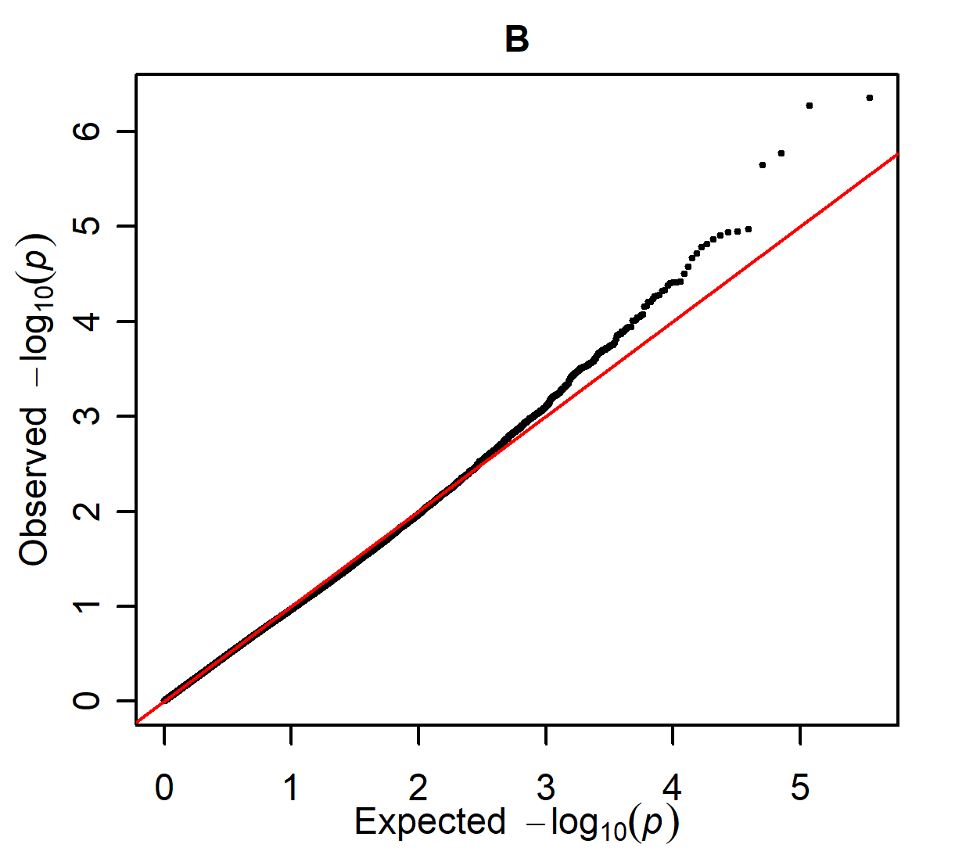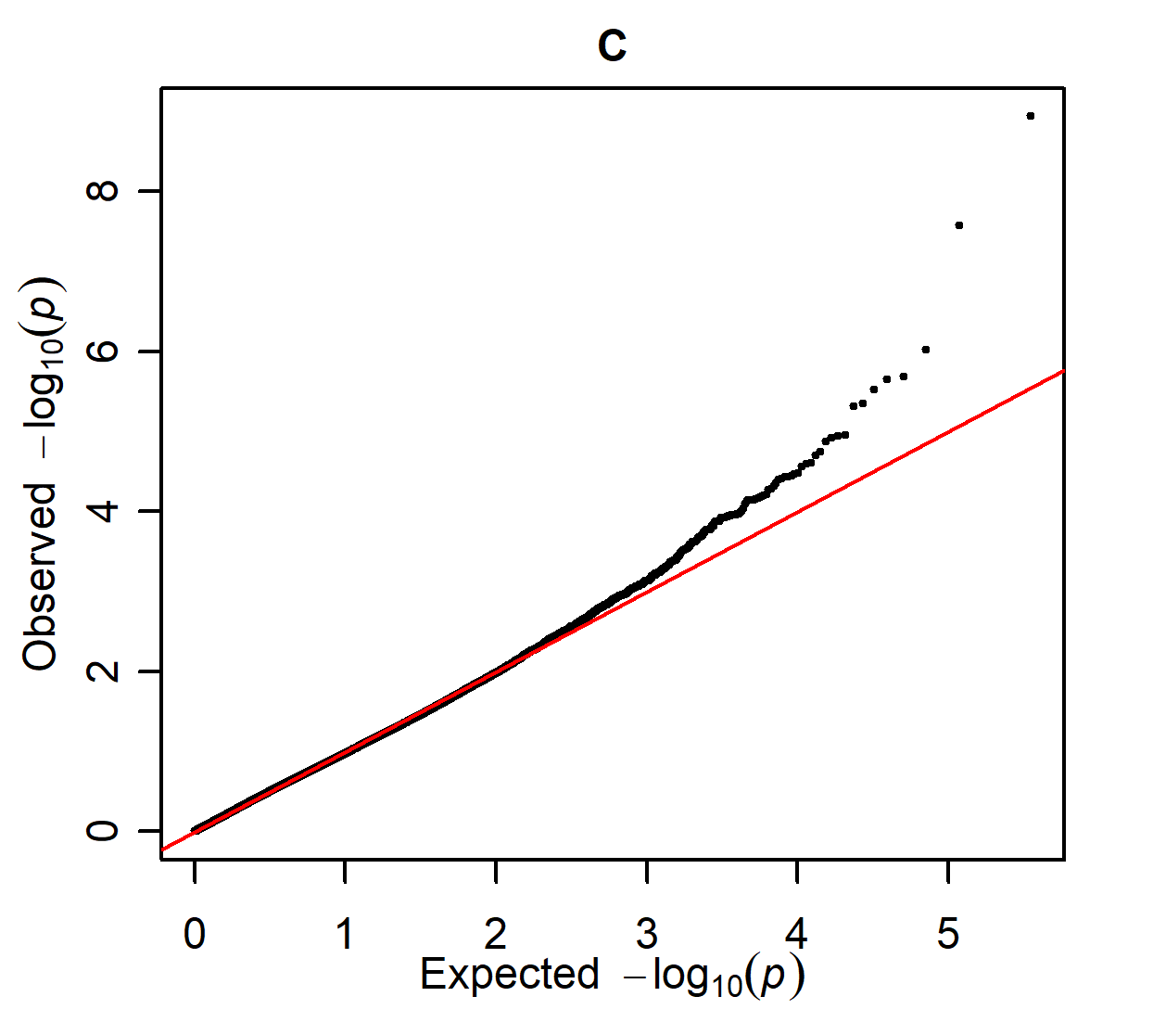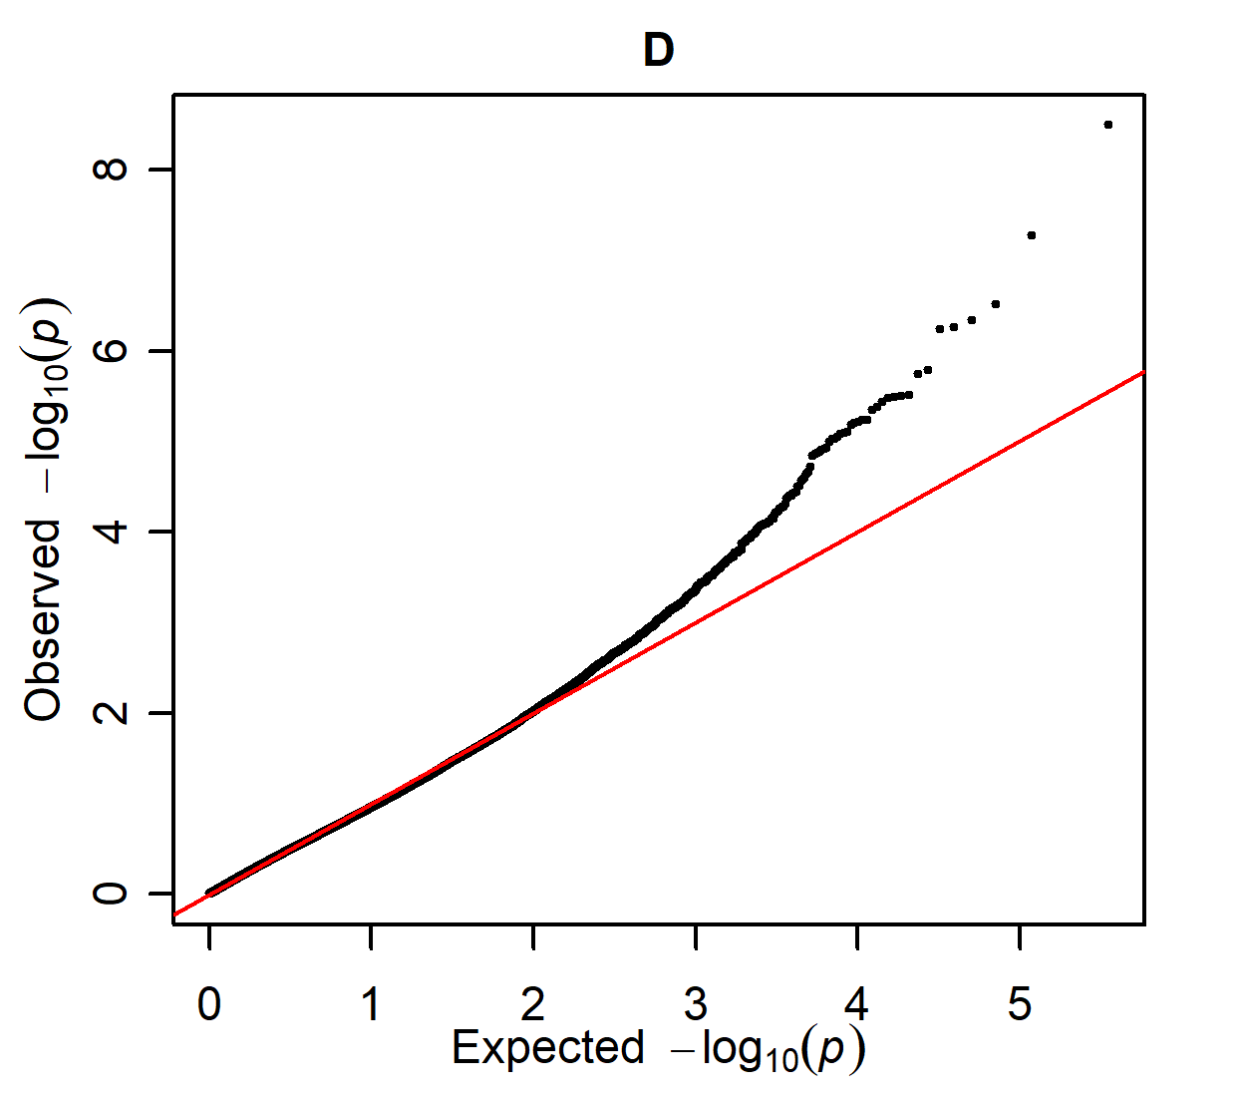

Q-Q plots of the four GWAS for DOF, as presented in supplementary figure S14.

