Appendices

Appendix A

Instructional Design Blueprint (6 Weeks; 90 minutes/session)

A1. Overview
The intervention ran for six weeks with one 90-minute session per week for both groups. Instructional content was aligned across conditions (setting and atmosphere, character development, and plot/world-building). The experimental group completed the activities in FrameVR.io, whereas the control group completed parallel tasks in a conventional classroom environment.

A2. Session structure (90 minutes; both groups)
• Orientation (10 min): recap and learning outcomes
• Input/modeling (15 min): brief exemplars and criterion reminders
• Guided task (25 min): week-specific structured activity
• Production (25 min): drafting/co-creation output
• Peer feedback (10 min): rubric-guided feedback
• Reflection (5 min): short reflection/exit prompt

A3. Curriculum map (aligned across groups)
Table A1
Curriculum Map Aligned Across Conditions (6 Weeks)
Week(s) | Writing focus | Experimental group (FrameVR.io) | Control group (traditional)
1–2 | Setting and atmosphere | Multi-sensory description via 3D navigation of themed worlds; sensory vocabulary prompts; descriptive paragraph drafting and revision. | Paper-based setting descriptions using textbook prompts and instructor modeling; paragraph drafting and revision.
3–4 | Character development | Avatar customization and live, embodied character interviews; character sketch drafting; dialogue refinement and peer feedback. | Character sketches and in-class role-play interviews; character sketch drafting; dialogue refinement and peer feedback.
5–6 | Plot and world-building | Collaborative plot mapping using interactive whiteboards and 3D objects; co-creating a short story with real-time peer feedback and revision. | Manual plot outlining; group brainstorming and discussion; short-story drafting with peer feedback and revision.
Note. Both conditions received equivalent scheduled instructional time (6 sessions × 90 minutes) and addressed the same learning outcomes.

Appendix B

Visual Evidence Package (Figures and What They Represent)
Images below demonstrate the learning environments used in the experimental and control conditions. All identifiers were removed or obscured using Gemini.
Images 1 & 2
FrameVR.io Immersive Setting Used for Setting and Atmosphere Tasks (Weeks 1–2)
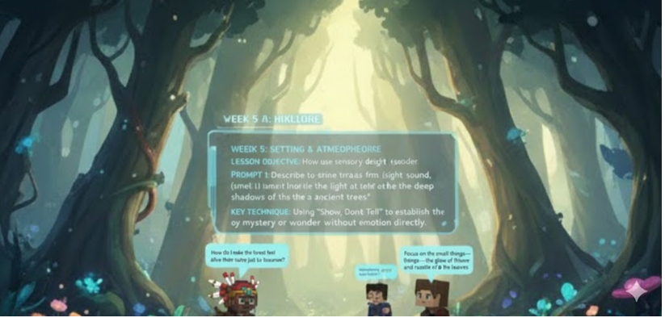
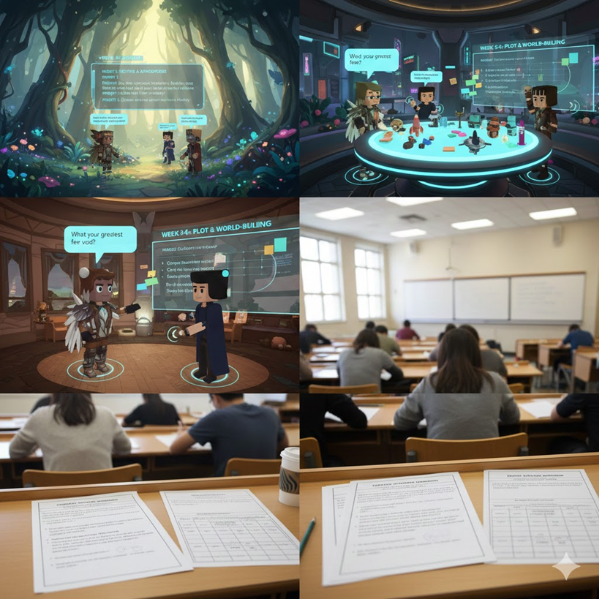
Note. Images show avatars in a thematically rich virtual environment used as a stimulus for multi-sensory description and setting construction. Identifiers anonymized.

Image 2
FrameVR.io Collaborative Workspace Used for Plot Mapping and Co-authoring (Weeks 5–6)
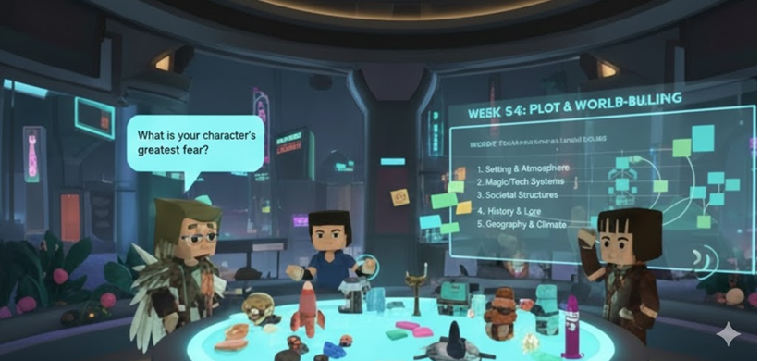
Note. Image shows shared space with interactive whiteboards and collaborative planning surfaces used for outlining and co-creating short narratives. Identifiers anonymized.
Image 3
Conventional Classroom Setting for the Control Group Under Standardized Writing Conditions

Note. Photo taken from the back of a standard university classroom. Students completed paper-based creative writing tasks aligned with the weekly lesson structure. Identifiers anonymized.

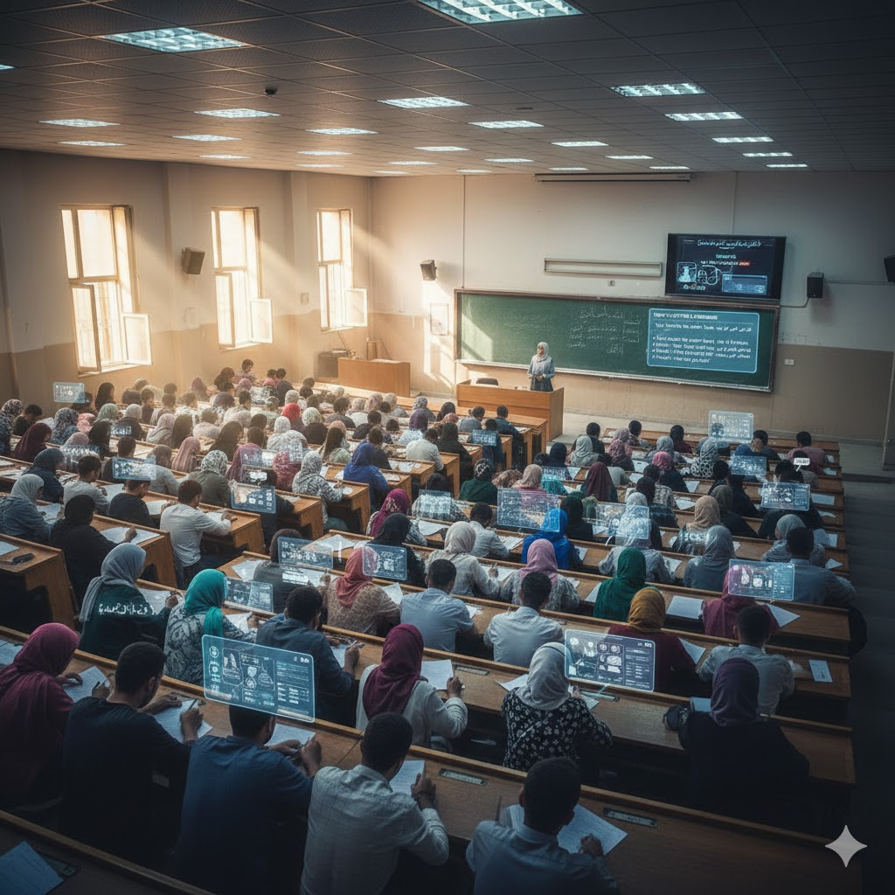
Note. Image depicts a modern, high-tech university lecture hall, blending traditional academic settings with futuristic digital o2verlays. (Experimental—Collaboration). AI-Enhanced Photo of the shared virtual space showing students using interactive whiteboards / shared planning surfaces for collaborative outlining or plot mapping.

Appendix C

Implementation Evidence Table (Intervention Fidelity Log)
This teacher checklist documents that both groups covered identical core writing components across the six-week program and that sessions were delivered as scheduled.
Table 1
Weekly Intervention Fidelity Log (Teacher Checklist)
Week | Core writing focus | Experimental (FrameVR.io) – planned components | Control (traditional) – planned components | Status
1 | Setting and atmosphere | 3D world exploration; sensory vocabulary prompts; paragraph drafting | Instructor modeling; paper-based setting prompts; paragraph drafting | Completed
2 | Setting and atmosphere | Mood/atmosphere scaffolds; peer sharing; revision pass | Mood/atmosphere mini-lesson; peer discussion; revision pass | Completed
3 | Character development | Avatar persona prompts; character interview dialogue task | Character sketch worksheet; peer interview role-play | Completed
4 | Character development | Motivation/conflict prompts; dialogue refinement; peer feedback | Motivation/conflict worksheet; dialogue refinement; peer feedback | Completed
5 | Plot and world-building | Plot mapping on shared whiteboard; object-supported planning; draft outline | Plot outline worksheet; group brainstorming; draft outline | Completed
6 | Plot and world-building | Co-creation and real-time feedback; short story drafting; final revision | Group discussion; short story drafting; final revision | Completed
Note. The checklist supports intervention fidelity by verifying content alignment and delivery across both instructional conditions.

Appendix D

Student Participation and Engagement Log (Minimal Implementation Evidence)
This appendix provides auditable implementation evidence that learners attended the scheduled sessions and produced the expected artifacts. Student identifiers are anonymized. For the experimental group, “minutes in FrameVR” reflects time logged in the platform; for the control group, this field is not applicable.
Table Z
Anonymized Participation and Engagement Log (Illustrative Rows With Summary Metrics)
Student ID | Group | Sessions attended (max 6) | Total minutes in FrameVR (EG only) | Artifacts/posts submitted
STU-01 | EG | 6/6 | 540 | 14
STU-02 | EG | 6/6 | 525 | 12
STU-03 | EG | 5/6 | 450 | 9
STU-04 | CG | 6/6 | N/A | 6
STU-05 | CG | 6/6 | N/A | 7
Mean (EG; n=37) | EG | 5.8/6 | 522 | 12.4
Mean (CG; n=36) | CG | 5.7/6 | N/A | 6.2
Note. Artifacts/posts represent virtual contributions (EG) or paper drafts/submissions (CG). The full log containing all anonymized student IDs was maintained by the instructor for audit purposes.

Implementation summary:
• Total instructional time: Both groups received equivalent instruction (6 sessions × 90 minutes, scheduled).
• Experimental context: FrameVR.io supported immersive setting exploration, avatar-based character interviews, and collaborative world-building using interactive whiteboards and 3D objects.
• Control context: Conventional instruction targeted the same outcomes via instructor modeling, paper-based prompts, peer discussion, and individual drafting.
• Engagement evidence: Artifact/post counts provide a behavioral engagement indicator for the experimental group, while draft/submission counts provide an equivalent indicator for the control group.

Appendix E

Scoring Integrity and Rater Blinding

E1. Blinding and rater independence
Creative writing scripts were scored by two independent raters who were blinded to group allocation (experimental vs. control) and measurement occasion (pretest vs. posttest). Scripts were anonymized, assigned random IDs, and shuffled into randomized scoring batches to minimize the possibility of inferring condition or time. Raters were not involved in delivering the intervention and had no access to class lists or study hypotheses. Inter-rater agreement was evaluated on an overlapping subset using an intraclass correlation approach; discrepancies were resolved via consensus using the rubric descriptors.

Appendix F.
Participant Flow Diagram (Enrollment, Allocation, Follow-up, and Analysis)
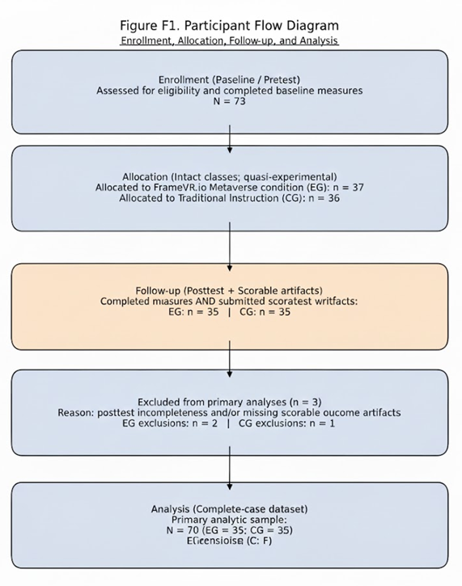
Figure 1. Exclusions reflect incomplete posttest data and/or non-scorable outcome artifacts.

