Supplementary data

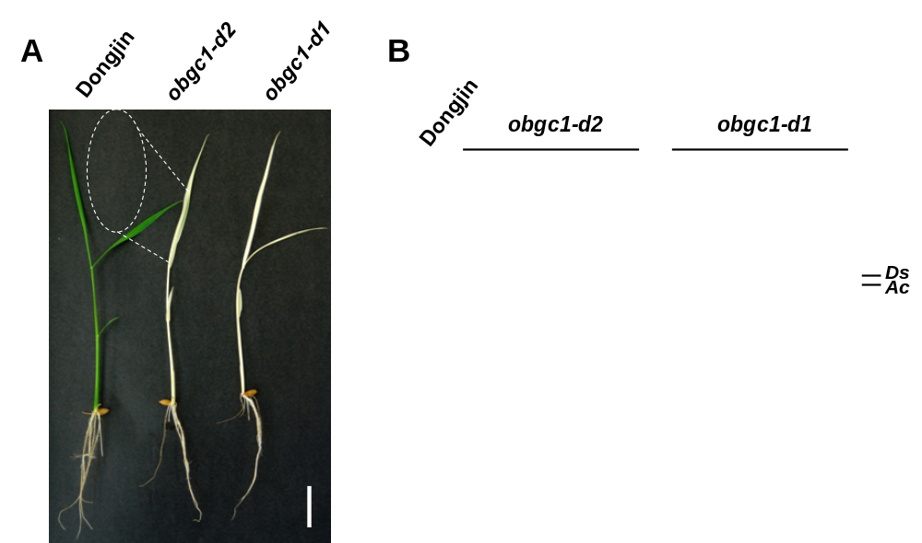

Supplementary Fig. S1. Identification of OsObgC1 Ds transposon insertion mutants by phenotypic and PCR method.
(A) Phenotypes of obgc1-d mutants and wild-type plants were photographed 10 days after sowing. Scale bar = 2 cm. (B) Polymerase chain reaction (PCR) products generated by specific primers of Ac and Ds transposons were loaded on the agrose gel. In obgc1-d1, OsObgC1 is knocked out by Ds. In obgc1-d2, immobile Ds elements are transposed by the presence of Ac. And as the result, knock-down mutant obgc1-d2 was obtained with somatic transposition of Ds insertion.

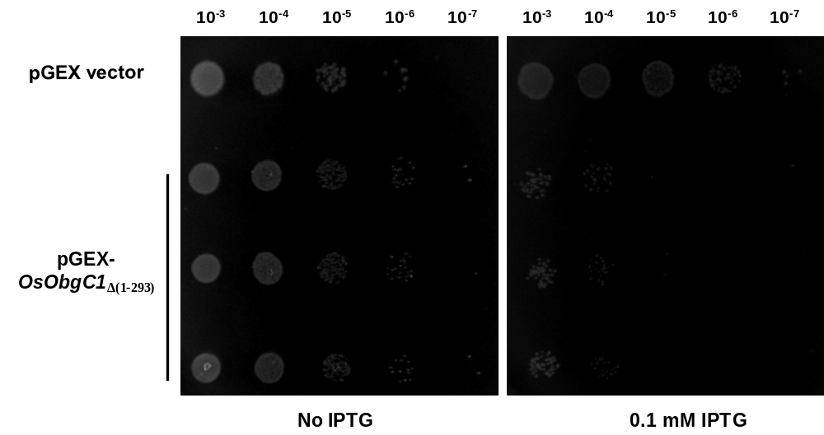

Supplementary Fig. S2. The effect of overexpression of OsObgC1_{Δ1-293} in E. coli on the cell growth.
The E. coli BL21 strains with empty pGEX vector or pGEX-OsObgC1_{Δ1-293} were serially diluted (10⁻³, 10⁻⁴, 10⁻⁵, 10⁻⁶ and10⁻⁷) on the LB plates with 0.1 mM IPTG. Cell cultures were incubated at 37 °C for 12 h.

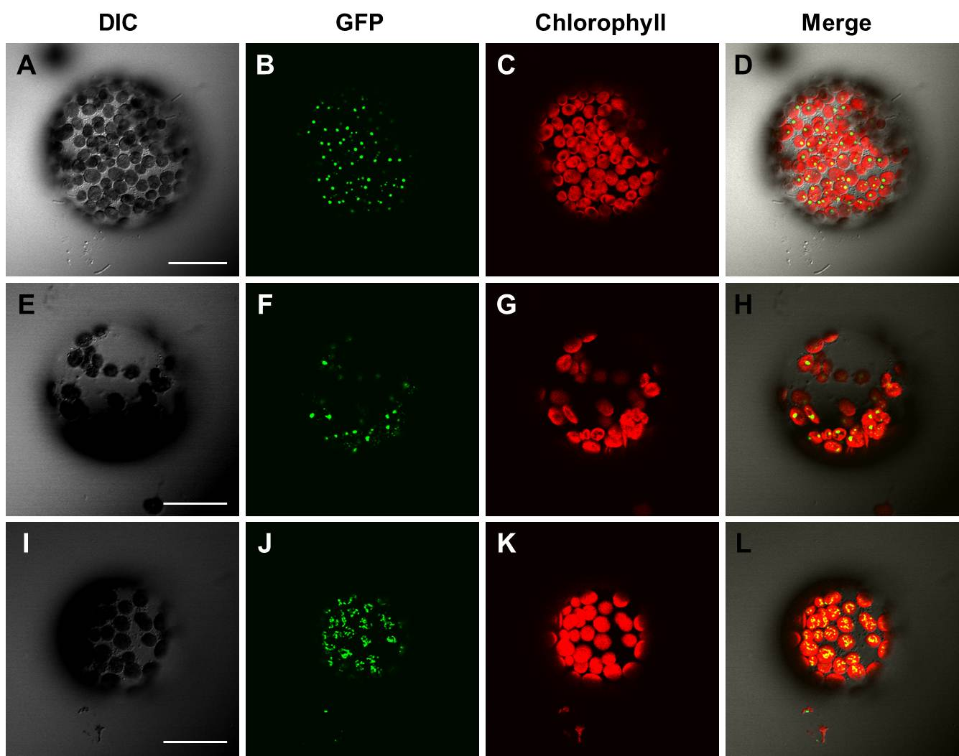

Supplementary Fig. S3. OsL13-GFP and OsL11-GFP exhibited a punctate staining pattern in chloroplasts
OsObgC1-GFP (A-D), OsL13-GFP (E-H) and OsL11-GFP (I-L) were observed under a confocal microscopy. DIC (differential interference contrast) and Merge (GFP + Chlorophyll) images are shown. Chlorophyll was used as a marker to detect chloroplast distribution. White bars in the DIC images represent 20 μm in length.

