Supplementary material
The dietary footprints and transition priorities of over 12,000 cities

Contents
MATILDA-City datasets 1
1. Integration of city-level population and dietary data 1
1.1 Population and city boundary data 1
1.2 Dietary intake data 1
1.3 Estimating city-level energy intake from GDP 2
1.4 Linking population and dietary intake data 3
2. Construction of country-specific per-food environmental coefficients 3
2.1 Food groups and environmental impacts 3
2.2 Environmental coefficient definition 3
3. Integrating impact coefficients with demographic dietary intake 4
4. EAT-Lancet diet 2.0 diet and city network adoption (C40, EUROcities, MUFPP) 4
Supplementary Table 1: Presence of dietary sustainability policies in highest impact cities 5
Supplementary Figure 1. Dietary pattern and diet-related GHGE of representative cities across world regions 7
Supplementary Figure 2. Total diet-related GHGE, Water Use, and Land Use across dietary scenarios (stacked by food group). 8
Supplementary Figure 3. Changes in global and city-network dietary environmental footprints when shifting from current diets to the EAT–Lancet 2.0 diet. 9

MATILDA-City datasets
This study extends MATILDA (Micro–Macro Assessment Tool to Identify Low-impact Dietary Actions) to the city level. The core structure of MATILDA couples harmonised dietary intake data from the Global Dietary Database (GDD)(1) with country-specific food supply chain data from the Food and Agriculture Biomass Input–Output (FABIO) model(2) to enable environmental footprinting of dietary intake in 165 countries, across 72 socio-demographic groups. Within this study, we extend this framework to the city level by connecting MATILDA to gridded population and economic data to derive age- and sex-resolved food consumption patterns and environmental footprints for approximately 13,000 cities worldwide. The resultant database, MATILDA-City, offers a tool for benchmarking food consumption patterns of cities and sustainable improvement actions.
Within this study we apply MATILDA-City to quantify baseline city-level dietary footprints for GHGE, water use, and land use, and conducted scenario analyses assessing urban dietary transitions towards the EAT-Lancet v1.0(3) and v2.0 reference diets(4), including full global adoption and partial adoption among major transnational food policy city networks (C40(5), Eurocities(6), and MUFPP(7)).

1. Integration of city-level population and dietary data

1.1 Population and city boundary data
To construct a harmonised global dataset linking city-level population structures with dietary intake data, we integrated gridded population estimates from WorldPop(8). All population datasets provided sex- and age-disaggregated estimates at a spatial resolution of 30 arc (approximately 1 km at the equator) for the year 2025, separately for males and females across 18 age groups (0-1, 1–4, 5–9, …, 75–79, 80+). The population raster data were aggregated to urban agglomerations using boundaries from Global Urban Polygons and Points Dataset (GUPPD)(9), ensuring consistency in boundary delineation and naming conventions.
Population counts were summarised by country, city, sex, and age group to generate a consistent dataset of over 12,683 cities disaggregated by sex and age.

1.2 Dietary intake data
Dietary intake data were obtained from the GDD, as integrated within the MATILDA (Micro–Macro Assessment Tool to Identify Low-impact Dietary Actions) framework (10). The GDD provides mean daily intakes (g/person/day) for 16 food and nutrient groups by country, sex, age group, education level, and urban/rural residence.
Age information was parsed from multiple string formats (e.g., “X–Y years”, “X+ years”, “X–Y months”) into numeric lower and upper bounds, which were then expanded into single-year ages (0–95). For example, “15–19 years” generated five single-year records (15–19). These were subsequently regrouped into 18 harmonised age bands consistent with the population dataset to enable cross-dataset alignment. Mean daily intakes were aggregated across all food variables within each combination of country × sex × age band.

1.3 Estimating city-level energy intake from GDP
To estimate city-level variation in dietary energy intake, we implemented a two-stage scaling approach that separates national calibration from subnational spatial allocation.
First, to capture within-country variation in energy intake across cities, we linked national economic development with food energy availability. Country-level data on daily per-capita calorie supply (kcal/person/day) were obtained from FAO food balance sheets(11), matched with country GDP per capita (purchasing power parity, constant 2021 international dollars) from the World Bank’s World Development Indicators(12). City total GDP was derived from the newly released downscaled global GDP dataset (1990–2022) by Kummu et al.(13). This dataset provides nationally harmonised estimates for GDP at admin-0/1/2 levels as well as on 5-arc-min grids (43,501 admin-2 units), and total GDP estimates at 30 arc-sec, 5 arc-min, and 30 arc-min resolutions. For our analysis, we used the 30 arc-sec (approximately 1 km at the equator) total GDP estimates for 2020, and aggregated them to urban agglomerations using Global Urban Polygons and Points Dataset boundaries (14), yielding total GDP for each city. City-level GDP per capita was estimated by dividing total city GDP by the respective city population. A mixed-effects model was fitted to the panel data, specifying daily calorie supply as the dependent variable and log country GDP per capita as the main predictor, with fixed effects for year and random intercepts by country. The model was estimated using maximum likelihood with robust variance estimation. The fitted coefficients and country-level random intercepts were then applied to the city GDP dataset. For each city, per-capita GDP was transformed to log scale, and predicted calorie supply was calculated as the sum of the fixed and country-specific random components from the fitted model. Missing values within countries were imputed using the mean predicted energy intake across cities in the same country, and any residual missing estimates were filled using the global mean. The resulting dataset provides city-level estimates of average dietary energy intake (kcal/person/day).
Second, national age- and sex-specific energy intake levels were aligned to externally estimated values derived from anthropometric-based modelling. Specifically, we adopted published estimates of total dietary energy intake by country, sex, and age group from Springmann (15), and used these to rescale the GDD, which reports dietary composition standardised to a 2,000 kcal reference.
Together, these two steps generate predicted city-level dietary energy intake estimates (kcal/person/day), which are subsequently used to rescale all dietary intakes prior to the calculation of environmental impacts.

1.4 Linking population and dietary intake data
To integrate dietary intake data with city-level population structures, the GDD-based age- and sex-specific dietary dataset was merged with the population dataset described above using country ISO codes, sex, and standardised age bands. This alignment linked each city’s demographic structure to its corresponding national-level dietary intake profiles. Records lacking matching identifiers (e.g., small island nations without GDD coverage, such as Antigua and Barbuda or Vanuatu) were excluded.
The resultant dataset contains harmonised age- and sex-resolved dietary intake information matched to the demographic composition of 12,683 cities worldwide.

2. Construction of country-specific per-food environmental coefficients
We derived country-, food-, and impact-specific environmental coefficients from FABIO in order to assign consumption-based environmental footprints to dietary intake across cities.

2.1 Food groups and environmental impacts
We considered 16 aggregated food groups consistent with MATILDA/GDD harmonisation: fruits, non-starchy vegetables, potatoes, other starchy vegetables, beans and legumes, nuts and seeds, refined grains, whole grains, total processed meats, unprocessed red meats, total seafoods, eggs, coffee, tea, total milk, and sugar-sweetened beverages (SSB). Three environmental dimensions were used: GHGE, water use, and land use.

2.2 Environmental coefficient definition
For each food group $f$ and impact $k ∈\{GHGE, water use, land use\}$, we define the coefficient
$$c_{f,k}^{\left(r\right)}=\frac{I_{f,k}^{\left(r\right)}}{Q_{f}^{\left(r\right)}}$$where $I_{f,k}^{\left(r\right)}$ is the country-specific impact total for food $f$ in country $r$ , and $Q_{f}^{\left(r\right)}$ is the corresponding consumed quantity. This yields per-unit impact coefficients (e.g., kg CO₂-eq per g food, m³ water per kg, or m²·year per kg).
To assess the sensitivity of environmental footprint estimates to uncertainty in food group composition, we propagated variability in impact factors linked to underlying product mixes. Each food group in the GDD, such as fruits, legumes, or dairy, maps onto multiple commodities in the FABIO framework with heterogeneous environmental intensities. We therefore applied Latin Hypercube Sampling to perturb the relative shares of these commodities within a ±10% range and conducted 200 simulations per country. For each simulation, greenhouse gas emissions, water use, and land use were recalculated, and uncertainty was characterised using interquartile ranges. Variability stabilised after approximately 80 simulations, indicating sufficient sampling to capture plausible uncertainty and ensuring that cross-city comparisons reflect compositional variability rather than reliance on single point estimates.

3. Integrating impact coefficients with demographic dietary intake
City-level dietary intake estimates from the previously harmonised GDD-population dataset were linked to country-specific environmental impact coefficients.
For each record defined by country $r$, sex, age band, and city identifier, the dataset contains:
- Dietary intake by food group $Q_{f}^{\left(r,s,a\right)}$ (g/person/day) from GDD,
- Per-unit coefficients $c_{f,k}^{\left(r\right)}$ (impact per g) as defined above,
- City-level demographic structure (population $P^{\left(city,s,a\right)}$by sex and age).
For each food group $f$ and impact dimension $k$, per-capita impacts are computed as:
$$E_{f,k}^{\left(r,s,a\right)}=Q_{f}^{\left(r,s,a\right)}×c_{f,k}^{\left(r\right)}.$$
We then sum across all food groups to obtain total per-capita impacts for each impact type:
$$E_{k}^{\left(r,s,a\right)}=\sum_{f}{E_{f,k}^{\left(r,s,a\right)}}.$$
For city-level totals, per-capita impacts are multiplied by the corresponding city population by sex-age band and then aggregated over sex and age bands within each city:
$$E_{k}^{\left(\text{city}\right)}=\sum_{s,a}{\left(E_{k}^{\left(r,s,a\right)}×P^{\left(\text{city},s,a\right)}\right)}.$$

4. EAT-Lancet diet 2.0 diet and city network adoption (C40, EUROcities, MUFPP)
Diet scenarios. We evaluated two dietary patterns aligned with the EAT-Lancet guidelines (v1.0 and v2.0). For both scenarios, target daily intakes (g/person/day) were assigned to major food groups. Coffee, tea, and refined grains, not explicitly constrained in the EAT-Lancet; diet were held at their baseline to maintain comparability.
Impact intensities. Country-specific supply-chain intensities for GHGE, blue water use, and land use (per kilogram of food) were taken from the MATILDA framework, based on FABIO (2).
Per-capita impacts. For each city, sex, and age band, per-capita environmental impacts were computed by multiplying recommended (scenario) or observed (baseline) intakes by the corresponding country-specific intensities, separately for GHGE, water use, and land use. Baseline per-capita intakes and impacts were first rescaled from the GDD 2,000-kcal reference to city-specific energy levels using the GDP-based energy estimates described earlier. In contrast, the EAT-Lancet scenarios applied the guideline gram targets directly (i.e., without calorie rescaling), while keeping coffee, tea, and refined grains at their baseline (GDP-adjusted) levels.
Annualisation and aggregation. Per-capita daily impacts were annualised and then multiplied by the corresponding city population in each sex–age stratum.
Dietary environmental footprints of cities were derived by aggregating environmental impacts across demographic subgroups. We also computed city-level dietary GHGE for each food group. All calculations were performed independently for GHGE, water, and land, from a consumption-based accounting perspective.
City-network adoption scenarios. In addition to the global EAT-Lancet diet scenario (all cities adopt v1.0 or v2.0), we constructed partial-adoption scenarios for three city networks—C40, Eurocities, and MUFPP. For each network, member cities were assigned their EAT-Lancet v2.0 totals (with coffee, tea, and refined grains retained at baseline), while all non-member cities remained at baseline. There are 112 cities in the C40 network, of which 107 were matched to the MATILDA-City framework. The Eurocities network includes 211 cities, with 202 matched to MATILDA-City. The MUFPP network comprises 326 cities, of which 263 were matched to MATILDA-City.

Supplementary Table 1: Presence of dietary sustainability policies in highest impact cities
City | Food Policy
Jakarta, Indonesia
São, Paulo, Brazil | MUFPP signatory with active policy
Guangzhou, China
Tokyo, Japan | C40 Good Food Cities commitment
Lima, Peru | C40 Good Food Cities commitment
Moscow, Russia
Quezon City, Philippines | C40 Good Food Cities commitment
Bogota, Colombia | MUFPP signatory with active policy
Rio De Janeiro, Brazil | MUFPP signatory with active policy
Bangkok, Thailand | MUFPP signatory with active policy, Bangkok Food Strategy 2023-2027
Mexico City, Mexico | MUFPP signatory with active policy
Buenos Aires, Argentina | MUFPP signatory with active policy
Shanghai, China | MUFPP signatory with active policy
Osaka, Japan | MUFPP signatory with active policy
Dhaka, Bangladesh
Istanbul, Turkey | MUFPP signatory with active policy
Seoul, South Korea | C40 Good Food Cities commitment
Ho Chi Minh City, Vietnam
Yangon, Myanmar
Beijing, China | MUFPP signatory with active policy
Delhi, India
Cairo, Egypt
Karachi, Pakistan
Riyadh, Saudi Arabia
New York, United States | C40 Good Food Cities commitment, Food Forward NYC Plan
Lagos, Nigeria
Malang, Indonesia
Medellín, Colombia | MUFPP signatory with active policy
Los Angeles, United States | Good Food Purchasing Policy
Tehran, Iran
Chengdu, China
London, United Kingdom | C40 Good Food Cities commitment, London Food Strategy
Nagoya, Japan | Food loss reduction plan
Johannesburg, South Africa | MUFPP signatory with active policy
Belo Horizonte, Brazil | MUFPP signatory with active policy
Bandug, Indonesia | MUFPP signatory with active policy
Lahore, Pakistan
Shantou, China
Paris, France | C40 Good Food Cities commitment, Sustainable Food Strategy
Suzhou, China
Kuala Lumpur, Malaysia
Saint Petersburg, Russia
Hangzhou, China
Abreu E Lima, Brazil
Asuncion, Paraguay
Hà Noi, Vietnam
Maracanaú, Brazil
Baghdad, Iraq
Tel Aviv, Israel | MUFPP signatory with active policy
Luanda, Angola

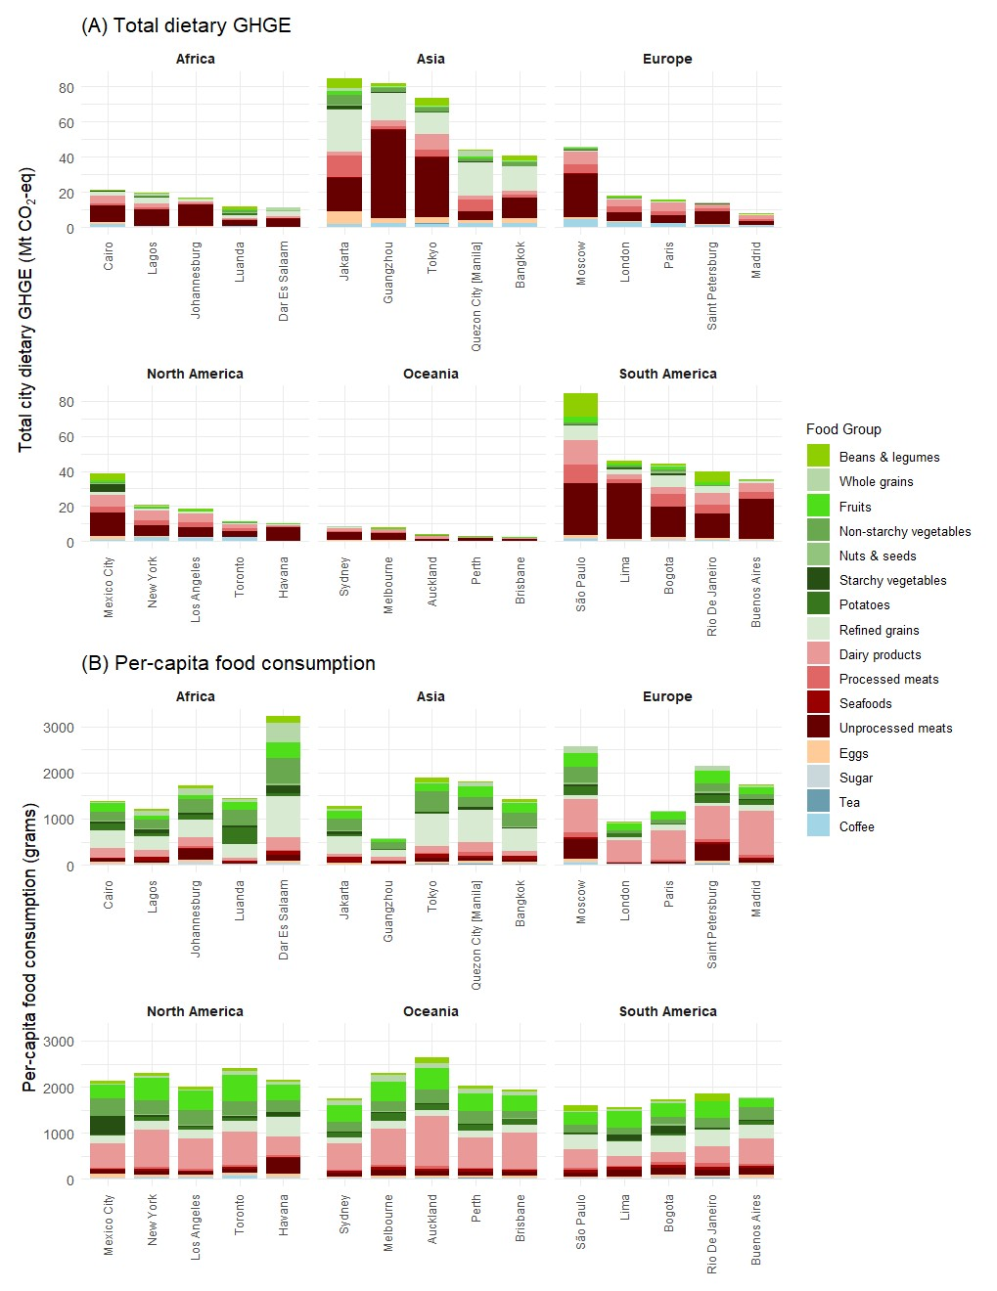

Supplementary Figure 1. Dietary pattern and diet-related GHGE of representative cities across world regions
Panel (A) shows total diet-related GHGE of the five highest-impact cities by GHGE in each world region, decomposed by 16 food groups. Panel (B) presents the per-capita food consumption profiles of the same representative cities, based on 16 harmonised food groups. Per-capita values are reported in grams per person per day. Data for city-level dietary water use and land use can be found in Supplementary Data S3.

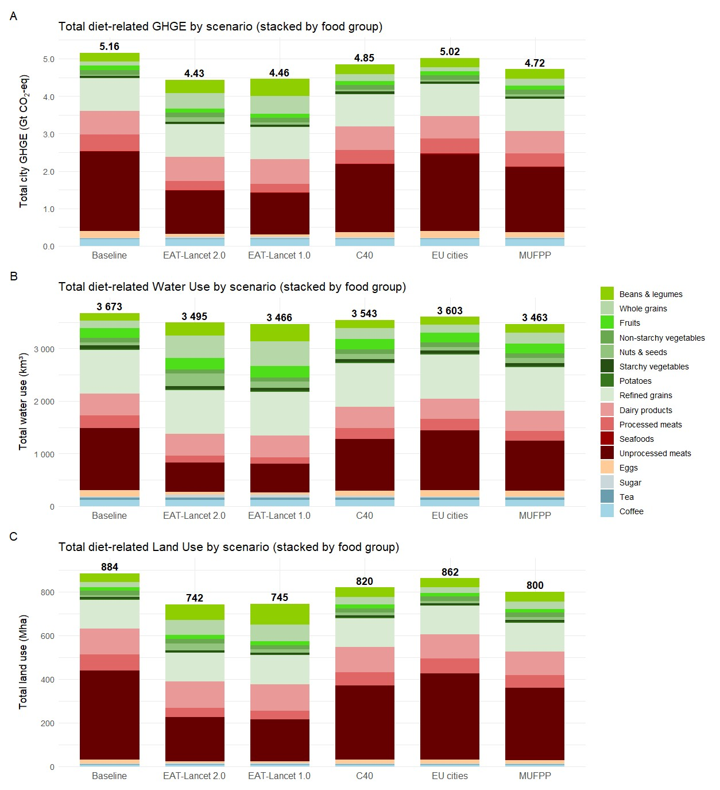

Supplementary Figure 2. Total diet-related GHGE, Water Use, and Land Use across dietary scenarios (stacked by food group).
Total diet-related GHGE (Panel A), Water Use (Panel B), and Land Use (Panel C) across six dietary scenarios—Baseline, EAT-Lancet 2.0, EAT-Lancet 1.0, C40, Eurocities, and MUFPP—summed over all 12,683 cities in the MATILDA-City framework. Bars represent the total environmental footprint for each scenario, stacked by food groups. Food group quantities reflect the proportional shift from baseline intake toward the EAT-Lancet recommended composition, applied either globally (EAT-Lancet scenarios) or within city networks (C40, EU cities, MUFPP). Numeric labels above each bar indicate the total footprint under each scenario.
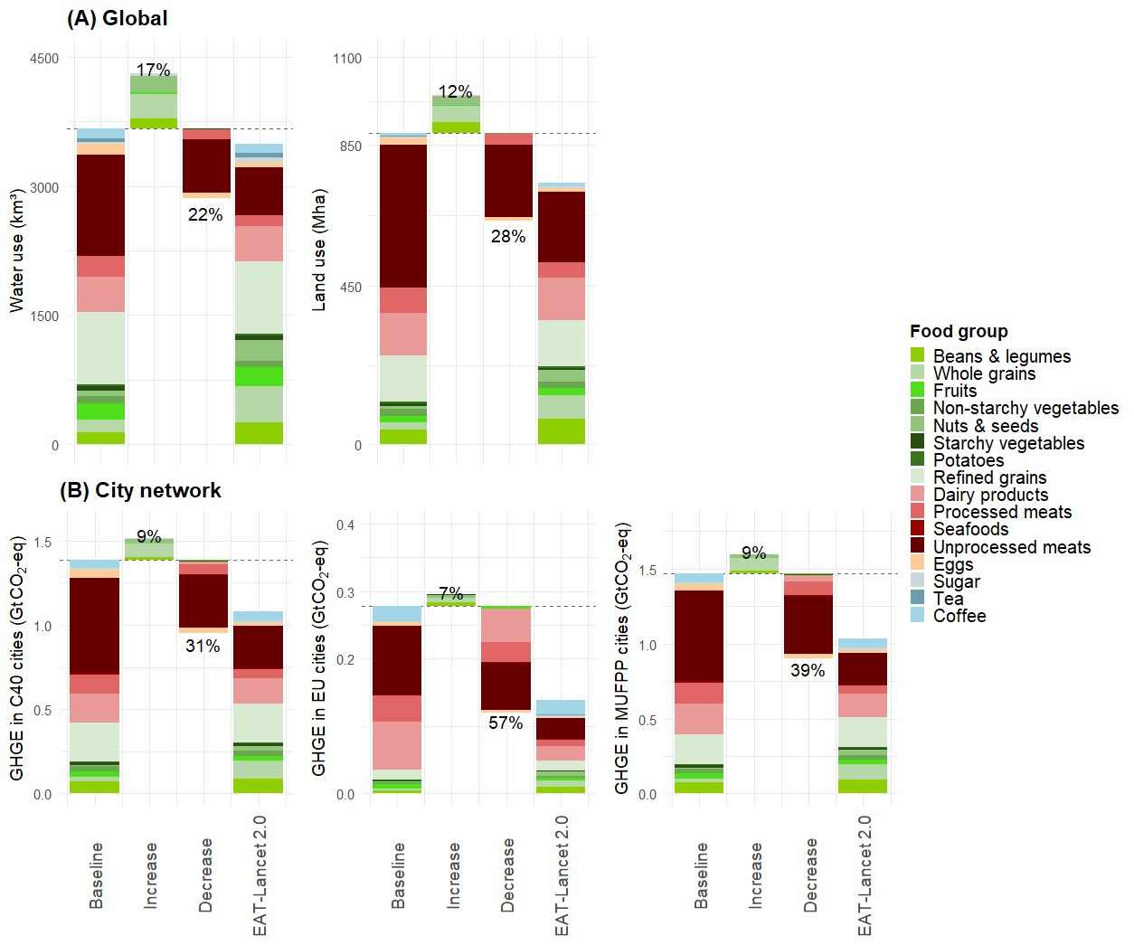

Supplementary Figure 3. Changes in global and city-network dietary environmental footprints when shifting from current diets to the EAT–Lancet 2.0 diet.
Panel (A) shows stacked waterfall plots illustrating changes in diet-related water use (km³), and land use (Mha) when shifting from current dietary patterns (Baseline) to full adoption of the EAT–Lancet 2.0 diet across all 12,683 cities. For each indicator, the Baseline and EAT–Lancet 2.0 columns show total footprints stacked by 16 food group, while the “Increase” and “Decrease” columns decompose positive and negative changes in footprints by food group resulting from compliance with the EAT-Lancet diet. Percent labels indicate the proportional change in environmental footprints in relation to the baseline due to adoption of the EAT–Lancet 2.0 diet. Panel (B) shows stacked waterfall plots for diet-related GHGE restricted to three city networks: C40 cities, Eurocities member cities and signatory cities of the Milan Urban Food Policy Pact (MUFPP). EAT-Lancet 2.0 refers to the updated EAT-Lancet diet proposed by EAT-Lancet Commission in 2025. C40 refers to the C40 Cities Climate Leadership Group Inc., a global network of mayors collaborating to address the climate crisis and drive urban sustainability(5). Eurocities represent the Eurocities network, a coalition of over 200 major European cities across 38 countries that promotes urban cooperation and policy exchange on climate, environment, mobility, and social issues(6). MUFPP refers to the Milan Urban Food Policy Pact, an international agreement on urban food policies signed by more than 200 cities worldwide to promote sustainable, inclusive, and resilient food systems(7).

Reference
1. V. Miller, et al., Global Dietary Database 2017: data availability and gaps on 54 major foods, beverages and nutrients among 5.6 million children and adults from 1220 surveys worldwide. BMJ Glob Health 6 (2021).
2. M. Bruckner, et al., FABIO—The Construction of the Food and Agriculture Biomass Input–Output Model. Environ. Sci. Technol. 53, 11302–11312 (2019).
3. W. Willett, et al., Food in the Anthropocene: the EAT–Lancet Commission on healthy diets from sustainable food systems. The Lancet 393, 447–492 (2019).
4. J. Rockström, et al., The EAT–Lancet Commission on healthy, sustainable, and just food systems. The Lancet 406, 1625–1700 (2025).
5. C40 Cities: Transforming urban systems for climate action. C40 Cities. Available at: https://www.c40.org/.
6. Eurocities - Home. Available at: https://eurocities.eu/.
7. Milan Urban Food Policy Pact. Milan Urban Food Policy Pact. Available at: https://www.milanurbanfoodpolicypact.org/.
8. WorldPop, Global 1km Population. University of Southampton. https://doi.org/10.5258/SOTON/WP00647. Deposited 2018.
9. Center For International Earth Science Information Network-CIESIN-Columbia University, Joint Research Centre-JRC-European Commission, Global Urban Polygons and Points Dataset (GUPPD), Version 1. Palisades, NY: NASA Socioeconomic Data and Applications Center (SEDAC). https://doi.org/10.7927/BRQ1-XC29. Deposited 2024.
10. O. Taherzadeh, A. Schoorlemmer, P. Behrens, M. Bruckner, H. Cai, Mapping high-impact groups across dietary sustainability and nutrition. [Preprint] (2025). Available at: https://www.researchsquare.com/article/rs-7188924/v1.
11. FAOSTAT. Available at: https://www.fao.org/faostat/en/#home.
12. World Development Indicators | DataBank. Available at: https://databank.worldbank.org/source/world-development-indicators.
13. M. Kummu, M. Kosonen, S. Masoumzadeh Sayyar, Downscaled gridded global dataset for gross domestic product (GDP) per capita PPP over 1990–2022. Sci Data 12, 178 (2025).
14. Center For International Earth Science Information Network-CIESIN-Columbia University, Joint Research Centre-JRC-European Commission, Global Urban Polygons and Points Dataset (GUPPD), Version 1. Palisades, NY: NASA Socioeconomic Data and Applications Center (SEDAC). https://doi.org/10.7927/BRQ1-XC29. Deposited 2024.
15. M. Springmann, Estimates of energy intake, requirements and imbalances based on anthropometric measurements at global, regional and national levels and for sociodemographic groups: a modelling study. bmjph 3 (2025).

