Supplementary for “Real-time Calibration-free Imaging Through Dynamic and Distinct Multimode Fibers via Spatial Harmonic Invariant Nonlinear Encoding (SHINE)’’
Zhiyuan Wang^{1,†}, Haoran Li^{1,†}, Songjie Luo², Jixiang Chen³, Tianting Zhong^{3,4}, Jing Yao^{1,4}, Jixiong Pu², Zhipeng Yu^{1,4,*}, Sylvain Gigan^{5,*}, Ziyang Chen^{2,*}, and Puxiang Lai^{1,4,6,*}
1 Department of Biomedical Engineering, The Hong Kong Polytechnic University, Hong Kong, China
2 College of Information Science and Engineering, Huaqiao University, Fujian Provincial Key Laboratory of Light Propagation and Transformation, Xiamen, China, 361021
3 Department of Electrical and Electronic Engineering, The University of Hong Kong, Hong Kong, China
4 Shenzhen Research Institute, The Hong Kong Polytechnic University, Shenzhen, China
5 Laboratoire Kastler Brossel, ENS-Université PSL, CNRS, Sorbonne Université, Collège de France, Paris, France
6 Photonics Research Institute, The Hong Kong Polytechnic University, Hong Kong, China
*Address correspondence to Zhipeng Yu at yu.zh.yu@polyu.edu.hk, Sylvain Gigan at sylvain.gigan@lkb.ens.fr, Ziyang Chen at ziyang@hqu.edu.cn, and Puxiang Lai at puxiang.lai@polyu.edu.hk
†These authors contributed equally to this work.

Supplementary Note 1: Experimental Setup
Figure S1 illustrates the experimental setup developed for nonlinear spectral encoding imaging. A femtosecond Ti: Sapphire laser (Vitara-T, Coherent; a central wavelength: 810 nm, spectral bandwidth: 125 nm) serves as the light source. The beam is first collimated by mirrors R1 and R2, passed through a polarizer (P), and modulated by a phase-only spatial light modulator (SLM, X13138-02WL, Hamamatsu). An achromatic doublet lens (L1, AC254-050-AB, Thorlabs) focuses the modulated beam into a 200 µm nonlinear crystal (BBO, β-BaB₂O₄, 7×7×0.2 mm, θ = 29.2°, φ = 0°, AR coating: 700–900 nm on S1, 700–900 nm / 350–450 nm on S2, CASTECH). The use of a thin crystal ensures a broad phase-matching bandwidth, allowing efficient SHG across the laser’s spectral range while sensitizing the conversion process to the angular components of the incident field.
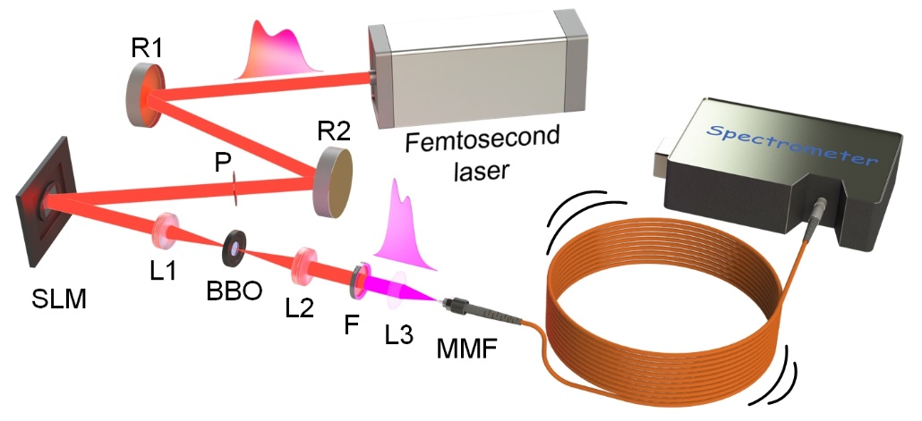
Fig. S1 Experimental setup and principle of nonlinear spectral encoding. A broadband femtosecond laser is spatially modulated and focused into a nonlinear crystal to generate second-harmonic generation (SHG) signals. Unlike plane-wave excitation, spatially structured wavefronts induce angle-dependent phase-matching conditions, resulting in variations in SHG efficiency that encode spatial information into distinct spectral signatures. R1, R2, mirror; P, polarizer; SLM, spatial light modulator; L1, L2, L3, lens; BBO, β-BaB₂O₄ crystal; F, filter; MMF, multimode fiber.
Following SHG, a second achromatic doublet lens (L2) collimates the up-converted beam. A short-pass filter (F, FESH0650; cut-off wavelength: 650 nm) isolates the SHG signal by suppressing the residual fundamental pump. The filtered signal is subsequently coupled into a multimode fiber (MMF, SUH105, 105µm core diameter, NA=0.22, 10 meters, Xinray) using a bi-convex lens (L3). As light propagates through the MMF, mode coupling and dispersion generate a randomized speckle field at the distal end. To capture the encoded information, a fiber-coupled spectrometer (HR4PRO-VIS-NIR, Ocean Optics; resolution: 0.185 nm/pixel) is connected to the MMF output. This device records the integrated intensity spectrum, which carries the unique spectral fingerprint of the object displayed on the SLM.

Supplementary Note 2: Implementation of the SHG Spectrum Decoding U-net (SSDU)
Data preprocessing
The spectrometer records the spectral range from 390.5 to 437.7 nm at intervals of 0.185 nm, yielding a vector of 256 intensity values per measurement. To facilitate processing by convolutional layers, these vectors are reshaped into 16×16 matrices. Although the effective spectral bandwidth containing signal information corresponds to approximately 200 points, the full 256-point window is retained to maintain a consistent input tensor shape for the neural network.
Network architecture
The reshaped matrices serve as inputs to a custom deep neural network, the SHG Spectrum Decoding U-net (SSDU), illustrated in Fig. S2. The SSDU employs a dual-output architecture designed to learn the nonlinear mapping between the SHG spectra and two distinct targets: the two-dimensional object images and its corresponding categorical label. The object categories are one-hot encoded, and classification is performed by identifying the index of the maximum output value.
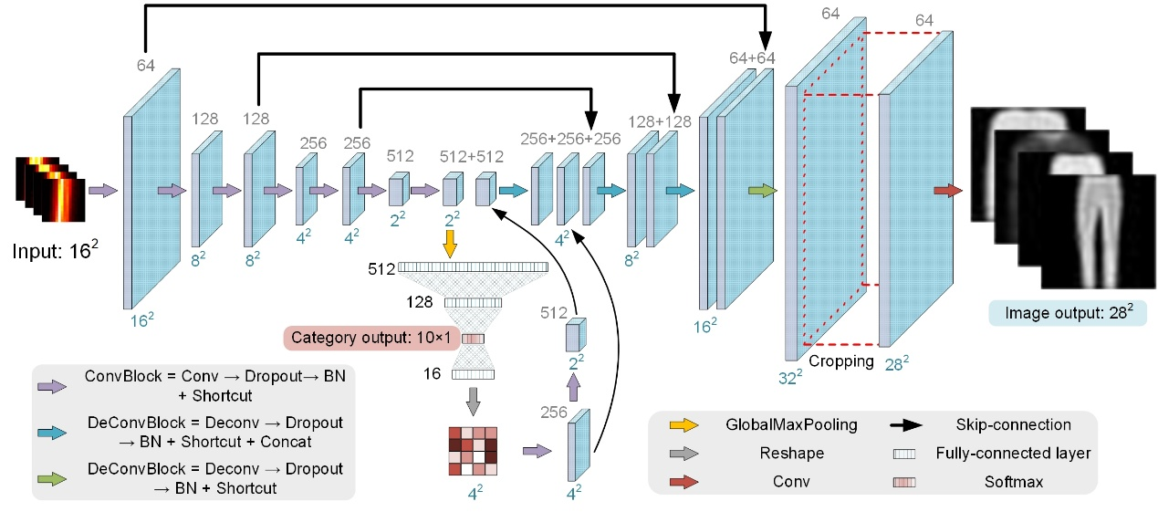
Fig. S2 Architecture of the proposed SSDU. The network accepts a reshaped 16×16 SHG spectrum matrix and processes it through a sequence of convolutional and deconvolutional residual blocks with skip connections. The bifurcates into two pathways: (1) a classification branch (center) that outputs a categorical label via global max pooling and fully connected layers, and (2) a reconstruction branch (right) that upsamples features to generate a 28×28 pixel image. Crucially, the classification features are fused into the reconstruction decoder to provide semantic context. Color arrows and blocks represent different types of operations. Conv, Convolution 2D; Deconv, Conv2DTranspose; BN, Batch Normalization; Concat, Concatenate.
Detailed layer structure
The network backbone comprises a series of residual convolutional blocks (“ConvBlock”) that perform hierarchical feature extraction while maintaining spatial coherence via shortcut connections. Each ConvBlock consists of the following sequence: Convolution → Dropout → Batch normalization → Residual addition. This residual structure facilitates gradient flow, mitigating the vanishing gradient problem during training.
At the network bottleneck, data flow splits into two branches. First, the classification branch: this pathway applies global max pooling followed by a fully connected layer and softmax activation to produce a 10-class categorical output. Second, the reconstruction branch: This pathway utilizes DeconvBlock modules (transposed convolution → dropout → batch normalization → shortcut connections) to upsample the latent features and maintain feature coherence during reconstruction.
To enhance reconstruction fidelity, we employ a feature fusion strategy: the output of the classification branch is passed through a fully connected layer (16 units), reshaped into a 4×4 tensor, and processed by two additional ConvBlocks to generate feature maps of size 4×4×256 and 2×2×512. These semantic feature maps are concatenated with the corresponding tensors in the decoder pathway. Standard skip connections from the encoder are also employed to preserve high-frequency spatial information. A final cropping and concatenation step ensures the output matches the target dimension of 28×28 pixels.
Training parameters and evaluation
The SSDU model was implemented in TensorFlow 2.6 and trained on a workstation equipped with an NVIDIA GeForce RTX 3090Ti (24GB RAM). Training proceeded for 50 epochs with a batch size of 32. We used the Adam optimizer with an initial learning rate of $1×{10}^{-3}$ and an exponential decay rate of 0.92 per epoch. Binary cross-entropy was utilized as the loss function for both reconstruction and classification tasks. Classification performance is quantified using accuracy, defined as:
where and denote the predictions from the network and true label, respectively; Argmax(·) returns the position where the maximum value is located; equal(·) is an indicator function which returns 1 if the condition is true and 0 otherwise;
n represents the total number of network predictions.

Supplementary Note 3: Data Analyzing for “Single-calibration imaging and classification under dynamic perturbations”
To validate the physical encoding efficiency prior to deep learning, we analyzed the spectral features using Principal Component Analysis (PCA). As shown in Fig. S3a, the Fisher discriminability analysis reveals that specific high-order principal components (e.g., PC2, PC4, PC5) exhibit significantly higher separability than the fundamental component (PC1). This suggests that category-specific information is encoded in the subtle spectral modulations rather than total intensity. Fig. S3b further visualizes the spectral weighting coefficients (loading vectors) of the first two components; while PC1 captures the broad spectral envelope, PC2 exhibits distinct oscillatory features that act as sensitive fingerprints for spatial features. As shown in Fig. S3c, the class-averaged feature vectors in the PC1–PC2 plane exhibit structured but non-uniform separation. Classes 0, 2, and 6 are located in proximity, indicating a high degree of spectral similarity among these categories.
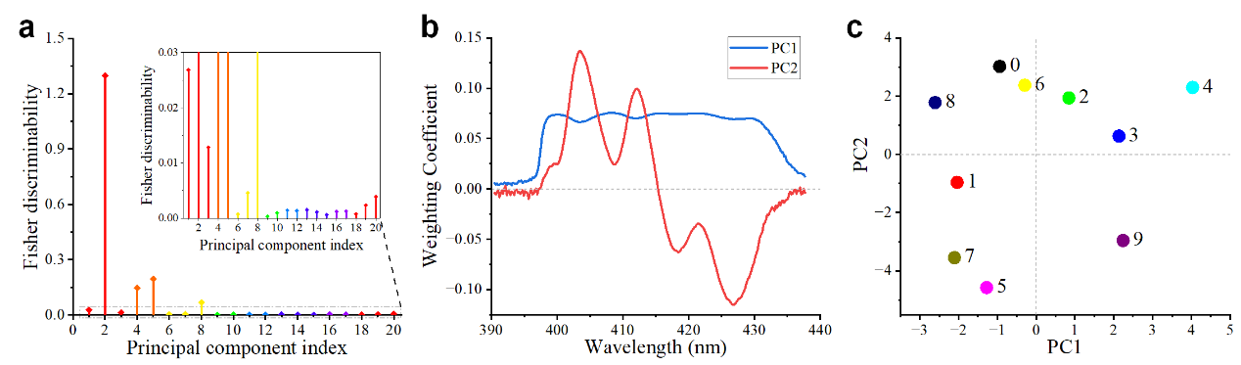
Fig. S3 Principal component analysis of spectral data. a, Fisher discriminability index of the principal components, highlighting that specific spectral modes contribute more significantly to class separation than the dominant energy component. b, Spectral weighting coefficients (loading vectors) for PC1 and PC2, revealing the wavelength-dependent encoding patterns where PC2 captures high-frequency modulations. c, Visualization of class centroids in the 2D latent space defined by PC1 and PC2, demonstrating preliminary clustering of categories based on spectral features alone.
As visualized in Fig. S3c, classes 0, 2, and 6 form a tight cluster in the PC1–PC2 latent space, confirming that their high spectral similarity poses a challenge for classification. Although Class 4 (Coat) also shows confusion with this group in the neural network predictions, its separation in the PC1-PC2 plane suggests that its ambiguity might arise from higher-order spectral features not captured by the first two principal components.
Supplementary Note 4: Reconstruction Examples Across Distinct MMFs
Figure S4 provides a comprehensive visual and quantitative analysis of the cross-fiber generalization capabilities of the proposed SHINE framework. The matrix of reconstruction examples demonstrates that models trained on fibers with standard core diameters (105 µm; A1–B2) generalize effectively to one another, preserving structural details even when the test fiber differs in length or manufacturer. While generalization to the large-core fiber (B3, 200 µm) shows expected degradation due to significant modal mismatch, the core features of the objects remain recognizable, validating the physical robustness of the encoding method.
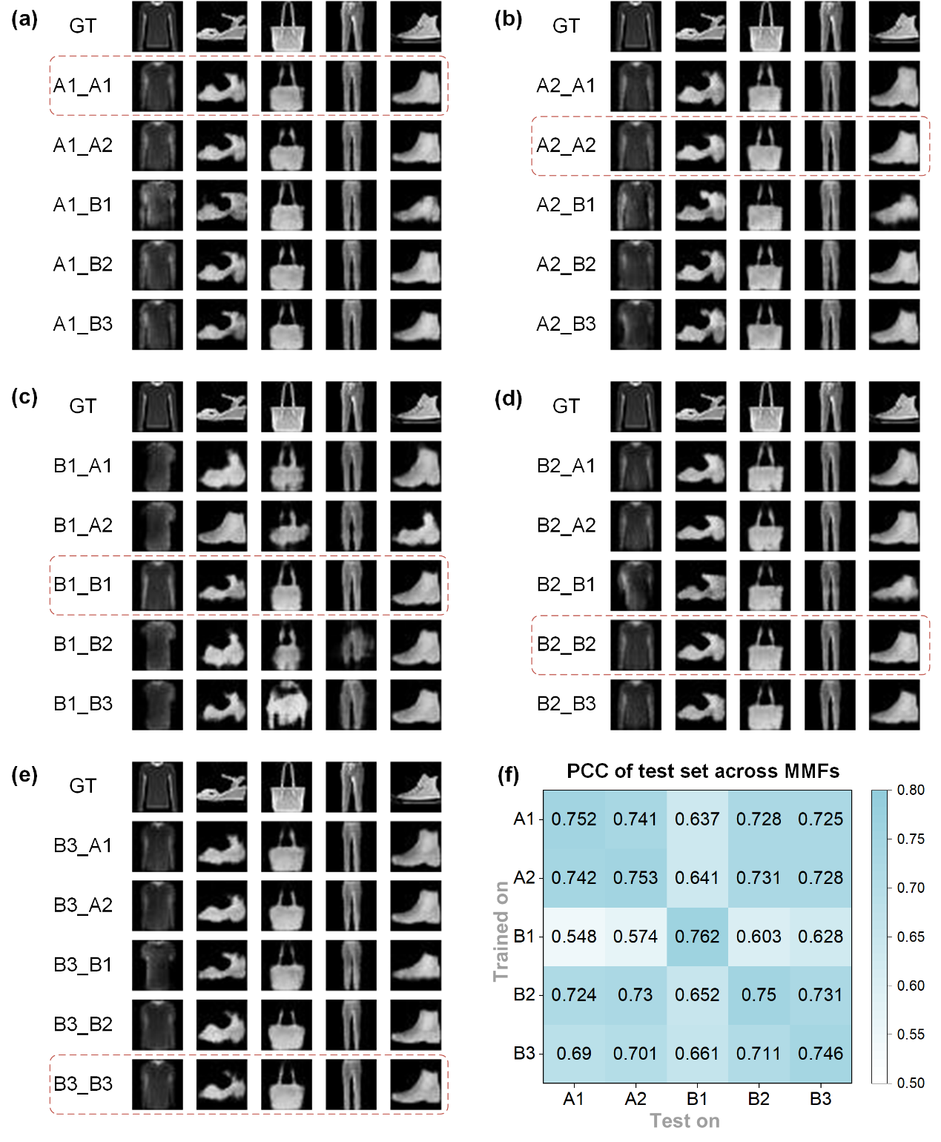
Fig. S4 Cross-fiber generalization performance and representative reconstructions across five distinct MMFs (A1–B3). a–e, Comparison between ground truth (GT) images and reconstructions generated by models trained on varying fibers. Each panel corresponds to a model trained on a specific fiber (A1 through B3). Within each panel, the columns display reconstruction results when that model is applied to test data from all five fibers. The diagonal elements (highlighted by red dashed boxes) represent the baseline performance where the model is trained and tested on the same fiber. f, Heatmap of the average PCC for image reconstruction. Rows indicate the fiber used for training, while columns indicate the fiber used for testing.
Supplementary Note 4: Robustness Analysis Against Signal Variation and Noise
To assess the stability of the proposed method under non-ideal experimental conditions, we numerically perturbed the experimentally acquired SHG spectra from the Fashion-MNIST test set. We evaluated two specific scenarios. First, global amplitude scaling: we applied scale factors ranging from 0.7 to 1.3 to the spectral intensity. This simulates variations in fiber coupling efficiency, laser power fluctuations, or changes in spectrometer integration time. Second, additive noise: we introduced random Gaussian noise with standard deviations ranging from 0.005 to 0.05 (normalized intensity). This simulates electronic sensor noise or stray light interference.
Figure S5a demonstrates that the system exhibits high tolerance to amplitude variations. Classification accuracy remains above 70% for scale factors within a ±15% range (0.85–1.15), and image reconstruction quality (PCC) degrades only marginally. This suggests the network relies on the relative spectral shape rather than absolute intensity values. Furthermore, Fig. S5c indicates robust noise immunity; the method maintains a PCC > 0.7 even at noise levels that visibly distort the spectral envelope (0.02). These results confirm the practicality of NSSE for real-world deployment, where signal-to-noise ratios and coupling efficiencies may fluctuate. Comprehensive quantitative results are detailed in Table S1 and Table S2.

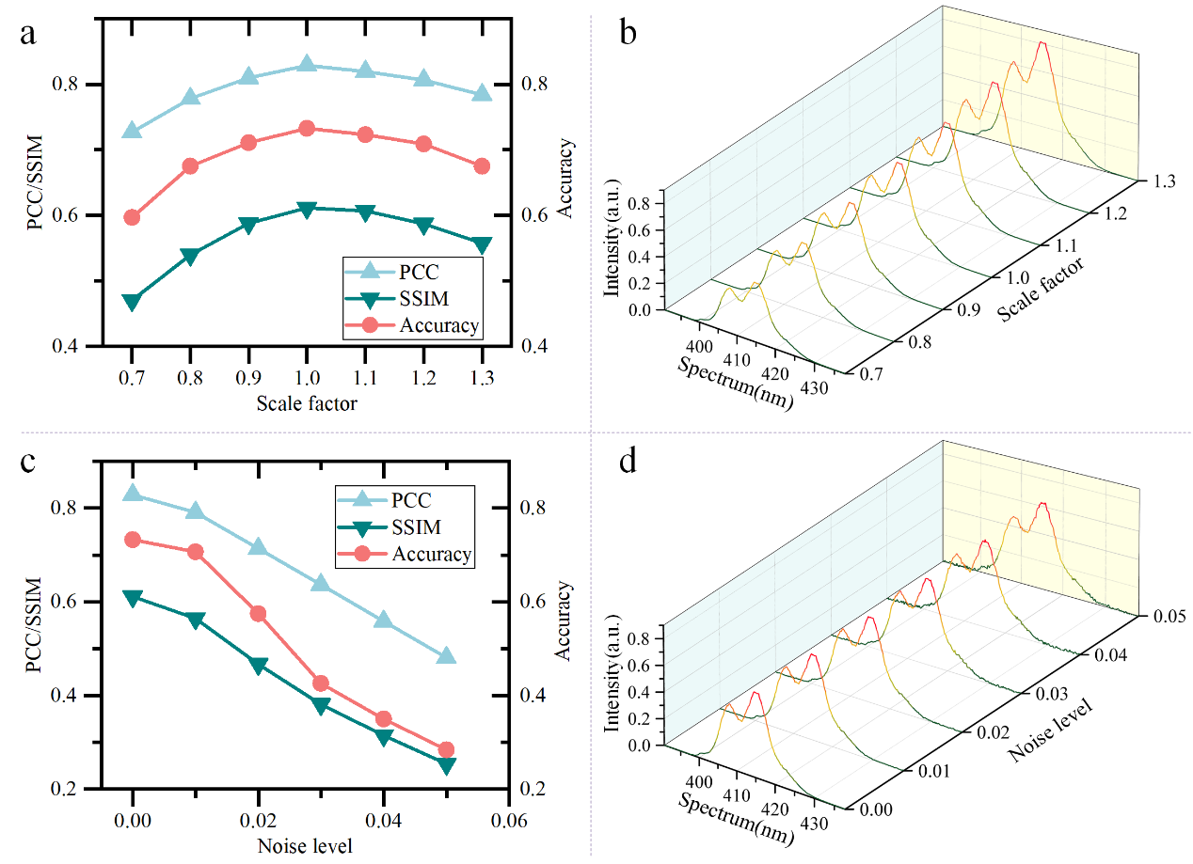
Fig. S5 Quantitative robustness analysis against spectral intensity scaling and additive noise. a, Evolution of reconstruction metrics (PCC, SSIM) and classification accuracy as a function of global intensity scaling factors. The shaded region indicates the regime of high stability. b, Representative SHG spectral intensity distributions under varying scale factors. c, Evolution of performance metrics as a function of additive Gaussian noise levels. d, Representative SHG spectral intensity distributions showing signal degradation at increasing noise levels.
Table S1 Quantitative evaluation of reconstruction and classification performance under input spectral intensity scaling.
Scale factor | PCC | SSIM | PSNR | Recognition accuracy
1.3 | 0.7842 | 0.5576 | 15.0148 | 67.5%
1.25 | 0.7962 | 0.5733 | 15.3050 | 69.2%
1.2 | 0.8064 | 0.5874 | 15.5733 | 70.9%
1.15 | 0.8142 | 0.5988 | 15.7957 | 71.8%
1.1 | 0.8193 | 0.6069 | 15.9518 | 72.3%
1.05 | 0.8219 | 0.6106 | 16.0303 | 73.7%
1 | 0.8289 | 0.6113 | 16.1758 | 73.3%
0.95 | 0.8178 | 0.6014 | 15.9034 | 73%
0.9 | 0.8097 | 0.5878 | 15.6851 | 71.10%
0.85 | 0.7969 | 0.567 | 15.3585 | 69.30%
0.8 | 0.7784 | 0.5398 | 14.9358 | 67.50%
0.75 | 0.7546 | 0.5064 | 14.4512 | 64.40%
0.7 | 0.7269 | 0.4706 | 13.9464 | 59.70%

Table S2 Quantitative evaluation of reconstruction and classification performance under additive Gaussian noise.
Noise level | PCC | SSIM | PSNR | Recognition accuracy
0 | 0.8289 | 0.6113 | 16.1758 | 73.3%
0.005 | 0.8145 | 0.597 | 15.8167 | 72.9%
0.01 | 0.791 | 0.5645 | 15.2839 | 70.7%
0.02 | 0.7142 | 0.467 | 13.8706 | 57.5%
0.03 | 0.6367 | 0.3811 | 12.5534 | 42.6%
0.04 | 0.5588 | 0.3151 | 11.5178 | 35.0%
0.05 | 0.4812 | 0.2539 | 10.5693 | 28.4%

