Supplementry Figure 1
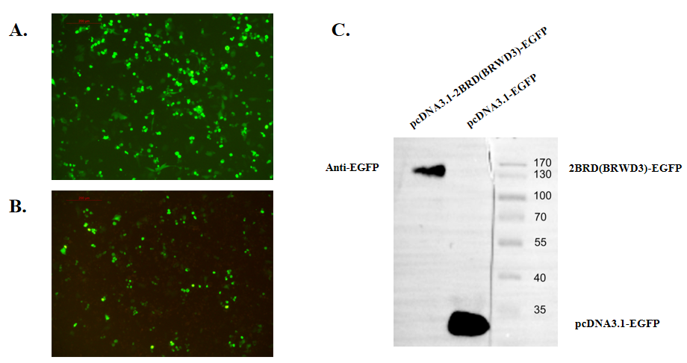
Supplementry Figure 1. Recombinant proteins expression detection with cell immunofluence and western blot. MDA-MB-231 was transfected with pcDNA3.1-EGFP (A) or pcDNA3.1-2BRD(BRWD3)-EGFP (B). Recombinant proteins expression was detected with western blot (C).

