Supplementary data
Identification of 2-keto-3-deoxy-D-xylonate as a natural inducer of the transcription factors XynR and YjhI and its application to the development of transcription-based biosensors for the bioproduction of non-natural 2,4-dihydroxybutyric acid in E. coli.

Thibault MALFOY^{1*}, Ceren ALKIM^{1*}, Julie FREDONNET² Juan LAJARIN-HERNANDEZ¹
and Jean Marie FRANCOIS^{1,2$}

¹Toulouse Biotechnology Institute, UMR INSA -CNRS5504 and UMR INSA-INRAE 792, 135 avenue de Rangueil, 31077 Toulouse, France
²Toulouse White Biotechnology, UMS INRAE-INSA-CNRS, 135 Avenue de Rangueil, 31077 Toulouse, France

Email address
Thibault Malfoy malfoy@insa-toulouse.fr
Ceren Alkim alkim@insa-toulouse.fr
Juan Lajarin-Hernandez lajarin-hern@insa-toulouse.fr
Julie Fredonnet Julie.fredonnet@inrae.fr
$Jean M François fran_jm@insa-toulouse.fr or jean-marie.francois@inrae.fr

Table S1: Primers used in this study
Oligonucleotide | Sequence
TM4 |  | tcgggctttgTCAGGCCGGGTAGCCCAG
TM5 |  | cccggcctgaCAAAGCCCGAAAGGAAGC
TM7 |  | ctagctcgaGGACTGCACCGAGCCATC
TM8 |  | tgcaagcttGAGATCTCCTTGCTGAATCATTTTG
TM9 |  | catgagcggatacatatttg
TM10 |  | aactaagatcggtactacgc
TM11 |  | ggataacgcaggaaagaacaAAACCGGATGCATACGATTAAGGCG
TM12 |  | TGTGAGCAAAAGGCCAGC
TM13 |  | TGTTCTTTCCTGCGTTATCC
TM14 |  | ttgctggccttttgctcacaGCGCCGCTACAGGGCGCG
TM15 |  | ctatggaaaaacgccagc
TM16 |  | gttgtttgtcggtgaacg
TM63 |  | tttacggctagctcagtcctaggtatagtgctagcACTAGTgaaagaggagaaatactag
TM64 |  | ctagtatttctcctctttcACTAGTgctagcactatacctaggactgagctagccgtaaa
TM65 |  | ggggttccgcgcacatttccccgaaTTTACGGCTAGCTCAGTC
TM66 |  | ggaaataatcatCTAGTATTTCTCCTCTTTCAC
TM67 |  | ggagaaatactagATGATTATTTCCGCAGCC
TM68 |  | tcgtgaggatgcgCTATGCCGCATTCCCTTTC
TM69 |  | aatgcggcatagCGCATCCTCACGATAATATC
TM70 |  | gtttcttagacgtcaggtggcacttGTTTCTACTGGTATTGGC
TM71 |  | AAGTGCCACCTGACGTCTAAG
TM72 |  | TTCGGGGAAATGTGCGCG
TM146 |  | tggccttttgctc
TM233 |  | CCTATATCGCCGACATCAC
TM234 |  | GGATCCGAATTCGAGCT
TM242 |  | aggcgccagcTAAAAATAGGCGTATCACG
TM243 |  | attcggatccCATAGTTAATTTCTCCTCTTTAATG
TM250 |  | cttcttaaagttaaaCgctagcataata
TM251 |  | gagatataccATGAAAGCCAAC
TM252 |  | TTTATGGCTAGCTCAGTCC
TM253 |  | AAGACGAAAGGGCCTC
JFR64 |  | GTGAGCAAAAGGCCAGACCTAGGGATA TATTCCGCTTCC
JFR65 |  | CGTCAGGTGGCACTTttagacgtcgga attgccag
JFR66 |  | CAGATTTCGTGATGCTTGTC
JFR67 |  | ATGGTGAAAGTTGGAACCTC
917 |  | TATTAATTAGAGCTCATGGCTGACACTCGCCCTGAACGTCGCTTTA
926 |  | TATTAATTAAGCTTTTATTCCGCGTTTTCGTGAATATGTTTGCTGCTGGCG
Seq_R |  | GTTCTTTCCTGCGTTATCCcc
Seq-F |  | atgCCGATTATTCAGTCTGTTGAAC
seq_ xynR rbs01_R |  | CTGAATAATCGGcatTCCAAACCTCCTCGAAAACGT
seq_xynR rbs01_J23119_R |  | CTGAATAATCGGcatTCCAAACCTCCTGCTAGCATTATAC
seq-xynR rbs01_J23100_R |  | CTGAATAATCGGcatTCCAAACCTCCTGCTAGCAC
seq_xynR rbs01 J23106_R |  | CTGAATAATCGGcatAATGCTGGCATGTCCACG
seq_xynR rbs01_J23104_R |  | CTGAATAATCGGcatTCCAAACCTCCTGCTAGCAC
seq-xynR_F |  | AACGCAGGAAAGAACAAAACCGGATGCATACGATTAAGG
1781-gRNA - lacZ |  | ACTAGTATTATACCTAGGACTGAG
2996-oligo-pTarget-asd |  | GTCCTAGGTATAATACTAGTATCGGCTGGCGCGGTATGGTGTTTTAGAGCTAGAAATAGC
2999-asd-vrf-F |  | ATCTGATTCGGGTACTGATG
3000-asd-vrf-rev |  | GATAATAGCCAGGCATCCAT
3116-vrf-yjhI-F |  | CCTCATTCAATAAAGTGATAAGT
3117-vrf-yjhI-R |  | CGATCTGCTGGTAATAGT
3131-amp-syfp2-F |  | GGACTGCACCGAGCCATCTT
3132-amp-syfp2-R |  | CGGCGGATTTGTCCTACTCA
3133-remove-2genes-F |  | CTGAAAGGAGGAACTATATCCGGATTGG
3134-remove-2genes-R |  | TCGAggtgaagacgaaagggc
3135-inf-pBS0-F |  | tcgtcttcaccTCGAGACTGCACCGAG
3136-inf-pBS0-R |  | AGTTCCTCCTTTCAGcggcggatttgtcctact
3126-xynR-remove-F |  | CTGAAAGGAGGAACTATATCCGGATTGG
3127-xynR-remove-R |  | GTTCTTTCCTGCGTTATCCcct
3128-yjhI-infusion-F |  | AACGCAGGAAGAATCCACACACTACGATGTTGAACA
3129-yjhI-infusion-R |  | AGTTCCTCCTTTCAGCAAAAAACCCCTCAAGACCCGT
3130-amp-yjhI-F |  | ATCCACACACTACGATGTTG
3137-ter7-pour yjhI-R |  | CAAAAAACCCC………CCTTTTCGTAAGTGC*
3146-enlever-yagE-F |  | AAGCTTTCCAACTTAAATACAAGGAAAATAAGGAG
3147_pyjhI_inf_F |  | TCGTCTTCACCTCGATCCACACACTACGATGTTGCAACA
3149_pBS8_inf_R |  | TAAGTTGGAAAGCTTAATGGCTCCTCCTTGCTCATG
3150_yagF_vrf_F |  | CGCAGATGTATCAGCTGGAT
3151_yagF_vrf_R |  | TGCCGAATTACAACATCGTG
3152_yjhG_vrf_F |  | ATACAGCATGCAGTGTGTCG
3153_yjhG_vrf_R |  | GATGGCGACAGCAATCGAGA
3154_pBS7_over_F |  | TATCCACAGAATCAGGGGATAACGCAGGAAAGAACCTGAAAGGAGGAACTATATCCGGATTGGCG
3155_pBS7_over_R |  | GTTCTTTCCTGCGTTATTCCCCTGATTCTGTGGATAACCGTATTACCGCCT
3159_del_v_xynR_F |  | GTATCAGGTGAACGCGCAGA
3160_del_v_xynR_R |  | GGGCTGACCTGCTACTACAA
3164_del_v_yjhI_F |  | CTGTAGCAACACTATCATGT
3165_del_v_yjhI_R |  | GATCTGCTGGTAATAGTCGT

Table S2: Genetic modifications of the promoter and RBS of the XynR-based biosensor
name |  | Synthetic DNA fragments
pBioS-JF1 (pBS3) | seq Pxynr:RBS_{xynR} |  | AAAACCGGATGCATACGATTAAGGCGGTGATGATGGCAACGCTTGGGGAGTGATTGGGTCCGCTGCGCGTTGGTGCCCTCACCCCGGCCCTCTCCCACAGGGAGAGGGAGAACACCGGCTCCATTTCATTGATTTTTCATCCCGAAAAAGGTACGTTTTCGCCTTAATTCCAGCGTGGACATGCCAGCATT
pBioS-JF2 | seq PxynR : RBS_{O1} |  | AAAACCGGATGCATACGATTAAGGCGGTGATGATGGCAACGCTTGGGGAGTGATTGGGTCCGCTGCGCGTTGGTGCCCTCACCCCGGCCCTCTCCCACAGGGAGAGGGAGAACACCGGCTCCATTTCAttgatttttcatcccgaaaaaggtacgttttcgAGGAGGTTTGGA
pBioS-JF3 | seq PJ23119: RBS_{O1} |  | AAAACCGGATGCATACGATTAAGGCGGTGATGATGGCAACGCTTGGGGAGTGATTGGGTCCGCTGCGCGTTGGTGCCCTCACCCCGGCCCTCTCCCACAGGGAGAGGGAGAACACCGGCTCCATTTCAttgacagctagctcagtcctaggtataatgctagcAGGAGGTTTGGA
pBioS-JF4 | seq Pj23100:RBS_{O1} |  | AAAACCGGATGCATACGATTAAGGCGGTGATGATGGCAACGCTTGGGGAGTGATTGGGTCCGCTGCGCGTTGGTGCCCTCACCCCGGCCCTCTCCCACAGGGAGAGGGAGAACACCGGCTCCATTTCAttgacggctagctcagtcctaggtacagtgctagcAGGAGGTTTGGA
pBioS-JF5 | seq Pj23104: RBS_{O1} |  | AAAACCGGATGCATACGATTAAGGCGGTGATGATGGCAACGCTTGGGGAGTGATTGGGTCCGCTGCGCGTTGGTGCCCTCACCCCGGCCCTCTCCCACAGGGAGAGGGAGAACACCGGCTCCATTTCAttgacagctagctcagtcctaggtattgtgctagcAGGAGGTTTGGA
pBioS-JF6 | seq Pj23106:RBS_{O1} |  | AAAACCGGATGCATACGATTAAGGCGGTGATGATGGCAACGCTTGGGGAGTGATTGGGTCCGCTGCGCGTTGGTGCCCTCACCCCGGCCCTCTCCCACAGGGAGAGGGAGAACACCGGCTCCATTTCAtttacggctagctcagtcctaggtatagtgctagcAGGAGGTTTGGA

In bold are the sequence of the synthetic promoter. RBS sequence is underlined

Table S3: Expression changes of the D-xylonate metabolic genes from the cryptic CP4-6 prophage regulated by xynR (yagI) and from the KpLE2 phage-like element regulated by yjhI in E. coli under fermentation process of 2,4-DHB production or in response to challenge with 1 M 2,4-DHB
 | Fermentation condition*  Value in fold change |  |  | Toxicity condition$  value in fold change
Gene name | T12/T2 | T28/T2 | T58/T2 | T30/T0 | T180/T0
xynR(yagI) | 0.9 | 1.08 | 0.40 | 1.05 | 0.65
yagE | 11.2 | 13.6 | 2.2 | 2.2 | 1.3
yagF | 8.3 | 9.1 | 1.2 | 2.9 | 1.8
yagG | 1.9 | 2.2 | 1.3 | 2.0 | 1.9
yagH | 1.7 | 2.1 | 1.1 | 2 | 1.9
yjhI | 8.7 | 7.4 | 1.3 | 4.7 | 1.7
yjhH | 3.6 | 2,0 | 1,2 | 1.8 | 1.1
yjhG | 2.5 | 1,4 | 1,1 | 3.1 | 2.0
yjhF | 2,5 | 1,4 | 1,1 | 3,1 | 2.0

*Fermentation was carried out with a E. coli MG1655 strain expressing the homoserine-2,4-DHB pathway (Walther et al. 2018) in a M9 medium with glucose alimentation in a fed batch mode. Samples were taken after 2, 12, 28 and 54 hr of culture for transcriptomic analysis using E. coli Agilent gene chips (Alkim et al. 2022). The data are the mean of two technical replicates from 2 biological experiments.
$Toxicity experiments were carried out with E. coli MG1655 cultivated in M9 medium with 0.4 % glucose. In mid log phase (OD₆₀₀$\sim$1.0), the cells were challenged with 1 M 2,4-DHB ammonium. Samples were taken at 30 and 180 min after addition 1 M 2,4-DHB or 1M ammonium sulphate used as control. Transcriptomic analysis was carried out using E. coli Agilent gene chips from three biological experiments according to (Alkim et al. 2022).

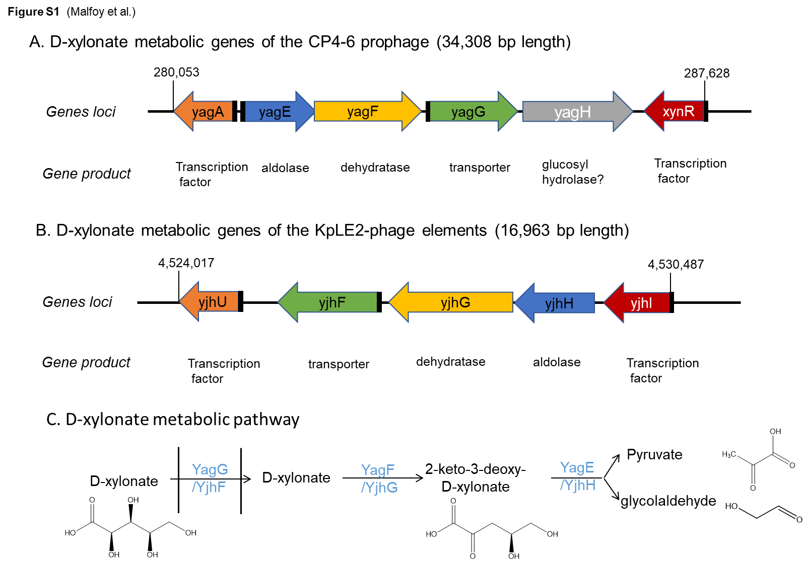
Figure S1: Scheme of the D-xylonate metabolic genes that are regulated by XynR or YjhI transcription factor-. (A) D-xylonate metabolic genes in the 34,308 bp genomic structure of the CP4-6 cryptic prophage that are under the control of DNA binding transcriptional repressor encoded by xynR. (B) D-xylonate metabolic genes in the 19,963 KplE2-phage elements that are under the DNA binding transcriptional activator encoded by yjhI. (C) D-xylonate catabolic pathway

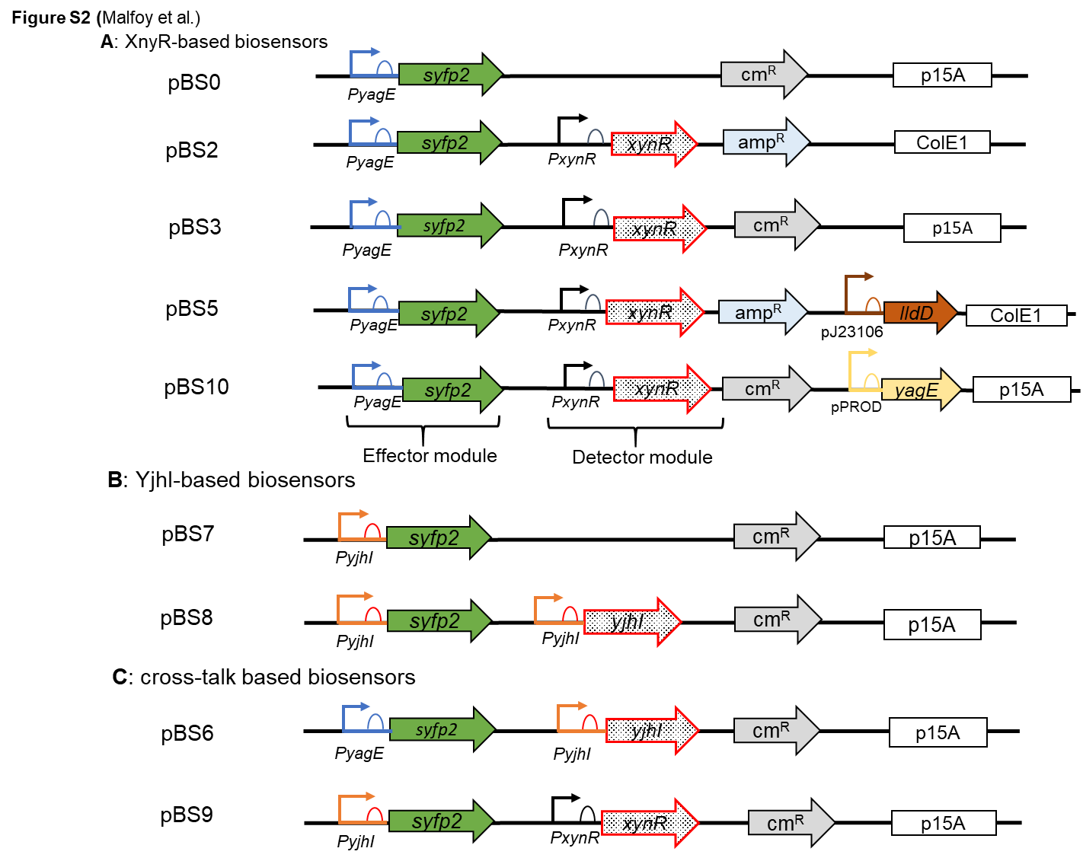
Figure S2: scheme of the transcription factor -based biosensor. (A) Description of the genomic construction of the xynR-based metabolite biosensor carried on medium copy (pBS3) plasmid. The syfP2 reporter gene was flanked upstream by a 300 bp of corresponding to XynR-sensitive promoter region of yagE. The gene lldD encoding L-lactate oxidase was inserted into pBS2 under the strong synthetic promoter pJ23106 to yield pBS5. The gene yagE which encodes a pyruvate -dependent aldolase of the XynR-operon was inserted in pBS3 under the strong constitutive ProD promoter. (B) Description of the genomic construction of the YjhI-based metabolite biosensor carried on medium copy (pBS7) plasmid. (C) description of genomic construction of cross-talk based biosensors.

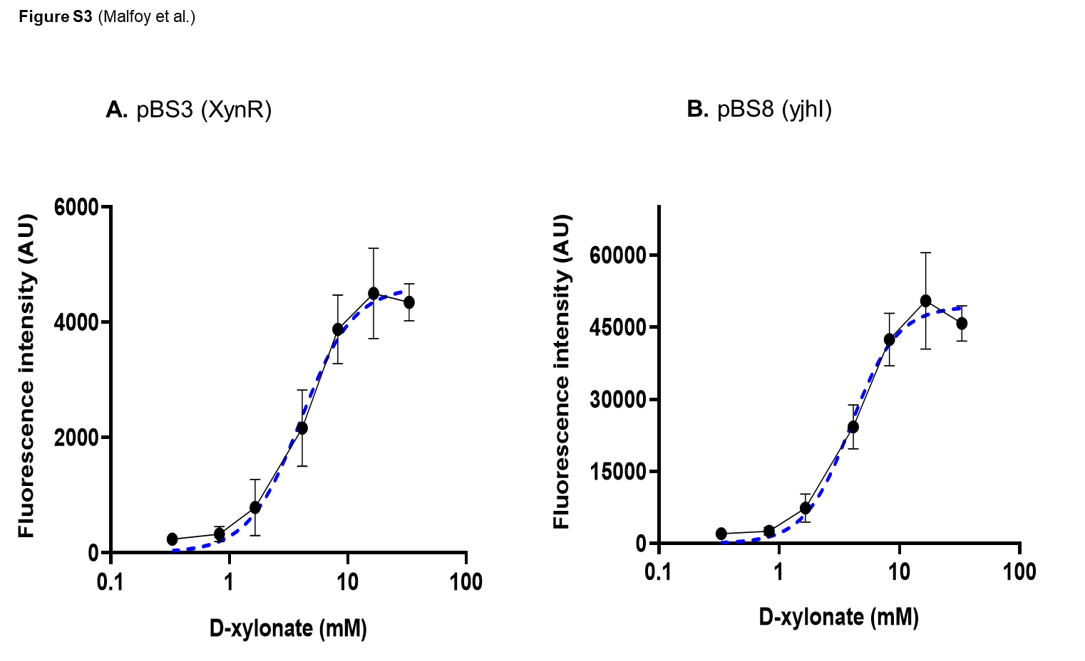
Figure S3: Dose-response curves of XynR- and YjhI-based biosensor to D-xylonate. The strain used for dose-response to D-xylonate was MGΔ7 transformed with pBS3 and pBS8. The fluorescence was measured by spectrofluorometer over 15 h and values at 12 h after addition of the effectors were used for dose-response analysis, using Graph Pad prism for analysis and graph representation. Data are the mean ± SD (shown by bars on the curves) of four biological replicates

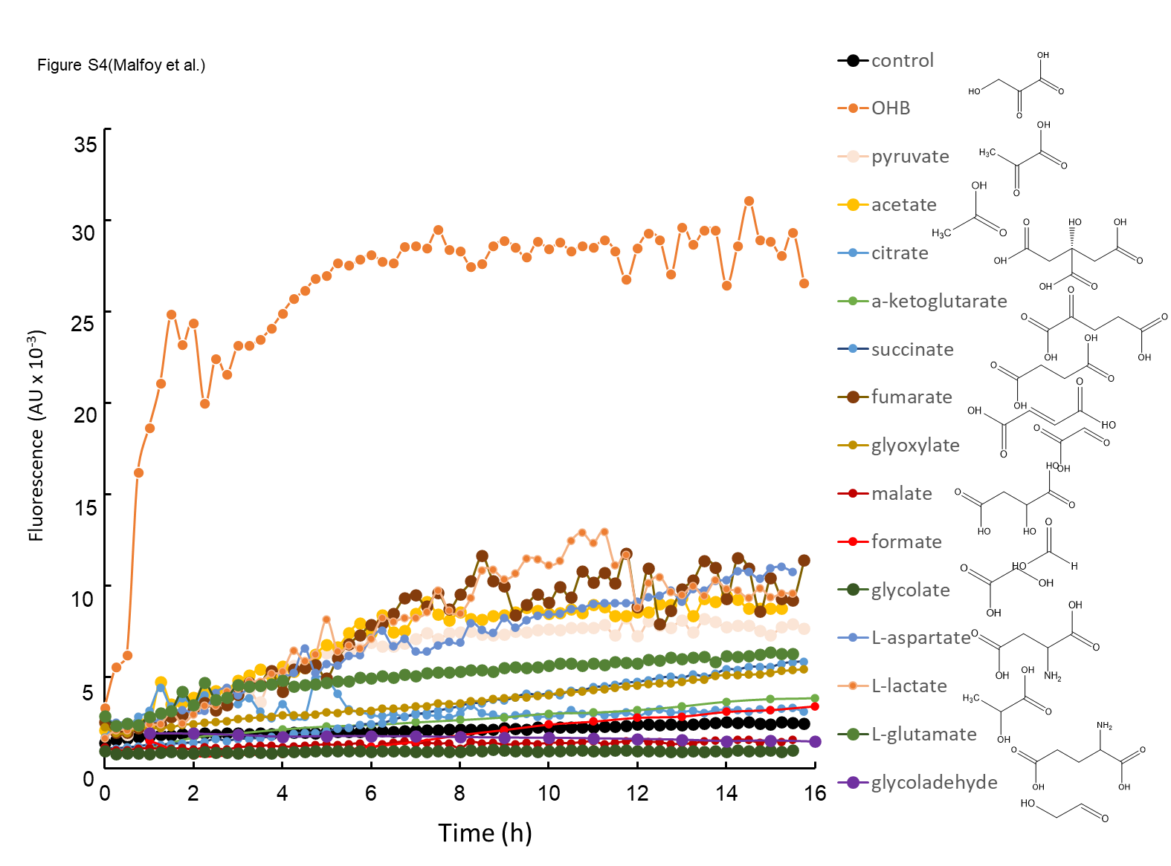
Figure S4: Kinetic of fluorescence response of XynR-based biosensor to various metabolites. The strain MGΔ7 transformed with pBS3 was incubated in the presence of various metabolites added at 10 mM except OHB which was 1 mM). The fluorescence was monitored over time from three independent replicates. Data reported are the mean of the three biological replicates and SD has been removed to simplify the visualisation of the figure but overall, the CV for each curve was in the range of 10 %

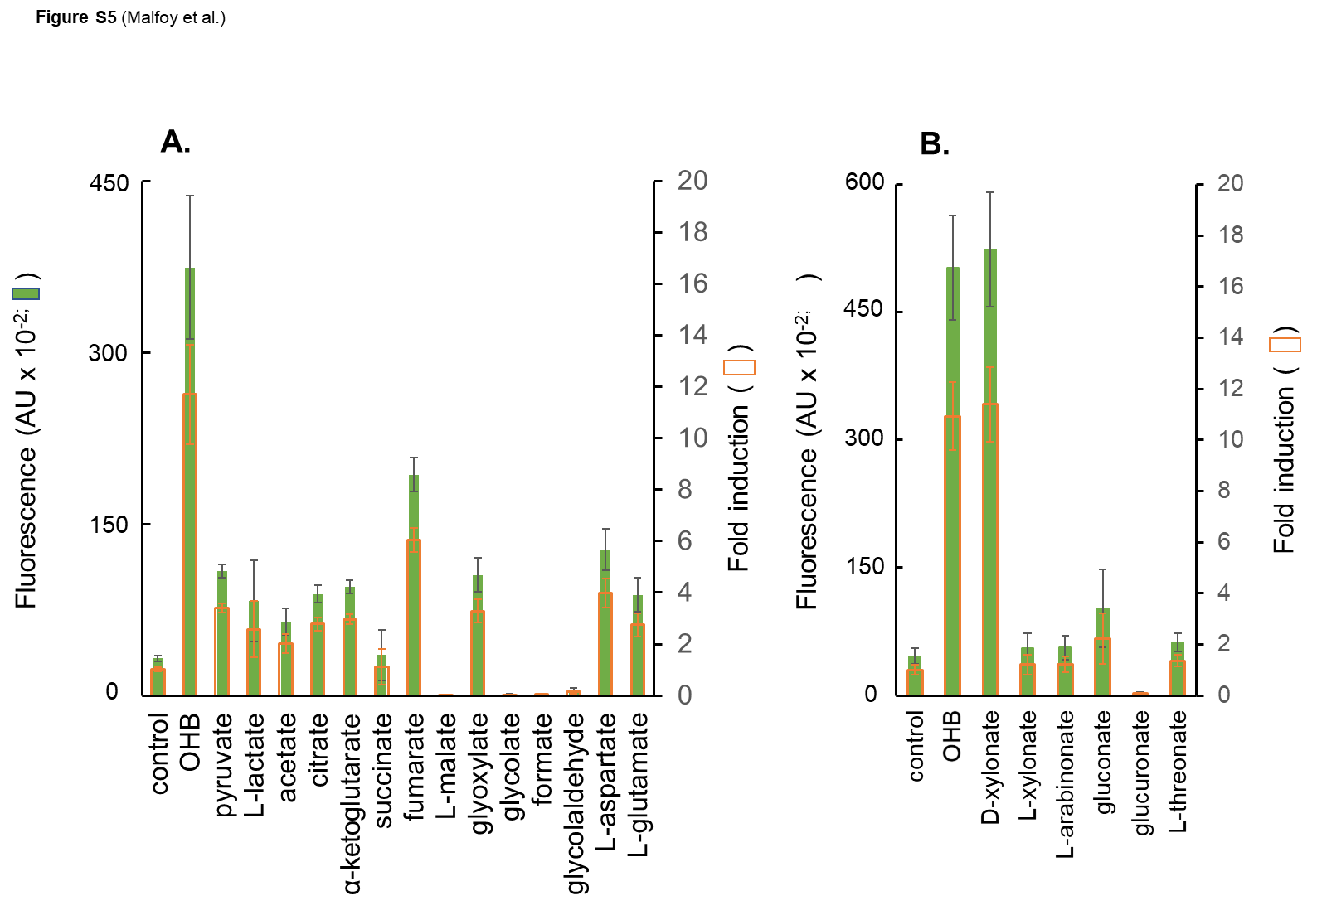
Figure S5: The YjhI-based biosensor is highly specific to OHB. In (A) is reported the fluorescence measured after 12 h incubation of the strain MGΔ7 transformed with pBS8 in the presence of various intracellular metabolites added at 10 mM except for OHB (1 mM). (B) is the same as (A) except that various sugar acids with similarity to D-xylonate were tested. Data are the mean ± SD (shown by bar on the histogram) of three biological replicates.

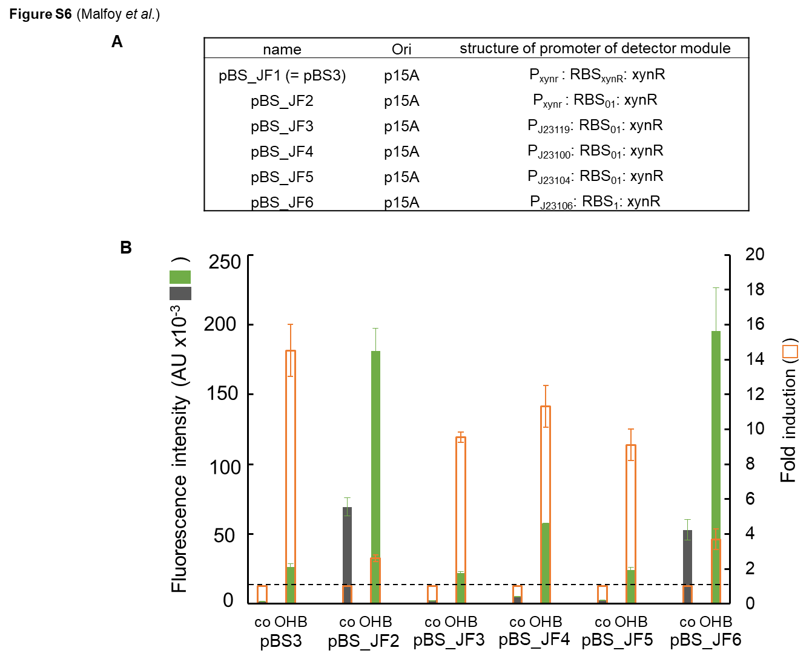
Figure S6: Effect of promoter strength on the dynamic response of the XynR-based biosensor to D-xylonate and OHB. In (A) is reported the structure of the XynR promoter and the name of the corresponding medium copy plasmid. In (B) is provided the fluorescence of MGΔ7 strain transformed by the different genetic constructs after 12 h incubation with 1 mM OHB. (C) is the same as (B) except that KDX was used at 1 mM. Data are the mean ± SD (shown by bars on the histogram) of three biological replicates.
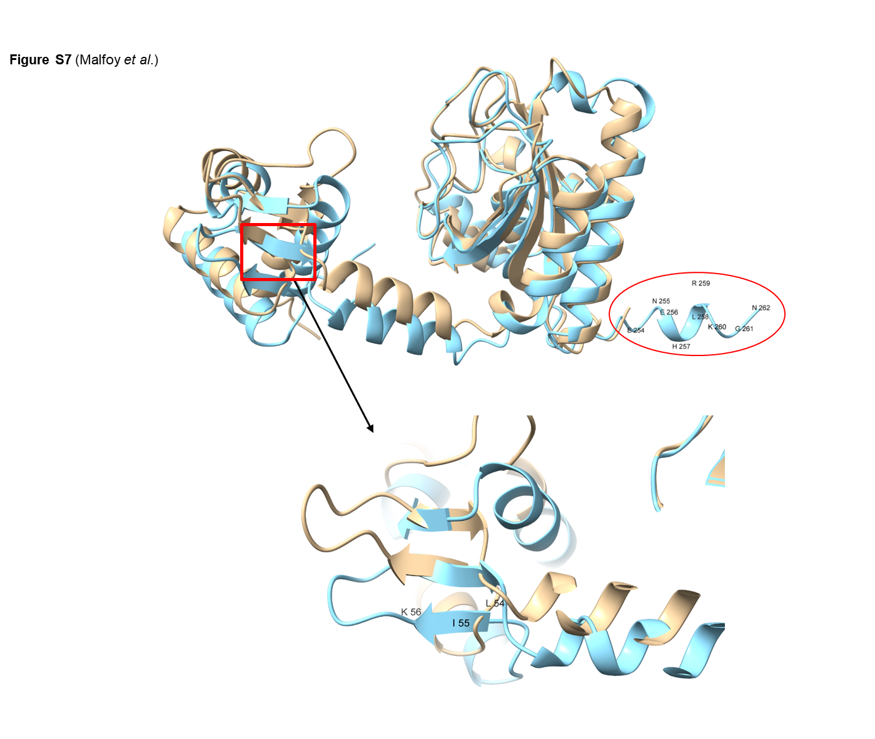
Figure S7: Alphafold modelled structure of XynR and YjhI transcription factors from E. coli. Overlay of the two structures are presented, with XynR in faint brown and YjhI in blue. As red rectangle and a red circle are highlighted differences in protein sequence/ structure between YjhI and XynR.

References cited
Alkim C, Farias D, Fredonnet J, Serrano-Bataille H, Herviou P, Picot M, Slama N, Dejean S, Morin N, Enjalbert B, Francois JM (2022) Toxic effect and inability of L-homoserine to be a nitrogen source for growth of Escherichia coli resolved by a combination of in vivo evolution engineering and omics analyses. Front Microbiol 13:1051425 doi:10.3389/fmicb.2022.1051425
Walther T, Calvayrac F, Malbert Y, Alkim C, Dressaire C, Cordier H, Francois JM (2018) Construction of a synthetic metabolic pathway for the production of 2,4-dihydroxybutyric acid from homoserine. Metab Eng 45:237-245 doi:10.1016/j.ymben.2017.12.005

